SCREENSHOTS
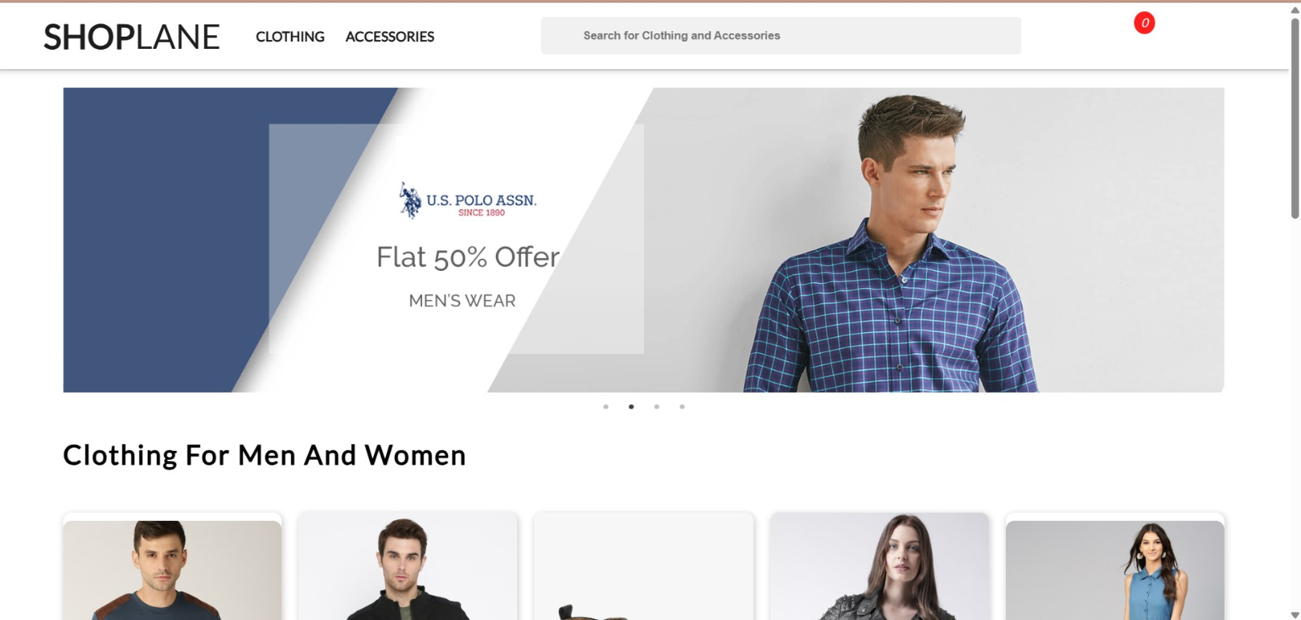
- Desktop Home Page Screenshot

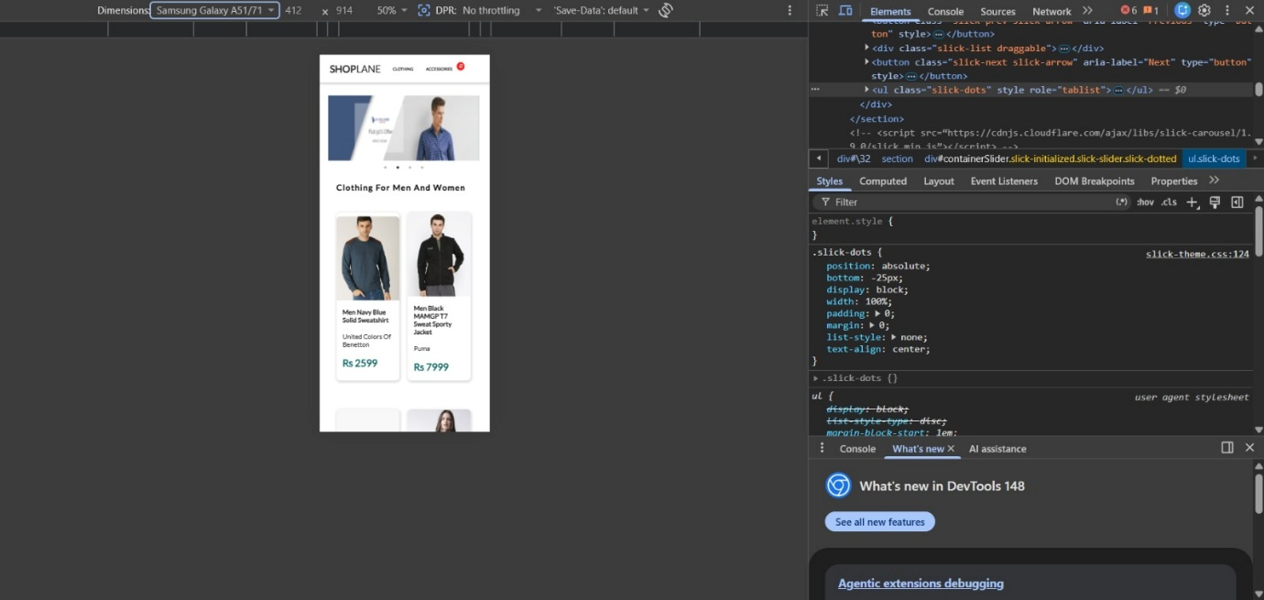
- Mobile Home Page Screenshot

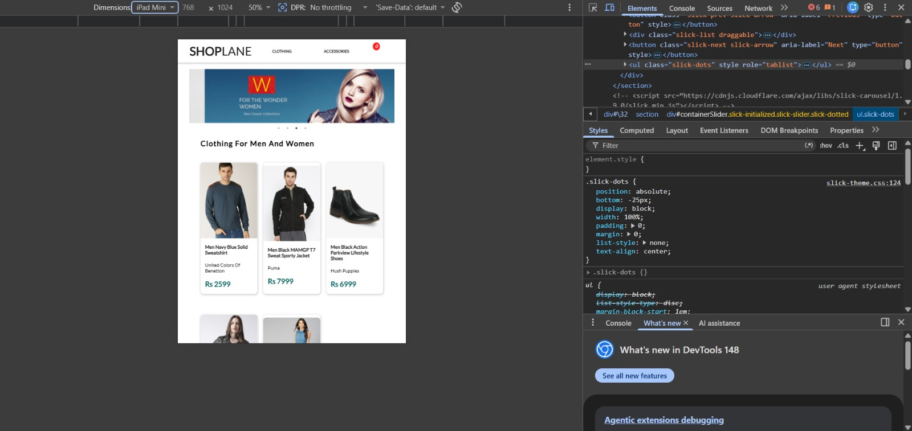
- Tablet Home Page Screenshot

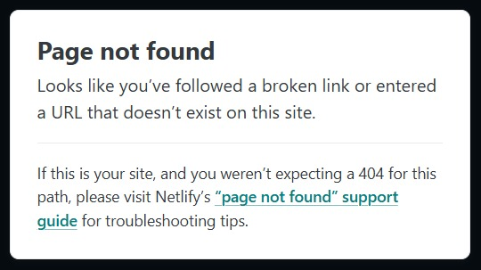
4.Clothing Category & Accessories Category 404 Error Screenshot

