# **Chat Bot Application**

## **Overview:**

The Chat Bot Application is a Python-based conversational agent that interacts with users in natural language. It utilizes the ChatterBot library to handle user inputs and generate appropriate responses. The application provides a simple command-line interface for users to engage in conversations with the chatbot.

## **Features:**

* Conversational interface for users to interact with the chatbot.
* Utilizes the ChatterBot library for natural language processing and response generation.
* Basic error handling for unexpected user inputs.
* Provides Accurate Response
* Large Dataset.
* Ability to exit the conversation gracefully.

## **Requirements:**

* Python (3.x recommended)
* ChatterBot library
* Requests library (pip install requests)
* ChatterBot version 1.0.4(Suitable for python v3)
* Git
* Setuptools Wheel

## **Execution Steps:**

### **Step 1: Clone the Repository**

Clone the repository containing the Registration Form Application code from the GitHub repository:  
  
git clone https://github.com/your_username/ chat_bot.git

**Step 2: Navigate to the Project Directory**

Navigate to the directory where the project files are located:

cd chat_bot

### **Step 3: Install Dependencies (if necessary)**

Ensure you have Python and Tkinter installed on your system. If not, install them using the following commands:

Install Python (if not already installed)

* **For Linux:**  
  sudo apt-get update  
  sudo apt-get install python3
* **For macOS:**  
  brew install python3
* **For Windows:**  
  Download Python installer from <https://www.python.org/downloads/>**# Install Chatter Bot**  
  Chatter Bot usually comes pre-installed with Python. If not, install it using the package manager specific to your operating system.

pip install chatterbot

### **Step 4: Run the Application** Navigate to the file path – cd path

Run the Python script **‘python** **chat_bot.py’** using the following command:

python lyrics_extractor.py

**Step 5: Start the Conversation**

Once the application starts, you can engage in a conversation with the chatbot by typing messages into the command-line interface.

**Step 6: Exit the Conversation**

To end the conversation and exit the application, type 'exit' and press Enter.

**Screen Shorts:**

**Welcome Interface:**

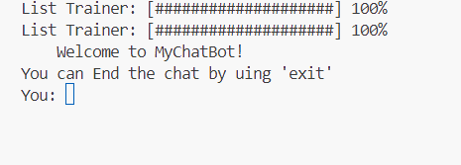

**Conversation:**

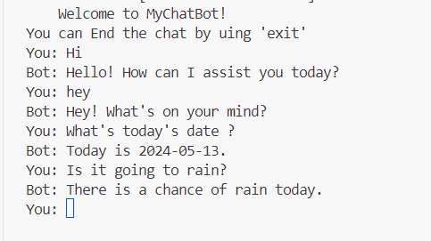

**End of Chat:**

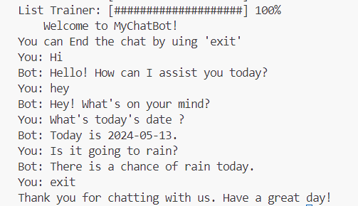

**Support and Feedback:**

For any issues or feedback regarding the Lyrics Extractor GUI Application, please contact

**Email:** ‘harani_uddandam@example.com’