PL/SQL programming

**Exercise 1: Control Structures**

**Scenario 1:** The bank wants to apply a discount to loan interest rates for customers above 60 years old.

**Question:** Write a PL/SQL block that loops through all customers, checks their age, and if they are above 60, apply a 1% discount to their current loan interest rates.

CODE:

BEGIN

FOR cust IN (

SELECT c.CustomerID, l.LoanID, l.InterestRate, c.DOB

FROM Customers c

JOIN Loans l ON c.CustomerID = l.CustomerID

)

LOOP

IF MONTHS_BETWEEN(SYSDATE, cust.DOB) / 12 > 60 THEN

UPDATE Loans

SET InterestRate = InterestRate - 1

WHERE LoanID = cust.LoanID;

END IF;

END LOOP;

COMMIT;

END;

OUTPUT:

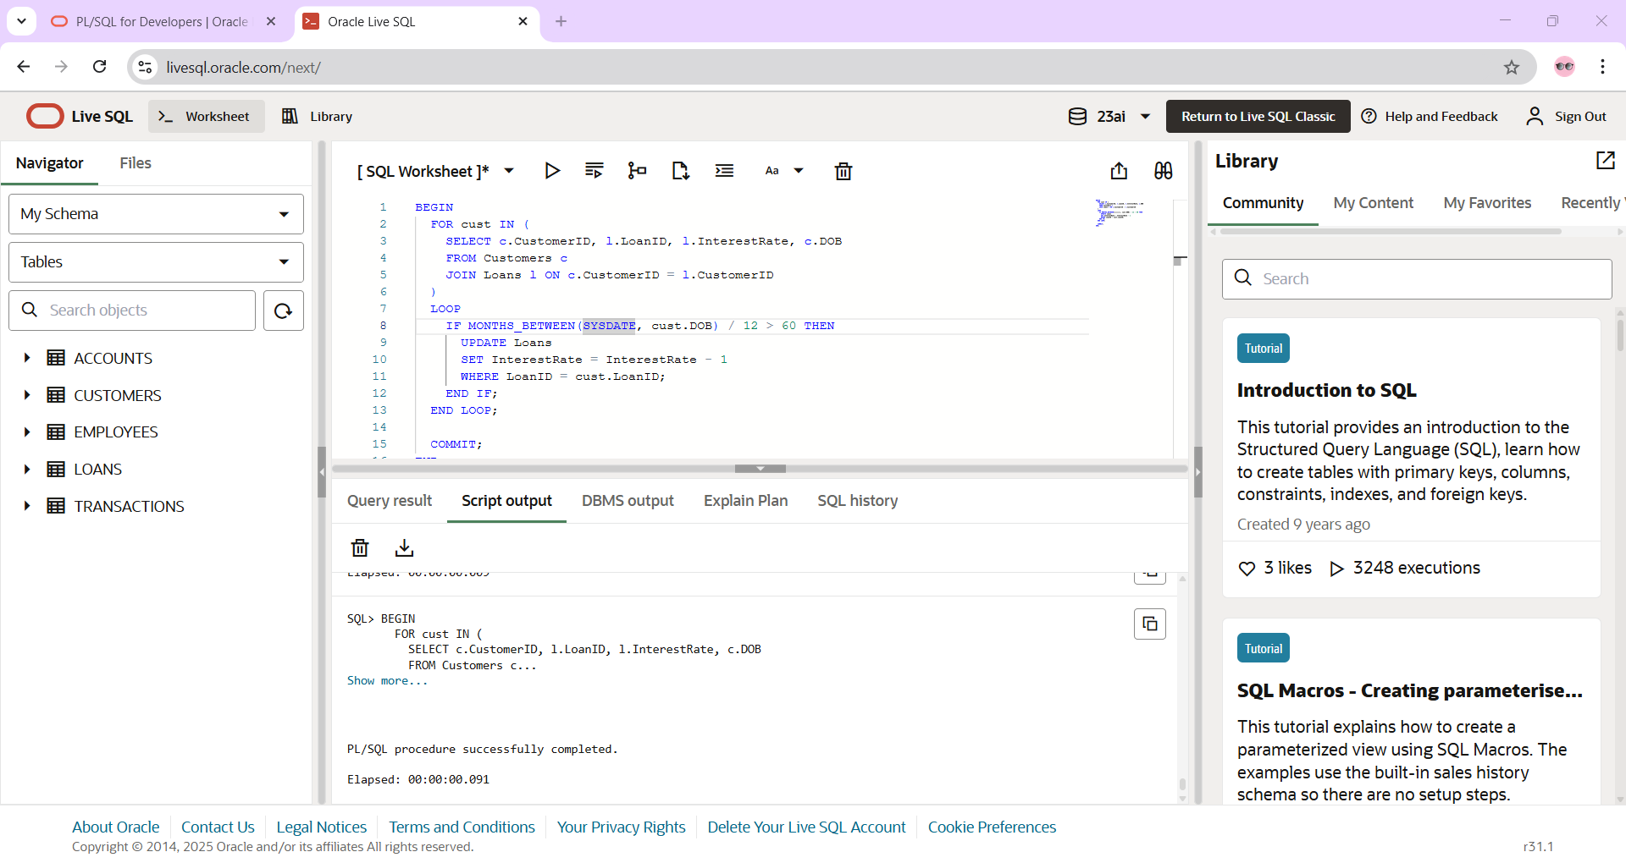

**Scenario 2:** A customer can be promoted to VIP status based on their balance.

**Question:** Write a PL/SQL block that iterates through all customers and sets a flag IsVIP to TRUE for those with a balance over $10,000.

CODE:

ALTER TABLE Customers ADD IsVIP VARCHAR2(5);

BEGIN

FOR cust IN (

SELECT CustomerID, Balance

FROM Customers

)

LOOP

IF cust.Balance > 10000 THEN

UPDATE Customers

SET IsVIP = 'TRUE'

WHERE CustomerID = cust.CustomerID;

END IF;

END LOOP;

COMMIT;

END;

OUTPUT:

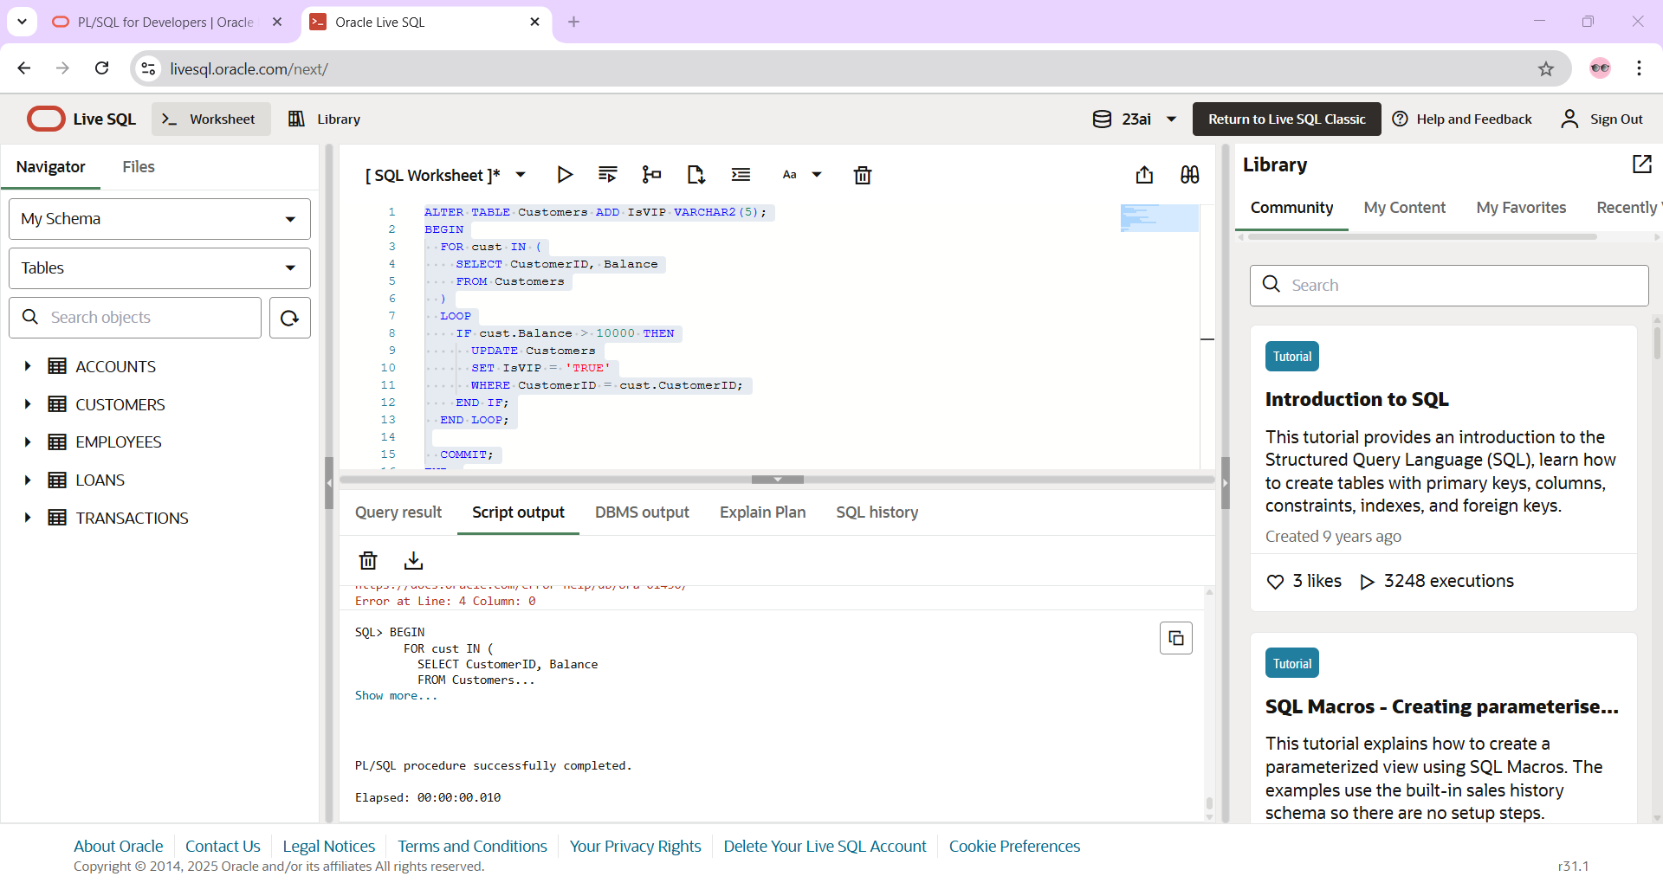

**Scenario 3:** The bank wants to send reminders to customers whose loans are due within the next 30 days.

**Question:** Write a PL/SQL block that fetches all loans due in the next 30 days and prints a reminder message for each customer.

CODE:

BEGIN

FOR loan_rec IN (

SELECT l.LoanID, l.EndDate, c.Name

FROM Loans l

JOIN Customers c ON l.CustomerID = c.CustomerID

WHERE l.EndDate BETWEEN SYSDATE AND SYSDATE + 30

)

LOOP

DBMS_OUTPUT.PUT_LINE('Reminder: Loan ' || loan_rec.LoanID ||

' for customer ' || loan_rec.Name ||

' is due on ' || TO_CHAR(loan_rec.EndDate, 'DD-MON-YYYY'));

END LOOP;

END;  
  
OUTPUT:

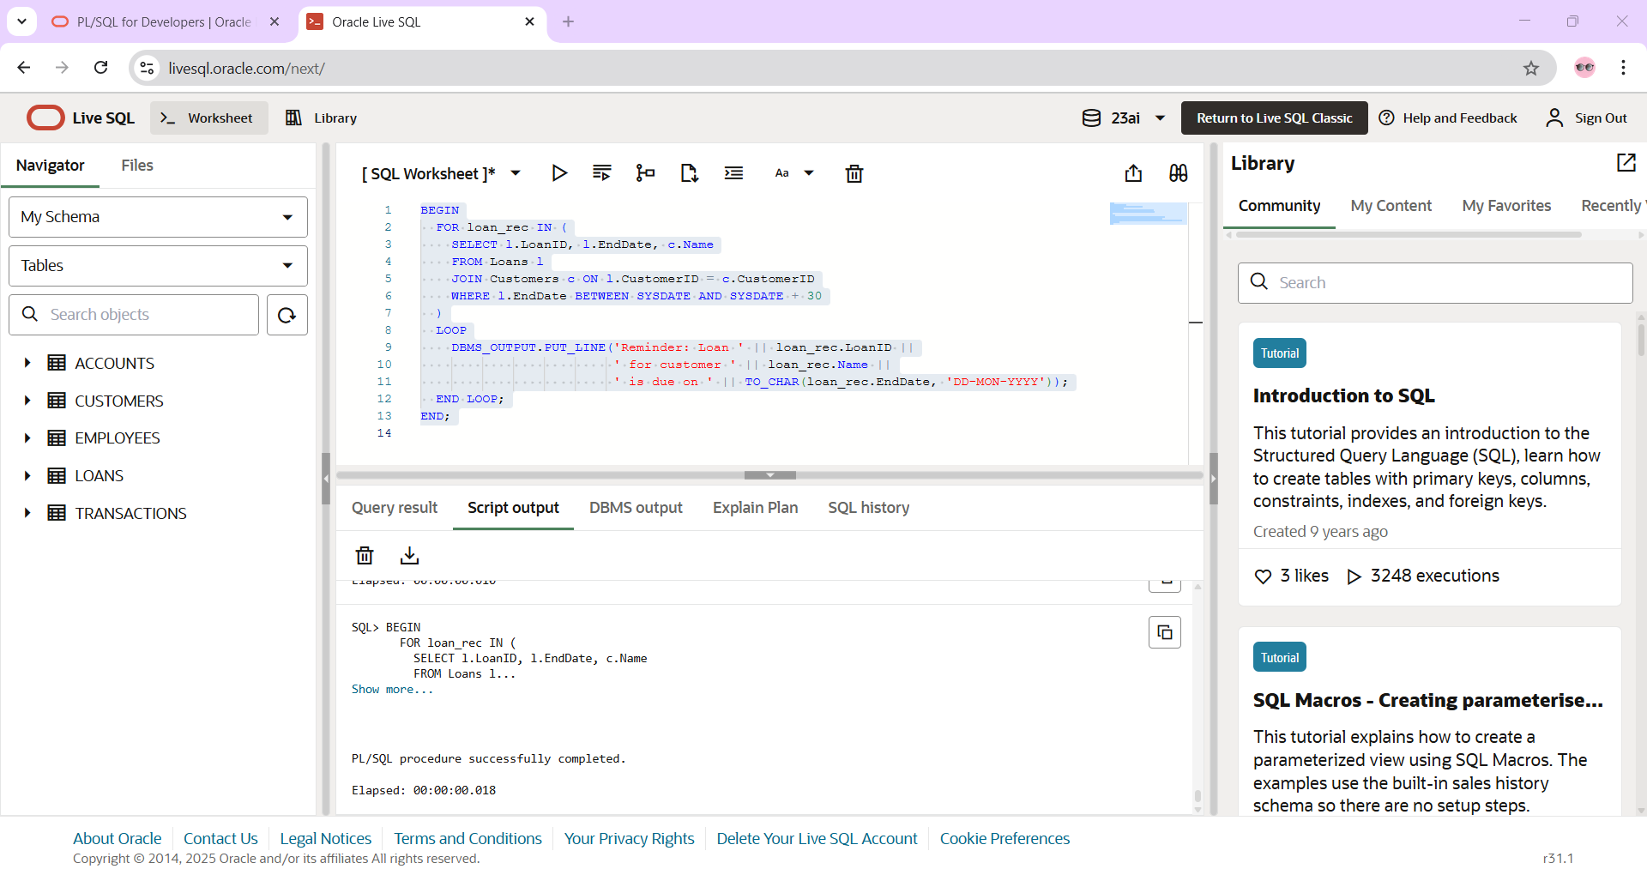

**Exercise 3: Stored Procedures**

**Scenario 1:** The bank needs to process monthly interest for all savings accounts.

**Question:** Write a stored procedure **ProcessMonthlyInterest** that calculates and updates the balance of all savings accounts by applying an interest rate of 1% to the current balance.

CODE:

CREATE OR REPLACE PROCEDURE ProcessMonthlyInterest IS

BEGIN

FOR acc IN (

SELECT AccountID, Balance

FROM Accounts

WHERE LOWER(AccountType) = 'savings'

)

LOOP

UPDATE Accounts

SET Balance = acc.Balance + (acc.Balance * 0.01),

LastModified = SYSDATE

WHERE AccountID = acc.AccountID;

END LOOP;

COMMIT;

END;

OUTPUT:

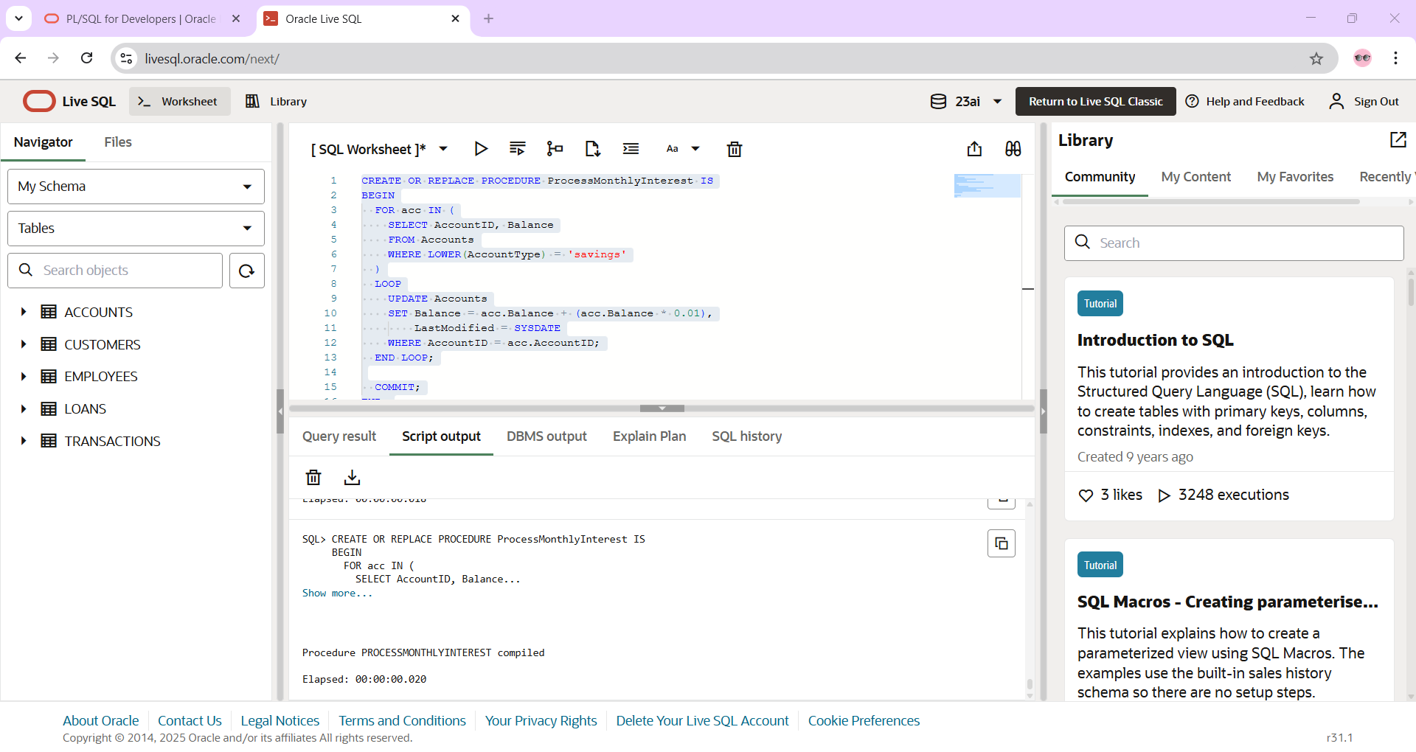

**Scenario 2:** The bank wants to implement a bonus scheme for employees based on their performance.

**Question:** Write a stored procedure **UpdateEmployeeBonus** that updates the salary of employees in a given department by adding a bonus percentage passed as a parameter.

CREATE OR REPLACE PROCEDURE UpdateEmployeeBonus (

p_Department IN VARCHAR2,

p_BonusPercent IN NUMBER

) IS

BEGIN

UPDATE Employees

SET Salary = Salary + (Salary * p_BonusPercent / 100)

WHERE Department = p_Department;

COMMIT;

END;

BEGIN

UpdateEmployeeBonus('IT', 10);

END;  
  
OUTPUT:

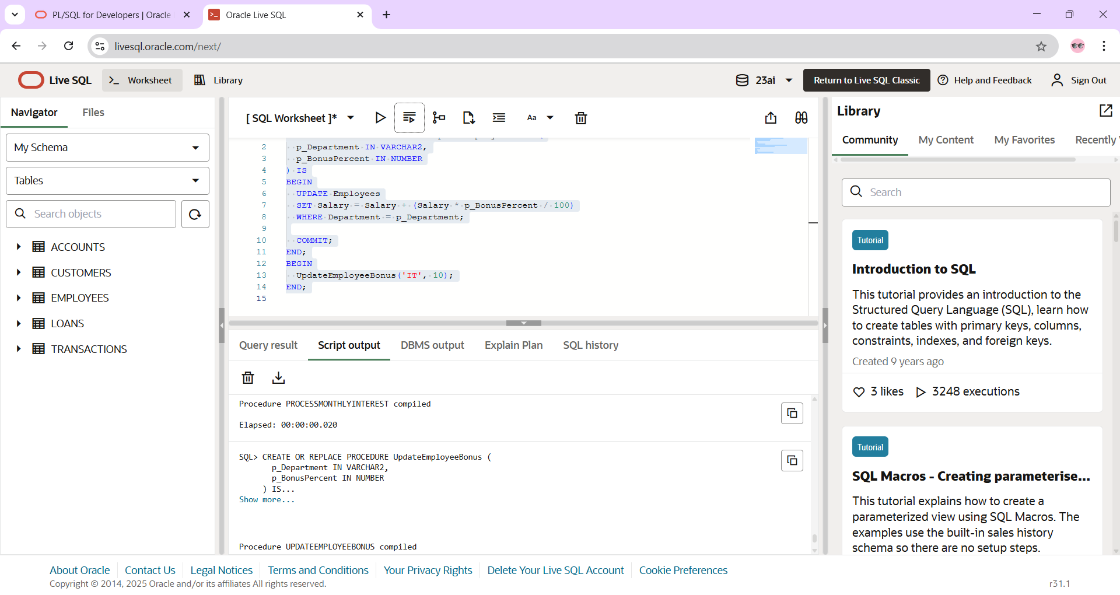

**Scenario 3:** Customers should be able to transfer funds between their accounts.

**Question:** Write a stored procedure **TransferFunds** that transfers a specified amount from one account to another, checking that the source account has sufficient balance before making the transfer.

CREATE OR REPLACE PROCEDURE TransferFunds (

p_FromAccountID IN NUMBER,

p_ToAccountID IN NUMBER,

p_Amount IN NUMBER

) IS

v_FromBalance NUMBER;

BEGIN

-- Lock the source account row

SELECT Balance INTO v_FromBalance

FROM Accounts

WHERE AccountID = p_FromAccountID

FOR UPDATE;

IF v_FromBalance < p_Amount THEN

RAISE_APPLICATION_ERROR(-20001, 'Insufficient funds in source account.');

END IF;

-- Deduct from source account

UPDATE Accounts

SET Balance = Balance - p_Amount,

LastModified = SYSDATE

WHERE AccountID = p_FromAccountID;

-- Add to target account

UPDATE Accounts

SET Balance = Balance + p_Amount,

LastModified = SYSDATE

WHERE AccountID = p_ToAccountID;

COMMIT;

END;  
BEGIN

TransferFunds(1, 2, 300);

END;

OUTPUT:

