**Create a Spring Web Project using Maven**

**CODE:**

**HomeController.java**

package com.cognizant.spring_learn;

import org.springframework.web.bind.annotation.GetMapping;

import org.springframework.web.bind.annotation.RestController;

*@RestController*

public class HomeController {

*@GetMapping*("/")

public String home() {

return "Welcome to Spring Learn Application!";

}

}

application.properties

spring.application.name=spring-learn

server.port=8085

**SpringLearnApplication.java**

package com.cognizant.spring_learn;

import org.slf4j.Logger;

import org.slf4j.LoggerFactory;

import org.springframework.boot.SpringApplication;

import org.springframework.boot.autoconfigure.SpringBootApplication;

*@SpringBootApplication*

public class SpringLearnApplication {

private static final Logger *LOGGER* = LoggerFactory.*getLogger*(SpringLearnApplication.class);

public static void main(String[] args) {

SpringApplication.*run*(SpringLearnApplication.class, args);

*LOGGER*.info("Inside main method");

}

}

**OUTPUT:**

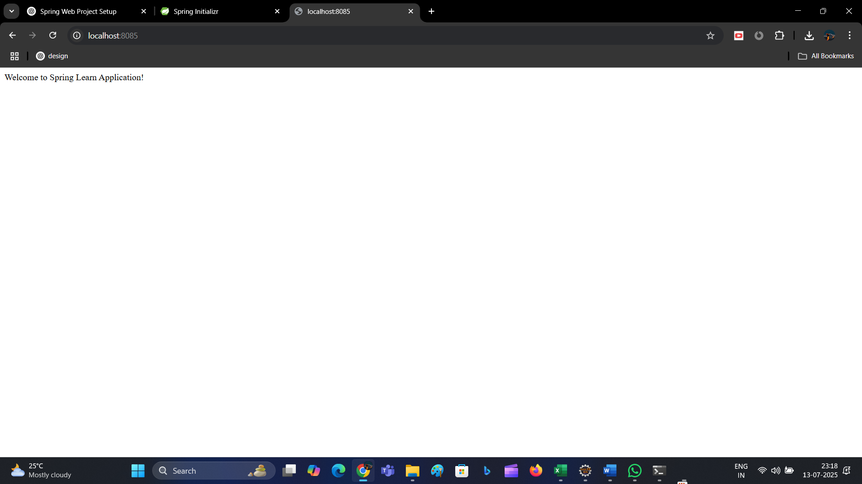

**Spring Core – Load SimpleDateFormat from Spring Configuration XML**

**SpringLearnApplication.java**

package com.cognizant.spring_learn;

import java.text.ParseException;

import java.text.SimpleDateFormat;

import java.util.Date;

import org.springframework.context.ApplicationContext;

import org.springframework.context.support.ClassPathXmlApplicationContext;

public class SpringLearnApplication {

public static void main(String[] args) {

*displayDate*();

}

public static void displayDate() {

ApplicationContext context = new ClassPathXmlApplicationContext("date-format.xml");

SimpleDateFormat format = context.getBean("dateFormat", SimpleDateFormat.class);

try {

Date date = format.parse("31/12/2018");

System.***out***.println("Formatted Date: " + format.format(date));

} catch (ParseException e) {

e.printStackTrace();

}

}

}

**date-format.xml**

<?xml version="1.0" encoding="UTF-8"?>

<beans xmlns="http://www.springframework.org/schema/beans"

xmlns:xsi="http://www.w3.org/2001/XMLSchema-instance"

xsi:schemaLocation="

http://www.springframework.org/schema/beans

https://www.springframework.org/schema/beans/spring-beans.xsd">

<bean id="dateFormat" class="java.text.SimpleDateFormat">

<constructor-arg value="dd/MM/yyyy" />

</bean>

</beans>

OUTPUT:

