What is Delta Lake?
Delta Lake is an open-source storage layer developed by Databricks that brings reliability, performance, and data management features to Data Lakes.
It sits on top of existing cloud storage such as AWS S3, Azure Data Lake Storage, or Google Cloud Storage and stores data in Parquet format while maintaining a transaction log.
Delta Lake combines the scalability of a Data Lake with the reliability and performance of a Data Warehouse.
Key Features
- ACID Transactions
  - Ensures data consistency during read and write operations.
  - Prevents corruption when multiple users access data simultaneously.
- Schema Enforcement
  - Validates incoming data against the table schema.
  - Prevents accidental insertion of incorrect data.
- Schema Evolution
  - Allows controlled modification of table schemas when new columns are added.
- Time Travel
  - Enables access to previous versions of data.
  - Useful for auditing, debugging, and recovery.
- Data Versioning
  - Every change is tracked in transaction logs.
- Faster Queries
  - Uses indexing and optimization techniques for improved performance.
Why Delta Lake?
Traditional Data Lakes can suffer from:
- Data duplication
- Inconsistent updates
- Lack of transactions
- Slow query performance
Database vs Data Warehouse vs Data Lake vs Delta Lake
1. Database
A Database is a system used to store and manage structured data for day-to-day business operations.
Characteristics
- Stores current operational data
- Supports frequent insert, update, and delete operations
- Optimized for transactions
- Handles structured data
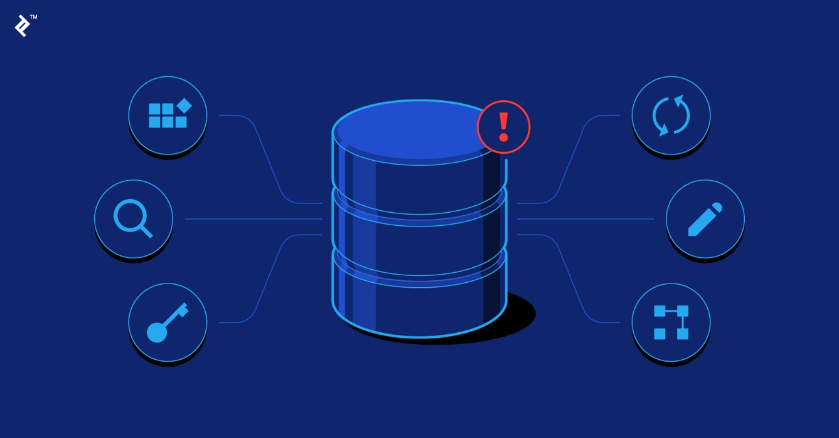
Examples
- MySQL
- PostgreSQL
- Oracle Database
- SQL Server
Use Cases
- Banking applications
- E-commerce websites
- Student management systems

2. Data Warehouse
A Data Warehouse is a centralized repository used for reporting, analytics, and business intelligence.
Characteristics
- Stores historical data
- Optimized for analytical queries
- Data is cleaned and transformed before loading
- Supports decision-making
Examples
- Snowflake
- Amazon Redshift
- Google BigQuery
- Azure Synapse Analytics
Use Cases
- Sales analysis
- Financial reporting
- Business dashboards
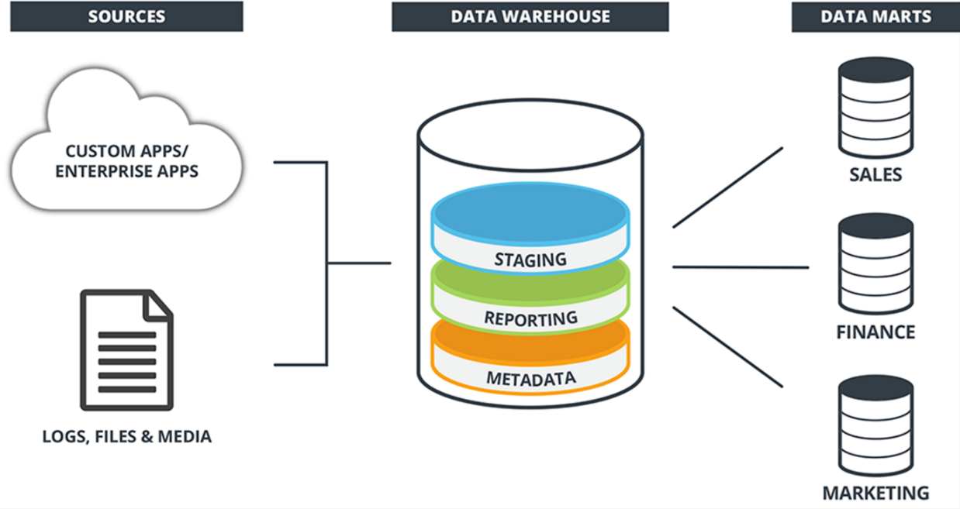

3. Data Lake
A Data Lake is a large storage repository that stores raw data in its original format.
Characteristics
- Stores structured, semi-structured, and unstructured data
- Highly scalable
- Low storage cost
- Schema applied when data is read
Examples
- Amazon S3
- Azure Data Lake Storage
- Google Cloud Storage
Use Cases
- IoT data storage
- Log analysis
- Machine Learning datasets
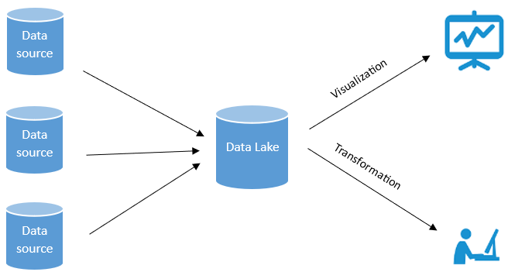

4. Delta Lake
Delta Lake is a storage layer built on top of a Data Lake that adds reliability and performance features.
Characteristics
- Supports ACID transactions
- Provides Time Travel
- Supports Schema Enforcement
- Enables Data Versioning
- Improves query performance
Examples
- Databricks Delta Lake
- Open-source Delta Lake
Use Cases
- Modern Data Platforms
- Data Engineering Pipelines
- Real-time Analytics
- Machine Learning Workflows

