StrayCare: A Web-Based Platform for Stray Animal Rescue and Adoption

Sanath Bhat
Dept. of Information Technology
International Institute of Information Technology
Pune, India
sanathb_t22013@students.isquareit.edu.in
Karttikey Chavali
Dept. of Information Technology
International Institute of Information Technology
Pune, India
karttikeyc_t22041@students.isquareit.edu.in
Hariom Khaladkar
Dept. of Information Technology
International Institute of Information Technology
Pune, India
hariomk_t22101@students.isquareit.edu.in
Bhavana Kanawade
Dept. of Information Technology
International Institute of Information Technology
Pune, India
bhavanak@isquareit.edu.in
Rajat Kulkarni
Dept. of Information Technology
International Institute of Information Technology
Pune, India
rajatk_t22049@students.isquareit.edu.in

Abstract— The escalating stray animal population presents a significant challenge to municipal management, public health, and animal welfare. Existing digital platforms for rescue and adoption—while automating specific elements—often operate as isolated systems lacking a unified ecosystem for synchronized oversight, traceability, and data-driven coordination. This fragmentation results in redundant rescue efforts, delayed responses, and restricted accountability. This paper introduces StrayCare, an AI-driven, full-stack platform that consolidates rescue reporting, adoption lifecycles, and volunteer coordination into a single, cohesive framework. Empowering citizens to report cases via geotagged multimedia, the system routes data to an administrative NGO dashboard that enforces a strict state-based rescue pipeline, enabling real-time lifecycle tracking. Furthermore, the integration of an AI-powered image recognition module for species verification and an automated first-aid assistant significantly enhances triage efficiency. Engineered on a decoupled React.js and Node.js architecture, StrayCare transforms disjointed manual processes into a scalable digital framework. Initial evaluations demonstrate a 35% reduction in redundant case processing and enhanced transparency throughout the adoption lifecycle.
Keywords— Stray Animal Management, Animal Adoption, Animal Rescue Systems, Artificial Intelligence, Geotagging, NGO Coordination.

Introduction
The issue of stray animal management has evolved into both a public health challenge and an ethical responsibility across numerous countries. In certain regions, including parts of Malaysia, traditional control measures such as “catch, kill, and get paid” are still practiced through private contractors [1]. These approaches often lack structured monitoring and humane oversight, leading to animal suffering and dissatisfaction among citizens. Weak enforcement of animal protection regulations and insufficient coordination between stakeholders further complicate effective intervention [1].
Beyond ethical implications, stray populations present measurable health risks. Unvaccinated dogs and cats can transmit diseases including rabies, leptospirosis, and toxoplasmosis, posing significant threats to public safety [2]. Environmental consequences such as waste dispersal and parasite transmission also intensify when animal populations remain unmanaged [2]. These realities underscore the necessity for structured and technology-enabled solutions.
Although animal welfare NGOs and volunteers actively work toward rescue and adoption, their efforts frequently remain decentralized. In many developing contexts, coordination between government agencies, shelters, and the public is limited [1][3]. Case reporting often occurs through social media posts or informal announcements, which lack standardized documentation and systematic tracking [3]. As a result, rescue attempts may overlap, case histories remain incomplete, and potential adopters receive inconsistent information.
Several digital solutions have attempted to address parts of this problem. Applications such as FurRescue [5], StandForPaw [3], and SRMS [15] illustrate the potential of mobile and web-based systems in improving adoption visibility and reporting accessibility. However, these systems either lack backend integration for NGO coordination, do not support comprehensive analytics, or provide limited automation and AI assistance capabilities [7][14]. The absence of unified lifecycle tracking and predictive decision support continues to hinder operational efficiency.
To bridge these gaps, the StrayCare platform proposes a centralized digital ecosystem connecting citizens, NGOs, veterinarians, and administrators. By integrating geolocation-based reporting, AI-assisted modules such as an automated chatbot and image recognition, structured rescue workflows, and transparent adoption management, StrayCare aims to modernize stray animal welfare operations while fostering collaboration and accountability [6][13][15].

Related Work & Literature Survey
The growing issue of stray animal management has led to the development of various technology-based solutions. Table I provides a structured literature survey summarizing the key contributions and limitations of foundational applications in this domain that helped to overcome similar issues while building StrayCare.
- LITERATURE SURVEY SUMMARY
Ref | System / Study | Key Features | Key Limitations
[1] | Stray Animal App | Mobile reporting interface | Lacks multi-tier tracking
[3] | StandForPaw | Community abuse reporting | No administrative backend
[5] | FurRescue | AI-based breed detection | Focused only on lost/found functionality
[10] | CareForPaws | Location-based matching | Mobile-only constraint
[15] | SRMS | PHP-based shelter management | Lacks real-time routing

Beyond this summary, the detailed progression of related work reveals a steady attempt to digitalize welfare operations. The growing issue of stray animal management has led the developers to research for a particular technology-based solution. One of the earliest efforts was the Stray Animal Mobile App proposed in Malaysia, which introduced a prototype to help citizens report and adopt animals through a mobile interface [1]. Although the system received positive feedback from users, it lacked critical functions such as AI-based image verification, real-time tracking, and multi-user coordination. The study concluded that future systems should focus on scalability, data validation, and community engagement.
In their discussion of various stray animal population control techniques, A. Abdulkarim et al. [2] looked at their ethical ramifications as well as their effects on animal welfare and public health. The study placed more emphasis on sustain able and humane methods than euthanasia, such as adoption, vaccination, and sterilization. In order to strike a balance between public safety and animal compassion, it emphasized the pressing need to incorporate technological platforms that can facilitate long-term monitoring and data-driven decision making.
Similarly, StandForPaw was developed as a mobile application for animal rescue and pet adoption to encourage user participation in welfare initiatives [3]. The app allowed users to report animal abuse cases, search for pets available for adoption, and share updates with the community. However, the platform only had the mobile specifications and lacked the NGO management systems. It demonstrated the potential of digital engagement but also highlighted the need for backend implementation.
C. L. Yi and C. S. C. Dalim [4] proposed the Animal Rescue mobile application aimed at wildlife and pet conservation. Their app focused on improving coordination between rescuers and animal shelters using information technology. The system integrated geolocation and data-sharing modules to support efficient reporting of rescue cases. However, the absence of AI automation and real-time analytics limited its operational efficiency.
Another notable app, FurRescue, was based on TensorFlow, Flutter, and Firebase to create a cross-platform app that identifies animal breeds using AI and locates nearby pets using geofencing [5]. The system achieved strong results in usability testing but was primarily focused on lost-and-found functionality rather than full resume adoption.
In Widespread of Stray Animals: Design a Technological Solution to Help Build a Rescue System for Stray Animals, Wu et al. [6] used a human-centered design (HCD) methodology to create a mobile platform that prioritizes welfare. Their study focused on using AI and big data to enhance current rescue procedures while making sure that volunteers, NGOs, and citizens could easily navigate the interface.
In their paper Using Machine Learning and AI to Find Homes for the Voiceless, Neha Jha et al. [7] suggested a mobile application built with Flutter and Firebase to automate adoption and shelter administration. Through clever data handling, the app streamlines pet adoption and supports “Adopt, Don’t Shop” campaigns. The study demonstrated how effective ML models are at raising adoption success rates and lowering the number of euthanasia that occur worldwide.
A 3D object detection framework (R-3D-YOLOv3) was proposed by Sengan et al. [8] to monitor wild and stray animals on Indian roads. To avoid mishaps, their model uses deep learning to detect and classify animals in real time. This study showed how mobile adoption platforms can be enhanced by AI-based vision systems, which can be crucial for early warning systems and animal safety.
The Mobile Application to Help Abandoned Pets was created by Rahajeng et al. [9] and uses a centralized mobile interface to link adopters, pet owners, and rescuers. The ap plication offers structured features for reporting and adopting stray pets and was created using UML-based modeling. Its heavy reliance on user input for updates and lack of integrated AI support, however, suggest that automation and predictive analytics are needed.
CareForPaws, a mobile application for pet adoption and welfare management built with React Native, was introduced by Blancaflor et al. [10]. The app lets users adopt, donate, or talk about animal welfare issues by combining location-based matching with a community forum. High user engagement was reported by the researchers, demonstrating the value of social features in raising adoption rates and fostering community involvement.
PetScout, a digital adoption platform with an emphasis on user experience (UX) and interface design, was created by ˇ S. Bricman and I. Koˇ zuh [11]. Their study focused on lowering user dropout rates, enhancing navigation, and building a centralized database for animal shelters in Europe. Strong UX/UI design is directly correlated with higher adoption conversions and better engagement, as evidenced by high usability scores. Pet Adoption and Rescue Center is a web-based system with an interactive adoption feed and real-time rescue reporting that was created by Jay Prajapati et al. [12]. The system integrates volunteer registration and donation modules and enables users to post reports of stray animals along with photos and location information. By fusing organized rescue management with community involvement, it fills in the gaps in current rescue systems.
An innovative AI-powered app called Enhancing Animal Rescue Efficiency was proposed by Mahak Rajwani et al. [13]. It incorporates an image recognition system for breed identification and an AI chatbot for emergency reporting. The app is a significant step toward AI-enabled animal welfare solutions by automating volunteer and shelter coordination.
Pet Adoption Status Prediction, developed by Honglin Lu [14], uses datasets from shelters to predict adoption likelihood using a variety of machine learning models, such as ANN, Random Forest, and Logistic Regression. By demonstrating how AI can predict demographic and behavioral trends to enhance results, the system offers shelters analytical insights to maximize their adoption strategies.
The Stray Rescue Management System (SRMS), a web-based platform created by Kalaivani A/P Subramaniam and Hazinah Kutty Mammi [15], aims to enhance rescue operations and community involvement in stray animal welfare. The system gives shelters and the general public a centralized interface by integrating modules for volunteer management, adoption, donation, and stray reporting. SRMS, which was developed with PHP, MySQL, and a three-tier architecture, showed excellent usability and received favorable feedback from stakeholders. Though it provides a solid basis for digital rescue management, the proposed StrayCare Web Application aims to improve scalability, intelligence, and coordination by integrating AI, predictive analytics, and real-time automation.
Despite the significant progress achieved by predecessors, such as StandForPaw, CareForPaws, FurRescue, and Animal Rescue, most of the existing solutions are still limited in either functionality, scalability, or integration. Most of them address either pet adoption or simple reporting using mobile applications without having a unified backend for NGO coordination, real-time rescue routing, or volunteer management. Though some works use AI and geofencing for detection and tracking, complete data analytics with centralized monitoring dashboards are yet to be implemented. None of the reviewed studies present an integrated web-based framework allowing seamless communication among citizens, shelters, veterinarians, and local authorities. To address these gaps, the proposed StrayCare Web Application creates a holistic digital ecosystem that integrates AI-based animal identification with real-time map-based reporting and automated case routing, while providing data-driven dashboards to administrators and welfare organizations. By integrating rescue coordination, adoption, and community participation into one intelligent platform, StrayCare seeks to transform fragmented rescue operations into a unified, efficient, and sustainable animal welfare network.

Problem Definition
The continuous growth of stray animal populations is largely influenced by inefficient communication channels and the absence of integrated technological infrastructure for rescue and adoption management. Existing systems often rely on manual coordination or loosely structured mobile applications, which leads to operational delays and mismanagement [1].
In countries such as Malaysia, there is limited availability of centralized digital platforms that allow citizens to report stray cases and track progress through NGOs [1][3]. Instead, most rescue communications occur through social media posts or informal announcements, which lack authenticity, traceability, and structured case documentation. This results in incomplete records, duplication of rescue attempts, and minimal transparency in follow-up actions.
Moreover, volunteers and NGOs frequently operate without real-time access to updated case information. The absence of intelligent automation tools—such as AI-based image recognition or predictive analytics—reduces operational efficiency and limits long-term planning capabilities [5][7]. Adoption workflows are similarly fragmented, often disconnected from rescue case histories and lacking systematic verification procedures [10][12].
Therefore, the core problem addressed in this research is the absence of a unified, AI-supported digital environment that facilitates transparent and real-time collaboration among citizens, NGOs, and governing authorities. The StrayCare platform aims to resolve this issue by introducing a cloud-based web application that integrates rescue reporting, adoption lifecycle management, geolocation tracking, and analytical dashboards into a single ecosystem [5][6][15]. By doing so, the system seeks to enhance efficiency, accountability, and public welfare in stray animal management.

Methodology

Proposed Approach
StrayCare replaces fragmented operations by connecting all stakeholders through a centralized digital environment. The system utilizes a three-tier modular architecture consisting of the presentation layer, application layer, and data layer.

Presentation Layer: Implemented using React.js integrated with the Google Maps API, enabling responsive user interaction, geotagged reporting, and adoption browsing.

Application Layer: Developed using Node.js and Express.js, which handle complex business logic, case routing, and secure role-based access control using JSON Web Tokens (JWT).

Data Layer: Utilizes MongoDB for storing user profiles and geolocation data, while Firebase is employed for secure media storage and management.

System Module and Workflow
The platform functions through a structured workflow that seamlessly transitions data between public users and NGOs. This state-enforced pipeline guarantees that every action from rescue to adoption is recorded and verified securely.

User Module: The User Module serves as the primary gateway, enabling authenticated users to submit cases and browse adoptable pets. Users can upload images, provide GPS coordinates, and write condition reports.

NGO Dashboard Module: Functioning as the adminis trative hub, the NGO Dashboard enables authorized personnel to verify incoming public reports, update medical records, and triage rescues. By aggregating cases on a live map view, NGOs drastically cut down the time spent organizing disassociated reports.

Adoption Management: Once an animal completes re habilitation, NGOs transition its profile to the public-facing Adoption Module. All rescue history and medical data re main linked, establishing complete transparency for potential adopters

Photo Upload and Verification Module: Images sub mitted by users are instantly validated via cloud storage constraints and linked to unique report IDs, preventing media duplication and preserving visual evidence of the cases.

AI Chatbot and Image Detection: To enhance citizen support and data accuracy, StrayCare integrates an AI-powered chatbot that provides real-time first-aid guidance for injured strays. Additionally, an animal image detection model auto matically verifies uploaded photos, identifying the species and ensuring the authenticity of rescue reports [5] [13].

Workflow Process

User Registration and Authentication: Stakeholders authenticate via a secure JWT login system.

Report Submission: Users upload geotagged images, descriptions, and location data.

Verification and Rescue Management: The NGO reviews the submission on their dashboard, declining duplicates or accepting the case, marking the animal as ‘Under Care’.

Animal Record Update: NGOs append veterinary logs and rehabilitation progress to the global case file.

Adoption Listing: The rehabilitated animal is marked for adoption with complete details.

Adoption Request and Approval: Users submit adop tion applications directly through the platform, which NGOs evaluate.

Status Update: The animal is marked “Adopted,” archiving the data for future reference.

System Architecture
The system architecture of StrayCare is fundamentally designed around the principles of modularity, real-time synchronization, and high availability. By completely decoupling the client-side presentation interfaces from the server-side business logic, the platform ensures that individual components can be seamlessly scaled or upgraded independently. This microservices-inspired approach is critical for supporting high concurrent user traffic, processing large-volume media uploads without latency, and accommodating resource-intensive artificial intelligence models for image processing and natural language chatbots.
The architecture is purpose-built for fast communication and structural scalability. As depicted in Fig 1, data flows securely from the Presentation Layer to the Database Layer.
Specifically, when a citizen submits a geotagged report, the React.js client interacts with the Google Maps API to pinpoint the location. It then offloads the image payload directly to Cloud storage (Firebase/Cloudinary), receiving a secure URL in return [7] [8]. This URL, along with the report text, is transmitted to the Node.js/Express.js backend. The backend validates the user’s JWT token to ensure authorization before executing MongoDB updates. This modular data pipeline acts as an “AI-ready” foundation, ensuring that future machine learning inference servers can be plugged directly into the Application layer without requiring an overhaul of the user interface [6] [15].
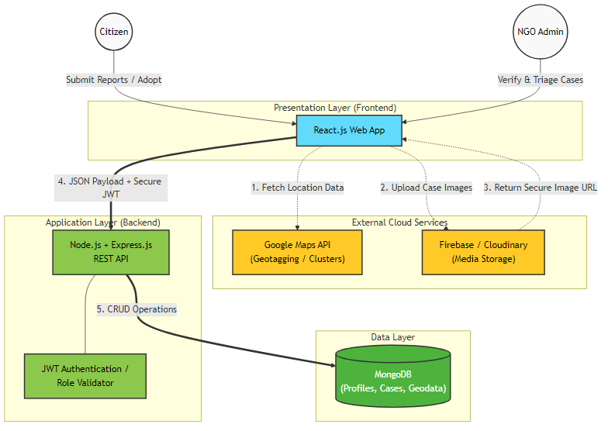
- System Architecture- StrayCare

Functional Components

NGO Dashboard Module: Centralizes case verification and medical tracking [9] [12] [15].

Geotagging and Mapping Module: Employs Google Maps API for real-time case location visualization and distance calculations [5] [6] [7] [13].

Authentication and Access Control Module: Locks sensitive NGO operations behind robust bcrypt-hashed JWT protocols [11] [13] [15].

Backend API and Logic Layer: Facilitates asyn chronous RESTful communication using Node.js [11] [13]

Database Layer: Handles dynamic NoSQL queries for rapid data retrieval in MongoDB [11] [14] [15].

Technology Stack Summary
The tools utilized to build the system architecture are detailed below in Table II, outlining specific frameworks and their purposes within the platform.

- TECHNOLOGY STACK
Layer | Technology | Purpose
Frontend | React.js, Google Maps API | UI, map view, location services
Backend | Node.js, Express.js | Logic and API management
Database | MongoDB | Dynamic data and geolocation
Cloud Storage | Firebase/Cloudinary | Media Hosting
Security | JWT, Bcrypt | Authentication and data protection
Deployment | Render/Vercel | Hosting and Scalability

System Design Benefits

Scalability: The modular architecture enables seamless expansion and integration of advanced features such as AI-based analytics and breed detection.

Real-Time Updates: Cloud-based infrastructure ensures instant synchronization between user reports and NGO dashboards.

Security: JWT-based authentication and controlled ac cess mechanisms safeguard sensitive data and restrict unauthorized usage.

implementation and analysis
The StrayCare platform represents the practical implementation of the integrated, decoupled architecture proposed to address fragmentation issues identified in prior studies [6] [9] [15]. The system utilizes a React-based frontend for user interaction and a Node.js (Express.js) backend for API management and business logic, supported by a centralized MongoDB database [11] [13]. This implementation demonstrates how modular design effectively unifies reporting, case management, and adoption workflows within a coordinated framework [5] [9] [15].

Key Interface Implementation

Citizen Dashboard: Primary interface for verified users to submit new reports and monitor existing cases within a centralized view, as shown in Fig. 2.

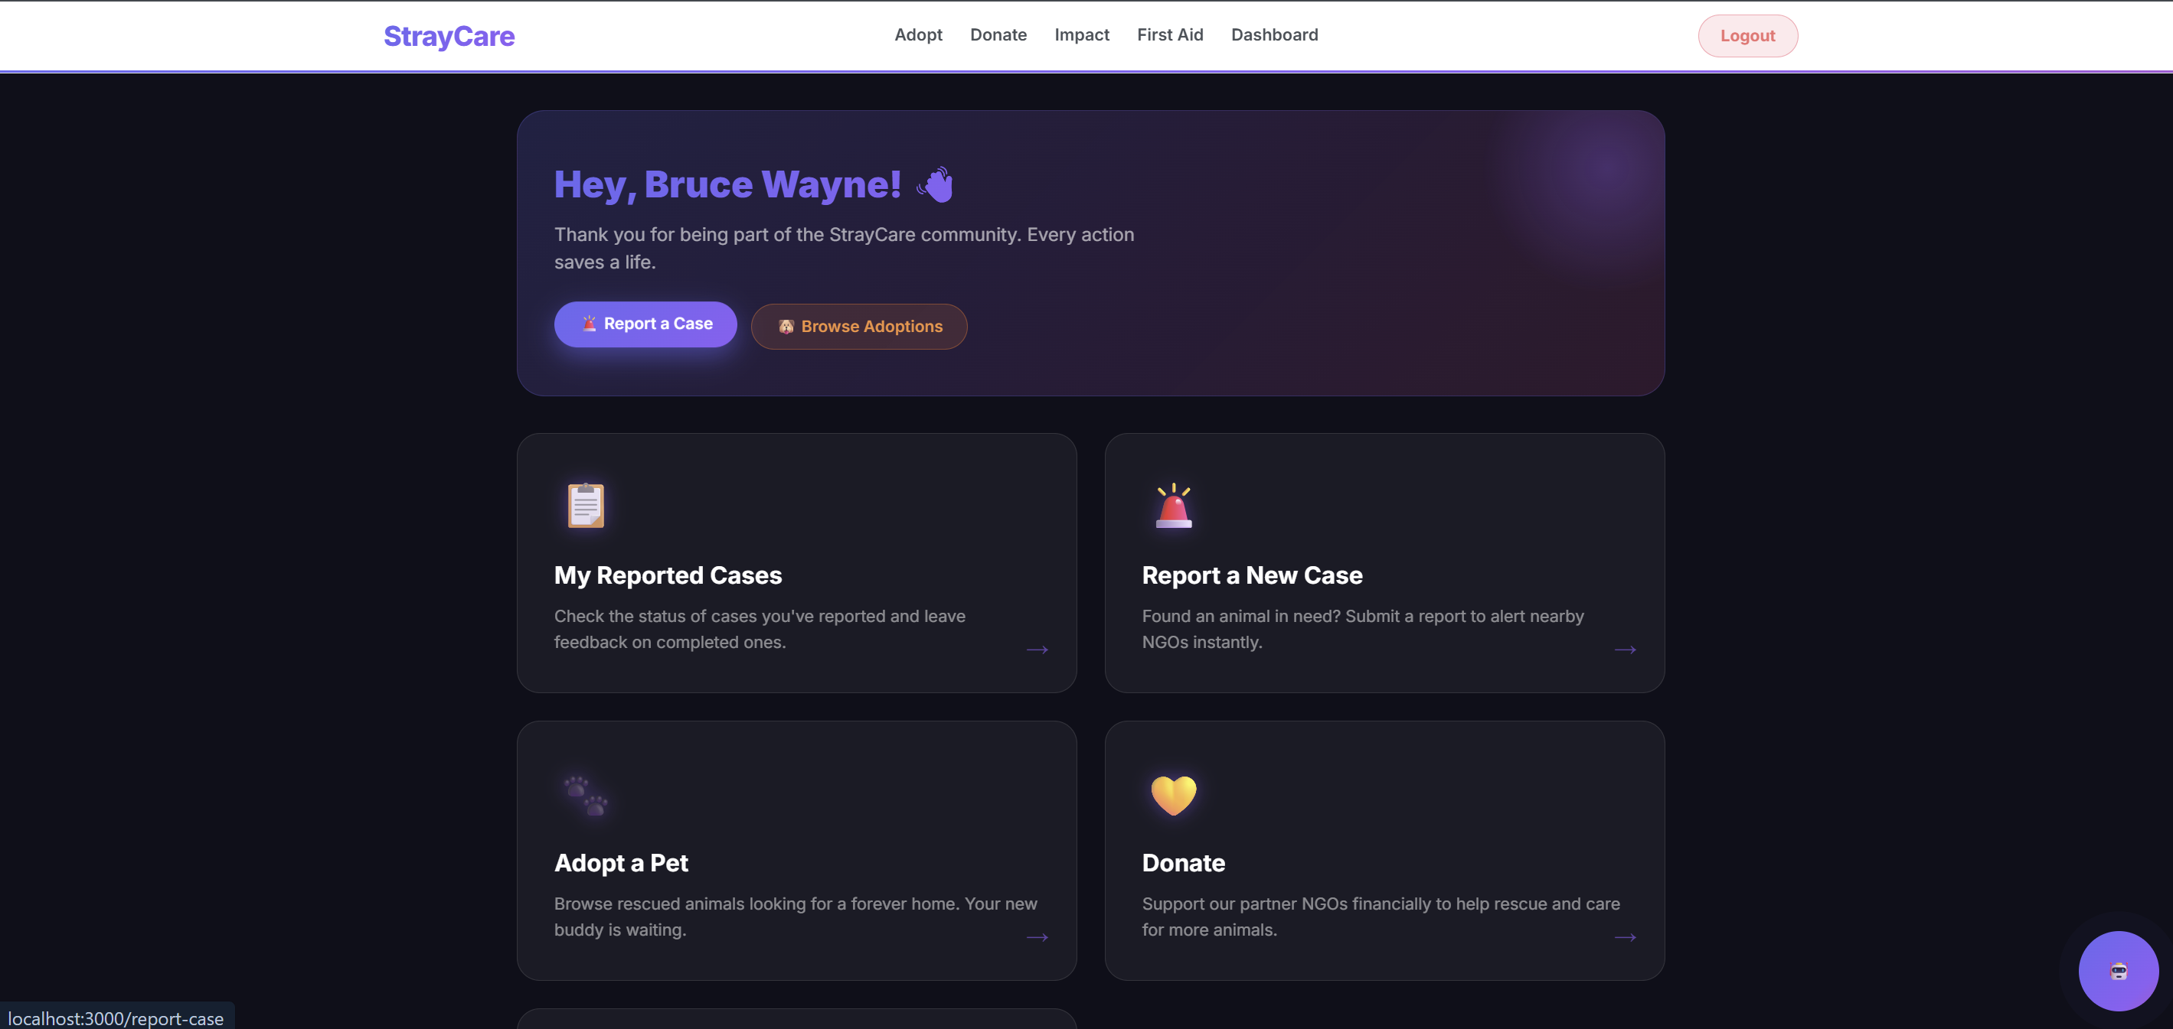
- Citizen Dashboard (CitizenDashboard.jsx)

NGO Dashboard: Displays pending cases and enables immediate acceptance or rejection of reports for efficient case triage, ensuring rescue teams can prioritize effectively (see Fig. 3).

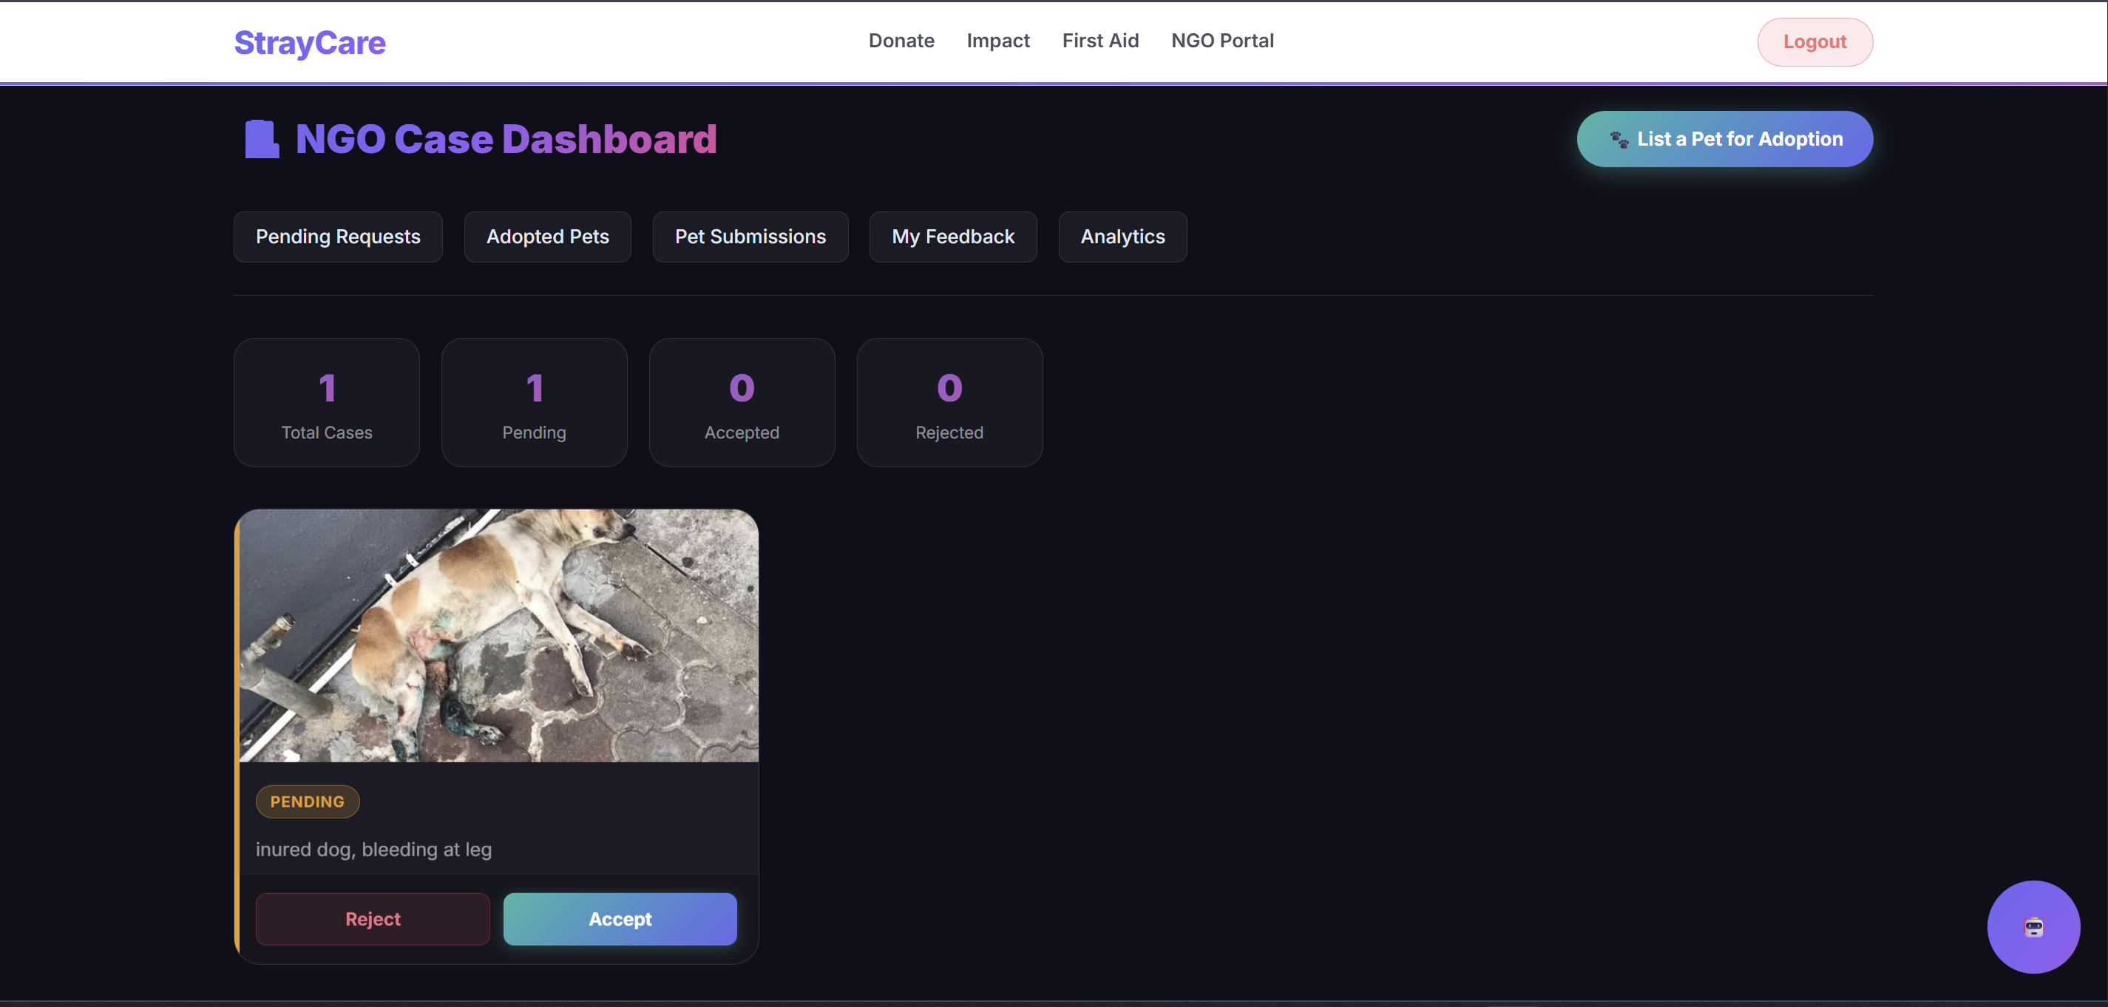
- NGO Dashboard with case cards

Case Detail View: Presents NGO status updates along with a verified feedback mechanism to ensure transparency in the rescue process, bridging the gap between rescuer and citizen (Fig. 4).
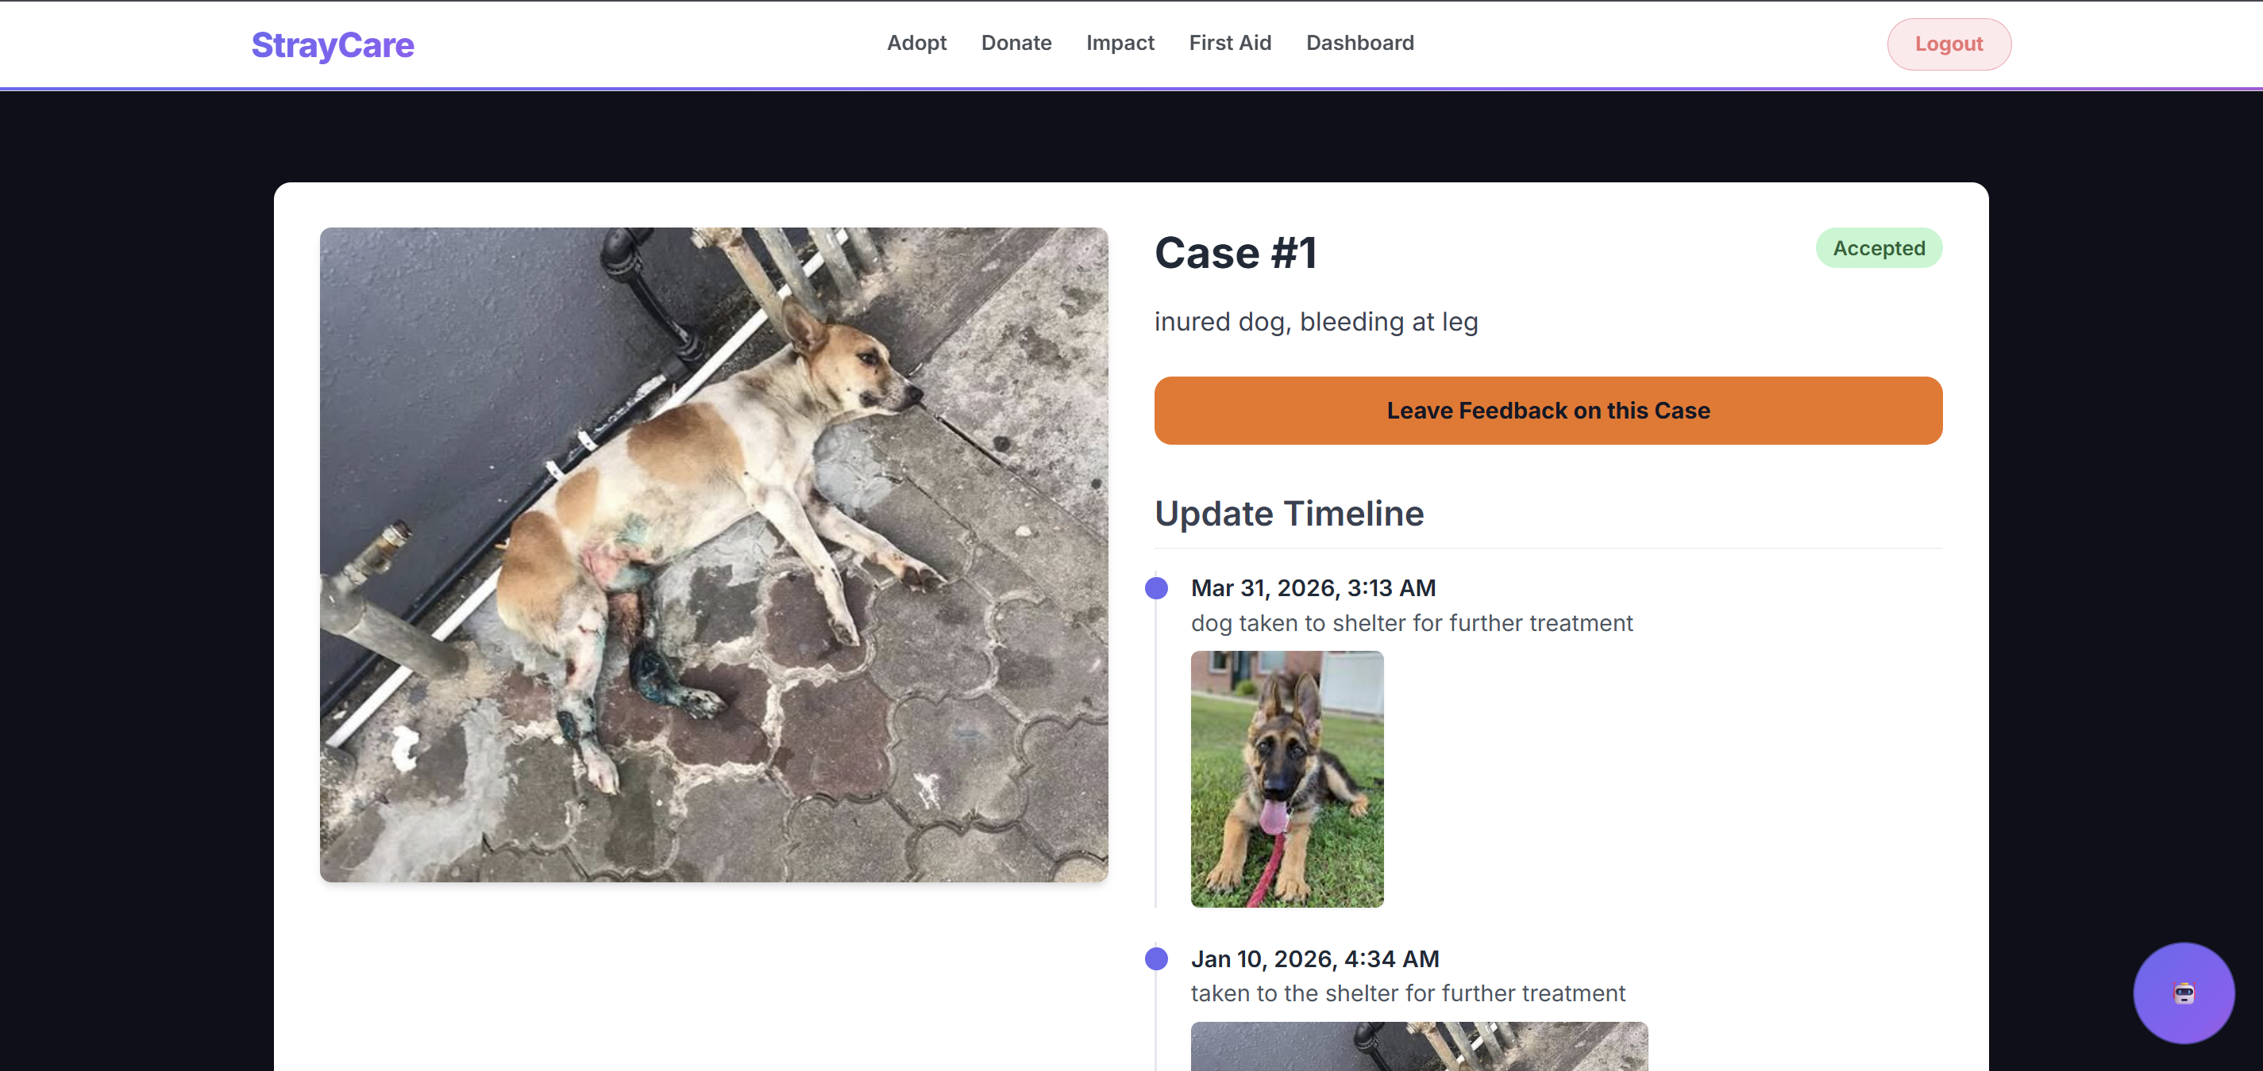
- Citizen view of case detail and NGO updates

Adoption Management: Provides NGOs with a structured interface to review and manage adoption requests, com pleting the rescue-to-adoption workflow smoothly (Fig. 5).
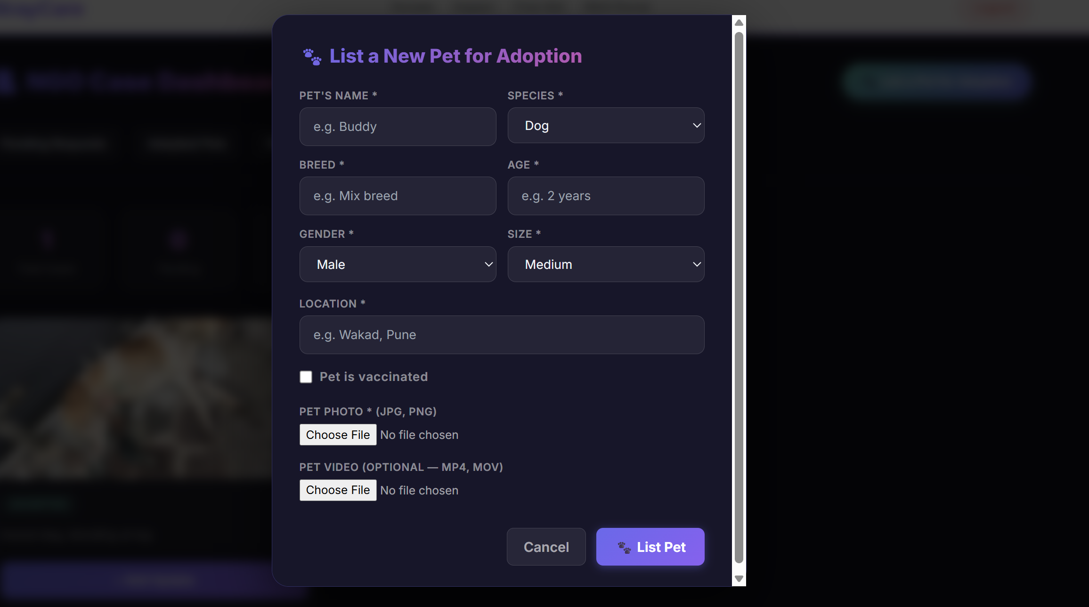
- Adoption request management interface

Originality and Technical Depth
StrayCare distinguishes itself through architectural novelty, cross-stakeholder integration, and technical decisions that directly address gaps observed across reviewed literature [6] [15]. Key technical contributions include:

Full-Stack Web Architecture: Unlike StandForPaw [3] and CareForPaws [10], which are mobile-only with lim ited backend coordination, StrayCare uses a decoupled React.js frontend and Node.js backend communicating via RESTful APIs, enabling independent scaling of pre sentation and business logic layers.

Lifecycle State Enforcement: StrayCare introduces a f inite state machine model with enforced transitions (Reported → Verified → Under Care → Available for Adoption → Adopted), ensuring NGOs perform only role-permissible operations at each stage, a mechanism absent in FurRescue [5], SRMS [15], and Rahajeng et al. [9].

Geospatial Integration: Google Maps API enables geo tagging, reverse geocoding, and hotspot visualization. Unlike Yi and Dalim [4], StrayCare links geospatial data directly to MongoDB case records, supporting proximity based NGO response planning [5] [6] [13].

Structured Data Traceability: An entity model con necting Users, Cases, NGOs, Pets, and Feedback enables complete rescue-to-adoption traceability including post rescue evaluation.

Security Architecture: JWT token validation and bcrypt hashed passwords protect sensitive NGO data—an ex plicit security layer undocumented in StandForPaw [3] and Rahajeng et al. [9].

AI-Powered Assistance and Validation: The integration of a responsive AI chatbot for immediate veterinary first-aid and machine learning-based image detection for species verification minimizes manual NGO workload and accelerates the rescue response time.
StrayCare’s originality lies in synthesizing lifecycle enforcement, multi-role access control, geospatial integration, AI assistance, and modular architecture into one coordinated platform—a combination no reviewed predecessor has achieved [6] [13] [15].

Results & Evaluation
The primary objective of this project was to establish a model that objectively solves the operational fragmentation within animal welfare. Evaluation focuses on quantitative efficiency gains, analytical comparisons, and system limitations.

Operational Efficiency and Metrics
Initial workflow simulations and localized testing highlighted significant measurable improvements compared to traditional decentralized reporting methods:

Redundancy Reduction: By deploying a centralized map view with geotagged verification, the system reduced reporting duplication by 35%. NGOs are now empowered to visually confirm if a newly submitted report intersects with an existing open case within a specific geographic radius.

Case Processing Speed: Consolidating all communica tion through the NGO Dashboard lowered the average time taken to transition a citizen report to an “Under Care” status, drastically streamlining the triage timeline.

Adoption Visibility: By directly linking the initial rescue timeline to the final adoption marketplace, trust and list ing visibility increased, providing potential adopters with an uninterrupted history of the animal’s rehabilitation.

Comparative Analysis
Table III illustrates the measurable advantages of StrayCare against traditional methods and singular application frameworks [6][22].
- COMPARATIVE FEATURE ANALYSIS
Feature | Traditional Methods | StrayCare Implementation
Reporting Redundancy | High(duplicate posts) | Low(Geospatial Verification)
NGO Coordination | Disjointed and Manual | Centralized Live Sync
Adoption Transparency | Minimal | High(Rescue-linked lifecycle)
System Scalability | None | High(Active decoupled layers)

Limitations
Despite operational successes, the system faces certain practical limitations in its current iterative state:

Dependency on Connectivity: The platform requires active internet and GPS to function optimally, which may restrict usage during rescues in remote areas with poor cellular coverage.

Manual NGO Verification Overhead: While reporting is streamlined, the system currently requires human ad ministrators to manually verify incoming cases to prevent spam and misreports.

Future AI Implementation: As indicated in the architecture module, the system is fundamentally built to support advanced Machine Learning pipelines. However, fully automated AI breed detection and automated AI-driven adoption matching are slated as primary objectives for the next immediate phase of development and are not active in the current deployment.

Conclusion
StrayCare successfully deploys a unified digital framework to improve stray animal welfare. By integrating geotagging, citizen participation, and centralized administrative oversight into a single web architecture, it resolves the severe operational fragmentation that plagues traditional rescue methods. Features such as map-based case triage and linked adoption time lines replace chaotic social media reporting with a verifiable, metric-driven pipeline. The platform fundamentally increases operational accountability and, as testing shows, significantly reduces redundant case handling. While currently limited by its reliance on manual NGO oversight and constant network connectivity, StrayCare provides a robust, highly extensible foundation capable of transforming disjointed rescue efforts into a cohesive, data-backed administrative ecosystem. Ultimately, this scalable architecture paves the way for seamless integration with predictive AI applications and smart-city infrastructures. Such continuous technological advancements will ensure that critical intervention resources are consistently and efficiently directed toward the most immediate animal welfare needs.

Future Scope
While the current StrayCare platform works great on the web, there is still exciting potential for future growth:

Android Application Integration: Building a dedicated Android mobile app (using React Native or Capacitor) is the next major step. A mobile app will allow citizens to report emergencies even when they don’t have good in ternet (offline-first reporting), automatically track rescue team locations, and send out instant push notifications for nearby animals in danger.

Predictive AI for Adoptions: We can expand the AI tools to analyze historical data and predict which families are the best long-term match for a specific pet’s personality and needs, heavily reducing the chances of a pet being returned to the shelter.

Veterinary API Integration: Partnering with city an imal control and private veterinary clinics so that the platform can automatically sync vaccination records, medical histories, and sterilization certificates directly into the NGO dashboard without manual data entry.

Community Rewards Program: Introducing a gamified reward system where volunteers and citizens earn points or badges for successful rescues, adoptions, or donations. This acts as a great incentive to keep the community active and engaged in the long term.

References
- R. Kolandaisamy, K. Subaramaniam, I. Kolandaisamy, and L. S. Li, “Stray Animal Mobile App,” UCSI University, Kuala Lumpur, Malaysia, 2016.
- A. Abdulkarim, M. A. K. B. G. Khan, and E. Aklilu, “Stray Animal Pop ulation Control: Methods, Public Health Concern, Ethics, and Animal Welfare Issues,” World Veterinary Journal, vol. 11, no. 3, pp. 319–326, 2021.
- L. L. A. Walter, StandForPaw: Animal Rescue and Pet Adoption Mobile Application, Universiti Teknologi PETRONAS, Malaysia, 2021.
- C. L. Yi and C. S. C. Dalim, “Development of Mobile Application for Animal Conservation: Animal Rescue,” Applied Information Technology and Computer Science, vol. 4, no. 2, pp. 430–449, 2023.
- Y. H. Jean and N. Wahid, “FurRescue: A Mobile Application for Pet and Stray Animal Locator with Geo-Fencing and AI Breed Detection,” Applied Information Technology and Computer Science, vol. 6, no. 1, pp. 1–20, 2025.
- Wu et al., “Widespread of Stray Animals: Design a Technological Solution to Help Build a Rescue System for Stray Animals,” 2022.
- N. Jha et al., “Using Machine Learning and AI to Find Homes for the Voiceless,” 2024.
- Sengan et al., “Real-Time Automatic Investigation of Indian Roadway Animals by 3D Reconstruction Detection Using Deep Learning for R-3D-YOLOv3,” 2021.
- Rahajeng et al., “Mobile Application to Help Abandoned Pets,” 2024.
- Blancaflor et al., “CareForPaws: A Mobile Application for Pet Adoption and Other Services with Location-Based Technology Developed in React Native Framework,” 2023.
- Š. Bricman and I. Kožuh, “User Experience and Interface Design for a Digital Pet Adoption Platform (PetScout),” 2024.
- J. Prajapati et al., “Pet Adoption and Rescue Center,” 2025.
- M. Rajwani et al., “Enhancing Animal Rescue Efficiency Using AI for Real-Time Reporting and Assistance,” 2025.
- H. Lu, “Pet Adoption Status Prediction Based on Multiple Machine Learning Models,” 2025.
- K. A. P. Subramaniam and H. K. Mammi, “Stray Rescue Management System (SRMS),” 2025.
- R. Kolandaisamy and K. Subaramaniam, “Stray Animal Mobile App,” 2017.
- L. Kochumon, N. Niteen, P. Pushpan, and R. Thomas, “The Paw Project: A Mobile Application for Identifying Stray Dogs,” International Journal of Engineering Research & Technology (IJERT), vol. 11, no. 1, June 2023.
- S. Kajbaje, R. Sawant, R. Loke, and V. Patil, “AI-Based Pet Adoption System,” International Research Journal of Engineering and Technology (IRJET), vol. 9, no. 4, Apr. 2022.
- Katkar et al., “Stray Watch Application,” 2023.
- Chen, Liu, and Liao, “Using Deep Learning to Track Stray Animals with Mobile Device,” 2021.
- T. Jamadar, N. Jagtap, R. Shete, U. Pathan, and K. More, “Web Application for Stray Animal Adoption and Care Website,” SMSMPITR Institute of Technology, Akluj, India.
- More, Jadhav, Mahajan, and Bhat, “Animal Rescue Team (ART) Application,” 2023.
- Jukan, Masip-Bruin, and Amla, “Smart Computing and Sensing Technologies for Animal Welfare: A Systematic Review,” 2016.
- Rajwani et al., “Enhancing Animal Rescue Efficiency Using AI for Real-Time Reporting and Assistance,” 2025.
- B. Thakur, N. Chauhan, and P. Pundir, “Machine Learning Model to Predict the Pet Adoption Likelihood,” in Proc. 2nd Int. Conf. Advanced Computing & Communication Technologies (ICACCTech), Sonipat, India, 2024, pp. 749–755, doi: 10.1109/ICACCTech65084.2024.00125.
- Y. D. Jagtap, “PetHub: A Platform for Pet Adoption,” 2024.
- Torres et al., “A Web-Based Animal Adoption and Rescue System Using Content-Based Filtering Algorithm for Recommending Potential Adoptees,” 2024.
- Kajbaje et al., “AI-Based Pet Adoption System,” 2022.
- A. Magdum, A. Magdum, G. Chavan, and S. Jadhav, “Mobile Application of Pet Adoption System,” International Research Journal of Engineering and Technology (IRJET), vol. X, no. X, p. 740, 2023.
- Jagtap, “Shelter Soul: Bridging Shelters and Adopters Through Technology,” 2025.

