# NAME: Hariom Dilip Tripathi

1. **CREATING TABLE**

CREATE TABLE employees ( emp_id INT PRIMARY KEY,

name VARCHAR(100) NOT NULL,

department VARCHAR(50), salary DOUBLE,

join_date DATE

);

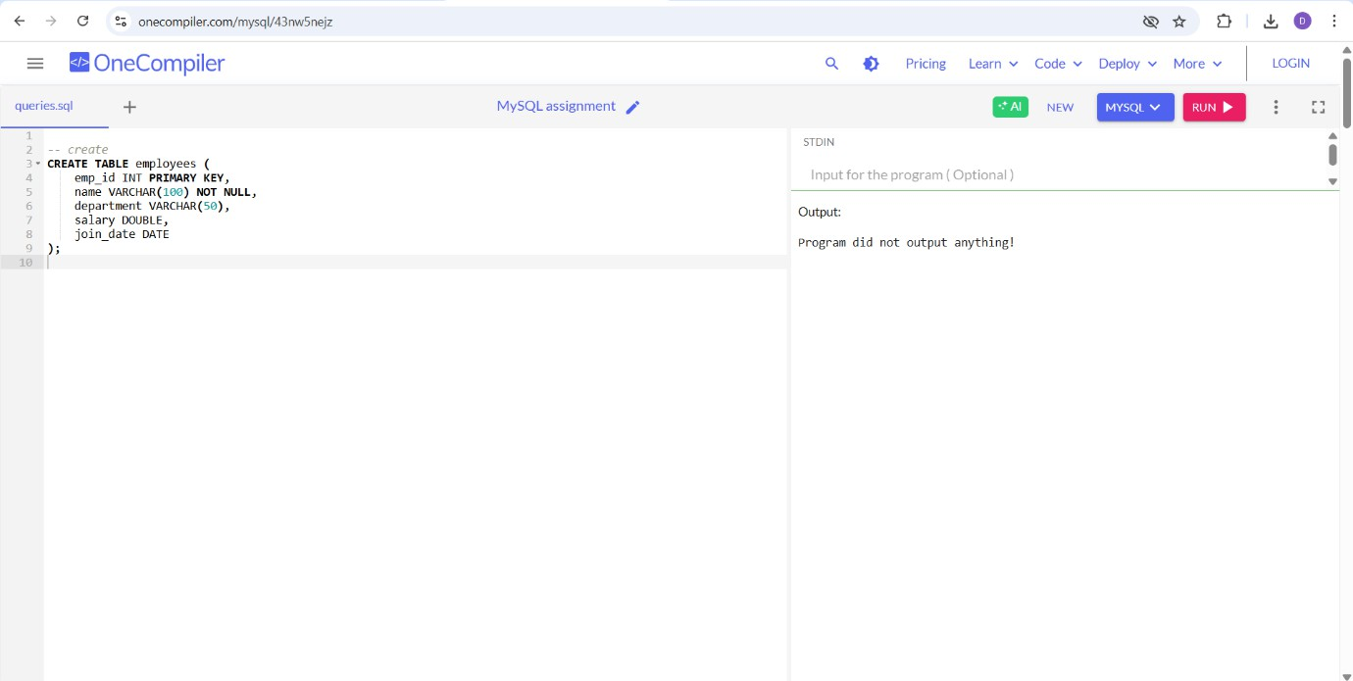

# INSERT QUERY

INSERT INTO employees (emp_id, name, department, salary, join_date) VALUES (201, 'Rahul Verma', 'HR', 47000, '2022-04-12'),

(202, 'Sneha Kapoor', 'IT', 82000, '2021-02-18'),

(203, 'Amit Sharma', 'Finance', 61000, '2020-09-07'),

(204, 'Neha Joshi', 'IT', 87000, '2023-01-20'),

(205, 'Karan Mehta', 'Sales', 53000, '2022-07-30');

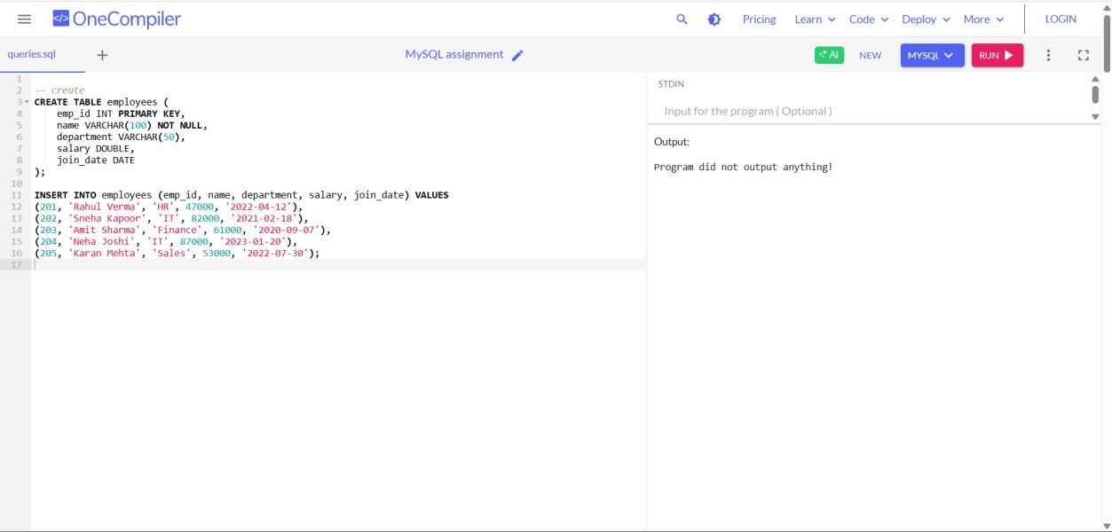

## SELECT QUERY

* + SELECT * FROM employees;

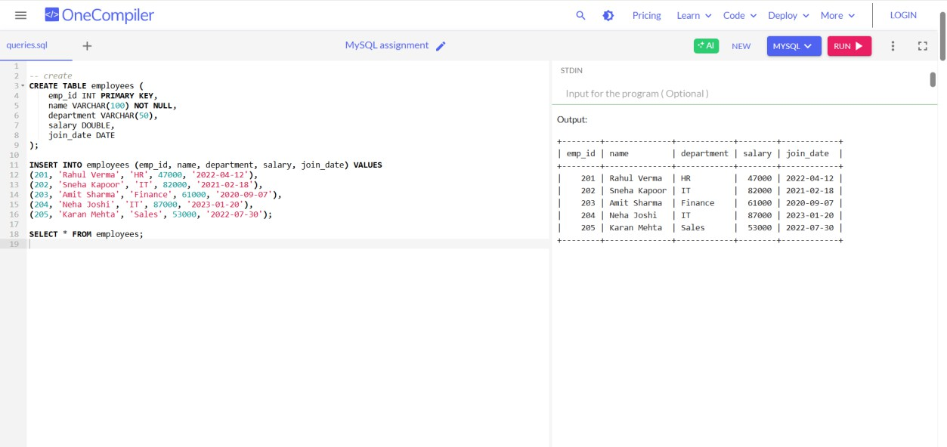

* + SELECT name, department FROM employees;

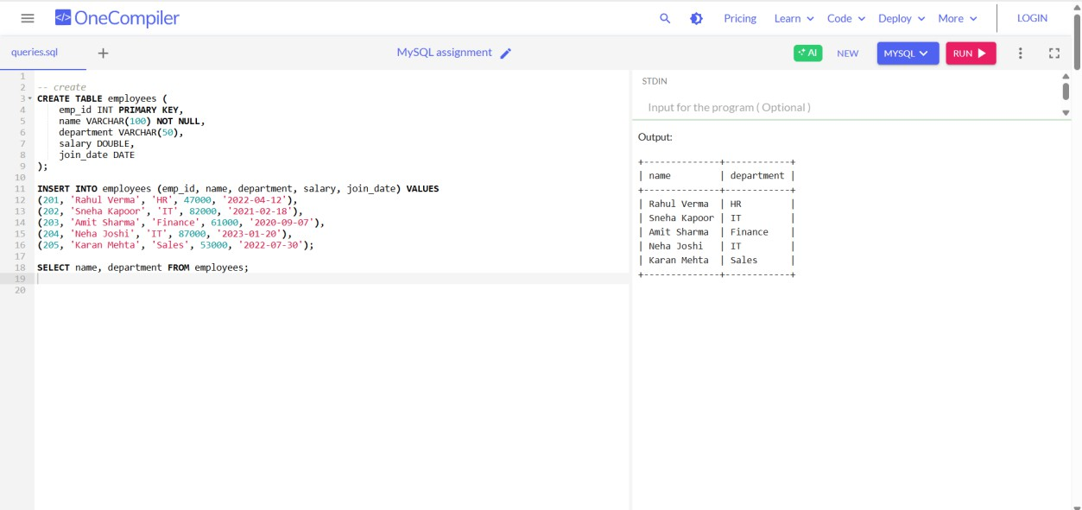

* + SELECT * FROM employees WHERE department = 'IT';

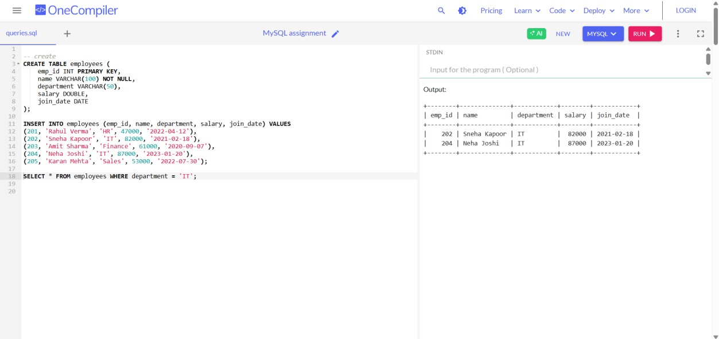

## AND, IN BETWEEN & LIKE

* + SELECT * FROM employees WHERE department = 'IT' AND salary > 75000;

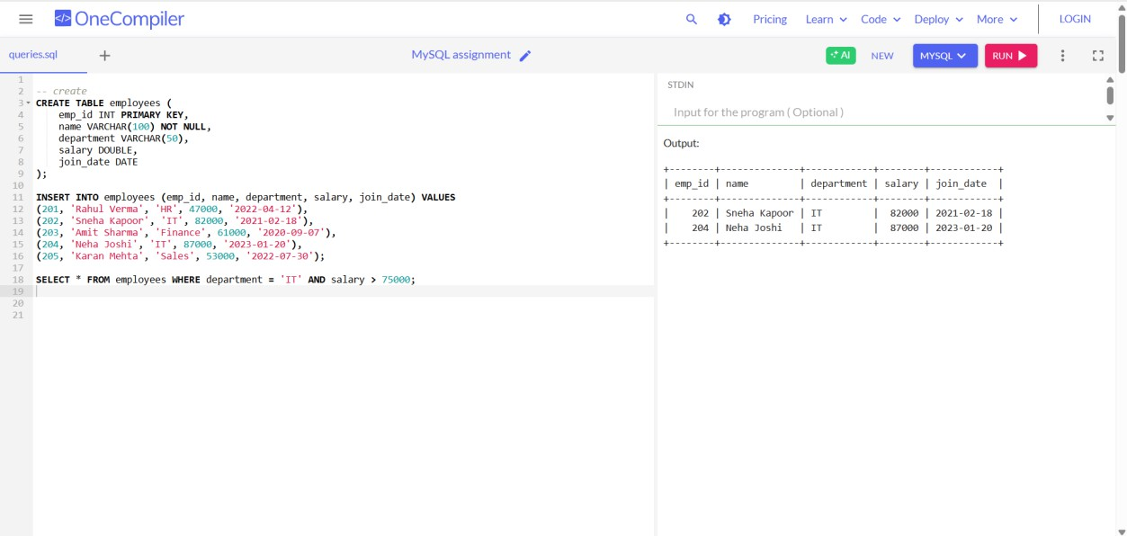

* + SELECT * FROM employees WHERE department IN ('IT', 'Finance');

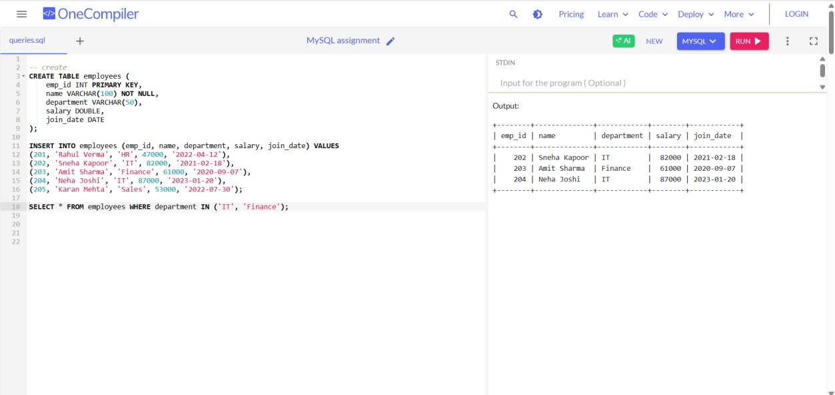

* + SELECT * FROM employees WHERE salary BETWEEN 50000 AND 70000;

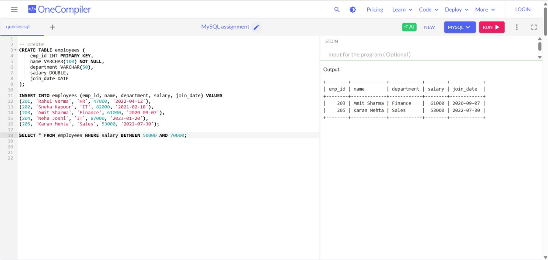

* + SELECT * FROM employees WHERE name LIKE 'N%'; -- Names starting with J

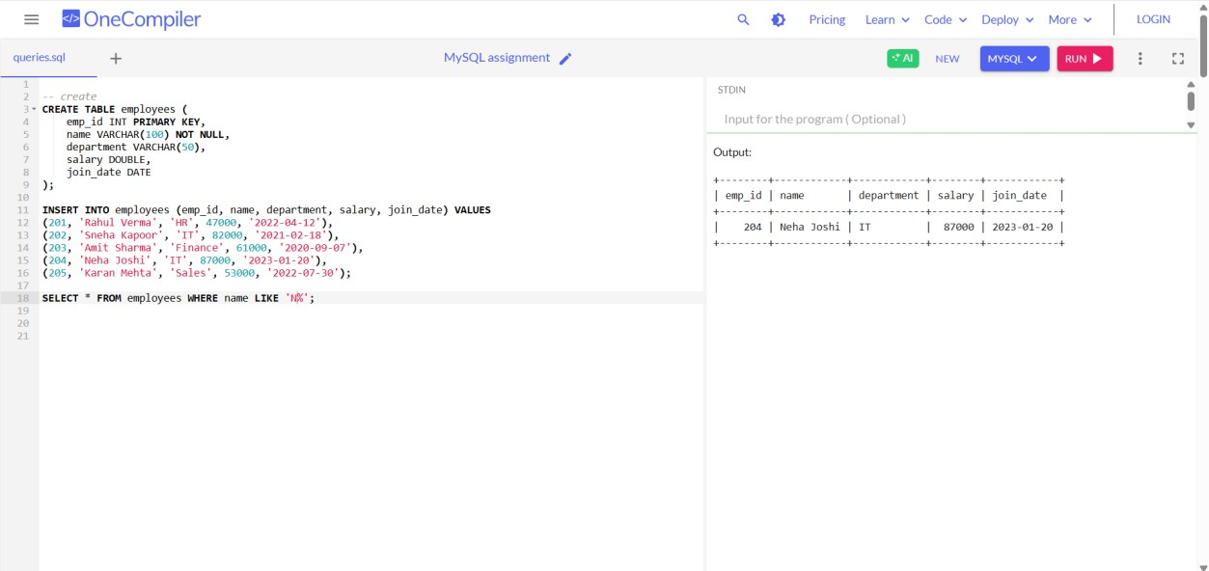

# CLAUSE -ORDER BY, WHERE, HAVING

SELECT * FROM employees ORDER BY salary DESC;

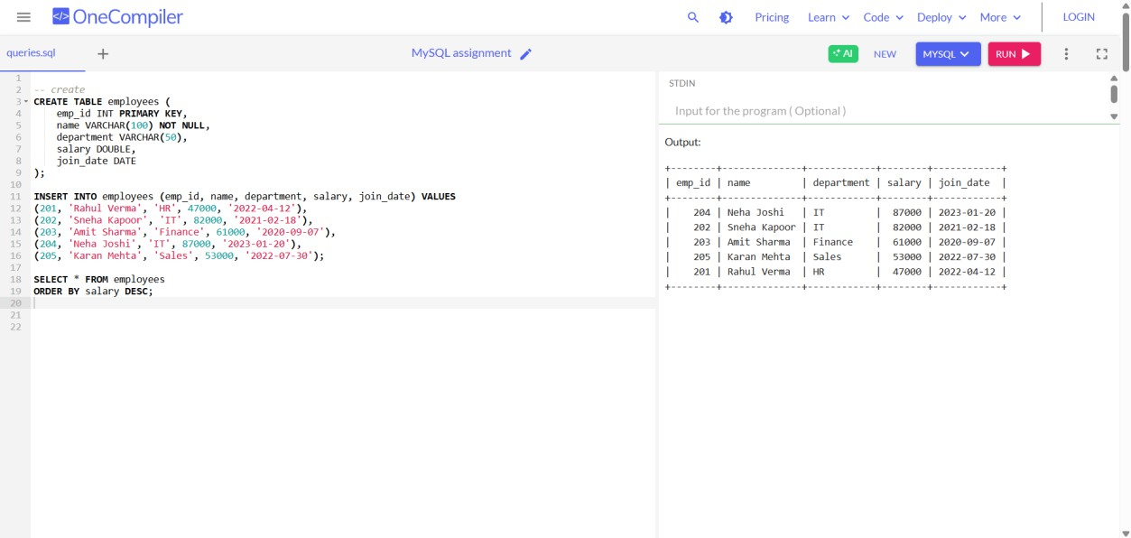

# UPDATE QUERY

* + SELECT department, AVG(salary) AS avg_salary FROM employees

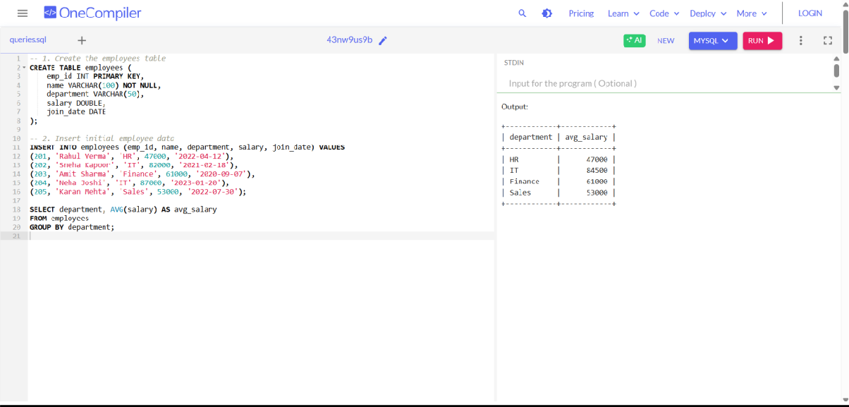GROUP BY department;

* + SELECT department, COUNT(*) AS emp_count FROM employees

GROUP BY department HAVING COUNT(*) > 1;

