**Part c**

**Question 1: Write a shell script that prints "Hello, World!" to the terminal.**

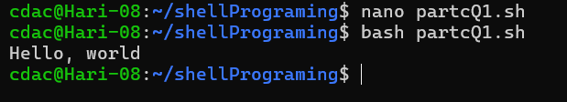

**Question 2: Declare a variable named "name" and assign the value "CDAC Mumbai" to it. Print the value of the variable.**

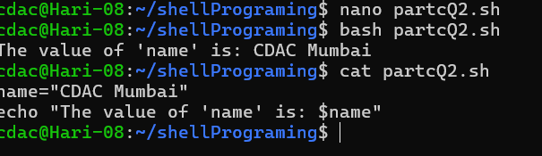

**Question 3: Write a shell script that takes a number as input from the user and prints it.**

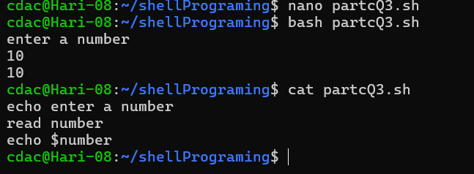

**Question 4: Write a shell script that performs addition of two numbers (e.g., 5 and 3) and prints the result.**

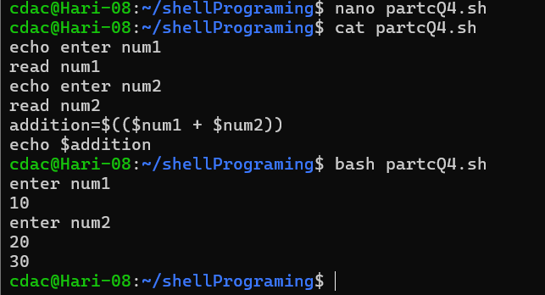

**Question 5: Write a shell script that takes a number as input and prints "Even" if it is even, otherwise prints "Odd".**

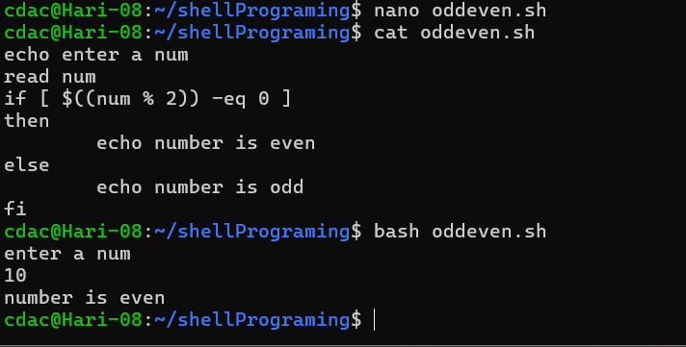

**Question 6: Write a shell script that uses a for loop to print numbers from 1 to 5.**

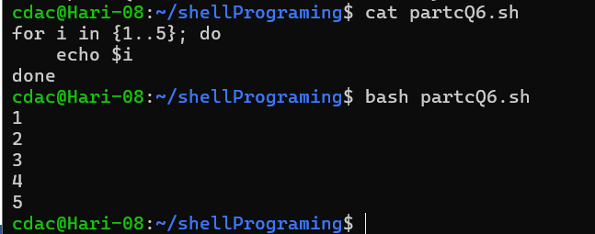

**Question 7: Write a shell script that uses a while loop to print numbers from 1 to 5.**

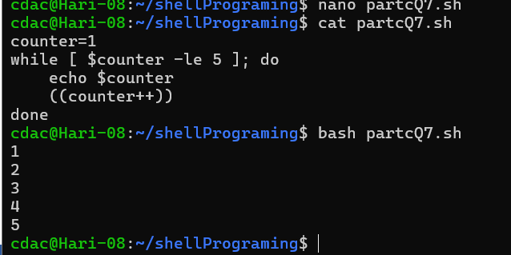

**Question 8: Write a shell script that checks if a file named "file.txt" exists in the current directory. If it does, print "File exists", otherwise, print "File does not exist".**

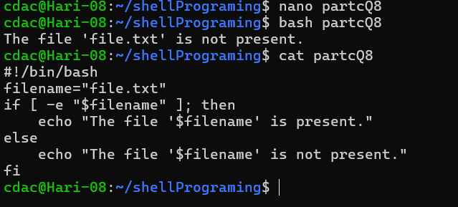

**Question 9: Write a shell script that uses the if statement to check if a number is greater than 10 and prints a message accordingly.**

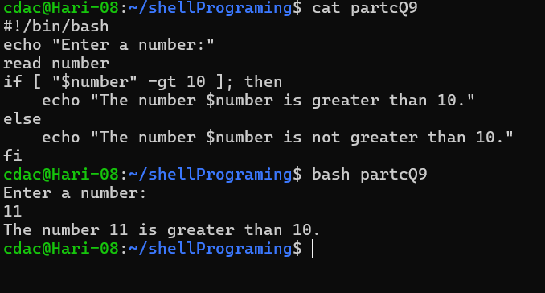

**Question 10: Write a shell script that uses nested for loops to print a multiplication table for numbers from 1 to 5. The output should be formatted nicely, with each row representing a number and each column representing the multiplication result for that number.**

