

**ANL201**

**Data Visualisation for Business**



**Group-based Assignment**

**July 2024**



|  |  |  |
| --- | --- | --- |
| **Student Name** | **PI No** | **Role** |
| B HARIPPRIYA | K2170295 | LEADER |
| THARINE T RAMACHANDRAN | K2372706 | MEMBER |
| NANTHAKUMAR S/O M.KRISHNAN | Z1611318 | MEMBER |
| RETA D/O RAJAKUMAR | M2170763 | MEMBER |

**T-Group & Team** **No. : T04 & Group 1**

**Date of Submission** **: 18/10/2024**

**1a)**

The organisation chosen for this Question 1 is McDonald’s.

|  |  |  |  |
| --- | --- | --- | --- |
| **Balance Scorecard Perspective** | **Strategic Objective** | **Measure** | **Target** |
| Financial | 1. Increase profitability  2. Reduce operational expenses | 1. Net profit margin  2. Operating cost | 1. Increase net profit margin by 8% over the next fiscal year  2. Decrease operating costs by 4% in 12 months |
| Customer | 1. Increase customer satisfaction  2. Improve customer mobile app retention | 1. Customer satisfaction score (CSAT)  2. Customer repurchase rate | 1. Increase CSAT by 5% this year  2. Increase mobile app repeat purchases by 5% this year |
| Internal Business  Process | 1. Enhance operational efficiency  2. Reduce restaurant energy consumption | 1. Average service time per order  2. Average restaurant energy consumption per region | 1. Reduce service time per order by 25% this year  2. Decrease restaurant energy consumption by 5% this year |
| Learning & Growth | 1. Improve employee retention  2. Improve employee capabilities | 1. Employee turnover rate  2. Employee training hours | 1. Reduce employee turnover rate from 20% to 10% this year  2. Increase training hours per employee by 3% this year |

**Word Count: 164 words**

**1b)**

The graphs for Financial perspective are created using data retrieved from McDonald’s corporate annual reports (Dybek, 2024) and (*Financial Information and Annual Reports | McDonald’s*). All other datasets have been created for this assignment.

**Financial**

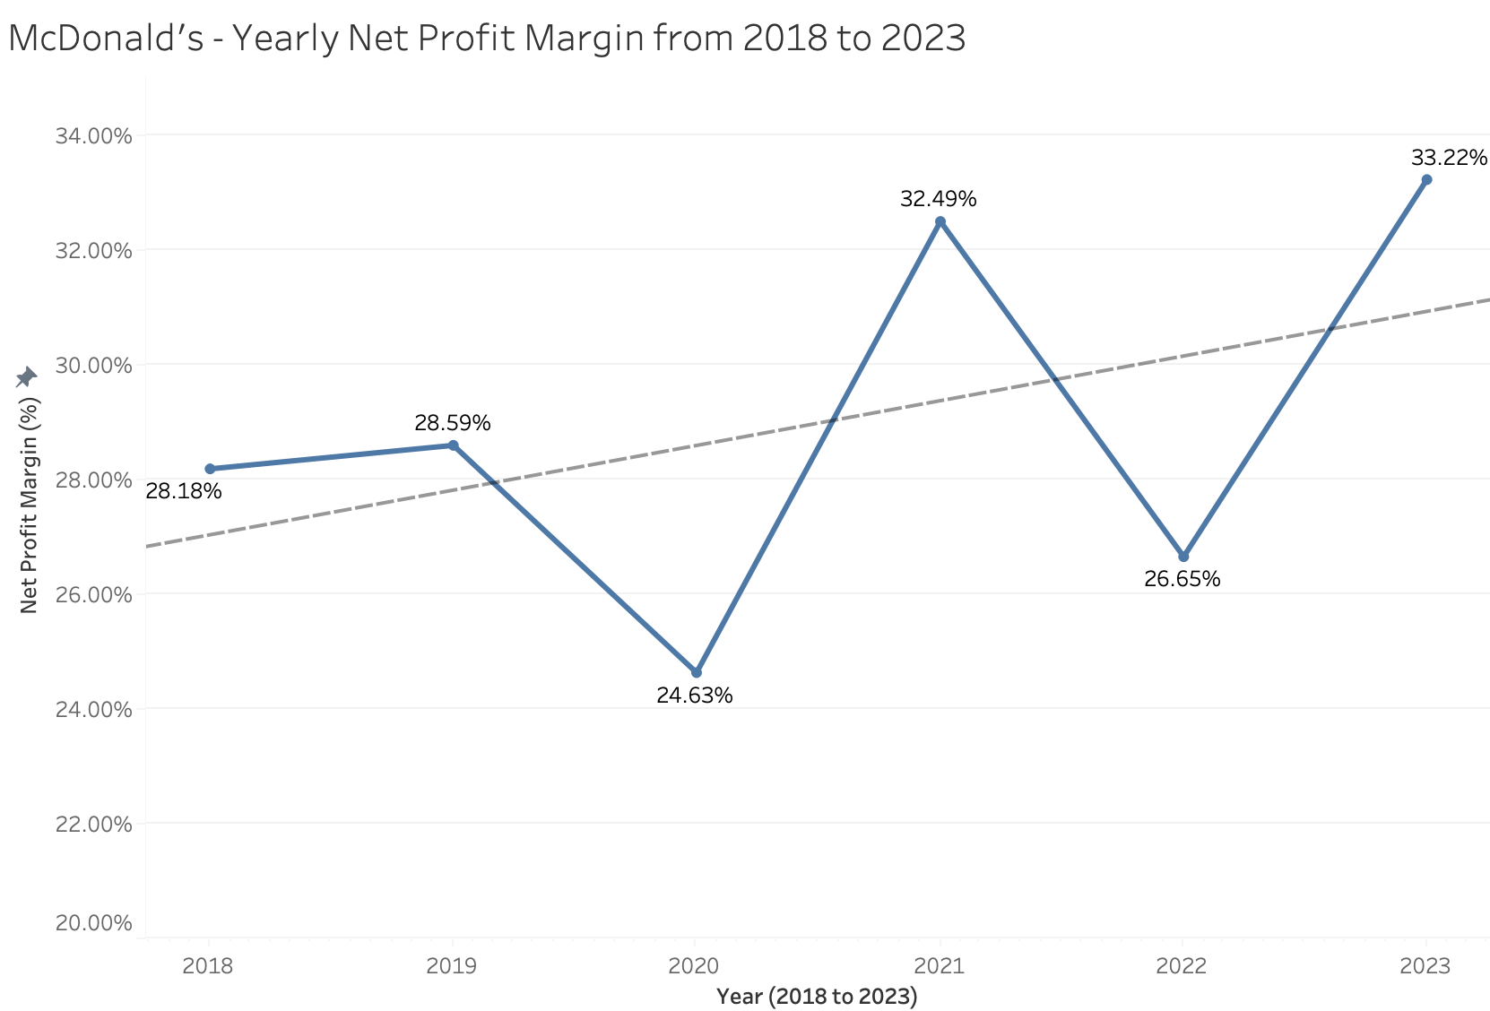  *Figure 1.1: Financial Measure 1, Net Profit Margin*

A line chart is great for visualizing time series data such as yearly net profit margins. It also shows the trends over time such as increase, decrease and any fluctuations. There is a positive trend line despite the dips in year 2020 and year 2022, showing McDonald’s ability to recover and grow financially. The highest net profit margin of 33.22% is in year 2023.

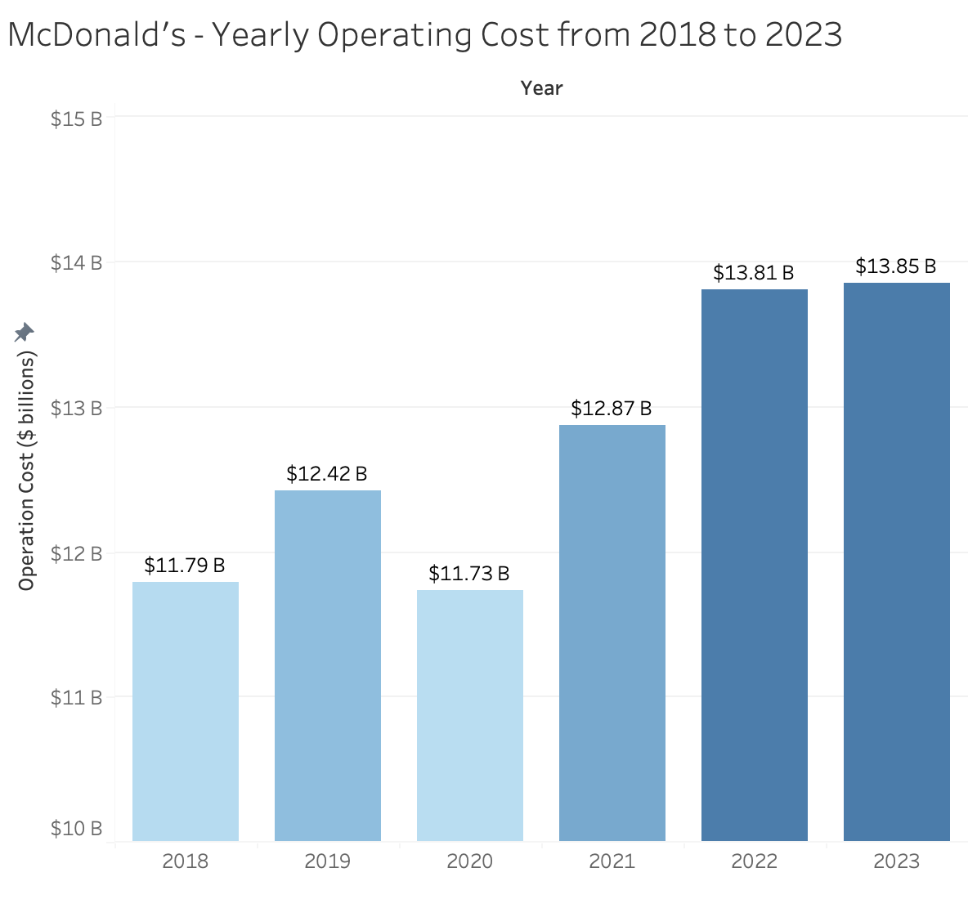 *Figure 1.2: Financial Measure 2, Operating Cost*

A bar chart is suitable for visualizing operating costs over a period of time. The color gradient and bar length show the lowest to highest operating cost, and trends like fluctuations. There is an overall upward trend and McDonald’s operating costs have been increasing. The largest operating costs increment is from year 2020 to 2021, and smallest from 2022 to 2023. The highest cost is in year 2023 of $13.85 billion.

**Customer**

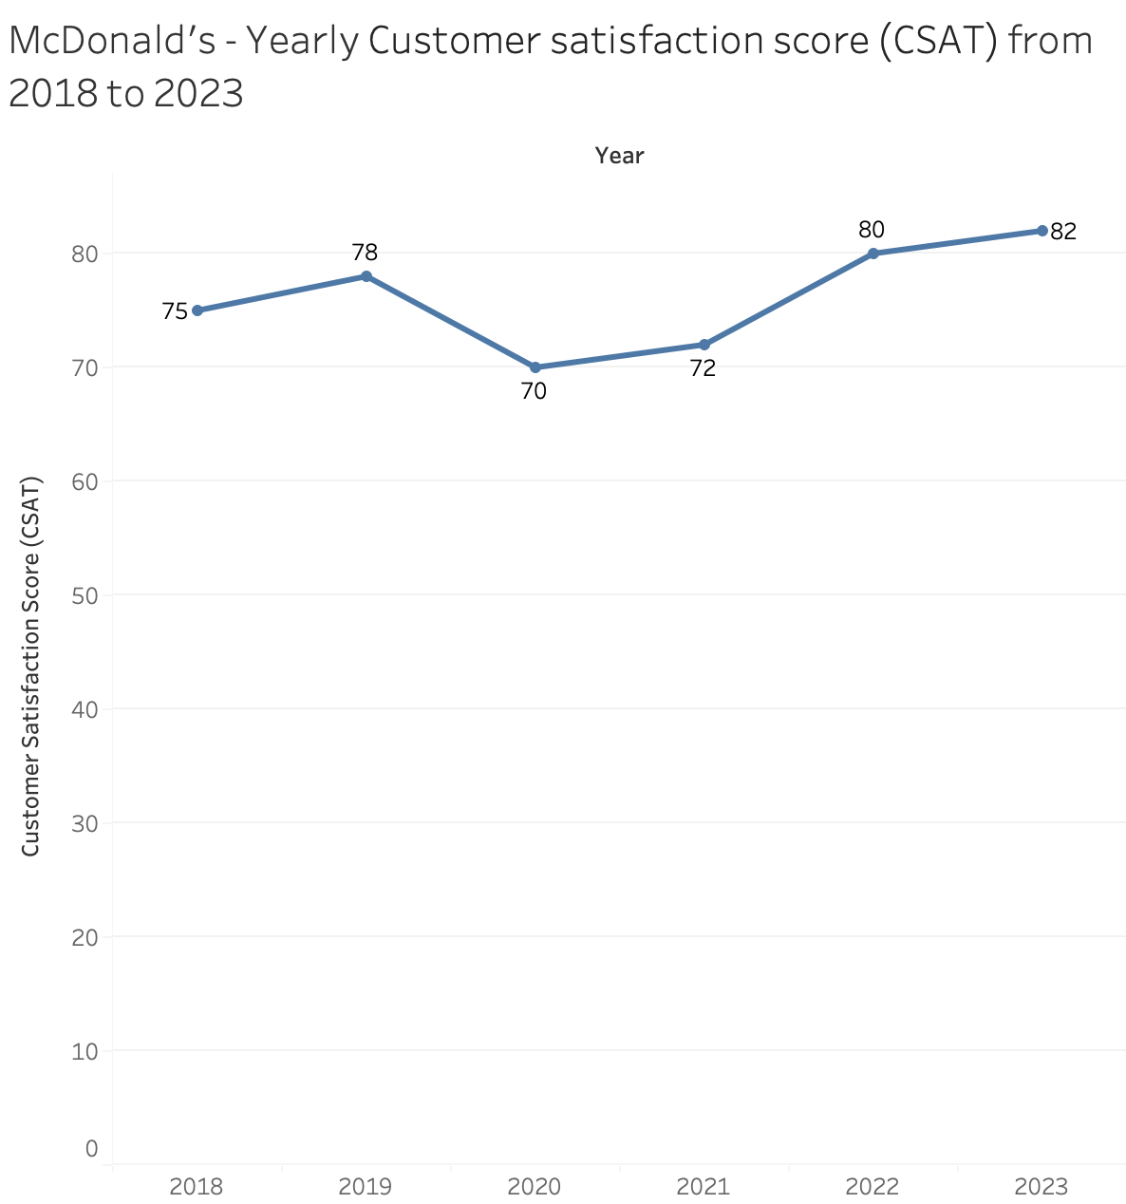

*Figure 2.1: Customer Measure 1, Customer Satisfaction Score (CSAT)*

Line chart is ideal in showing the trends of CSAT scores over the years. Although CSAT has decreased in year 2020, it has been rising every year since, with the highest score of 82 in year 2023. This shows McDonald’s has been able to improve customer satisfaction.

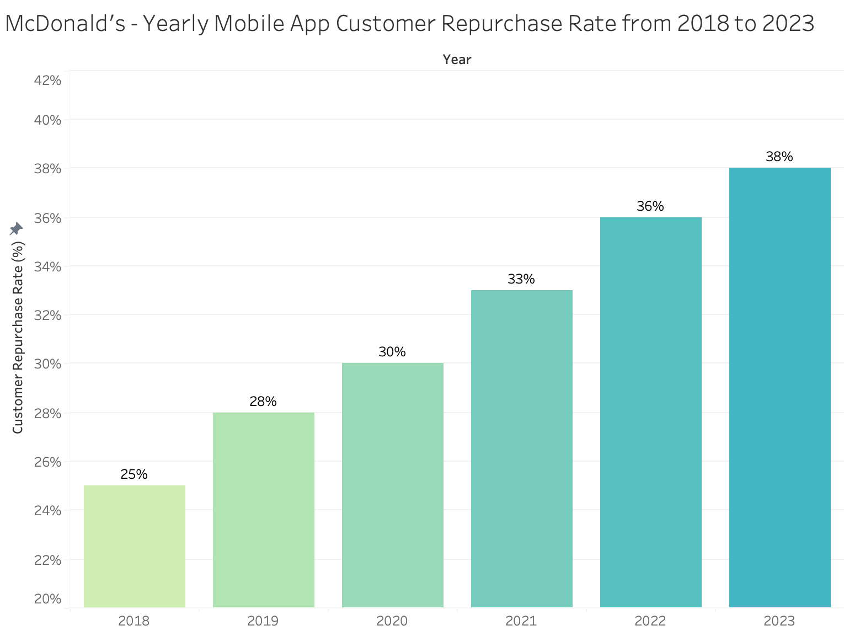 *Figure 2.2: Customer Measure 2, Customer Repurchase Rate through Mobile App*

Bar chart is great for visualizing year on year changes for mobile application repurchase rate. Shortest bar length and lightest color gradient allows easy visualization of the lowest rate, and vice versa. There is a steady increase in McDonald’s mobile app customer repurchase rate from 2018 to 2023. It shows the success of using the mobile application and repeat purchases.

**Internal Business Process**

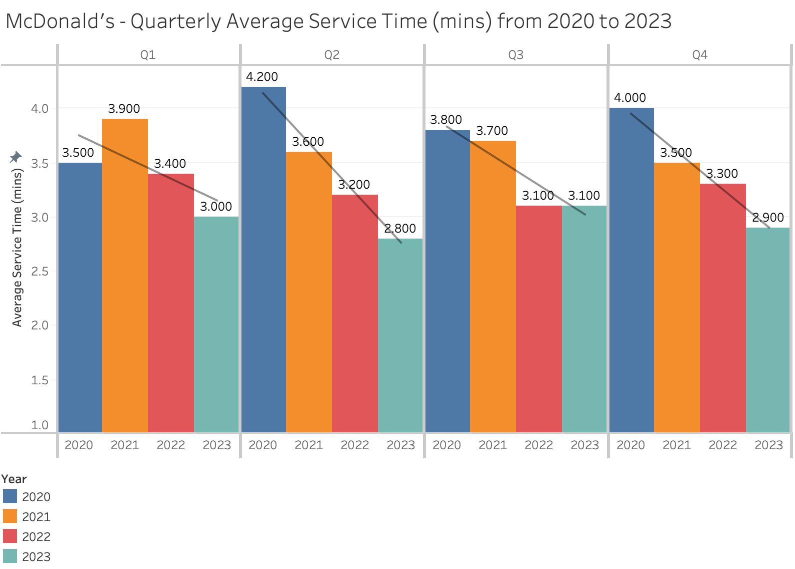 *Figure 3.1: Internal Business Process Measure 1, Average Service Time per Order*

This grouped bar chart allows easy comparisons for quarterly changes over the years, with each year having a different color. Every quarter has a downward trend line, showing decreased average service time and thus increased efficiency. Quarter 2 has the steepest decrease.

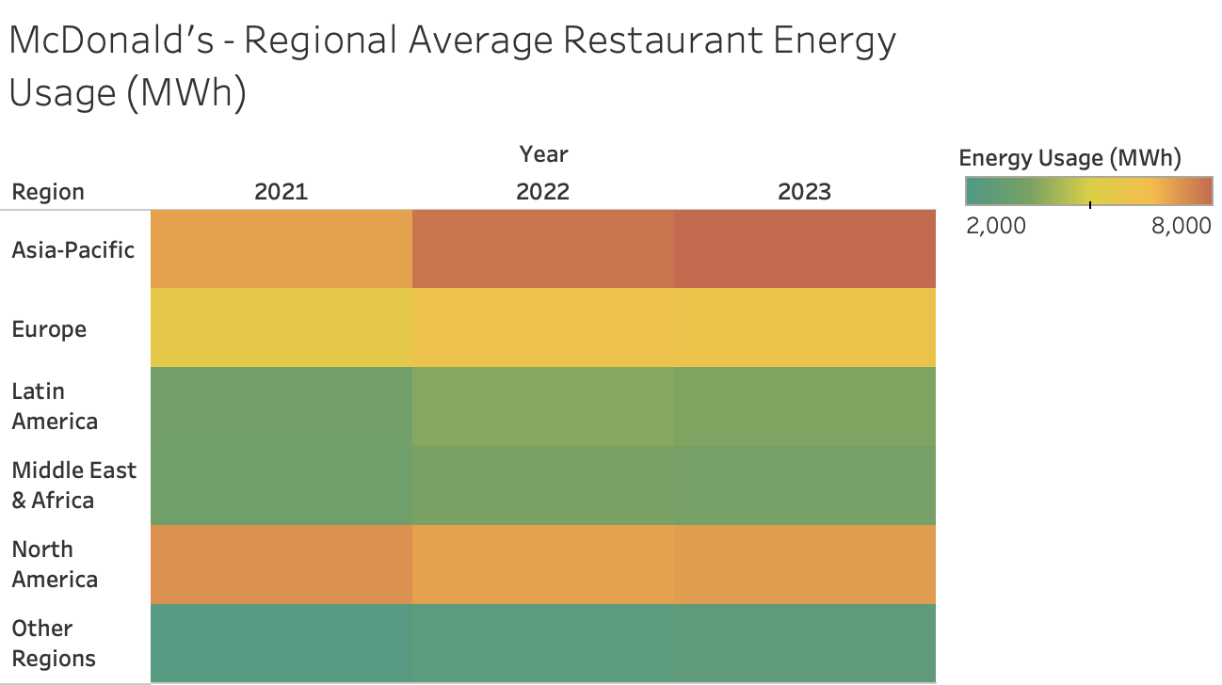 *Figure 3.2: Internal Business Process Measure 2, Average Restaurant Energy Consumption per Region*

This heat map is a quick way to visualize regional differences in energy usage over the years by looking at the color intensity and hue. Areas that are darker and nearer to red color indicate higher energy consumption, McDonald’s can thus focus energy consumption efforts in these areas such as Asia-Pacific and North America. Asia-Pacific also has significantly increased energy consumption over the years.

**Learning and Growth**

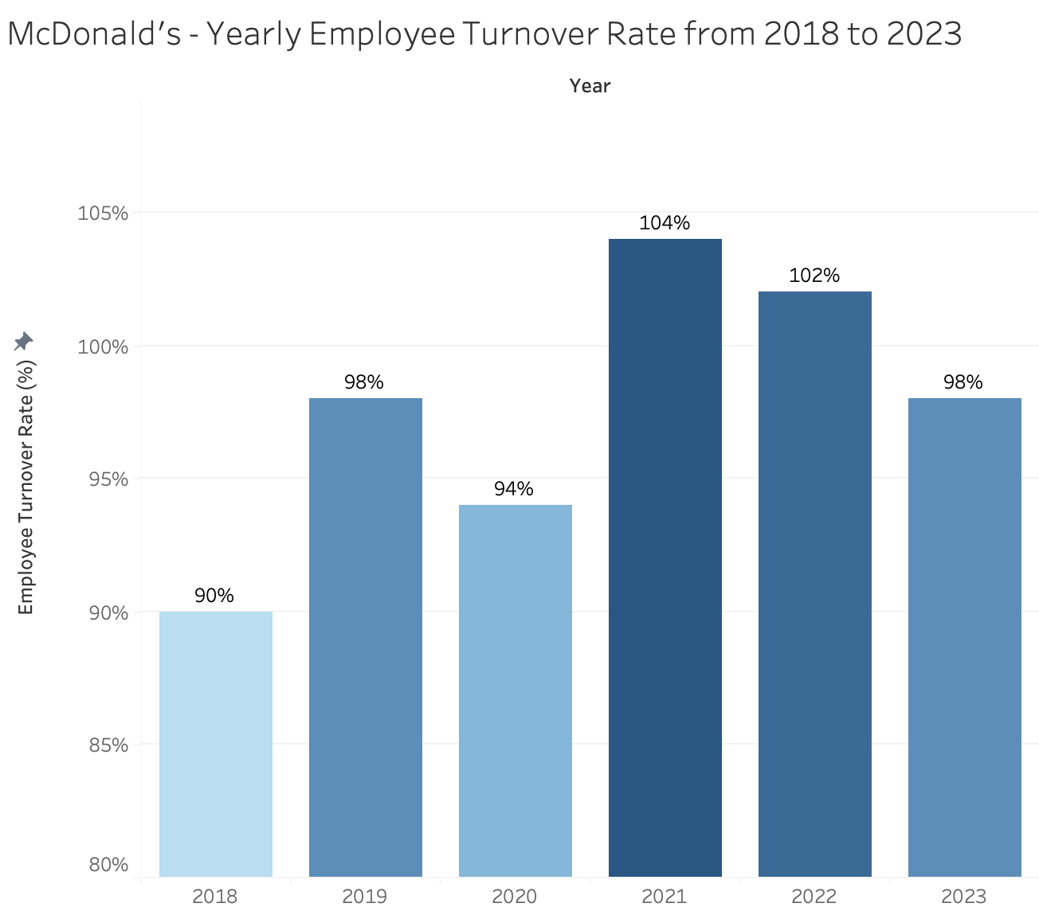 *Figure 4.1: Learning and Growth Measure 1, Employee Turnover Rate*

The bar chart is ideal to visualize yearly changes in employee turnover rate. The biggest spike in turnover from year 2020 could be due to opening of job market after COVID-19 lockdowns. The darkest color gradient and longest bar in year 2021 shows the highest turnover rate of 104%. It has also been decreasing for the last 3 years, indicating improvements in employee retention.

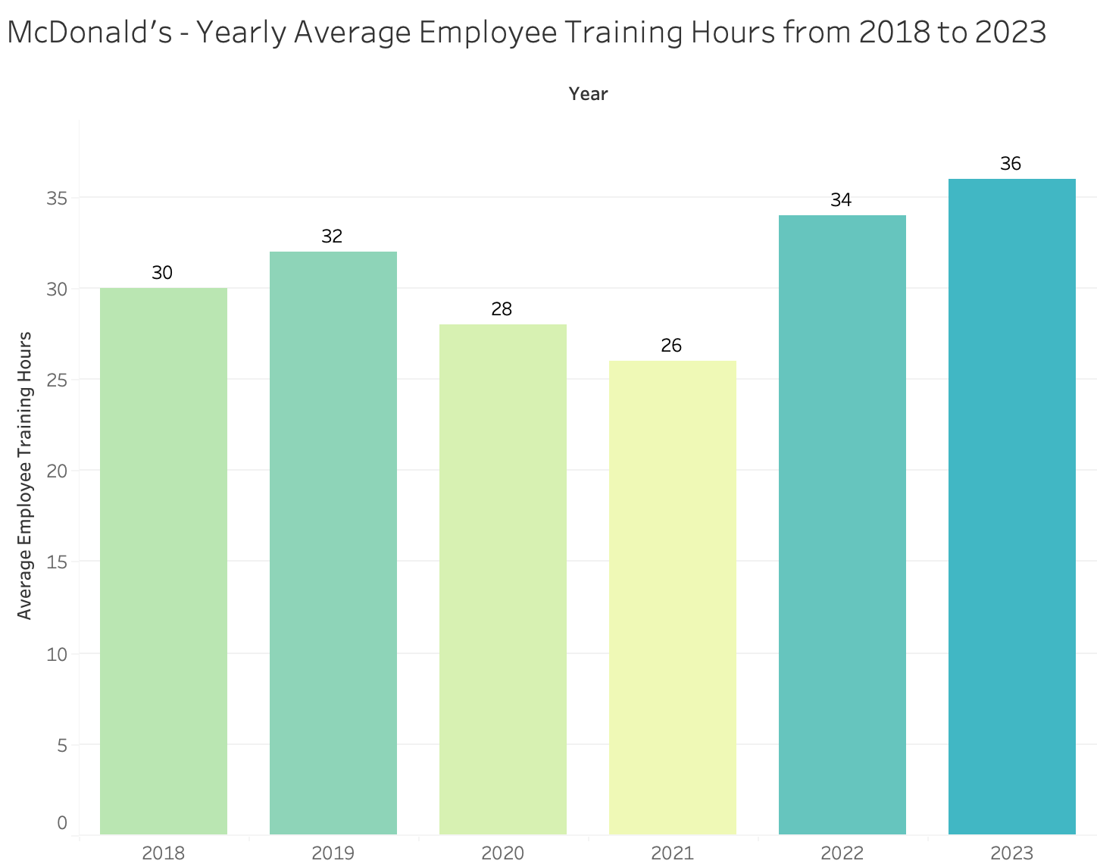 *Figure 4.2: Learning and Growth Measure 2: Employee training hours*

This bar chart is great for quickly visualizing yearly changes in average employee training hours. The lightest color and shortest bar in 2021 shows the lowest average training hours of 26. The highest being 26 hours in 2023. There has been yearly increase since 2021 which indicates McDonald’s success in increasing employee training hours.

**Word Count: 500 words (excluding text underneath charts)**

**2a)**

|  |  |  |  |
| --- | --- | --- | --- |
| **Variable** | **Data Type** | **Number of Observations** | **Summary Statistics** |
| satisfaction_level | Ratio | 2206 | Mean: 0.55 Median: 0.54 Mode: 0.11 Min: 0.09 Max: 1.2 Std Dev: 0.27 |
| last_evaluation | Ratio | 2206 | Mean: 0.72 Median: 0.75 Mode: 1 Min: 0.37 Max: 1 Std Dev: 0.18 |
| number_project | Ratio | 2206 | Mean: 3.85 Median: 4 Mode: 2 Min: -6 Max: 7 Std Dev: 1.51 |
| average_monthly_hours | Ratio | 2206 | Mean: 203.7 Median: 206 Mode: 156 Min: 96 Max: 310 Std Dev: 55.03 |
| time_spend_company | Interval | 2206 | Mean: NA Median: NA Mode: NA Min: 2 Max: 6 Std Dev: NA |
| left | Nominal | 2192 | Mean: NA Median: NA Mode: 1 Min: NA  Max: NA Std Dev: NA |
| Department | Nominal | 2206 | Mean: NA Median: NA Mode: sales Min: NA Max: NA Std Dev: NA |
| salary | Ordinal | 2206 | Mean: NA Median: NA Mode: low Min: NA Max: NA Std Dev: NA |

**2b)**

**Identified quality issues:**

|  |
| --- |
| **Inspection of data for anomality (Before any treatment)** |
| **Figure 1. (Inconsistent row count)** |
| **Figure 2. (Missing Data/Value)** |
| **Figure 3. (Descriptive Analysis)**  Impacted Columns: “satisfaction_level”, “number_project”, “left” |
| **Figure 4. (Negative value data)**  Impacted Column “number_project” |
| **Figure 5. (Data exceeding data dictionary range) & Decimal range to be shortened**  Impacted Column “satisfaction_level” |
| **Figure 6. (added decimal places)**  Impacted Column “last_evaluation” |

**Data Treatments:**

|  |
| --- |
| **Figure 2. Missing Values/Data** |
| **After treatment method: Deletion of impacted rows** |
| Steps taken to treat:   1. Delete the 14 rows impacted 2. Imputing this is not possible as unable to predict or calculate. |

|  |
| --- |
| **Figure 4. (Negative value data)** |
| **After treatment method: Applied median analysis to replace negative data field** |
| **Steps taken to treat:**   1. Applied formula =IF(D2<1,MEDIAN($D$2:$D$2193),D2) 2. Explained formula:    * If value in cell D2 is less than **1**.    * It replaces the value in D2 with the **median** of the range D2:D2193.    * If D2 is 1 or greater, the formula keeps the original value in D2.    * The ($) in ($D$2:$D$2193) to lock the range. 3. Replaced with new values “number_project” and deleted N_P-Median column. |

|  |
| --- |
| **Figure 5. (Data exceeding data dictionary range) & Decimal range to be shortened** |
| **Applied median analysis to replace data field which are of value more than 1**        **Steps taken to treat:**   1. Applied formula =IF(A671>1,MEDIAN($A$1:$A$2193),A671) 2. Explained formula:    1. Checks if the value in cell A671 is greater than 1.    2. If true (A671 is greater than 1), it replaces the value in A671 with the median of the range A1    3. The ($) in ($A$1:$A$2193) is to lock the range. 3. Replaced with new values “satisfaction_level” and deleted S_L- Median column. 4. Reduced decimal point to 1 to condense the data for better visualization and abide by data dictionary. |

|  |
| --- |
| **Figure 6. (added decimal places)** |
| **Steps taken to treat:**   1. Reduced decimal point to 1 to condense the data for better visualization and abide by the data dictionary. |

**Word Count: 249 Words (excluding figure titles)**

**References**

Dybek, M. (2024) *McDonald’s Corp. (NYSE:MCD): Analysis of profitability ratios*. [Online]. 23 February 2024. Stock Analysis on Net. Available from: <https://www.stock-analysis-on.net/NYSE/Company/McDonalds-Corp/Ratios/Profitability#Net-Profit-Margin> [Accessed: 14 October 2024].

McDonald’s (n.d.) *Financial information and annual reports | McDonald’s*. [Online]. Financial Information and Annual Reports. Available from: <https://corporate.mcdonalds.com/corpmcd/investors/financial-information.html> [Accessed: 14 October 2024].