Entropy Guided Hierarchical Job Placement for Heterogeneous HPC Workloads
K R Hari Prajwal  Manipal Institute of Technology Bengaluru  Manipal Academy of Higher Education, Manipal, India  Bengaluru, India  krhariprajwal.mitblr2026@learner.manipal.edu | Megha P. Arakeri  Manipal Institute of Technology Bengaluru  Manipal Academy of Higher Education, Manipal, India  Bengaluru, India  megha.arakeri@manipal.edu
Srushti H. R.  Manipal Institute of Technology Bengaluru  Manipal Academy of Higher Education, Manipal, India  Bengaluru, India  srushti.mitblr2026@learner.manipal.edu | Nishka Shetgaonkar  Manipal Institute of Technology Bengaluru  Manipal Academy of Higher Education, Manipal, India  Bengaluru, India  nishka2.mitblr2026@learner.manipal.edu

Abstract—This paper evaluates an entropy guided, three level job placement heuristic for heterogeneous high performance computing clusters. A cluster root groups rack summaries and compute nodes; each job uses a weighted CPU, memory, network, and disk score, while recent CPU variance classifies node stability. We audit the implementation and compare its recorded discrete event simulations on 1,500 jobs from each of three original Standard Workload Format traces with Round Robin, least loaded, centralized work queue, and random policies. On the CEA Curie trace, the hierarchical policy reduces mean sampled load variance by 26.6% and mean modeled wait by 27.0% relative to Round Robin; on LLNL Thunder the respective reductions are 4.7% and 31.1%. On LANL CM-5, however, its variance is 18.7% higher and its wait is 172.1% higher. The scheduler scans racks and their children, and can scan the cluster in its stability fallback; the current implementation therefore does not support a logarithmic worst case dispatch claim. A separate synthetic trace experiment shows lower measured dispatch time than a full least loaded scan at 1,024 nodes but higher time than Round Robin. We identify how generated resource demands, simulator wait rules, and terminal state fairness measurement limit causal conclusions. The results establish a trace dependent tradeoff and specify the changes needed for a stronger scheduling evaluation.
Index Terms—hierarchical scheduling, high performance computing, load balancing, volatility, workload traces, discrete event simulation, resource aware placement.
I. INTRODUCTION
Large clusters assign jobs to nodes with different resource capacities and changing contention. A placement decision made from CPU load alone can overlook memory pressure or I/O demand, while a low instantaneous load need not indicate stable service. The scheduling problem is therefore multidimensional and temporal: a dispatcher must make an inexpensive decision using incomplete observations, and the resulting assignment must remain useful as concurrent work changes node state [1], [2].
The project studied here implements a three level cluster–rack–node hierarchy. Job categories determine weights for CPU, memory, network, and disk; a sliding window of CPU observations estimates volatility; and an alternative node is considered for long predictable jobs when the minimum score candidate is volatile. The repository contains both generated SWF format traces and separately stored original archive traces. This distinction is material: a file that follows SWF syntax is not thereby an observed supercomputer workload [3], [4].
We treat the project as an empirical heuristic rather than a claim of a new entropy formula or a proved optimal scheduling algorithm. Our contributions are (1) an implementation faithful description of the job placement and refresh paths; (2) an evaluation centered on recorded results from original CEA Curie, LANL CM-5, and LLNL Thunder trace files; (3) a separate presentation of synthetic scaling measurements; and (4) a validity audit of data provenance, time complexity, model assumptions, and outcome metrics. The audit matters because the earlier draft mixed generated and original traces and made claims that its own recorded tables do not establish.
The paper follows the layout of the supplied reference: related work is followed by a precise method, experimental results and discussion, and a conclusion. All reported numbers are taken from the project repository at the inspected revision; no production cluster deployment or independently replicated statistical effect is implied.
The central design tension is measurable. A flat least loaded scan sees every node and can identify a global minimum under its chosen score, but incurs work proportional to cluster size. A cyclic policy places a job with almost no search work, but ignores current load. Aggregating by rack offers an intermediate organization, provided the aggregate is predictive of the best leaf and maintenance does not erase the query saving. Volatility information introduces a further tradeoff: avoiding an unstable node can raise the immediate load score yet reduce an assumed runtime penalty later. A credible evaluation has to expose the costs of all three effects rather than fold them into a single improvement percentage.
Throughout, “original trace” describes the source of job records, not direct replay on the original machine. The simulated cluster always has 128 nodes for the main comparison, although the source machines had different historical processor counts and architectures. The policy therefore sees a transformed workload under a new, explicitly modeled environment. This is useful for comparing rules under controlled conditions but does not reproduce the historical scheduler or its actual queue.
II. RELATED WORK
A. HPC workload scheduling and allocation
Batch scheduling chooses which job to run and where to allocate it. These are distinct decisions, especially when resource requests cover several dimensions. Recent hierarchical reinforcement learning work jointly addresses job selection and heterogeneous resource allocation, illustrating the richer state and action space of modern HPC schedulers [5]. The present system instead uses fixed job profiles and an inexpensive greedy node choice; it does not train a policy or perform queue level backfilling.
The Parallel Workloads Archive provides original logs and models for scheduling studies, and SWF defines a common 18 field interchange format [3], [4]. Archive records include submit time, runtime, allocated processors, and sometimes memory fields, but the project must infer the four resource requirements used by its balancer. These inferred quantities should be understood as simulator inputs, not direct historical measurements of network or disk use.
B. Hierarchical and volatility aware balancing
Hierarchical load balancing predates this project. Zheng et al. organized load balancing domains into a tree and demonstrated the approach in Charm++ at large machine scales [1]. Their work concerns periodic migration and load balancing of parallel application objects; the current implementation selects a node for each incoming simulated job and refreshes aggregated rack information. A tree can reduce search work only when summaries and an admissible selection rule avoid inspecting most leaves. A three level topology by itself does not establish a logarithmic query bound.
Entropy has also been applied to balancing decisions, including a maximum entropy method for homogeneous clusters [6]. In this project, the operational guardrail is based on sample variance of recent CPU values; discretized Shannon entropy is computed and displayed but is not used by the placement class test. Calling both measurements “entropy guided” without stating this distinction would misrepresent the decision rule. Our analysis preserves the project name while separating the two calculations.
C. Evaluation gap
Prior scheduling studies show that objectives such as utilization, waiting time, fairness, throughput, and makespan need not move together [1], [5]. For this implementation, the central question is narrower: when the same simulator and mapped jobs are used, how does a profile weighted hierarchical choice compare with simple baselines across traces? A second question is whether the implementation actually avoids the flat scan it claims to replace. We answer both by relating the recorded measurements to the code paths that produced them.
The distinction from earlier hierarchy work is also one of scope. Charm++ style periodic balancing can migrate application objects based on measurements across domains [1], [5]; the present simulator makes an arrival time placement choice and later releases a job from its assigned node. It does not evaluate migration cost, communication locality, or gang scheduling for parallel jobs. Likewise, the cited maximum entropy cluster method seeks a global state of balance [6], whereas this project computes local temporal CPU variation. These are related motivations but not interchangeable objective functions. We avoid a novelty claim that would conflate them.
A fair baseline comparison must control the environment passed to every policy. The repository uses the same mapped input sequence, simulated node speeds, and seeded jitter setup for each policy, which supports within trace comparisons. Yet several queue delay additions depend explicitly on which policy is running. This creates an evaluation asymmetry: a lower simulated wait may be partly imposed by the model even if node assignments were similar. We therefore present waits as modeled outcomes and treat the CPU variance and dispatch timing as complementary evidence, not a causal validation of the guardrail.
III. PROPOSED METHODOLOGY
A. System architecture and input pipeline
The root holds rack objects, and each rack holds a fixed group of compute node objects (32 nodes per rack in the reported experiments). Each node stores a resource vector, active job accounting, and an entropy tracker. A rack aggregates mean load and records a cached minimum composite score by job type. The parser reads SWF records, a mapper creates job types and four dimensional requests, and the discrete event simulator drives arrivals, completions, periodic samples, and occasional refresh operations.
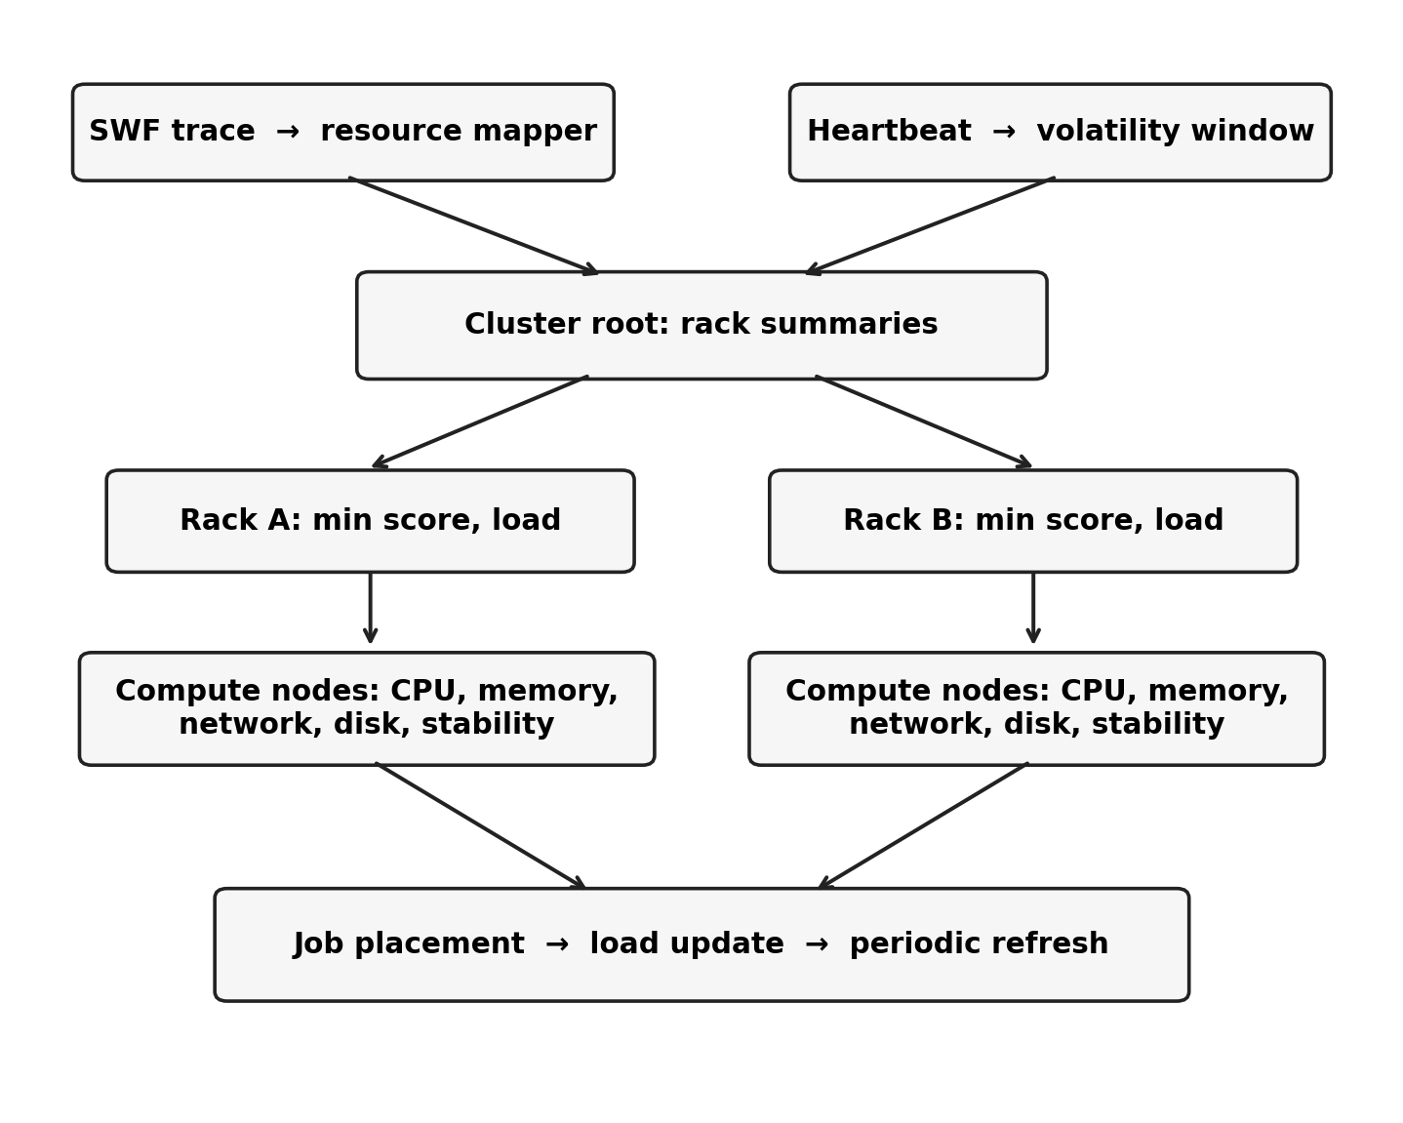
Fig. 1. Implemented input, placement, and aggregation path. The arrows show data flow; the diagram makes no asymptotic complexity claim.
The resource mapper labels jobs CPU bound, memory bound, I/O bound, or balanced using CPU time ratio, allocated processor count, recorded memory, and runtime. Network and disk demands are assigned by heuristic constants and functions of processor count because the trace does not directly report them. Runtime and submit times are multiplied by 0.05 in the original trace evaluation. Simulated nodes use speed multipliers sampled from 0.85 to 1.15 and 20% are selected for background volatility. Consequently, a benchmark result reflects both original job timing and the project’s resource and interference model.
B. Event driven execution model
An arrival event invokes the selected policy and immediately adds the job’s requested resources to the chosen node. The simulator then estimates waiting from current node queue depth and CPU load. A predictable job on a classified HIGH node or on a preselected jitter node receives a 1.35 execution duration multiplier. A completion event releases its allocated resource values. Periodic SAMPLE events update entropy histories with larger perturbations on jitter nodes, record per node CPU load, and trigger the rebalancer when its interval elapses. The event queue is a time ordered heap; a sample event is enqueued while other events remain.
This procedure abstracts away multiple production constraints. The requested processor count is used to form the job profile but a job is assigned to one simulated ComputeNode object; the code does not reserve a set of processors across racks or ensure that memory and I/O requests fit physical capacity. Several jobs may coexist on a node, with CPU and memory values clipped at 100 while network and disk values can accumulate without an explicit cap. These choices are appropriate to a teaching scale discrete event model, but they limit interpretation as a batch scheduler for actual multi node parallel allocations.
C. Composite resource score
For node n and job category j, let u(n) = (uCPU, uMEM, uNET, uDISK) denote the current stored load vector. The dispatcher minimizes S(n,j) = Σr wr(j)ur(n), with nonnegative weights summing to one. The CPU bound profile uses (0.70, 0.10, 0.10, 0.10); the memory bound profile uses (0.10, 0.70, 0.10, 0.10); the I/O bound profile uses (0.10, 0.10, 0.50, 0.30); and the balanced profile assigns 0.25 to each coordinate. The score is a ranking heuristic, not a measured estimate of job completion time.
The code stores CPU and memory as percentage like values but network and disk as nonnegative unnormalized rates. As a result, weights alone do not make the four terms commensurate. Changes in request units could alter node rankings. A capacity normalized demand vector and a measured saturation model would be necessary before comparing the importance of these dimensions across hardware platforms.
For example, the I/O profile places a combined weight of 0.80 on network and disk. If those two coordinates represent MB/s while CPU represents a percentage, a tenfold change in the arbitrary throughput unit can change the numerical ordering of nodes without changing any physical load. The scheduler does not reject a node before assignment on the basis of insufficient remaining capacity. Score based matching should therefore be characterized as a heuristic preference rather than a feasibility guarantee. Future experiments could normalize each utilization against measured per node capacity and make admission a separate Boolean condition.
D. Stability measurements and guardrail
For the most recent K = 10 CPU samples x1,…,xm (m ≤ K), the tracker computes sample variance V(n) = Σi(xi − x̄)²/(m − 1) when m ≥ 2, and zero otherwise. The node is LOW when V < 15, MEDIUM when 15 ≤ V ≤ 50, and HIGH when V > 50. The tracker also bins CPU percentage into five equal width intervals and computes Shannon entropy H(n) = −Σb pb log2 pb. These are different statistics with different units. The implementation classifies with V, not H; Shannon entropy is retained as descriptive telemetry [6].
The scheduler first chooses the rack with the smallest cached minimum score for the job type, then scans that rack’s children for its smallest score. If the chosen node is HIGH and the job is marked predictable (original runtime at least 600 s), it scans for a LOW or MEDIUM alternative in the same rack within a score tolerance. If none exists, it may scan other racks for a LOW alternative. Thus stability acts as a conditional override, and a volatile node may still be selected when no qualifying alternative is found.
The alternative threshold is 1.25 times the initial candidate score plus five score units. The additive term allows an alternative even when the initial candidate has a zero score; the multiplicative term widens tolerance as load rises. The local search accepts LOW or MEDIUM classes, while the cross rack search accepts LOW only. This asymmetry can produce different decisions for two identical nodes depending on which rack contains the first candidate. The choice is deterministic given scores and traversal order, but no optimality property follows from this guardrail.
In implementation order, the placement procedure can be stated as follows: derive weights from the job category; compare each rack’s cached minimum composite score; inspect all nodes in the best rack to select the smallest current score; conditionally substitute a stable node within tolerance; add the job’s resource request; and refresh ancestor summaries. This sequence clarifies that the stability filter is applied after the first best score has been found. It is not integrated into a global optimization over both score and volatility, and it can select a node in another rack whose score is acceptable under the tolerance but not globally minimal. These details affect both runtime and interpretation of a chosen path.
Samples enter the tracker at assignment and release as well as during periodic heartbeats. Therefore the variance window combines event driven observations and clock driven samples rather than a uniformly sampled time series. Heavy job arrival rates can shorten the window’s effective real time coverage. Shannon entropy is calculated on five equal width CPU intervals, but the interval counts are not used in classifying a node. A statement that the algorithm jointly optimizes both entropy measures would go beyond the implementation. These details suggest an ablation of sample source and window length before attributing any performance change to volatility awareness.
E. Refresh and complexity
After assignment or completion the chosen rack recomputes aggregates by scanning its children, and the root recomputes aggregate load by scanning all racks. A periodic rebalancer checks the class of every node; if more than 20% changed since the previous check, it rebuilds the same rack grouping, otherwise it refreshes aggregates. The refresh changes cached values but does not migrate executing jobs. The simulator schedules this check every 300 simulated seconds.
Let N be node count, b nodes per rack, and R = ⌈N/b⌉. With a warm rack cache, selecting among racks costs O(R) and scanning the selected rack costs O(b). A cold cache can compute each rack minimum by scanning all children, O(N). The cross rack fallback can also inspect O(N) nodes; root update scans O(R), while rack aggregation scans O(b). Therefore an ordinary warm query is O(R + b) and a cold or fallback query has O(N) worst case work. With b = 32 fixed, R grows linearly with N. The tree depth is three, not logarithmic in N. Periodic classification over K samples has O(NK) work; a full aggregate rebuild is O(N). Dispatch measurements should be interpreted as finite size timing observations rather than proof of an O(log N) asymptotic bound.
There is a more subtle cache cost. Each chosen rack’s aggregate call clears its composite minimum cache after the node changes, so that rack may be rescanned by a later query of the same job category. The root stores a mean of rack means, not a best candidate pointer or a lower bound for every profile. Rebuilding the tree retains the same membership order and does not reorganize nodes by stability class, contrary to descriptions that imply entropy driven restructuring. A rigorous complexity improvement would require a maintained summary that supports both fast updates and a search that can safely prune subtrees, plus tests that count visited leaves under adversarial arrivals.
IV. EXPERIMENTAL RESULTS
A. Datasets, policies, and measurement protocol
The main comparison uses the repository’s separately stored original LANL-CM5-1994-4, LLNL-Thunder-2007-1.1-cln, and CEA-Curie-2011-2.1-cln SWF files, identified by their archive style filenames and file headers. The processing script reads the first 1,500 records with positive runtime from each file, normalizes submit times to the first selected record, maps resource requests, and simulates 128 nodes in four racks. It does not establish that every retained record has a completed status, despite that description in an earlier report. The repository results were recorded from one seeded simulation per policy and trace. We do not assign confidence intervals to those single runs.
TABLE I ORIGINAL TRACE SLICES USED IN THE RECORDED COMPARISON
Trace | Jobs | Mean runtime  (raw s) | Simulated  nodes
CEA Curie | 1,500 | 11,091 | 128
LANL CM-5 | 1,500 | 1,834 | 128
LLNL Thunder | 1,500 | 3,267 | 128

Five policies are recorded: hierarchical, Round Robin, least loaded node, centralized work queue, and random assignment. Mean load variance is averaged over periodic samples of node CPU loads; average wait and its 95th percentile are calculated from simulator modeled queue delays; makespan is the terminal event time; dispatch time is wall clock time spent in each assignment call. These are model outputs. The simulation applies policy specific queue penalties to Round Robin, random, and work queue decisions, so comparisons of wait include those assumptions rather than isolating placement alone.
Round Robin increments a cyclic node index. Least loaded scans the nodes for a minimum composite score. The centralized work queue baseline uses its own assignment and queue logic, and random dispatch draws a node using the simulator’s seeded random state. Each policy run resets the seed and creates a fresh cluster, so the initial speed multipliers and jitter set are repeatable. However, later random draws can diverge between policies because the policy logic and event order differ. Repeat runs across independent seeds would show how much variation comes from these choices.
The original trace script reports mean raw runtime over its selected 1,500 jobs; Table I gives rounded values for characterization. These means are not the mean duration actually experienced by a simulated job after the 0.05 scaling and any speed or jitter multiplier. The script retains positive runtime records until it reaches the sample limit, regardless of the SWF status field. Thus “1,500 completed tasks” in the repository’s prose is not verified by the selection code. The input slice should be described as the first 1,500 positive runtime records. An archive release identifier and per file digest would improve provenance further.
TABLE II MAPPED JOB PROFILES IN THE ORIGINAL TRACE SLICES
Trace | CPU | Memory | I/O | Balanced
CEA Curie | 0 | 0 | 681 | 819
LANL CM-5 | 95 | 0 | 802 | 603
LLNL Thunder | 0 | 0 | 816 | 684

Table II was obtained by rerunning the repository’s parser and mapper over the same 1,500 positive runtime records in each original file, without rerunning the simulator. The mapping produces no MEMORY_BOUND jobs in these slices. The I/O category accounts for 45.4% of CEA, 53.5% of LANL, and 54.4% of LLNL records; the rest are mostly BALANCED, with 95 CPU bound LANL jobs. These labels reflect the mapping rule, not measured I/O bandwidth. Consequently, an argument that the recorded improvement arose from many measured memory bound jobs would have no support in this evaluation. The guardrail’s potential exposure also differs: 679, 597, and 390 jobs respectively satisfy its predictable runtime flag.
B. Metric definitions
At a sample time t, let li(t) be the simulated CPU load on node i and μ(t) its mean over N nodes. The sampled dispersion is v(t) = (1/N)Σi(li(t) − μ(t))²; the result file reports an arithmetic mean of v(t) over sample events. This measures spatial balance in the simulation at observed instants and has units of squared percentage points. It is not a variance of job runtimes, a Shannon entropy, or a hardware utilization measurement. An improvement percentage is calculated as 100(vbaseline − vmethod)/vbaseline; a positive value favors the proposed policy for this metric.
For each job j, the simulator records an estimated queue wait qj at assignment. The mean is (1/J)Σj qj and the tail value is the 95th percentile of the qj array. These quantities are generated before completion and are distinct from the historical SWF wait field, which the mapper does not replay as the simulated delay. The reported makespan is the simulation’s final event timestamp. Since the trace submit times are rescaled and the simulator may extend the final timestamp to a sample event, the reported seconds are simulated units after the 0.05 transformation, not wall clock seconds required to process the benchmark.
Per decision overhead times the `query_and_assign` call with a high resolution process timer. It includes Python loops, candidate scoring, resource update, and ancestor aggregation. It excludes trace parsing, periodic sampling and full benchmark execution. Thus its value is relevant to dispatcher cost but cannot, by itself, establish end to end system throughput. The overhead sweep and the original trace comparison also use different input families and node counts; they address complementary questions and are intentionally placed in distinct subsections.
C. Original trace outcomes
TABLE III TRACE RESULTS FOR HIERARCHICAL AND ROUND ROBIN
Trace / policy | Var. | Wait  (s) | P95  (s) | Span  (s)
CEA / Hier. | 185.95 | 177.32 | 437.69 | 34,360
CEA / RR | 253.24 | 242.88 | 528.84 | 34,760
LANL / Hier. | 327.99 | 84.16 | 256.44 | 23,820
LANL / RR | 276.36 | 30.93 | 90.61 | 23,600
LLNL / Hier. | 226.71 | 64.52 | 254.28 | 30,120
LLNL / RR | 237.86 | 93.60 | 493.39 | 30,500

CEA Curie shows the strongest improvement over Round Robin: variance falls from 253.24 to 185.95 (26.6%), average wait from 242.88 to 177.32 s (27.0%), and the 95th percentile from 528.84 to 437.69 s (17.2%). Makespan falls by 400 s, approximately 1.2%. Least loaded has a slightly shorter makespan than the hierarchical policy, 34,260 versus 34,360 s, while its variance and wait are higher. The comparison is a multidimensional tradeoff, not a sweep of every objective.
On LLNL Thunder, hierarchical placement lowers variance 4.7% and mean wait 31.1% relative to Round Robin, and shortens the 95th percentile from 493.39 to 254.28 s. Makespan decreases from 30,500 to 30,120 s, but least loaded completes in 29,740 s. These figures support lower modeled waiting under the simulator’s assumptions, not a conclusion that the policy is uniformly fastest.
LANL CM-5 reverses the ranking. Hierarchical variance is 327.99 compared with Round Robin’s 276.36, an 18.7% increase. Average modeled wait rises from 30.93 to 84.16 s, and the 95th percentile rises from 90.61 to 256.44 s. Hierarchical makespan is also 220 s longer. Because this adverse trace is part of the same evaluation, an across trace improvement claim would be false. The different job mix, mapped demands, and runtime distribution warrant a targeted explanation through controlled experiments.
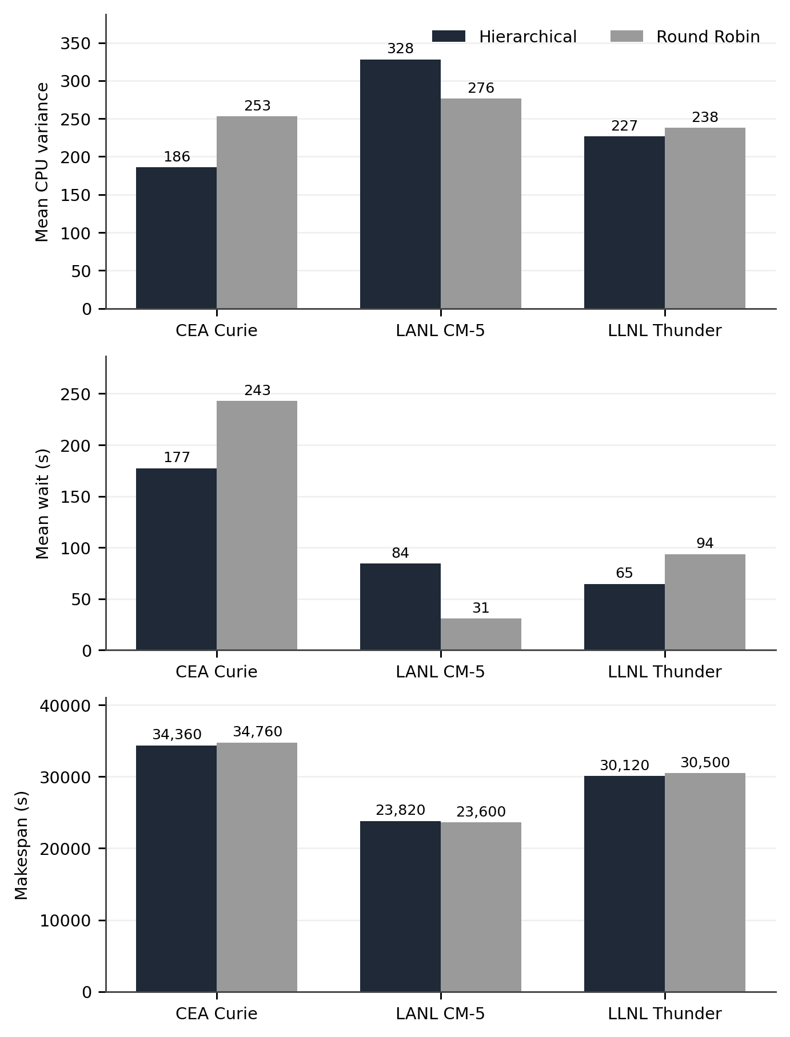
Fig. 2. Original trace comparison from the repository’s aggregate result files. Axes use independent scales by metric; lower values are favorable.
Against the centralized work queue, hierarchical placement lowers variance and modeled wait on all three traces. That baseline uses a contention and waiting model specific to the simulator, so the large margins should be interpreted with care. Random and least loaded comparisons further show that no one policy dominates every result; for example random has lower LANL variance (271.15) than the proposed policy (327.99).
TABLE IV CEA AND LLNL POLICY COMPARISON
Trace / policy | Var. | Wait (s) | Span (s)
CEA / Hier. | 185.95 | 177.32 | 34,360
CEA / LLN | 221.78 | 189.56 | 34,260
CEA / RR | 253.24 | 242.88 | 34,760
CEA / Queue | 720.27 | 490.76 | 35,310
CEA / Random | 368.30 | 294.38 | 34,380
LLNL / Hier. | 226.71 | 64.52 | 30,120
LLNL / LLN | 232.69 | 67.61 | 29,740
LLNL / RR | 237.86 | 93.60 | 30,500
LLNL / Queue | 341.35 | 293.39 | 31,770
LLNL / Random | 253.66 | 110.56 | 30,140

Table IV makes the ranking more precise. The hierarchical policy has the smallest variance and mean wait among the five listed policies for both CEA and LLNL, but least loaded has the shortest makespan on each. In CEA the proposed policy’s makespan is 100 s above least loaded; in LLNL it is 380 s above. This difference may be acceptable in a setting that values mean queue delay more than overall completion time, yet no objective weights were elicited from a real cluster operator. “Best” therefore depends on the chosen metric and the simulator model. The centralized work queue’s very high CEA variance and wait illustrate its poor behavior under this model, but its disadvantage cannot be generalized to all centralized implementations.
TABLE V ALL POLICY RESULTS ON THE LANL SLICE
Policy | Var. | Wait (s) | P95 (s)
Hierarchical | 327.99 | 84.16 | 256.44
Least loaded | 338.48 | 98.99 | 277.62
Round Robin | 276.36 | 30.93 | 90.61
Work queue | 371.03 | 291.76 | 709.67
Random | 271.15 | 38.70 | 127.33

The LANL counterexample is particularly informative because the least loaded and hierarchical policies both yield more variance than Round Robin, while random placement has the lowest reported variance. One possible interpretation is that the mapper and interference model produce a job distribution for which spreading assignments cyclically works well. Another is that the hierarchy’s score and stability override are poorly calibrated for this trace. The aggregate result cannot distinguish those explanations. Per job assignment logs, profile counts, stability transition counts, and repeated seeds are needed before selecting a causal story.
The CEA and LLNL results also do not establish that adding entropy to a hierarchy caused the improvements: the experiment compares complete policies, not the same hierarchy with and without the variance guardrail. An ablation with a profile weighted flat minimum, a hierarchy without the stability override, and a variance only rule under common simulator assumptions would separate the effects of grouping, resource weighting, and volatility. Reporting only the full system against broad baselines leaves that decomposition unresolved.
D. Separate generated trace experiment
The earlier paper draft’s main N = 512 table derives from files produced by `generate_traces.py`. The generator samples arrivals and runtimes and assigns memory and processor requests, then labels the output with system names. These are generated SWF format workloads; they cannot be described as observed LANL, LLNL, or CEA jobs. We retain this experiment as a simulator sensitivity and finite size overhead comparison, separate from the original trace results in Tables III–V.
TABLE VI GENERATED TRACE COMPARISON AT N = 512
Policy | Variance | Mean wait  (s) | Span  (s)
Hierarchical | 15.53 | 3.58 | 4,650
Round Robin | 20.24 | 3.43 | 3,615
Least loaded | 17.92 | 9.69 | 4,440
Work queue | 53.04 | 107.08 | 4,650
Random | 17.70 | 6.24 | 4,650

In this generated workload, the hierarchical policy’s mean sampled variance is 23.3% below Round Robin, while its mean wait is slightly higher (3.58 versus 3.43 s) and its makespan is 28.6% longer (4,650 versus 3,615 s). A statement that the same table demonstrates shorter makespan or shorter waiting than Round Robin would contradict the data. The project’s cross generated trace table also changes sign by metric and trace; it should not be combined with original trace outcomes as if the input provenance were identical.
The generated trace scripts deliberately use different mean interarrival and runtime distribution parameters for their three named profiles. This can be valuable as a controlled sensitivity experiment if those parameters are disclosed. It cannot serve as an empirical characterization of LANL, LLNL, or CEA systems merely because the generated headers contain their names. In the revised analysis the original trace files and generated trace files are separate data families, and a numerical comparison between them is not interpreted as a replication result.
E. Dispatch cost and scalability
The generated trace sweep records per assignment timing for N = 128, 256, 512, and 1,024. At N = 1,024 the hierarchical scheduler takes 0.4812 ms, compared with 0.6391 ms for least loaded and 0.0190 ms for Round Robin. At N = 128, least loaded is faster than hierarchical (0.0849 versus 0.1564 ms). The timing crossover is consistent with fewer scans in some conditions, but cache invalidation and the conditional global fallback prevent a logarithmic worst case assertion. Microbenchmarks should report hardware, repeat counts, cache state, and uncertainty before an asymptotic or general speed conclusion is drawn.
At the tested sizes, the hierarchical time rises 3.08 fold from 128 to 1,024 nodes, while least loaded rises 7.53 fold. An eightfold change in N cannot establish the functional growth rate from four measurements, especially because the number of racks also changes and the chosen rack contains at most 32 nodes. Timing includes Python interpreter, object, and cache behavior. A dedicated query benchmark should vary N by orders of magnitude, hold the job and load distributions fixed, measure visited racks and leaves, and distinguish cache hit, cache miss, and fallback cases. It should also time update work and periodic rebuilds if the objective is total scheduler cost.
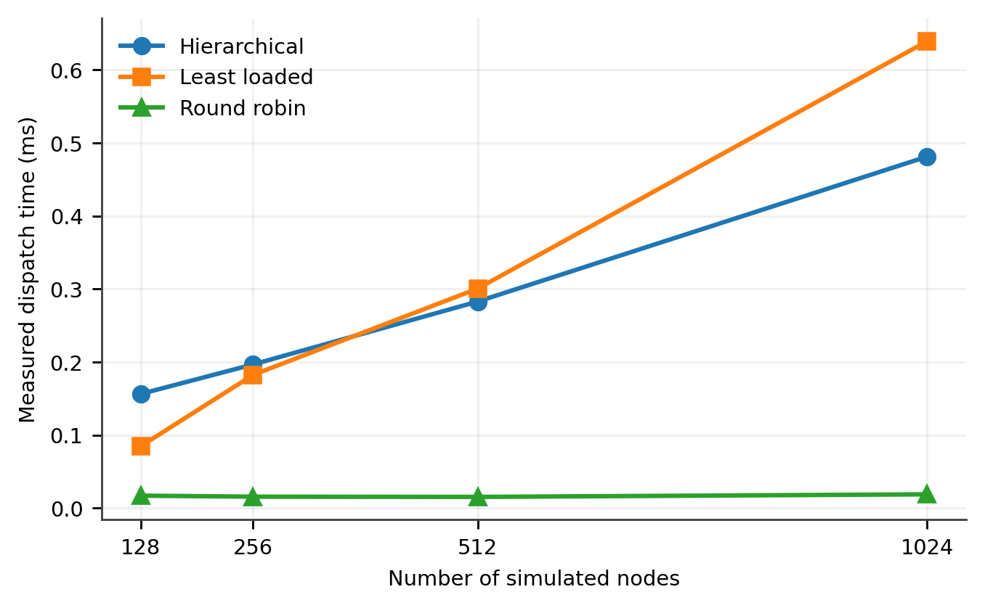
Fig. 3. Measured dispatch time in the separate generated trace sweep. The lines summarize four tested sizes and are not complexity proofs.
F. Metric integrity and threats to validity
The stored Jain fairness value is 1.000 for every policy in both result sets. The simulator computes it from final node CPU loads after all active jobs are released, replacing each zero load with 1.0. The resulting identical vector makes the index trivially equal to one; it does not measure fairness of assignments or service. Jain’s index remains a valid metric when x is chosen to represent meaningful per node service or allocation over a declared interval [7]. We exclude the recorded terminal fairness from comparative conclusions and recommend recomputing it from time averaged utilization or completed work.
The makespan calculation also deserves an explicit boundary. A SAMPLE event can be scheduled after the last completion was already placed in the heap; when it becomes the final event, the reported current time advances to that sample point. The value may therefore be rounded upward by up to one sample interval relative to the last job completion. The original trace evaluation uses a ten second sampling interval. That granularity is small relative to its tens of thousands of simulated seconds, but a future run should record the maximum completion time directly, especially where policy differences are small. The queue depth is incremented by execution duration and decremented on completion by the original job duration, another modeling choice that can leave residual depth when speed or jitter changes actual duration.
Several assumptions constrain external validity. Network and disk demands are inferred rather than observed; CPU and memory and I/O quantities are mixed without capacity normalization; predictable jobs are tagged using known run time, which a live scheduler generally cannot know exactly; and queue wait incorporates explicit policy dependent penalties. All experiments use a simulator with seeded synthetic interference, not a physical HPC deployment. Only one seed and the first selected records are reported. The original SWF file headers support provenance of the source files, but the paper has not independently checked every file hash against an archive release or reconstructed every figure from raw event logs.
These limitations point to concrete follow up experiments: compare policies under identical queue delay rules, run multiple independent seeds and trace segments, recompute fairness from a nonterminal interval, normalize resources by actual node capacity, ablate the stability guardrail and Shannon telemetry, and count examined nodes on warm, cold, and fallback paths. A balanced search structure with sound lower bounds would be required for a provable sublinear placement operation. The experiments here should be read as a reproducible project level evaluation with trace dependent outcomes, not as a validated claim of general superiority.
For reproducibility, the benchmark inputs and implementation are identified by repository revision 196ea0ea3e7a713007da887f6f1c4a54c1bc1835 at the time of inspection [8]. The original trace processor is `OG-dataset/process_og_dataset.py`; its per trace results and combined comparison reside in `OG-dataset/results/`. The generated trace producer is `src/simulation/generate_traces.py`, and its separate benchmark results reside in `data/benchmark_results.json`. The node, entropy, dispatch, rebalance, mapper, and simulator implementations are in `src/core/` and `src/simulation/`. Recording the invocation, platform, dependency versions, seed list, and archive digests with a future release would allow a stronger independent replication.
G. Implications for a revised scheduler
The strongest practical reason to retain a hierarchy is to localize updates and allow a scheduler to reason about rack topology. To turn that organization into a demonstrated search advantage, a rack summary would need a score lower bound for each relevant job profile and a way to maintain it after assignment or release. A priority structure over racks could then identify a promising rack without scanning every rack. Yet the stability guardrail complicates this design: if a predictable job rejects a volatile best node, the summary also needs information about eligible stable candidates. Maintaining separate eligible minima by profile and class is one possible design, subject to measured update costs and stale telemetry. The present code does not implement that index, and this suggestion is future work rather than a reported result.
Likewise, rebalancing should be defined by an observable decision it changes. In the current version, a rebuild groups nodes by their original position, so a class transition triggers reconstruction without a different topology. It may clear caches and refresh aggregates, but it does not move nodes between racks, migrate jobs, or establish a new search order. A controlled comparison between refresh only and reconstruction at the same event times would reveal whether this step has any measurable benefit. Reporting how often the 20% threshold fires on each trace would also reveal whether the claimed periodic mechanism is active during the measured runs. The stored aggregate result files alone do not provide that count.
The score could be improved in a distinct, testable way. Define each resource coordinate as demand divided by available per node capacity, reject allocations that violate hard constraints, and compare feasible nodes under the same normalized objective. If future runtime is unknown, a predictor may estimate whether a job is long running, but its error should be included in evaluation; using the observed runtime as an input creates information a live dispatcher would not have at submission. Stability thresholds should be calibrated on training segments and evaluated on held out trace segments. Otherwise thresholds, weights, and fallback tolerance may silently fit one sampled workload while failing on another, as the LANL result warns.
A useful redesigned experiment would proceed in stages. First, preserve the existing five policy implementations and remove policy named delay additions from the simulator, applying one common contention equation. Second, execute the same trace slices with multiple seeds and report distributions or confidence intervals for variance, wait, makespan, and dispatch time. Third, add hierarchy without guardrail, guardrail without hierarchy, and normalized resource scoring as controlled variants. Fourth, publish per decision visited node counts, cache misses, selected stability classes, and class transitions. Finally, verify the model on a cluster or a well validated external simulator. Each stage addresses a specific uncertainty identified here; none requires inventing a performance figure in advance.
For users of this project, the immediate result is a qualified choice. In the recorded CEA and LLNL simulations, the hierarchical policy is a candidate when reduced simulated imbalance and waiting are valued and a submillisecond Python dispatch call is acceptable. On the LANL slice, Round Robin or even the random baseline is preferable on the reported variance measure, and Round Robin has much shorter modeled waiting. An operator could not infer a deployment choice from these simulated observations alone. The measurements do show which cases deserve further study and which broad statements the evidence already rules out.
H. Trace dependent interpretation
The profile counts in Table II help frame the different outcomes, but they do not explain them by themselves. All three original slices contain many jobs that the mapper calls I/O bound, yet CEA and LLNL favor the hierarchical policy on variance and modeled wait while LANL does not. This rules out the simple explanation that the presence of an I/O heavy mapped class is sufficient for improvement. The temporal order of arrivals, the processor and memory fields, the frequency of predictable jobs, the number of simultaneously active jobs, and the simulated volatility pattern may each influence choices. Disentangling these interactions requires logs linking each decision to its score, stability class, queue state, and eventual completion.
The recorded means also hide important variation over time. A policy could have a low average spatial variance because it performs well during long quiet intervals while producing severe short bursts. A separate peak variance or a time weighted quantile would expose such cases. Conversely, the mean across periodic sample events weights every recorded event equally, whether many jobs are active or the cluster is nearly idle. A work weighted measure could emphasize periods that matter to users, but it would answer a different question and must be labeled. Figures showing time series can complement aggregate tables only if their traces, sampling interval, shared color scale, and underlying values are all available.
Waiting time and makespan tell different stories because of arrival patterns. If late arriving jobs determine the last completion, improvements in earlier waits may barely affect makespan. If a few long predictable jobs receive a runtime penalty, the last completion can change even when mean waiting improves. This is a hypothesis about the model’s mechanics, not a finding about the present results. The current aggregate files do not expose the last completed jobs or a decomposition of their queue and execution times. Such a decomposition would be especially useful for CEA and LLNL, where the proposed policy wins on average wait but loses to least loaded on makespan.
Finally, there is no statistically estimated uncertainty in the repository tables. The seed is fixed for one run, and the paper has three distinct trace slices rather than repeated samples from a defined population of future workloads. Reporting a percentage to one decimal place is arithmetic precision, not evidence that a similar percentage would recur. A stronger study would vary random interference seeds and disjoint time segments, report paired differences for each policy under common randomness where possible, and give intervals for the comparison. It would predefine the primary metric and avoid selecting the most favorable trace after inspecting results. These steps are necessary before a journal submission could support a general performance claim.
V. CONCLUSION
We examined an entropy guided hierarchical job placement project using its implementation and recorded benchmark files. The system combines fixed profile weights, rack summaries, a CPU variance stability class, and periodic aggregation. On original trace slices, it improves modeled variance and waiting against Round Robin for CEA Curie and LLNL Thunder, but the LANL CM-5 slice shows worse variance, waiting, and makespan. Its synthetic trace result lowers variance at 512 nodes while increasing makespan and slightly increasing average wait relative to Round Robin. The observations support a useful heuristic with a workload dependent tradeoff.
The current code scans rack and node lists and can fall back to a cluster wide search, so its worst case dispatch work remains linear. The stored fairness index does not discriminate policies, and parts of the performance comparison depend strongly on the simulator’s generated demands and wait model. A future submission should incorporate the controlled ablations and corrected measurements described above before making broader claims about scalability or production benefit.
REFERENCES
[1] G. Zheng, A. Bhatelé, E. Meneses, and L. V. Kalé, “Periodic hierarchical load balancing for large supercomputers,” Int. J. High Perform. Comput. Appl., vol. 25, no. 4, pp. 371–385, 2011, doi: 10.1177/1094342010394383.
[2] L. Wang, M. A. Rodriguez, and N. Lipovetzky, “Optimizing HPC scheduling: a hierarchical reinforcement learning approach for intelligent job selection and allocation,” J. Supercomput., vol. 81, art. 918, 2025, doi: 10.1007/s11227-025-07396-3.
[3] D. G. Feitelson, “The Parallel Workloads Archive,” Hebrew University of Jerusalem. Available: https://www.cs.huji.ac.il/labs/parallel/workload/ . Accessed: Oct. 22, 2026.
[4] Parallel Workloads Archive, “The Standard Workload Format.” Available: https://www.cs.huji.ac.il/labs/parallel/workload/swf.html . Accessed: Oct. 22, 2026.
[5] G. Zheng, E. Meneses, A. Bhatelé, and L. V. Kalé, “Hierarchical load balancing for Charm++ applications on large supercomputers,” in Proc. ICPP Workshops, 2010, pp. 436–444, doi: 10.1109/ICPPW.2010.65.
[6] L. Chen, K. Wu, and Y. Li, “A load balancing algorithm based on maximum entropy methods in homogeneous clusters,” Entropy, vol. 16, no. 11, pp. 5677–5697, 2014, doi: 10.3390/e16115677.
[7] R. Jain, D. M. Chiu, and W. R. Hawe, “A quantitative measure of fairness and discrimination for resource allocation in shared computer systems,” DEC Research Report TR-301, 1984. Available: https://www.cs.wustl.edu/~jain/papers/fairness.htm .
[8] K. R. Hari Prajwal et al., “Adsa-project: entropy guided hierarchical load balancing,” project source, benchmark scripts, original and generated trace files, and result artifacts, GitHub, inspected Oct. 22, 2026. Available: https://github.com/Hariprajwal/Adsa-project .

