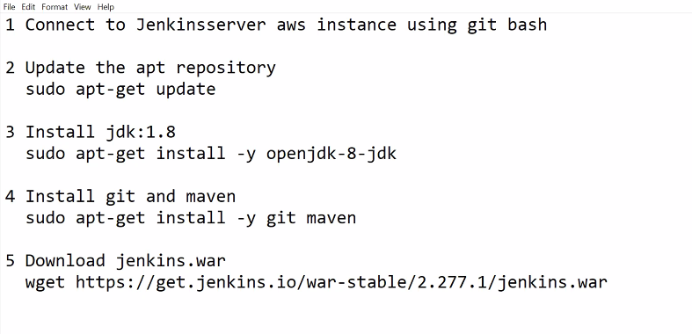

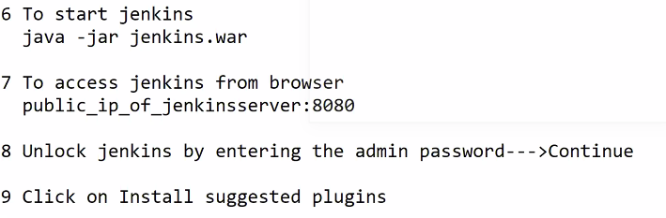



Stage1 (Continuous download):

1. Open the dashboard of Jenkins.
2. Click on New Item 🡪 Enter some item name ( development)
3. Select free style project -🡪 OK
4. Goto source code management
5. Select git
6. Enter git hub url
7. Click on apply -🡪 Save
8. Go to the dashboard of Jenkins
9. Go to the development job 🡪 click on build icon

This job will download all the code which developed by developers.

Stage2 (Continuous Build):

1. Open the dashboard of Jenkins.
2. Go to the development job 🡪 Click on configure
3. Goto build section
4. Click on Add build step
5. Click Invoke top level maven targets.
6. Enter maven goal: package
7. Click apply 🡪 save
8. Goto the dashboard of Jenkins and run the development job

This job will create an artefact from the

