PRODUCT DESIGN DOCUMENT

Multi-Agent Indian Macroeconomic Intelligence Platform

An Agentic AI System for Economic Understanding, Explainable Market Analysis, and Scenario Simulation

Project Title | Multi-Agent Indian Macroeconomic Intelligence Platform
Team Members | Nithish Kumar CS (23BAI1035)  Hariprasaadh K (23BAI1061)  Arulprasaad SJ (23BAI1089)
Guide / Mentor | TULASI PRASAD SARIKI
Department | Computer Science & Engineering  (Artificial Intelligence and Machine Learning)
Institution | Vellore Institute of Technology, Chennai
Course | BCSE497J - Project – I
GitHub Link | https://github.com/Hariprasaadh/macrograph-ai
Drive Link | https://drive.google.com/drive/folders/1gtKm955zdBtc9PG7nhwoXycp5bbTxRGu

Table of Contents
Table of Contents
1. Executive Summary
2. Problem Statement
2.1 Current Challenges
2.2 Why Existing Solutions Are Insufficient
2.3 Motivation
3. Objectives
4. Scope
5. System Overview
6. Functional Requirements
7. Non-Functional Requirements
8. Overall Architecture
10. Detailed Agent Architecture
10.1 Monetary Policy Agent
10.2 Inflation Agent
10.3 Financial Market Agent
10.4 Agriculture Agent
10.5 Weather Agent
10.6 Sentiment Agent
10.7 Policy Agent
10.8 Knowledge Graph Agent
10.9 LLM Reasoning Agent (LLM Economic Analyst)
11. Data Flow
11.1 Ingestion-to-Insight Flow
11.2 Example Query Sequence
12. LLM Reasoning Agent — Agentic Explanation Layer
12.1 Why This Matters
12.2 Worked Example
12.3 Design Notes
13. Inter-Agent Communication
14. Retrieval-Augmented Generation (RAG)
14.1 Document Corpus
14.2 Pipeline
14.3 Example Queries Enabled
15. Knowledge Graph Design
15.1 Example Relationship Chain
15.2 Dynamic Update Model
15.3 Node and Relationship Types
16. Technology Stack
16.1 Data Sources by Agent
17. Explainability Framework
18. Conclusion
19. References / Data Source Portals

1. Executive Summary
Problem: Macroeconomic indicators — inflation, interest rates, exchange rates, bond yields, liquidity, commodity prices, and fiscal policy — move markets in interconnected ways that are difficult for students, retail investors, and early-career professionals to follow. Data is scattered across RBI, MoSPI, SEBI, NSE, and other portals, and existing dashboards report numbers without explaining causal linkages.
Solution: A multi-agent, agentic-AI platform for the Indian economy. Specialised agents continuously collect and interpret data across monetary policy, inflation, financial markets, agriculture, weather, sentiment, and fiscal policy. Their outputs feed a dynamic Neo4j knowledge graph and an LLM Economic Analyst, which together generate natural-language explanations, causal pathways, confidence-scored attributions, and scenario simulations — not just forecasts, but reasoning a user can follow.
Key Features: (1) Eight to nine domain agents with clearly defined inputs/outputs; (2) an LLM Reasoning Agent that converts agent signals into conversational explanations with confidence scores and primary contributors; (3) a Retrieval-Augmented Generation layer over RBI circulars, Budget documents, the Economic Survey, and policy statements; (4) a dynamic, self-updating Neo4j knowledge graph of causal economic relationships; (5) an interactive dashboard with scenario simulation and alerts.
Technology: Python-based data agents, FastAPI backend, PostgreSQL for structured data, Neo4j for the knowledge graph, a vector database for RAG, an LLM (via API) for reasoning and explanation, SHAP for explainability, and Plotly for visualisation.
Expected Impact: Improves economic literacy for students and retail investors, gives early-career professionals an explainable, source-grounded assistant for economic reasoning, and demonstrates a practical, defensible application of agentic AI, RAG, and knowledge graphs to a real-world Indian data ecosystem.

2. Problem Statement

2.1 Current Challenges
- Macroeconomic data in India is fragmented across RBI DBIE, MoSPI, OGD India, Agmarknet, NSE, and SEBI, with no unified, explainable interface.
- Existing financial dashboards (e.g., trading terminals, news aggregators) show what changed, but rarely explain why, or how one indicator causally affects another.
- Students and retail investors often rely on secondary commentary (news, social media) that is not grounded in verifiable data or transparent reasoning.
- Relationships between indicators (e.g., crude oil → import bill → INR → inflation → repo rate) are conceptually taught but rarely demonstrated with live, connected data.
- Policy documents such as RBI circulars, Monetary Policy Statements, and the Economic Survey are lengthy and technical, making them inaccessible to non-experts.

2.2 Why Existing Solutions Are Insufficient
- Bloomberg Terminal, Refinitiv Eikon: powerful but expensive, closed, and oriented toward institutional traders rather than learners.
- RBI/MoSPI portals: authoritative but present raw tables and PDFs with no cross-linking, narrative explanation, or reasoning layer.
- News and finance apps: provide commentary but lack transparent, data-traceable causal reasoning or confidence-scored attribution.
- General-purpose chatbots: can discuss economics conversationally but are not grounded in live Indian data, official documents, or a structured knowledge graph, and cannot show their reasoning chain.

2.3 Motivation
There is a clear gap for a platform that combines authoritative Indian economic data, structured causal reasoning, and natural-language explanation in one explainable system. By pairing domain-specific agents with an LLM reasoning layer, a dynamic knowledge graph, and retrieval-augmented generation over policy documents, this project aims to make macroeconomic cause-and-effect legible to a much wider audience, while remaining technically rigorous enough to be a substantial final-year engineering project.

3. Objectives
- Design and build a multi-agent economic intelligence platform covering monetary policy, inflation, financial markets, agriculture, weather, sentiment, and fiscal policy.
- Model causal economic relationships explicitly using a dynamic knowledge graph rather than opaque statistical correlation alone.
- Integrate an LLM Reasoning Agent that produces natural-language, confidence-scored explanations grounded in agent outputs and the knowledge graph.
- Build a Retrieval-Augmented Generation layer over RBI circulars, Budget documents, the Economic Survey, and Monetary Policy Statements so users can query primary sources conversationally.
- Provide scenario simulation so users can test hypothetical shocks (e.g., “what if Brent crude rises 20%?”) and see propagated effects.
- Improve economic and financial literacy for students, retail investors, and early-career professionals through explainable, source-grounded outputs.
- Ensure the system is explainable, auditable, and reproducible, using SHAP-based feature attribution alongside LLM explanations.

4. Scope
In Scope | Out of Scope
Indian macroeconomic indicators (monetary, inflation, market, agriculture, weather, sentiment, fiscal) | Non-Indian / global macroeconomic platforms (may be a future extension)
Explainable causal reasoning via knowledge graph + LLM | Real-money trading, execution, or brokerage integration
RAG over public RBI/SEBI/Budget/Economic Survey documents | Access to non-public or subscription-only institutional data (e.g., Bloomberg feeds)
Scenario simulation on user-specified indicator shocks | Guaranteed financial forecasting or investment advice
Dashboard, alerts, and natural-language Q&A interface | Mobile app (web dashboard only, in the initial version)
Explainability via SHAP and LLM-generated rationale | Regulatory-grade compliance / audit certification

The platform is an educational and analytical decision-support tool. It explains relationships and simulates scenarios; it does not provide investment advice or execute trades. This distinction should be stated clearly in the product's disclaimers.

5. System Overview
At a high level, the platform follows a layered flow from raw data ingestion to explainable, natural-language output:
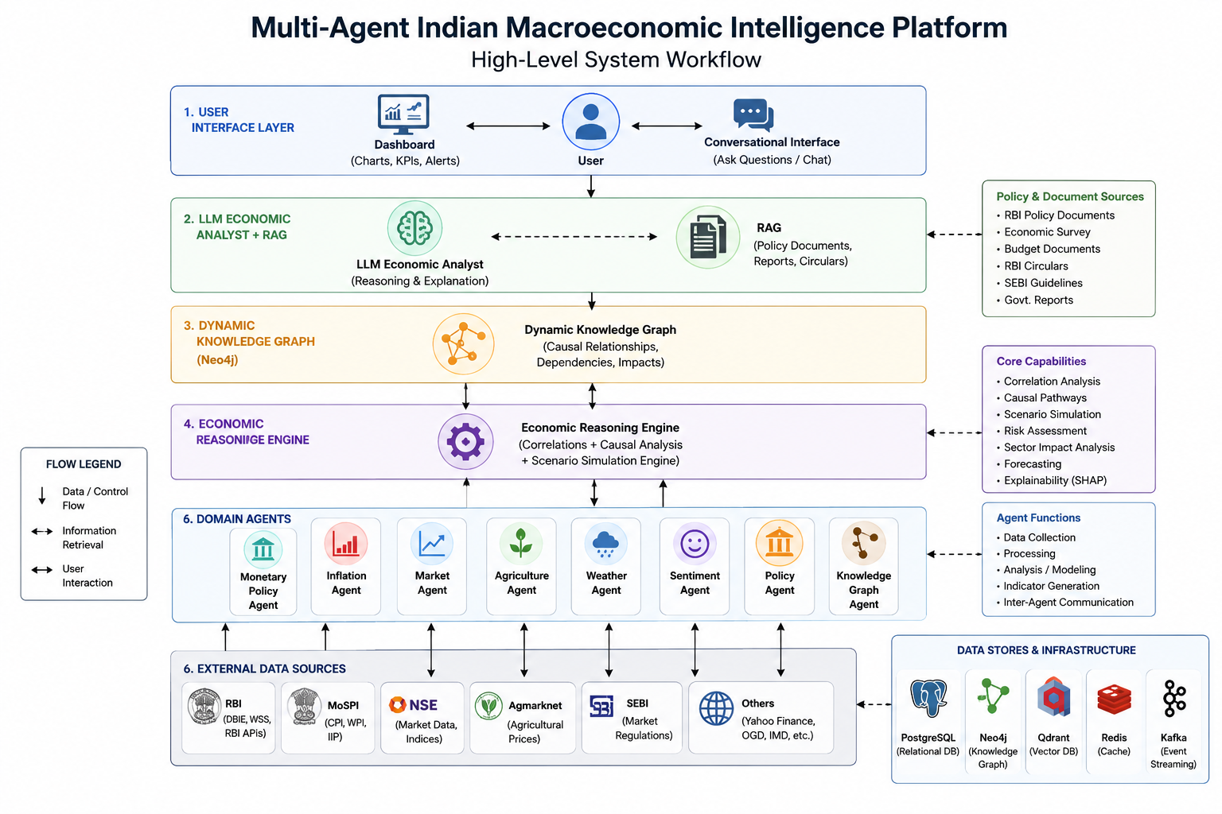
Figure 5.1 — High-level system workflow
This is an evolution of the originally proposed flow (Indicators → Reasoning Engine → Output). The revised flow inserts a knowledge graph and an LLM reasoning layer between raw indicators and the final output, so the system reasons over structured causal relationships and explains its conclusions in natural language, rather than only returning a static output.

6. Functional Requirements
ID | Requirement | Description
FR-1 | Ask economic questions | User can ask natural-language questions (e.g., “Why did banking stocks fall today?”) and receive an LLM-generated, evidence-based explanation.
FR-2 | View economic dashboard | Real-time and historical view of key indicators (repo rate, CPI, NIFTY, USD/INR, bond yields, etc.).
FR-3 | Scenario simulation | User specifies hypothetical shocks (e.g., Brent Crude +20%) and views simulated downstream effects.
FR-4 | Knowledge graph visualisation | Interactive graph view of nodes (indicators/sectors) and weighted causal edges.
FR-5 | Market analysis | Agent-level breakdown of market risk, sector sensitivity, and contributing factors.
FR-6 | Alerts | Threshold-based and anomaly-based notifications (e.g., CRR change, inflation spike, VIX surge).
FR-7 | Reports | Exportable summary reports (PDF) combining dashboard snapshots, graph views, and LLM explanations.
FR-8 | Policy document Q&A (RAG) | User can query RBI circulars, Budget documents, Economic Survey, and Monetary Policy Statements conversationally.
FR-9 | Confidence-scored explanations | Every LLM explanation includes a confidence score and a ranked list of primary contributing indicators.
FR-10 | Agent-level drill-down | User can inspect the raw signal and output of any individual agent behind a given explanation.

7. Non-Functional Requirements
Attribute | Requirement
Scalability | Architecture must support adding new agents (e.g., a Global Trade Agent) without redesigning the reasoning engine or knowledge graph schema.
Reliability | Data pipelines must handle upstream source outages gracefully (retry, cache last-known-good values, flag staleness).
Performance | Dashboard queries should return within 2–3 seconds; LLM explanations within 5–10 seconds for typical queries.
Explainability | Every automated output (score, alert, or explanation) must be traceable to specific agent signals and, where applicable, cited source documents.
Security | API keys, credentials, and any user data must be stored securely; RAG document store must not leak licensed or non-public data.
Availability | Target 99% uptime for the dashboard and API during evaluation/demo periods; scheduled data-refresh windows documented.
Maintainability | Each agent is an independently deployable module with a defined input/output contract, enabling isolated testing and updates.
Auditability | Knowledge graph edge weights and LLM prompts/responses should be logged for later review and reproducibility.

8. Overall Architecture
The platform is organised into five layers: (1) Data Collection, (2) Domain Agents, (3) Knowledge & Reasoning (Knowledge Graph + Reasoning Engine + LLM Economic Analyst + RAG), (4) API/Backend, and (5) Presentation (Dashboard).
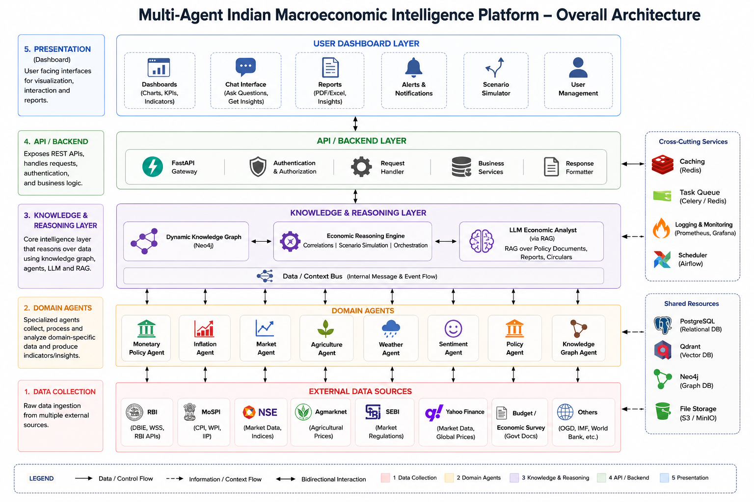
Figure 8.1 — Overall system architecture

10. Detailed Agent Architecture
Each agent is an independently deployable module with a defined data contract. Sections 10.1–10.9 describe purpose, inputs, outputs, models, data sources, and inter-agent communication for every agent, including the newly added LLM Reasoning Agent and RAG subsystem.

10.1 Monetary Policy Agent
Purpose: Track RBI policy actions, banking-system liquidity, and short-term interest rates.

Inputs
- Repo Rate, Reverse Repo Rate, SDF Rate, MSF Rate, CRR, SLR
- Net Liquidity Position, Call Money Rate, TREPS Rate

Outputs
- Monetary Tightening Score
- Liquidity Stress Index
- Rate Hike Probability

Models / Techniques
- Time-series trend detection
- Rule-based policy-change classifier
- Logistic regression for hike probability

APIs / Data Sources
- RBI Database on Indian Economy (DBIE)
- RBI Weekly Statistical Supplement

Communication
Sends interest-rate expectations to the Market Agent and monetary signals to the Reasoning Engine and Knowledge Graph Agent.

10.2 Inflation Agent
Purpose: Track inflation trends across categories and regions, and attribute inflation spikes to specific drivers.

Inputs
- Headline CPI, Food Inflation, Fuel Inflation, Core Inflation
- Rural CPI, Urban CPI, WPI

Outputs
- Inflation Pressure Index
- Inflation Attribution Scores

Models / Techniques
- Seasonal decomposition
- SHAP-based attribution across CPI sub-components

APIs / Data Sources
- MoSPI CPI Database
- Open Government Data (OGD) Platform India

Communication
Receives food-price-pressure signals from the Agriculture Agent; sends inflation expectations to the Monetary Agent and Reasoning Engine.

10.3 Financial Market Agent
Purpose: Track how markets react to economic events and quantify sector-level sensitivity.

Inputs
- NIFTY 50, BANKNIFTY, India VIX
- USD/INR, Brent Crude, Gold, 10Y G-Sec Yield

Outputs
- Market Risk Index
- Sector Sensitivity Scores

Models / Techniques
- Event-window return analysis
- Rolling volatility / VIX regime detection

APIs / Data Sources
- NSE Market Data
- Yahoo Finance

Communication
Receives interest-rate expectations from the Monetary Agent; sends market responses to the Knowledge Graph Agent and LLM Economic Analyst.

10.4 Agriculture Agent
Purpose: Monitor agricultural commodity prices and food-supply risk.

Inputs
- Wheat, Rice, Onion, Tomato, Pulses prices
- Vegetable inflation, rainfall/production data

Outputs
- Food Inflation Risk Index

Models / Techniques
- Price-anomaly detection
- Seasonal supply-risk scoring

APIs / Data Sources
- Agmarknet Portal
- OGD India
- Ministry of Agriculture and Farmers Welfare

Communication
Sends food-price-pressure signals to the Inflation Agent.

10.5 Weather Agent
Purpose: Track rainfall and weather anomalies that affect agricultural output and food-supply risk.

Inputs
- Rainfall data (IMD), monsoon forecasts, regional deficits/surplus

Outputs
- Rainfall Deficit / Surplus Index
- Monsoon Risk Score

Models / Techniques
- Anomaly detection against historical rainfall baselines

APIs / Data Sources
- India Meteorological Department (IMD)

Communication
Sends weather-risk signals to the Agriculture Agent and, indirectly, the Inflation Agent.

10.6 Sentiment Agent
Purpose: Gauge market and public sentiment from news and policy communications.

Inputs
- Financial news headlines, RBI/SEBI press releases, social/market commentary

Outputs
- Sentiment Score (bullish/bearish/neutral)
- Topic-level sentiment breakdown

Models / Techniques
- NLP sentiment classification (transformer-based)
- Topic modelling

APIs / Data Sources
- Financial news APIs
- RSS feeds from RBI/SEBI/MoF

Communication
Sends sentiment signals to the Market Agent and LLM Economic Analyst.

10.7 Policy Agent
Purpose: Track fiscal policy actions — Union Budget announcements, government spending, and SEBI regulatory changes.

Inputs
- Union Budget documents, fiscal deficit data, SEBI circulars

Outputs
- Fiscal Stance Score
- Regulatory Change Log

Models / Techniques
- Document classification
- Structured extraction from budget tables

APIs / Data Sources
- Union Budget portal
- SEBI circulars
- Economic Survey

Communication
Feeds fiscal-policy context to the Reasoning Engine and supplies source documents to the RAG subsystem.

10.8 Knowledge Graph Agent
Purpose: Build and continuously update causal relationships between economic variables.

Inputs
- Aggregated outputs from all domain agents
- Historical correlation and event-study data

Outputs
- Economic Dependency Graph (Neo4j)
- Sector Impact Analysis

Models / Techniques
- Graph construction (NetworkX → Neo4j)
- Correlation-to-edge-weight mapping, periodic weight recalibration

APIs / Data Sources
- Derived from all other agents (no external API)

Communication
Receives outputs from all agents; supplies the causal graph to the Reasoning Engine and the LLM Economic Analyst.

10.9 LLM Reasoning Agent (LLM Economic Analyst)
Purpose: The central agentic-AI component. Converts structured agent signals and knowledge-graph paths into grounded, natural-language explanations with confidence scores and ranked contributors — turning the platform from a dashboard into a reasoning system.

Inputs
- Structured outputs from all domain agents
- Relevant subgraph / causal path from the Knowledge Graph Agent
- Retrieved passages from the RAG subsystem (for policy-grounded queries)
- User's natural-language question

Outputs
- Natural-language explanation
- Confidence score (%)
- Ranked list of primary contributing indicators
- Optional scenario narrative

Models / Techniques
- LLM via API (prompted with structured agent context + retrieved documents)
- Prompt template enforcing citation of contributing agents
- Guardrails to prevent unsupported numeric claims

APIs / Data Sources
- Internal — consumes outputs from all agents plus the RAG vector store; no external web API required

Communication
Sits at the top of the reasoning stack: pulls from every agent (directly or via the Knowledge Graph Agent) and from RAG, and is the component the user actually converses with.

11. Data Flow

11.1 Ingestion-to-Insight Flow
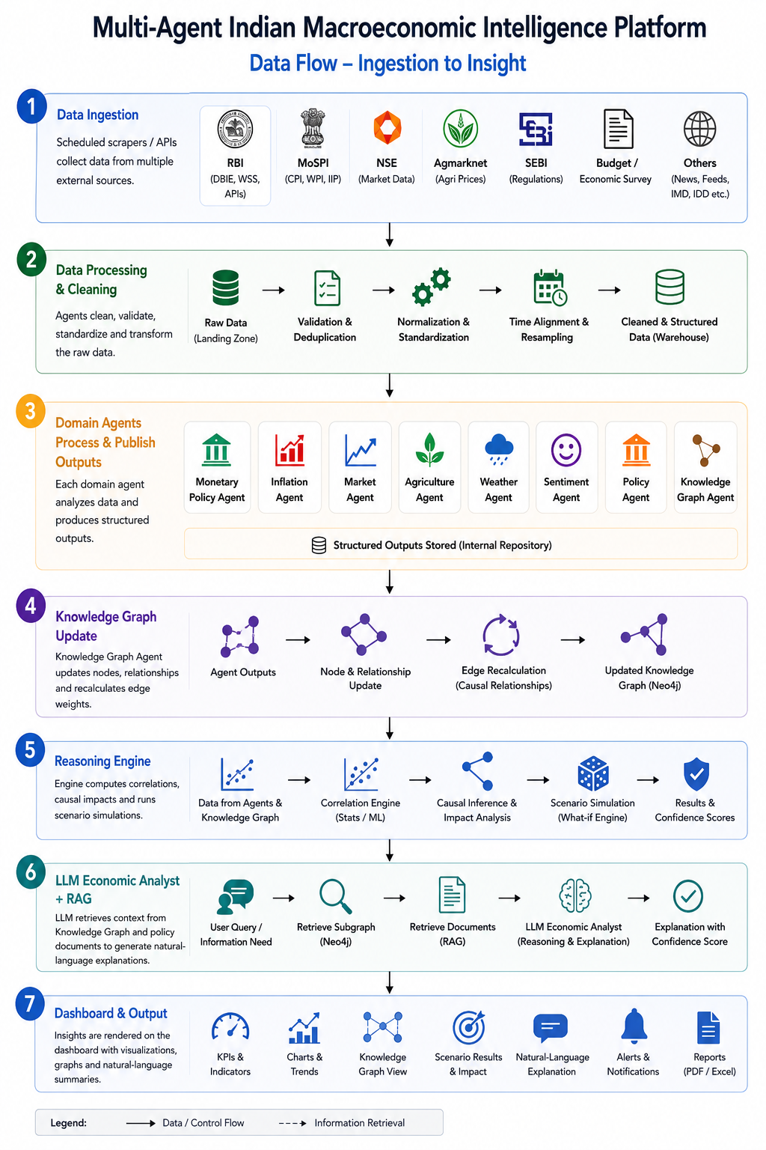
Figure 11.1 — End-to-end data flow

11.2 Example Query Sequence
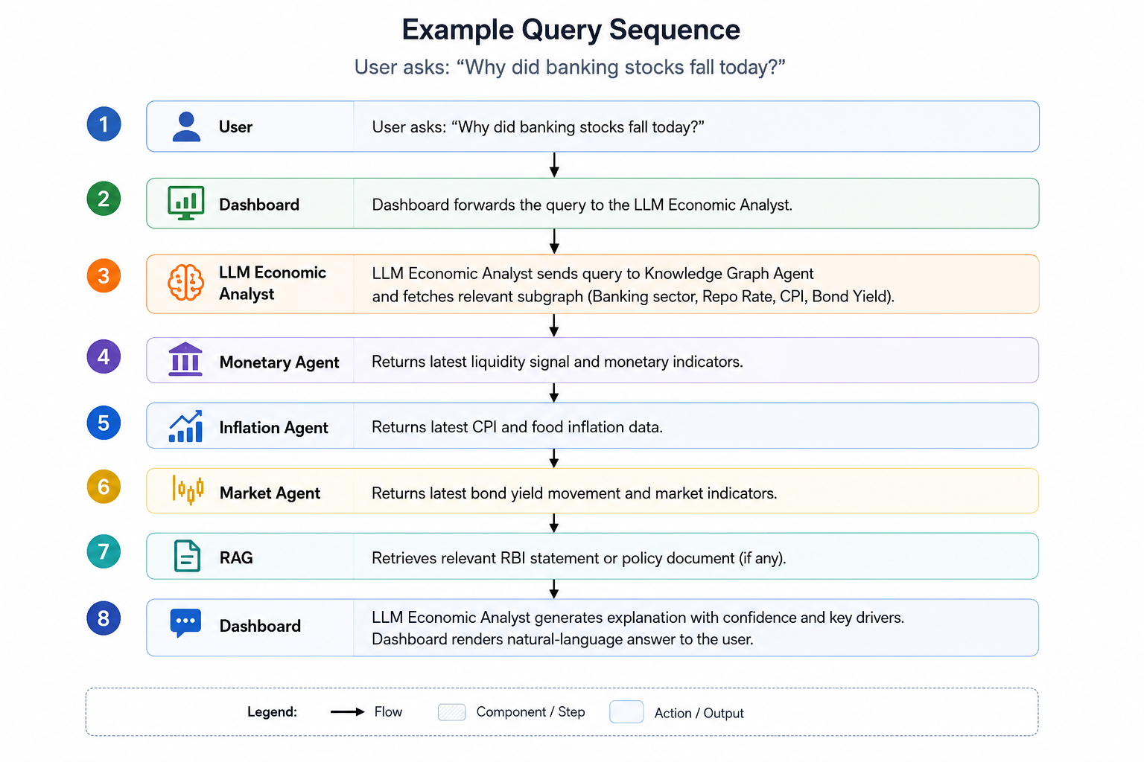
Figure 11.2 — Sequence for a representative user query

12. LLM Reasoning Agent — Agentic Explanation Layer
This is the most significant addition to the original design. Rather than terminating the pipeline at a Reasoning Engine that outputs indicators (“Indicators → Reasoning Engine → Output”), the platform routes structured signals through a knowledge graph and then through an LLM Economic Analyst, producing a natural-language explanation grounded in agent evidence.
Indicators
|
v
Knowledge Graph
|
v
LLM Economic Analyst
|
v
Natural Language Explanation
Figure 12.1 —Reasoning pipeline

12.1 Why This Matters
- Moves the system from a reporting dashboard to a reasoning assistant — the defining trait of agentic AI.
- Every explanation is traceable to specific agent signals and, where relevant, specific source documents.
- Confidence scoring communicates uncertainty honestly instead of presenting a single deterministic answer.
- Enables natural extension to conversational, multi-turn economic Q&A.

12.2 Worked Example
User Query: “Why did banking stocks fall today?”
The Monetary Agent detected liquidity tightening.
The Inflation Agent observed persistent food inflation.
The Market Agent observed rising bond yields.

Based on these signals, banks are expected to
experience slower credit growth.

Confidence: 82%

Primary Contributors:
- CPI
- Repo Rate Expectations
- 10Y Bond Yield
Figure 12.2 — Example LLM Economic Analyst response

12.3 Design Notes
- The LLM is prompted with structured JSON from each contributing agent, not free text — this keeps the explanation grounded and reduces hallucination.
- Confidence scores can be derived from a combination of signal agreement across agents and historical correlation strength on the relevant knowledge-graph edges.
- The LLM is instructed to always list its primary contributors, enabling the drill-down feature (FR-10).
- For policy-related queries, the LLM additionally consults the RAG subsystem (Section 14) so answers can cite official documents.

13. Inter-Agent Communication
The platform adopts the Agent-to-Agent (A2A) Protocol to enable secure, structured, and autonomous communication among specialized economic agents. Instead of interacting through tightly coupled APIs, each agent exposes its capabilities through a standardized Agent Card and communicates using structured task requests and responses.
This architecture enables agents to collaborate while remaining independently deployable and scalable. New agents can be added to the platform without requiring modifications to existing agents, making the system highly extensible.
The A2A protocol supports:
- Agent capability discovery
- Task delegation between agents
- Structured request and response messaging
- Asynchronous task execution
- Agent status monitoring
- Independent deployment and versioning
- Loose coupling between components

Source Agent | Destination Agent | Information Shared
Agriculture Agent | Inflation Agent | Food price pressure
Weather Agent | Agriculture Agent | Rainfall deficit / monsoon risk
Inflation Agent | Monetary Agent | Inflation expectations
Monetary Agent | Market Agent | Interest rate expectations
Sentiment Agent | Market Agent | Sentiment score
Policy Agent | Reasoning Engine | Fiscal stance, regulatory changes
Market Agent | Knowledge Graph Agent | Market responses
All Domain Agents | Knowledge Graph Agent | Structured signals for graph update
Knowledge Graph Agent | LLM Economic Analyst | Causal subgraph / relevant paths
RAG Subsystem | LLM Economic Analyst | Retrieved policy-document passages
All Agents | Reasoning Engine | Aggregated indicators

Agent Discovery
Each domain agent publishes an Agent Card, which acts as a machine-readable description of the services provided by that agent.
The Agent Card contains metadata including:
- Agent Name
- Agent Description
- Supported Capabilities
- Available Tasks
- Input Schema
- Output Schema
- Communication Endpoint
- Authentication Requirements
- Supported Protocol Version
Before delegating a task, the requesting agent discovers the appropriate Agent Card and determines whether the requested capability is supported.
Example:
Agent Name:
Inflation Agent

Capabilities:
• Inflation Forecasting
• CPI Analysis
• Inflation Attribution
• Inflation Pressure Index

Input:
Date Range
Commodity Category

Output:
Inflation Metrics
Confidence Score
Explanation
Communication Workflow
Communication between agents follows a request-response model defined by the A2A protocol.
- A requesting agent discovers the target agent through its Agent Card.
- The requesting agent submits a structured task request.
- The receiving agent validates the request and executes the task.
- The result is returned as a structured response containing outputs, metadata, and confidence scores.
- The requesting agent integrates the response into the reasoning pipeline.

Task Delegation
The LLM Economic Analyst acts as the primary orchestrator for user queries. Rather than performing all analysis internally, it delegates specialized tasks to domain agents responsible for different areas of the economy.
For example, when a user asks:
Why did banking stocks fall today?
The LLM Economic Analyst may delegate:
- Liquidity analysis to the Monetary Agent
- Inflation trend analysis to the Inflation Agent
- Bond yield analysis to the Market Agent
- Policy document retrieval to the RAG subsystem
- Causal relationship retrieval to the Knowledge Graph Agent
The responses from these agents are aggregated before generating the final explanation.

Structured Task Messages
All communication follows a standardized message format consisting of:
- Task Identifier
- Requesting Agent
- Target Agent
- Task Type
- Input Parameters
- Timestamp
- Correlation ID
- Response Payload
- Confidence Score
This standardized structure enables interoperability among independently developed agents.

Agent Registry
The platform maintains an Agent Registry that stores the Agent Cards of all available agents. The registry enables dynamic agent discovery without hardcoding communication endpoints.
Each Agent Card includes:
- Agent ID
- Agent Name
- Description
- Supported Capabilities
- Available Tasks
- Endpoint URL
- Status (Online / Offline / Busy)
- Version
- Protocol Version
During execution, the LLM Economic Analyst queries the Agent Registry to identify agents capable of fulfilling the requested task, enabling dynamic orchestration and seamless integration of new domain agents.

14. Retrieval-Augmented Generation (RAG)
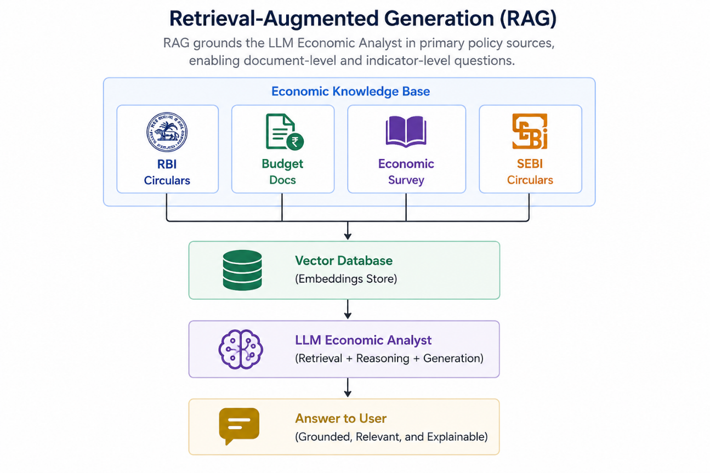
Figure 14.1 — RAG pipeline over policy documents

14.1 Document Corpus
- RBI Circulars and Monetary Policy Statements
- Union Budget documents
- Economic Survey of India
- SEBI circulars and regulatory notifications

14.2 Pipeline
- Ingestion: PDF/HTML parsing and chunking of official documents (e.g., 500–800 token chunks with overlap).
- Embedding: chunks embedded and stored in a vector database (e.g., FAISS / Chroma / pgvector).
- Retrieval: top-k relevant chunks retrieved per user query using semantic similarity, optionally filtered by document type/date.
- Generation: retrieved passages passed to the LLM Economic Analyst along with the user question and, where relevant, live agent signals.

14.3 Example Queries Enabled
- “Why did RBI increase CRR in 2022?”
- “Explain Monetary Policy 2025.”
- “Summarize the latest RBI Monetary Policy Committee minutes.”
- “How has inflation changed over the last decade?”
Each answer should cite the source document (name and date) so users can verify claims against the original text.

15. Knowledge Graph Design
The knowledge graph moves from a static, manually authored set of relationships to a dynamic graph that agents update as new data arrives, with edge weights recalibrated from observed correlations.

15.1 Example Relationship Chain
Brent Crude (up)
|
v
Import Bill (up)
|
v
USD Demand (up)
|
v
INR Weakens
|
v
Imported Inflation (up)
|
v
CPI Inflation (up)
|
v
Repo Rate (up)
Figure 16.1 — Example causal chain modelled in the graph

15.2 Dynamic Update Model
- Each domain agent writes/updates its own nodes and observed values on every refresh cycle.
- The Knowledge Graph Agent periodically recalculates edge weights using rolling correlation / Granger-causality style analysis between connected node histories.
- Edge weights decay slowly over time if no new supporting evidence is observed, preventing stale relationships from dominating explanations.

15.3 Node and Relationship Types
Type | Examples | Notes
Node: Indicator | Repo Rate, CPI, Brent Crude, USD/INR, 10Y Bond Yield | Carries current value, history reference, and last-updated timestamp
Node: Sector | Banking, FMCG, IT, Auto, Energy | Aggregation target for sector impact analysis
Node: Document | RBI Circular #123, Union Budget 2026 | Linked from RAG corpus; enables source-grounded graph queries
Relationship | POSITIVE_INFLUENCE, NEGATIVE_INFLUENCE, LAGGED_INFLUENCE | Carries a numeric weight (−1 to 1) and a last-recalibrated timestamp

16. Technology Stack
Layer | Technologies
Data Collection | Python, Requests, BeautifulSoup, scheduled jobs (cron / Airflow)
Data Processing | Pandas, NumPy, Scikit-learn
LLM & Agentic Reasoning | LLM via API (prompted reasoning agent), orchestration layer for multi-agent calls
Retrieval-Augmented Generation | Vector database (FAISS / Chroma / pgvector), document parsers (PDF/HTML)
Explainability | SHAP, feature-importance models
Knowledge Graph | NetworkX (construction/prototyping), Neo4j (production graph store)
Visualisation | Plotly
Backend / API | FastAPI
Messaging (inter-agent) | Google A2A Protocol
Database | PostgreSQL (structured/time-series data), Neo4j (graph), Vector DB (embeddings)

16.1 Data Sources by Agent
Agent | Source | Purpose
Monetary Policy Agent | RBI Database on Indian Economy (DBIE) | Interest rates, liquidity, bond yields
Monetary Policy Agent | RBI Weekly Statistical Supplement | Banking liquidity and monetary statistics
Inflation Agent | MoSPI CPI Portal | CPI and inflation data
Inflation Agent | Open Government Data Platform India | WPI, IIP, commodity statistics
Market Agent | Yahoo Finance | NIFTY, USD/INR, Brent Crude, Gold
Market Agent | National Stock Exchange of India | Indian market indices
Agriculture Agent | Agmarknet Portal | Agricultural commodity prices
Agriculture Agent | Ministry of Agriculture and Farmers Welfare | Agricultural production statistics
Weather Agent | India Meteorological Department | Rainfall and monsoon data
Policy Agent / RAG | RBI Circulars, Union Budget, Economic Survey, SEBI | Policy-document corpus for RAG

17. Explainability Framework
Explainability is delivered at two levels: a statistical level (SHAP-based attribution over model features feeding each agent's scores) and a narrative level (the LLM Economic Analyst's natural-language explanation, grounded in agent outputs and, where relevant, cited source documents).
- Every agent score (e.g., Inflation Pressure Index, Market Risk Index) is accompanied by SHAP feature-importance values.
- The LLM Economic Analyst always names its primary contributing indicators and a confidence score, never a bare number.
- RAG-grounded answers cite the specific document and date used, so claims are independently verifiable.
- All graph-based reasoning paths shown to the user can be traced back to the underlying agent signals that produced them.

18. Conclusion
The Multi-Agent Indian Macroeconomic Intelligence Platform combines domain-specialised data agents, a dynamic causal knowledge graph, retrieval-augmented generation over official policy documents, and an LLM-based reasoning agent to move beyond indicator dashboards toward genuine explainable economic reasoning. By grounding every explanation in traceable agent signals and source documents, and by exposing confidence scores rather than false certainty, the platform is positioned both as a credible final-year engineering project and as a genuinely useful economic-literacy tool for Indian students, retail investors, and early-career professionals.

19. References / Data Source Portals
- Reserve Bank of India — Database on Indian Economy (DBIE): https://dbie.rbi.org.in
- RBI Weekly Statistical Supplement — https://www.rbi.org.in
- Ministry of Statistics and Programme Implementation (MoSPI) — CPI Portal
- Open Government Data (OGD) Platform India — https://data.gov.in
- National Stock Exchange of India (NSE) — https://www.nseindia.com
- Yahoo Finance — https://finance.yahoo.com
- Agmarknet Portal — https://agmarknet.gov.in
- Ministry of Agriculture and Farmers Welfare, Government of India
- India Meteorological Department (IMD) — https://mausam.imd.gov.in
- Securities and Exchange Board of India (SEBI) — https://www.sebi.gov.in
- Union Budget of India — https://www.indiabudget.gov.in
- Economic Survey of India (Ministry of Finance)

