Decoding Sentiments in the Blend: A Comprehensive Study on Sentiment Analysis of Tanglish Text Using Advanced Machine Learning Algorithms
By
Jayasurya S (20BAI1004)
A project report submitted to
Dr. Bharadwaja Kumar G
Professor, School of Computer Science and Engineering in partial fulfillment of the requirements for the course of
CSE4049 - Speech and Language Processing using deep learning in
B. TECH., COMPUTER SCIENCE AND ENGINEERING



Vellore Institute of Technology, Chennai
Vandalur – Kelambakkam Road Chennai – 600 127

NOVEMBER 2023
Chennai

ABSTRACT
As multilingual communication becomes more common on digital platforms, sentiment analysis on non-standardized language variants is becoming essential. This work focuses on sentiment analysis on text in Tanglish, a hybrid language that combines English and Tamil and is often used in messaging apps, social media, and casual online communication.
The study investigates how well different machine learning algorithms can identify emotions in Tanglish. The collection of user-generated material from many sources captures the subtleties and cultural background present in Tanglish idioms. To improve model performance, preprocessing methods specifically designed for Tanglish are used, such as code-switching management and linguistic feature extraction.
A comparison study is carried out on many machine learning algorithms, such as Recurrent Neural Networks, Random Forests, Support Vector Machines, Logistic Regression, and Naive Bayes. The assessment criteria include F1 score, accuracy, precision, and recall to give a thorough picture of how well the algorithm performs in recognizing Tanglish-specific sentiment subtleties.
The results contribute to the area of natural language processing by illuminating the potential and difficulties presented by sentiment analysis in non-standardized language varieties. This study contributes to our understanding of sentiment analysis in multilingual and culturally varied environments and offers useful information for creating context-aware and more accurate sentiment analysis models for hybrid languages like Tanglish.
The LSTM model produced the best results among the models used, with a testing accuracy of 96.36% and a training accuracy of 99.6%. Aside from the models mentioned above, other models that demonstrated respectable testing accuracy were Logistic Regression (86%), Support Vector Machine (93%), Random Forest (80%), and Naive Bayes (85%).

INTRODUCTION
Understanding user attitudes on a variety of digital platforms has become increasingly dependent on sentiment analysis, the computer study of beliefs and feelings conveyed in text. Although sentiment analysis has advanced significantly in assessing feelings in major languages, dealing with code-mixed languages like Tanglish—a combination of Tamil and English—presents more difficulties. In order to investigate the efficacy of various machine learning algorithms in capturing the nuanced details of sentiment expression, this study explores the challenging field of sentiment analysis using Tanglish text.
Tanglish poses a particular set of hurdles for sentiment analysis due to its unusual combination of Tamil and English. Due to the complexity of feature extraction caused by linguistic hybridity, a variety of machine learning techniques must be investigated in order to achieve reliable sentiment categorization. In order to determine if techniques like Support Vector Machines (SVM), Naive Bayes, Decision Trees, and Neural Networks are appropriate for managing Tanglish sentiment, this study focuses on their application.
The primary obstacle this study faced was the lack of information in the Negative sentiment category. The distribution is unbalanced, with a comparatively small number of negative sentiment expressions, which presents a considerable challenge to model training and assessment. Model predictions are significantly impacted by this data mismatch, which inadvertently creates a bias in favor of positivity. Consequently, all models have a tendency to anticipate positive test data, giving the impression of having a high accuracy of about 70%. This problem emphasizes how crucial it is to manage class imbalance in sentiment analysis, especially when it comes to Tanglish, where a lack of negative data might distort the performance of the model as a whole.
In this regard, the study not only assesses how well different machine learning algorithms perform on Tanglish sentiment analysis, but it also highlights the necessity of resolving difficulties with data imbalance in order to guarantee the models' applicability and generalizability over a range of sentiment categories. In order to tackle these complex problems in the field of Tanglish sentiment analysis, the next sections explore the technique used, the features of the dataset, and the comparison of machine learning methods.

METHODOLOGY

DATASET DESCRIPTION
This dataset is a gold standard code-switched, sentiment-annotated YouTube comment post dataset of 15,744 comments of Tanglish. There are two classes, +ve and -ve comments in Tamil-English, or Tamil words in English alphabets which make up this dataset. The Data contains 2 object columns without header, and they signify the sentiment and its corresponding text data.
All things considered, a Tamil-English text dataset is an invaluable tool for anybody dealing with multilingual natural language data, and it may be applied to a wide range of activities.

PRE-PROCESSING
First, we discovered during pre-processing that there are no missing values, indicating that no data cleanup is required. The information will be converted to lowercase in order to standardize it. Punctuations and special characters are then eliminated to prevent them from altering the context of the material. Next, stopwords are eliminated by comparing each token to nltk.stopwords after each text data set has been tokenized using word-tokenize in the nltk package. Lastly, all the data are lemmatized to reduce each token to its most basic form.
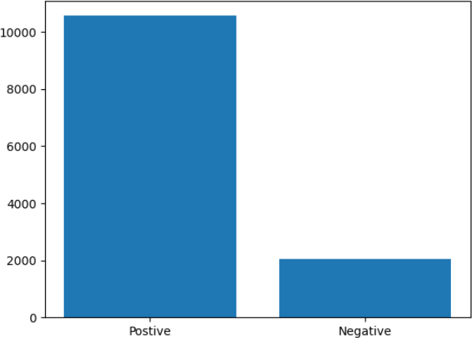

Additionally, we may see that there is a markedly greater deficiency of data in negative values than in positive values. This can lead to the algorithm producing a biased model with excellent accuracy. We have used data augmentation to boost the amount of negative data prior to training in order to overcome this problem.
Ultimately, the text input is vectorized before being fed into the model to be trained. In this case, TF-IDF vectorization is used. It is used to both fit the vectorizer to the data and transform the data into a TF-IDF matrix. It does this by converting a set of raw documents into a matrix of TF-IDF characteristics.

MODEL TRAINING
In order to determine the best method for Tanglish sentiment analysis, the study assesses a number of machine learning techniques, such as Support Vector Machines (SVM), Naive Bayes, Decision Trees, and Neural Networks. The preprocessed dataset is used to train each method, and hyperparameter adjustment is done to maximize model performance. The data is divided into training and testing subsets, with 20% of the data designated for testing and the remaining 80% for training.
Gradient descent and other optimization techniques are used in the training of logistic regression. This approach evaluates the difference between the actual and expected attitudes, or logistic loss, and iteratively modifies the feature weights to minimize it. It picks up on a decision border that divides occurrences of positive and negative mood. The method seeks to identify the weights that best define the decision boundary, which is represented by a hyperplane in the feature space.
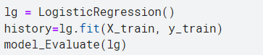

SVMs, or support vector machines, are strong machine learning algorithms that are frequently used to applications involving binary categorization. SVM is used in Tanglish sentiment analysis to identify sentiment expressions and classify them as either positive or negative. The preprocessed and feature-engineered Tanglish dataset is used to train the SVM model. The algorithm gains the ability to identify a hyperplane in the feature space that most effectively divides positive and negative sentiment expressions during training. The data points that are closest to the decision boundary, or support vectors, are essential for identifying the best hyperplane.
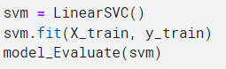
An ensemble learning technique called Random Forest combines several decision trees to improve performance all around. The Tanglish dataset, which has been feature-engineered and preprocessed, is used to train the Random Forest model. Every decision tree in the ensemble is constructed using a different subset of the training set of features and data during training. This unpredictability enhances generalizability and lessens overfitting. Random Forest combines forecasts from several decision trees to maximize the benefits of ensemble learning. Depending on the assignment, a majority vote or an average is used to establish the final forecast after each tree in the forest separately classes the input data. Particularly, we have employed hyperparameter tweaking, such as n_estimators set to 20, criteria set to 'entropy', and max_depth of each tree set to 50.

Naive Bayes relies on the independence of characteristics and works on the basis of the Bayes theorem. Through probabilistic training, the model learns the conditional probabilities of words assigned to a certain emotion class. This entails figuring out how likely it is for each word to appear in papers with various sentiment classifications. Based on the training data, the Naive Bayes model continually modifies its parameters throughout training. In order to update the data, probabilities for every word are adjusted within several emotion groups.
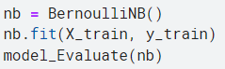

Recurrent neural networks (RNNs) with Long Short-Term Memory (LSTM) show significant potential for identifying patterns and sequential relationships in textual input. This makes RNNs especially well-suited for sentiment analysis applications involving complex languages such as Tanglish. To fully utilize the ability of LSTM in interpreting and forecasting sentiment in the code-mixed language environment, a number of crucial measures must be taken throughout the model training process.
We utilized a tokenizer to turn the text corpus into an integer list for the LSTM, and then we padded the integer series to a maximum length.

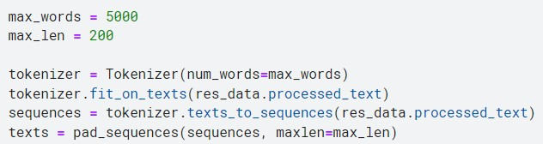

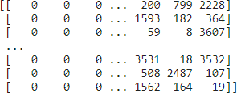

The prepared Tanglish dataset is used to train the model, and backpropagation through time (BPTT) is used to update the LSTM network's weights. Adam has been utilized as the optimization algorithm to reduce the loss function. In order to increase the predicted accuracy of the model, its internal parameters are adjusted throughout the training phase, which entails iterating over the dataset for a predetermined epoch of 100.

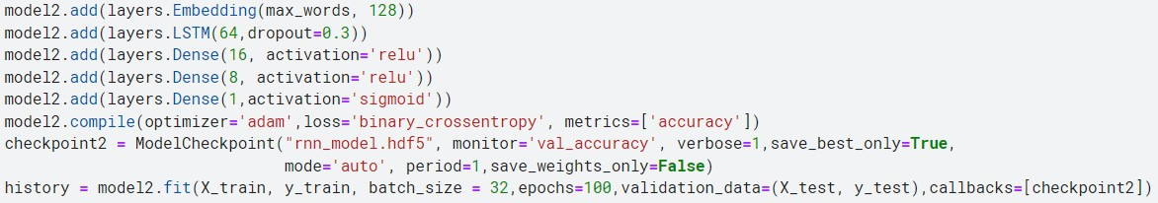

EVALUATION
The model is assessed using common assessment measures, such as F1-score, Accuracy, Precision, and Recall. An assessment statistic known as the accuracy score calculates a model's proportion of accurate predictions to total predictions. One measure of the caliber of a successful prediction the model makes is precision. The percentage of data samples that a model properly classifies as being a member of an interest class is known as recall. An indicator of a model's accuracy on a dataset is the F1-score. It is applied to assess binary categorization schemes that categorize instances as either "positive" or "negative."

RESULT
While all of the aforementioned models could achieve respectable accuracy of about 80%, LSTM outperformed the others in terms of output. The evaluation metrics that each model produced are listed below along with their Confusion Matrix:
- Logistic Regression:
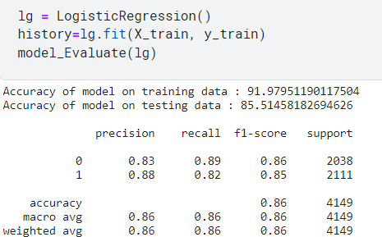
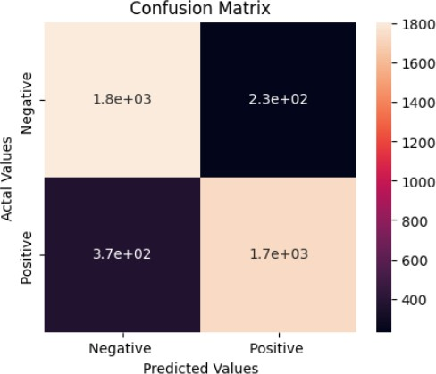
- Support Vector Machine

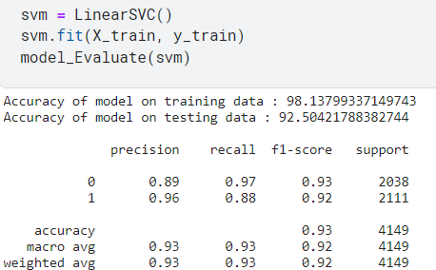
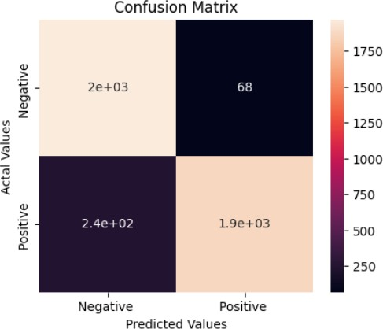
- Random Forest

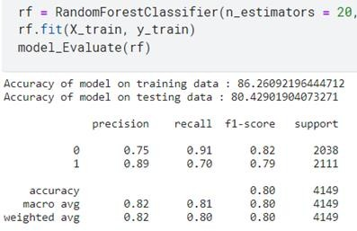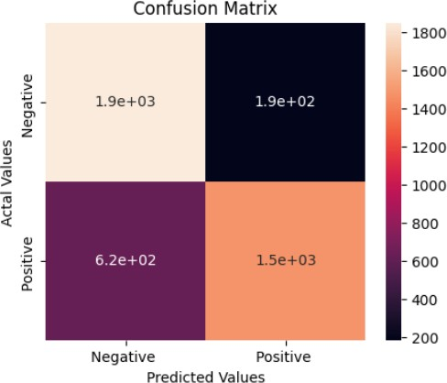

- Naïve Bayes
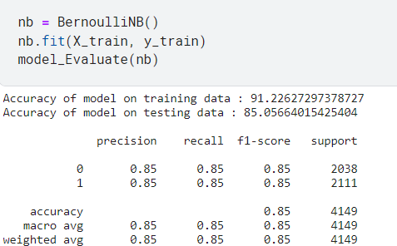
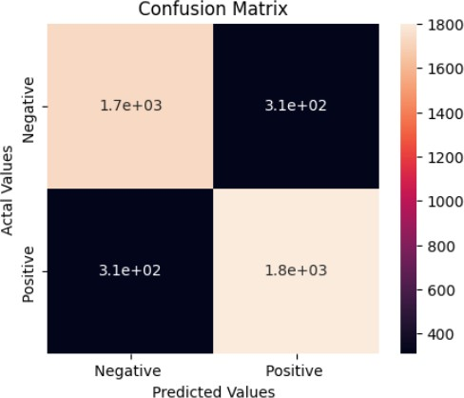

- LSTM
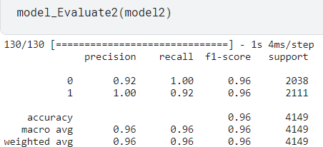
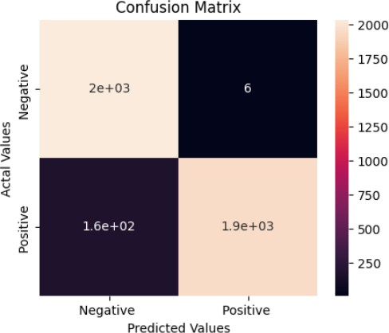

CONCLUSION
The results of this study highlight how important it is to use the right algorithm for sentiment analysis in code-mixed languages. Out of all the models that were tested, including Decision Trees, Support Vector Machines (SVM), Naive Bayes, and Neural Networks, the Long Short- Term Memory (LSTM) neural network was the best at identifying the subtle emotional expressions in Tanglish.
The LSTM outperformed the other models tested, offering the best accuracy thanks to its embedding layer for contextual word representations and its capacity to detect sequential relationships. This emphasizes how crucial it is to use sophisticated neural network designs for sentiment analysis in languages like Tanglish that have complex linguistic blends.
One significant obstacle was the lack of data in the Negative category, which affected the way some models—Naive Bayes in particular—predicted the future. This emphasizes how important it is to handle class imbalance in sentiment analysis in order to prevent unintentional biases towards the majority class in the models.
The project's all-inclusive methodology, which includes feature engineering, data pretreatment, algorithm selection, and careful model training, adds significant value to the sentiment analysis community. The study's conclusions provide useful advice for creating reliable sentiment analysis systems in code-mixed languages, an area where conventional models might not perform well.
To summarize, this study highlights the effectiveness of LSTM neural networks in resolving language difficulties and clarifies the difficulties associated with sentiment analysis in Tanglish. This effort is a step toward recognizing and interpreting sentiments in code-mixed languages, as sentiment analysis continues to develop, particularly in various linguistic circumstances.

REFERENCES
- https://www.kaggle.com/code/smitshah00/sentiment-analysis-ml-rnn
- https://stackoverflow.com/

- https://www.statology.org/pandas-replicate-rows/

Dataset Link:
https://www.kaggle.com/datasets/danushkumarv/sentiment-analysis-in-tamilenglish-text/

