**CODE:**

<!DOCTYPE html>

<html>

<body>

<style>

    body{

    position:absolute;

    margin-top:160px;

    margin-left:750px;

    width:150px;

    height: 150px;

    }

</style>

<script align="center">

    function turnOnOff() {

        var image=document.getElementById('Image');

        if(image.src.match("ONbulb"))

            image.src=

"https://media.geeksforgeeks.org/wp-content/uploads/OFFbulb.jpg";

        else

            image.src=

"https://media.geeksforgeeks.org/wp-content/uploads/ONbulb.jpg";

    }

</script>

    <img id="Image"

        onclick="turnOnOff()"

        src=

"https://media.geeksforgeeks.org/wp-content/uploads/OFFbulb.jpg">

<p>

    Click on the bulb to turn it ON and OFF

</p>

</body>

</html>

**SCREENSHOT:**

**BEFORE:**

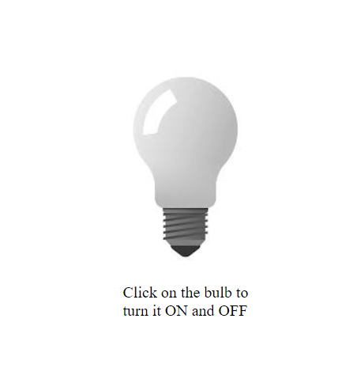

**AFTER:**

