**Project Information**

**Assignment-2**

**Team ID:** LTVIP2025TMID50326

**Team Leader :** KANCHARANA HARIPRASAD

**ID:** 22761A0524

**INSTITUTION:** Lakireddy Bali Reddy College of Engineering

**Project Title**: Measuring the Pulse of Prosperity: An Index of Economic Freedom Analysis

]¡# **Visualization Screenshots**

# ⬛¹ Donut Chart – Branch-wise Sales Contribution

**Caption: this is made by me as gif type…**

This donut chart displays the total sales contribution from each branch (A, B, C). The center highlights the overall sales volume while the segments show the proportional share by branch.

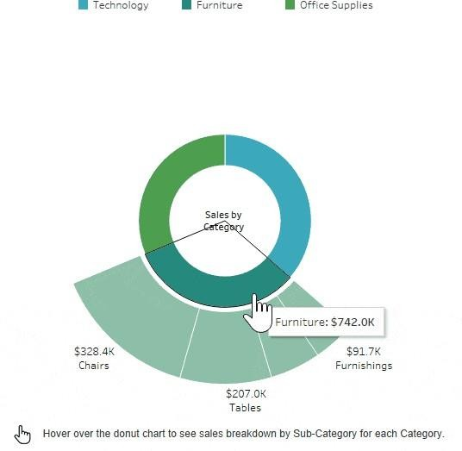

# 

# ⬛2 Area Chart – Monthly Sales Trend

**Caption:**

This area chart visualizes the total sales over the three months (January to March 2019). It uses color shading to show branch-level contributi

on across time.

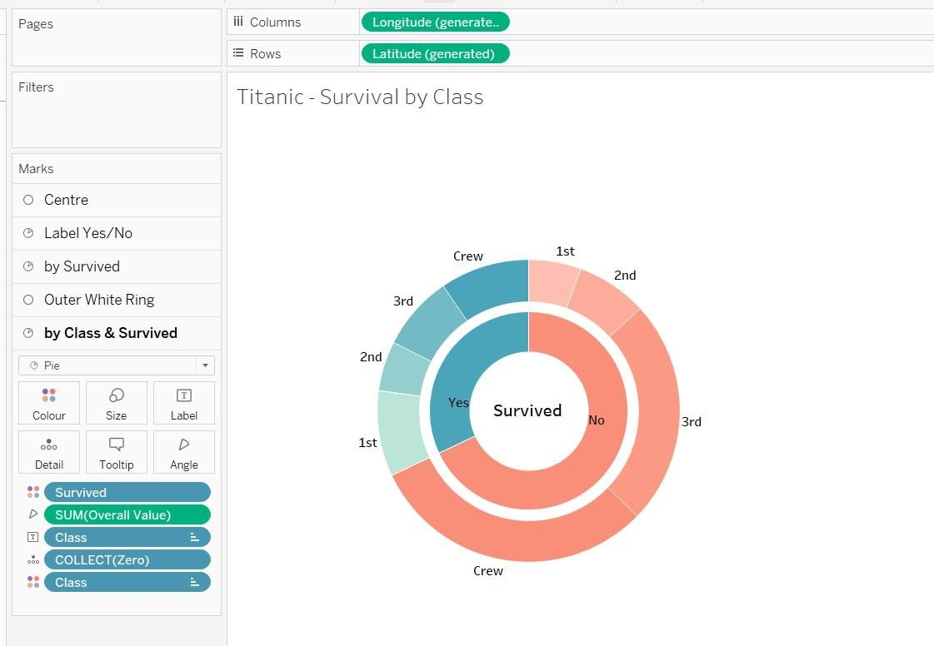

⬛3 **Text Table – Product Line Sales Summary**

# Caption: converted into gif by me…

This text table provides a detailed breakdown of sales, quantity sold, gross income, and average customer rating per product line and customer type.



.

# ⬛f Word Cloud – Most Purchased Product Lines

**Caption:**

This word cloud illustrates the popularity of different product lines based on the number of items purchased. Font size reflects quantity sold.

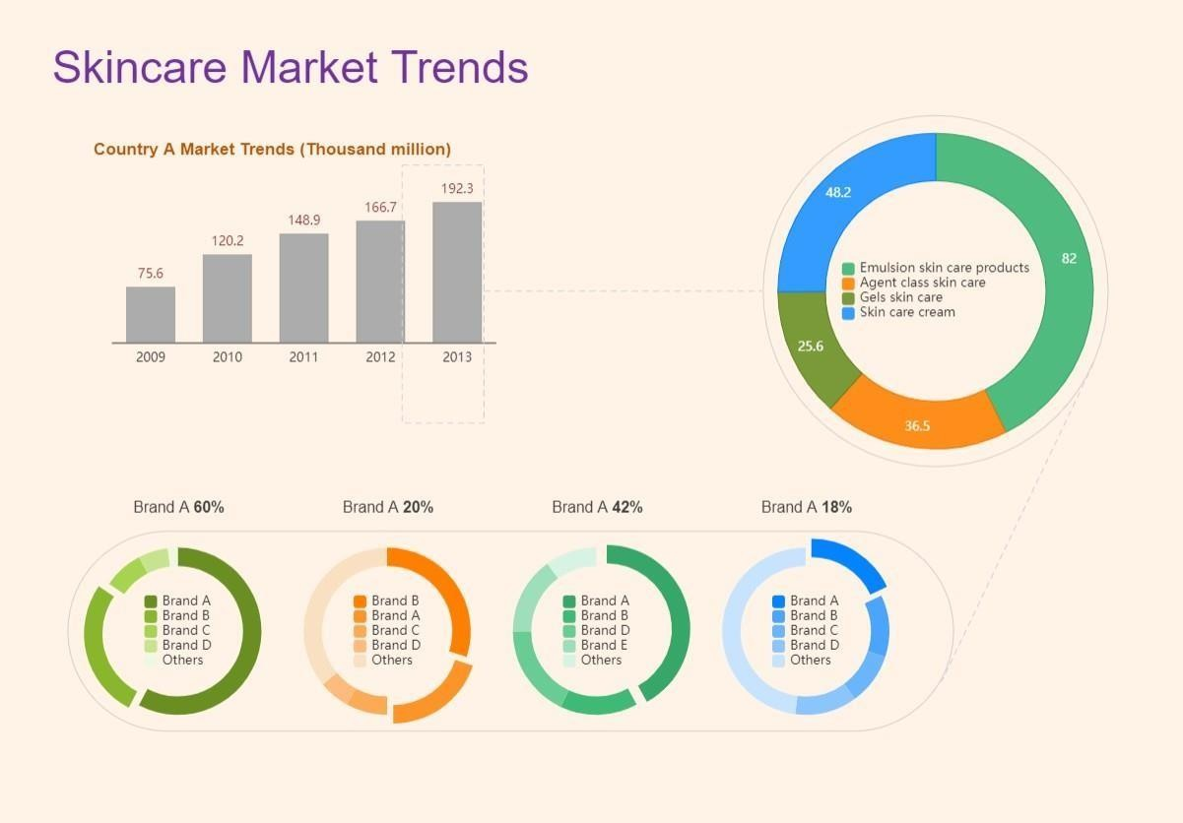

# ⬛6 Funnel Chart – Payment Method Usage

**Caption:**

This funnel chart visualizes the volume of sales through each payment method. It narrows from the most to least used method.