1. Name of emp with the highest salary

Select * from EMPLOYEE where SALARY =( select MAX(SALARY) from EMPLOYEE );

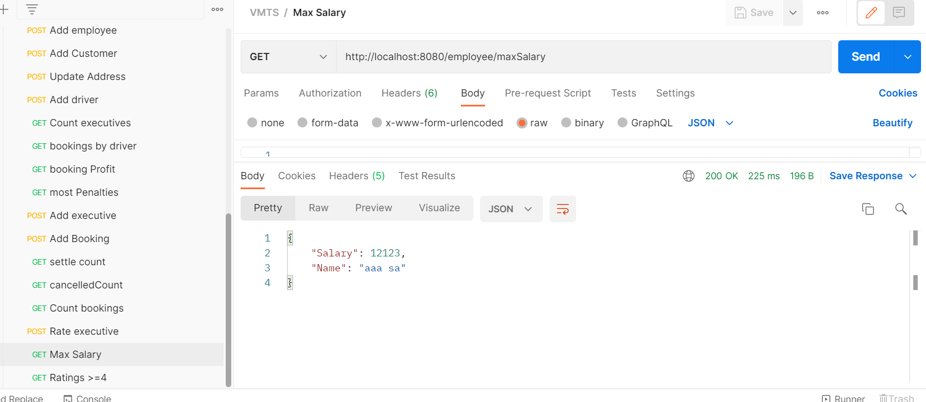

2. Number of executives in the company

SELECT COUNT(*) FROM VMTS.EXECUTIVE;

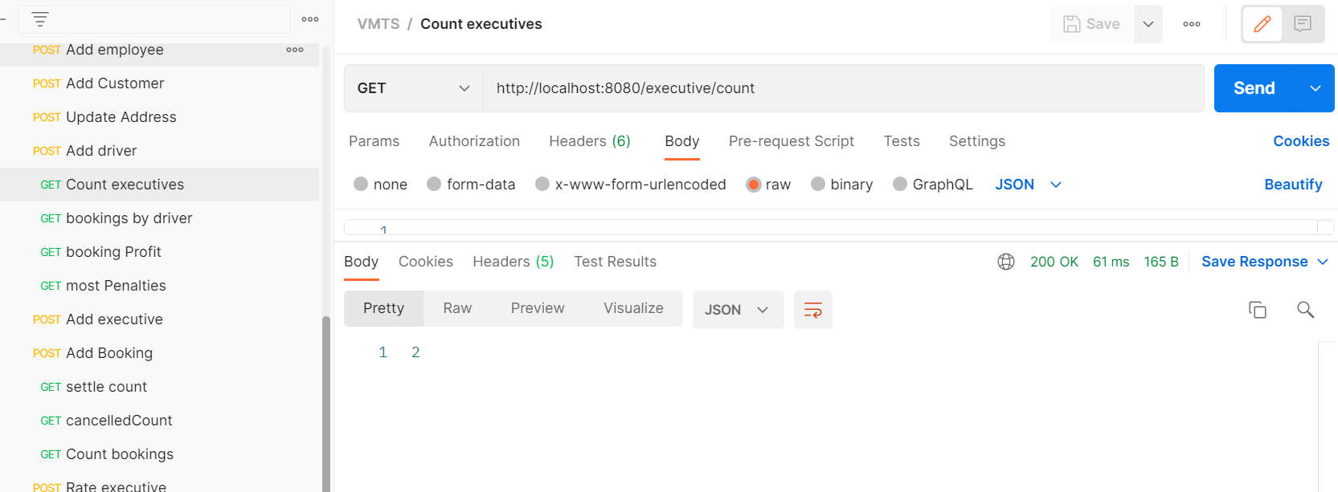

3.Number of vehicles in the company

SELECT COUNT(*) FROM VMTS.VEHICLE;

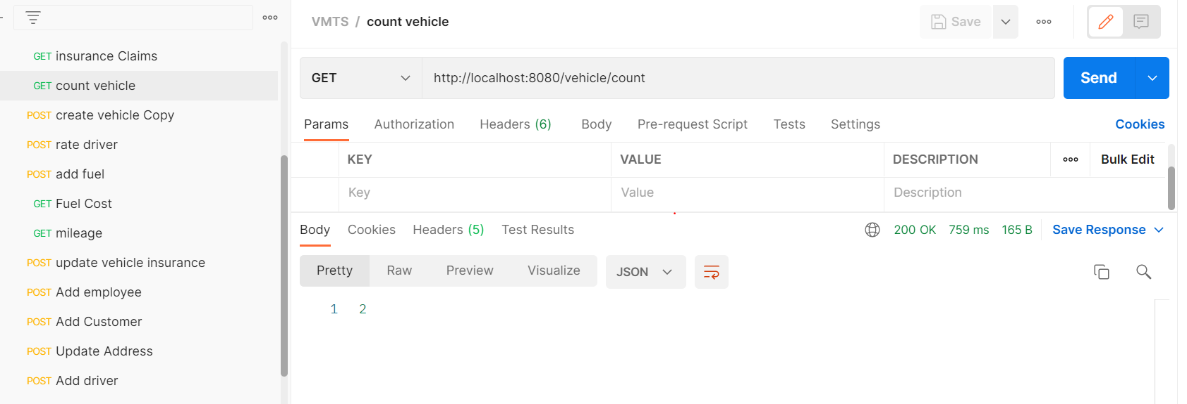

4. Number of total bookings made between specific dates

SELECT COUNT(*) FROM VMTS.BOOKING WHERE START_DATE BETWEEN <from_date> AND <to_date>;

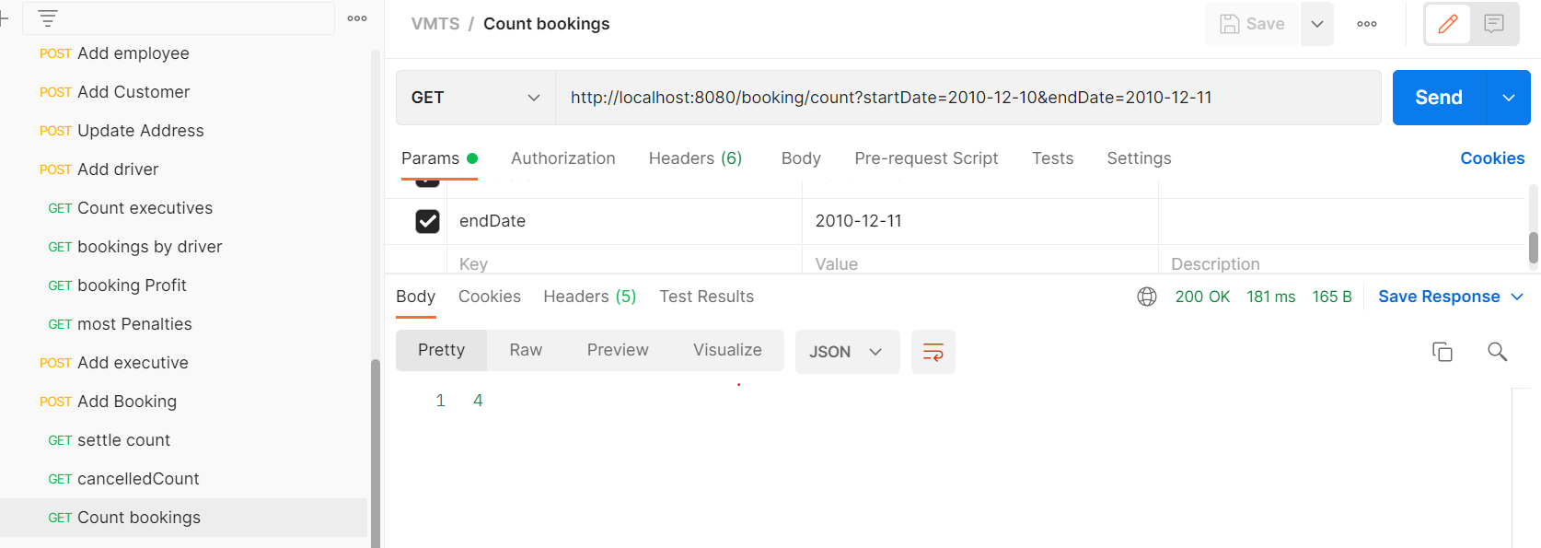

5. Number of bookings that need to be settled

SELECT COUNT(*) FROM VMTS.BOOKING WHERE BOOKING_STATUS = 'completed';

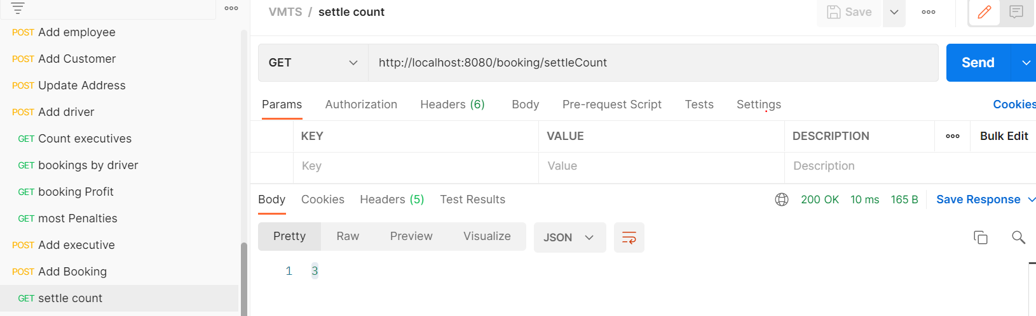

6. Profit from bookings

select (sum(V.RENT_PER_DAY * ((B.END_DATE - B.START_DATE) + 1)) - sum(B.penalty_charge) - sum(F.fuel_filled_amount)) AS 'Total PROFIT'

from VMTS.VEHICLE V, VMTS.Booking B, VMTS.fuel_dtls F \where V.reg_no = B.vehicle_id AND B.booking_status = 'PAID';

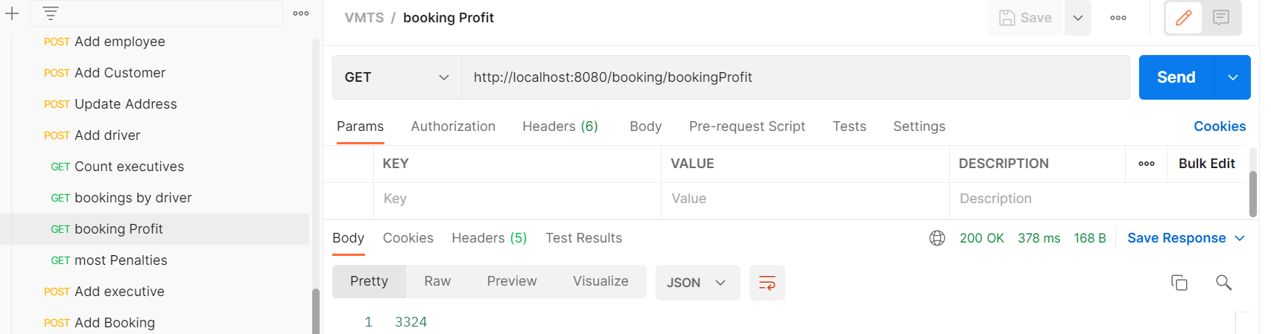

7. Get driver name/executive name with rating '4'

SELECT distinct CONCAT(A.FNAME,' ', A.LNAME) AS Highest_rated_employee FROM VMTS.EMPLOYEE A, VMTS.DRIVER B, VMTS.EXECUTIVE E

WHERE (A.EMP_ID = E.EMP_ID AND E.RATING >= '4') OR (A.EMP_ID = B.EMP_ID AND B.RATING >= '4');

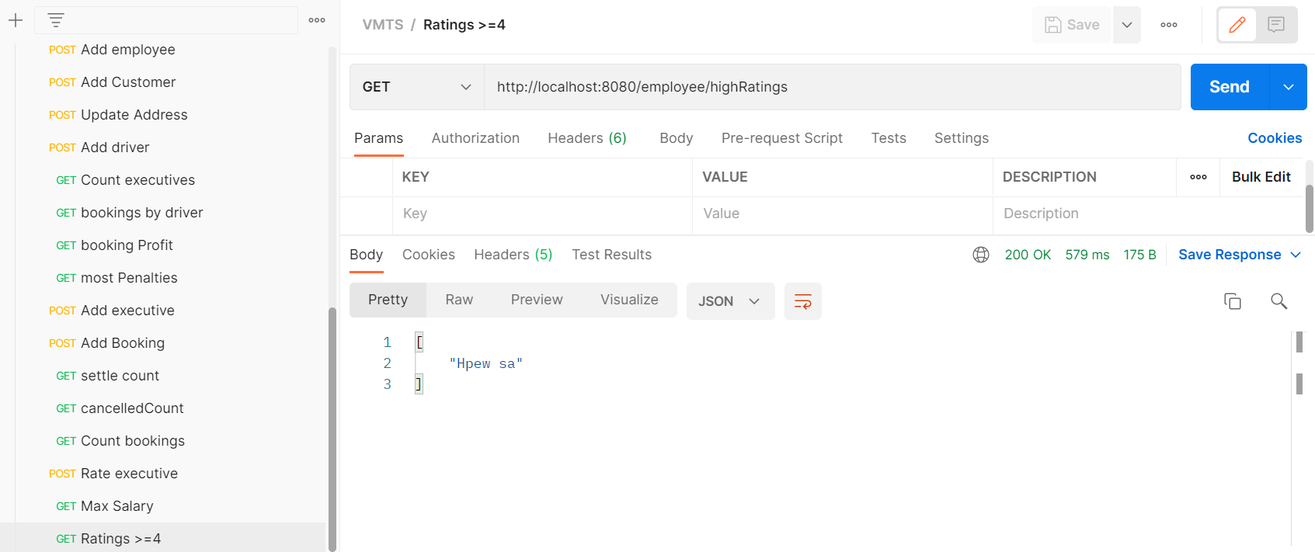

8. No.of bookings made by specific driver

SELECT COUNT(BOOKING_ID) FROM VMTS.BOOKING WHERE DRIVER_ID = '<ID >'

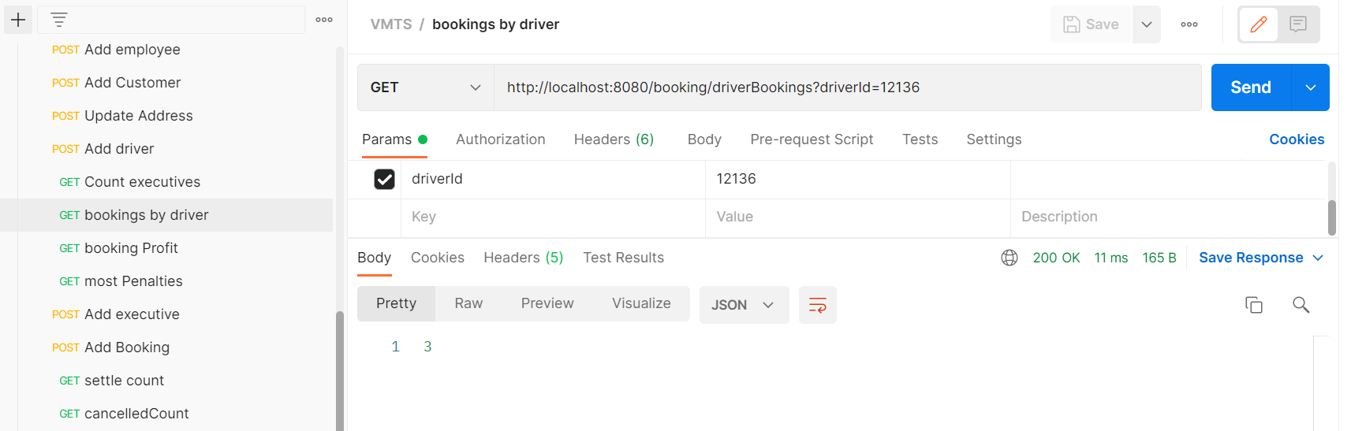

9. Number of cancelled bookings

SELECT COUNT(*) FROM VMTS.BOOKING WHERE BOOKING_STATUS = 'cancelled';

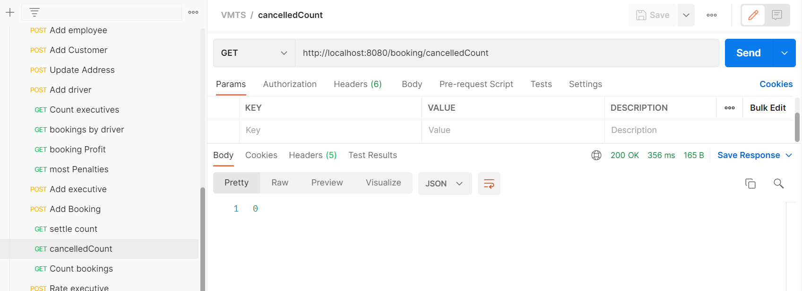

10. No.of insurance claims made by vehicle with Reg.No

SELECT A.NO_OF_CLAIMS FROM VMTS.INSURANCE_DTLS A,VMTS.VEHICLE B WHERE B.INSURANCE_NO = A.INSURANCE_ID AND

B.REG_NO = <regNo>;

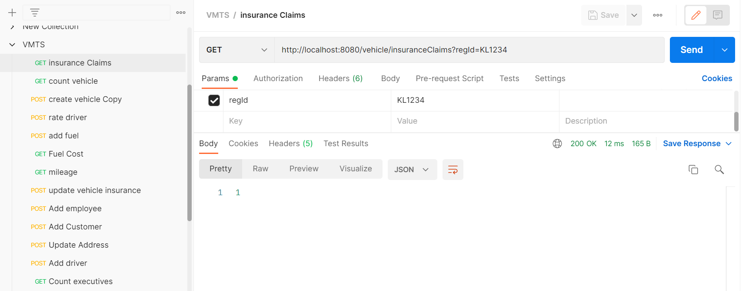

11. Total fuel cost in last month

SELECT SUM(FUEL_FILLED_AMOUNT) FROM VMTS.FUEL_DTLS WHERE DATE_OF_FILLING < current_date() AND DATE_OF_FILLING > current_date()-30;

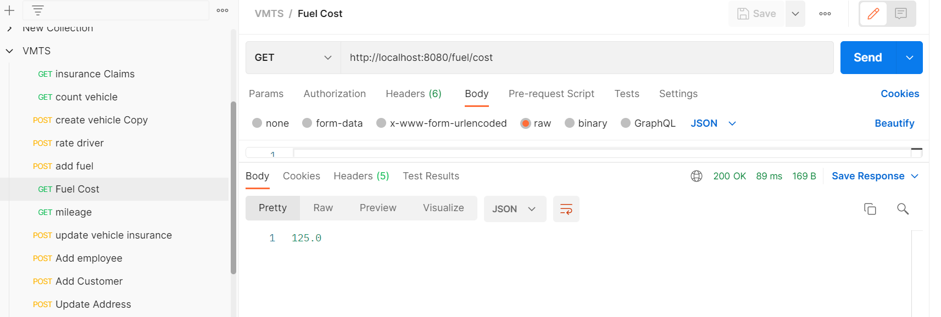

12. Mileage for a vehicle with reg no (new column added fuel_filled)

select round((SUM(b.km_driven)/SUM(f.fuel_filled)),2) AS mileage from vmts.fuel_dtls f, vmts.booking b where f.vehicle_id=b.vehicle_id AND f.vehicle_id = <vehicleId>;

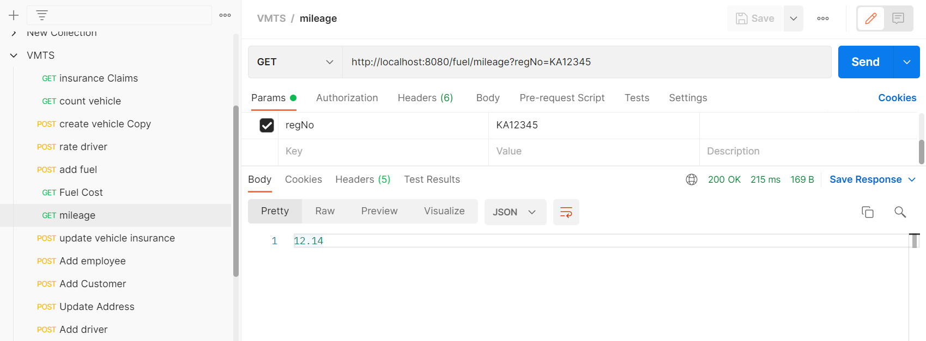

13. Driver involved with more number of penalties

select MAX(count) from (select driver_id, count(penalty_charge) count from vmts.booking

where penalty_charge <> 0 group by driver_id) AS Penalty_Count;

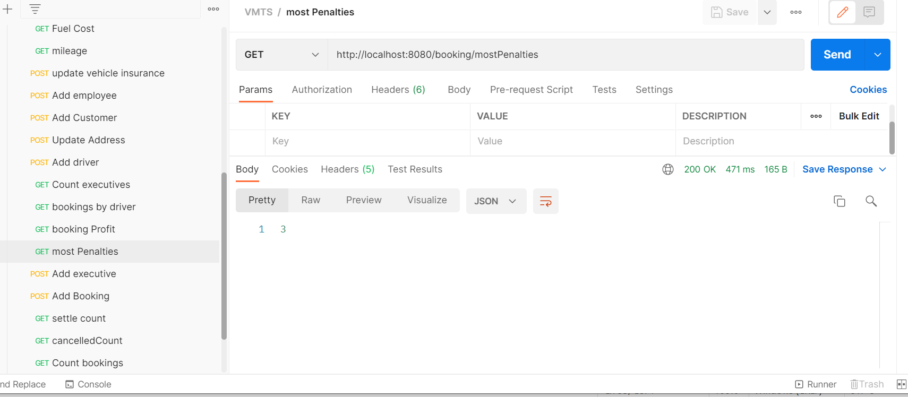

Tables:

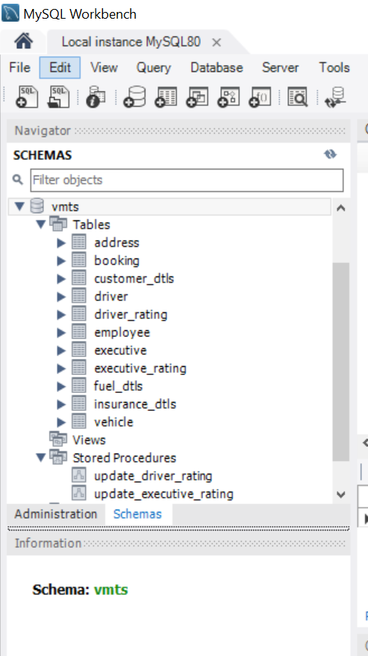

**Stored Procedures**

DELIMITER //

CREATE PROCEDURE vmts.update_driver_rating ()

BEGIN

update vmts.driver d set d.rating = round((select avg(r.rating)

from vmts.driver_rating r where r.driver_id=d.emp_id group by r.driver_id ),2) ;

END

DELIMITER //

CREATE PROCEDURE vmts.update_executive_rating ()

BEGIN

update vmts.executive e set e.rating = round((select avg(r.rating)

from vmts.executive_rating r where r.executive_id=e.emp_id group by r.executive_id ),2) ;

END

**Triggers**

DELIMITER //

CREATE TRIGGER vmts.update_driver

AFTER INSERT

ON vmts.driver_rating FOR EACH ROW

BEGIN

call vmts.update_driver_rating();

END

DELIMITER //

CREATE TRIGGER vmts.update_executive

AFTER INSERT

ON vmts.executive_rating FOR EACH ROW

BEGIN

call vmts.update_executive_rating();

END