Exp. No.: 2 | Study of Network Cables

Aim
To study different types of network cables and to make a cross-wired cable and a straight-through cable using a clamping/crimping tool.
Theory / Concepts
The different types of cables used in networking are:
1. Unshielded Twisted Pair (UTP) Cable
2. Shielded Twisted Pair (STP) Cable
3. Coaxial Cable
4. Fibre Optic Cable

Cable Type | Category | Max. Data Rate | Advantages / Disadvantages | Application / Use
UTP | Category 3 | 10 bps | Advantages: Cheaper in cost; easy to install due to smaller overall diameter. | 10Base-T Ethernet
 | Category 5 | Up to 100 Mbps | Disadvantages: More prone to electromagnetic interference (EMI) and noise. | Fast Ethernet, Gigabit Ethernet
 | Category 5e | 1 Gbps |  | Fast Ethernet, Gigabit Ethernet
STP | Category 6, 6a | 10 Gbps | Advantages: Shielded; faster than UTP; less susceptible to noise and interference. Disadvantages: Expensive; greater installation effort. | Gigabit Ethernet, 10G Ethernet (55m); widely used in data centres
SSTP | Category 7 | 10 Gbps |  | Gigabit Ethernet, 10G Ethernet (100m)
Coaxial cable | RG-6, RG-59, RG-11 | 10–100 Mbps | Advantages: High bandwidth; immune to interference; low loss; versatile. Disadvantages: Limited distance; costly; bulky size. | Speed of signal up to 500m; television network; high-speed internet connections
Fibre optic cable | Single mode, Multi mode | 100 Gbps | Advantages: High speed; high bandwidth; high security; long distance. Disadvantages: Expensive; requires skilled installers. | Maximum distance around 100 metres

Straight-Through vs Crossover Wiring
A straight-through cable has both ends wired identically (both ends use arrangement A), and is used to connect dissimilar devices such as a PC to a switch/router. A crossover cable has one end wired to arrangement A and the other to arrangement B, and is used to connect similar devices, such as PC-to-PC or switch-to-switch.
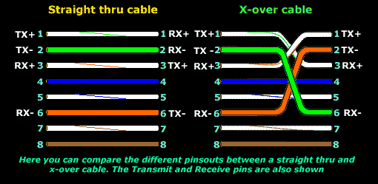
Fig. 1 — Difference between straight-through and crossover pinouts (TX/RX mapping)
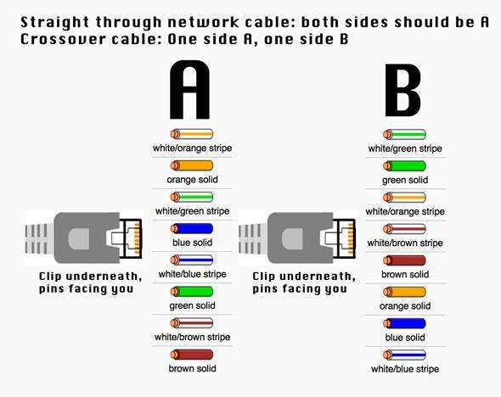
Fig. 2 — T568A / T568B wire colour arrangement used at each end
Procedure
Making an Ethernet cross-over / straight-through cable
Tools and parts needed:
• Ethernet cabling — CAT5e (certified for gigabit support) or CAT5 (works over shorter distances).
• A crimping tool — an all-in-one networking tool used to push down the pins in the plug and to strip/cut the cable shielding.
• Two RJ45 plugs.
• Optional: two plug shields.
1. Thread the shields onto the cable before starting construction.
2. Strip approximately 1.5 cm of cable shielding from both ends, using the round stripping area on the crimping tool.
3. Untangle the four twisted pairs inside the cable. Arrange the wires from top to bottom as per the reference diagram — one end in arrangement A and the other in arrangement B (for a crossover cable), or both ends in arrangement A (for a straight-through cable).
4. Once the order is correct, line up the wires evenly and snip back any that stick out. Hold the RJ45 plug with the clip facing away and the gold pins facing towards you, then insert the wires in the correct order.
5. Push the cable fully into the plug so that the notch at the end of the plug sits just over the cable shielding. If it does not, trim back a little more shielding.
6. Once the wires are seated securely in the plug, insert the plug into the crimping tool and press down firmly (without excessive force, to avoid cracking the plug).
7. Repeat the process for the other end of the cable — using arrangement B to make a crossover cable, or arrangement A again to make a straight-through cable.
To test the finished cable, plug it in and attempt to connect two devices directly.
Observation
1. What is the difference between a cross cable and a straight cable?
2. Which type of cable is used to connect two PCs? (straight / cross cable)
3. Which type of cable is used to connect a router/switch to a PC? (straight / cross cable)
4. Find out the category of twisted pair cable used in your lab to connect the PC to the network socket.
5. Write down your understanding, the challenges faced, and the output received while making a twisted pair cross/straight cable.
Result
Different types of network cables were studied, and a cross-wired cable and a straight-through cable were successfully made and tested using a crimping tool.

