Exp. No.: 3 | Experiments on CISCO Packet Tracer (Simulation Tool)

Aim
To study the Packet Tracer tool installation and user interface overview, to understand the environment of Cisco Packet Tracer for designing a simple network, and to analyse the behaviour of network devices (HUB and Switch) using the Packet Tracer simulator.
Required Software / Tools
• Cisco Packet Tracer (network design, simulation and modelling tool)
Theory / Concepts
A simulator, as the name suggests, simulates network devices and their environment. Packet Tracer is a network design, simulation and modelling tool:
• It allows modelling complex systems without the need for dedicated equipment.
• It helps practice network configuration and troubleshooting skills via a computer or an Android/iOS mobile device.
• It is available for both Linux and Windows desktop environments.
• Protocols in Packet Tracer are coded to work and behave in the same way as they would on real hardware.
Installing Packet Tracer
To download Packet Tracer, go to https://www.netacad.com and log in with Cisco Networking Academy credentials, then click on the Packet Tracer graphic and download the package appropriate for the operating system.
Windows:
Installation is simple and straightforward — the setup comes as a single file (e.g., PacketTracer_Setup6.0.1.exe). Open the file to begin the setup wizard, accept the license agreement, choose a location, and start the installation.
Linux:
Ubuntu/Debian users should download the Ubuntu package, and Fedora/RedHat/CentOS users must download the Fedora package. Grant executable permission to the file using chmod, and execute it to begin installation.
chmod +x PacketTracer601_i386_installer-rpm.bin
./PacketTracer601_i386_installer-rpm.bin
User Interface Overview
The Packet Tracer layout is divided into several components:

1. Menu bar — a common menu found in all software applications; used to open, save, print, change preferences, etc.
2. Main toolbar — provides shortcut icons to commonly accessed menu options such as open, save, zoom, undo and redo; an icon on the right is for entering network information for the current network.

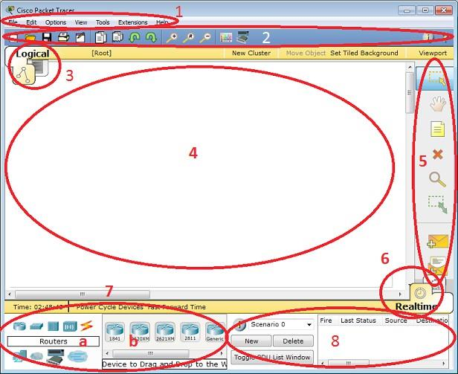
Fig. 1 — Cisco Packet Tracer user interface, with components numbered 1–8
3. Logical/Physical workspace tabs — allow toggling between the Logical and Physical work areas.
4. Workspace — the area where topologies are created and simulations are displayed.
5. Common tools bar — provides controls for manipulating topologies, such as select, move layout, place note, delete, inspect, resize shape, and add simple/complex PDU.
6. Real-time/Simulation tabs — used to toggle between real and simulation modes; buttons are also provided to control time and to capture packets.
7. Network component box — contains all network and end devices available with Packet Tracer, divided into: Area 7a (device-type selection box, containing device categories) and Area 7b (device-specific selection box, showing device models within a selected category).
8. User-created packet box — allows users to create highly customised packets to test their topology; results are displayed as a list.
Procedure
a) Understand the Packet Tracer environment to design a simple network — covered under the User Interface Overview above.
b) Analyse the behaviour of network devices using the Packet Tracer simulator
1. From the network component box, click and drag-and-drop the following components:
• 4 Generic PCs and one HUB
• 4 Generic PCs and one Switch
2. Click on Connections:
• Click on the Copper Straight-Through cable.
• Select one of the PCs and connect it to the HUB using the cable. The link LED should glow green, indicating that the link is up. Similarly, connect the remaining 3 PCs to the HUB.
• Similarly, connect 4 PCs to the switch using the copper straight-through cable.
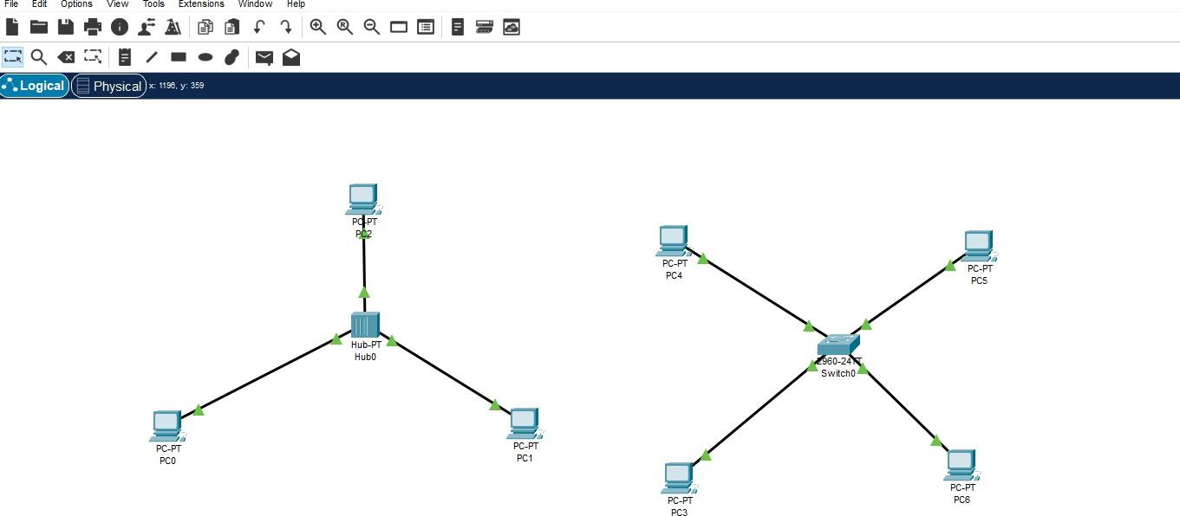
Fig. 2 — Topology with 4 PCs connected via a HUB (left) and 4 PCs connected via a Switch (right)
3. Click on the PCs connected to the HUB, go to the Desktop tab, click on IP Configuration, and enter an IP address and subnet mask. The default gateway and DNS server information are not needed here, as there are only two end devices in the network.
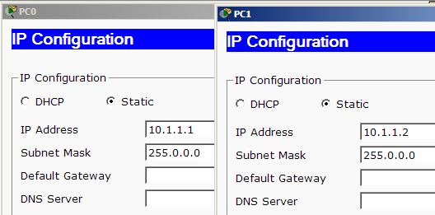
Fig. 3 — IP Configuration for PC0 (10.1.1.1) and PC1 (10.1.1.2)
Click on the PDU (message icon) from the common tool bar:
• Drag and drop it on one PC (source machine) and then drop it on another PC (destination machine) connected to the HUB.
4. Observe the flow of the PDU from the source PC to the destination PC by selecting the Realtime mode of simulation.
5. Repeat steps 3 to 4 for the PCs connected to the switch.
6. Observe how the HUB and switch forward the PDU, and note the observation and conclusion about the behaviour of the switch and HUB.
Result
The Cisco Packet Tracer environment was studied, and a simple network with a HUB and a Switch, each connecting 4 PCs, was designed and simulated successfully. The behaviour of the HUB (broadcasting to all ports) and the Switch (forwarding selectively to the destination port) was observed.

