Exp. No.: 4 | Setup and Configure a LAN Using a Switch and Ethernet Cables

Aim
To set up and configure a Local Area Network (LAN) using a Switch and Ethernet cables in the lab — connecting host machines to a switch, assigning IP addresses, checking connectivity, and sharing files/folders across the LAN.
Required Software / Tools
• 4 Computers (host machines)
• A network switch (8, 16, or 24 ports)
• 4 Ethernet cables
Theory / Concepts
What is a LAN?
A Local Area Network (LAN) refers to a network that connects devices within a limited area, such as an office building, school, or home. A LAN connects devices to promote collaboration and transfer information between users, such as computers, printers, servers, and switches. A local area network (LAN) switch serves as the primary connecting device, managing and directing communications within the local network. Each connected device on a LAN switch can communicate directly with each other, allowing for fast and secure data transfer.
Procedure
How to set up a LAN
Step 1: Plan and design an appropriate network topology, taking into account network requirements and equipment location.
Step 2: Take 4 computers, a switch with 8, 16, or 24 ports (sufficient for networks of this size), and 4 Ethernet cables.
Step 3: Connect the computers to the network switch via an Ethernet cable — plugging one end of the cable into the computer and the other end into the network switch.
Step 4: Assign IP address to the PCs:
1. Log on to the client computer as Administrator or as Owner.
2. Click Network and Internet Connections.
3. Right-click Local Area Connection/Ethernet → go to Properties → select Internet Protocol (TCP/IPv4) → click on Properties → select "Use the following IP address" option and assign the IP address.
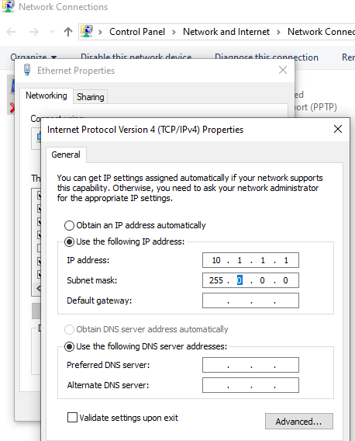
Fig. 1 — Assigning a static IP address (10.1.1.1, subnet mask 255.0.0.0) via TCP/IPv4 Properties
Similarly, assign IP addresses to all the PCs connected to the switch:
• PC1 — IP address: 10.1.1.1, subnet mask 255.0.0.0
• PC2 — IP address: 10.1.1.2, subnet mask 255.0.0.0
• PC3 — IP address: 10.1.1.3, subnet mask 255.0.0.0
• PC4 — IP address: 10.1.1.4, subnet mask 255.0.0.0
Step 5: Configure a network switch:
1. Connect your computer to the switch — to access the switch's web interface, connect the computer to the switch using an Ethernet cable.
2. Log in to the web interface — open a web browser and enter the IP address of the switch in the address bar. This should bring up the login page for the switch's web interface. Enter the username and password to log in.
3. Configure basic settings — once logged in, configure the basic settings for the switch.
4. Assign IP address as: 10.1.1.5, subnet mask 255.0.0.0.
Step 6: Check the connectivity between the switch and other machines by using the ping command in the command prompt of the device.
Step 7: Select a folder → go to Properties → click the Sharing tab → share it with everyone on the same LAN.
Step 8: Try to access the shared folder from other computers on the network.
Result
A LAN was successfully set up and configured using a switch and Ethernet cables — host machines were connected to the switch, static IP addresses were assigned, connectivity was verified using the ping command, and a shared folder was successfully accessed across the LAN.

