The cascade network given below is considered

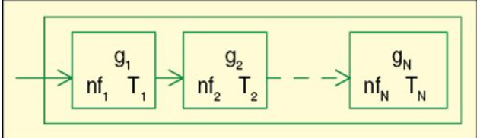

The total gain of the network = g1+g2+g3….+gn

The total noise figure of the network = nf1 + (nf2-1)/g1+….+(nfn-1)/(g1\*g2\*…g(n-1)

The total noise temperature of the network = T1 + (T2)/g1+… +(Tn)/(g1\*g2\*…g(n-1)