Course Coverage Report (CCR)
System Architecture & Technical Specifications
Jaya Engineering College | Version 1.0 | September 2026

1. Executive Summary1. Executive Summary
The Course Coverage Report (CCR) Management System is an offline-first mobile and web platform built for Jaya Engineering College. It automates syllabus tracking, weekly course coverage logging, extra hour requests, and multi-tier approval workflows across Subject Teachers, Class Coordinators, HODs, and the Principal.

2. High-Level System Architecture2. High-Level System Architecture
The system features an Offline-First Client-Server Architecture. Mobile devices run an Expo React Native application with on-device SQLite storage, communicating with a Node.js Express REST API and a Cloud MongoDB database via Prisma ORM.
High-Level Architecture Data Flow
[Client] React Native / Expo UI ➔ [Local Cache] SQLite & NetInfo Sync ➔ [Security] JWT & Domain Firewall ➔ [Backend] Express REST API ➔ [Database] MongoDB via Prisma ORM

3. Offline-First Sync Architecture3. Offline-First Sync Architecture
When faculty members log course progress in areas of weak connectivity, entries are instantly cached in SQLite. Once internet connection is restored, NetInfo triggers an automatic sync to the central API.
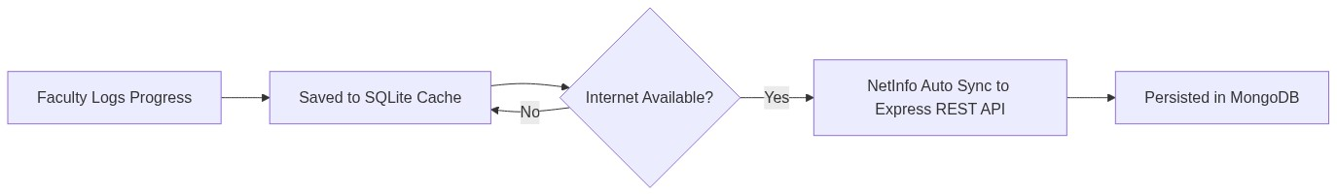

4. Database Architecture (Prisma & MongoDB)4. Database Architecture (Prisma & MongoDB)
The application persists structured academic data across seven core database collections:
- User Model: Stores profile details, institutional roles (STAFF, HOD, ADMIN), and coordinator flags.
- TimetableSlot Model: Tracks daily schedules, subjects, class sections, and contact rooms.
- SyllabusNode Model: Stores syllabus units and granular topic definitions.
- WeeklyPlan Model: Defines weekly targets set by faculty.
- ProgressLog Model: Logs actual completed topics, pending topics, and period counts.
- ExtraHourRequest Model: Handles extra contact period scheduling and approvals.
- ConsolidatedReport Model: Aggregates weekly subject statistics for HOD approval.

5. Technical Stack Specifications5. Technical Stack Specifications

Frontend Architecture (Mobile & Web)Frontend Architecture (Mobile & Web)
Category | Technology | Description / Function
Framework | React Native 0.86 + Expo v57 | Cross-platform mobile and web application runtime
Language | TypeScript 6.0 | Type-safe interface & logic definitions
UI System | React Native Paper v5.15 | Material Design UI components & icon sets
State Store | Zustand v5.0 | Predictable, modular client state store
Local Storage | Expo SQLite v57 | On-device database for offline caching
Network Sync | @react-native-community/netinfo | Network connectivity monitoring
Exports | Expo Print & docx v9.7 | PDF & DOCX report generation

Backend REST API ArchitectureBackend REST API Architecture
Category | Technology | Description / Function
Runtime | Node.js (v20+) | Asynchronous server runtime
API Framework | Express.js v4.19 | RESTful API routes and controller logic
Database ORM | Prisma ORM v5.12 | Type-safe MongoDB database queries
Database | MongoDB (Cloud) | Scalable document storage
Security | JWT + bcryptjs + Helmet | Role-based authentication & route security
Validation | Zod v4.4 | API request body validation

6. Role-Based Access Control (RBAC) & Workflows6. Role-Based Access Control (RBAC) & Workflows
System functionality is split across four distinct user roles:
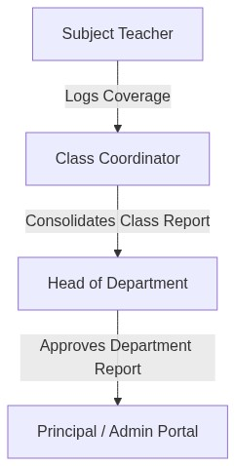
- Subject Teacher (STAFF): Logs weekly syllabus progress and submits weekly teaching plans.
- Class Coordinator (CC): Consolidates class subject progress and forwards reports to HOD.
- Head of Department (HOD): Reviews, approves, or returns consolidated class reports.
- Principal / Admin: College-wide oversight and report tracking dashboard.

7. Repository Structure7. Repository Structure
- backend/: REST API controllers, services, routes, and Prisma schema.
- frontend/: React Native mobile app features, SQLite local database, and navigators.

