
College of Business,
Technology and
Engineering

MSc Dissertation Report
"Optimizing Deep Learning Integration in ADAS For Enhanced Vehicle Safety”
A dissertation submitted in partial fulfilment of the requirements of Sheffield Hallam University for the degree of Master of Science in Big Data Analytics.

Student Name | Hariprasath Mohanraj
Student ID | C2068019
Supervisor | Dr Samuele Vinanzi
Date of Submission | 16.01.2024

This dissertation does NOT contain confidential material and thus
can be made available to staff and students via the library.

Abstract
This research looks at how YOLOv5 models help Advanced Driver Assistance Systems (ADAS) detect vehicles faster and more accurately, making driving safer. It focuses on testing different YOLOv5 models to see how well they identify cars, using simple measures of how correct and precise they are. The findings reveal that YOLOv5 models, especially the YOLOv5s version, are really effective at quickly and correctly recognizing objects. This is very important for things like keeping an eye on traffic and helping self-driving cars. The study points out the importance of using diverse and good quality data to train these models and how YOLOv5 can be adjusted for use in various real situations. In conclusion, YOLOv5 models are very useful for improving systems in smart cities and advanced transport, and the study suggests more work on tailoring these models and encouraging cooperation between industries and universities to make them even better.

Declaration
I declare that this project, “Optimizing Deep Learning Integration in ADAS For Enhanced Vehicle Safety”, is submitted by me, Hariprasath Mohanraj to the Sheffield Hallam University. Furthermore, I affirm that this work is my own and has not been submitted to this university or any other institution for the purpose of receiving a degree.

M.Hariprasath
Date: 16/01/2024 Signature

Acknowledgement
I appreciate the help and suggestions that enabled me to complete this research on deep learning in advanced driver Assistance systems. I really appreciate thanking my supervisor. The advice and help they gave me were very helpful. I appreciate the tools that the academic community provides us and the players' time and skills. My family and friends have always been there for me, so I want to thank them. The people in my area have all worked together to improve my trip. I'm very grateful to everyone who supported me, gave me advice, and helped me with this work.

Table of Contents
Chapter 1: Introduction 1
1.1 Background of the study 1
1.2 Research Question, Aims & Objectives 1
1.3 Research rationale 2
1.4 Significance of the study 4
1.5 Research Structure 5
Chapter 2: Literature Review 8
2.1 Introduction to Deep Learning in Advanced Driver Assistance Systems (ADAS) 8
2.2 Impact of Deep Learning on ADAS Functionalities 9
2.3 Evolution of Driver Assistance Technology 11
2.4 Empowering ADAS with Deep Learning 14
2.5 Deep Learning for Enhanced Lane Detection 17
2.5.1 Substantial Impact on Lane Recognition 18
2.5.2 Role in Lowering Probability of Lane Departure Occurrences 19
2.5.3 Challenges and Future Directions 19
2.6 Research Gap 20
2.7 Summary of the chapter 22
Chapter 3: Research design and Methodology 24
Overview of the Chapter 24
3.1 Research Design 25
3.2 Research Methodologies 26
3.2.1 Research Philosophy (Positivism) 26
3.2.2 Research Approach (Deductive) 27
3.2.3 Research Strategy (Experimental) 27
3.2.4 Methodological Choice (Mixed-Method) 28
3.2.5 Time Horizon (Cross-Sectional) 29
3.2.6 Data Collection and Analysis Techniques 29
Chapter 4: Data Analysis and Findings 32
Chapter 5: Discussions 72
Chapter 6: Conclusion and Recommendation 73
6.1 Conclusion 73
6.2 Recommendations 73
References 75
Appendix 81
Appendix A: Research Proposal 81
Appendix B: Ethics Form 89
Appendix C: Source Code 97

List of Figures
Figure 3.1 Flow Chart of the Research Method 25
Figure 3.2 Research Onion (Saunders et al., 2007) 26
Figure 4.1: Detection object in the bounding box determined by class probabilities 36
Figure 4.2: IoU Definition 37
Figure 4.3: Layers of EfficientNet model 38
Figure 4.4: Model layers for YOLOv5 40
Figure 4.5: YOLOv5l Model’s performance curves 42
Figure 4.6: Confusion matrix among the objects 42
Figure 4.7: Labels and measurement on its instances 43
Figure 4.8: Training and Testing analysis 43
Figure 4.9: YOLOv5m Model’s performance curves 44
Figure 4.10: Confusion matrix among the objects 45
Figure 4.11: Labels and measurement on its instances 45
Figure 4.12: Training and Testing analysis 46
Figure 4.13: YOLOv5n Model’s performance curves 47
Figure 4.14: Confusion matrix among the objects 48
Figure 4.15: Labels and measurement on its instances 48
Figure 4.16: Training and Testing analysis 49
Figure 4.17: YOLOv5s Model’s performance curves 50
Figure 4.18: Confusion matrix among the objects 51
Figure 4.19: Labels and measurement on its instances 51
Figure 4.20: Training and Testing analysis 52
Figure 4.21: YOLOv5x Model’s performance curves 53
Figure 4.22: Confusion matrix among the objects 54
Figure 4.23: Labels and measurement on its instances 54
Figure 4.24: Training and Testing analysis 55
Figure 4.25: Accuracy test on Image sample 58
Figure 4.26: Time Complexity analysis 60
Figure 4.27: Space Complexity analysis 60
Figure 4.28: Time (1:1) Complexity and Space (1:1000) Complexity analysis 61
Figure 4.29: Parametersused in model analysis 61
Figure 4.30: mAP measurements with Depth and width multiplierused in model analysis 62
Figure 4.31: Essential feature analysis for selecting the best models and retest for 100 epochs in analysis 62
Figure 4.32: Test Score values of different models 65
Figure 4.33: Ratios of the different selecting parameters for weight matrix $wi$ 65
Figure 4.34: YOLOv5m model’s Performances 66
Figure 4.35: Confusion matrix among the objects 68
Figure 4.36: Training and Testing analysis 69
Figure 4.37: YOLOv5s model’s Performances 70
Figure 4.38: Comparison between two best models 71

List of Tables
Table 4.1: Showing of Image and its Label 34
Table 4.2: YOLOv5l Model’s details and its analysis 41
Table 4.3: YOLOv5m Model’s details and its analysis 44
Table 4.5: YOLOv5s Model’s details and its analysis 49
Table 4.6: YOLOv5x Model’s details and its analysis 52
Table 4.7a: Time complexity and Space Complexity Analysis on Model’s performances 59
Table 4.7b: Side by side comparative Analysis on Model’s performances 63
Table 4.7c: To obtain the Test Score by weighted linear equation from the selecting variables 64
Table 4.8: Performance data of YOLOv5m Model (1/2 best model) 66
Table 4.9: Performance Curves of YOLOv5m Model (1/2 best model) 67
Table 4.10: Performance data of YOLOv5s Model (2/2 best model) 69

Chapter 1: Introduction

1.1 Background of the study
Vehicle safety and autonomy are developed by the integration of deep learning techniques into Advanced Driver Assistance Systems (ADAS). A new era of vehicles was developed through the growing evaluation of ADAS, it not only assists in equipping with traditional safety features but also provides capabilities of computer vision, machine learning, and artificial intelligence (Balan et al., 2022). This changing pattern has the ability to slowly increase real-time decision-making in dynamic driving environments and mitigate the issues of human errors, this contributes to creating a safe marketing lane. The importance of controlling the integration of deep learning code into ADAS is justified by this study. This justification contributes to opening their full potential for enhancing vehicle performance and safety. The literature reveals valuable insights into analyzing the existing challenges and opportunities that need to be identified. As per Borrego-Carazo (2020),vital ADAS functionalities including object identification, driver inspecting, and lane departure warnings are transformed through deep learning the Convolutional Neural Networks (CNNs). This evaluation plays a vital role in covering the way for features like adaptive cruise control, and forefront collision warning, and finding the accurate route for recognition, this can collectively contribute to a safer and more efficient driving experience.

1.2 Research Question, Aims & Objectives
Aim: To elevate automotive performance and safety in real-world scenarios by effectively integrating deep learning into ADAS, ensuring smarter, safer, and more responsive vehicles.
Question: How can the integration of deep learning techniques into Advanced Driver-Assistance Systems (ADAS) enhance vehicle performance and safety in the UK driving conditions?
Objectives:
- To Analyse the integration of deep learning in ADAS, focusing on current trends, successes, and challenges.
- To Investigate the impact of deep learning on ADAS functionalities like lane departure warnings and object detection, highlighting key advancements.
- To Conduct a detailed evaluation for choosing specific deep learning approach within ADAS.
- To ensure driving safety, apply findings from deep learning methods in ADAS integration.

Deliverables:
- Critical analysis of a particular deep learning strategy for integrating deep learning into ADAS
- To improve driving safety and performance
- Evaluation of deep learning in ADAS and study of deep learning on ADAS features.

Beneficiary: By providing insights to improve vehicle efficiency and safety, the research will be extremely helpful to ADAS developers and automotive manufacturers. Academic researchers will obtain key information for additional studies on safety and automobile technology. Meanwhile, the enhanced safety and efficiency for vehicles for drivers, enabling driving safer and more responsive.

For analyzing the interaction of deep learning and Advanced Driver Assistance Systems (ADAS) need to establish an extensive approach. The process starts with an extensive review of the literature, which involves assessing different types of sources like deep learning. It has an influence on specific ADAS functionalities including object recognition, driver control, and route departure alarms will inspected to address success stories, case studies, and limitations (Abdennour et al., 2021). The report identifies challenges related to data quality and real-time processing. Thereby potential solutions will be unrevealed such as data augmentation and hardware optimization. A sample solution will be generated and inspected against current methodologies through a deep exploration of learning architecture.

1.3 Research rationale
Safety and efficiency of contemporary transport structures are evaluated by way of the mixing of deep learning into Advanced Driver Assistance Systems (ADAS). It is additionally well-known as a vital place of research with profound implications. The study reflects the significance of every facet and provides an in-depth evaluation of the motivations and justifications for exploring the interaction between deep learning and ADAS engagement. The autonomic industry goes past an essential change of sensible, independent driving, marking a transformative shift in the direction of the manner vehicles perform and depend on their surroundings (Bachute&Subhedar, 2021).

ADAS is a function of self-reliant automobiles that provides precious insights into augmenting human using competencies and growing usual street safety. To harness the capability of ADAS technology, it's miles critical to develop advanced technology that can correctly become aware of complex actual-world scenarios (Formosa et al., 2020). It additionally guarantees to continue consistent performance and safety in diverse conditions. The use of deep learning in ADAS systems contributes to analyzing huge datasets and the addressed of complex patterns, which can help to strengthen the abilities of ADAS systems. To detect the state-of-the-art practices, evolving trends, challenges, and development in the integration of deep learning and ADAS an extensive exploration of the current literature is essential. The objective of this research is to implement a robust base for understanding the existing knowledge landscape by engaging in a comprehensive literature review. To ensure a sturdy studies system, it's infinitely important to collect know-how from various assets, along with current studies papers and research it also assists in sure comprehensive information of the sector. Object popularity, driving force tracking, and lane departure alarms were impacted with the aid of the deep learning of specific ADAS, which is additionally called a key focal factor of this study (Grigorescu et al., 2020).

Objective recognition is crucial for looking at several elements on the street, along with motors, pedestrians, and traffic symptoms. Deep learning is carried out via driver tracking, it also will increase driving force safety through examining signs and symptoms of distraction and weariness in addition to investigating facial expressions and head actions. Deep learning gives lane departure alarms, that can assist in offering timely notifications and correct verification of lane borders. It can contribute to mitigating surprising lane deviations. It is vital to check out fulfilment memories, case studies, and barriers associated with the unique ADAS functionalities to obtain extensive expertise on the challenges and advancements in the area. Valuable insights collected through the fulfilment of testimonies and case studies contribute to the establishment of deep learning, upholding its sensible effect. In contrast, addressing limitations is important to identify challenges that contribute to the effectiveness of deep learning in ADAS applications.

A comprehensive analysis of data quality and usability challenges addressed the challenges of integrating deep learning into ADAS. It is important to ensure that the use of data for assistance is effective deep learning models provided in a dynamic vehicle environment are realistic. Practical settings are needed to efficiently evaluate decision-making over time and to help solve the problems of long-term intensive analysis associated with deep learning models (Redhu& Kumar, 2023). It is important to evaluate potential solutions such as data enhancement techniques and hardware optimization to enhance the overall performance of deep learning models in ADAS applications. The importance of this research is to evaluate and test solution models. The integration of deep learning algorithms in ADAS involves models that help to verify the proposed methods in real-time.

1.4 Significance of the study
Advanced Driver Assistance Systems is an important component of the suggested study. The strategic blend of deep learning technologies helps to structure the future of the ADAS model. Understanding and controlling the combination of deep learning and ADAS becomes crucial for the growing automotive industry. It transforms towards intelligent and autonomous driving (Yang et al., 2002). It also helps to achieve advanced vehicle safety and performance. An extensive literature review helps the study to identify critical gaps in the existing deep learning integration into ADAS. To address the latest trends, challenges, and breakthroughs in the field need to inspect current research papers and studies. The study reclines the base for informed decision-making by mixing the knowledge. It also offers a detailed understanding of state-of-the-art practices that can secure future research and evaluation efforts. According to Choi & Lim, (2020),studying the impact of deep learning on specific ADAS functionalities, like object recognition, driver verification, and lane departure warnings. These are the crucial aspects for developing the capabilities of ADAS systems. This can collectively contribute to collision avoidance and overall road safety. Deep learning allows drivers to monitor the improvement systems’ ability to identify driver distractions and tiredness, it is an essential factor in mitigating accidents. Departure alarms are necessary to ensure adequate information and accurate identification of road boundaries and reduce the risk of unintended detours reinforced by deep learning. Monitoring success stories, case studies, and usability limitations gather valuable insights to help develop and manage deep learning integration with ADAS.

Data rate and processing complexity are vital to effectively check deep learning models and effectively execute them in superior driving force help systems (Ali et al., 2021). Training information plays a crucial function in ensuring that this model is strong in accuracy in real-global driving conditions. Potential solutions, along with higher information development techniques and hardware, have to be explored to make deep learning models in ADAS packages greater efficient. These elements are used to keep in mind the wider goals of smart driving tasks. Modelling answers include actual-time simulations into the analysis, permitting actual-international verification of the proposed methods via simulating a specific deep learning getting to know the set of rules (Tang et al., 2022). Validation plays a critical role in the actual international feasibility and utility of integrating deep learning into ADAS. The series of quantitative records on the accuracy, responsiveness, and flexibility in dynamic environments gives adaptable evidence of the prototype's overall performance by means of using the trying-out method. The study findings and realistic implementation assist in overcoming key boundaries and improve the inexperienced and scalable integration of deep learning in ADAS. Ultimately, the importance of this examination is going past the trajectory of Advanced Driver Assistance Systems (ADAS). This factor is evaluated by strategically incorporating deep learning technology.

1.5 Research Structure
Introduction: This study investigates the potential benefits of integrating deep learning, an advanced form of computer learning, into automotive safety systems to improve driving efficiency and safety. With the use of technologies like computer vision and artificial intelligence, traditional safety features in automobiles are being improved, making vehicles smarter in real-time scenarios and lowering human error. The goal of the study is to determine how incorporating deep learning into these safety systems can raise vehicle performance and safety standards overall. It will examine current developments, case studies, difficulties, and even put a model integration solution to the test. Improving functions like object recognition, driver monitoring, and lane departure warnings are the main objectives. Understanding how cutting-edge technology affects driving safety and efficiency depends on this research.

Literature Review: Deep learning's function in Advanced Driver Assistance Systems (ADAS) is thoroughly examined in this study's literature review. Reviewing the transformative impact of deep learning on enhancing ADAS functionalities, the study focuses on aspects like object detection, driver monitoring, and lane detection. The text explores the development of driver assistance technology, the incorporation of deep learning models, and their practical uses, underscoring the noteworthy progress and obstacles in enhancing road safety and driving encounters. Additionally, the review highlights the crucial role of deep learning in lane detection, emphasising its substantial impact on precision, accuracy, and lowering the probability of lane departure occurrences, while also addressing challenges and future directions in this domain.

Research design and Methodology: In this chapter, we explore the research design and methodologies used in studying the YOLO v5 model within the context of Advanced Driver-Assistance Systems (ADAS). In this chapter, the significance of controlled experiments and empirical data is emphasised, along with the role of positivism and the deductive method for hypothesis testing. It is emphasised that the mixed methods approach—which blends quantitative and qualitative research—offers a thorough grasp of the model's performance and user interaction. Additionally covered are the use of a cross-sectional time horizon to evaluate the capabilities of the current model and ethical considerations when handling large datasets. The chapter seeks to provide a thorough understanding of the methods, moral issues, and real-world uses of the YOLO v5 model in ADAS research through this multimodal approach.

Data Analysis and Findings: We examine a dataset of about 29,800 photos that we extracted from a GitHub repository and divided into 80% training and 20% test sets in the data analysis and findings section. The object detection algorithm YOLO (You Only Look Once), renowned for its accuracy in real-time, is the main subject of discussion. We examine the YOLOv5 model in detail, going over its development and contrasting it with previous iterations. Results on recall, F1 scores, precision, and model performance metrics for various YOLOv5 variants are presented in this chapter. To assess the efficiency of the model, we also look at the complexity in time and space. The best-performing models are highlighted in the section.

Discussions: It provided an overview of the use of deep learning in Advanced Driver Assistance Systems (ADAS), looking at recent advancements, difficulties, and the effects on important functions including identifying objects using YOLO architecture. It examined several deep learning approaches and emphasised how YOLO has improved accuracy and dependability. The study's conclusion included methods for incorporating these developments into the current ADAS, emphasising the enhancement of driving safety and the use of real-world data for continuous improvement.

Conclusion and Recommendation: This chapter discusses the performance of the YOLOv5s model, emphasising its accuracy and speed in real-time automobile identification. It highlights how crucial it is to use training datasets and update the model often in order to improve performance. In the future, the text points to YOLOv5's flexibility for low-resource settings and its promise in smart city applications. The main points of emphasis of the proposals are data diversification, model customisation for certain circumstances, and industry-academia cooperation. The article predicts greater application and increased efficacy of YOLOv5 in a variety of real-world contexts, with an emphasis on optimisation for edge devices.

Chapter 2: Literature Review

2.1 Introduction to Deep Learning in Advanced Driver Assistance Systems (ADAS)
Deep learning is a vital element of Advanced Driver Assistance Systems (ADAS) that enables autonomous motors to end up a reality Neural networks and system mastering algorithms are crucial for analyzing and explaining huge quantities of records received from sensors which include cameras, LiDAR, radar, and ultrasonic sensors ADAS structures utilize (Guerrero‐Ibañez et al., 2021). Object detection and classification in computer vision is important to utilize Convolutional neural networks (CNNs). The advanced neural networks in ADAS systems can contribute to the control of complex situations and become self-sufficient to handle independently as they are developed and uncover varied data. To identify physiological signals like the PPG signal need to utilize various methodologies of safety driving monitoring can be developed including bio-sensing systems. The integration of deep learning-based techniques in ADAS systems is vital to enhance the safety of transportation. A significant change is gained through the combination of deep learning with Advanced Driver Assistance Systems (ADAS) in the landscape of vehicle safety and the trajectory toward autonomous driving (Tang et al., 2022). The literature review offers an extensive overview of the crucial role of deep learning help to strengthening the abilities of ADAS. As nicely as analyzing its significance in the broader context of improvements in automobile safety and the fast improvement of independent driving technologies is imperative. Advanced Driver Assistance Systems revel in a rapid evaluation by transferring from traditional protection functions to advanced structures in realistic selection-making. The evolution of the mixing of deep learning famous a set of artificial intelligence (AI) that advantage information like the human brain’s neural networks. Convolutional Neural Networks (CNNs) are a deep learning of a set of rules unrevealed awesome talents in explaining complicated patterns and analyzing an extensive variety of datasets. In the context of ADAS, this includes the ability to understand, analyse, and replica dynamic driving scenarios with a remarkable stage of experience, which changed into formerly unreachable. The overarching purpose of advancing car protection and progressing closer to self-reliant riding is inspected by way of the floor of deep learning in ADAS (Tikhamarine et al., 2020). Vehicle protection has traditionally depended on mechanical systems like Anti-lock Braking Systems (ABS) and airbags. To lessen capability risks the standard panorama calls for a wise gadget that cannot best sense its environment but, additionally, make informed and realistic decisions. Deep learning contributes importantly to this vision by enabling ADAS to mitigate basic risks, this can help to improve overall road safety. The integration within the improvement of ADAS highlights the significance and dynamic of the automotive industry in holding technological advancements (Gao et al., 2020). ADAS can contribute augmentation to vehicle safety and is an innovative approach to integration. The rapid integration of deep learning highlights the industry’s commitment to using cutting-edge technologies to identify the complexities of modern driving environments. Deep learning algorithms support the consistent development and refinement of ADAS functionalities.

The important automotive safety developments in the past were non-resistant safety measures shaped to reduce damage throughout an accident. Technology has an important role in the drivers avoid crashing in a fast place. Advanced Driver Assistance Systems (ADAS) can contribute to autonomous vehicles (Gui et al., 2020). Deep learning plays a vital role in the development of ADAS, enabling vehicles to analyze their environment, make decisions, and take action. One of the key areas where deep learning shines in ADAS is computer vision, which allows vehicles to understand the rigorous environment. This is achieved using convolutional neural networks (CNNs), which are highly effective in object recognition, path detection, traffic signal classification, pedestrian detection, etc. as well as annotating the data from these sensors decrease this, and enable vehicles to make informed decisions in practical applications (Que et al., 2023). Additionally, deep learning helps create a platform for ADAS to continue to learn and grow from the experience. ADAS can adjust its performance over time to achieve new conditions through advanced learning and other methods. Flexibility in learning and research is a key characteristic that characterizes ADAS based on deep learning in addition to traditional systems. ADAS has the potential to dramatically improve transportation system security by integrating deep learning. By allowing vehicles to more accurately perceive and react to their surroundings, deep learning can help reduce accident rates and increase overall road safety.

2.2 Impact of Deep Learning on ADAS Functionalities
Evaluation of deep learning of the Advanced Driver Assistance Systems capabilities enables automobiles to perceive, interpret, and reply to their environment with extra autonomy and safety (Wang et al., 2023). The item detection in ADAS systems has been reworked through deep learning technologies, inclusive of convolutional neural networks (CNNs). Objects like pedestrians, motors, and limitations are dealt with and classified by way of these networks. To improve the vehicle’s function and plan optical routes based totally on realistic information from sensors and maps needs to utilize deep knowledge of algorithms. It helps to localize and directly make plans, enabling ADAS systems. Deep learning fashions can forecast capacity collisions and offer well-timed warnings or take protective measures by examining the conduct of locality objects. Deep learning techniques well extensively utilized to make riding-associated selections primarily based on the interpretation of sensor records, like camera images, LiDAR factor clouds, and radar signals. Deep learning models can process and examine data from several sensors, like cameras, LiDAR, radar, and ultrasonic sensors, allowing ADAS systems to recognize their environment and adapt to different driving scenarios (Zafar et al., 2023). Adaptive cruise control, which adjusts vehicle speed based on local environment and traffic conditions, improves highway driving safety. Deep learning can be simulated to adjust light it has brightness and pixel lights based on local darkness and traffic conditions and can be configured to continuously learn and update based on driving conditions, ensuring the system remains efficient and accurate for objects an environmental change.

One of the key regions in which deep learning exerts its impact inside ADAS is object reputation. Traditional ADAS systems depend upon rule-primarily based procedures and predefined feature extraction, regularly struggling with the range and complexity of practical situations (Gai et al., 2020). Deep learning, especially Convolutional Neural Networks (CNNs), has converted item popularity by permitting the system to autonomously analyze level representations of objects from information. Tesla's Autopilot fulfillment stories in deep learning facilitate the accurate verification and classification of several gadgets, consisting of vehicles, pedestrians, and visitors' symptoms. A huge variety of datasets facilitates gadgets to continuously learn, adapting to diverse situations and situations. By presenting well-timed warnings and interventions case research can reveal instances where deep learning-based object popularity has prevented collisions. The need for comprehensive and numerous datasets for powerful education is diagnosed through persevering limitations (Tsai et al., 2020). Additionally, items reveal unconventional behaviours or appearances, it also provide diverse challenges. Current investigation allows us to discover those limitations and try for a more potent and extra flexible item reputation framework.
Deep learning has been made through various critical research within the realm of motive force monitoring, and it's miles a crucial factor of ADAS for making sure motive force attentiveness and protection. Critical factors inclusive of facial expression evaluation, eye motion monitoring, and head posture have to be examined (Cai et al., 2023). These components are developed through deep learning techniques. Success tales exhibit the instances in which deep learning algorithms accurately become aware of signs of driving force distraction or drowsiness, encouraging well-timed signals and interventions. The capability of deep learning to determine subtle cues indicative of driver fatigue or inattention is emphasized with the aid of the case research, this can contribute to mitigating injuries. However, the demanding situations appear as a pillar for the generalizability of driver monitoring systems throughout diverse demographics and cultural contexts. Limitations include the significance of a wide variety of datasets surrounding various power profiles and environmental situations (Hannan et al., 2020). To pick out these demanding situations, consistent development of algorithms and greater interest in ethical issues are critical. The accuracy and actual-time capability of lane departure caution structures inside ADAS are stepped forward by using the integration of deep learning. Deep learning models, in particular, the ones strengthening semantic segmentation strategies, increase in precisely addressing and monitoring lane limitations in diverse using situations. Success memories help to hold the ones extreme in which deep learning-based lane departure alarms have correctly alerted drivers to ability lane deviations, contributing to more secure driving stories. To mitigate the occurrences of unintended lane departures and subsequent injuries, case studies can contribute to showing the generation’s performance. However, boundaries exist, especially concerning the interpretability of deep learning fashions (Ullah et al., 2020). Existing research concentrates on enhancing model interpretability via feasibility strategies, figuring out this pertinent drawback.

2.3 Evolution of Driver Assistance Technology
In an era of technological advancement and increasing commitment to enhance road safety, the use of Advanced Driver Assistance Systems (ADAS) provides detailed information on vehicle performance (Kanna & Santhi, 2021). A collection of handy technologies designed to improve driver safety and comfort are making their way more and more into vehicles around the world. This review explores the fascinating world of ADAS technologies, highlights their versatile capabilities, and demonstrates their transformative impact on road safety and driving behavior ADAS consists of various components and sensors configured to help it on roads of various types. These include adaptive cruise control and lane keeping assist, automatic emergency braking, blind spot monitoring, and parking assist (Lyridis, 2021) This system uses many state-of-the-art technologies such as cameras, radar, lidar, and artificial intelligence, all of these work together to achieve a smooth, safe, and efficient driving experience. The overall goal is to reduce the number of accidents on the road, and the results are nothing short of spectacular. The survey represents that few surveys have been addressed by ADAS technology. The emergency braking feature of ADAS systems has been shown to help reduce rear-end collisions, while the assistive braking system helps to reduce the risks associated with road accidents continuity decreases The implementation of ADAS has not only increased road safety but in different countries, driving habits have also begun to change (Wongchai et al., 2022). Accurate ADAS systems can improve the driver experience, and these systems have increased reliability. This belief encourages drivers to adopt automation, which can lead to a more comfortable and stress-free driving experience. Advanced features like adaptive cruise control help drivers constantly have to change gears, making long journeys easier.

This reduces fatigue and helps translate fatigue into safer channels. Adaptive traffic management and cooperative adaptive cruise control are key ADAS technologies, these have the potential to manage traffic and reduce accidents, making daily commuting easier and more convenient (Ullah et al., 2023). These features make the driving experience much easier for many vehicles. This organized approach goes beyond more convenient traffic Historically, driver-assistive technology has relied on traditional safety features, often viewed as passive systems. Additional safety features are highlighted with anti-lock brakes (ABS) and airbags. It also helps to reduce rather than mitigate the effects of accidents. Although these features significantly improve vehicle safety, they are also controlled by a reactive model, responding to events rather than actively anticipating and preventing potential accidents (Liu et al., 2020). The emergence of comprehensive driver assistance programs marked a significant departure from this approach. ADAS aims to integrate technology solutions with passive security. This helps support smart people dynamically and proactively of understanding and explaining security. Deep learning is seen as a key and integral part of driver assistance technology. Deep learning works on the principle of neural networks and uses traditional rule-based algorithms (Mondal et al., 2023). This means a move from default algorithms to systems that can be learned and adapted in real time, enabling intelligent decision-making Integration of deep learning helps in a place where driver support system systems can’t hear not only affect their surroundings but also inform and inform the contextual decisions. Deterministic to probabilistic model transformation helps to enable vehicles to find the complexities of dynamic driving environments with a level of nuance previously unattainable (Gupta et al., 2021). One of the key areas where deep learning has a permanent mark is in the realm of adaptive cruise control (ACC). ACC systems continue at a constant speed set by the driver. This can lead to quick deceleration in the presence of slower-moving vehicles. ACC systems transform this functionality through the incorporation of deep-learning algorithms. Deep learning fashions like Convolutional Neural Networks (CNNs) help motors no longer best pick out the presence of different vehicles but additionally understand their behaviour and protect destiny trajectories. To alter the automobile’s speed in a smoother, anticipatory way this level of information strengthens the technique, importantly enhancing motive force comfort and common road protection. In mitigating the intentions of surrounding cars fulfilment testimonies thrive with times when deep learning of-powered ACC systems has confirmed remarkable accuracy. This nuanced information about the driving environment is a witness to the adaptability and intelligence conferred with the aid of deep learning algorithms. Emergency braking systems offer every other border in which deep learning has played an important role in assessing the performance of motive force help generation (Peng et al., 2020).

Traditionally, emergency braking structures operated on predefined guidelines, and active braking interventions were based totally on simplistic standards just as the proximity to an impediment. Deep learning algorithms, specifically those employing object detection and popularity techniques, have converted emergency braking systems. These algorithms assist motors to discover limitations however additionally discern their nature, whether they be motors, pedestrians, or other objects. This superior knowledge allows the gadget to make cut up-2d choices, prioritize priorities, and keep away from pointless panic braking in case research with emergency braking pushed using deep learning had been capable of saving you collisions via accurately evaluating the severity of ability effect areas (Kumbhar et al., 2021). These applications aid the electricity of deep learning to make a distinction and produce previously unimaginable insights into driving force assistive era between detrimental and extreme situations.

Despite the extremely good progress in deep learning, demanding situations and barriers may be set. Effective schooling of deep learning fashions calls for precise records that represent beneficial statistics (Arefnezhad et al., 2020). Collecting representative facts requires complicated curation and annotation strategies, which are key to achievement in deep learning. Practical system optimization is visible as in every other assignment. ADAS structures require timely and quick-term suitable interventions. To manage it with low latency requires a deep learning version. The technical competencies of deep learning fashions to meet the time-ingesting requirements of real-time structures, coupled with feasible hardware limitations, also require careful optimization (Lee et al., 2019). With the understanding of selection mechanisms in deep learning models, version interpretation remains an issue, especially in safety-related environments.

2.4 Empowering ADAS with Deep Learning
A modern-day era in usual overall performance and car protection started with the incorporation of deep learning into the Advanced Driver Assistance System (ADAS). This research delves into the complicated results of studying ADAS functions as well as concentrates on monitoring precision, object identity and reputation, and large elements like collision alerts (Wang et al., 2020). Moreover, this application of deep learning in-purpose pressure monitoring is explored right here and it additionally highlights its function in enhancing safety through meticulous analysis of facial expressions, eye movements, and head orientation. Object Identification: Convolutional neural networks (CNNs) are a kind of deep learning and feature-revolutionized item detection within the context of ADAS. Real-international driving eventualities are complicated and variable and also make conventional techniques that might be hard to deal with (Shi et al., 2020). Deep learning algorithms is suitable for extracting hierarchical functions from unprocessed facts which makes gadgets apprehend greater prise and delicate.

Success memories and case research: Various success examples display deep learning’s capability to perceive items. For instance, CNN has proved to be accurate in figuring out and objectifying an extensive variety of objects along with cars, pedestrians, and site visitors signs. Case studies show some examples of ADAS system procedures to deep learning capabilities( Chung& Kim, 2020). This has successfully identified significant objects resulting in prompt actions and the avoidance of accidents.

Limitation: Problems still exist even though various achievements such as training data diversity and quality have an impact on deep learning models (Gui et al., 2019). Deep learning algorithms must be continuously enhanced and adjusted to deal with obstacles that are generated by changes in light conditions, weather, and object occlusion.
Recognition Accuracy and Collision Warnings: One significant aspect of deep learning's influence on ADAS is the enhancement of tracking accuracy. Conventional monitoring systems generally had hassle awaiting objects’ trajectories with enough accuracy, which led to false positives or a delay in collision signals. Deep learning fashions greatly boosts the accuracy of item monitoring due to their ability to understand complex styles.

Critical Features: The heightened accuracy demonstrate via deep learning directly allows essential Advanced Driver Assistance Systems (ADAS) functions like collision warnings. Pedestrian detection/avoidance, lane departure warning/correction, traffic sign reputation, automatic emergency braking, and blind spot detection are essential protection-crucial programs for the ADAS model. These systems are applied to mitigate injuries and reduce the number of vehicle injuries, improving road protection and mitigating fatalities (Khatri et al., 2021). ADAS can enable self-sufficient driving in an extensive range of modes and features verifying the capacity to seriously lessen road deaths by way of reducing human error. Adaptive cruise control with precise depth learning, collision avoidance systems, advanced conversational warnings, and pedestrian protection systems are possible features of the typical ADAS systems. Life-saving tools, including the most recent interface standards and executing several computer vision-based algorithms in real-time scenarios, help ADAS to go beyond its success for implementations.

Incorporation of Deep Learning Models
To improve recognition accuracy and enable proactive collision prevention deep learning models, such as region-based CNNs and single-shot detectors, have been successfully integrated into ADAS systems. These models are trained to control their performance and enable accurate predictions in practical driving scenarios by using optimization algorithms and loss functions. The integration helps to analyze and interpret large amounts of data obtained from sensors such as cameras, LiDAR, radar, and ultrasonic sensors, enabling accurate object detection, collision prediction, and proactive decision-making.

Real World Applications
Real-world applications ADAS can highlight the impact of deep learning. Saving and enhancing road experience on collision warnings can save lives and road traveling experience. In addition, vehicles that have lost control or have their brakes failed will also be censored through ADAS (Franciosa et al., 2020). Thus saving other passengers from probable accidents and collisions. There are instances where applications of deep learning models have appropriated the potential collisions. The documented signals give an underscore of the practical benefits of these similar advanced technologies. Setups like ADAS can mitigate the risks involved and ensure driver safety.
The utilization of deep learning in driver monitoring is beneficiary. Detection of facial expressions can help in identifying the driver’s awareness and consciousness in the driving seat. In addition, distraction detection can help in alarming other passer by drivers from beaming threats and security alarms. The deep learning attitudes can foray into driver monitoring and represent safety (ArunKumar et al., 2021). A ground breaking advancement in enhancing safety can be achieved by analyzing facial expressions. The motion of eyes and head orientation offer a major signal these algorithms can discern signs of driver distraction and lack of attention.

Monitoring the driver’s front seat systems is powered by deep learning. This conducts meticulous analyses of facial features in real-time activities. By making simple changes in expressions for prolonged periods ADAS can detect the averted gaze of the drivers and enhance driver experience. The real-time analysis of face and expression allows for prompt interventions to alert drivers and reduce their risk to life.

The integration of deep learning in driver monitoring is a significant breakthrough. Thus, it contributes to overall ADAS safety. The distraction detection algorithms have successfully demonstrated the ability to identify drivers who might be losing focus. Thus detecting who are engaged in activities like texting or mishandling of devices will be alarmed by the ADAS systems to issue warnings. By repeating alarms when needed, the ADAS system saves lives and identifies major accidental threats.

Challenges and Future Directions
Deep learning models are heavily dependent on trained artificial intelligence. Thus, diverse and high-quality datasets for training can improve real-world driving experience. The challenges lie in creating the proximities and datasets that can accurately represent complex real-world driving situations. Several ongoing efforts are being made to improve the focus on refining data curation techniques. This can ensure that deep learning models are practical and adaptable across various real-life conditions.

The temporal demands of ADAS systems require the need to establish real-time processing capabilities. Thus deep learning models that have computational intensity often require optimization (Loey et al., 2022). This helps to meet the stringent latency and requirements of real-time deployment. Thus, research endeavors concentrate on refining hardware architectures. Such algorithms offer efficient real-time processing.

Model Interpretability: The opaqueness provided by deep learning models poses challenges. In safety-sensitive scenarios where interpretability is crucial, it is required to note that the efforts are directed towards developing model flexibility which has attention mechanisms and explain ability techniques, to enhance transparency and user trust in ADAS systems.

Hence, the inclusion of ADAS systems has brought about a paradigm shift in vehicle safety. By improving performance and the transformative impact on object identification, tracking accuracy has become critical. Features like collision warnings demonstrate the effectiveness of deep learning in enhanced versions of ADAS capabilities. Thus, the utilization of deep learning in driver monitoring underscores its role. In improving safety by analyzing the driver’s behavior ADAS represents the real time scenarios. It also intervenes in real-time and thus paves the way for future safety and more innovative traveling experiences.

2.5 Deep Learning for Enhanced Lane Detection
In the Advance Driver Assistance Systems (ADAS), the collaboration of Deep Learning (DL) has vitally enhanced lane identification and the warning of departure systems. In this section, the look at investigates the impact of deep learning methods which aim at precision, accuracy, and hands-on functionality. In the implication of lane strains and boundaries in several conditions, deep studying techniques have shed light on the effectiveness of the manner like glare, terrible lights, or complex avenue layouts (Han et al., 2020). Lane detection is a crucial element of ADAS and independent cars. It offers data approximately the road position and format of the cars within the lane, that is essential for protection and monitoring. To combine the PC model strategies, the algorithms are normally used. It is used for area detection, transforms, and shade filtering in recognizing and monitoring the lane markings in a road scene. The section delves into the dynamic nature of deep learning techniques which have revolutionized these processes.

2.5.1 Substantial Impact on Lane Recognition
In the advanced driver assistance system, the efficiency and accuracy of lane recognition have been revolutionized through deep learning technologies. It sheds light on the edge-detection algorithm with threshold superposition which achieved a fruitful impact of superiorities and benefits of the complementary level. For accurate lane recognition, these findings are conducive. It facilitates the next transformation based on the reverse perspective. In the context of performance enhancement, to greatly improve the driving safety of intelligent vehicles, the fully enhanced lane recognition accuracy was conducive. Recognizing and tracking lanes in hands-on experiences, and deep learning models, excelling in learning dynamic lane methods, and being trained on diverse datasets illustrate a valuable ability. There are various approaches that are based on deep learning and they have evolved to involve lane detection. These approaches include encoder-decoder CNN, VPGNet, YOLOP, BDD100K, etc. To be involved in the challenges of accurate lane recognition, each of these lane detection processes shows its strengths. Through these processes of lane detection, the lane recognition technique involves identifying the limitation of driving lanes in an image or a video of a road scene. The focus of lane detection is to track the lane markings and accurately locate the lane in real-time, even in times of threatening conditions like glare, poor lighting, or complex road layouts. There are some promising challenges in the technique of deep learning-based lane detection. It sheds light on the hardware requirements, strengths, and model complexity in complex road conditions. According to Islam et al. (2021), The evolution of these techniques reflects their competitive benefits and potential for further enhancement in the improvement of driving safety. Lane detection is primarily based on visual sensors. For a smart car visual sensors have become the eyes that assist in road scenes in the front side of the car through the cameras. Through the significance of improving robustness and accuracy, the deep learning technique has affected lane recognition. The potentiality of the improvement of driving safely based on ADAS and autonomous driving methods. Various scholars and experts have aimed at lane detection with the rapid increase in computer speed. It is primarily divided into model- and feature-based lane detection.

2.5.2 Role in Lowering Probability of Lane Departure Occurrences
The main objective of deep learning in lane detection is to reduce the potentiality of lane departure occurrences. This is a vital aspect in mitigating accidents and enhances road safety. Deep learning holds a pivotal role in reducing the probability of lane departure occurrences. Deep learning based on advanced driver assistance systems vitally reduces the probability of international lane departures. It occurs through the offers of accurate and hands-on information about lane position. Deep learning approaches are highly employed in vision-based lane departure detection in solutions that rely on end-on-end. The used lanes are carefully marked through images captured by the laterally mounted down-towards camera. For the detection of lane changing or lane departure warnings, the detected lanes could be used. Individuals can find lane lines on the road in an easy way even in a wide range of variety of situations. The rapid alerts formatted through the ADAS system in response to the deviations have proven to be instrumental in mitigating probable accidents. With the active interventions, the collaboration of deep learning in lane departure systems improves security features. In lane detection systems, one of the vital robustness of deep learning is the adaptability to diverse driving conditions. In the pre-processing steps, lane detection techniques have a significant role in the heuristic recognition-based process. Lane modeling and feature extraction are vital for gaining mathematical descriptions of lanes (Maniyath&Thanikaiselvan, 2020). The advanced driver assistance systems can problem warnings, rapid corrective actions, and ranging from visual alerts to haptic feedback when a driver shows signs of unintentional lane departure.

2.5.3 Challenges and Future Directions
For an in-depth study in the context of departure warning systems, challenges and future directions include interaction with ADAS functions, complex real-world scenarios, reliability, and understanding they are used.

1. Real-world complexity:
It performs well in handling the complexity of real-world driving scenarios through deep learning algorithms (Mao et al., 2021). This occasion includes poorly marked trails, various weather situations, and low light. These methods require complicated processing and flexibility to get to know fashions. It ensures that departure warnings are correct under extraordinary driving conditions.

2. Interface with different ADAS functions:
Based on deep learning, the lane departure warning machine wishes to work perfectly with other ADAS applications (Lee et al., 2019). These features encompass emergency braking and variable cruise control. This overlapping trend raises demanding situations in collaboration.

3. Confidence and information via the consumer:
In self-sustaining vehicle systems, deep learning strategies are very common. This aspect ensures that know-how and reliability of the person’s limitations and talents in the gadget are critical to the machine. To offer accurate and timely alerts, users need to have confidence in the ability of the lane departure warning system.

2.6 Research Gap

Reference | Identified Research Gap
Guerrero-Ibañez et al., 2021 | Need for improved algorithms for processing data from diverse sensors in ADAS.
Tang et al., 2022 | Exploration of deep learning models for better handling of complex driving scenarios.
Tikhamarine et al., 2020 | Further research on AI's role in enhancing decision-making capabilities of ADAS.
Gao et al., 2020 | Integration and testing of bio-sensing systems for enhanced safety monitoring.
Gui et al., 2020 | Improvements in computer vision algorithms for more accurate environmental analysis.
Que et al., 2023 | Optimization of learning algorithms to adapt to changing driving conditions.
Wang et al., 2023 | Development of more sophisticated object detection systems in varied environments.
Zafar et al., 2023 | Enhancement of adaptive cruise control using advanced deep learning models.
Gai et al., 2020 | Addressing limitations in object recognition under unconventional scenarios.
Tsai et al., 2020 | Expansion of datasets to include diverse driving situations for training models.
Cai et al., 2023 | Need for generalized driver monitoring systems across different demographics.
Hannan et al., 2020 | Improvements in real-time lane departure warning systems for better accuracy.
Ullah et al., 2020 | Enhancing interpretability of deep learning models in ADAS.
Kanna & Santhi, 2021 | Investigation into the long-term effects of ADAS on driving habits and road safety.
Lyridis, 2021 | Exploration of new sensor technologies and their integration into ADAS.
Wongchai et al., 2022 | Assessing the impact of ADAS on driver behavior in different cultural contexts.
Liu et al., 2020 | Research on combining deep learning with traditional safety systems.
Mondal et al., 2023 | Study on how deep learning can adapt to dynamic driving environments.
Gupta et al., 2021 | Developing deep-learning-powered ACC systems for predictive vehicle behavior.
Peng et al., 2020 | Innovations in emergency braking systems using object recognition technologies.
Kumbhar et al., 2021 | Addressing hardware limitations and optimization for real-time deep learning applications in ADAS.
Arefnezhad et al., 2020 | Focusing on data curation and annotation for effective training of deep learning models.
Lee et al., 2019 | Solutions for real-time processing challenges in deep learning models for ADAS.
Wang et al., 2020 | Enhancing the accuracy of driver monitoring systems through advanced algorithms.
Shi et al., 2020 | Overcoming challenges in object detection under varying environmental conditions.
Chung & Kim, 2020 | Continuous improvement of CNNs for diverse object identification in ADAS.
Gui et al., 2019 | Developing more robust algorithms for light and weather variations in computer vision.
Khatri et al., 2021 | Innovative approaches in collision avoidance and pedestrian safety systems.
Franciosa et al., 2020 | Research on ADAS in scenarios like brake failure or loss of vehicle control.
ArunKumar et al., 2021 | Advancements in facial expression and distraction detection for driver safety.
Loey et al., 2022 | Optimization of hardware architectures for efficient deep learning in ADAS.
Han et al., 2020 | Improving deep learning methods for lane detection in challenging conditions.
Islam et al., 2021 | Comparative study of different lane detection models and their effectiveness.
Maniyath & Thanikaiselvan, 2020 | Addressing the adaptability of deep learning in diverse driving conditions for lane detection.
Mao et al., 2021 | Ensuring the reliability of lane departure warning systems in complex scenarios.
Bui et al., 2019 | Integration of deep learning in traditional safety features like ABS and airbags

2.7 Summary of the chapter
The literature review bankruptcy on the combination of deep learning Advanced Driver Assistance Systems (ADAS) outlines the transformative effect of deep learning on precise ADAS functionalities, like item popularity, using control, and lane departure alarms. Revolutionized object identity and popularity through Convolutional Neural Networks (CNNs) and semantic segmentation fashions. This can make a contribution to imparting capabilities like adaptive cruise control and front collision warnings (Bui et al., 2019). To become aware of distractions and tiredness via facial evaluation, and enhance average using protection deep learning has empowered driver tracking systems. The incorporation of deep learning allows the literature to music the improvement of driving force help technology from traditional protection features, it additionally examines adaptive cruise control and self-sustaining emergency braking systems. Challenges include data quality, real-time processing optimization, and model interpretability, the literature helps to outline them. Deep learning models have importantly enhanced lane detection and accuracy, mitigating the probability of lane departure occurrence and improving driver experience and safety. This section acts as a base for future research by offering insights into the state-of-the-art in deep learning and ADAS integration. It emphasizes the relevance of the literature review to the overall study, shapes the stage for the research design, and observes the investigation in subsequent chapters. The addressed gaps and challenges in the literature point towards the need for continuous research, identifying complexities in practical scenarios, integration with other ADAS functionalities, and enhancing user trust. Researchers can search through the crucial areas for further exploration of the impact of deep learning in ADAS. Inspect the role of deep learning in other ADAS functionalities, like brake support systems, blind-spot detection, and cross-traffic warning systems. To enhance the accuracy and reliability of ADAS want to examine the mixing of deep learning with different advanced technologies, consisting of laptop imaginative and prescient, radar, and lidar. Analyze the impact of deep learning on the shape and establishment of ADAS in various sorts of motors, together with passenger vehicles, industrial cars, and self-sustaining motors (Tsolaki et al., 2022). Evaluate the potential of deep learning in figuring out complex realistic international scenarios, like monitoring uncommon weather situations, various road conditions, and diverse visitor situations. In enhancing consumer acceptance as true with and attractiveness of ADAS want to explore the role of deep learning via thinking about elements that include consumer interface design, consumer understanding, and public notion. The literature overview bankruptcy helps to the understanding of the latest in deep learning and ADAS integration with the aid of identifying these studies gaps, it also contributes to offer precious insights for studies and real-world eventualities applications in the subject of advanced motive force help structures.

Chapter 3: Research design and Methodology

Overview of the Chapter
This chapter used the YOLO v5 model to examine important areas of research in Advanced Driver-Assistance Systems (ADAS). includes the value of positivism, which emphasizes empirical data, and the deductive method of testing model-related hypotheses. Additionally, we looked at the experimental plan to evaluate the model's performance in controlled environments and emphasized the use of mixed methods to gain a thorough understanding of the YOLO v5 model in ADAS. Furthermore, we tackled ethical issues, particularly when working with big datasets like the 29,000 photos from GitHub, and employed a cross-sectional time horizon to record the model's current efficacy. Overall, this chapter shed light on the procedures used in ADAS research using the YOLO v5 model as well as the ethical considerations involved.

3.1 Research Design
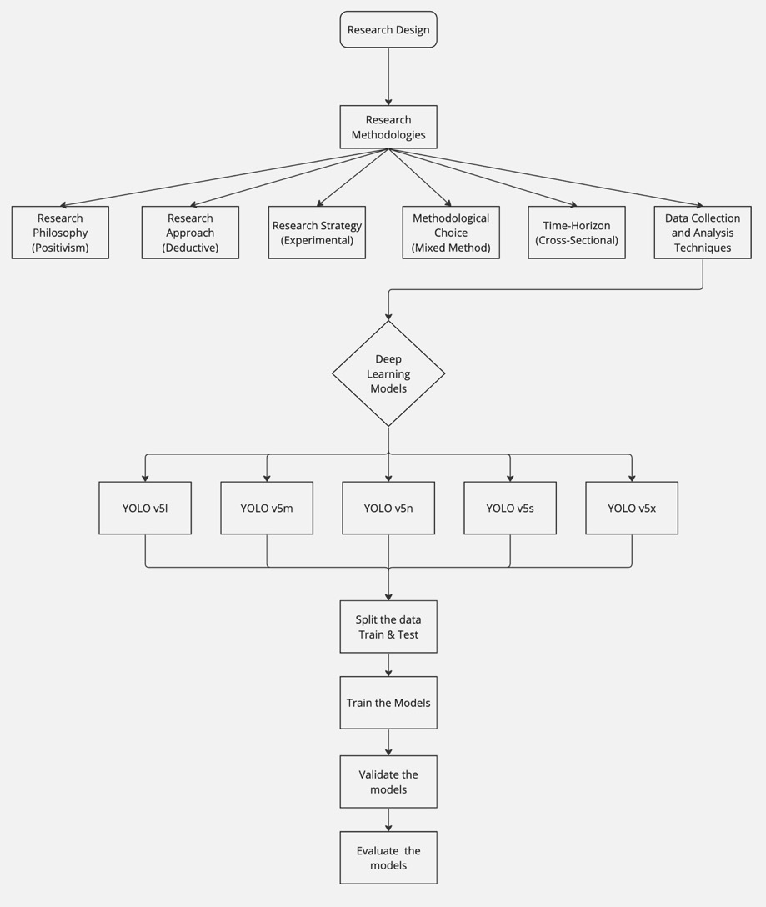
Figure 3.1 Flow Chart of the Research Method

Figure 3.1 illustrates the research methodology, which combines a deductive approach and positivist philosophy to carry out an experimental investigation using a mixed-methods, cross-sectional design. YOLO deep learning models for object detection are being implemented and evaluated in several iterations as part of this research. Validation, evaluation, model training, and data splitting are all steps in the process.

3.2 Research Methodologies
This chapter employs the Saunders Research Onion (Saunders et al., 2007) method to structure the research design and methodologies. This methodology stacks many research components to provide a thorough and organised way to investigating the intricacies of ADAS technology and assessing it.

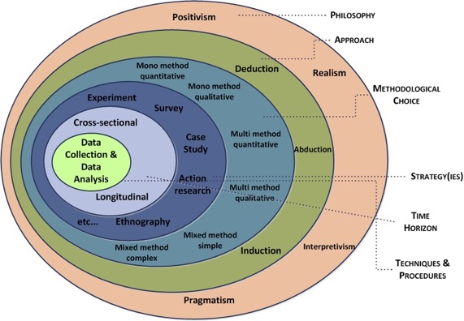
Figure 3.2 Research Onion (Saunders et al., 2007)

3.2.1 Research Philosophy (Positivism)
The positive theory has shown to be extremely useful in the field of Advanced Driver-Assistance Systems (ADAS) research, especially when utilising the cutting-edge YOLO v5 model. True knowledge, according to positivism (Comte, 1858), which has roots in the empirical sciences, comes from sensory experience and empirical data. This is consistent with ADAS research, which demands observable and quantifiable results. In this field, the principles of positivism emphasize the significance of objective analysis, empirical data, a quantitative approach, and a knowledge of causal relationships. To apply positivism to the research on the YOLO v5 model (Redmon & Farhadi, 2018), controlled experiments, meticulous data collection, and statistical analysis are required. Replicability and verification are stressed to validate results. Alternative approach for positivism, Realism places an emphasis on practicality and real-world testing, acknowledging technology constraints to enhance utility and safety in real-world driving scenarios.

3.2.2 Research Approach (Deductive)
The deductive method is essential in Advanced Driver-Assistance Systems (ADAS) research, especially when using the YOLO v5 model. Creating hypotheses based on accepted theories or performance predictions for the model is the first step in this process. One hypothesis could be, for instance, that, in a given set of driving conditions, the object detection accuracy of the YOLO v5 model is higher than that of its predecessors. After that, an organised approach is created to verify these theories using simulations and experiments that mimic actual ADAS situations. Since it entails gathering empirical data on performance metrics like error rates, response times, and detection accuracy, this step is very important (Zhang & Zhang, 2022). After that, the data is carefully examined to see if it confirms or refutes the original theories. Deductive reasoning is by its very nature iterative, frequently producing new hypotheses and additional investigation. This strategy guarantees that the incorporation of the YOLO v5 model into ADAS is not only supported by empirical data but also compliant with the continuous advancements in driving conditions and technology. By offering a strong framework for the methodical validation of ADAS technologies, it guarantees that the YOLO v5 model's implementation makes a significant contribution to the creation of dependable, safe, and efficient driver-assistance systems.

Deductive reasoning is by its very nature iterative, frequently producing new hypotheses and additional investigation (Liang et al., 2020). This strategy guarantees that the incorporation of the YOLO v5 model into ADAS is not only supported by empirical data but also compliant with the continuous advancements in driving conditions and technology. By offering a strong framework for the methodical validation of ADAS technologies, it guarantees that the YOLO v5 model's implementation makes a significant contribution to the creation of dependable, safe, and efficient driver-assistance systems.

3.2.3 Research Strategy (Experimental)
The YOLO v5 model integration in Advanced Driver-Assistance Systems (ADAS) research necessitates the use of an experimental strategy in order to assess and comprehend the model's behaviour under controlled circumstances. Through the design and execution of experiments that closely mimic real-world driving scenarios, this approach enables researchers to systematically test the model's accuracy in decision-making, response times, and object detection capabilities. These experiments could test the YOLO v5 model's resilience under various environmental conditions, such as variations in lighting or weather. To comprehend each variable's unique influence on the functioning of the system, it is important to isolate it. Precise data collection is made possible by this controlled environment, and conclusions regarding the model's effectiveness are then reached through analysis. ADAS research can yield trustworthy, repeatable, and impartial results by using an experimental approach. This method is essential in a field where technological advancements must be thoroughly reviewed for safety and efficiency before being implemented in real-world driving situations. In the end, this approach guarantees that the YOLO v5 model's implementation in ADAS is supported by substantial empirical data, improving vehicle efficiency and safety.

3.2.4 Methodological Choice (Mixed-Method)
In ADAS research, a mixed-methods approach is crucial, particularly when analysing the efficacy and integration of the YOLO v5 model. This method blends qualitative and quantitative research techniques (Johnson & Onwuegbuzie, 2004), providing a thorough lens through which the various facets of ADAS can be investigated. The collection and analysis of data, such as the YOLO v5 model's performance metrics, is the main goal of quantitative approaches. For the purpose of objectively evaluating characteristics such as detection accuracy, response times, and system reliability under different circumstances, this data is essential. Simultaneously, qualitative techniques are utilised to acquire more profound understanding of the user experience, encompassing viewpoints, usability issues, and real-world consequences of integrating the YOLO v5 model in ADAS.

Methods such as focus groups, surveys, and interviews with developers, users, and subject matter experts offer important context for the quantitative outcomes. This dual strategy guarantees a comprehensive comprehension of the influence of the YOLO v5 model in ADAS (Creswell & Clark, 2017). The qualitative data provides depth by examining the human factors involved in the application of technology, whereas the quantitative data provides a strong empirical foundation regarding the technical performance of the model. Such a mixed-methods approach is especially helpful in ADAS research, where the technology's acceptance and success depend on both the systems' technical performance and their interaction with human users.

3.2.5 Time Horizon (Cross-Sectional)
Using a cross-sectional time horizon is especially helpful in ADAS involving the YOLO v5 model in order to get an accurate relevant snapshot of the model's capabilities. Instead of gathering and evaluating data over a longer period of time, this method does so all at once. A cross-sectional study enables researchers to evaluate the model's performance under particular conditions at the time of the study (Babbie, 2020), which is helpful in the context of ADAS, where technology is developing quickly. This can involve testing the object detection precision, response time, and general dependability of the YOLO v5 model in a range of simulated or actual driving situations. This method's advantage is its capacity to offer quick, contextual insights into the efficacy and functionality of the model as it stands right now. This is critical in an area where technological advancements happen all the time, and keeping up with the most recent changes is necessary to guarantee efficiency and safety. Therefore, a cross-sectional approach provides a useful and quick way to assess the cutting-edge ADAS technology and gives a clear picture of the performance of the YOLO v5 model at a particular moment in time. ADAS technology development and implementation decisions can be made with great help from this snapshot.

3.2.6 Data Collection and Analysis Techniques
The data collection and analysis methods used in Advanced Driver-Assistance Systems (ADAS) research with the YOLO v5 model are designed to efficiently handle and interpret a large dataset, like the 29,000-image dataset that was gathered from GitHub. In this case, the main steps in the data collection process are to extract and curate these images to make sure they accurately represent a range of real-world driving situations and scenarios that are relevant to ADAS features. These photos are essential for the YOLO v5 model's training, testing, and validation because they give the system the visual input it needs to adapt and recognise objects in various driving situations.

Following data collection, the analysis techniques involve essential stages. To improve the dataset's diversity and resilience, data pre-processing is first carried out, which entails cleaning, labelling, and potentially augmenting the images. This stage makes sure the model is trained on high-quality data and experiences a variety of scenarios, including difficult ones like dim lighting or bad weather. The use of machine learning algorithms, especially deep learning methods appropriate for image recognition applications, is the next stage. Using this dataset, the YOLO v5 models are trained to recognise and classify a variety of objects essential to ADAS, including bikes, cars, trucks, pedestrians, and traffic signs. In order to reduce errors and maximise performance, the model's parameters are changed during the training process.

The model is thoroughly examined and validated using a subset of the dataset that it was not previously exposed to after training (Bojarski et al., 2016). To evaluate the model's generalizability, accuracy, and reliability, this step is necessary. Performance metrics are computed to assess the model's object detection abilities, including precision, recall, and the F1 score.

Finally, an analysis is conducted to pinpoint the outcomes' strong points and possible avenues for enhancement. This could entail looking into particular instances where the model performed remarkably well or poorly to identify the underlying causes and guide future research. The YOLO v5 model's application in ADAS will advance thanks to the insights gained from this extensive data collection and analysis process, which guarantees the model's dependability under real-world driving conditions.

Ethical Consideration
Ethical considerations are important when working with large datasets like the 29,000 images from GitHub, as is the case with deep learning models used in advanced driver assistance systems (ADAS). Paramount among these is ensuring data privacy and consent, especially if the images contain identifiable information such as faces or licence plates. To preserve privacy, it's imperative to either get permission from the people portrayed or anonymize the data. The safety of this data is equally crucial, requiring strong security measures to thwart unwanted access and guard against potential online attacks. In order to prevent bias and ensure fairness, it is imperative that the dataset encompass a wide variety of driving conditions and environments. This will help to prevent any distortion of the model's performance.

In a field where public safety is directly affected, ethical integrity requires transparency and accountability in the documentation of methodologies and data handling procedures. Furthermore, especially in areas with strict data protection laws, this research must abide by industry standards and applicable laws. Furthermore, because ADAS technologies and vehicle safety are directly related, it is imperative to take public safety into account. The study also has to conform to ethical AI use guidelines, guaranteeing that the model's implementation respects people's rights and welfare and takes into account the technology's potential effects on society as a whole. To ensure that technological advancements are not only innovative but also safe, equitable, and compliant with ethical standards, ethical considerations are fundamental to conducting responsible and meaningful ADAS research.

Chapter 4: Data Analysis and Findings
In this technical analysis the data collection have been done from GitHub repository and total image was to about 29800. The splitting total images between train image and test image in 80:20 ratios was done. However before going detailing on technical analysis some key terms are discussed which is essential how the technical analysis is performed by respective model.

- Dataset Description : The dataset have taken in such a way while driving a video was set to take front images. This dataset was downloaded from the GitHub weblink. There was 29800 images with image labels. The main folder is export and under export folders there are two folders named as images and labels. Some of images with respect to labels are shown in below (Table 1).

- Direct Link For The Dataset: https://github.com/HariprasathM1611/ADAS/tree/e1daddd73cc9af0f5efdf25ccde79d7904584fa5/datasets

Image | Label
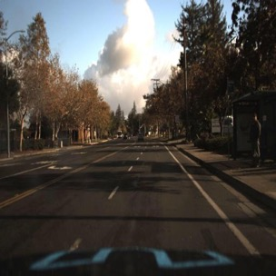  Image name:  1478019952686311006_jpg.rf.54e2d12dbabc46be3c78995b6eaf3fee.jpg | 10 0.43359375 0.48828125 0.0166015625 0.0283203125  1 0.458984375 0.494140625 0.0244140625 0.0263671875  1 0.5087890625 0.4970703125 0.0283203125 0.0380859375  2 0.9287109375 0.5107421875 0.0361328125 0.21875  Label name:  1478019952686311006_jpg.rf.54e2d12dbabc46be3c78995b6eaf3fee.txt
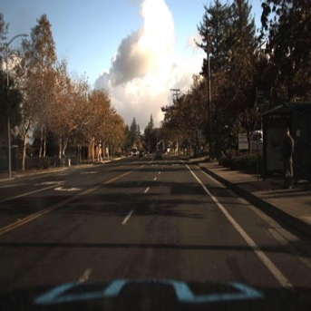  Image name:  1478019952686311006_jpg.rf.JLSB3LP2Q4RuGHYKqfF6.jpg | 10 0.43359375 0.48833333333333334 0.01614583333333333 0.028333333333333335  1 0.45859374999999997 0.4941666666666667 0.024479166666666666 0.02666666666666667  1 0.5088541666666666 0.49750000000000005 0.028125 0.03833333333333334  2 0.9286458333333333 0.5108333333333334 0.036458333333333336 0.21833333333333335  Label name:  1478019952686311006_jpg.rf.JLSB3LP2Q4RuGHYKqfF6.txt
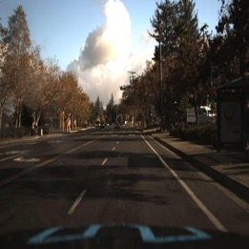  Image name:  1478019953180167674_jpg.rf.8a816c9d7e9b423a63ed6ecd4a663e47.jpg | 10 0.39453125 0.49609375 0.017578125 0.0302734375  1 0.4130859375 0.5029296875 0.0224609375 0.025390625  10 0.8125 0.46875 0.1123046875 0.0849609375  1 0.4677734375 0.5078125 0.0283203125 0.0380859375  Label name:  1478019953180167674_jpg.rf.8a816c9d7e9b423a63ed6ecd4a663e47.txt
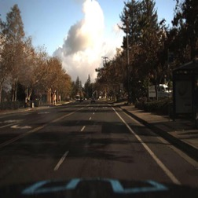  Image name:  1478019953180167674_jpg.rf.azslsZnM8FLQPu3QWLTl.jpg | 10 0.39479166666666665 0.49583333333333335 0.017708333333333333 0.030000000000000002  1 0.41328125 0.5029166666666667 0.022395833333333334 0.025833333333333337  10 0.8122395833333333 0.4683333333333334 0.11197916666666667 0.085  1 0.46822916666666664 0.5075000000000001 0.028125 0.03833333333333334  Label name:  1478019953180167674_jpg.rf.azslsZnM8FLQPu3QWLTl.txt

Table 4.1: Showing of Image and its Label
The YOLO (You Only Look Once) framework, developed in 2015 by Joseph Redmon, Santosh Divvala, Ross Girshick, and Ali Farhadi, is a groundbreaking method in object detection. Its primary benefit lies in its ability to maintain high precision while operating in real-time. This method views object detection as a regression challenge, solved through a comprehensive neural network. The core of YOLO's approach involves segmenting the input image into an S×S grid. Each grid cell is responsible for predicting bounding boxes and their associated confidence levels, along with class probabilities. These predictions are represented as an S×S×(B*5 +C) tensor. Architecturally, YOLO is composed of 24 convolutional layers, complemented by 2 fully connected layers. It employs alternating 1×1 convolution layers to streamline the feature space from preceding layers. The network's final output is a predictive tensor with dimensions 7×7×30.
- Combination pair of YOLO and RCNN

- YOLO proposes to use an end-to-end neural network that performs predictions of bounding boxes and class probabilities simultaneously. It differs from the approach taken by previous object detection algorithms, which reuse classifiers to perform detection. By following a fundamentally different approach to object detection, YOLO achieved advanced results, beating other real-time object detection algorithms by a large margin. While algorithms like Faster RCNN work by using a regional proposal network to find potential regions of interest and then identify those regions separately, YOLO makes all its predictions using a single fully connected layer. Methods that use Region Proposal Networks perform multiple iterations for the same image, while YOLO gets away with a single iteration.

- Since YOLO debuted in 2015, several new versions of the same model have been offered, each one building and improving on the previous one. Here's a timeline of YOLO's growth over the years. One of the key techniques used in the YOLO model is Non-Maximum Pressure (NMS). NMS is a processing step used to improve the accuracy and efficiency of object detection. When an object is detected, it is common to create several boxes for an object in the image. These link boxes may overlap or be in different places, but they all represent the same object. NMS is used to identify and remove redundant or invalid bounding boxes and extract a number of boxes for each object in the image.

- Mechanism behind the principle of YOLO method
Each bounding box (as shown in Figure 4.1) has 5 additional values ​​in addition to the class probabilities, which are as follows:
- P_{c}: certainty of the presence of an object in the bounding box
- b_{x}, b_{y} : The coordinates of the center of the current object, if any. This value is "don't worry" if there is no object.
- b_{h}, b_{w}: height and width of the current object. This value is "don't worry" if there is no object.
- c: Class of the detected object
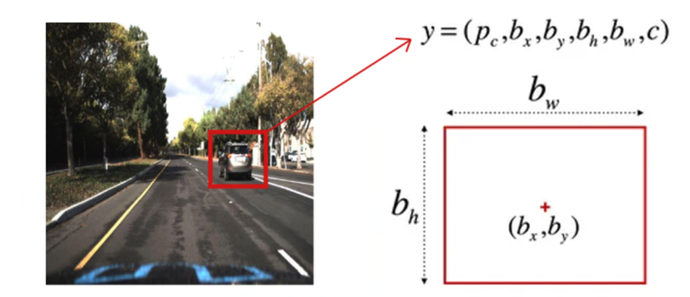
Figure 4.1: Detection object in the bounding box determined by class probabilities

- Non-max Suppression - Streamlines object detection by keeping only the most confident bounding box for each object. It starts by selecting the box with the highest confidence score, then removes any overlapping boxes with lower scores. This process repeats until all objects have a single, best bounding box.

Here are the steps:
- Step 1: Start by figuring out the potential object parameters for each grid element: bx (box centre x-coordinate), by (box centre y-coordinate), bw (box width), and bh (box height).
- Step 2: Any items with a probability of confidence, Pc, equal to or less than 0.6 should be removed since they have a lower probability of having a true object.
- Step 3: For the remaining components of the grid:
- Step 3.1: Assign the potential item to the element whose enclosing box corresponds to the highest Pc value.
- Step 3.2: Eliminate any remaining bounding boxes with considerable overlap with the projected box (IoU of 0.5 or greater).
- Step 3.3: Return to step 3

- Intersection over Union (IoU) - Intercept over sum is a popular metric for measuring localization accuracy and calculating localization errors in object detection models. To calculate the IoU (as shown in Figure 4.2) between predicted and ground bounding boxes, we first take the intersection area between two corresponding bounding boxes for the same object. We then calculate the total area covered by the two bounding boxes - also known as the "Union" and the area of ​​overlap between them called the "intersection”. The intersection divided by Union gives us the ratio of overlap to total area, providing a good estimate of how close the prediction bounding box is to the original bounding box.
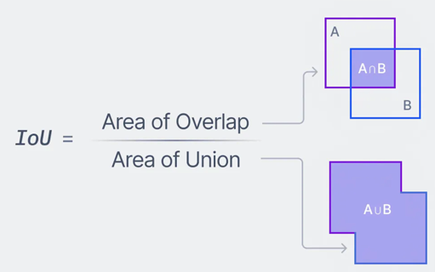
Figure 4.2: IoU Definition

Average Precision (AP) - Accuracy (AP) is calculated as the area under the accuracy vs a set of predictions. The recall information is calculated as the ratio of the total estimates produced by the model within a category to the total number of existing labels for that category. Accuracy refers to the ratio of true positives compared to the total estimates produced by the model. There is usually a trade-off between recall and precision, which can be graphically represented through a curve by varying the categorization threshold. The area under this precision versus recall curve gives us the average precision for each class within the model. The average of this value, obtained across all classes, is called the mean average accuracy (mAP).In object detection, precision and recall are not used for class prediction. Instead, they serve as bounding box projections to measure decision performance. IoU value > 0.5. IoU values ​​< 0.5 are considered negative predictions.

- YOLO v5 - YOLO v5 was introduced in 2020 by the same team that developed the original YOLO algorithm as an open-source project and is maintained by Ultralytics. YOLO v5 builds on the success of previous versions and adds several new features and improvements. Unlike YOLO, YOLO v5 uses a more complex architecture based on the EfficientNet network architecture (as shown in Figure 4.3). The use of a more complex architecture in YOLO v5 allows for higher accuracy and better generalization to a wider range of object categories.

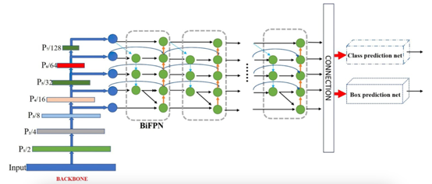
Figure 4.3: Layers of EfficientNet model

- The computer vision model YOLOv5 presents an innovative anchor box creation method known as "dynamic anchor boxes." This technique combines the actual sizes and shapes of items observed in photos using a unique algorithm. The ideal forms and sizes for the anchor boxes are then determined using these groupings. In essence, this makes the model more accurate in identifying the size and form of things by improving the match between the anchor boxes and the real items it is attempting to detect.
- Another difference between YOLO and YOLO v5 is the training data used to learn the object detection model. YOLO was trained on the PASCAL VOC dataset, which consists of 20 object categories. YOLO v5, on the other hand, was trained on a larger and more diverse dataset called D5, which includes a total of 600 object categories.

- Comparison steps for finding concrete reasons of utilizing the YOLO v5 over YOLO v4 –

- Spatial pyramid pooling (SPP), a pooling layer approach that reduces the spatial resolution of feature maps, is a new feature in YOLO (You Only Look Once) iteration five. This improvement helps the model recognise things of different sizes, which is especially useful for spotting tiny items. SPP is already included in YOLO v4, however v5 improves this design for better performance.
- During model training, YOLO v4 and v5 use a similar mechanism for their loss function. However, YOLO v5 incorporates a new feature called "CIoU loss." This version of the IoU loss function was designed specifically to increase model performance in imbalanced datasets.
- You Only Look Once, or YOLO is a well-known object recognition technique that has had a big impact on computer vision. YOLO is particularly well-suited for real-time recognition of object tasks because of its efficiency and rapidity. It has state-of-the-art performance on several benchmarks and is widely used in real-world applications.
- One of YOLO's main advantages is its rapid processing speed, which allows for real-time image analysis. This functionality is particularly helpful in situations involving augmented reality, autonomous vehicles, and video surveillance. Yolo's simple design makes it easier to build and adapt to a variety of applications, and it requires less training data than other systems.
- YOLO is still a useful technique for object detection even in the face of some obstacles, such as the inability to identify small objects and the limits of thorough item categorization. Many new directions for research and innovation have been made possible by its contribution to the area. Exciting future improvements to YOLO and related object recognition techniques are anticipated due to the continuous advancements in computer vision research.

Analysis –In the analysis section, 5 types of YOLOv5 (as shown in Figure 4.4) have been experimented for car vehicle detection on the basis of their precision, recall, F1 scores and observation on confusion table. First of all the layer’s formation of YOLOv5 is shown in below.

- Model layers for YOLOv5:

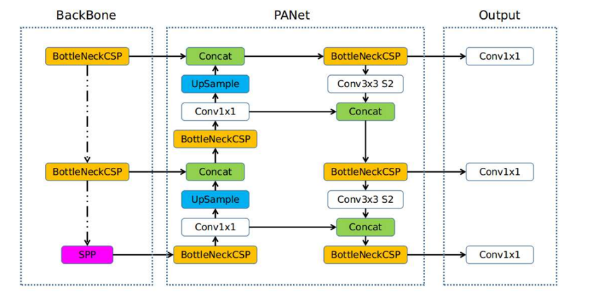
Figure 4.4: Model layers for YOLOv5

- Result analysis –In the result analysis section, the five custom formation of YOLOv5 have been shown for their accuracy and precision over detection on car vehicle which assists the driver’s awareness on the road while driving. In the dataset there are distinct 11 class labels for detection. Class, Image, Instances, P (Precision), R(Recall), mAP50 (mean average Precision), and mAP50-95:100% are the columns for showing the result accuracy.

- YOLOv5l Model:

custom_YOLOv5l summary: 302 layers, 47418512 parameters, 0 gradients
Class Images Instances P R mAP50 mAP50-95: 100% 15/15 [00:08<00:00, 1.70it/s]
all 476 3159 0.889 0.0593 0.0797 0.032
biker 476 44 1 0 0.000604 0.000239
car476 2089 0.621 0.537 0.576 0.254
pedestrian 476 368 1 0 0.012 0.00321
trafficLight 476 84 1 0 0.0422 0.0146
trafficLight-Green 476 179 1 0 0.0108 0.00356
trafficLight-GreenLeft 476 9 1 0 0 0
trafficLight-Red 476 211 0.273 0.0569 0.0486 0.0134
trafficLight-RedLeft 476 51 1 0 0.0907 0.0252
trafficLight-Yellow 476 16 1 0 0 0
truck 476 108 1 0 0.0158 0.00533

Table 4.2: YOLOv5l Model’s details and its analysis
From the above Table 4.2, for the car detection the parameters P = 0.621 and mAP=0.576 are shown.

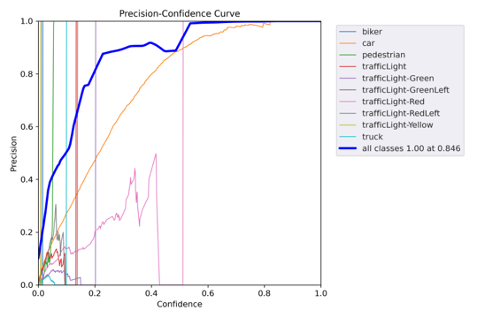 | 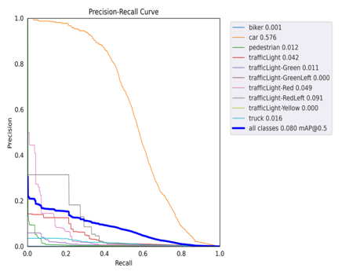
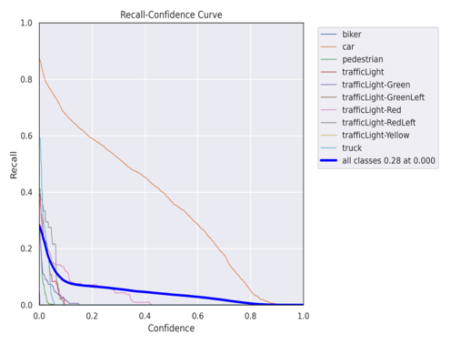 | 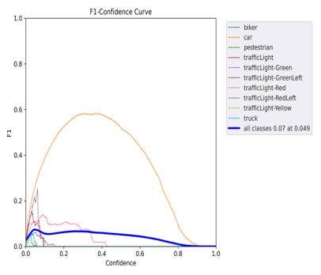

Figure 4.5: YOLOv5l Model’s performance curves

From the above Figure 4.5, it is clear that car vehicle detection is more detectable than other objects by this type of model.

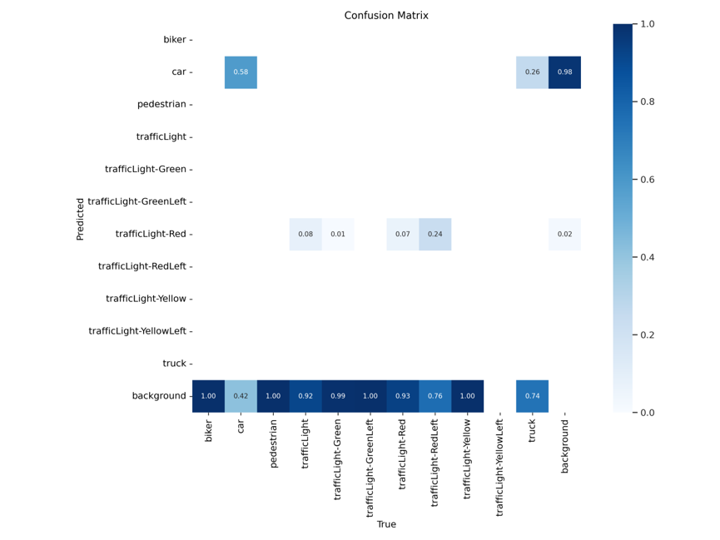

Figure 4.6: Confusion matrix among the objects

From the above Figure 4.6, it is depicted that TP (true positive) between car-car is detected as 58% which is highest than other object’s detection.

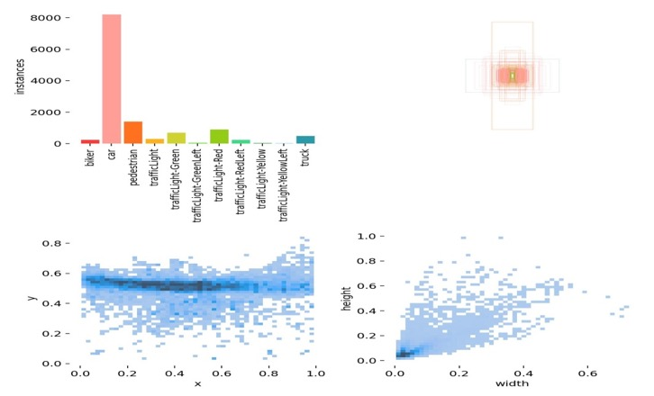
Figure 4.7: Labels and measurement on its instances
From the above Figure 4.7, car object have highest instances than others.

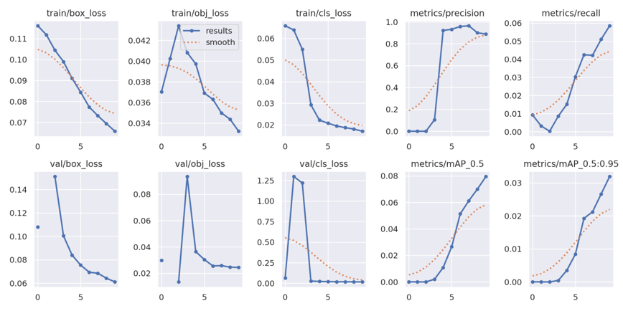
Figure 4.8: Training and Testing analysis

From the above figure, if box_loss, obj_loss and cls_lossare observed then it is found that these parameter’s values are gradually decreased over incremental iteration which means the improvement of precision value as well as moving average precision of detection rate.

- YOLOv5m Model:

custom_YOLOv5m summary: 212 layers, 20893344 parameters, 0 gradients, 48.0 GFLOPs
Class Images Instances P R mAP50 mAP50-95: 100% 15/15 [00:08<00:00, 1.73it/s]
all 476 3159 0.501 0.127 0.093 0.0388
biker 476 44 1 0 0.0011 0.00024
car 476 2089 0.368 0.675 0.609 0.277
pedestrian 476 368 0 0 0.0194 0.00386
trafficLight 476 84 0.16 0.179 0.0992 0.0384
trafficLight-Green 476 179 0.142 0.128 0.037 0.0117
trafficLight-GreenLeft 476 9 1 0 0 0
trafficLight-Red 476 211 0.155 0.166 0.085 0.0273
trafficLight-RedLeft 476 51 0.187 0.118 0.0585 0.0229
trafficLight-Yellow 476 16 1 0 0 0
truck 476 108 1 0 0.0207 0.00674

Table 4.3: YOLOv5m Model’s details and its analysis
From the above Table 4.3, for the car detection the parameters P = 0.368 and mAP=0.609 are shown.

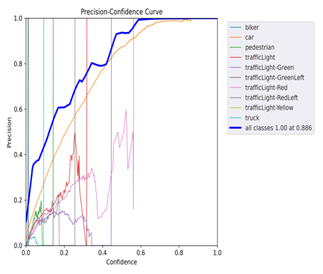 | 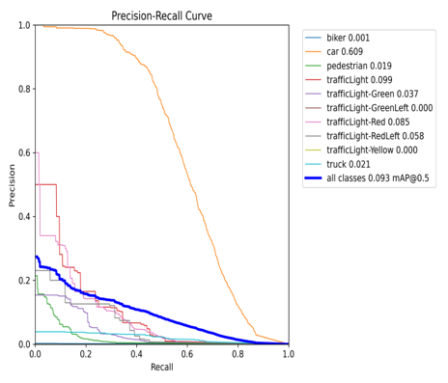
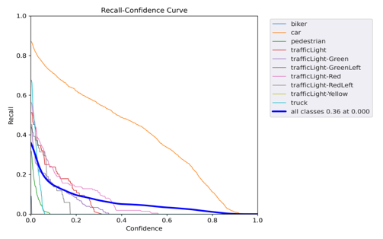 | 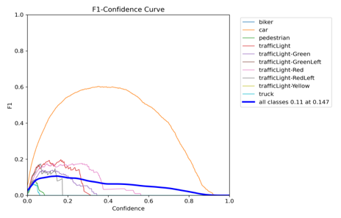

Figure 4.9: YOLOv5m Model’s performance curves

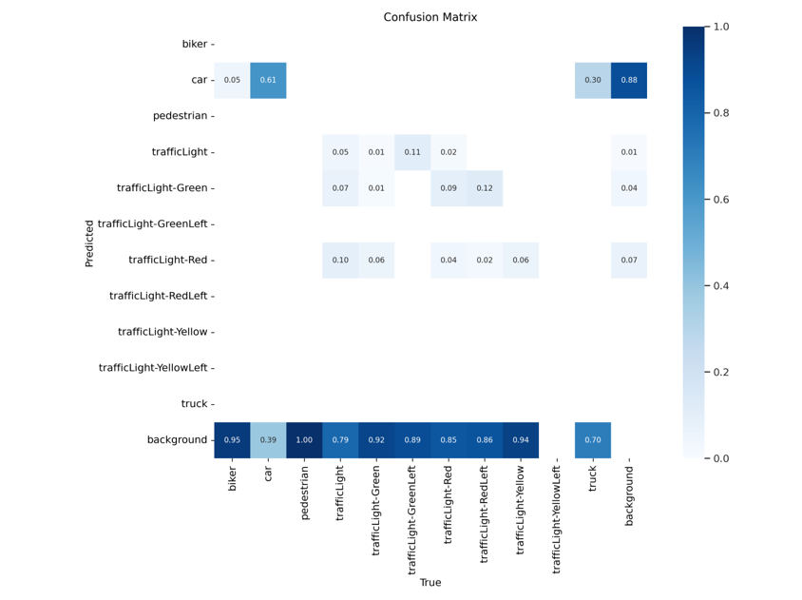
Figure 4.10: Confusion matrix among the objects

From the above Figure 4.10, it is depicted that TP (true positive) between car-car is detected as 61% which is highest than other object’s detection.
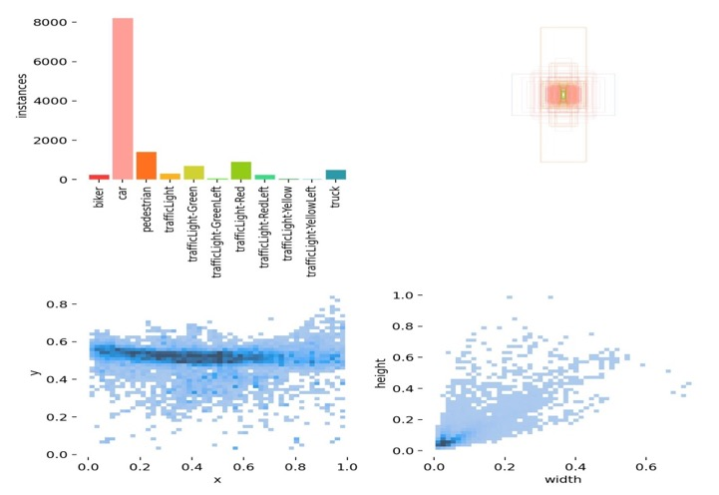
Figure 4.11: Labels and measurement on its instances
From the above Figure 4.11, car object have highest instances than others.

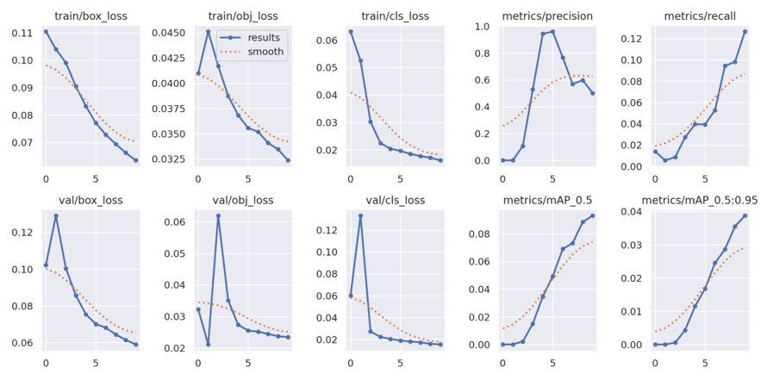
Figure 4.12: Training and Testing analysis

From the above Figure 4.12, if box_loss, obj_loss and cls_lossare observed then it is found that these parameter’s values are gradually decreased over incremental iteration which means the improvement of precision value as well as moving average precision of detection rate.

- YOLOv5n Model:

custom_YOLOv5n summary: 157 layers, 1774048 parameters, 0 gradients, 4.2 GFLOPs
Class Images Instances P R mAP50 mAP50-95: 100% 15/15 [00:06<00:00, 2.16it/s]
all 476 3159 0.963 0.0403 0.0481 0.0176
biker 476 44 1 0 0 0
car 476 2089 0.632 0.403 0.462 0.171
pedestrian 476 368 1 0 0.00078 0.000177
trafficLight 476 84 1 0 0 0
trafficLight-Green 476 179 1 0 0 0
trafficLight-GreenLeft 476 9 1 0 0 0
trafficLight-Red 476 211 1 0 0.00841 0.00181
trafficLight-RedLeft 476 51 1 0 0 0
trafficLight-Yellow 476 16 1 0 0 0
truck 476 108 1 0 0.00935 0.00261

Table 4.4: YOLOv5n Model’s details and its analysis
From the above Table 4.4, for the car detection the parameters P = 0.632 and mAP=0.462 are shown.

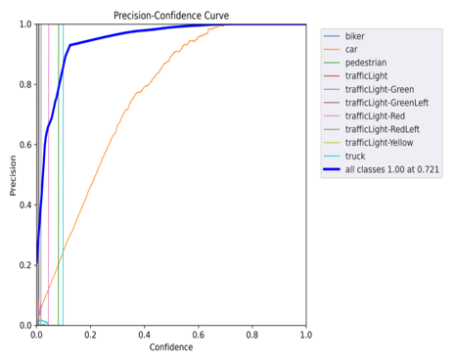 | 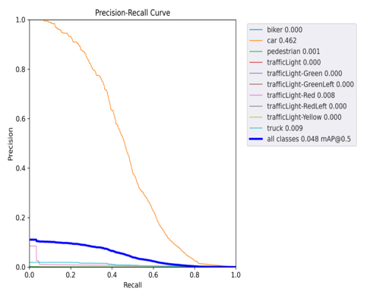
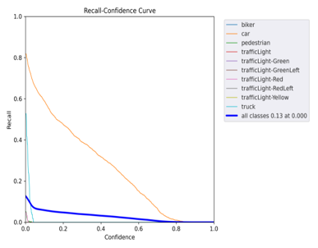 | 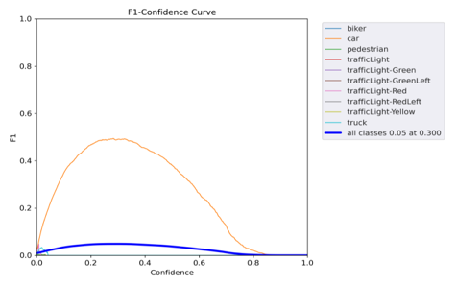
Figure 4.13: YOLOv5n Model’s performance curves
From the above Figure 4.13, it is clear that car vehicle detection is more detectable than other objects by this type of model.

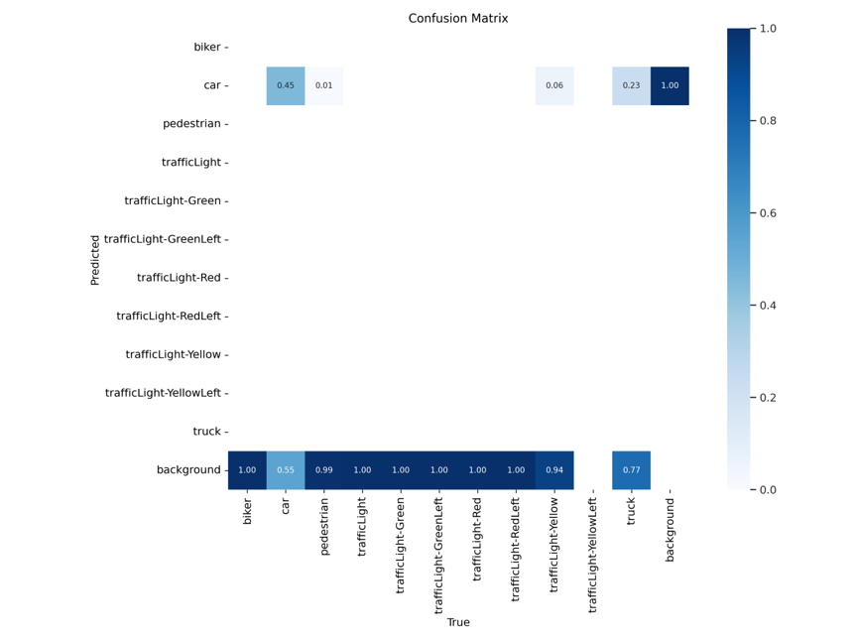
Figure 4.14: Confusion matrix among the objects

From the above Figure 4.14 it is depicted that TP (true positive) between car-car is detected as 45% which is highest than other object’s detection.

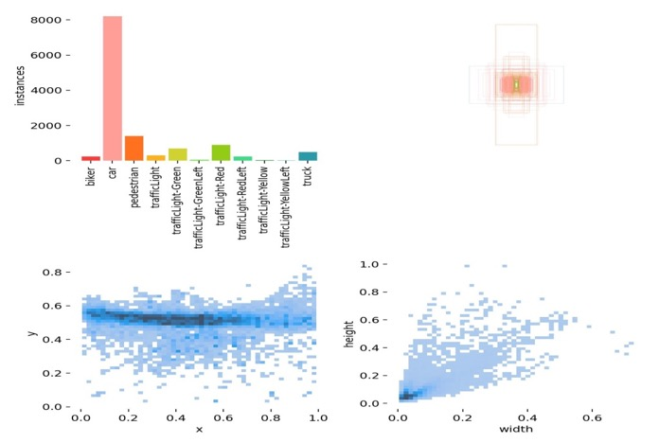
Figure 4.15: Labels and measurement on its instances
From the above Figure 4.15, car object have highest instances than others.

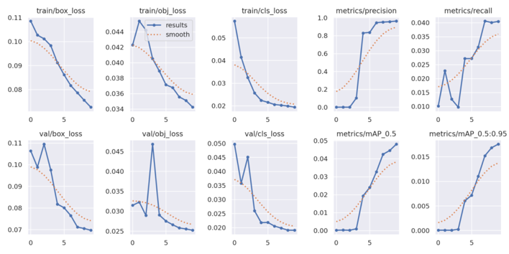

Figure 4.16: Training and Testing analysis

From the above Figure 4.16, if box_loss, obj_loss and cls_lossare observed then it is found that these parameter’s values are gradually decreased over incremental iteration which means the improvement of precision value as well as moving average precision of detection rate.

- YOLOv5s Model:

custom_YOLOv5s summary: 182 layers, 7273488 parameters, 0 gradients
Class Images Instances P R mAP50 mAP50-95: 100% 15/15 [00:06<00:00, 2.47it/s]
all 476 3159 0.868 0.0511 0.0773 0.031
biker 476 44 1 0 0.000824 0.00019
car 476 2089 0.684 0.511 0.577 0.248
pedestrian 476 368 1 0 0.00299 0.000676
trafficLight 476 84 1 0 0.0585 0.02
trafficLight-Green 476 179 1 0 0.0184 0.00531
trafficLight-GreenLeft 476 9 1 0 0 0
trafficLight-Red 476 211 0 0 0.0454 0.0132
trafficLight-RedLeft 476 51 1 0 0.0561 0.0183
trafficLight-Yellow 476 16 1 0 0 0
truck 476 108 1 0 0.0137 0.00437
Table 4.5: YOLOv5s Model’s details and its analysis
From the above Table 4.5, for the car detection the parameters P = 0.684 and mAP=0.577 are shown.

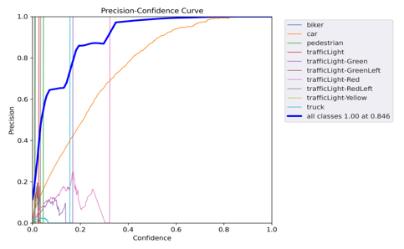 | 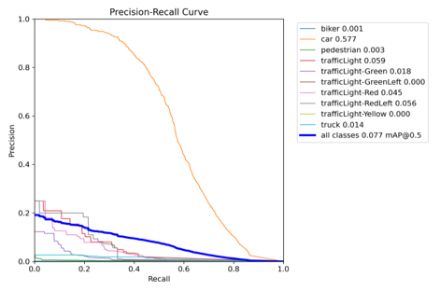
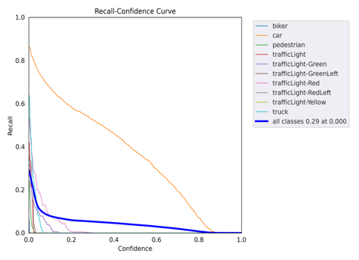 | 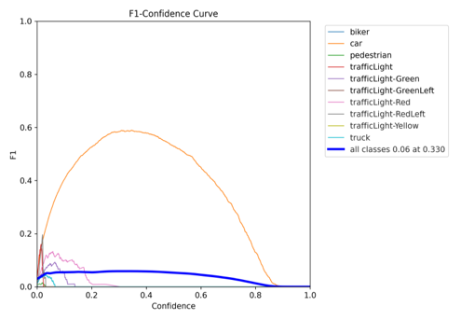
Figure 4.17: YOLOv5s Model’s performance curves
From the above Figure 4.17, it is clear that car vehicle detection is more detectable than other objects by this type of model.
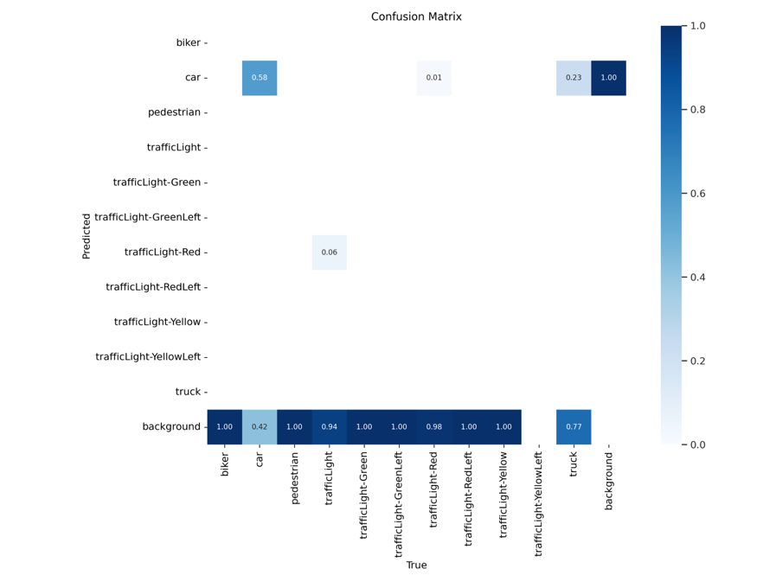
Figure 4.18: Confusion matrix among the objects
From the above Figure 4.18, it is depicted that TP (true positive) between car-car is detected as 58% which is highest than other object’s detection.

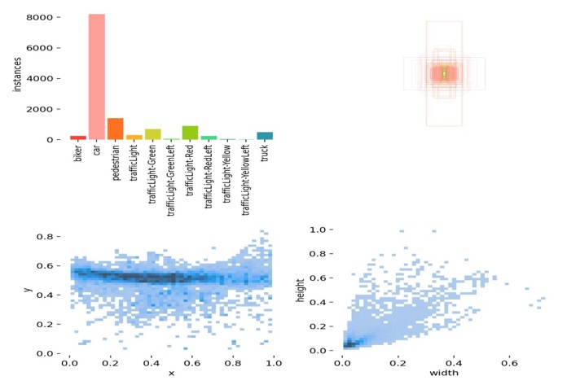

Figure 4.19: Labels and measurement on its instances

From the above Figure 4.19, car object have highest instances than others.

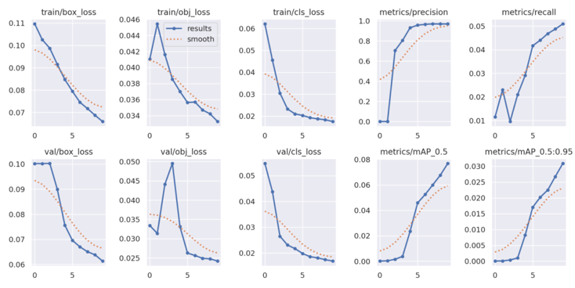
Figure 4.20: Training and Testing analysis

From the above Figure 4.20, if box_loss, obj_loss and cls_lossare observed then it is found that these parameter’s values are gradually decreased over incremental iteration which means the improvement of precision value as well as moving average precision of detection rate.

- YOLOv5x Model:

custom_YOLOv5x summary: 322 layers, 86240704 parameters, 0 gradients, 204.0 GFLOPs
Class Images Instances P R mAP50 mAP50-95: 100% 15/15 [00:09<00:00, 1.52it/s]
all 476 3159 0.563 0.104 0.101 0.0419
biker 476 44 1 0 0.00095 0.000207
car 476 2089 0.209 0.763 0.628 0.291
pedestrian 476 368 0.164 0.0272 0.0231 0.00651
trafficLight 476 84 1 0 0.0871 0.0285
trafficLight-Green 476 179 0.0689 0.0503 0.0189 0.00669
trafficLight-GreenLeft 476 9 1 0 0 0
trafficLight-Red 476 211 0.17 0.182 0.0864 0.0301
trafficLight-RedLeft 476 51 1 0 0.145 0.0493
trafficLight-Yellow 476 16 1 0 0 0
truck 476 108 0.0221 0.0185 0.0188 0.00675

Table 4.6: YOLOv5x Model’s details and its analysis
From the above Table 4.6, for the car detection the parameters P = 0.209 and mAP=0.628 are shown.

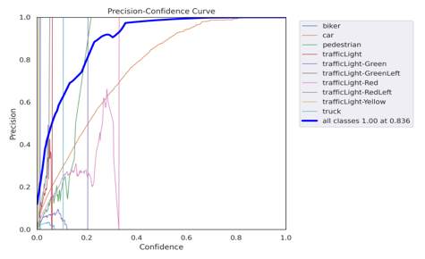 | 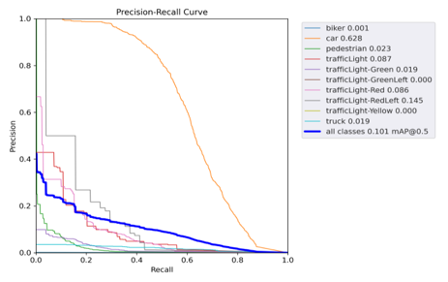
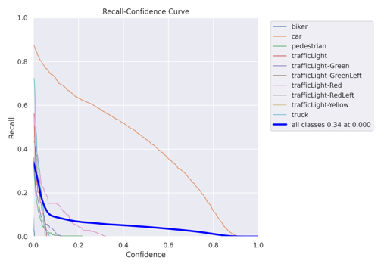 | 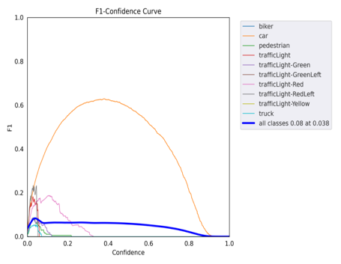

Figure 4.21: YOLOv5x Model’s performance curves
From the above Figure 4.21, it is clear that car vehicle detection is more detectable than other objects by this type of model.
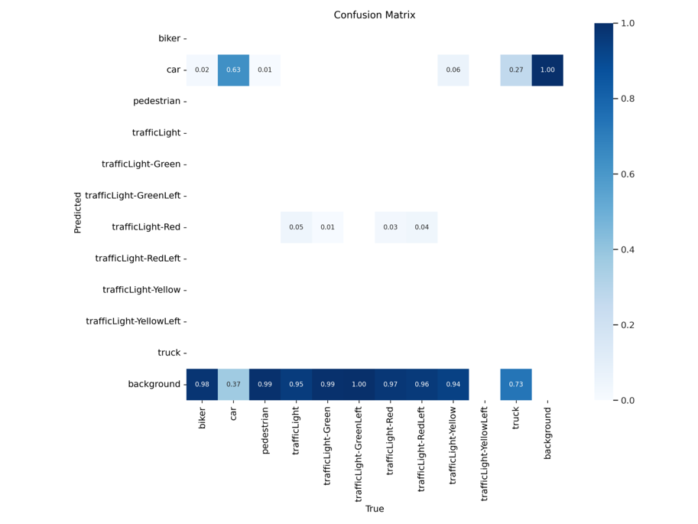
Figure 4.22: Confusion matrix among the objects

From the above Figure 4.22, it is depicted that TP (true positive) between car-car is detected as 63% which is highest than other object’s detection.
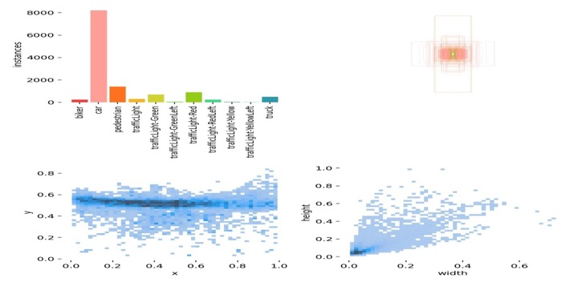

Figure 4.23: Labels and measurement on its instances

From the above Figure 4.23, car object have highest instances than others.

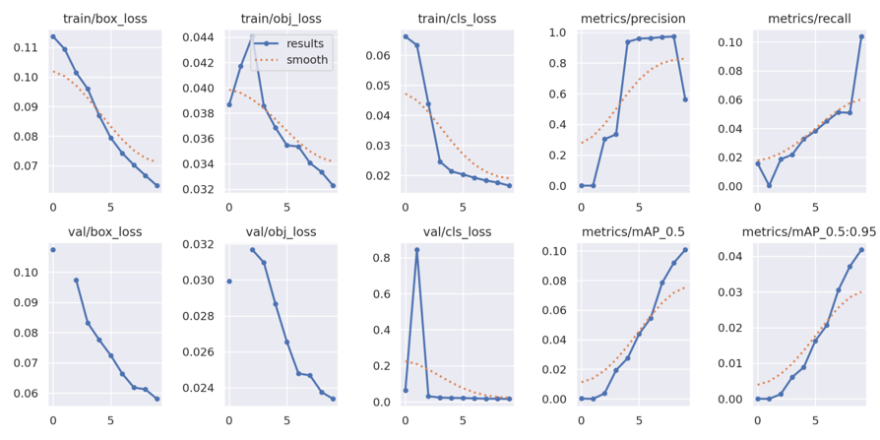

Figure 4.24: Training and Testing analysis

From the above Figure 4.24, if box_loss, obj_loss and cls_lossare observed then it is found that these parameter’s values are gradually decreased over incremental iteration which means the improvement of precision value as well as moving average precision of detection rate.

Detection by Yolov models

YOLOv5l – 65% prob. matched

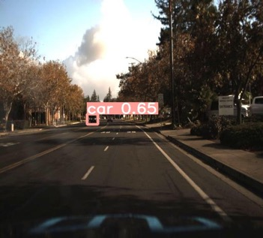

YOLOv5m - 65% prob. matched
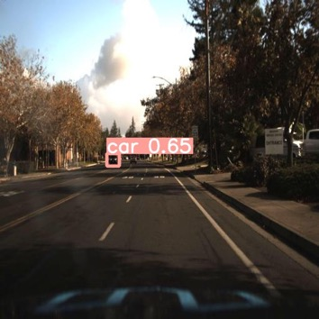

YOLOv5n - 56% prob. matched

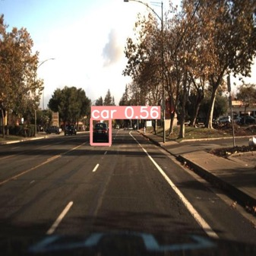

YOLOv5s - 65% prob. matched

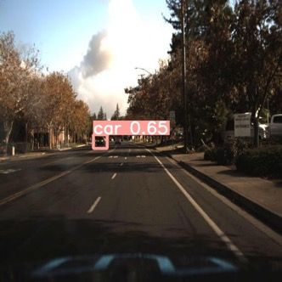

YOLOv5x - 46% prob. matched

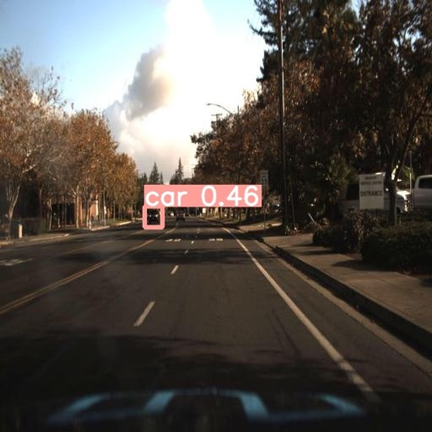

Figure 4.25: Accuracy test on Image sample

Time complexity and Space Complexity Analysis on Model’s performances
custom_YOLOv5l summary: 401 layers, 47447184 parameters, 47447184 gradients | Wall time: 10min 6s  10 epochs completed in 0.151 hours. | depth_multiple: 1.0  width_multiple: 1.0
custom_YOLOv5m summary: 291 layers, 20911728 parameters, 20911728 gradients, 48.3 GFLOPs | Wall time: 7min 39s  10 epochs completed in 0.111 hours. | depth_multiple: 0.67  width_multiple: 0.75
custom_YOLOv5n summary: 214 layers, 1778800 parameters, 1778800 gradients, 4.3 GFLOPs | Wall time: 5min 56s  10 epochs completed in 0.084 hours. | depth_multiple: 0.33  width_multiple: 0.25
custom_YOLOv5s summary: 233 layers, 7282064 parameters, 7282064 gradients | Wall time: 5min 46s  10 epochs completed in 0.081 hours. | depth_multiple: 0.33  width_multiple: 0.50
custom_YOLOv5x summary: 445 layers, 86285104 parameters, 86285104 gradients, 204.8 GFLOPs | Wall time: 14min 51s  10 epochs completed in 0.228 hours. | depth_multiple: 1.33  width_multiple: 1.25

Table 4.7a: Time complexity and Space Complexity Analysis on Model’s performances

Figure 4.26: Time Complexity analysis

Figure 4.27: Space Complexity analysis

Figure 4.28: Time (1:1) Complexity and Space (1:1000) Complexity analysis

Figure 4.29: Parametersused in model analysis

Figure 4.30: mAP measurements with Depth and width multiplierused in model analysis

Figure 4.31: Essential feature analysis for selecting the best models and retest for 100 epochs in analysis

Side by side comparison of different models
Sl Nos. | Model name | P : Precision | R: Recall | mAP50 : Mean average precision at an intersection over union (IoU) threshold of 0.50 | car-car detection in True Positive from confusion matrix | Sample image testing in terms of probability | Nos. of Layers | 10 epochs completed in hrs | Test Score
1 | YOLOv5l | 0.621 | 0.537 | 0.576 | 0.58 | 0.65 | 401 | 0.151 | 3.51
2 | YOLOv5m | 0.368 | 0.675 | 0.609 | 0.61 | 0.65 | 291 | 0.111 | 3.67
3 | YOLOv5n | 0.632 | 0.403 | 0.462 | 0.45 | 0.56 | 214 | 0.084 | 3.06
4 | YOLOv5s | 0.684 | 0.511 | 0.577 | 0.58 | 0.65 | 233 | 0.081 | 3.87
5 | YOLOv5x | 0.209 | 0.763 | 0.628 | 0.63 | 0.46 | 445 | 0.228 | 2.67

Table 4.7b: Side by side comparative Analysis on Model’s performances

Selecting Criteria:
$Test score=\sum_{i=1}^{n=6}{(variable_{i}×w_{i})+\frac{{ L}_{m}}{{max of L}_{m_{allmodels}}}}$

(Note that all variables and its symbol are shown in the below Table 4.7c and Figure 4.33)

List of variables:

P : Precision | R: Recall | mAP50 : Mean average precision at an intersection over union (IoU) threshold of 0.50 | car-car detection in True Positive from confusion matrix | Sample image testing in terms of probability | Nos. of Layers | 10 epochs completed in hrs
variable₁ | variable₂ | variable₃ | variable₄ | variable₅ | L_{m} | variable₆
6% | 6% | 11% | 12% | 6% | $$\frac{L_{m}}{\max{of all L_{m}}}$$ | 59%
weight | weight | weight | weight | weight | constant | weight

Table 4.7c: To obtain the Test Score by weighted linear equation from the selecting variables

Figure 4.32: Test Score values of different models

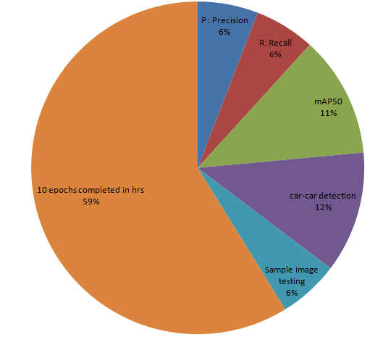
Figure 4.33: Ratios of the different selecting parameters for weight matrix $w_{i}$
From the above Figure 4.31, 4.32, 4.33 and Table 4.7b4.7c, YOLOv5m and YOLOv5s are selected as in best models as per Accuracy test on Image samples, mAP, Time complexity, layers and depth as well as width multiplier factors.

Summary of best two models:

- YOLOv5m Model (1/2 best model)

custom_YOLOv5m summary: 291 layers, 20911728 parameters, 20911728 gradients, 48.3 GFLOPs
Class Images Instances P R mAP50 mAP50-95: 100% 15/15 [00:08<00:00, 1.86it/s]
all 476 3159 0.74 0.382 0.429 0.213
biker 476 44 0.551 0.182 0.258 0.0948
car 476 2089 0.795 0.741 0.792 0.461
pedestrian 476 368 0.506 0.277 0.294 0.0967
trafficLight 476 84 0.663 0.445 0.56 0.279
trafficLight-Green 476 179 0.569 0.575 0.53 0.191
trafficLight-GreenLeft 476 9 1 0 0.0325 0.0158
trafficLight-Red 476 211 0.757 0.602 0.661 0.328
trafficLight-RedLeft 476 51 0.862 0.369 0.478 0.227
trafficLight-Yellow 476 16 1 0 0.0331 0.0116
truck 476 108 0.7 0.63 0.656 0.423
100 epochs completed in 0.964 hours.

Table 4.8: Performance data of YOLOv5m Model (1/2 best model)

From the above Table, 4.8 for the car detection the parameters P = 0.795 and mAP=0.792are shown.

Figure 4.34: YOLOv5m model’s Performances

From the above Figure 4.34, it is clear that Precision and mAP values are both incremental in accuracy from observing the cases between 10 epochs and 100 epochs.

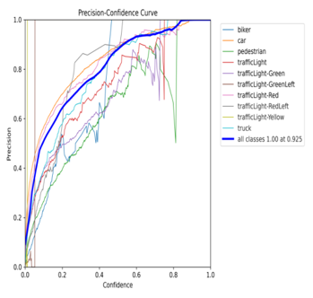 | 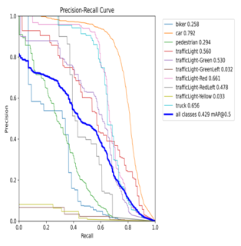
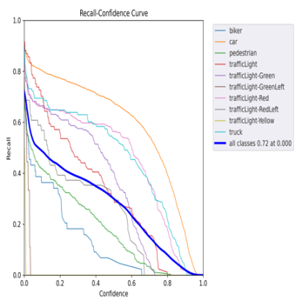 | 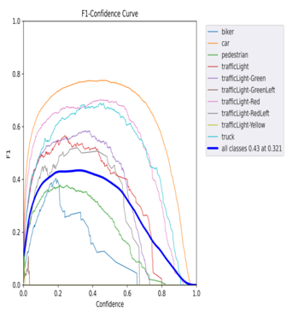

Table 4.9: Performance Curves of YOLOv5m Model (1/2 best model)

From the above Table 4.9, it is clear that car vehicle detection is more detectable than other objects by this type of model.
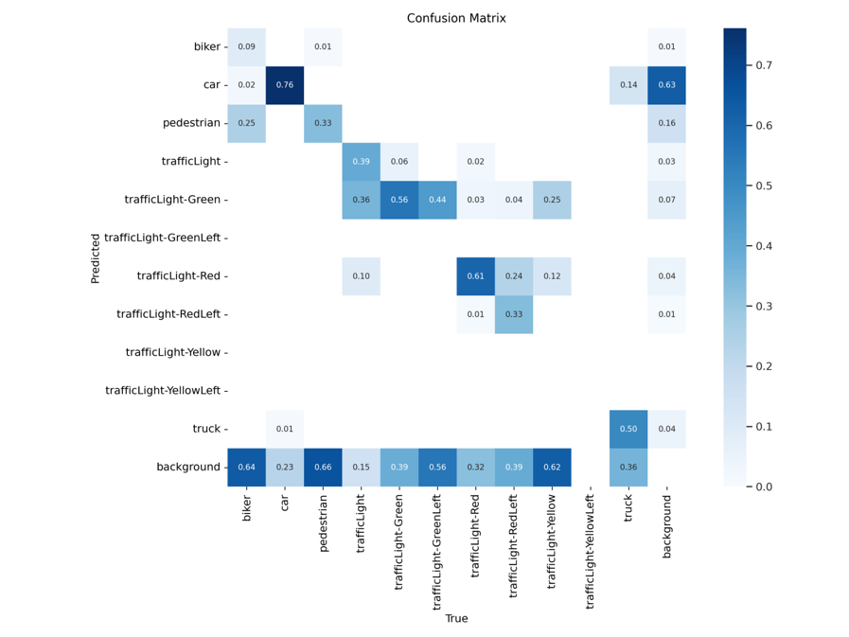

Figure 4.35: Confusion matrix among the objects

From the above Figure 4.35 it is depicted that TP (true positive) between car-car is detected as 76% which is highest than other object’s detection while in 10 epochs cases only 61% detection is achieved.

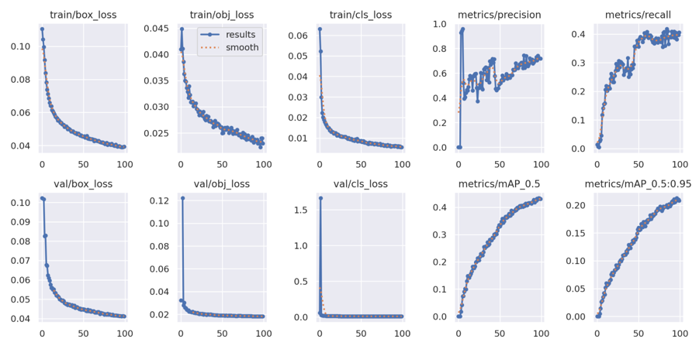
Figure 4.36: Training and Testing analysis

From the above Figure 4.36, if box_loss, obj_loss and cls_lossare observed then it is found that these parameter’s values are gradually decreased over incremental iteration which means the improvement of precision value as well as moving average precision of detection rate.

- YOLOv5s Model (2/2 best model)
custom_YOLOv5s summary: 233 layers, 7282064 parameters, 7282064 gradients
Class Images Instances P R mAP50 mAP50-95: 100% 15/15 [00:06<00:00, 2.22it/s]
all 476 2889 0.658 0.362 0.37 0.176
biker 476 56 0.254 0.286 0.238 0.101
car 476 1890 0.671 0.743 0.769 0.431
pedestrian 476 378 0.362 0.397 0.322 0.104
trafficLight 476 72 0.261 0.5 0.411 0.204
trafficLight-Green 476 176 0.609 0.619 0.584 0.207
trafficLight-GreenLeft 476 9 1 0 0.0237 0.0154
trafficLight-Red 476 167 0.465 0.575 0.551 0.229
trafficLight-RedLeft 476 52 1 0.105 0.419 0.215
trafficLight-Yellow 476 2 1 0 0 0
trafficLight-YellowLeft 476 1 1 0 0.0129 0.00129
truck 476 86 0.619 0.756 0.745 0.429
100 epochs completed in 0.749 hours.

Table 4.10: Performance data of YOLOv5s Model (2/2 best model)

From the above Table 4.10, for the car detection the parameters P = 0.671 and mAP=0.769 are shown.

Figure 4.37: YOLOv5s model’s Performances

From the above Figure 4.37, it is clear that Precision and mAP values are not both simultaneously incremental in accuracy from observing the cases between 10 epochs and 100 epochs. Precision values slightly fall in the case of 100 epochs.

- Comparison between two best models:

Figure 4.38: Comparison between two best models

Conclusion on comparison: YOLOv5m’s performance is higher than YOLOv5s according to the above Figure 4.38.

Chapter 5: Discussions
The research effectively addressed four main objectives in the adoption of deep learning into Advanced Driver Assistance Systems (ADAS). It began exploring the state of deep learning in ADAS today, emphasising algorithmic developments and data processing methods as well as the difficulties encountered. Next, it looked at how deep learning affected particular ADAS features like identifying objects and lane departure alerts, particularly when using YOLO architecture, which showed increases in accuracy and dependability. Additionally, a thorough assessment of many deep learning techniques for ADAS was carried out, with a focus on YOLO's performance with important criteria. Finally, with an emphasis on driving safety and ongoing development using real-world data, the study suggested methods for integrating these deep learning improvements into current ADAS frameworks.

Chapter 6: Conclusion and Recommendation

6.1 Conclusion
Focusing on YOLOv5s in particular, the test of YOLOv5 models shows that they can recognise cars quickly and correctly. Testing tools that looked at things like mean Average accuracy (mAP) and accuracy showed that the models, which were made to find cars, did very well. In real life, YOLOv5 can be useful. It can be used to spy, watch traffic, and make self-driving cars better, per the results. Because it was simple, YOLOv5s worked very well and was fast and accurate at detecting things. So it's a very useful tool when quick and correct recognition is needed because it works in real time and can correctly identify cars. But keep in mind that the types and amounts of samples used for training affect how well YOLOv5 models work. The models can work better and be used in more situations if they are fine-tuned on specific datasets that are important to implementation scenarios. You should also keep up with the constant changes and improvements made to the YOLOv5 design if you want to use the newest features and better performance. With YOLOv5, it looks like things will be able to be identified in real time in smart towns, smart transportation systems, and other places. Researchers might also try to figure out how to use YOLOv5 most effectively on low-resource devices in the future, making sure that it works in a range of computer settings. A lot of this work is about how useful YOLOv5 is in computer vision, especially for smart mobility. A good example of this is YOLOv5, which can identify cars in real time. This shows that deep learning techniques are always getting better and are changing a lot of different types of uses in a lot of different industries.

6.2 Recommendations
People who test YOLOv5 models for real-time car identification can come up with many ways to improve how these models are used. Making data more varied and well-organized should be the main goal of ongoing projects. Set them up to work with a lot of different real-life events in large datasets to make sure they are strong and useful in many cases. Also, the YOLOv5 models need to be kept up to date and changed so that they work better in the planned deployment situation. Making the models fit certain situations, like traffic on roads or in towns, can help them work better and be more useful in some cases. People in business and science are also told to work together so they can share YOLOv5 information, problems, and new developments. This method of working together can get people to fix new issues, improve how things are done, and help YOLOv5 grow. It is important to work on making YOLOv5 work better on edge devices because it is becoming more and more important to use computer vision models on systems that don't have a lot of resources. YOLOv5 will be able to work in more places, like Internet of Things devices and embedded systems, because it will be easy to understand the design and need less processing power. If you put these ideas first, YOLOv5 will be used by more people and have better results in real life.

References
Abdennour, N., Ouni, T., & Amor, N. B. (2021). Driver identification using only the CAN-Bus vehicle data through an RCN deep learning approach. Robotics and Autonomous Systems, 136, 103707.
Ali, E. S., Hasan, M. K., Hassan, R., Saeed, R. A., Hassan, M. B., Islam, S., ... &Bevinakoppa, S. (2021). Machine learning technologies for secure vehicular communication in the internet of vehicles: recent advances and applications. Security and Communication Networks, 2021, 1-23.
Arefnezhad, S., Samiee, S., Eichberger, A., Frühwirth, M., Kaufmann, C., & Klotz, E. (2020). Applying deep neural networks for multi-level classification of driver drowsiness using Vehicle-based measures. Expert Systems with Applications, 162, 113778.
ArunKumar, K. E., Kalaga, D. V., Kumar, C. M. S., Chilkoor, G., Kawaji, M., & Brenza, T. M. (2021). Forecasting the dynamics of cumulative COVID-19 cases (confirmed, recovered, and deaths) for the top 16 countries using statistical machine learning models: Auto-Regressive Integrated Moving Average (ARIMA) and Seasonal Auto-Regressive Integrated Moving Average (SARIMA). Applied soft computing, 103, 107161.
Bachute, M. R., &Subhedar, J. M. (2021). Autonomous driving architectures: insights of machine learning and deep learning algorithms. Machine Learning with Applications, 6, 100164.
Balan, G., Arumugam, S., Muthusamy, S., Panchal, H., Kotb, H., Bajaj, M., ... &Kitmo. (2022). An improved deep learning-based technique for driver detection and driver assistance in electric vehicles with better performance. International Transactions on Electrical Energy Systems, 2022, 1-16.
Borrego-Carazo, J., Castells-Rufas, D., Biempica, E., & Carrabina, J. (2020). Resource-constrained machine learning for ADAS: A systematic review. IEEE Access, 8, 40573-40598.
Bui, D. T., Hoang, N. D., Nguyen, H., & Tran, X. L. (2019). Spatial prediction of shallow landslide using Bat algorithm optimized machine learning approach: A case study in Lang Son Province, Vietnam. Advanced Engineering Informatics, 42, 100978.
Babbie, E. R. (2020). The practice of social research. Cengage AU.
Bojarski, M., Del Testa, D., Dworakowski, D., Firner, B., Flepp, B., Goyal, P., Jackel, L. D., Monfort, M., Muller, U., & Zhang, J. (2016). End to end learning for self-driving cars. arXiv Preprint arXiv:1604.07316,
Cai, X., Shi, K., Sun, Y., Soh, Y., & Tian, Z. (2023). Performance analysis and design of intelligent optimising integral-based event-trigger control for autonomous ground vehicles under DoS attacks. IEEE Transactions on Intelligent Vehicles.
Choi, J. A., & Lim, K. (2020). Identifying machine learning techniques for classification of target advertising. ICT Express, 6(3), 175-180.
Chung, J. J., & Kim, H. J. (2020). An automobile environment detection system based on deep neural network and its implementation using IoT-enabled in-vehicle air quality sensors. Sustainability, 12(6), 2475.
Creswell, J. W., & Clark, V. L. P. (2017). Designing and conducting mixed methods research. Sage publications.
Comte, A. (1858). The positive philosophy of Auguste Comte. Blanchard.
Dodds, S., & Hess, A. C. (2020). Adapting research methodology during COVID-19: lessons for transformative service research. Journal of Service Management, 32(2), 203-217.
Dubey, U. K. B., & Kothari, D. P. (2022). Research methodology: Techniques and trends. CRC Press.
Formosa, N., Quddus, M., Ison, S., Abdel-Aty, M., & Yuan, J. (2020). Predicting real-time traffic conflicts using deep learning. Accident Analysis & Prevention, 136, 105429.
Franciosa, P., Sokolov, M., Sinha, S., Sun, T., & Ceglarek, D. (2020). Deep learning enhanced digital twin for Closed-Loop In-Process quality improvement. CIRP annals, 69(1), 369-372.
Gai, J., Shen, J., Hu, Y., & Wang, H. (2020). An integrated method based on hybrid grey wolf optimizer improved variational mode decomposition and deep neural network for fault diagnosis of rolling bearing. Measurement, 162, 107901.
Gao, X., Xing, G., Roy, S., & Liu, H. (2020). Ramp-cnn: A novel neural network for enhanced automotive radar object recognition. IEEE Sensors Journal, 21(4), 5119-5132.
Greening, N. (2019). Phenomenological research methodology. Scientific Research Journal, 7(5), 88-92.
Grigorescu, S., Trasnea, B., Cocias, T., &Macesanu, G. (2020). A survey of deep learning techniques for autonomous driving. Journal of Field Robotics, 37(3), 362-386.
Guerrero‐Ibañez, J., Contreras‐Castillo, J., &Zeadally, S. (2021). Deep learning support for intelligent transportation systems. Transactions on Emerging Telecommunications Technologies, 32(3), e4169.
Gui, G., Liu, F., Sun, J., Yang, J., Zhou, Z., & Zhao, D. (2019). Flight delay prediction based on aviation big data and machine learning. IEEE Transactions on Vehicular Technology, 69(1), 140-150.
Gui, G., Zhou, Z., Wang, J., Liu, F., & Sun, J. (2020). Machine learning aided air traffic flow analysis based on aviation big data. IEEE Transactions on Vehicular Technology, 69(5), 4817-4826.
Gupta, A., Anpalagan, A., Guan, L., & Khwaja, A. S. (2021). Deep learning for object detection and scene perception in self-driving cars: Survey, challenges, and open issues. Array, 10, 100057.
He, Y., Zhu, C., Wang, J., Savvides, M., & Zhang, X. (2019). Bounding box regression with uncertainty for accurate object detection. Paper presented at the Proceedings of the Ieee/Cvf Conference on Computer Vision and Pattern Recognition, 2888-2897.
Han, X., Ning, W., Ma, X., Wang, X., & Zhou, K. (2020). Improving protein solubility and activity by introducing small peptide tags designed with machine learning models. Metabolic engineering communications, 11, e00138.
Hannan, M. A., Lipu, M. H., Hussain, A., Ker, P. J., Mahlia, T. I., Mansor, M., ... & Dong, Z. Y. (2020). Toward enhanced state of charge estimation of lithium-ion batteries using optimized machine learning techniques. Scientific reports, 10(1), 4687.
Islam, S., Amin, S. H., & Wardley, L. J. (2021). Machine learning and optimization models for supplier selection and order allocation planning. International Journal of Production Economics, 242, 108315.
Johnson, R. B., & Onwuegbuzie, A. J. (2004). Mixed methods research: A research paradigm whose time has come. Educational Researcher, 33(7), 14-26.
Kanna, P. R., & Santhi, P. (2021). Unified deep learning approach for efficient intrusion detection system using integrated spatial–temporal features. Knowledge-Based Systems, 226, 107132.
Khatri, S., Vachhani, H., Shah, S., Bhatia, J., Chaturvedi, M., Tanwar, S., & Kumar, N. (2021). Machine learning models and techniques for VANET based traffic management: Implementation issues and challenges. Peer-to-Peer Networking and Applications, 14, 1778-1805.
Kumbhar, A., Dhawale, P. G., Kumbhar, S., Patil, U., &Magdum, P. (2021). A comprehensive review: Machine learning and its application in integrated power system. Energy Reports, 7, 5467-5474.
Lee, S., Kim, Y., Kahng, H., Lee, S. K., Chung, S., Cheong, T., ... & Kim, S. B. (2020). Intelligent traffic control for autonomous vehicle systems based on machine learning. Expert Systems with Applications, 144, 113074.
Lee, S., Ngoduy, D., & Keyvan-Ekbatani, M. (2019). Integrated deep learning and stochastic car-following model for traffic dynamics on multi-lane freeways. Transportation research part C: emerging technologies, 106, 360-377.
Liu, Y., Duan, W., Huang, L., Duan, S., & Ma, X. (2020). The input vector space optimization for LSTM deep learning model in real-time prediction of ship motions. Ocean Engineering, 213, 107681.
Loey, M., El-Sappagh, S., &Mirjalili, S. (2022). Bayesian-based optimized deep learning model to detect COVID-19 patients using chest X-ray image data. Computers in Biology and Medicine, 142, 105213.
Lyridis, D. V. (2021). An improved ant colony optimization algorithm for unmanned surface vehicle local path planning with multi-modality constraints. Ocean Engineering, 241, 109890.
Liang, B., Wu, S., Xu, K., & Hao, J. (2020). Butterfly detection and classification based on integrated YOLO algorithm. Paper presented at the Genetic and Evolutionary Computing: Proceedings of the Thirteenth International Conference on Genetic and Evolutionary Computing, November 1–3, 2019, Qingdao, China 13, 500-512.
Maniyath, S. R., &Thanikaiselvan, V. (2020). An efficient image encryption using deep neural network and chaotic map. Microprocessors and Microsystems, 77, 103134.
Mao, W., Feng, W., Liu, Y., Zhang, D., & Liang, X. (2021). A new deep auto-encoder method with fusing discriminant information for bearing fault diagnosis. Mechanical Systems and Signal Processing, 150, 107233.
Mondal, P. P., Galodha, A., Verma, V. K., Singh, V., Show, P. L., Awasthi, M. K., ... & Jain, R. (2023). Review on machine learning-based bioprocess optimization, monitoring, and control systems. Bioresource technology, 370, 128523.
Nayak, J. K., & Singh, P. (2021). Fundamentals of research methodology problems and prospects. SSDN Publishers & Distributors.
Ocaña-Fernández, Y., & Fuster-Guillén, D. (2021). The bibliographical review as a research methodology. Revista Tempos E Espaços Em Educação, 14(33), e15614-e15614.
Peng, Z., Yang, J., Chen, T. H., & Ma, L. (2020, November). A first look at the integration of machine learning models in complex autonomous driving systems: a case study on Apollo. In Proceedings of the 28th ACM Joint Meeting on European Software Engineering Conference and Symposium on the Foundations of Software Engineering (pp. 1240-1250).
Que, Y., Dai, Y., Ji, X., Leung, A. K., Chen, Z., Tang, Y., & Jiang, Z. (2023). Automatic classification of asphalt pavement cracks using a novel integrated generative adversarial networks and improved VGG model. Engineering Structures, 277, 115406.
Redhu, P., & Kumar, K. (2023). Short-term traffic flow prediction based on optimized deep learning neural network: PSO-Bi-LSTM. Physica A: Statistical Mechanics and its Applications, 625, 129001.
Redmon, J., & Farhadi, A. (2018). Yolov3: An incremental improvement. arXiv Preprint arXiv:1804.02767,
Shi, X., Wong, Y. D., Chai, C., & Li, M. Z. F. (2020). An automated machine learning (AutoML) method of risk prediction for decision-making of autonomous vehicles. IEEE Transactions on Intelligent Transportation Systems, 22(11), 7145-7154.
Saunders, M., Lewis, P., & Thornhill, A. (2007). Research methods. Business Students 4th Edition Pearson Education Limited, England, 6(3), 1-268.
Tang, S., Zhu, Y., & Yuan, S. (2022). Intelligent fault diagnosis of hydraulic piston pump based on deep learning and Bayesian optimization. ISA transactions, 129, 555-563.
Tikhamarine, Y., Souag-Gamane, D., Ahmed, A. N., Sammen, S. S., Kisi, O., Huang, Y. F., & El-Shafie, A. (2020). Rainfall-runoff modelling using improved machine learning methods: Harris hawks optimizer vs. particle swarm optimization. Journal of Hydrology, 589, 125133.
Tsai, C. W., Hsia, C. H., Yang, S. J., Liu, S. J., & Fang, Z. Y. (2020). Optimizing hyperparameters of deep learning in predicting bus passengers based on simulated annealing. Applied soft computing, 88, 106068.
Tsolaki, K., Vafeiadis, T., Nizamis, A., Ioannidis, D., &Tzovaras, D. (2022). Utilizing machine learning on freight transportation and logistics applications: A review. ICT Express.
Ullah, I., Liu, K., Yamamoto, T., Shafiullah, M., & Jamal, A. (2023). Grey wolf optimizer-based machine learning algorithm to predict electric vehicle charging duration time. Transportation Letters, 15(8), 889-906.
Ullah, Z., Al-Turjman, F., Moatasim, U., Mostarda, L., & Gagliardi, R. (2020). UAVs joint optimization problems and machine learning to improve the 5G and Beyond communication. Computer Networks, 182, 107478.
Wang, H., Ji, C., Shi, C., Yang, J., Wang, S., Ge, Y., ... & Wang, X. (2023). Multi-objective optimization of a hydrogen-fueled Wankel rotary engine based on machine learning and genetic algorithm. Energy, 263, 125961.
Wang, X., Chen, J., Quan, S., Wang, Y. X., & He, H. (2020). Hierarchical model predictive control via deep learning vehicle speed predictions for oxygen stoichiometry regulation of fuel cells. Applied Energy, 276, 115460.
Wongchai, A., Shukla, S. K., Ahmed, M. A., Sakthi, U., & Jagdish, M. (2022). Artificial intelligence-enabled soft sensor and internet of things for sustainable agriculture using ensemble deep learning architecture. Computers and Electrical Engineering, 102, 108128.
Yang, Q., Li, J., Cao, W., Li, S., Lin, J., Huo, D., & He, H. (2020). An improved vehicle to the grid method with battery longevity management in a microgrid application. Energy, 198, 117374.
Zafar, M. H., Mansoor, M., Abou Houran, M., Khan, N. M., Khan, K., Moosavi, S. K. R., & Sanfilippo, F. (2023). Hybrid deep learning model for efficient state of charge estimation of Li-ion batteries in electric vehicles. Energy, 282, 128317.
Zhang, S., & Zhang, L. (2022). Construction site safety monitoring and excavator activity analysis system. Construction Robotics, 6(2), 151-161.

Appendix

Appendix A: Research Proposal

Working Title: Optimizing Deep Learning Integration in ADAS for Enhanced Vehicle Safety

HARIPRASATH MOHANRAJ(C2068019)

1.Introduction and Justification

A new era of vehicle safety and the potential for autonomous driving has arrived because to the Advanced Driver Assistance Systems (ADAS)' quick development. However, there is still plenty of potential to fully utilize deep learning's capabilities to improve these systems. This study looks at how deep learning techniques can be used into ADAS to improve vehicle performance and safety in real-world circumstances(Youssef & Houda, 2020). This work uses deep learning to understand complicated situations, enable better informed decision-making in dynamic driving environments, adapt to new data for ongoing improvement, and ultimately lower the occurrence of human mistake. These developments are in line with the changing environment of automobile norms and regulations, providing safer roads and a more effective driving experience.

2.Research Question, Aims & Objectives

2.1Aim: To improve vehicle safety and performance in real-time scenarios, this report will make the most of the integration of deep learning techniques into ADAS.

2.2Research Question: How can the Advanced Driver Assistance Systems (ADAS) integration of deep learning algorithms be enhanced to improve vehicle performance and safety in real-time scenarios?

2.3Objectives:

This research takes a comprehensive approach to researching the interaction of deep learning and Advanced Driver Assistance Systems (ADAS). It begins with a thorough examination of the literature, assessing sources such as research papers and studies to better understand current trends, difficulties, and breakthroughs. Deep learning's impact on certain ADAS functionalities like as object recognition, driver monitoring, and lane departure alarms will be investigated to find success stories, case studies, and limitations. Data quality and real-time processing challenges will be investigated, as will potential solutions such as data augmentation and hardware optimization. A prototype solution will be constructed and tested against existing methodologies utilizing a chosen deep learning architecture. Then, actionable recommendations will be developed to guide effective deep learning integration into ADAS systems.

3.Literature Review

3.1 Deep Learning in Advanced Driver Assistance Systems (ADAS)

Deep learning technology integration with Advanced Driver Assistance Systems (ADAS) has resulted in amazing breakthroughs in vehicle safety, driver comfort, and the path toward autonomous driving. This critical review examines the existing literature to investigate how deep learning has changed the discipline and its implications for improving vehicle safety and advancing autonomous driving technology. Driver assistance technology has progressed from traditional safety features to the addition of computer vision, machine learning, and artificial intelligence algorithms, allowing ADAS to not only sense its surroundings but also make smart real-time judgments. Convolutional Neural Networks (CNNs) have revolutionised object identification and recognition, enhancing real-time tracking accuracy for automobiles, pedestrians, and traffic signs, leading to crucial features such as adaptive cruise control and front collision warnings (Veres & Moussa, 2020). Furthermore, deep learning has enabled driver monitoring systems to detect distractions and tiredness by analysing facial expressions and head posture. Notably, deep learning has a significant impact on lane recognition and departure warning systems, enabling accurate identification of lane borders in real-time and therefore improving driving safety through timely notifications. While deep learning has made significant advances, obstacles like as data quality, real-time processing optimization, and model interpretability must all be solved to fully realize its promise. Through the combination of deep learning and ADAS technology, the automobile sector aims to deliver safer and more autonomous driving experiences as research and development continues.

3.2 Evolution of Driver Assistance Technology

The incorporation of deep learning has fundamentally impacted the evolution of driver assistance technology, resulting in a paradigm shift away from traditional safety features such as Anti-lock Braking Systems (ABS) and into a more expansive and intelligent world. Advanced Driver Assistance Systems (ADAS) have surpassed conventional constraints by incorporating computer vision, machine learning, and artificial intelligence algorithms (Martinez et al., 2017). Because of this convergence, vehicles can now not only observe their surroundings but also make real-time, informed decisions. Deep learning is used in features such as adaptive cruise control, which optimizes speed based on traffic circumstances, reducing driver workload, and improving safety (M. Defaoui et al., 2022). Furthermore, autonomous emergency braking systems powered by deep learning algorithms identify possible collisions and deploy brakes autonomously, when necessary, dramatically reducing accident severity. Furthermore, lane departure warning systems powered by deep learning reliably identify lane borders, alerting drivers to unexpected lane changes. Through intelligent, proactive support, this combination of deep learning and ADAS technology redefines vehicular capabilities, contributing to safer and more efficient roads.

3.3 Empowering ADAS with Deep Learning

Deep learning has emerged as a game-changing force in the advancement of Advanced Driver Assistance Systems (ADAS), as seen by its dramatic impact on object identification and recognition. Deep learning has significantly improved tracking accuracy for objects such as vehicles, pedestrians, and traffic signs in real-time by leveraging Convolutional Neural Networks (CNNs) (I. Ogunrinde & S. Bernadin, 2021), bolstering critical features such as front collision warnings and adaptive cruise control, thereby improving driving safety. Deep learning techniques have also propelled driver monitoring systems by meticulously analysing facial expressions, eye movements, and head orientation to discern signs of distraction and drowsiness (P. S. Nandhini et al., 2022), strengthening ADAS's ability to promptly alert drivers to potential hazards and contribute to a safer driving environment.

3.4 Deep Learning for Enhanced Lane Detection

The substantial impact of deep learning on Advanced Driver Assistance Systems (ADAS) is likely most visible in the domains of lane recognition and departure warning systems. This program, distinguished by its amazing accuracy and real-time functionality, exemplifies deep learning's disruptive potential. These systems demonstrate enhanced capability to identify and track lane borders with outstanding precision and speed by leveraging modern deep learning models such as Convolutional Neural Networks (CNNs) and semantic segmentation (Narote et al., 2018). This sophisticated recognition not only assists in maintaining the vehicle's proper lane position, but it also works as a powerful deterrent against unexpected lane deviations. The seamless integration of deep learning technologies has increased driving safety to previously unheard-of levels, effectively lowering the probability of lane departure occurrences. In addition, the use of deep learning-based lane recognition results in timely notifications, ensuring that drivers are notified when they depart from their allotted lanes (Horton et al., 2023). The combination of deep learning with ADAS technology not only improves road safety but also demonstrates the possibility for sophisticated real-time interventions in which vehicles act as vigilant partners in averting accidents and assuring safer journeys.

3.5 Overcoming Challenges and Future Directions

The incorporation of deep learning into Advanced Driver Assistance Systems (ADAS) has advanced the discipline, but it comes with daunting difficulties as well as exciting opportunities for future growth. Data quality and variety provide a significant challenge; effective deep learning model training is dependent on different datasets that effectively mimic the complicated tapestry of real-world driving scenarios (Bojarski et al., 2016). The effort to collect such complete and representative data, however, necessitates complex curation and annotation techniques that reflect the changing nature of driving situations. Another significant problem is real-time processing, which is required for ADAS systems to conduct timely and contextually relevant interventions. Deep learning models' computational intensity and latency necessitate thorough adjustment to meet the stringent temporal demands of real-time ADAS deployment (Hoffmann et al., 2021). This optimization is critical in ensuring that the benefits of deep learning in ADAS are not jeopardized due to computational limitations. Furthermore, the opacity of deep learning models is a source of worry in safety-sensitive scenarios such as ADAS, where interpretability is crucial. Models explain ability approaches, such as gradient-based attribution and attention mechanisms, are being developed to illuminate the decision-making processes of these complex models (Arbabi et al., 2022).

These solutions support user trust and regulatory compliance by increasing transparency, bridging the gap between the technical complexities of deep learning and the requirement for interpretable outcomes in ADAS applications. The issues of data quality, real-time processing, and model interpretability emerge as critical focal points in the evolution of ADAS. The resolution of these difficulties promises a future in which the potential of deep learning is completely realized, bringing not just remarkable safety benefits but also a sense of openness and reliability in these intelligent systems.

4. Research Design

4.1 Research strategies and methodologies

Experimental Research approach involves designing controlled experiments to compare the performance of different deep learning models for various ADAS functionalities. It is a methodical and rigorous strategy for gathering empirical evidence through controlled experiments. This method is very useful when comparing and evaluating the performance of different factors, such as deep learning models, in a controlled setting. This approach can provide valuable insights into the effectiveness of various deep learning models for specific ADAS functionalities (A. E. Eiben & M. Jelasity, 2002), such as object detection and lane departure warning systems, in the context of enhancing vehicle safety and performance in Advanced Driver Assistance Systems (ADAS) through the integration of deep learning. This approach has several advantages, including controlled environments for establishing cause-and-effect relationships, quantifiable results amenable to statistical analysis, replicability for increased validity, and the ability to draw conclusions about causal relationships between variables.

4.2 Development and Implementation Decisions

Problem Definition and Hypothesis:

Define the exact research problem that you plan to solve with this study. The research question in this scenario is how different deep learning models influence the effectiveness and real-time capabilities of ADAS features. Create hypotheses that forecast the likely outcomes of using various deep learning model architectures on these ADAS functions. For example, we can add more layers to deep learning models will improve item detection accuracy.

Selection of Variables:

Identify the major factors that will be changed and measured in your experiment. In the context of ADAS functionalities, these variables include different deep learning model architectures, dataset variations (such as different traffic scenarios or weather conditions), and the overall performance of the ADAS system (including accuracy, response time, and processing load).

Experimental Design:

Create an experimental design that ensures our results' legitimacy and reliability. Check for potential confounding factors that influence the results. For example, we can conduct tests in a controlled environment or simulation in which external influences like changing lighting conditions are reduced. To provide unbiased outcomes, randomization and counterbalancing procedures can be used.

Selection of Participants or Samples:

Select participants or samples that accurately represent the intended users of ADAS systems. These could include software developers, testers, or those with prior familiarity with ADAS technology. we must ensure that our participants are diverse enough to capture a wide range of opinions and experiences.

Development of Deep Learning Models:

Implement and train a variety of deep learning models, each reflecting a unique architecture, configuration, and dataset. For object identification we can try models like Faster R-CNN, YOLO, or SSD. For lane departure warning systems D. Maturana & S. Scherer, investigate architectures like Convolutional Neural Networks (CNNs) and semantic segmentation models.

Experiment Execution:

During the execution phase of the experiment, we immerse ourselves in the world of real-world driving circumstances, successfully bringing the complicated dynamics of ADAS functionalities into focus. This requires inputting data that properly simulates the various driving situations and problems. To do this, we can use pre-existing standardized datasets or create unique simulation scenarios that mimic a wide range of real-world driving conditions. To protect the integrity and durability of our experiment, we must maintain a firm commitment to consistency throughout each iteration. This uniformity acts as our guiding concept, reducing any extraneous deviations that may muddy the interpretation of data. By keeping this level of consistency, we can be confident that the observed effects are a direct result of the characteristics of the deep learning models under consideration, adding to the legitimacy and dependability of the insights gained from our experiments.

Data Collection:

During the data collection phase, a wide range of critical information will be gathered, including crucial performance parameters like accuracy, processing time, and responsiveness. These criteria are critical in assessing the efficacy of various deep learning models in the context of ADAS. The data obtained will be quantitative in form, ensuring precision and allowing for robust statistical analysis. Consistency across all testing instances will be carefully maintained to guarantee that the data acquired retains its dependability and comparability, allowing for relevant and informative conclusions about the influence of various deep learning models on ADAS functionality.

Analysis of Results:

During the analysis phase, obtained data is rigorously analysed to assess the performance of several deep learning models. Statistical analysis techniques like as t-tests, ANOVA, and regression are used to establish the significance of differences in efficacy and real-time capabilities. This process reveals trends in the data, allowing for educated judgments regarding the varying influence of deep learning models on ADAS functionality. This procedure improves our understanding of vehicle safety and performance optimization.

5.Ethics, Risks, and Issues

Deep learning frameworks like TensorFlow or PyTorch, programming languages like Python, and access to relevant datasets or simulation environments that simulate ADAS scenarios are all required to complete the project effectively. Adequate computational resources are critical for effective model training and real-time processing, especially high-performance GPUs.

Potential hazards include differences in data quality, which might impede model training and performance evaluation. Mitigation entails a meticulous data curation procedure, which includes data augmentation approaches to increase diversity and coverage. Real-time processing may be hampered by hardware limitations, affecting the practical implementation of ADAS functions. This problem can be solved by investigating hardware enhancements or utilizing cloud-based computing resources.

Individual privacy must be protected while employing real-world data that may contain personally identifiable information, according to ethical principles. It is critical to ensure data anonymization and compliance with data protection rules. The initiative benefits society by improving road safety; nevertheless, implementation issues may arise due to costs or integration complexities within existing automobile systems.

To achieve responsible technology deployment, deep learning models' transparency and accountability in decision-making processes must be upheld ethically. When using third-party libraries or frameworks, it is legally required to respect intellectual property rights and licensing agreements. Overall, this project must manage a few technical, ethical, and regulatory issues to provide useful insights and advances in the field of ADAS and deep learning integration.

6.Time Plan: Gantt Chart

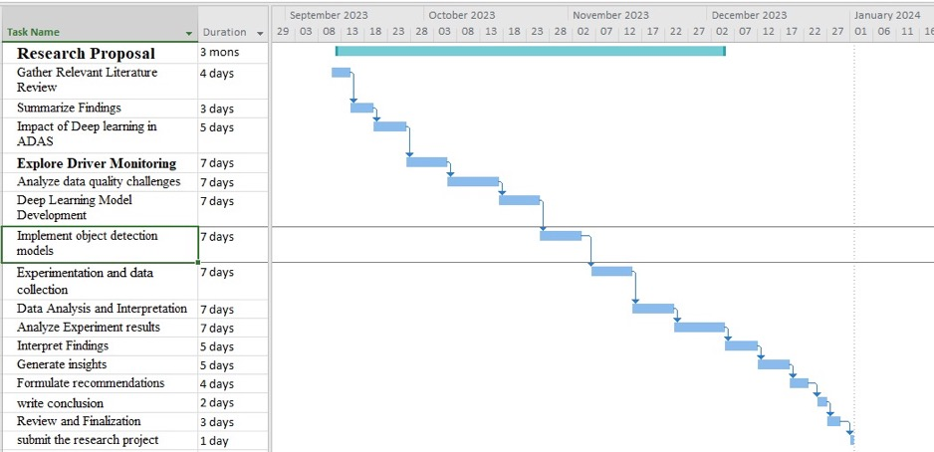

7.Reference

- M. Defaoui, L. Koutti, M. El Ansari, R. Lahmyed, & L. Masmoudi. (2022). PedVis-VGG-16: A Fine-tuned deep convolutional neural network for pedestrian image classifications. Paper presented at the - 2022 9th International Conference on Wireless Networks and Mobile Communications (WINCOM), 1-6. 10.1109/WINCOM55661.2022.9966465

- Ogunrinde, & S. Bernadin. (2021). A Review of the Impacts of Defogging on Deep Learning-Based Object Detectors in Self-Driving Cars. Paper presented at the - SoutheastCon 2021, 1. 10.1109/SoutheastCon45413.2021.9401941

- Horton, S., Garbacik, N. R., & Li, D. (2023). Multiple resolution deep neural networks for vehicle autonomous driving systems

- E. Eiben, & M. Jelasity. (2002). A critical note on experimental research methodology in EC. Paper presented at the - Proceedings of the 2002 Congress on Evolutionary Computation. CEC'02 (Cat. no.02TH8600), , 1 582-587 vol.1. 10.1109/CEC.2002.1006991

- Narote, S. P., Bhujbal, P. N., Narote, A. S., & Dhane, D. M. (2018). A review of recent advances in lane detection and departure warning system. Pattern Recognition, 73, 216-234. 10.1016/j.patcog.2017.08.014

- Martinez, C. M., Heucke, M., Wang, F., Gao, B., & Cao, D. (2017). Driving style recognition for intelligent vehicle control and advanced driver assistance: A survey. IEEE Transactions on Intelligent Transportation Systems, 19(3), 666-676.

- D. Maturana, & S. Scherer. (2015). VoxNet: A 3D Convolutional Neural Network for real-time object recognition. Paper presented at the - 2015 IEEE/RSJ International Conference on Intelligent Robots and Systems (IROS), 922-928. 10.1109/IROS.2015.7353481

- Bojarski, M., Del Testa, D., Dworakowski, D., Firner, B., Flepp, B., Goyal, P., Jackel, L. D., Monfort, M., Muller, U., & Zhang, J. (2016). End to end learning for self-driving cars. arXiv Preprint arXiv:1604.07316,

- Youssef, F., & Houda, B. (2020). Comparative Study of End-to-end Deep Learning Methods for Self-driving Car. International Journal of Intelligent Systems and Applications, 12(5), 15-27. 10.5815/ijisa.2020.05.02

- Hoffmann, J. E., Tosso, H. G., Santos, M. M. D., Justo, J. F., Malik, A. W., & Rahman, A. U. (2021). Real-Time Adaptive Object Detection and Tracking for Autonomous Vehicles. IEEE Transactions on Intelligent Vehicles, 6(3), 450-459. 10.1109/TIV.2020.3037928

- Arbabi, S., Tavernini, D., Fallah, S., & Bowden, R. (2022). Learning an Interpretable Model for Driver Behavior Prediction with Inductive Biases.10.48550/arxiv.2208.00516

- Veres, M., & Moussa, M. (2020). Deep Learning for Intelligent Transportation Systems: A Survey of Emerging Trends. IEEE Transactions on Intelligent Transportation Systems, 21(8), 3152-3168. 10.1109/TITS.2019.2929020

Appendix B: Ethics Form



UREC 1 RESEARCH ETHICS REVIEW FOR STUDENT RESEARCH WITH NO HUMAN PARTICIPANTS OR DIRECT COLLECTION OF HUMAN TISSUES, OR BODILY FLUIDS.
All University research is required to undergo ethical scrutiny to comply with UK law. The University Research Ethics Policy (www.shu.ac.uk/research/excellence/ethics-and-integrity/policies) should be consulted before completing this form. The initial questions are there to check that completion of the UREC1 is appropriate for this study. The supervisor will approve the study, but it may also be reviewed by the College Teaching Program Research Ethics Committee (CTPREC) as part of the quality assurance process (additional guidance can be obtained from your College Research Ethics Chair¹).
The final responsibility for ensuring that ethical research practices are followed rests with the supervisor for student research.
Note that students and staff are responsible for making suitable arrangements to ensure compliance with the General Data Protection Regulations (GDPR), for keeping data secure and if relevant, for keeping the identity of participants anonymous. They are also responsible for following SHU guidelines about data encryption and research data management. Guidance can be found on the SHU Ethics Website www.shu.ac.uk/research/excellence/ethics-and-integrity

Please note that it is mandatory for all students to only store data on their allotted networked F drive space and not on individual hard drives or memory sticks etc.

This form also enables the University and College to keep a record confirming that research conducted has been subjected to ethical scrutiny. Students should retain a copy for inclusion in their research projects, and a copy should be uploaded to the relevant module Blackboard site.

The form must be completed by the student and approved by supervisor and/or module leader (as applicable). In all cases, it should be counter-signed by the supervisor and/or module leader and kept as a record showing that ethical scrutiny has occurred. Students should retain a copy for inclusion in the appendices of their research projects, and a copy should be uploaded to the module Blackboard site for checking.

Please note that it may be necessary to conduct a health and safety risk assessment for the proposed research. Further information can be obtained from the University’s Health and Safety Website https://sheffieldhallam.sharepoint.com/sites/3069/SitePages/Risk-Assessment.aspx

1 College of Social Sciences and Arts – Dr. Antonia Ypsilanti (a.ypsilanti@shu.ac.uk ) College of Business, Technology and Engineering – Dr. Tony Lynn (t.lynn@shu.ac.uk ) College of Health, Wellbeing and Life Sciences – Dr. Nikki Jordan-Mahy (n.jordan- mahy@shu.ac.uk )

ARE YOU COMPLETING THE CORRECT FORM?
Does this study include collecting data or samples from human participants. YES/NO
Is the secondary data used in this study of a sensitive or contentious nature, or does it allow the identification of individuals or organisations (e.g., companies, school, councils, communities).
YES/NO
If you have answered YES to either of these two questions you must complete a UREC2, 3 or 4 as appropriate.

- General Details

Details
Name of student | Hariprasath Mohanraj
SHU email address | C2068019@hallam.shu.ac.uk
Department/College | Msc Big Data Analytics
Name of supervisor | Samuele Vinanzi
Supervisor’s email address | s.vinanzi@shu.ac.uk
Title of proposed research | Optimizing Deep Learning Integration in ADAS for Enhanced Vehicle Safety
Proposed start date | 12.09.2023
Proposed end date | 01.01.2024
Brief outline of research to include, rationale (reasons) for undertaking the research & aims, and methods (max 500 words). | The research endeavour at hand is motivated by the profound transformations witnessed in Advanced Driver Assistance Systems (ADAS), a technological domain that has  revolutionized vehicle safety and steered us closer to the realm of autonomous driving. Yet, the latent potential of integrating deep learning algorithms into ADAS beckons for exploration,  thereby setting the backdrop for this study. The overarching aim is to delve into the seamless amalgamation of deep learning into ADAS, with the ultimate objective of elevating vehicle performance and safety within real-time driving scenarios. By harnessing the computational prowess inherent in deep learning, the aspiration is to empower ADAS with the cognitive ability to comprehend intricate driving contexts, make informed real-time decisions, adapt adeptly to dynamically changing conditions, and thereby mitigate the incidence of human errors. This overarching vision resonates harmoniously with the evolving  landscape of automotive technologies, poised to carve out safer roads and more streamlined driving experiences.

Details
To concretize these aspirations, the research methodology adopts an experimental approach that systematically scrutinizes the multifaceted impacts of diverse deep learning models on a spectrum of ADAS functionalities. The methodological journey can be distilled into a series of pivotal steps. It commences with a meticulous articulation of the research problem, which forms the bedrock for the formulation of pertinent hypotheses.
Subsequently, the spotlight shifts to the identification of variables, encompassing an array of deep learning model architectures, datasets, and measurable indicators of ADAS efficacy and real-time performance. A robust experimental design is then meticulously conceived, engineered to preemptively nullify confounding factors and engender
credibility within the outcomes. The selection of appropriate participants or samples, representative of actual ADAS users, ensues.

The crux of this research endeavor unfolds in the meticulous development and training of diverse deep learning models, each emblematic of varying architectural paradigms and trained on distinct datasets. The central focus gravitates toward two quintessential ADAS functionalities: object detection and lane departure warning systems. Subsequent to the painstaking
model development, the experimentation phase is ushered in, characterized by the injection of real-world driving data. This experimental data is harnessed either through the utilization of standardized datasets or by orchestrating bespoke simulation scenarios that mirror distinct driving conditions. The data collection process is inherently quantitative, capturing vital performance metrics encompassing accuracy, processing time, and responsiveness. This treasure trove of data serves as the foundation for robust analysis.

The data analysis stage employs an array of statistical
techniques, ranging from t-tests and ANOVA to regression analysis, thereby enabling discerning comparisons across the performance spectrum of varied deep learning models. The resultant insights are then judiciously interpreted, enunciating the nuanced impacts and implications of distinct models on ADAS functionality. The culmination of this scholarly journey encapsulates a synthesis of findings, coupled with a contemplative discourse on the implications thereof. This dialogue manifests into pragmatic recommendations that underpin the judicious selection and implementation of deep
learning models within the ADAS framework. In essence, this research endeavor aspires to catalyze the symbiotic union of deep learning and ADAS, facilitating a paradigm shift towards

Details
fortified road safety and efficacious driving experiences.

- Research in External Organisations

Question | Yes/No
1. Will the research involve working with/within an external organisation (e.g.,  school, business, charity, museum, government department, international agency, etc.)? | no
2. If you answered YES to question 1, do you have granted access to conduct the research?  If YES, students please show evidence to your supervisor. PI should retain safely. | NA
- If you answered NO to question 2, is it because:  - you have not yet asked  - you have asked and not yet received an answer  - you have asked and been refused access.  Note: You will only be able to start the research when you have been granted access. | NA

- Research with Products and Artefacts

Question | Yes/No
1. Will the research involve the use of specialist copyrighted documents, films, broadcasts, photographs, artworks, designs, products, programs, databases,  networks, processes, existing datasets, or secure data? | Yes

Question | Yes/No
- If you answered YES to question 1, are the materials you intend to use in the public domain?  Notes: ‘In the public domain’ does not mean the same thing as ‘publicly accessible’.  - Information which is 'in the public domain' is no longer protected by copyright (i.e., copyright has either expired or been waived) and can be used without permission.  - Information which is 'publicly accessible' (e.g., TV broadcasts, websites, artworks, newspapers) is available for anyone to consult/view. It is still protected by copyright even if there is no copyright notice. In UK law, copyright protection is automatic and does not require a copyright statement, although it is always good practice to provide one. It is necessary to check the terms and conditions of use to find out exactly how the material may be reused etc.  If you answered YES to question 1, be aware that you may need to consider other ethics codes. For example, when conducting Internet research, consult the code of the Association of Internet Researchers; for educational research, consult the Code of Ethics of the British Educational Research Association. | Yes
3. If you answered NO to question 2, do you have explicit permission to use these materials as data?  If YES, please show evidence to your supervisor. | NA
- If you answered NO to question 3, is it because:  - you have not yet asked permission  - you have asked and not yet received and answer  - you have asked and been refused access.  Note: You will only be able to start the research when you have been granted permission to use the specified material. | NA

- Does this research project require a health and safety risk assessment for the procedures to be used? (Discuss this with your supervisor)

No

If YES the completed Health and Safety Risk Assessment form should be attached. A standard risk assessment form can be generated through the Awaken system (https://shu.awaken- be.com). Alternatively if you require more specific risk assessment, e.g. a COSHH, attach that instead.

Insurance Check

The University’s standard insurance cover will not automatically cover research involving any of the following:

  - Participants under 5 years old
  - Pregnant women
  - 5000 or more participants
  - Research being conducted in an overseas country
  - Research involving aircraft and offshore oil rigs
  - Nuclear research
  - Any trials/medical research into Covid 19

If your proposals do involve any of the above, please contact the Insurance Manager directly (fin-insurancequeries-mb@exchange.shu.ac.uk) to discuss this element of your project.

Adherence to SHU Policy and Procedures

Ethics sign-off
Personal statement
I can confirm that:
- I have read the Sheffield Hallam University Research Ethics Policy and Procedures
- I agree to abide by its principles.
Student
Name: Hariprasath Mohanraj | Date: 26.8.2023
Signature:
Supervisor ethical sign-off
I can confirm that completion of this form has confirmed that this research does not involve human participants. The research will not commence until any approvals required under Sections 2 & 3 have been received and any health and safety measures are in place.
Name: Samuele Vinanzi | Date: 31/10/2023
Signature: 
Independent Reviewer ethical sign off (if required to permit publication of findings with supervisor co- authorship).
Name: | Date:
Signature:

Please ensure that you have attached all relevant documents. Your supervisor must approve them before you start data collection:

Relevant Documents | N/A
Research proposal if prepared previously
Any associated materials (e.g., posters, letters, etc.)
Health and Safety Risk Assessment Form

Appendix C: Source Code

# Drive mounting and dataset connection with github
"""

from google.colab import drive
drive.mount('/content/drive')

"""**Vehicle and other Object detection by different layer frames on yolov5 model**"""

# Commented out IPython magic to ensure Python compatibility.
!git clone https://github.com/ultralytics/yolov5
!pip install -qr yolov5/requirements.txt
# %cd yolov5

import torch
from IPython.display import Image, clear_output
from utils.downloads import attempt_download

clear_output()

"""# Dataset loading through roboflow and loading the data images in train/test/val folders and also format in yaml"""

# Commented out IPython magic to ensure Python compatibility.
# %cd /content
!curl -L "https://public.roboflow.com/ds/dLOots79Wl?key=HpJrEkrdkH" > roboflow.zip; unzip roboflow.zip; rm roboflow.zip

!mkdir train/
!mkdir train/images
!mkdir train/labels
!mkdir valid/
!mkdir valid/images
!mkdir valid/labels
!mkdir test/
!mkdir test/images
!mkdir test/labels

import os
import shutil

# allImages = glob.glob("/export/images/*.jpg")
allImages = []
for filename in os.listdir("export/images/"):
if filename.endswith(".jpg"):
allImages.append(filename)
trainImages = []
valImages = []
trainLabels = []
valLabels = []
testImages = []
testLabels = []
print(len(allImages))
testCount = int(0.2 * len(allImages)/10)
trainCount = len(allImages)/10 - testCount-1
valCount = int(0.2 * trainCount)
trainCount = trainCount - valCount-1

print(trainCount, valCount, testCount)

# create training Dataset
j = 0
k = 0
for i in range(0,int(len(allImages)/10)):
if i < trainCount: # create training images
trainImages.append(allImages[i])
elif i >= trainCount and i<(valCount + trainCount):
valImages.append(allImages[i])
# j += 1
else:
testImages.append(allImages[i])
# k += 1

print(len(trainImages), len(valImages), len(testImages))

# moving training images
source = "export/images/"
destination = "train/images/"
for fileT in trainImages:
shutil.move(source+fileT , destination+fileT)

source = "export/images/"
destination = "valid/images/"
for fileT in valImages:
shutil.move(source+fileT , destination+fileT)

source = "export/images/"
destination = "test/images/"
for fileT in testImages:
shutil.move(source+fileT , destination+fileT)

# moving labels
source = "export/labels/"
destination = "train/labels/"
for fileT in trainImages:
fileT = fileT.replace(".jpg",".txt")
shutil.move(source+fileT , destination+fileT)

source = "export/labels/"
destination = "valid/labels/"
for fileT in valImages:
fileT = fileT.replace(".jpg",".txt")
shutil.move(source+fileT , destination+fileT)

source = "export/labels/"
destination = "test/labels/"
for fileT in testImages:
fileT = fileT.replace(".jpg",".txt")
shutil.move(source+fileT , destination+fileT)

# Commented out IPython magic to ensure Python compatibility.
#extracting information from the roboflow file
# %cat data.yaml

# define number of classes based on data.yaml
import yaml
with open("data.yaml", 'r') as stream:
num_classes = str(yaml.safe_load(stream)['nc'])

"""# Layered Architecture of Yolov deep neural network models"""

# Commented out IPython magic to ensure Python compatibility.
# %cat /content/yolov5/models/yolov5l.yaml

# Commented out IPython magic to ensure Python compatibility.
# %cat /content/yolov5/models/yolov5m.yaml

# Commented out IPython magic to ensure Python compatibility.
# %cat /content/yolov5/models/yolov5n.yaml

# Commented out IPython magic to ensure Python compatibility.
# %cat /content/yolov5/models/yolov5s.yaml

# Commented out IPython magic to ensure Python compatibility.
# %cat /content/yolov5/models/yolov5x.yaml

"""Here the models of yolo are runned at once separately. Restart and run because of under detect folder different exp folders are created so avoid this it is required to run in this way.

Dataset loading + layered archi....+ model 1
then restart

Dataset loading + layered archi....+ model 2
......
in this ways.

# 1.custom format of yolov5l and training / testing
"""

#customize iPython writefile so we can write variables
from IPython.core.magic import register_line_cell_magic

@register_line_cell_magic
def writetemplate(line, cell):
with open(line, 'w') as f:
f.write(cell.format(**globals()))

# Commented out IPython magic to ensure Python compatibility.
# %%writetemplate /content/yolov5/models/custom_yolov5l.yaml
#
# # parameters
# nc: {num_classes} # number of classes
# depth_multiple: 1.0 # model depth multiple
# width_multiple: 1.0 # layer channel multiple
#
# # anchors
# anchors:
# - [10,13, 16,30, 33,23] # P3/8
# - [30,61, 62,45, 59,119] # P4/16
# - [116,90, 156,198, 373,326] # P5/32
#
# # YOLOv5 backbone
# backbone:
# # [from, number, module, args]
# [[-1, 1, Focus, [64, 3]], # 0-P1/2
# [-1, 1, Conv, [128, 3, 2]], # 1-P2/4
# [-1, 3, BottleneckCSP, [128]],
# [-1, 1, Conv, [256, 3, 2]], # 3-P3/8
# [-1, 9, BottleneckCSP, [256]],
# [-1, 1, Conv, [512, 3, 2]], # 5-P4/16
# [-1, 9, BottleneckCSP, [512]],
# [-1, 1, Conv, [1024, 3, 2]], # 7-P5/32
# [-1, 1, SPP, [1024, [5, 9, 13]]],
# [-1, 3, BottleneckCSP, [1024, False]], # 9
# ]
#
# # YOLOv5 head
# head:
# [[-1, 1, Conv, [512, 1, 1]],
# [-1, 1, nn.Upsample, [None, 2, 'nearest']],
# [[-1, 6], 1, Concat, [1]], # cat backbone P4
# [-1, 3, BottleneckCSP, [512, False]], # 13
#
# [-1, 1, Conv, [256, 1, 1]],
# [-1, 1, nn.Upsample, [None, 2, 'nearest']],
# [[-1, 4], 1, Concat, [1]], # cat backbone P3
# [-1, 3, BottleneckCSP, [256, False]], # 17 (P3/8-small)
#
# [-1, 1, Conv, [256, 3, 2]],
# [[-1, 14], 1, Concat, [1]], # cat head P4
# [-1, 3, BottleneckCSP, [512, False]], # 20 (P4/16-medium)
#
# [-1, 1, Conv, [512, 3, 2]],
# [[-1, 10], 1, Concat, [1]], # cat head P5
# [-1, 3, BottleneckCSP, [1024, False]], # 23 (P5/32-large)
#
# [[17, 20, 23], 1, Detect, [nc, anchors]], # Detect(P3, P4, P5)
# ]

# Commented out IPython magic to ensure Python compatibility.
# # train yolov5s on custom data for 10 epochs
# # time its performance
# %%time
# %cd /content/yolov5/
# !python train.py --img 416 --batch 16 --epochs 10 --data '../data.yaml' --cfg ./models/custom_yolov5l.yaml --weights '' --name yolov5l_results --cache

!python detect.py --weights runs/train/yolov5l_results/weights/best.pt --img 416 --conf 0.4 --source ../test/images

import glob
from IPython.display import Image, display
i=0
for imageName in glob.glob('/content/yolov5/runs/detect/exp/*.jpg'):
display(Image(filename=imageName))
print("\n")
i=i+1
if(i==10):
break

!python detect.py --weights runs/train/yolov5l_results/weights/best.pt --source /content/drive/MyDrive/yolo_models/videofile.mkv --conf 0.4

"""# 2.custom format of yolov5m and training / testing"""

#customize iPython writefile so we can write variables
from IPython.core.magic import register_line_cell_magic

@register_line_cell_magic
def writetemplate(line, cell):
with open(line, 'w') as f:
f.write(cell.format(**globals()))

# Commented out IPython magic to ensure Python compatibility.
# %%writetemplate /content/yolov5/models/custom_yolov5m.yaml
#
# nc: {num_classes} # number of classes
# depth_multiple: 0.67 # model depth multiple
# width_multiple: 0.75 # layer channel multiple
# anchors:
# - [10,13, 16,30, 33,23] # P3/8
# - [30,61, 62,45, 59,119] # P4/16
# - [116,90, 156,198, 373,326] # P5/32
#
# # YOLOv5 v6.0 backbone
# backbone:
# # [from, number, module, args]
# [[-1, 1, Conv, [64, 6, 2, 2]], # 0-P1/2
# [-1, 1, Conv, [128, 3, 2]], # 1-P2/4
# [-1, 3, C3, [128]],
# [-1, 1, Conv, [256, 3, 2]], # 3-P3/8
# [-1, 6, C3, [256]],
# [-1, 1, Conv, [512, 3, 2]], # 5-P4/16
# [-1, 9, C3, [512]],
# [-1, 1, Conv, [1024, 3, 2]], # 7-P5/32
# [-1, 3, C3, [1024]],
# [-1, 1, SPPF, [1024, 5]], # 9
# ]
#
# # YOLOv5 v6.0 head
# head:
# [[-1, 1, Conv, [512, 1, 1]],
# [-1, 1, nn.Upsample, [None, 2, 'nearest']],
# [[-1, 6], 1, Concat, [1]], # cat backbone P4
# [-1, 3, C3, [512, False]], # 13
#
# [-1, 1, Conv, [256, 1, 1]],
# [-1, 1, nn.Upsample, [None, 2, 'nearest']],
# [[-1, 4], 1, Concat, [1]], # cat backbone P3
# [-1, 3, C3, [256, False]], # 17 (P3/8-small)
#
# [-1, 1, Conv, [256, 3, 2]],
# [[-1, 14], 1, Concat, [1]], # cat head P4
# [-1, 3, C3, [512, False]], # 20 (P4/16-medium)
#
# [-1, 1, Conv, [512, 3, 2]],
# [[-1, 10], 1, Concat, [1]], # cat head P5
# [-1, 3, C3, [1024, False]], # 23 (P5/32-large)
#
# [[17, 20, 23], 1, Detect, [nc, anchors]], # Detect(P3, P4, P5)
# ]

# Commented out IPython magic to ensure Python compatibility.
# # train yolov5s on custom data for 10 epochs
# # time its performance
# %%time
# %cd /content/yolov5/
# !python train.py --img 416 --batch 16 --epochs 10 --data '../data.yaml' --cfg ./models/custom_yolov5m.yaml --weights '' --name yolov5m_results --cache

!python detect.py --weights runs/train/yolov5m_results/weights/best.pt --img 416 --conf 0.4 --source ../test/images

import glob
from IPython.display import Image, display
i=0
for imageName in glob.glob('/content/yolov5/runs/detect/exp/*.jpg'):
display(Image(filename=imageName))
print("\n")
i=i+1
if(i==10):
break

!python detect.py --weights runs/train/yolov5m_results/weights/best.pt --source /content/drive/MyDrive/yolo_models/videofile.mkv --conf 0.4

"""# 3.custom format of yolov5n and training / testing"""

#customize iPython writefile so we can write variables
from IPython.core.magic import register_line_cell_magic

@register_line_cell_magic
def writetemplate(line, cell):
with open(line, 'w') as f:
f.write(cell.format(**globals()))

# Commented out IPython magic to ensure Python compatibility.
# %%writetemplate /content/yolov5/models/custom_yolov5n.yaml
#
# # Parameters
# nc: {num_classes} # number of classes
# depth_multiple: 0.33 # model depth multiple
# width_multiple: 0.25 # layer channel multiple
# anchors:
# - [10,13, 16,30, 33,23] # P3/8
# - [30,61, 62,45, 59,119] # P4/16
# - [116,90, 156,198, 373,326] # P5/32
#
# # YOLOv5 v6.0 backbone
# backbone:
# # [from, number, module, args]
# [[-1, 1, Conv, [64, 6, 2, 2]], # 0-P1/2
# [-1, 1, Conv, [128, 3, 2]], # 1-P2/4
# [-1, 3, C3, [128]],
# [-1, 1, Conv, [256, 3, 2]], # 3-P3/8
# [-1, 6, C3, [256]],
# [-1, 1, Conv, [512, 3, 2]], # 5-P4/16
# [-1, 9, C3, [512]],
# [-1, 1, Conv, [1024, 3, 2]], # 7-P5/32
# [-1, 3, C3, [1024]],
# [-1, 1, SPPF, [1024, 5]], # 9
# ]
#
# # YOLOv5 v6.0 head
# head:
# [[-1, 1, Conv, [512, 1, 1]],
# [-1, 1, nn.Upsample, [None, 2, 'nearest']],
# [[-1, 6], 1, Concat, [1]], # cat backbone P4
# [-1, 3, C3, [512, False]], # 13
#
# [-1, 1, Conv, [256, 1, 1]],
# [-1, 1, nn.Upsample, [None, 2, 'nearest']],
# [[-1, 4], 1, Concat, [1]], # cat backbone P3
# [-1, 3, C3, [256, False]], # 17 (P3/8-small)
#
# [-1, 1, Conv, [256, 3, 2]],
# [[-1, 14], 1, Concat, [1]], # cat head P4
# [-1, 3, C3, [512, False]], # 20 (P4/16-medium)
#
# [-1, 1, Conv, [512, 3, 2]],
# [[-1, 10], 1, Concat, [1]], # cat head P5
# [-1, 3, C3, [1024, False]], # 23 (P5/32-large)
#
# [[17, 20, 23], 1, Detect, [nc, anchors]], # Detect(P3, P4, P5)
# ]

# Commented out IPython magic to ensure Python compatibility.
# # train yolov5s on custom data for 10 epochs
# # time its performance
# %%time
# %cd /content/yolov5/
# !python train.py --img 416 --batch 16 --epochs 10 --data '../data.yaml' --cfg ./models/custom_yolov5n.yaml --weights '' --name yolov5n_results --cache

!python detect.py --weights runs/train/yolov5n_results/weights/best.pt --img 416 --conf 0.4 --source ../test/images

import glob
from IPython.display import Image, display
i=0
for imageName in glob.glob('/content/yolov5/runs/detect/exp/*.jpg'):
display(Image(filename=imageName))
print("\n")
i=i+1
if(i==10):
break

!python detect.py --weights runs/train/yolov5n_results/weights/best.pt --source /content/drive/MyDrive/yolo_models/videofile.mkv --conf 0.4

"""# 4.custom format of yolov5s and training / testing"""

#customize iPython writefile so we can write variables
from IPython.core.magic import register_line_cell_magic

@register_line_cell_magic
def writetemplate(line, cell):
with open(line, 'w') as f:
f.write(cell.format(**globals()))

# Commented out IPython magic to ensure Python compatibility.
# %%writetemplate /content/yolov5/models/custom_yolov5s.yaml
#
# # parameters
# nc: {num_classes} # number of classes
# depth_multiple: 0.33 # model depth multiple
# width_multiple: 0.50 # layer channel multiple
#
# # anchors
# anchors:
# - [10,13, 16,30, 33,23] # P3/8
# - [30,61, 62,45, 59,119] # P4/16
# - [116,90, 156,198, 373,326] # P5/32
#
# # YOLOv5 backbone
# backbone:
# # [from, number, module, args]
# [[-1, 1, Focus, [64, 3]], # 0-P1/2
# [-1, 1, Conv, [128, 3, 2]], # 1-P2/4
# [-1, 3, BottleneckCSP, [128]],
# [-1, 1, Conv, [256, 3, 2]], # 3-P3/8
# [-1, 9, BottleneckCSP, [256]],
# [-1, 1, Conv, [512, 3, 2]], # 5-P4/16
# [-1, 9, BottleneckCSP, [512]],
# [-1, 1, Conv, [1024, 3, 2]], # 7-P5/32
# [-1, 1, SPP, [1024, [5, 9, 13]]],
# [-1, 3, BottleneckCSP, [1024, False]], # 9
# ]
#
# # YOLOv5 head
# head:
# [[-1, 1, Conv, [512, 1, 1]],
# [-1, 1, nn.Upsample, [None, 2, 'nearest']],
# [[-1, 6], 1, Concat, [1]], # cat backbone P4
# [-1, 3, BottleneckCSP, [512, False]], # 13
#
# [-1, 1, Conv, [256, 1, 1]],
# [-1, 1, nn.Upsample, [None, 2, 'nearest']],
# [[-1, 4], 1, Concat, [1]], # cat backbone P3
# [-1, 3, BottleneckCSP, [256, False]], # 17 (P3/8-small)
#
# [-1, 1, Conv, [256, 3, 2]],
# [[-1, 14], 1, Concat, [1]], # cat head P4
# [-1, 3, BottleneckCSP, [512, False]], # 20 (P4/16-medium)
#
# [-1, 1, Conv, [512, 3, 2]],
# [[-1, 10], 1, Concat, [1]], # cat head P5
# [-1, 3, BottleneckCSP, [1024, False]], # 23 (P5/32-large)
#
# [[17, 20, 23], 1, Detect, [nc, anchors]], # Detect(P3, P4, P5)
# ]

# Commented out IPython magic to ensure Python compatibility.
# # train yolov5s on custom data for 10 epochs
# # time its performance
# %%time
# %cd /content/yolov5/
# !python train.py --img 416 --batch 16 --epochs 10 --data '../data.yaml' --cfg ./models/custom_yolov5s.yaml --weights '' --name yolov5s_results --cache

!python detect.py --weights runs/train/yolov5s_results/weights/best.pt --img 416 --conf 0.4 --source ../test/images

import glob
from IPython.display import Image, display
i=0
for imageName in glob.glob('/content/yolov5/runs/detect/exp/*.jpg'):
display(Image(filename=imageName))
print("\n")
i=i+1
if(i==10):
break

!python detect.py --weights runs/train/yolov5s_results/weights/best.pt --source /content/drive/MyDrive/yolo_models/videofile.mkv --conf 0.4

"""# 5.custom format of yolov5x and training / testing"""

#customize iPython writefile so we can write variables
from IPython.core.magic import register_line_cell_magic

@register_line_cell_magic
def writetemplate(line, cell):
with open(line, 'w') as f:
f.write(cell.format(**globals()))

# Commented out IPython magic to ensure Python compatibility.
# %%writetemplate /content/yolov5/models/custom_yolov5x.yaml
#
# # YOLOv5 🚀 by Ultralytics, AGPL-3.0 license
#
# # Parameters
# nc: {num_classes} # number of classes
# depth_multiple: 1.33 # model depth multiple
# width_multiple: 1.25 # layer channel multiple
# anchors:
# - [10,13, 16,30, 33,23] # P3/8
# - [30,61, 62,45, 59,119] # P4/16
# - [116,90, 156,198, 373,326] # P5/32
#
# # YOLOv5 v6.0 backbone
# backbone:
# # [from, number, module, args]
# [[-1, 1, Conv, [64, 6, 2, 2]], # 0-P1/2
# [-1, 1, Conv, [128, 3, 2]], # 1-P2/4
# [-1, 3, C3, [128]],
# [-1, 1, Conv, [256, 3, 2]], # 3-P3/8
# [-1, 6, C3, [256]],
# [-1, 1, Conv, [512, 3, 2]], # 5-P4/16
# [-1, 9, C3, [512]],
# [-1, 1, Conv, [1024, 3, 2]], # 7-P5/32
# [-1, 3, C3, [1024]],
# [-1, 1, SPPF, [1024, 5]], # 9
# ]
#
# # YOLOv5 v6.0 head
# head:
# [[-1, 1, Conv, [512, 1, 1]],
# [-1, 1, nn.Upsample, [None, 2, 'nearest']],
# [[-1, 6], 1, Concat, [1]], # cat backbone P4
# [-1, 3, C3, [512, False]], # 13
#
# [-1, 1, Conv, [256, 1, 1]],
# [-1, 1, nn.Upsample, [None, 2, 'nearest']],
# [[-1, 4], 1, Concat, [1]], # cat backbone P3
# [-1, 3, C3, [256, False]], # 17 (P3/8-small)
#
# [-1, 1, Conv, [256, 3, 2]],
# [[-1, 14], 1, Concat, [1]], # cat head P4
# [-1, 3, C3, [512, False]], # 20 (P4/16-medium)
#
# [-1, 1, Conv, [512, 3, 2]],
# [[-1, 10], 1, Concat, [1]], # cat head P5
# [-1, 3, C3, [1024, False]], # 23 (P5/32-large)
#
# [[17, 20, 23], 1, Detect, [nc, anchors]], # Detect(P3, P4, P5)
# ]

# Commented out IPython magic to ensure Python compatibility.
# # train yolov5s on custom data for 10 epochs
# # time its performance
# %%time
# %cd /content/yolov5/
# !python train.py --img 416 --batch 16 --epochs 10 --data '../data.yaml' --cfg ./models/custom_yolov5x.yaml --weights '' --name yolov5x_results --cache

!python detect.py --weights runs/train/yolov5x_results/weights/best.pt --img 416 --conf 0.4 --source ../test/images

import glob
from IPython.display import Image, display
i=0
for imageName in glob.glob('/content/yolov5/runs/detect/exp/*.jpg'):
display(Image(filename=imageName))
print("\n")
i=i+1
if(i==10):
break

!python detect.py --weights runs/train/yolov5x_results/weights/best.pt --source /content/drive/MyDrive/yolo_models/videofile.mkv --conf 0.4

"""# Conclusion on comparison

yolov5m and yolov5s are selected from their confusion matrix according to the car detection.

# Decision 1.custom format of yolov5m and training / testing for 100 epochs
"""

#customize iPython writefile so we can write variables
from IPython.core.magic import register_line_cell_magic

@register_line_cell_magic
def writetemplate(line, cell):
with open(line, 'w') as f:
f.write(cell.format(**globals()))

# Commented out IPython magic to ensure Python compatibility.
# %%writetemplate /content/yolov5/models/custom_yolov5m.yaml
#
# nc: {num_classes} # number of classes
# depth_multiple: 0.67 # model depth multiple
# width_multiple: 0.75 # layer channel multiple
# anchors:
# - [10,13, 16,30, 33,23] # P3/8
# - [30,61, 62,45, 59,119] # P4/16
# - [116,90, 156,198, 373,326] # P5/32
#
# # YOLOv5 v6.0 backbone
# backbone:
# # [from, number, module, args]
# [[-1, 1, Conv, [64, 6, 2, 2]], # 0-P1/2
# [-1, 1, Conv, [128, 3, 2]], # 1-P2/4
# [-1, 3, C3, [128]],
# [-1, 1, Conv, [256, 3, 2]], # 3-P3/8
# [-1, 6, C3, [256]],
# [-1, 1, Conv, [512, 3, 2]], # 5-P4/16
# [-1, 9, C3, [512]],
# [-1, 1, Conv, [1024, 3, 2]], # 7-P5/32
# [-1, 3, C3, [1024]],
# [-1, 1, SPPF, [1024, 5]], # 9
# ]
#
# # YOLOv5 v6.0 head
# head:
# [[-1, 1, Conv, [512, 1, 1]],
# [-1, 1, nn.Upsample, [None, 2, 'nearest']],
# [[-1, 6], 1, Concat, [1]], # cat backbone P4
# [-1, 3, C3, [512, False]], # 13
#
# [-1, 1, Conv, [256, 1, 1]],
# [-1, 1, nn.Upsample, [None, 2, 'nearest']],
# [[-1, 4], 1, Concat, [1]], # cat backbone P3
# [-1, 3, C3, [256, False]], # 17 (P3/8-small)
#
# [-1, 1, Conv, [256, 3, 2]],
# [[-1, 14], 1, Concat, [1]], # cat head P4
# [-1, 3, C3, [512, False]], # 20 (P4/16-medium)
#
# [-1, 1, Conv, [512, 3, 2]],
# [[-1, 10], 1, Concat, [1]], # cat head P5
# [-1, 3, C3, [1024, False]], # 23 (P5/32-large)
#
# [[17, 20, 23], 1, Detect, [nc, anchors]], # Detect(P3, P4, P5)
# ]

# Commented out IPython magic to ensure Python compatibility.
# # train yolov5s on custom data for 100 epochs
# # time its performance
# %%time
# %cd /content/yolov5/
# !python train.py --img 416 --batch 16 --epochs 100 --data '../data.yaml' --cfg ./models/custom_yolov5m.yaml --weights '' --name yolov5m_results --cache

"""# Decision 2.custom format of yolov5s and training / testing for 100 epochs"""

#customize iPython writefile so we can write variables
from IPython.core.magic import register_line_cell_magic

@register_line_cell_magic
def writetemplate(line, cell):
with open(line, 'w') as f:
f.write(cell.format(**globals()))

# Commented out IPython magic to ensure Python compatibility.
# %%writetemplate /content/yolov5/models/custom_yolov5s.yaml
#
# # parameters
# nc: {num_classes} # number of classes
# depth_multiple: 0.33 # model depth multiple
# width_multiple: 0.50 # layer channel multiple
#
# # anchors
# anchors:
# - [10,13, 16,30, 33,23] # P3/8
# - [30,61, 62,45, 59,119] # P4/16
# - [116,90, 156,198, 373,326] # P5/32
#
# # YOLOv5 backbone
# backbone:
# # [from, number, module, args]
# [[-1, 1, Focus, [64, 3]], # 0-P1/2
# [-1, 1, Conv, [128, 3, 2]], # 1-P2/4
# [-1, 3, BottleneckCSP, [128]],
# [-1, 1, Conv, [256, 3, 2]], # 3-P3/8
# [-1, 9, BottleneckCSP, [256]],
# [-1, 1, Conv, [512, 3, 2]], # 5-P4/16
# [-1, 9, BottleneckCSP, [512]],
# [-1, 1, Conv, [1024, 3, 2]], # 7-P5/32
# [-1, 1, SPP, [1024, [5, 9, 13]]],
# [-1, 3, BottleneckCSP, [1024, False]], # 9
# ]
#
# # YOLOv5 head
# head:
# [[-1, 1, Conv, [512, 1, 1]],
# [-1, 1, nn.Upsample, [None, 2, 'nearest']],
# [[-1, 6], 1, Concat, [1]], # cat backbone P4
# [-1, 3, BottleneckCSP, [512, False]], # 13
#
# [-1, 1, Conv, [256, 1, 1]],
# [-1, 1, nn.Upsample, [None, 2, 'nearest']],
# [[-1, 4], 1, Concat, [1]], # cat backbone P3
# [-1, 3, BottleneckCSP, [256, False]], # 17 (P3/8-small)
#
# [-1, 1, Conv, [256, 3, 2]],
# [[-1, 14], 1, Concat, [1]], # cat head P4
# [-1, 3, BottleneckCSP, [512, False]], # 20 (P4/16-medium)
#
# [-1, 1, Conv, [512, 3, 2]],
# [[-1, 10], 1, Concat, [1]], # cat head P5
# [-1, 3, BottleneckCSP, [1024, False]], # 23 (P5/32-large)
#
# [[17, 20, 23], 1, Detect, [nc, anchors]], # Detect(P3, P4, P5)
# ]

# Commented out IPython magic to ensure Python compatibility.
# # train yolov5s on custom data for 100 epochs
# # time its performance
# %%time
# %cd /content/yolov5/
# !python train.py --img 416 --batch 16 --epochs 100 --data '../data.yaml' --cfg ./models/custom_yolov5s.yaml --weights '' --name yolov5s_results --cache

"""# Final conclusion

After comparison between yolov5m and yolov5s models, yolov5m' accuracy in terms of P value is best than yolov5s model.
"""

