#### **ShopNest Store Power BI Capstone**

ShopNest stands as the leading department store in the e-commerce marketplaces in Portugal. Serving as a seamless link, it connects small businesses from various regions in Portugal to channels, streamlining the process with a single point of contact. Through the ShopNest Store, these merchants can showcase and sell their products, with the added convenience of direct shipment to customers facilitated by ShopNest logistics partners. The provided data represents authentic commercial information that has undergone the process of anonymization.

Tasks:

**1. Top Categories by Total Price:**

* **Question Statement:** Identify and visually represent the top 10 product categories by total sales.
* **Visualization:**

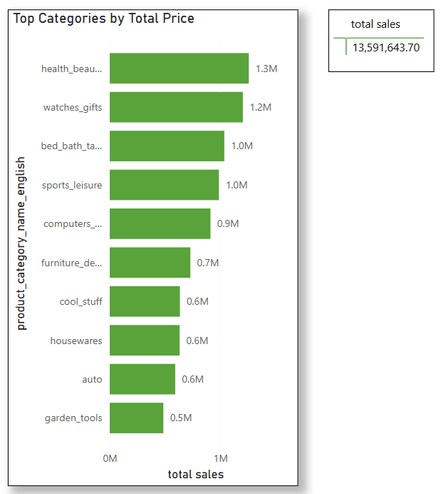

* **Explanation:**  The bar chart contains the information about the product name and its total sales and the labels show the total sales of each category. We have total sales information besides the chart.

**2. Delayed Orders Analysis:**

* **Question Statement:** Determine the number of delayed orders in each category. An order is considered delayed if the actual delivery date is later than the estimated delivery date.
* **Visualization:**

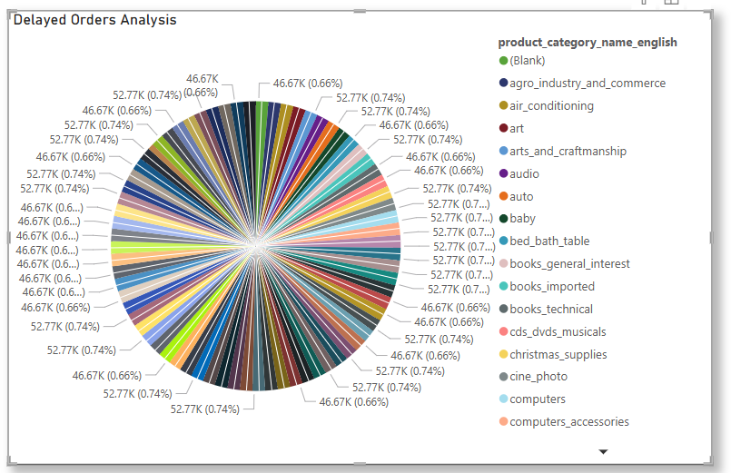

* **Explanation:** This pie chart shows the information about delayed orders count based on each category. The data model shows the number of delayed orders in each category.

**3. Monthly Comparison of Delayed and On-Time Orders:**

* **Question Statement:**  Create a dynamic visual that compares the number of delayed orders to the number of orders received earlier for each month. Utilize the drillthrough cross-report feature to provide a detailed analysis of late and on-time deliveries.
* **Visualization:**

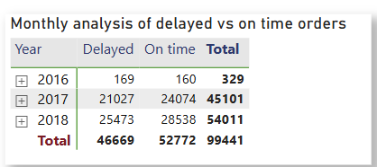

* **Explanation:** The matrix table shows the number of delayed orders and the number of on-time orders month-wise.

**4. Payment Method Analysis:**

* **Question Statement:**  Analyze the most frequently used payment methods by customers using a visually appealing representation, such as a pie chart or other suitable visuals.
* **Visualization:**

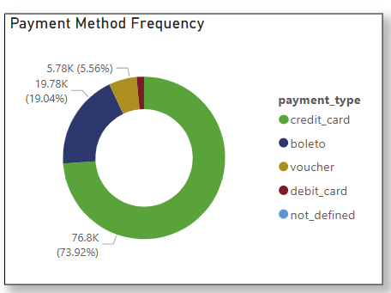

* **Explanation:** The doughnut chart represents the frequency of the payment types which gives the count and percentage of each payment type made by the customer.

**5. Product Rating Analysis:**

* **Question Statement:** Determine the top 10 highest-rated products and the bottom 10 lowest-rated products using a bar or column chart.
* **Visualization:**

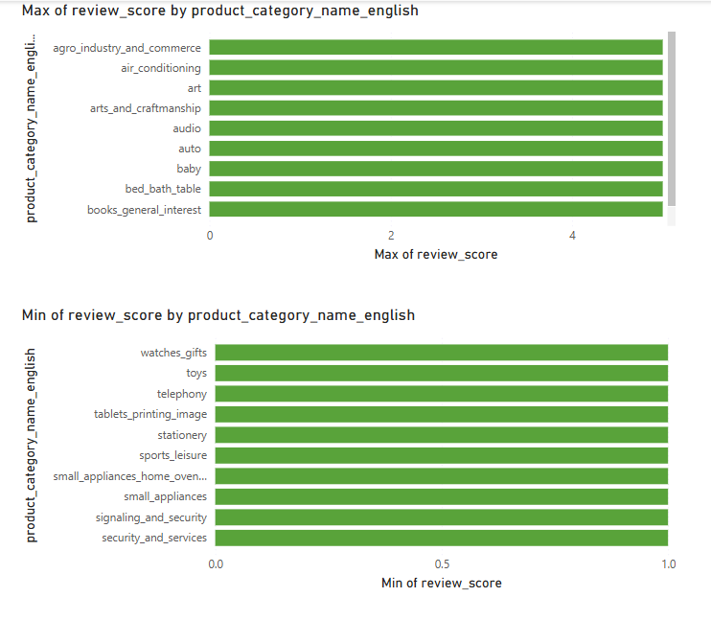

* **Explanation:** The bar charts show the top 10 high rated products category and the top 10 low rated product category.

**6. State-wise Sales Analysis:**

* **Question Statement:** Identify and visually represent states with high and low sales, providing a clear understanding of regional sales performance.
* **Visualization:**

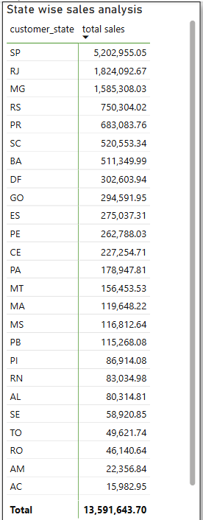

* **Explanation:**  The table contains state-wise sales analysis which shows the total sales in each state.

**7. Seasonal Sales Patterns:**

* **Question Statement:** Investigate and visualize any seasonal patterns(Quarterly) or trends in sales data over the course of the year.
* **Visualization:**

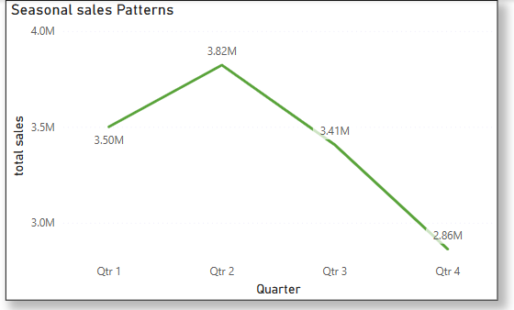

* **Explanation:** The line graph shows quarterly sales patterns of the company.

**8. Revenue Analysis:**

* **Question Statement:**  Determine the total revenue generated by ShopNest Store and analyze how it changes over time(Yearly). Represent this information through suitable visuals to highlight trends and patterns.
* **Visualization:**

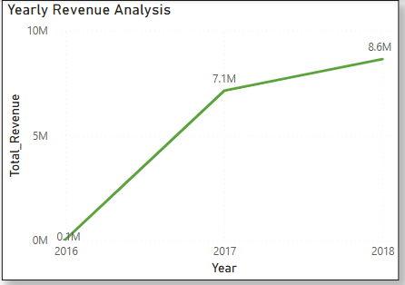

* **Explanation:** The line graph shows yearly revenue generated by the company.