**FLOW DIAGRAM:**

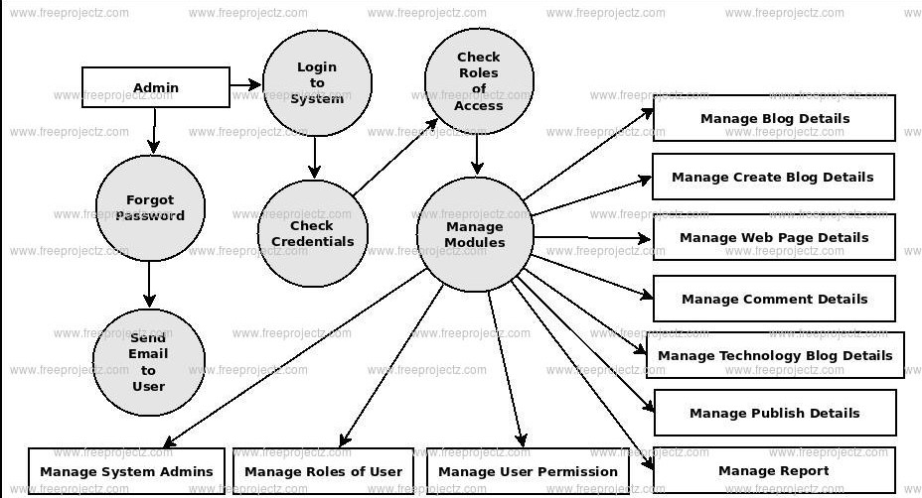

**High-Level Documentation:**

**Title**: Simple Blogging Platform

**Overview**:

The Simple Blogging Platform allows users to create, publish, and manage blog posts. It provides an intuitive interface for writers to share their thoughts and engage with readers.

**Features**:

User Registration and Authentication: Users can sign up for accounts and securely log in to access the platform.

**Blog Post Management**: Users can create, edit, delete, and publish blog posts.

**Commenting System**: Readers can leave comments on blog posts to interact with authors and other readers.

**Responsive Design**: The platform is designed to be accessible on various devices, ensuring a seamless reading and writing experience.

**Technologies Used**:

**Frontend**: HTML, CSS, JavaScript

**Backend**: Node.js, Express.js

**Database**: MongoDB

**Dependencies**:

**Express.js:** Web application framework for Node.js

**MongoDB**: NoSQL database for storing user data, blog posts, and comments

**Mongoose**: MongoDB object modeling tool for Node.js

**bcrypt**: Library for password hashing and authentication

**JSON Web Tokens (JWT):** Secure authentication mechanism for web applications

**Deployment**:

The platform is deployed on a cloud platform such as Heroku or AWS to ensure accessibility to users from anywhere with an internet connection.

**Conclusion**:

In conclusion, the Simple Blogging Platform is a web application designed to facilitate the creation, publishing, and management of blog posts. It offers a user-friendly interface for both writers and readers, allowing for seamless interaction within the blogging community.

The low-level documentation delves into the specific modules and components responsible for the platform's functionality. It details the user authentication module, which ensures secure access to user accounts, and the blog post management module, which handles the creation, editing, and publication of blog posts.