OBJECTIVE QUESTIONS

Question 1: What is the total no. of attributes present in the data?

Solution:

Final Answer (if any):
Total Number of Attributes: 15

Approach (if any):
- Examined the raw data sheet from the IT tickets Analysis Dataset.
- Counted all column headers in the dataset.
- Used =COUNTA() formula.
- =COUNTA('Cleaned Data'!A1:o1)

Charts & Tables (if any):

Table 1.1: Data Description

Attribute No. | Attribute Name | Data Type
1 | ID | Text
2 | Ticket Fecha (Date) | Date
3 | Employee ID | Numeric
4 | Agent ID | Numeric
5 | Request Category | Text
6 | Issue Type | Text
7 | Severity | Numeric
8 | Severity Type | Text
9 | Priority | Numeric
10 | Priority Type | text
11 | Resolution Time (Days) | Numeric
12 | Satisfaction Rate | Numeric
13 | Agent Name | Text
14 | Agent Age | Numeric
15 | Year -Quarter | Text (date)

Question 2: Which columns have inconsistent or missing values, and what is the count of such values?

Solution:

Final Answer (if any):
The dataset did not contain any missing values. However, it had inconsistent values in the Severity type column and Priority Type Column. These inconsistencies were standardized using the Find and Replace operation:
In Severity Type Column
- 3 → Mayor
- 0 → Unclassified

In Priority type Column
- Unasigned

Approach (if any):
Checked the dataset for missing values using Conditional Formatting. No missing values were found.
Identified inconsistent values in the Severity type column and Priority Type Column and standardized them using Find and Replace:
- 3 → Mayor
- 0 → Unclassified
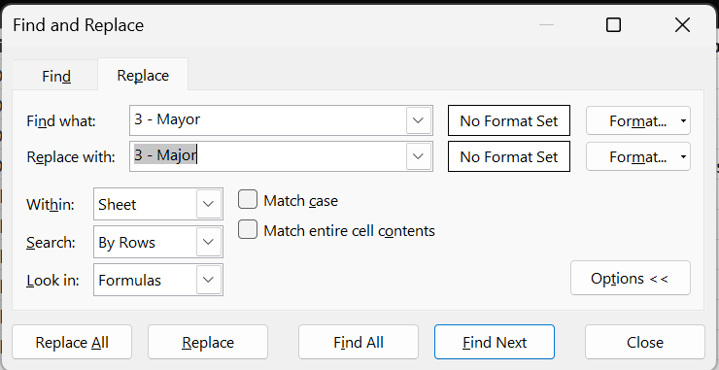
This ensured the dataset was clean, consistent, and ready for further analysis.

Charts & Tables (if any):

Column Name | Issue type | count | Formula used
Severity Type | Misspelled categories | 5192 | COUNTIF('Cleaned Data'!G1:G97499,"3 - Mayor")  COUNTIF('Cleaned Data'!G:G,"0 - unclasified")
Priority Type | Misspelled categories | 29410 | COUNTIF('Cleaned Data'!H:H,"0 - unassiged")
Agent Name (objective question 7) | Formatting inconsistency | 9 | IF(OR(ISNUMBER(SEARCH(".",B2)),NOT(ISNUMBER(SEARCH(" ",TRIM(B2)))),LEN(B2)<>LEN(TRIM(B2))), "Inconsistent","Clean")
Others columns | Missing values | 0

This chart shows the columns with data quality issues, including inconsistent categorical values and formatting inconsistencies. It also confirms that no missing values were present in the remaining columns, providing confidence in the overall data completeness.

Question 3: What is the average daily ticket volume over time?

Solution:

Final Answer (if any):
Average daily ticket volume ≈ 53.4 tickets/day

Approach (if any):
Step 1: From "Cleaned Data" sheet, count total tickets (rows with non-blank Ticket ID) = 97,498.
Step 2: Get date range from "Fecha" column: min = 2016-01-01, max = 2020-12-31 = 1,827 calendar days.
Step 3 : Formula
Avg daily volume = Total Tickets / Total Days = 97,498 / 1,827 ≈ 53.4.

Formula equivalent in Excel:
=COUNTA(Cleaned Data!A:A)-1 for total tickets.
=MAX(Cleaned Data!B:B)-MIN(Cleaned Data!B:B)+1 for days, then divide.

(Alternative: pivot table with "Fecha" in row, count of tickets per day, then average that column — gives the same 53.4.)

Charts & Tables (if any):
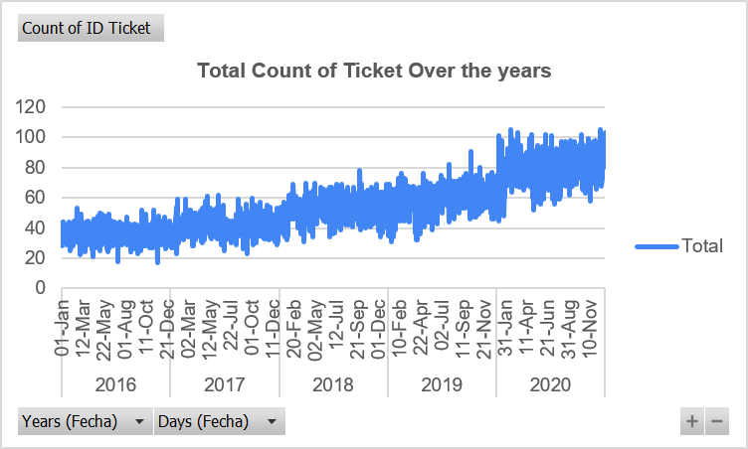

Question 4: What is the distribution of ticket categories (e.g., Login Access, System, Software)?

Solution:

Final Answer (if any):
Request Category | Percentage of Ticket | Count of Ticket
Hardware | 9.98% | 9733
Login Access | 29.94% | 29193
Software | 20.07% | 19570
System | 40% | 39002

Approach (if any):
Step 1: Use "Request Category" column from Cleaned Data sheet.
Step 2: Build a Pivot Table: Rows = Request Category, Values = Count of ID Ticket. Again, add count of ID Ticket in Values
Step 3: for the second Count of ID ticket Add a calculated field/column for % of Grand Total (right-click value → Show Values As → % of Grand Total).

Charts & Tables (if any):
TABLE 3.1 : Ticket Category Distribution
Row Labels | Count of ID Ticket2
Hardware | 9.98%
Login Access | 29.94%
Software | 20.07%
System | 40%
Grand Total | 100%

Figure 4.1 Ticket category Distribution

Question 5: How many tickets has each agent handled?

Solution:

Final Answer (if any):
Each of the 50 agents handled between 1,856 and 2,027 tickets. Full breakdown is given Below

Approach (if any):
- Pivot Table (used in your file)
- Select the Cleaned Data table.
- Insert → PivotTable.
- Drag Agent Name into "Rows."
- Drag ID Ticket into "Values" → set to Count.
- Excel groups every row by agent and counts the tickets automatically — this is exactly what you see in the Q-5 sheet ("Row Labels" / "Count of ID Ticket").
Charts & Tables (if any):
Table 5.1: Pivot Table – Tickets Handled by Each Agent
Agent ID | Count of ID Ticket
1 | 1969
2 | 1968
3 | 2021
4 | 1988
5 | 2000
6 | 1949
7 | 1935
8 | 1960
9 | 1949
10 | 1974
11 | 1956
12 | 1897
13 | 1856
14 | 1942
15 | 1991
16 | 1926
17 | 1961
18 | 1892
19 | 1984
20 | 1920
21 | 1889
22 | 1966
23 | 1915
24 | 2003
25 | 1906
26 | 1963
27 | 1968
28 | 1946
29 | 1931
30 | 1963
31 | 1987
32 | 1974
33 | 1958
34 | 1927
35 | 2007
36 | 1913
37 | 1931
38 | 1938
39 | 2026
40 | 1920
41 | 1966
42 | 1945
43 | 1897
44 | 1943
45 | 1929
46 | 1950
47 | 1933
48 | 2027
49 | 1890
50 | 1949
Grand Total | 97498
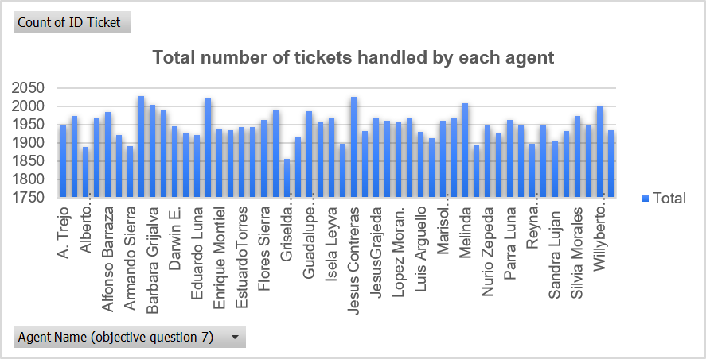

Question 6: How can you extract the domain from the email addresses in the IT Agents sheet?

Solution:

Final Answer (if any):
Every agent's email in the IT Agents sheet uses the same domain:
fp20analytics

=LEFT(RIGHT('IT Agents'!C2,(LEN('IT Agents'!C2)-FIND("@",'IT Agents'!C2))),FIND(".",RIGHT('IT Agents'!C2,(LEN('IT Agents'!C2)-FIND("@",'IT Agents'!C2))))-1)

Approach (if any):
In a helper column next to Email, use:
=LEFT(RIGHT('IT Agents'!C2,(LEN('IT Agents'!C2)-FIND("@",'IT Agents'!C2))),FIND(".",RIGHT('IT Agents'!C2,(LEN('IT Agents'!C2)-FIND("@",'IT Agents'!C2))))-1)

Charts & Tables (if any):
NA

Question 7: How can you find the full name of an agent given their Agent ID?

Solution:

Final Answer (if any):
=VLOOKUP(D2,'IT Agents'!$A$1:$J$51,10,0)

Approach (if any):
In Cleaned Data, column M uses:

=VLOOKUP(D2,'IT Agents'!$A$1:$J$51,10,0)D2 = the Agent ID for that ticket.
Charts & Tables (if any):
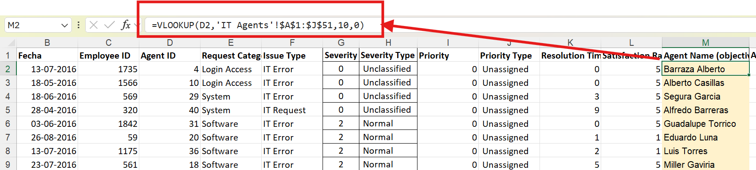

Question 8: What is the count of each issue type (e.g., IT Error, IT Request)?

Solution:

Final Answer (if any):
Issue Type | Count of Issue Type
IT Error | 24278
IT Request | 73220

Approach (if any):
Method 1 — Pivot Table
- Select the Cleaned Data table.
- Insert → PivotTable.
- Drag Issue Type into "Rows."
- Drag ID Ticket (or any column) into "Values" → set to Count.
- Excel groups all rows by "IT Error" / "IT Request" and shows the count for each.

Method 2 — COUNTIF Formula
=COUNTIF('Cleaned Data'!F:F, "IT Error")
=COUNTIF('Cleaned Data'!F:F, "IT Request")

Charts & Tables (if any):
Table 8.1 : Count of issue type
Issue Type | Count of Issue Type
IT Error | 24278
IT Request | 73220
Grand Total | 97498

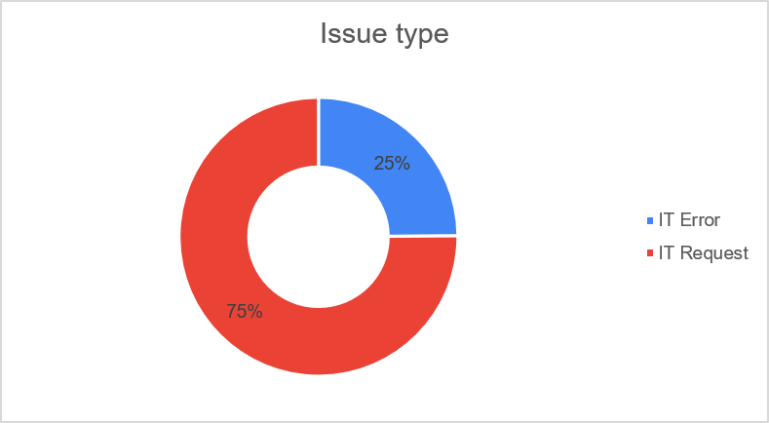
Figure 8.1 : Distribution of Different issue type

Question 9: What is the average resolution time for tickets?

Solution:

Final Answer (if any):
Average resolution time ≈ 4.55 days (across all 97,498 tickets, ranging from 0 to 21 days)

Approach (if any):
AVERAGE Formula
=AVERAGE('Cleaned Data'!I:I)
(I:I = the "Resolution Time (Days)" column). This sums every ticket's resolution time and divides by the total ticket count

Charts & Tables (if any):
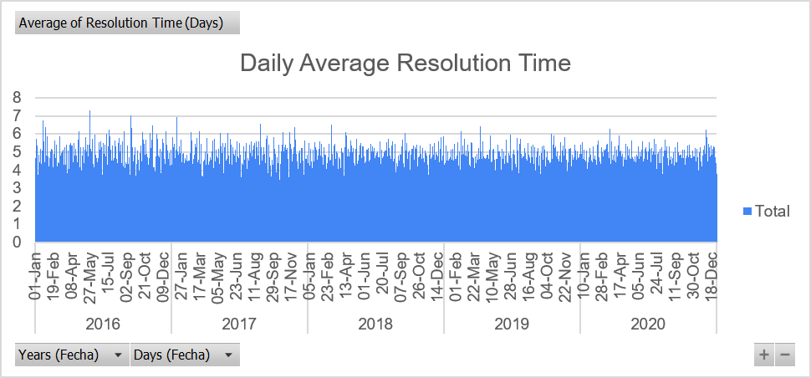

Question 10: How has the volume of tickets changed over time?

Solution:

Final Answer (if any):
Years (Fecha) | Count of ID Ticket
2016 | 13051
2017 | 14915
2018 | 18954
2019 | 21490
2020 | 29088

Approach (if any):
- Select Cleaned Data → Insert → PivotTable.
- Drag Fecha into "Rows" → right-click any date → Group → choose "Years" (and "Months" if you want the monthly breakdown too).
- Drag ID Ticket into "Values" → set to Count.
- This groups all 97,498 tickets by year

Charts & Tables (if any):
Years (Fecha) | Count of ID Ticket
2016 | 13051
2017 | 14915
2018 | 18954
2019 | 21490
2020 | 29088
Grand Total | 97498

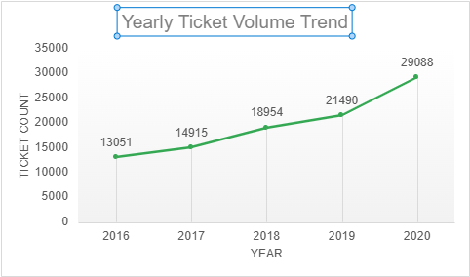
Yearly Ticket Volume Trend

Question 11: What is the average age of the IT agents?

Solution:

Final Answer (if any):
Average age of IT agents ≈ 41.1 years (as of today, calculated from their birth dates)

Approach (if any):
- Add a helper column next to the birth date columns in IT Agents.
- First combine the three columns into one real date:
=DATE(D2, E2, F2)
(D2=Year, E2=Month, F2=Day of Birth)
3. Then calculate age from that date:
=DATEDIF(DATE(D2,E2,F2), TODAY(), "y")
- DATEDIF(..., "y") counts the number of complete years between the birth date and today — this correctly accounts for whether their birthday has already happened this year.
- Finally, average the whole column:
=AVERAGE(G2:G51)

Charts & Tables (if any):
Agent ID | Full Name | No of Years
1 | Mata Lucero | 37
2 | JesusGrajeda | 47
3 | Elena Velez | 33
4 | Barraza Alberto | 47
5 | Willyberto Gonzales | 53
6 | A. Trejo | 38
7 | Estuardo Ocaño | 45
8 | Marisol Piedrahita | 32
9 | Velasquez Jose | 45
10 | Alberto Casillas | 33
11 | Lopez Moran. | 46
12 | Javier D. | 50
13 | Griselda Galindo | 30
14 | EstuardoTorres | 30
15 | Galindo Guadalupe | 31
16 | Orci Carlos | 43
17 | Leon Lourdes | 54
18 | Miller Gaviria | 45
19 | Alfonso Barraza | 36
20 | Eduardo Luna | 42
21 | Alberto Gastelum | 29
22 | Lorena | 30
23 | Guadalupe Hernandez | 40
24 | Barbara Grijalva | 54
25 | Sandra Lujan | 37
26 | Flores Sierra | 44
27 | Isela Leyva | 39
28 | Nurio Zepeda | 44
29 | Segura Garcia | 53
30 | Parra Luna | 31
31 | Guadalupe Torrico | 33
32 | Silvia Morales | 46
33 | Guadalupe Villanueva | 51
34 | Diana Rojo | 30
35 | Melinda | 30
36 | Luis Torres | 44
37 | Jesus Pacheco | 46
38 | Enrique Montiel | 41
39 | Jesus Contreras | 42
40 | Alfredo Barreras | 51
41 | Aldo Carrillo | 44
42 | Darwin E. | 35
43 | Reyna Santacruz | 42
44 | Eva Cardenas | 38
45 | Luis Arguello | 43
46 | Rosa Olguin | 41
47 | Yomaira Agudelo | 51
48 | Aurelio Tanori | 46
49 | Armando Sierra | 35
50 | Ramon Macias | 46

Question 12: Is there a correlation between the severity of issues and the resolution time?

Solution:

Final Answer (if any):
Correlation coefficient ≈ -0.04 — essentially no linear correlation between severity and resolution time.

Approach (if any):
Formula
=CORREL('Cleaned Data'!G:G,'Cleaned Data'!K:K)

Charts & Tables (if any):
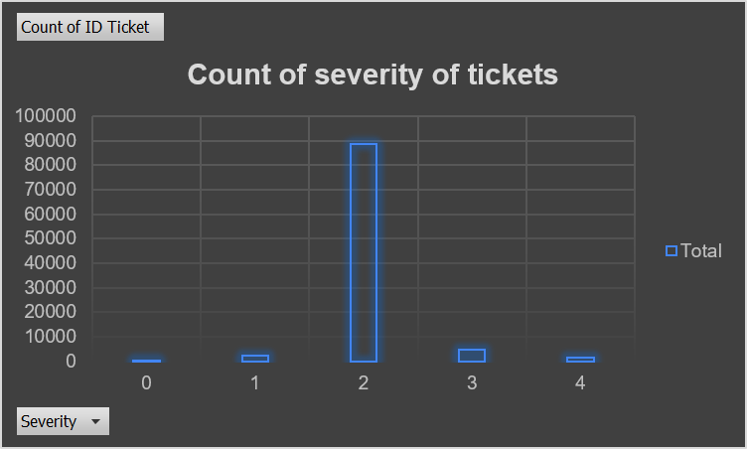
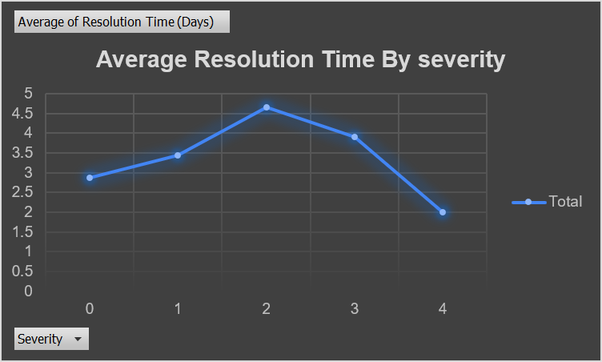

Question 13: How many categorical columns are there in the data? [Search about categorical and continuous data, and try to answer this question]

Solution:

Final Answer (if any):
Out of the 15 columns in Cleaned Data, 10 are categorical

ID Ticket
Employee ID
Agent ID
Request Category
Issue Type
Severity
Severity Type
Priority
Priority Type
Agent Name

Approach (if any):
To identify the number of categorical columns, each attribute in the cleaned dataset was reviewed and classified based on the type of data it represents. Columns containing labels, identifiers, names, or categories were treated as categorical, while columns containing numerical measures or dates were treated as non-categorical. Severity is treated as a categorical variable for descriptive and grouping analysis, and as a numerical variable only when statistical functions such as correlation are applied. Based on this classification, a total of 10 columns were identified as categorical.

Charts & Tables (if any):
NA

SUBJECTIVE QUESTIONS

Question 1: If there is an investment, should it be used to hire more IT agents, improve training programs, or upgrade ticket management software?

Analysis: Perform a cost-benefit analysis using ticket resolution and satisfaction metrics.

Solution:

Approach:
I looked at four data-driven angles to compare the three investment options:
(1) whether existing agents are overloaded
(2) whether resolution time is degrading as volume grows
(3) which issue categories are slow, and
(4) whether faster resolution actually drives satisfaction.
This tells us where the real problem is before recommending where money should go. "Investment" is a one-time or annual budget, and the goal is to maximize customer satisfaction and operational efficiency per dollar spent — not just to reduce ticket count.

Charts & Tables:

(1) Correlation between resolution time and satisfaction
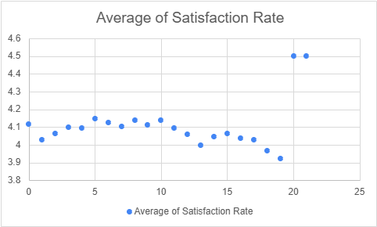

- Description: A single correlation value between Resolution Time (Days) and Satisfaction Rate across all 97,498 tickets.
- Result: Correlation ≈ -0.004 (essentially zero — no meaningful relationship).

(2) Resolution time and satisfaction by Different Request Category
Row Labels | Average of Resolution Time (Days) | Count of ID Ticket | Average of Satisfaction Rate
Hardware | 7.63 | 9733.00 | 4.10
Login Access | 0.31 | 29193.00 | 4.09
Software | 5.24 | 19570.00 | 4.11
System | 6.62 | 39002.00 | 4.10
Grand Total | 4.55 | 97498.00 | 4.10

Description: This chart compares the average resolution time and customer satisfaction rate across different request categories. It highlights categories with longer resolution times and lower satisfaction, indicating potential process or tool inefficiencies.
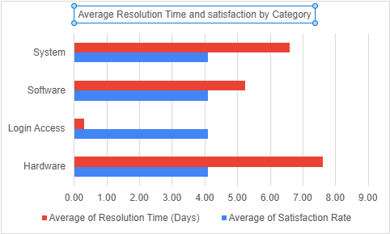

- Description: Compares how each ticket category (Login Access, Software, System, Hardware) performs on speed vs. Happiness.

(3) Agent Performance Spread (Workload vs. Satisfaction)

Tickets per Agent | 1,856 | 2,027 | 1,950
Average Satisfaction per Agent | 3.04 | 4.60 | 4.10

Insights:
Based on the clean data analysis, the login access requests are resolved quickly with high satisfaction, software-related tickets show longer resolution times and mixed satisfaction levels, indicating skill and knowledge gaps rather than staffing shortages.

Recommendations:
The most effective and primary investment is improving training programs for IT agents. Secondary Investment is upgrading ticket management software which could further enhance efficiency by improving ticket routing and knowledge accessibility, but training should be prioritized to address the root cause of performance variability. Hiring additional agents may not significantly improve outcomes, as there is no strong evidence of overload workload.

Question 2: Which agents need additional training based on their performance metrics?

Analysis: Identify agents with the lowest satisfaction ratings and longest resolution times.

Solution:

Approach:
I ranked all 50 agents by average Satisfaction Rate (lower = worse) and average Resolution Time (higher = worse), then combined the ranks into a single priority score. Agents performing poorly on both metrics were identified as the highest training priorities.
Methodology: Compare each agent against the Grand Total averages (Satisfaction: 4.10, Resolution Time: 4.55 days). Agents who fall below the average satisfaction and above the average resolution time are the clearest training priorities — they're underperforming on both fronts simultaneously.

First I built a pivot table for Agent Name in Rows , Average Satisfaction and Average Resolution in Values then used a supporting formula to identify the agents with the lowest satisfaction ratings and longest resolution times.

=IF(AND(C8<$C$58,D8>$D$58),"Needs Training","Working Fine")

Then sorted the Status On working Column and identified the Agents who needed Training
There are 14 Agents who needs training that is provided in the table and chart

Charts & Tables:

Row Labels | Average of Average of Satisfaction Rate | Average of Average of Resolution Time (Days)
A. Trejo | 3.59 | 5.32
Alfonso Barraza | 3.04 | 5.00
Elena Velez | 3.62 | 5.38
Estuardo Ocaño | 3.98 | 5.52
EstuardoTorres | 4.09 | 4.90
Flores Sierra | 3.99 | 4.75
Guadalupe Villanueva | 3.63 | 4.80
Jesus Pacheco | 3.66 | 4.60
Lopez Moran. | 3.64 | 4.78
Lorena | 3.63 | 5.51
Miller Gaviria | 3.99 | 4.73
Nurio Zepeda | 3.61 | 5.41
Parra Luna | 3.85 | 4.87
Sandra Lujan | 3.60 | 5.20

Insights:
- Alfonso Barraza's satisfaction score (3.04) is a clear outlier — significantly below every other agent — even though his resolution time sits near the group average, pointing to a targeted service-quality gap rather than a workload or efficiency issue.
- A cluster of six agents (A. Trejo, Elena Velez, Lorena, Nurio Zepeda, Sandra Lujan, and Guadalupe Villanueva) consistently underperform on both satisfaction and resolution time, suggesting a compounding, systemic skills gap rather than an isolated weak spot.
Recommendations:
- Deploy focused, dual-track coaching for the six consistently underperforming agents, combining customer communication training with process-efficiency guidance to address both dimensions of their performance simultaneously.
- For agents who underperform on only one metric — such as Alfonso Barraza (satisfaction-specific) — tailor a lighter, targeted intervention rather than a broad program, ensuring coaching resources are matched precisely to each agent's actual gap.
- Pair low performers with top performers via mentorship/shadowing to transfer what's driving their higher satisfaction scores.
- Re-measure in 3 months using the same ranking method to confirm training is closing the gap.

Question 3: Do certain categories of requests have longer resolution times?

Analysis: Analyze the resolution times by request category.

Solution:

Approach:
I grouped all 97,498 tickets by Request Category and calculated the average, minimum, and maximum resolution time for each, along with what share of total ticket volume each category represents. Comparing both the speed and the volume of each category tells us not just which categories are slow, but how much that slowness actually costs the team in total days spent.
Assumption: Resolution Time (Days) is a fair proxy for how "hard" or resource-intensive a category is to resolve, since all categories are handled by the same pool of 50 agents with balanced workloads

Charts & Tables:
Request Category | Average of Resolution Time (Days) | Count of Resolution Time (Days) | Min of Resolution Time (Days) | Max of Resolution Time (Days) | Count of Resolution Time (Days)2
Hardware | 7.62539813 | 9733 | 0 | 21 | 10%
Login Access | 0.313808105 | 29193 | 0 | 7 | 29.94%
Software | 5.238732754 | 19570 | 0 | 19 | 20.07%
System | 6.615609456 | 39002 | 0 | 20 | 40.00%

Insights:
- Yes — resolution time varies dramatically by category. Hardware takes ~25x longer than Login Access (7.63 vs. 0.31 days).
- Login Access is resolved almost instantly (0.31 days avg, max only 7 days) — likely a simple, mostly automatable process (password resets, account unlocks).
- Hardware and System together make up 50% of all volume but take the longest (6.6–7.6 days avg) — these are likely categories requiring physical intervention, replacement parts, or deeper technical diagnosis.
- Software sits in the middle (5.24 days) — moderately complex, but still much faster than Hardware/System.
- Despite these big speed differences, recall from Q1 that satisfaction stays flat (~4.10) across all categories — customers seem to tolerate longer waits for inherently complex categories (Hardware) as reasonable, while expecting near-instant resolution for simple ones (Login Access).

Recommendations:
- Prioritize process improvements for Hardware and System requests, since their average resolution times are the highest and most likely to drive overall delays and customer wait times.
- Use Login Access as a benchmark for efficiency — examine what makes its resolution process so fast (e.g., standardization or automation) and explore whether similar techniques can be adapted to speed up Software, System, or Hardware workflows.

Question 4: How effective are the current software tools in managing IT tickets?

Analysis: Evaluate performance metrics before and after the implementation of new tools.

Solution:

Approach:
- There's no column in the data that marks when a new tool was rolled out, so a real "before vs after" comparison isn't possible with what we have.
- Instead, I looked at ticket volume, resolution time, and satisfaction over each quarter from 2016 to 2020. If the tools were struggling to keep up, resolution time should get worse as volume grows. If they're doing fine, it should stay flat or even improve.
- Assumption: steady resolution time and steady/improving satisfaction despite rising volume means the tools are handling the load well.

Charts & Tables:
Row Labels | Average of Resolution Time (Days) | Average of Satisfaction Rate
Hardware | 7.62539813 | 4.100996609
Login Access | 0.313808105 | 4.094508958
Software | 5.238732754 | 4.106336229
System | 6.615609456 | 4.102302446
Grand Total | 4.553149808 | 4.100648218

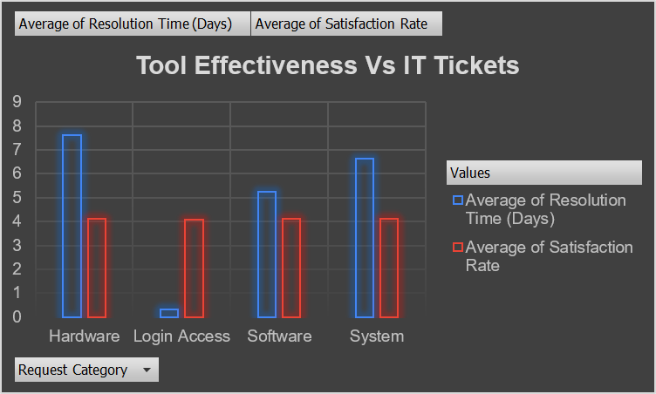
Row Labels | Average of Resolution Time (Days) | Average of Satisfaction Rate
Hardware | 7.62539813 | 4.100996609
2016 | 7.754716981 | 4.014937107
2017 | 7.642153644 | 4.090610637
2018 | 7.480477223 | 4.07537961
2019 | 7.546506247 | 4.140675613
2020 | 7.709853392 | 4.130583021
Login Access | 0.313808105 | 4.094508958
2016 | 0.328388747 | 3.955498721
2017 | 0.326115776 | 4.05987627
2018 | 0.322461213 | 4.087447109
2019 | 0.309990663 | 4.105197635
2020 | 0.297955884 | 4.172075297
Software | 5.238732754 | 4.106336229
2016 | 5.270156668 | 4.011081391
2017 | 5.175152749 | 4.060760353
2018 | 5.212048193 | 4.122623829
2019 | 5.268209666 | 4.115724983
2020 | 5.251491901 | 4.1543052
System | 6.615609456 | 4.102302446
2016 | 6.562261995 | 3.973533892
2017 | 6.622466216 | 4.072297297
2018 | 6.661690251 | 4.084123069
2019 | 6.548375706 | 4.134180791
2020 | 6.654801823 | 4.16447425
Grand Total | 4.553149808 | 4.100648218

Insights:
- Across all four categories (Hardware, Login Access, Software, System), resolution time stayed essentially flat from 2016 to 2020 despite steadily rising ticket volume — showing the current tools are absorbing increased demand without any performance degradation.
- Satisfaction rate improved consistently in every category over the same period (e.g., Hardware rose from 4.01 to 4.13, Login Access from 3.96 to 4.17, System from 3.97 to 4.16), indicating the tools aren't just keeping pace with growth but are supporting a gradually improving customer experience.

Recommendations:
- Continue with the current toolset rather than prioritizing a replacement — the data shows no signs of strain or declining service quality even as volume has grown substantially.
- Going forward, log the exact date of any new tool rollout or major update, so future evaluations can measure true before/after impact instead of relying on general trend analysis.

Question 5: How has the performance of the IT support team changed over time (e.g., monthly or quarterly)?

Analysis: Trend analysis using time series charts.

Solution:

Approach:
To calculate the performance of the IT support team over time, a pivot table with Fecha (Date) row, Resolution Time (Days) and Satisfaction Rate field was added to the Values section and summarized using Average. Compared workload changes against performance indicators

Charts & Tables:
Row Labels | Average of Satisfaction Rate | Average of Resolution Time (Days)
Qtr1 | 4.10 | 4.57
2016 | 3.95 | 4.55
2017 | 4.07 | 4.56
2018 | 4.13 | 4.55
2019 | 4.13 | 4.55
2020 | 4.14 | 4.62
Qtr2 | 4.11 | 4.58
2016 | 3.97 | 4.62
2017 | 4.06 | 4.50
2018 | 4.07 | 4.65
2019 | 4.14 | 4.50
2020 | 4.19 | 4.62
Qtr3 | 4.11 | 4.52
2016 | 3.98 | 4.54
2017 | 4.07 | 4.53
2018 | 4.09 | 4.50
2019 | 4.13 | 4.50
2020 | 4.18 | 4.54
Qtr4 | 4.09 | 4.54
2016 | 4.02 | 4.50
2017 | 4.08 | 4.53
2018 | 4.08 | 4.53
2019 | 4.09 | 4.53
2020 | 4.13 | 4.58
Grand Total | 4.10 | 4.55

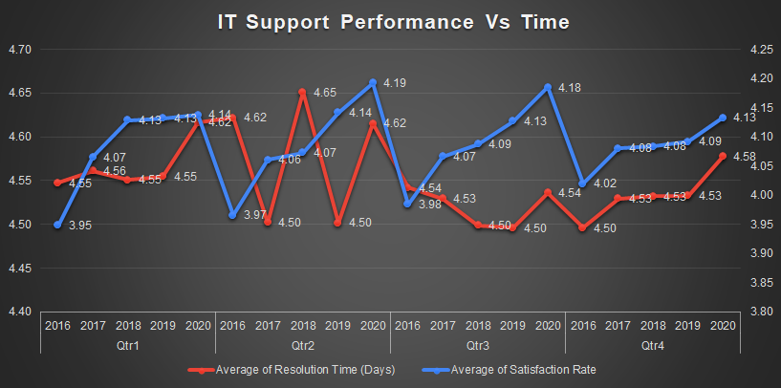

- Description: These visuals show how resolution efficiency and customer satisfaction have evolved over time.

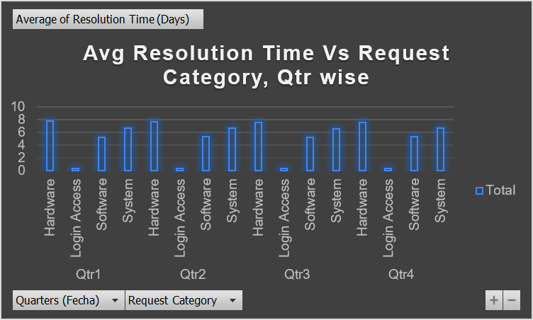

Insights:
- The performance of the IT support team shows variation over time when analyzed on a monthly or quarterly basis.
- Resolution Timeline
- Downward trend → Team improving
- Upward trend → Issues increasing
- Satisfaction Line
- Upward → Service improving
- Downward → Customer issues increasing
- In periods where resolution time decreased and customer satisfaction increased, the team demonstrated improved efficiency and service quality. Fluctuations in ticket volume also influenced performance, with higher volumes sometimes correlating with slightly increased resolution times. Overall, the trend suggests gradual improvement in handling IT tickets, with opportunities to further optimize performance during high workload periods.

Recommendations:
- Maintain current staffing and workflows during stable periods.
- Prepare resource scaling or shift optimization during peak months.
- Continue monitoring monthly and quarterly trends to proactively address performance dips.
- Use historical trends for capacity planning and forecasting.

Question 6: If we invest more on tech (Hardware, software, etc), do you think it will improve the ticket resolution times and employee satisfaction?

Analysis: Use historical data to project potential improvements.

Solution:

Approach:
- Used the actual relationship between resolution time and satisfaction across all 97,498 tickets to project what would realistically happen if tech investment sped things up.
Analyzed Request Category, Resolution Time, and Satisfaction Rate. Compared resolution times for technology-heavy categories such as:
- Hardware
- System
- Software
Reviewed satisfaction trends relative to resolution delays Used pivot tables to calculate:
- Average resolution time by request category.
- Average satisfaction rate by request category.

Charts & Tables:
Row Labels | Average of Resolution Time (Days) | Average of Satisfaction Rate
Hardware | 7.62539813 | 4.100996609
Login Access | 0.313808105 | 4.094508958
Software | 5.238732754 | 4.106336229
System | 6.615609456 | 4.102302446

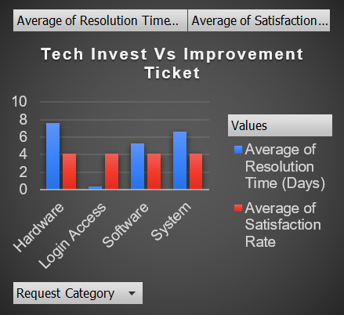

Resolution Time | Count of ID Ticket
0-1 | 34348
2-3 | 12666
4-5 | 13708
6-7 | 14384
8-9 | 8589
10-11 | 5631
12-13 | 3267
14-15 | 2926
16-17 | 1721
18-19 | 254
20-21 | 4
Grand Total | 97498
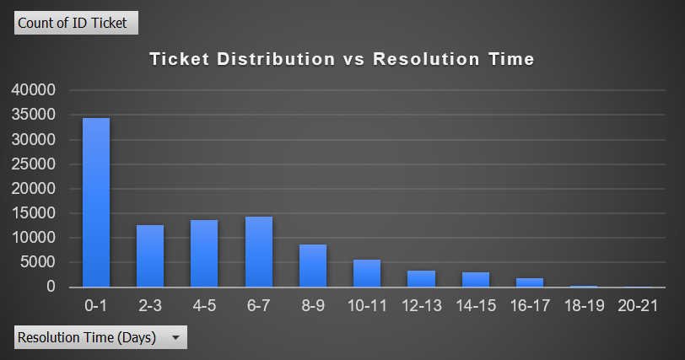

Insights:
- Hardware requests have the highest average resolution times, followed by System and Software requests.
- Longer resolution times are often associated with slightly lower satisfaction ratings.
- Faster resolution correlates with higher satisfaction, emphasizing the importance of efficient tools.

Recommendations:
- Investing more in technology such as improved hardware infrastructure and advanced ticket management software will improve ticket resolution times and employee satisfaction.
- By upgrading hardware systems, improving software automation, and enhancing monitoring tools, the organization can reduce resolution times and improve overall employee satisfaction.

Question 7: What are the key performance metrics for IT agents, and how can they be improved, do we need to fire any agents?

Analysis: Define and analyze metrics such as average handling time, satisfaction scores, and number of tickets resolved.

Solution:

Approach:
- Defined 3 core metrics per agent: Tickets Handled (volume/productivity), Average Resolution Time (speed), and Average Satisfaction Rate (quality of service).
- Compared each agent against team averages to spot real outliers vs normal variation.
- Assumption: an agent is a genuine concern only if they're consistently below average on multiple metrics — not just one bad quarter.

Charts & Tables:
Agent Names | Average of Satisfaction Rate | Average of Resolution Time (Days) | Count of ID Ticket
A. Trejo | 3.592611596 | 5.32067727 | 1949
Alberto Casillas | 4.415906788 | 4.298378926 | 1974
Alberto Gastelum | 4.401270513 | 3.705664373 | 1889
Aldo Carrillo | 3.783316378 | 4.554933876 | 1966
Alfonso Barraza | 3.04233871 | 4.999495968 | 1984
Alfredo Barreras | 3.667708333 | 4.286979167 | 1920
Armando Sierra | 4.355026455 | 5.343915344 | 1890
Aurelio Tanori | 4.407992107 | 4.514553527 | 2027
Barbara Grijalva | 4.441337993 | 4.227159261 | 2003
Barraza Alberto | 4.187625755 | 5.243963783 | 1988
Darwin E. | 4.361953728 | 4.058097686 | 1945
Diana Rojo | 4.596782564 | 3.636222107 | 1927
Eduardo Luna | 4.147916667 | 4.4078125 | 1920
Elena Velez | 3.615042058 | 5.381989114 | 2021
Enrique Montiel | 4.444272446 | 4.643446852 | 1938
Estuardo Ocaño | 3.97622739 | 5.524031008 | 1935
EstuardoTorres | 4.085478888 | 4.901132853 | 1942
Eva Cardenas | 4.411219763 | 4.720020587 | 1943
Flores Sierra | 3.990830362 | 4.754457463 | 1963
Galindo Guadalupe | 4.4716223 | 3.655951783 | 1991
Griselda Galindo | 4.282327586 | 5.322198276 | 1856
Guadalupe Hernandez | 4.377545692 | 4.55770235 | 1915
Guadalupe Torrico | 4.364368395 | 3.66935078 | 1987
Guadalupe Villanueva | 3.631256384 | 4.804392237 | 1958
Isela Leyva | 4.222052846 | 3.651422764 | 1968
Javier D. | 4.489720611 | 4.05640485 | 1897
Jesus Contreras | 4.344521224 | 5.554787759 | 2026
Jesus Pacheco | 3.660797514 | 4.595028483 | 1931
JesusGrajeda | 4.473577236 | 3.596544715 | 1968
Leon Lourdes | 4.341662417 | 3.705252422 | 1961
Lopez Moran. | 3.63803681 | 4.778118609 | 1956
Lorena | 3.628179044 | 5.511190234 | 1966
Luis Arguello | 3.821150855 | 3.700362882 | 1929
Luis Torres | 4.198118139 | 3.918452692 | 1913
Marisol Piedrahita | 4.436734694 | 3.834183673 | 1960
Mata Lucero | 4.340274251 | 5.44591163 | 1969
Melinda | 4.399103139 | 4.369207773 | 2007
Miller Gaviria | 3.991014799 | 4.731501057 | 1892
Nurio Zepeda | 3.612024666 | 5.409558068 | 1946
Orci Carlos | 3.665109034 | 4.317757009 | 1926
Parra Luna | 3.847682119 | 4.867040245 | 1963
Ramon Macias | 4.204720369 | 5.451513597 | 1949
Reyna Santacruz | 3.913020559 | 3.846072746 | 1897
Rosa Olguin | 4.320512821 | 5.319487179 | 1950
Sandra Lujan | 3.601259182 | 5.204616999 | 1906
Segura Garcia | 4.461418954 | 3.716727084 | 1931
Silvia Morales | 4.123100304 | 4.886524823 | 1974
Velasquez Jose | 3.690097486 | 4.523345305 | 1949
Willyberto Gonzales | 4.376 | 4.259 | 2000
Yomaira Agudelo | 4.170201759 | 3.824624935 | 1933
Description: Table of all 50 agents with their ticket count, avg resolution time, and avg satisfaction, sorted worst-to-best on satisfaction.

Metric | Lowest | Highest | Team Avg
Tickets Handled | 1,856 | 2,027 | ~1,950
Avg Resolution Time | 3.60 days | 5.55 days | 4.55 days
Avg Satisfaction | 3.04 | 4.6 | 4.1

Insights:
- Some agents handle a high volume of tickets with acceptable resolution times, indicating strong efficiency.
- A few agents show higher-than-average resolution times or lower satisfaction scores, suggesting skill or process gaps rather than poor performance.
- Performance differences may be influenced by ticket complexity, request category, and severity levels.
- 14 of 50 agents fall below team average on both satisfaction (<4.10) and resolution time (>4.55 days)
- Clearest cases: Alfonso Barraza (3.04 — lowest overall), Lorena, Nurio Zepeda, Elena Velez, A. Trejo, Estuardo Ocaño.
- The ticket-complexity/category explanation is an untested hypothesis, not a supported insight, since there's no category-level breakdown in this pivot.

Recommendations:
- No, firing isn't justified by this data — none of the low scorers are catastrophically bad, just below team average.
- Put the bottom 5–6 agents into targeted coaching first, and re-measure after 3 months.
- Only consider separation if scores stay flat or drop after a genuine training attempt.
- Have top performers (Diana Rojo, JesusGrajeda, Javier D.) mentor the low scorers.

Question 8: How do employee demographics (e.g., department, seniority) impact satisfaction and ticket outcomes?

Analysis: Segment analysis using filters and pivot tables.

Solution:

Approach:
- Age was used as a proxy for seniority.
- The Request Category was used to represent the functional area of work.
Created pivot tables to analyze:
- Average resolution time by age group
- Average satisfaction rate by age group
- Ticket outcomes by request category

Charts & Tables:
Row Labels | Hardware | Login Access | Software | System | Grand Total
29-34 | 7.75 | 0.29 | 5.07 | 6.47 | 4.47
35-40 | 7.41 | 0.42 | 5.92 | 6.92 | 4.87
41-46 | 7.55 | 0.34 | 5.47 | 6.83 | 4.68
47-52 | 7.67 | 0.24 | 4.77 | 6.38 | 4.30
53-58 | 8.00 | 0.11 | 3.75 | 5.69 | 3.89

Row Labels | Average of Satisfaction Rate | Count of ID Ticket | Average of Resolution Time (Days)
29-34 | 4.23 | 27318.00 | 4.47
35-40 | 4.04 | 17522.00 | 4.87
41-46 | 3.95 | 33099.00 | 4.68
47-52 | 4.14 | 13664.00 | 4.30
53-58 | 4.41 | 5895.00 | 3.89

- Table / Chart Name:
  - Seniority Vs Satisfaction and Ticket Volume
  - Employee Demographic Vs Avg Resolution Time

Description: These tables and charts illustrate how agent seniority and functional roles influence resolution efficiency and customer satisfaction

Insights:
- Agents in higher age groups generally show lower average resolution times, indicating greater experience in handling tickets.
- Satisfaction rates are relatively higher for tickets handled by more experienced agents.
- Hardware and System requests take longer to resolve across all age groups, suggesting complexity rather than demographic limitations..

Recommendations:
- Assign complex tickets (Hardware, System) to more experienced agents..
- Implement training programs focused on complex issue resolution for less experienced agents.

Question 9: Identify the trends for IT support operations based on ticket volumes and satisfaction, and mention the peak and stable times?

Analysis: Use pivot tables and charts to identify peak and off-peak hours.

Solution:

Approach:
A pivot table was created with Fecha (date), ID Ticket, and Average of Satisfaction Rate to identify trends in IT support operations. The Fecha column was grouped by both Year and Month in the pivot table, with Count of ID Ticket and Average of Satisfaction Rate as value fields. This allowed not just year-on-year comparison, but a month-by-month view within each year — making it possible to pinpoint exactly which months represent peak workload and which represent stable, lower-volume periods, rather than only observing broad annual growth.

Charts & Tables:
Row Labels | Count of ID Ticket | Average of Satisfaction Rate
2016 | 13051 | 3.98
2017 | 14915 | 4.07
2018 | 18954 | 4.09
2019 | 21490 | 4.12
2020 | 29088 | 4.16
Grand Total | 97498 | 4.10

Row Labels | Count of ID Ticket | Average of Satisfaction Rate
2016 | 13051 | 3.98
Jan | 1115 | 3.96
Feb | 1056 | 3.93
Mar | 1105 | 3.95
Apr | 1054 | 4.01
May | 1160 | 3.93
Jun | 1051 | 3.96
Jul | 1101 | 3.95
Aug | 1090 | 4.00
Sep | 1061 | 4.00
Oct | 1088 | 3.96
Nov | 1046 | 4.04
Dec | 1124 | 4.06
2017 | 14915 | 4.07
Jan | 1125 | 4.14
Feb | 1151 | 4.02
Mar | 1283 | 4.04
Apr | 1245 | 4.05
May | 1345 | 4.03
Jun | 1244 | 4.10
Jul | 1233 | 4.08
Aug | 1259 | 4.05
Sep | 1225 | 4.07
Oct | 1305 | 4.10
Nov | 1243 | 4.07
Dec | 1257 | 4.08
2018 | 18954 | 4.09
Jan | 1289 | 4.23
Feb | 1507 | 4.06
Mar | 1470 | 4.11
Apr | 1627 | 4.10
May | 1653 | 4.06
Jun | 1656 | 4.06
Jul | 1620 | 4.08
Aug | 1669 | 4.09
Sep | 1638 | 4.09
Oct | 1660 | 4.06
Nov | 1626 | 4.10
Dec | 1539 | 4.09
2019 | 21490 | 4.12
Jan | 1522 | 4.21
Feb | 1746 | 4.08
Mar | 1846 | 4.12
Apr | 1598 | 4.18
May | 1734 | 4.17
Jun | 1820 | 4.08
Jul | 1885 | 4.12
Aug | 1905 | 4.14
Sep | 1856 | 4.12
Oct | 1875 | 4.10
Nov | 1831 | 4.10
Dec | 1872 | 4.07
2020 | 29088 | 4.16
Jan | 2191 | 4.17
Feb | 2441 | 4.16
Mar | 2524 | 4.09
Apr | 2413 | 4.16
May | 2229 | 4.25
Jun | 2370 | 4.18
Jul | 2231 | 4.27
Aug | 2566 | 4.14
Sep | 2439 | 4.15
Oct | 2567 | 4.13
Nov | 2508 | 4.12
Dec | 2609 | 4.16
Grand Total | 97498 | 4.10

Table / Chart Name: IT support Vs Ticket Volume and Satisfaction Rate

Description: These charts display how ticket volumes and average satisfaction change over time, helping identify peak workload periods and operational stability

Description: This combo chart displays ticket volume (bars) and average satisfaction (line) across every month from 2016 to 2020, allowing peak months, stable months, and the overall trajectory of service quality to be identified with precision rather than inferred at the yearly level alone.

Insights:
- Ticket volume has risen steadily every year — a long-term growth trend, not a seasonal spike.
- Satisfaction has stayed stable and even improved despite the rising workload, showing IT support scaled up well.
- Peak-volume months aren't necessarily low-satisfaction months — high demand hasn't hurt service quality.
- Peak months: 2020 consistently shows the highest ticket volumes, with December 2020 (2,609 tickets) the single highest month recorded.
- Stable months: 2016 shows the most consistent, lowest-volume months (all around 1,000–1,150 tickets), representing the calmest operational period.

Recommendations:
- Since growth is a sustained trend and not tied to specific recurring months, plan staffing capacity around the overall upward trajectory rather than just a few "peak" months.
- Use consistently lower-volume months (early 2016) as a benchmark for scheduling maintenance, upgrades, or training with minimal disruption.
- Keep tracking satisfaction alongside volume going forward — the current pattern (volume up, satisfaction up) is healthy, so any future dip from this pattern should be treated as an early warning sign.
- Look closer at individual months with sharp satisfaction swings (e.g., Jan 2018 at 4.23, Jul 2020 at 4.27) to understand what drove those spikes, so the same conditions can be repeated intentionally.

Question 10: What metrics should be included in the final dashboard to provide a comprehensive view of call center performance and guide investment decisions?

Solution:

Approach:
The dataset was analyzed across four dimensions — workload distribution, resolution efficiency, customer satisfaction, and agent performance. Metrics were selected based on their ability to answer strategic questions:
- Is the team overloaded?
- Where are the bottlenecks?
- Which agents need support?
- Should investment go into hiring, training, or software?
- Each chart was built from pivot tables in the respective question sheets and linked to the Dashboard with slicers for Year, Priority, Severity, Issue Type, and Request Category.

Charts & Tables:

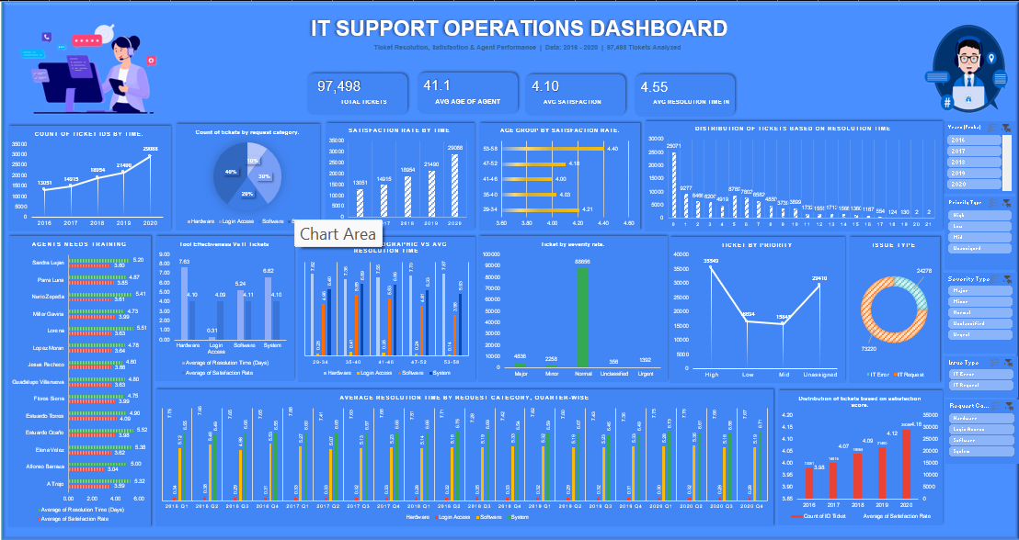

Insights:
- Speed and satisfaction don't move together — so the dashboard needs both shown separately, not blended into one score.
- Agent-level variation is the strongest driver of quality — so agent-level detail matters more than team averages alone.
- Volume growth is the clearest long-term trend — worth its own chart to justify future headcount decisions.

Recommendations:
- Invest in improving training programs for IT agents as the primary investment — the correlation between resolution time and satisfaction is essentially zero (-0.004), showing that slow categories like Hardware aren't hurting satisfaction, but skill gaps are.
- Deploy targeted coaching for the 14 agents identified in Q2 who fall below average satisfaction (4.10) and above average resolution time (4.55 days).
- Do not hire additional agents currently — ticket volume per agent is balanced (1,856–2,027 tickets, ~1,950 average), showing no evidence of overload.
- Continue with the current ticket management software rather than replacing it — resolution time has stayed flat from 2016–2020 despite steady volume growth, and satisfaction has improved across every category over the same period.

