1. **Introduction**

Now-a-days with the advancement of technology particularly in the field of mobiles, all the activities in our day-to-day living have become part of information technology and we find everything possible with mobiles. Today’s mobile phone models also serve to combine the functions of portable media players, low-end compact digital cameras, pocket video cameras, and GPS navigation units. The most common mobile operating system (OS) used by modern smart phones includes Apple’s iOS, Google’s android and Microsoft’s Windows Phone etc. which can be installed on many different phone models, and typically each device can receive multiple OS software updates over its lifetime. This project is a mobile application done in Android.

Personal Diary is a personal note taking application. It keeps our texts safe and later it we can search the text on any date. It lets browse our entry, edit them. User can browse recent entries from the home page, or go to list page to list out the entries. Currently it has very basic features like adding entries, searching, list of diaries date of entry.

**1.1 Motivation**

The motivation for doing this project was primarily an interest in creating a personal diary that can save image along with text. This application even has the feature to convert text to speech and can even enter diary based on selected date.

**1.2 Problem Definition**

The project Personal Diary will help you to record your life in mobile phone with security option. This Android based application provides Good User Interface to Show entries in any range of dates, Speech to text feature. Attach photo to diary, Search entries. This application supports 4.0 version of android frame work.

**1.3 Objective of the Project**

The general objective of this project is to provide user a good interface in terms of saving all emotions and interests. It keeps our texts safe and later it we can search the text on any date. It lets browse our entry, edit them. User can browse recent entries from the home page, or go to list page to list out the entries, can search for a particular diary.

**1.4 Limitations of the Project**

* Only one user can access application with his password.
* For changing password user has to provide old password with new password.
* Only one image can be saved for a particular date.
* User cannot change the image.
* If image is removed from sdcard, that image will not be displayed in application.

**2.Literature Survey**

The main motivation behind taking up this project is to make the user enter the diary more conveniently along with password security. This application helps the user to view the diaries entered in the diary, search diary from any particular date. They time for reading the text in diary is reduced because of text to speech converter. Else they need to read the whole text in diary. These two scenarios’ may be possible or may not by the user. So, once the user downloads this application from the market and install on his device place he can use anytime, anywhere, any number of times.

The main problem with the existing scenario is having no image storage for a diary, no text to speech converter. Android is the platform of this application. Personal diary application complete with a password and easy to use. Much better than using the traditional writing one. Even user can put picture in the diary. Android platform provided internal storage

**3.Analysis**

**3.1 Introduction**

One of thefastest growing industries now a day is mobile industry. There are many competitors in this area who are doing research and development on new platforms & user experience. The project Personal Diary will help you to record your life in mobile phone with security option.

.

**3.2 Existing System**

# The already existing system is a private diary. The private diary is used to record an text and photo in diary with security measures.

.

**3.3 Proposed System**

In the proposed system user can set a password of your diary, show entries in any range of dates, change Diary appearance, write notes about your life, text to speech feature, attach photo to diary, search entries.

**3.4 Software Requirement Specification**

**3.4.1 Purpose**

This application can be installed to the android mobile device from the sdcard.

After installing, the user can enter password to save any diary along with the image, view all the diaries and search any particular diary.

**3.4.2 Scope**

One of the fastest growing industries is mobile industry. There are many competitors in this area who are doing research and development on new platforms & user experience. One such technology is Android from Google which is supported for Google phones. These phones are described as next Generation mobiles [As described by Google]. Developing application for such mobile phones using the open source android SDK is quite interesting. This makes the application call history quite easy, efficient, flexible and economic.

**3.4.3 Overall Description**

Personal Diary will help you to record your life. It will save all your emotions and interests. You can entrust all secrets. It has following possibilities like Set a password of your diary, Show entries in any range of dates, Change Diary appearance, Write notes about your life, Text to speech feature. Attach photo to diary. Search entries.

**3.4.4 External Interface Requirements**

Text to Speech (TTS) speaks the text in different languages.

Hardware interface for this application needs a device having android operating system to run application

**4. Design**

**4.1 Introduction**

Architecture diagram is a diagram of a system, in which the principal parts or functions are represented by blocks connected by lines that show the relationships of the blocks. The block diagram is typically used for a higher level, less detailed description aimed more at understanding the overall concepts and less at understanding the details of implementation.

User

Android SDK

SQLite

Java program

Get diary

Fig 4.1 Architecture of Call History

Get diary user for who the application looks like an user interface actually consists of a database called as SQLite that comes along with Android SDK and need no other installation. This is the database that is used to store and retrieve information. This is an application that is developed in java and hence all its features apply here as well such as platform independence, data hiding, portable etc.

**UNIFIED MODELING LANGUAGE (UML) diagrams**

The unified modeling is a standard language for specifying, visualizing, constructing and documenting the system and its components is a graphical language which provides a vocabulary and set of semantics and rules. The UML focuses on the conceptual and physical representation of the system. It captures the decisions and understandings about systems that must be constructed. It is used to understand, design, configure and control information about the systems.

**4.2 UML Diagrams**

Class diagram-class diagram is a type of static structure diagram that describes the structure of a system by showing the system's classes, their attributes, operations (or methods), and the relationships among the classes.

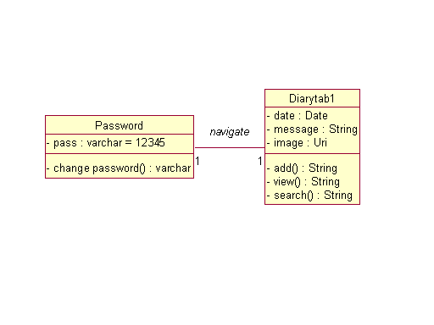

Use case diagram - A Use case diagram at its simplest is a representation of a user's interaction with the system and depicting the specifications of a use case.

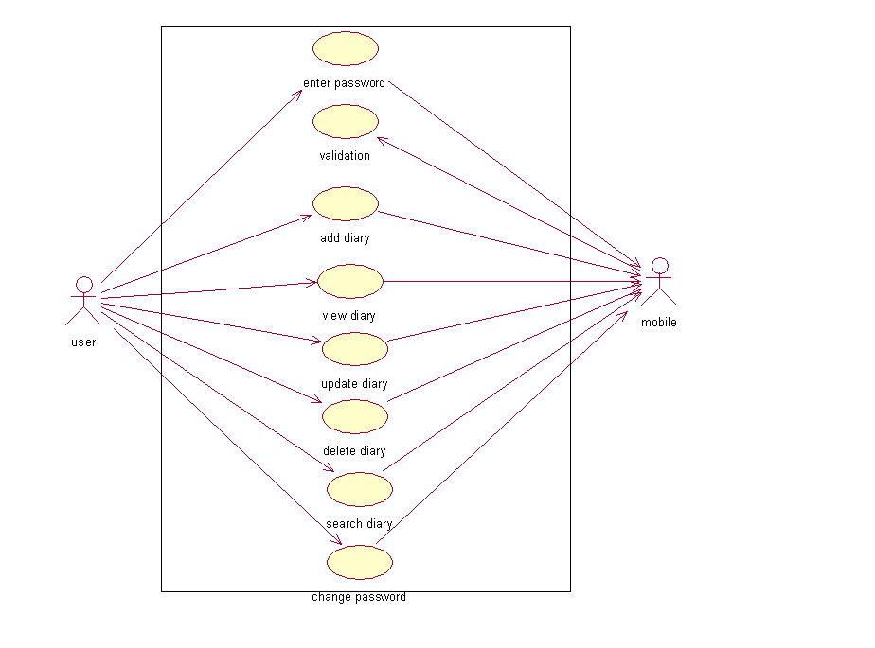

Sequence diagram- A sequence diagram is a kind of interaction diagram that shows how processes operate with one another and in what order. It is a construct of a Message Sequence Chart.

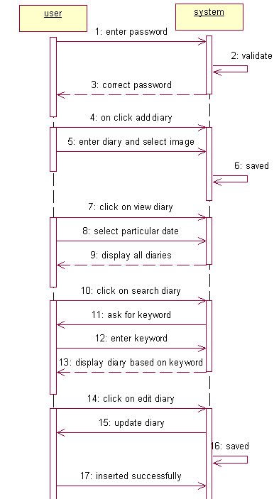

Collaboration diagram-A collaboration diagram describes interactions among objects in terms of sequenced messages.

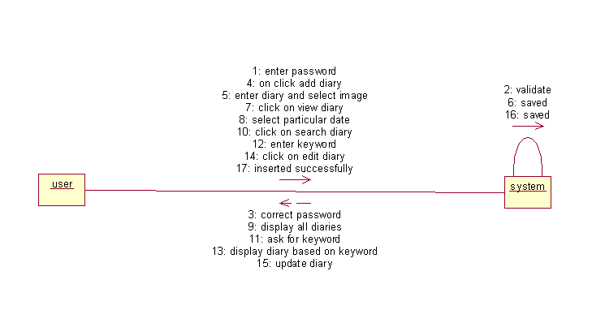

State chart diagram -A state chart diagram shows the behavior of classes in response to external stimuli. This diagram models the dynamic flow of control from state to state within a system.

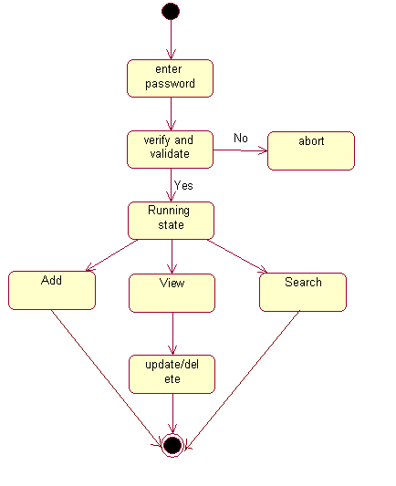

Activity diagram-An activity diagram illustrates the dynamic nature of a system by modeling the flow of control from activity to activity. An activity represents an operation on some class in the system that results in a change in the state of the system.

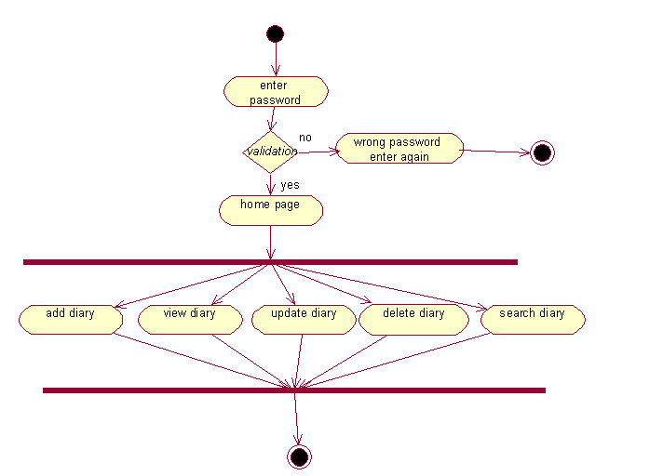

Component diagram-A component diagram describes the organization of the physical components in a system.

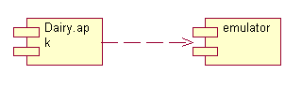

Deployment diagram-Deployment diagrams depict the physical resources in a system including nodes, components, and connections.

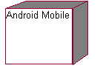

\

**5. Implementation**

**5.1 Modules**

1. Add module.

2. View module.

3. Search module.

4. Update module.

5. Delete module.

6. Password change module.

**5.2 Module description**

**1. Add module**

I want to create entry by some date, or no date (today). I want to make sure the date is valid. I don't want any restriction of date when to make an entry. I want to easily go back to where I came from (may be search, list, home) if I just remembered I don't want to make this entry any more. I want to save this entry. After saving my entry I want to go to see all the list of entries for the date which I just added the entry. So we can have as many entries we want to have even for a single day. User can add image in their diary by clicking on browsing image.

**2. View module**

Browse list for some date, and scroll if pages exceed given limit for page size. I want to go to view diary just by clicking the title. User can perform browsing to be done with or without specific date. In this module only 15 character of diary text is displayed along with the date.

**3. Search module**

User can search by any text that appears on the title, whether it is at front or back, small case or upper case. I want to have all the facilities like display of title view, updating a specified diary and going back to home as in add module from this search result page.

**4. Update module**

User can update a specified diary text. Clicking on the update button user enter in to a page that consist of edit text box with original text of that diary .then user can append text or modify text and finally save to get updated.

**5. Delete module**

User can even delete a specified diary text by clicking on delete button .this module delete the diary from the sqlite data base.

**6. Password change module**

User can change default password by providing old password along with the new password. This module update password in the sqlite database

**5.3 Technologies used**

* Java
* Android SDK 1.5 or later
* Eclipse IDE.

**JAVA**

Java is an object-oriented language, and is very similar to C++. Java is simplified to eliminate language features that cause common programming errors. Java source code files are compiled into a format called byte code, which can then be executed by a Java interpreter.Features being

1. **Platform Independent**

The programs written on one platform can run on any platform provided the platform must have the JVM.

1. **Portable**

The feature Write-once-run-anywhere makes the java language portable provided that the system must have interpreter for the JVM.

1. **Simple**

Programs are easy to write and debug because java does not use the pointers explicitly. It also has the automatic memory allocation and de allocation system.

1. **Multithreaded**

Multithreading means a single program having different threads executing independently at the same time.

1. **Robust**

Java has the strong memory allocation and automatic garbage collection mechanism. It provides the powerful exception handling and type checking mechanism as compare to other programming languages.

1. **Object Oriented**

To be an Object Oriented language, any language must follow at least the four characteristics.

* Inheritance
* Encapsulation
* Polymorphism
* Dynamic binding

1. **Distributed**

The widely used protocols like HTTP and FTP are developed in java. Internet programmers can call functions on these protocols and can get access to the files from any remote machine on the internet rather than writing codes on their local system.

1. **Secure**

All the programs in java are run under an area known as the sand box. Security manager determines the accessibility options of a class like reading and writing a file to the local disk.

1. **High Performance**

In the beginning interpretation of byte code resulted in slow performance but the advance version of JVM uses the adaptive and just in time compilation technique that improves the performance.

1. **Integrated**

Java is an interpreted language as well. Programs run directly from the source code.

**ANDROID**

Android is a software stack for mobile devices that includes an operating system, middleware and key applications. The android SDK provides the tools and APIs necessary to begin developing applications on the Android platform using the Java programming language.

The Android SDK includes a comprehensive set of development tools. These include a debugger, libraries, a handset emulator (based on QEMU), documentation, sample code, and tutorials. Currently supported development platforms include x86-architecture computers running Linux (any modern desktop Linux distribution), Mac OS X 10.4.8 or later, Windows XP or Vista. The officially supported integrated development environment (IDE) is Eclipse (3.2 or later) using the Android Development Tools (ADT) Plug in, though developers may use any text editor to edit Java and XML files then use command line tools to create, build and debug Android applications.

**ECLIPSE IDE**

Android Development Tools (ADT) is a plugin for the Eclipse IDE that is designed to give you a powerful, integrated environment in which to build Android applications.ADT extends the capabilities of Eclipse to let you quickly set up new Android projects, create an application UI, add packages based on the Android Framework API, debug your applications using the Android SDK tools, and even export signed (or unsigned) .apk files in order to distribute your application.

**5.4 Sample code**

**Diary.java**

Public class diary extends Activity implements OnClickListener {

private EditText msg;

SQLiteDatabase db;

SQLiteDatabase myDb;

int i=0;

private Button save, cancel;

private String selectedImagePath;

private static final int SELECT_PICTURE = 1;

Static final int DATE_DIALOG_ID = 0;

protected void onCreate(Bundle savedInstanceState) {

super.onCreate(savedInstanceState);

setContentView(R.layout.add_diary);

// Set the views

msg=(EditText)findViewById(R.id.editTextfile);

db=openOrCreateDatabase("diary", MODE_PRIVATE, null);

save=(Button)findViewById(R.id.save);

cancel=(Button)findViewById(R.id.Cancel);

save.setOnClickListener(this);

cancel.setOnClickListener(this);

mDateDisplay = (TextView) findViewById(R.id.showMyDate);

mPickDate = (ImageButton) findViewById(R.id.myDatePickerButton);

get_image=(Button)findViewById(R.id.get_image);

get_image.setOnClickListener(this);

iv=(ImageView)findViewById(R.id.imageView1);

mPickDate.setOnClickListener(new View.OnClickListener() {

public void onClick(View v) {

showDialog(DATE_DIALOG_ID);

} });

updateDisplay();

}

private void updateDisplay() {

this.mDateDisplay.setText( new StringBuilder()

.append(mDay).append("-")

.append(mMonth+1).append("-")

.append(mYear).append(" "));}

private DatePickerDialog.OnDateSetListener mDateSetListener =

new DatePickerDialog.OnDateSetListener() {

public void onDateSet(DatePicker view, int year, int monthOfYear, int dayOfMonth) {

mYear = year;

mMonth = monthOfYear;

mDay = dayOfMonth;

updateDisplay();

} };

protected Dialog onCreateDialog(int id) {

switch (id) {

case DATE_DIALOG_ID:

return new DatePickerDialog(this,

mDateSetListener,

mYear, mMonth, mDay);

} return null;}

public void onClick(View v) {

switch(v.getId()) {

case R.id.save:

db.execSQL("create table if not exists diarytab1(date varchar,message varchar,image

varchar)");message=msg.getText().toString();

if(message.length()==0){

Toast.makeText(getApplicationContext(), "Please Enter Message",

Toast.LENGTH_SHORT).show(); }

if(message.length()<15){

Toast.makeText(getApplicationContext(), "Please Enter Some more text",

Toast.LENGTH_SHORT).show();

}else{Cursor cc=null;

cc=db.rawQuery("select * from diarytab1 where date='"+ss+"' ", null);

if(cc.moveToFirst()){

String dt=cc.getString(cc.getColumnIndex("date"));

String m=cc.getString(cc.getColumnIndex("message"));

String i=cc.getString(cc.getColumnIndex("image"));

if(dt.equalsIgnoreCase(ss)){

message=m+". "+message;

db.execSQL("update diarytab1 set message='"+message+"'

,image='"+selectedImageUri+"' where date='"+ss+"'");

Toast.makeText(getApplicationContext(), "Inserted

Message",Toast.LENGTH_SHORT).show();

Intent it=new Intent(diary.this,second.class);

startActivity(it); finish(); }}

} break;

case R.id.Cancel:

Intent it=new Intent(diary.this,second.class);

startActivity(it);

finish();break;

case R.id.get_image:

Intent intent = new Intent();

intent.setType("image/*");

intent.setAction(Intent.ACTION_GET_CONTENT);

startActivityForResult( Intent.createChooser(intent, "Select Picture"),

SELECT_PICTURE);break; }}

**6. Testing**

**6.1 Introduction**

The development of software systems involves of a series of production activities where opportunities for injection of human fallibilities are enormous. Errors may begin to occur at the very inception of the process where the objectives may be erroneously or imperfectly specified, as well as in later design and development stages. Because of human inability to perform and communicate with perfection, software development is accompanied by a quality assurance activity.

**TESTING TECHNIQUES**

Testing is the process of executing a program with the intention of finding errors. The various test strategies used for testing the software are as follows.

**1 Unit Testing**

Unit testing focuses on verification effort on the smallest unit of the software design module. The main goal is to make sure that every source statement and logic path has been executed correctly at least once. The output of this stage is the source code.

**2 Integration Testing**

In Integration testing, we find errors that have occurred during the integration. After testing each module, which is then integrated into subsystems and then to form the entire system on which integration testing is performed. The goal of testing is to detect the design errors, while focusing on the testing the interconnection between modules.

## 3 Validation Testing

This testing concentrates on confirming that the software is error-free in all respects. All the specified validations are verified and the software is subjected to hard-core testing. It also aims at determining the degree of deviation that exists in the software designed from the specification; they are listed out and are corrected.

**6.2 Test Cases**

|  |  |  |  |  |  |
| --- | --- | --- | --- | --- | --- |
| **S.no** | **Test case name** | **Test case description** | **Expected result** | **Actual result** | **status** |
| 1 | Enter password | Enter valid password | Login to home page | Login to home page if correct password | success |
| 2 | Enter text | Enter minimum 15 characters of text | Inserted message | Inserted message | success |
| 3 | Click on from date | Display diaries from that date | View of diaries | View of diaries | success |
| 4 | Click on image browsing | Insert image uri  Along with text | Inserted image | Inserted image | success |
| 5 | Click on change password | Changes from old password to new password | Changes to new password | Changes to new password if only old password is correct | success |
| 6 | Click on edit | Update the text of particular diary | updated | updated | success |
| 7 | Click on speech | Convert text to speech | speech | speech | success |

**6.3 Screen Shots**-

1.Login page

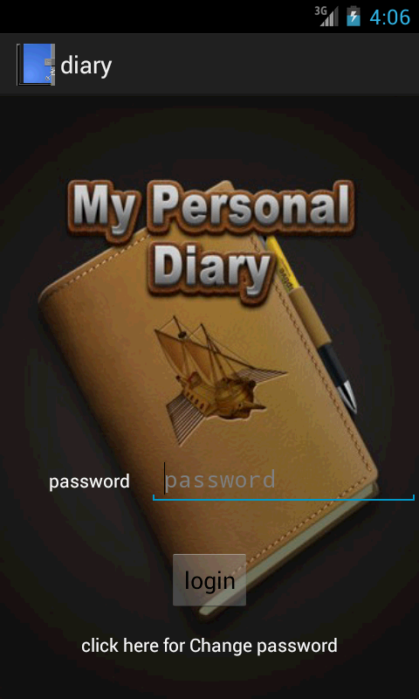

2.Home page

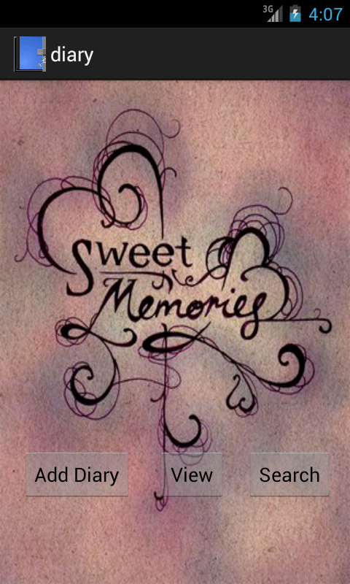

3.View page

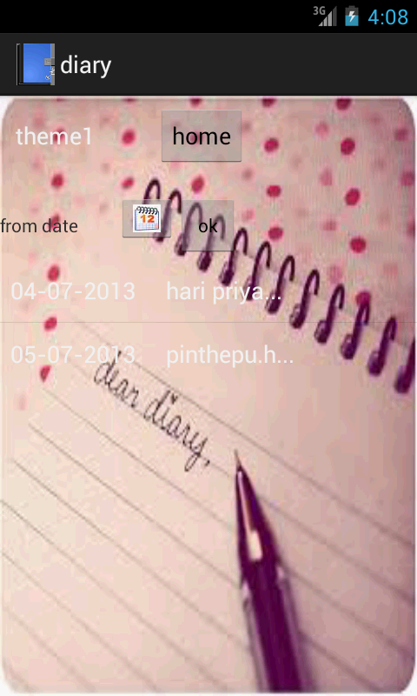

7. **Conclusions and Limitations**

This application is used for storing diaries of user. This application is build using Android SDK. It is a tool developed for android platform, which is used to search for diary and maintain the diares of user along with date and picture. This is an advantage when compared to existing system because a single mobile piece is enough for deploying the application .As this is a mobile application one can easily search for required information. One can search for diaries whenever one wants to without waiting for some system. This makes this application efficient, convenient and easy to use along with providing maximum user satisfaction which is the key aspect for any developer.

**8. Future Enhancement**

Any project that has been already developed can always be improved further

for better efficiency, better performance, easy understanding and important of all satisfy customer/user to a higher extent.

The future enhancements that can be done to this project are

* Send text to mail feature attached with image.
* Convert single image selection to image gallery.
* Inserting image directly into database for which application is currently using uri.

**9. Bibliography**

1. Herbert Schildt.2008 ,”Java Complete Reference”, Tata McGraw-Hill ,

7th Edition, pp.177-180 .

1. Grady Booch, James Rambaugh.1998,“UnifiedModeling Language User Guide”, Addison Wesley Publishing, chapter 8-31.
2. http://developer.android.com/index.html.
3. http://en.wikipedia.org/wiki/SQLite.