**AMAZON**

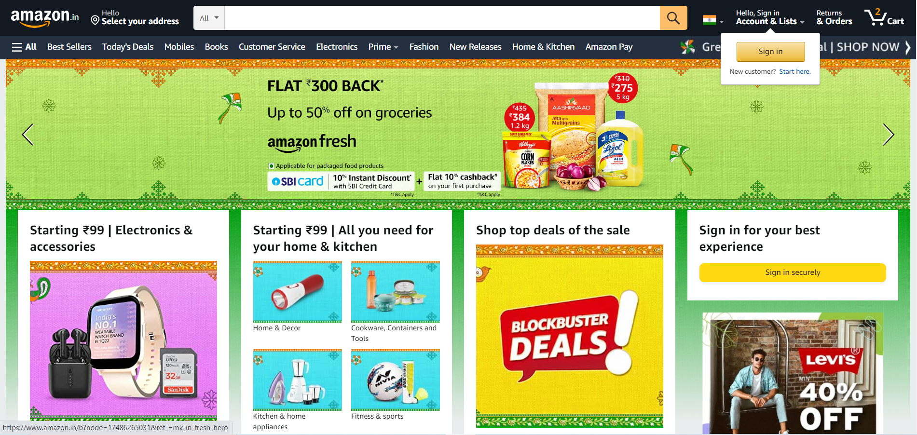

**Objective:**

The main objective of this project is to make an e-commerce shopping website. The aim is to build a clone of amazon.in website.

**Home Page:**

* Amazon logo
* Search Bar
* Login/Sign Up
* Slider images(banners and offer advertisements)
* Today deals(Images)
* Trending(Images)
* Footer (Copyrights, contact us, bottom to top)

**Register Page:**

* Name
* Contact Number
* Email(optional)
* Password – atleast 6 characters

**Main page:**

* Categories
* Search bar
* Recommended items
* Deals and offers
* Filters-(Brand, color, Price, Discounts, Size, features and specifications.)
* Product chosen -Description with all feature and specifications and details of free delivery, return policy ,etc
* Offers-Bank offers like credit card offers, etc

**Payment Page:**

* Selection of Payment method
* Payment method -UPI, Credit card, Debit card, EMI, Net Banking, Cash on Delivery
* Apply promo code/coupon code.
* Confirmation of Address and contact number
* Confirm with payment process and message generation of booking successful.