**Media Streaming with IBM Cloud Video Streaming**

**Problem Statement Understanding**

**Problem Statement**

In today's digital world, the demand for high-quality media streaming has increased because of live events, webinars, and the rise of over-the-top (OTT) platforms. The content creators and broadcasters facing challenges. The existing solutions often lack the necessary flexibility and robustness . IBM Cloud Video Streaming to address these challenges and to provide a solution.

**Proposed solution**

To address the challenges presented in the problem statement, we propose an integrated solution that leverages IBM Cloud Video Streaming:

**1.Architecture overview**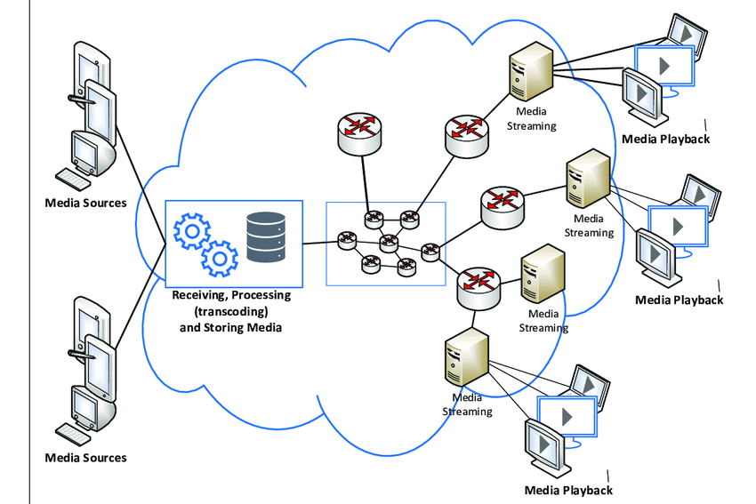

**1.COMPONENTS**

**Content Source:** The origin of video content is the live camera , pre-recorded video files, or screen capture from a computer. The quality and format of your content source are crucial for the streaming experience.

**Video Encoding:** The encoding process involves converting your raw video content into digital formats suitable for streaming. It includes compressing the video and audio data into different bitrates and resolutions for adaptive streaming .

**IBM Cloud Video Streaming Dashboard:** The web-based interface allows you to set up, configure, and manage your streaming events. You can schedule live events, manage access controls, customize the player, and access analytics through this dashboard.

**Interactive Features:** IBM Cloud Video Streaming offers interactive features like live chat, Q&A, and polls. These features engage viewers in real-time during live events, enhancing their experience and allowing content creators to interact with their audience.

**Security Measures:** To protect your content, IBM Cloud Video Streaming offers security features such as token-based authentication, DRM (Digital Rights Management), and access controls to ensure only authorized users can access your streams.

**Analytics and Monitoring:** IBM Cloud Video Streaming provides analytics tools that give you insights into viewer behavior, engagement metrics, and geographic distribution. These analytics help you make data-driven decisions to improve your streaming strategy.

**Feedback and Improvement:** Collecting feedback from viewers and monitoring performance are crucial components for the improvement. Regularly assess and optimize your streaming strategy based on the feedback and data from users.

**2.Implementation steps**

**Step 1: Account Setup and Configuration:**

* Create an IBM Cloud Video Streaming account if you don't have one.
* Configure your account settings, including branding, privacy settings, and access controls.

**Step 2: Content Preparation:**

* Prepare your video content, whether it's live streaming or on-demand videos.
* Ensure that your content is properly encoded in various formats and bitrates for adaptive streaming.

**Step 3: Event Setup:**

* Access the IBM Cloud Video Streaming dashboard.
* Create a new event and configure event details, including title, description, and schedule.
* Choose whether the event is public, password-protected, or private.

**Step 4: Content Ingestion:**

* Set up your video source, such as a camera feed, prerecorded video, or screen capture.
* Use encoding software to capture and encode your content.
* Configure your streaming software to transmit the encoded video to IBM Cloud Video Streaming using RTMP or other supported protocols.

**Step 5: Security Measures**:

* Implement security measures based on your needs, such as token-based authentication, DRM, or geo-blocking.
* Configure access controls to ensure only authorized users can view your content.

**Step 6: Monetization :**

* If you plan to monetize your content, set up pay-per-view or subscription-based access using IBM's monetization options.

**Step 7: Analytics and Monitoring:**

* Use the analytics tools provided by IBM Cloud Video Streaming to track viewer engagement, geographic distribution, and other key metrics.
* Monitor the performance of your streams and viewers' quality of experience.

**Step 8: Content Delivery Network (CDN) Integration**:

* If needed, integrate IBM's Content Delivery Network (CDN) for global scalability and low-latency content delivery.

**Step 9: Testing and Quality Assurance:**

* Before going live, perform thorough testing to ensure that your streams are of high quality and all interactive features work as intended.

**Step 10: Promotion and Engagement:**

* Promote your streaming events through various channels, such as social media, email marketing, and your website.
* Engage with your audience to build anticipation and encourage attendance.

**Step 11: Continuous Improvement:**

* Collect feedback from viewers and analyze performance metrics.
* Use this information to optimize your streaming strategy and enhance future streaming events.

**Step 12: Maintenance and Support:**

* Regularly maintain and update your streaming setup as needed.
* Utilize IBM's support and educational resources to address any issues or questions.

**3.Testing and quality assurance**

Testing and quality assurance are critical steps in ensuring that the media streaming solution using IBM Cloud Video Streaming delivers a seamless and high-quality experience to your audience.

**1. Pre-Launch Testing:**

**a. Content Quality Testing:** - Verify the quality and resolution of your video streams, ensuring they match your intended output. - Check for any encoding artifacts or audio-video synchronization issues.

**b. Interactive Features Testing:** - Test interactive features like live chat, Q&A, and polls to ensure they function correctly. - Check for any delays or technical glitches in real-time audience interaction.

**c. Security Testing:** - Verify that security measures, such as access controls and geo-blocking, are properly configured and effective. - Test token-based authentication if used to ensure authorized access.

**2. Network and Infrastructure Testing:**

a. Latency and Buffering Testing: - Test your streams under various network conditions to identify and address latency and buffering issues. - Optimize the use of IBM's Content Delivery Network (CDN) to minimize these problems.

**3. Compatibility Testing:**

**Device and Browser Testing**: - Test your streams on various devices (e.g., smartphones, tablets, desktops) and browsers (e.g., Chrome, Firefox, Safari) to ensure compatibility. - Pay attention to responsive design and playback issues on different screen sizes.

**4. Post-Event Analysis:**

**a. Audience Feedback:** - Collect feedback from viewers regarding their streaming experience, including video quality, interactivity, and overall satisfaction.

**b. Performance Metrics:** - Analyze performance metrics such as viewership statistics, engagement data, and error logs to identify any issues that may have occurred during the live event.

**4.Deployment and maintenance**

**Infrastructure Setup:**

* Provision the necessary hardware and software resources in the IBM Cloud to support your media streaming solution, including servers, storage, and network resources.

**Software Configuration:**

* + Install and configure the media streaming software and encoding tools on your servers.
  + Ensure that all components of your streaming solution are integrated and communicate seamlessly.
* **Content Ingestion:**
  + Set up the ingestion process for live events and on-demand content.
  + Configure the encoding and transcoding settings to prepare video content for streaming.
* **Security Configuration:**
  + Implement security measures such as access controls, authentication, and encryption to protect your streaming infrastructure and content.

**Maintenance:**

* **Regular Backups:**
  + Implement a regular backup strategy for your content, configurations, and databases to prevent data loss.
* **Monitoring**:
  + Set up continuous monitoring of your streaming infrastructure, including server health, network performance, and CDN usage.
  + Monitor user engagement, viewer statistics, and error logs to detect and address issues promptly.
* **Security Updates:**
  + Keep your streaming software, servers, and security measures up to date with the latest patches and updates to protect against vulnerabilities.
* **Scalability Planning**:
  + Continuously monitor audience growth and plan for scalability as needed to accommodate larger viewer numbers.
* **Quality of Service (QoS) Optimization:**
  + Optimize the quality of service by fine-tuning encoding settings, adjusting CDN configurations, and minimizing latency.
* **User Support:**
  + Provide user support and a help desk to assist viewers with technical issues and inquiries.
* **Performance Optimization:**
  + Use performance data and viewer feedback to identify areas for improvement and enhance the viewer experience.
* **Cost Management:**
  + Continuously review your usage and optimize costs based on your streaming needs and audience size.