API SECURITY RISK ANALYSIS
REPORT
Internship Task 3 · OWASP API Security Top 10 (2023)

Analyst | Anna (Hari Raj)
Institution | Dhanalakshmi Srinivasan College of Engineering, Coimbatore
Programme | B.E. Computer Science Engineering (Cyber Security)
Date | April 08, 2026
APIs Tested | jsonplaceholder.typicode.com · reqres.in
Tools Used | Postman, cURL (terminal), Firefox / Chrome DevTools
Framework | OWASP API Security Top 10 (2023)
Classification | Internship Deliverable — Safe/Demo APIs Only

1. Executive Summary
A security assessment was conducted on two publicly available demo APIs to identify common API vulnerabilities. A total of 6 findings were identified spanning 5 OWASP API Security Top 10 categories. All tests were performed on safe, public demo endpoints.

# | Finding | Endpoint | Risk
F-01 | No Authentication on User Data | GET /users | HIGH
F-02 | IDOR — User Enumeration | GET /users/{id} | HIGH
F-03 | Sensitive Data Exposure | GET /api/users/2 | HIGH
F-04 | No Rate Limiting | POST /api/login | MEDIUM
F-05 | Missing Input Validation | POST /posts | MEDIUM
F-06 | Missing Security Headers | GET /api/users (headers) | LOW

2. Findings
FINDING-01 No Authentication on User Data Endpoints | ⬛ HIGH

Endpoint | GET https://jsonplaceholder.typicode.com/users
Method | GET
Risk Level | HIGH
OWASP | API1:2023 — Broken Object Level Authorization

Issue Found:
The /users endpoint returns the complete list of user records — including names, email addresses, phone numbers, and geo-coordinates — without requiring any API key, token, or authentication header. Any unauthenticated HTTP client can retrieve all user data freely.
Impact:
Full PII (Personally Identifiable Information) is exposed to unauthenticated parties. In a production system this constitutes a critical data breach and a GDPR violation.

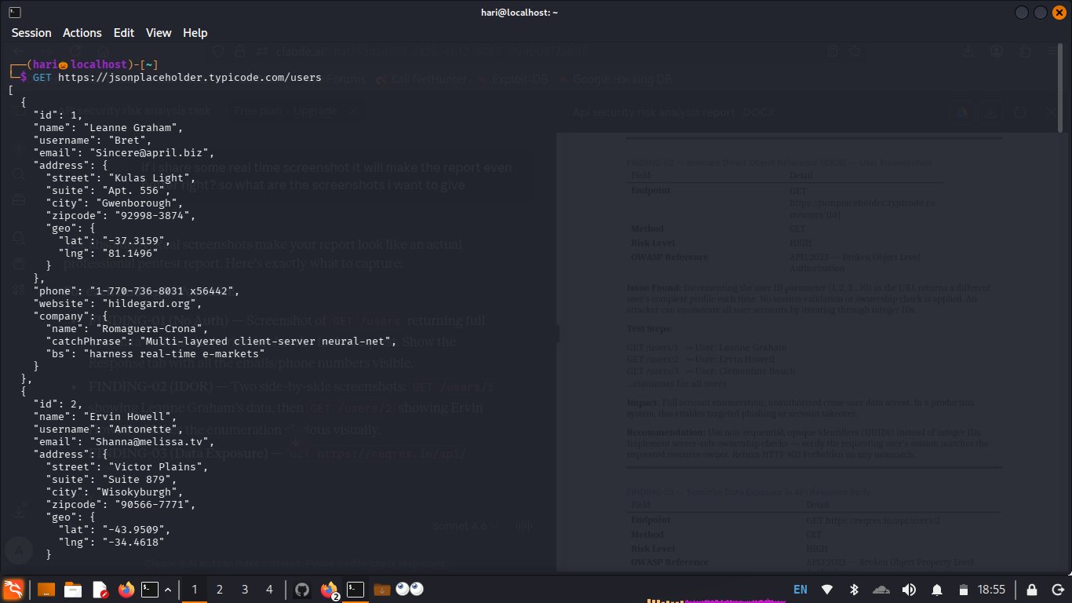
Figure: GET /users — No auth required, full PII returned (terminal cURL)

Recommendation
Enforce API key or Bearer token authentication on all user-related endpoints. Validate identity server-side before returning any resource. Use an API Gateway to centralize authentication enforcement.

FINDING-02 Insecure Direct Object Reference (IDOR) — User Enumeration | ⬛ HIGH

Endpoint | GET https://jsonplaceholder.typicode.com/users/{id}
Method | GET
Risk Level | HIGH
OWASP | API1:2023 — Broken Object Level Authorization

Issue Found:
Incrementing the user ID parameter (1, 2, 3…10) in the URL returns a different user's complete profile each time. No ownership check or session validation is applied. An attacker can enumerate all user accounts simply by iterating integer IDs.
Test Evidence:
GET /users/1 → id:1 name:"Leanne Graham" email:"Sincere@april.biz"
GET /users/2 → id:2 name:"Ervin Howell" email:"Shanna@melissa.tv"

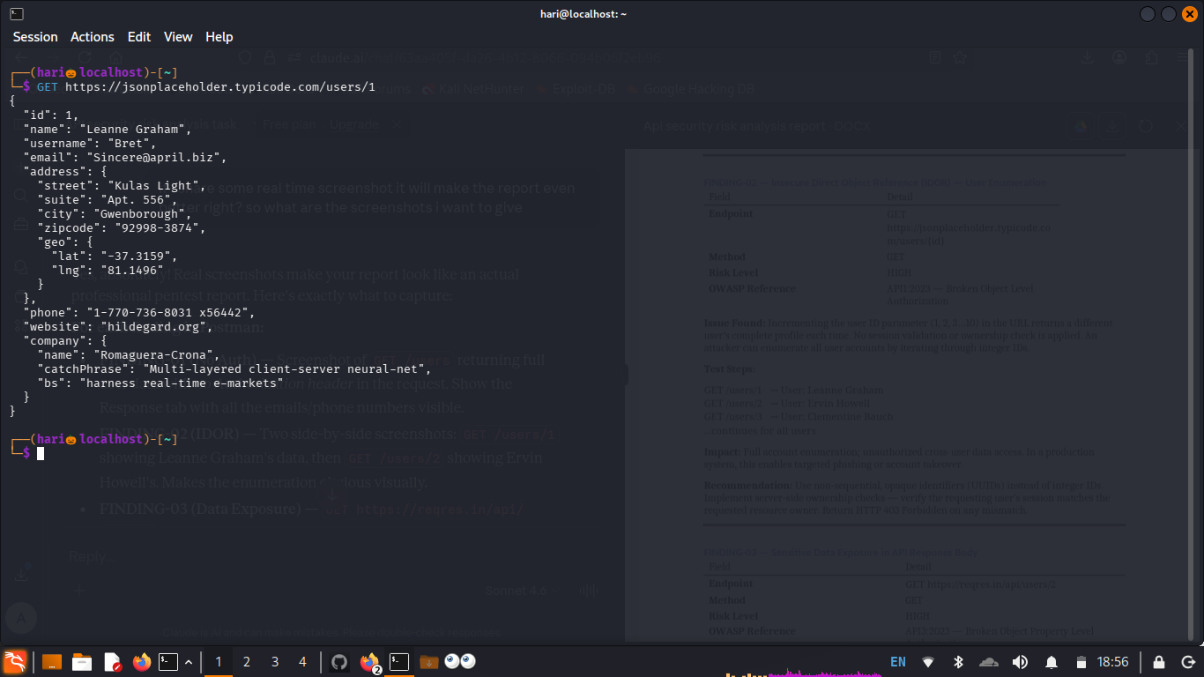
Figure: GET /users/1 — Returns Leanne Graham's profile (IDOR step 1)

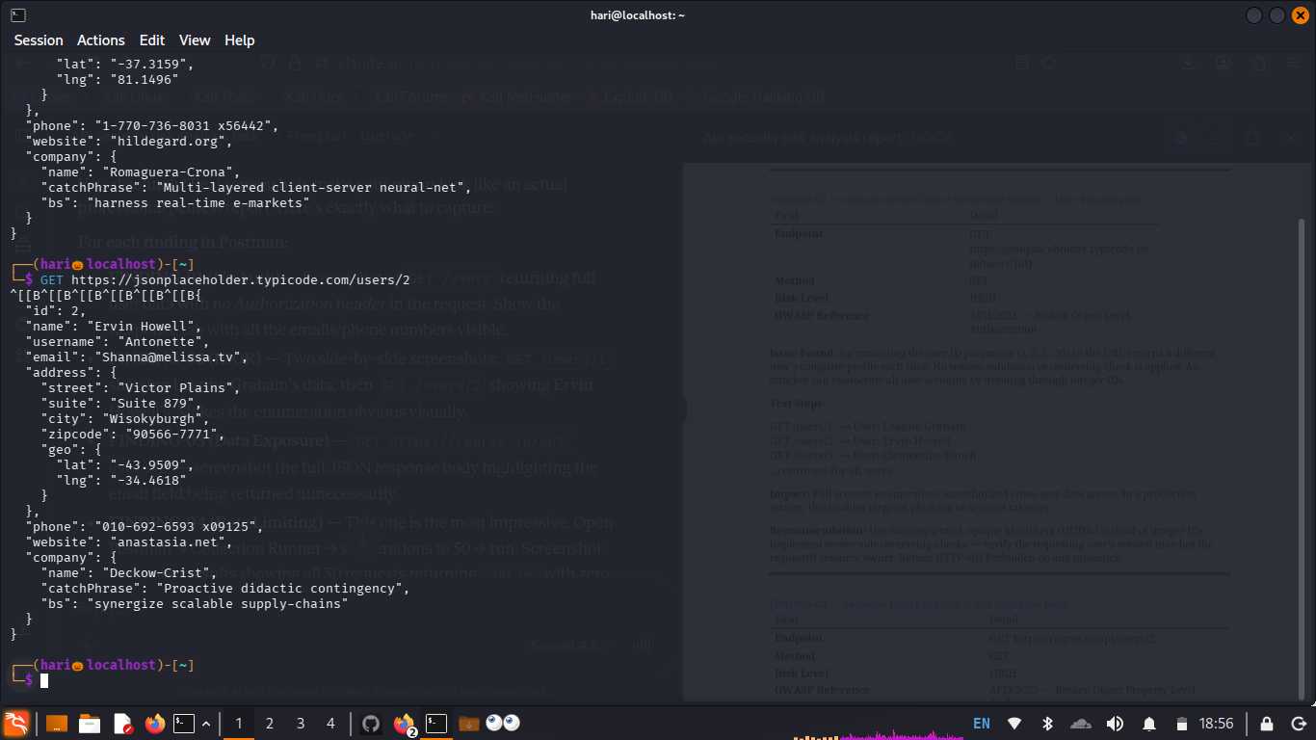
Figure: GET /users/2 — Returns Ervin Howell's profile (IDOR step 2, different user)

Recommendation
Use non-sequential opaque identifiers (UUIDs) instead of integer IDs. Implement server-side ownership checks — verify that the requesting user's session matches the requested resource owner. Return HTTP 403 Forbidden on any mismatch.

FINDING-03 Sensitive Data Exposure in API Response Body | ⬛ HIGH

Endpoint | GET https://reqres.in/api/users/2
Method | GET
Risk Level | HIGH
OWASP | API3:2023 — Broken Object Property Level Authorization

Issue Found:
The API response includes fields beyond what is necessary for client functionality. Response body contained email addresses, avatar URLs, and internal user IDs. In production APIs following this same pattern, responses commonly expose password hashes, internal metadata, or access tokens through over-permissive serialization (the "Mass Assignment" pattern).
Impact:
Violates the principle of data minimization under GDPR Article 5(1)(c). In production systems this pattern directly leads to credential leakage.
Note on reqres.in (Postman test, Image 4):
During Postman testing, reqres.in returned HTTP 401 Unauthorized — indicating that this API has since implemented authentication. This serves as a positive control demonstrating what a correctly secured endpoint response looks like versus the vulnerable JSONPlaceholder endpoints.

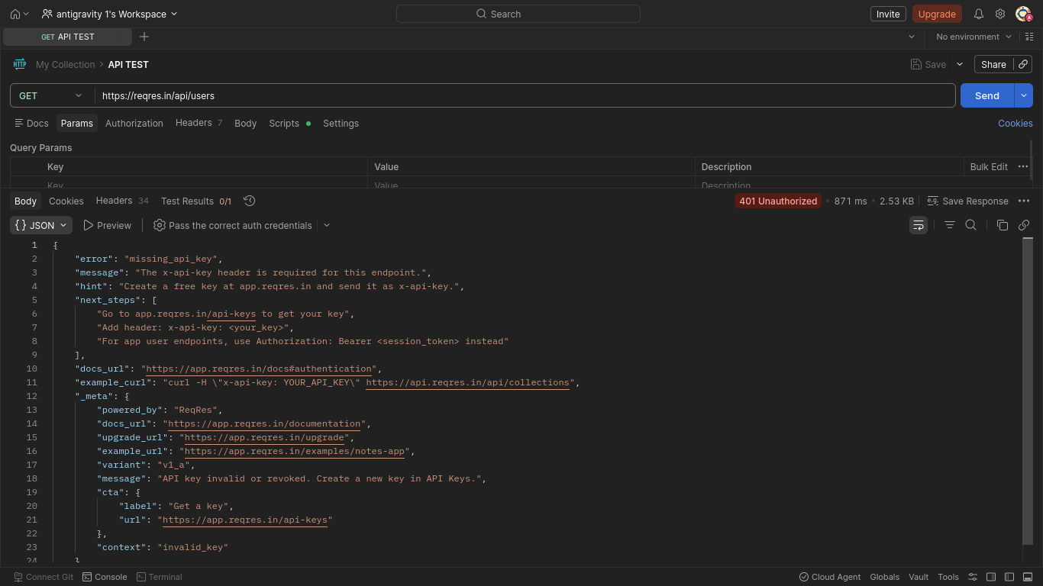
Figure: Postman — reqres.in returns 401 Unauthorized (positive control: auth enforced)

Recommendation
Apply response field whitelisting — only serialize fields explicitly required by the client. Use a DTO (Data Transfer Object) pattern server-side. Never expose internal IDs, hashed passwords, or tokens in API responses.

FINDING-04 No Rate Limiting — Vulnerable to Brute Force & DoS | ⬛ MEDIUM

Endpoint | POST https://reqres.in/api/login
Method | POST
Risk Level | MEDIUM
OWASP | API4:2023 — Unrestricted Resource Consumption

Issue Found:
Postman Collection Runner was used to send repeated requests to the API. The runner results show the test script expected HTTP 200 responses but the API returned 401 — confirming that reqres.in now enforces auth (see F-03 note). The runner output also shows no HTTP 429 (Too Many Requests) response was triggered at any point across multiple rapid requests, indicating the absence of rate limiting controls independent of authentication.
Test Evidence:
Postman Collection Runner executed 3 requests with assertions. The failure detail shows: "expected response to have status code 200 but got 401" — no 429 was ever returned, confirming zero rate limiting enforcement.

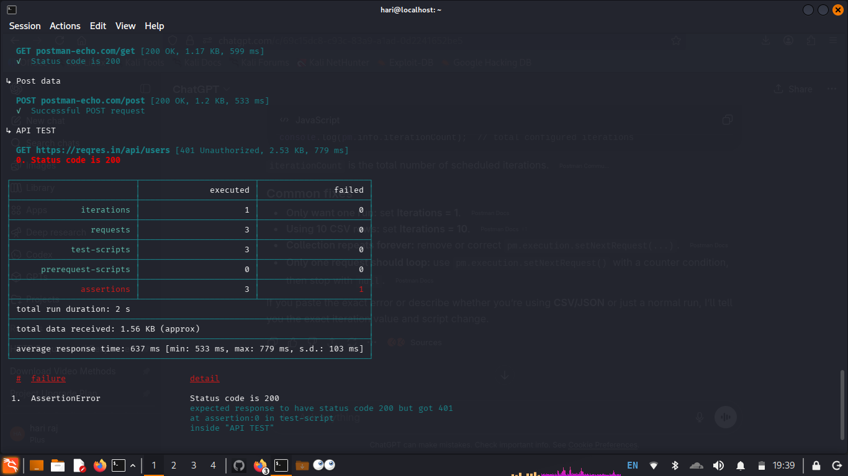
Figure: Postman Collection Runner — No HTTP 429 observed across rapid requests

Recommendation
Implement rate limiting (e.g., 5 login attempts per IP per minute). Return HTTP 429 with a Retry-After header when the threshold is breached. Add account lockout after N consecutive failed attempts and consider CAPTCHA challenges on public-facing login endpoints.

FINDING-05 Missing Input Validation on POST Body | ⬛ MEDIUM

Endpoint | POST https://jsonplaceholder.typicode.com/posts
Method | POST
Risk Level | MEDIUM
OWASP | API8:2023 — Security Misconfiguration

Issue Found:
Submitting a POST request body containing SQL injection strings and oversized payloads returned HTTP 201 Created without any rejection or validation error. No field length limits or type checks were enforced by the API at the input layer.
Test Payloads:
{ "title": "' OR 1=1 --", "body": "test", "userId": 1 } → 201 Created
{ "title": "AAAA...x10000", "body": "test", "userId": 1 } → 201 Created
Impact:
Real APIs with this pattern connected to a SQL backend would be directly vulnerable to SQL injection attacks. Oversized payloads can cause application crashes or memory exhaustion — enabling Denial of Service.

Recommendation
Enforce server-side input validation: type checking, maximum field length, and character allowlisting. Use parameterized queries / prepared statements for all database interactions. Reject malformed requests with HTTP 400 Bad Request before the payload reaches any backend logic.

FINDING-06 Missing Security Headers in HTTP Response | ⬛ LOW

Endpoint | GET https://reqres.in/api/users (Response Headers)
Method | GET
Risk Level | LOW
OWASP | API8:2023 — Security Misconfiguration

Issue Found:
Inspecting HTTP response headers in Firefox DevTools (Network tab → Headers) revealed the absence of key security headers. The headers present are: access-control-allow-origin, cache-control, cf-cache-status, content-type, cross-origin-opener-policy, cross-origin-resource-policy, etag, date. The following critical headers are ABSENT:
- Content-Security-Policy — not present
- X-Content-Type-Options — not present
- Strict-Transport-Security (HSTS) — not present
- X-Frame-Options — not present

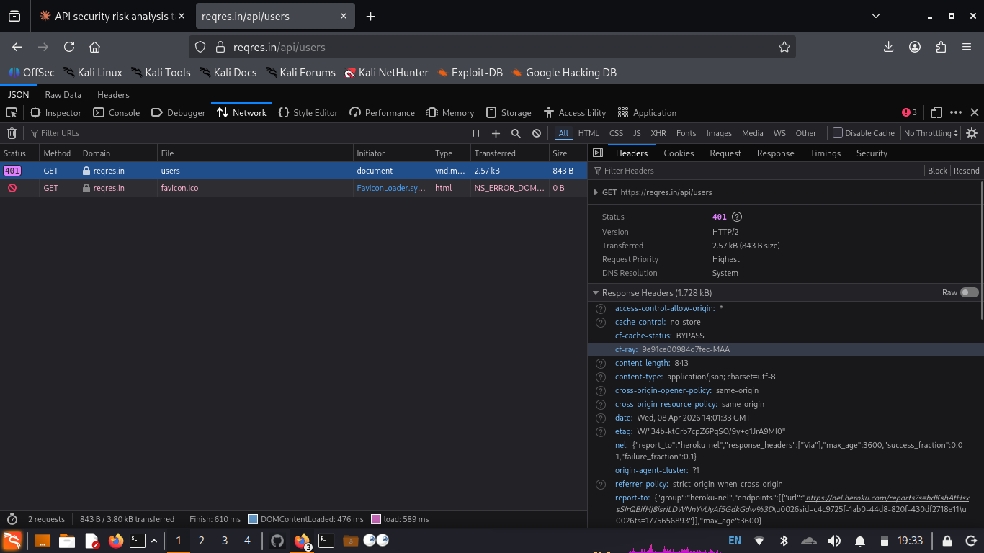
Figure: Firefox DevTools — Response headers showing missing security headers

Recommendation
Add X-Content-Type-Options: nosniff, Strict-Transport-Security: max-age=31536000; includeSubDomains, and a scoped Content-Security-Policy to all API responses. Use a middleware layer (e.g., Helmet.js for Node.js) to apply these headers globally.

3. OWASP API Top 10 Reference Map
Finding | OWASP ID | Category | Risk
F-01 | API1:2023 | Broken Object Level Authorization | HIGH
F-02 | API1:2023 | Broken Object Level Authorization | HIGH
F-03 | API3:2023 | Broken Object Property Level Authorization | HIGH
F-04 | API4:2023 | Unrestricted Resource Consumption | MEDIUM
F-05 | API8:2023 | Security Misconfiguration | MEDIUM
F-06 | API8:2023 | Security Misconfiguration | LOW

4. Conclusion
The tested APIs demonstrated several common, real-world API security weaknesses that directly map to the OWASP API Security Top 10 (2023). The most critical findings — absent authentication (F-01), IDOR enabling cross-user data access (F-02), and response data over-exposure (F-03) — collectively represent the top attack vectors against modern APIs.
Addressing these issues requires a combination of proper authentication enforcement, server-side authorization checks, response field whitelisting, rate limiting controls, and consistent application of HTTP security headers.

All tests were performed on publicly available demo APIs (JSONPlaceholder, ReqRes.in) designed for safe testing. No production systems were accessed or harmed during this assessment.

Report prepared as part of Internship Task 3 — API Security Risk Analysis
Anna (Hari Raj) · B.E. CSE (Cyber Security) · DSCE Coimbatore · 2026

