VULNERABILITY ASSESSMENT REPORT

Target: scanme.nmap.org

Prepared By | Hariraj S
Institution | Dhanalakshmi Srinivasan College of Engineering, Coimbatore
Department | B.E. Computer Science & Engineering (Cyber Security)
Assessment Date | April 8, 2026
Tools Used | Nmap 7.98, OWASP ZAP 2.17.0
Report Version | v1.0 - Initial Assessment

⚠ DISCLAIMER: This assessment was conducted on scanme.nmap.org, an authorized legal test target provided by the Nmap Project for educational purposes.

1. Introduction

This report presents the findings of a Vulnerability Assessment (VA) conducted against the host scanme.nmap.org (IP: 45.33.32.156). The assessment was performed as part of a hands-on cybersecurity portfolio project to demonstrate practical penetration testing and security analysis skills.

The objective of this assessment was to identify open ports, enumerate running services, detect outdated software versions, and discover web application security misconfigurations using industry-standard tools: Nmap 7.98 for network reconnaissance and OWASP ZAP 2.17.0 for web application scanning.

scanme.nmap.org is an authorized scanning target explicitly provided by the Nmap Project for educational and testing purposes. No unauthorized systems were targeted during this assessment.

2. Target Information

Parameter | Details
Hostname | scanme.nmap.org
IPv4 Address | 45.33.32.156
IPv6 Address | 2600:3c01::f03c:91ff:fe18:bb2f
Operating System | Linux 4.19 - 5.15 (Ubuntu)
Network Distance | 15 hops (scan_results.txt) / 5 hops (live terminal)
Scan Duration | ~53 seconds (Nmap) + ~3 minutes (ZAP Active Scan)
Scan Type | Service Version Detection, OS Detection, Traceroute, Web Spider, Active Scan
Authorization | Authorized – Official Nmap test target

3. Tools Used

Tool | Version | Purpose
Nmap | 7.98 | Network port scanning, service version detection, OS fingerprinting, traceroute
OWASP ZAP | 2.17.0 | Web application active & passive scanning, spider crawling, alert detection
Kali Linux | Rolling | Testing operating system platform

4. Network Reconnaissance – Nmap Scan

The following Nmap command was executed to perform a comprehensive network scan:

nmap -sV -A -T4 scanme.nmap.org -oN scan_results.txt

Flags used:
- -sV : Probe open ports to determine service/version info
- -A : Enable OS detection, version detection, script scanning, and traceroute
- -T4 : Aggressive timing template for faster scanning
- -oN : Output results to normal text file (scan_results.txt)

4.1 Open Ports Discovered

Port | State | Service | Version / Details
22/tcp | OPEN | SSH | OpenSSH 6.6.1p1 Ubuntu 2ubuntu2.13 (protocol 2.0)
80/tcp | OPEN | HTTP | Apache httpd 2.4.7 (Ubuntu) — Title: Go ahead and ScanMe!
9929/tcp | OPEN | nping-echo | Nping echo service
31337/tcp | OPEN | tcpwrapped | tcpwrapped — suspicious port (leet/hacker port)

4.2 Screenshot – Nmap Terminal Output

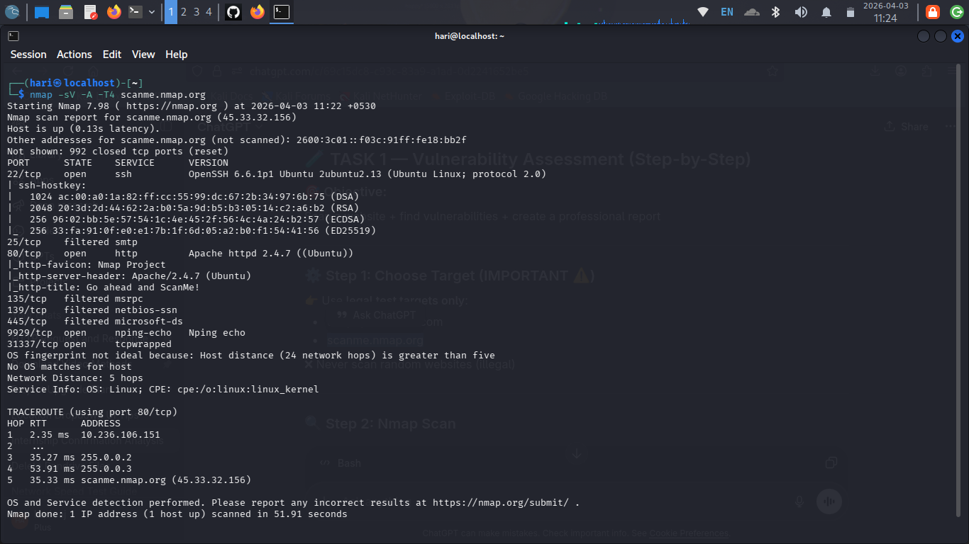
Figure 1: Nmap -sV -A -T4 scan output on scanme.nmap.org (Kali Linux terminal, April 3, 2026)

4.3 Key Observations

- SSH port 22 is running OpenSSH 6.6.1p1 — this is an outdated version (released ~2014) and may be vulnerable to known CVEs.
- Apache 2.4.7 on port 80 is significantly outdated (released 2013). Apache 2.4.x versions below 2.4.58 contain multiple known vulnerabilities.
- Port 31337 (commonly known as 'elite' or 'leet' port) is open with tcpwrapped service — requires further investigation as this port is historically associated with backdoors and trojan activity.
- Port 9929 running Nping echo is expected for this test host but would be unusual on a production server.
- OS fingerprinting identified Linux kernel version 4.19 - 5.15.

5. Web Application Scanning – OWASP ZAP

OWASP ZAP 2.17.0 was used to perform an automated web application security scan against http://scanme.nmap.org. The scan included passive analysis, active attack simulation, and spider crawling to enumerate endpoints.

5.1 Scan Summary

Target URL | http://scanme.nmap.org
Total HTTP Requests | 1,808 requests sent
New Alerts Generated | 62 alerts identified
Alert Severity Breakdown | 0 High, 5 Medium, 5 Low, 3 Informational
Scan Duration | Approx. 3 minutes
Scan Mode | Active Scan + Passive Analysis

5.2 Screenshot – ZAP Active Scan in Progress

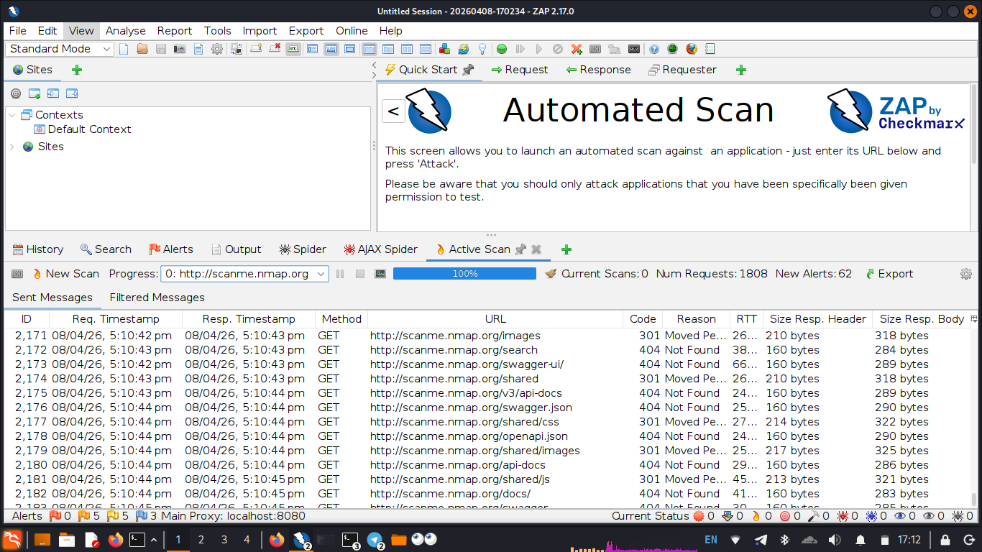
Figure 2: OWASP ZAP 2.17.0 Active Scan running against scanme.nmap.org — 1808 requests, 62 alerts (April 8, 2026)

5.3 Screenshot – ZAP Alerts Panel

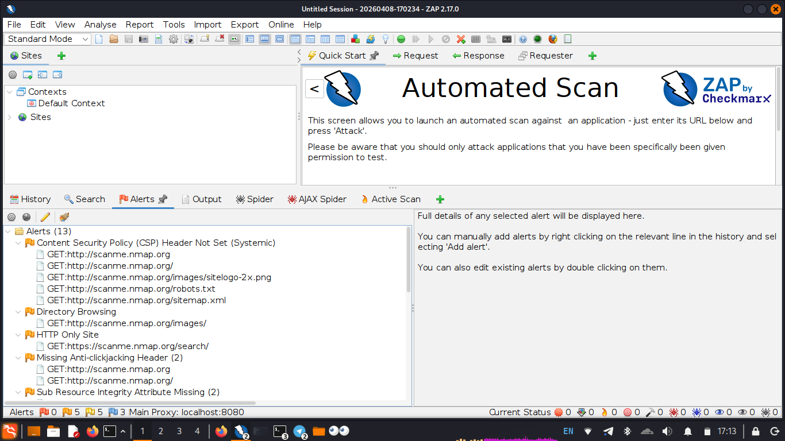
Figure 3: OWASP ZAP Alerts Panel showing 13 alert categories including CSP Header, Directory Browsing, HTTP Only, and Missing Anti-clickjacking Header (April 8, 2026)

6. Vulnerability Findings & Risk Classification

The following table presents all identified vulnerabilities, mapped to OWASP Top 10 categories, assigned CVSS scores, and accompanied by remediation recommendations.

ID | Finding | Severity | OWASP Mapping | CVSS | Real-World Impact | Recommendation
F-01 | Outdated Apache 2.4.7 | Medium | A06:2021 – Vulnerable Components | 5.3 | Remote code execution via known CVEs (e.g. CVE-2017-9798 Optionsbleed) | Upgrade to Apache 2.4.58 or latest stable
F-02 | Outdated OpenSSH 6.6.1p1 | Medium | A06:2021 – Vulnerable Components | 5.9 | Potential for brute-force or exploitation via old SSH CVEs | Upgrade to OpenSSH 9.x; enforce key-based auth
F-03 | Missing Content Security Policy (CSP) Header | Medium | A05:2021 – Security Misconfiguration | 4.3 | Enables XSS attacks by allowing inline scripts and untrusted sources | Set strict CSP: default-src 'self'
F-04 | Missing Anti-Clickjacking Header | Medium | A05:2021 – Security Misconfiguration | 4.3 | Allows the site to be embedded in iframes enabling clickjacking attacks | Add X-Frame-Options: DENY or SAMEORIGIN
F-05 | Directory Browsing Enabled | Medium | A05:2021 – Security Misconfiguration | 5.3 | Exposes /images directory listing — reveals internal file structure to attackers | Disable directory listing in Apache config: Options -Indexes
F-06 | HTTP Only Site (No HTTPS) | Medium | A02:2021 – Cryptographic Failures | 6.5 | All traffic transmitted in plaintext — susceptible to MITM interception | Implement TLS/SSL certificate; redirect HTTP to HTTPS
F-07 | Sub Resource Integrity (SRI) Missing | Low | A08:2021 – Software & Data Integrity | 3.7 | JS/CSS loaded from external CDNs without integrity checks — supply chain risk | Add integrity and crossorigin attributes to all external resource tags
F-08 | Port 31337 Open (tcpwrapped) | Low | A05:2021 – Security Misconfiguration | 3.5 | Historically associated with backdoor activity; unnecessary exposure increases attack surface | Close port if not required; monitor traffic on this port

7. Risk Summary

Severity | 🔴 HIGH | 🟠 MEDIUM | 🟢 LOW
Count | 0 | 6 | 2

8. Recommendations

Based on the findings above, the following remediation actions are recommended in priority order:

Priority 1 – Immediate (Medium Severity)
- Enable HTTPS/TLS: Deploy an SSL/TLS certificate and enforce HTTPS to prevent data interception. Use Let's Encrypt for free certificates.
- Upgrade Apache: Update from 2.4.7 to the latest Apache 2.4.x release to patch known CVEs including Optionsbleed and path traversal vulnerabilities.
- Upgrade OpenSSH: Update from 6.6.1p1 to OpenSSH 9.x. Disable password authentication and enforce RSA/ED25519 key-based authentication.
- Add Security Headers: Implement Content-Security-Policy, X-Frame-Options: DENY, and Strict-Transport-Security headers in the Apache configuration.

Priority 2 – Short Term (Low Severity)
- Disable Directory Browsing: Add Options -Indexes to Apache configuration or .htaccess to prevent directory listing on /images and other paths.
- Implement SRI: Add integrity and crossorigin attributes to all externally loaded JavaScript and CSS resources.
- Close Port 31337: If not actively required by any service, close this port via firewall rules (ufw deny 31337).

General Security Hardening
- Implement a Web Application Firewall (WAF) such as ModSecurity to filter malicious requests.
- Enable fail2ban to block repeated SSH login attempts and reduce brute-force risk.
- Conduct regular vulnerability scans (monthly) and keep all software packages patched.

9. Conclusion

This vulnerability assessment of scanme.nmap.org identified 8 security issues — 6 of medium severity and 2 of low severity. No critical or high severity vulnerabilities were discovered; however, the combination of outdated software (Apache 2.4.7 and OpenSSH 6.6.1p1), missing security headers, unencrypted HTTP traffic, and an exposed directory listing creates a meaningful attack surface.

The most significant risk is the lack of HTTPS combined with outdated server software, which together enable both passive interception and potential exploitation via known CVEs. Prompt remediation of the medium severity findings — particularly enabling TLS, upgrading web server components, and adding security response headers — would substantially improve the security posture of the host.

This report was prepared as part of a hands-on cybersecurity portfolio project demonstrating practical skills in network reconnaissance, web application security testing, vulnerability classification, and professional security documentation.

Legal Disclaimer: This assessment was conducted solely on scanme.nmap.org, an authorized legal test target provided by the Nmap Project (https://nmap.org/book/legal-issues.html). All findings are for educational purposes only. Unauthorized scanning of systems without explicit written permission is illegal.

