Flipkart Online Shopping App
Low-fidelity Wireframes | Customer App | Mobile
Concept wireframes for an e-commerce shopping app. Layouts are illustrative and not official Flipkart designs.

1. Overview
This document lays out 12 core screens of the shopping app: onboarding, discovery, product selection, checkout, order tracking and account management. Each screen shows structure and hierarchy only, with no final colours, imagery or copy.

2. Wireframe legend
Blue | Header bar, active tab and brand accent
Orange | Main conversion actions (Buy Now, Place Order, Pay)
Grey with cross | Image or banner placeholder
White box | Input field, button or card
Circle | Icon, avatar, radio button or tab icon

3. Core user flow
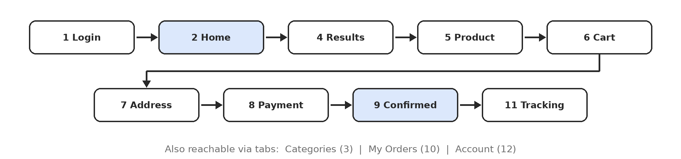

4. Design assumptions
- Portrait phone layout, about 360 x 720 dp; primary actions sit in a sticky bar at the bottom.
- The search bar is available on Home, Categories and Results so shoppers can search from anywhere.
- Guests can browse without logging in; login is requested at checkout.
- Cash on Delivery, UPI, cards, net banking and wallet payments are all supported.

5. Onboarding & discovery
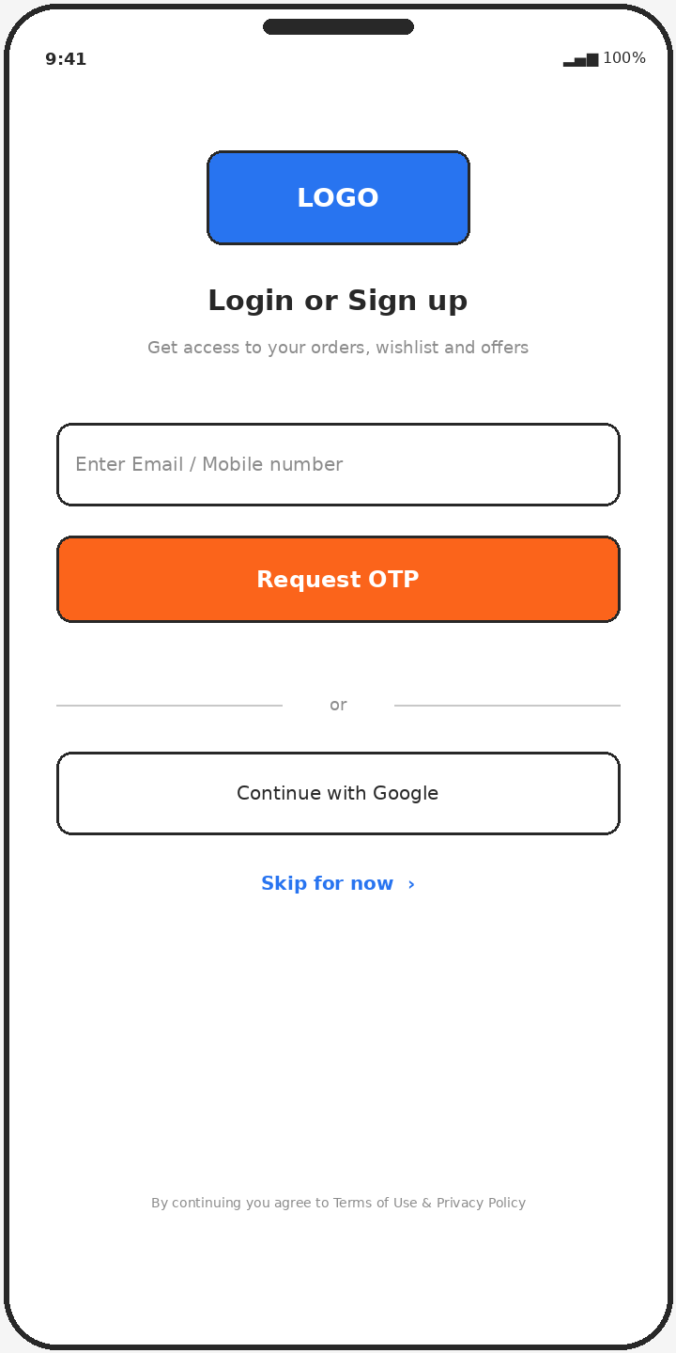  Screen 1: Login / Sign up  - Email or mobile number with OTP request  - Google sign-in alternative and "Skip for now" for guests  - Terms of use and privacy consent line | 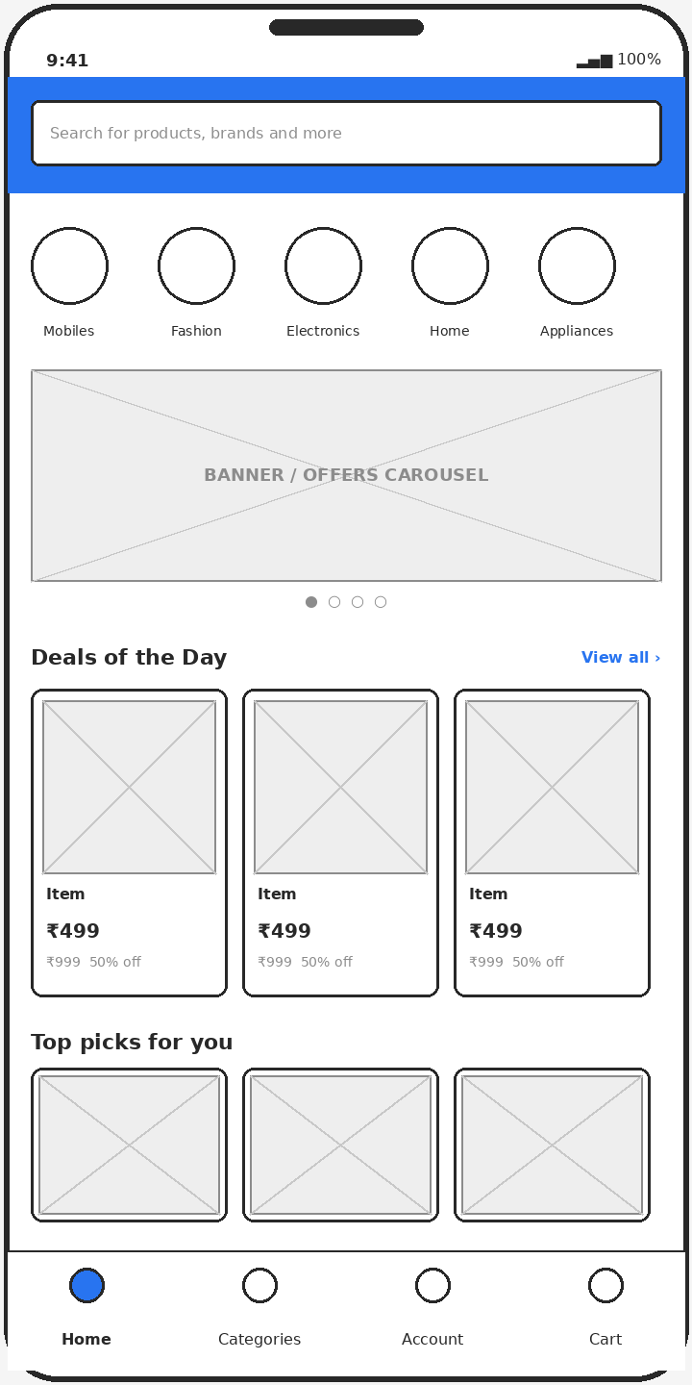  Screen 2: Home  - Search bar pinned at the top  - Quick category icons and offers carousel  - Deals of the Day and personalised product rows  - Bottom tabs: Home, Categories, Account, Cart | 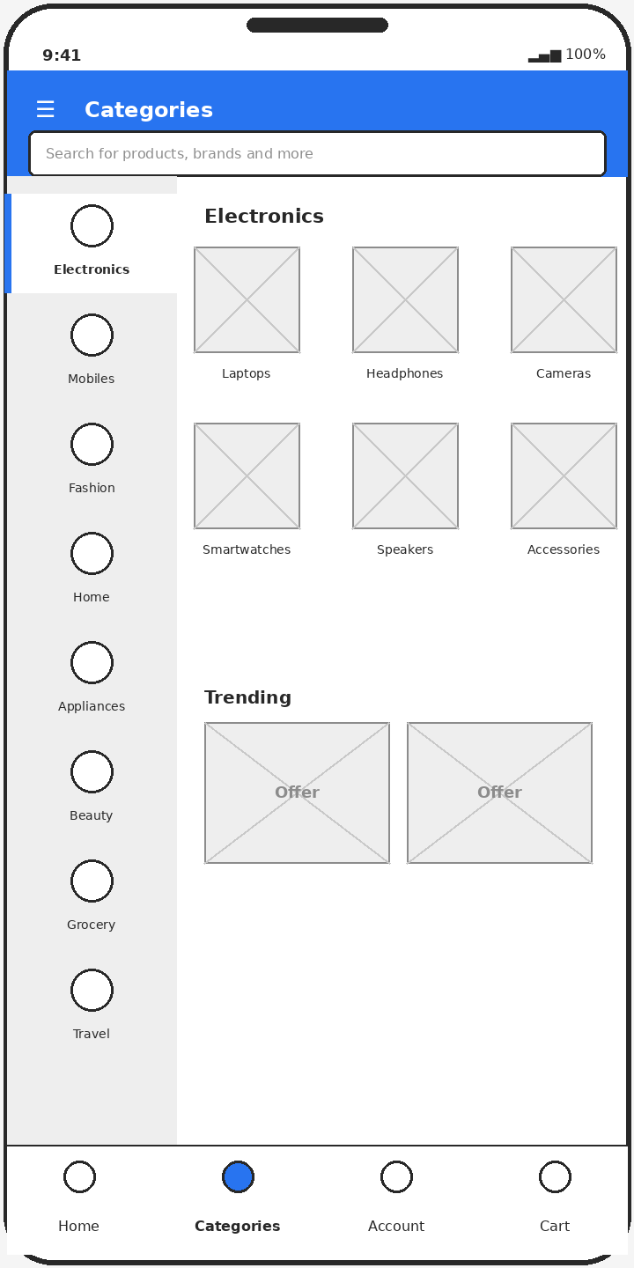  Screen 3: Categories  - Left rail of top-level categories  - Sub-category grid for the selected category  - Trending offers banners

6. Browse, select & cart
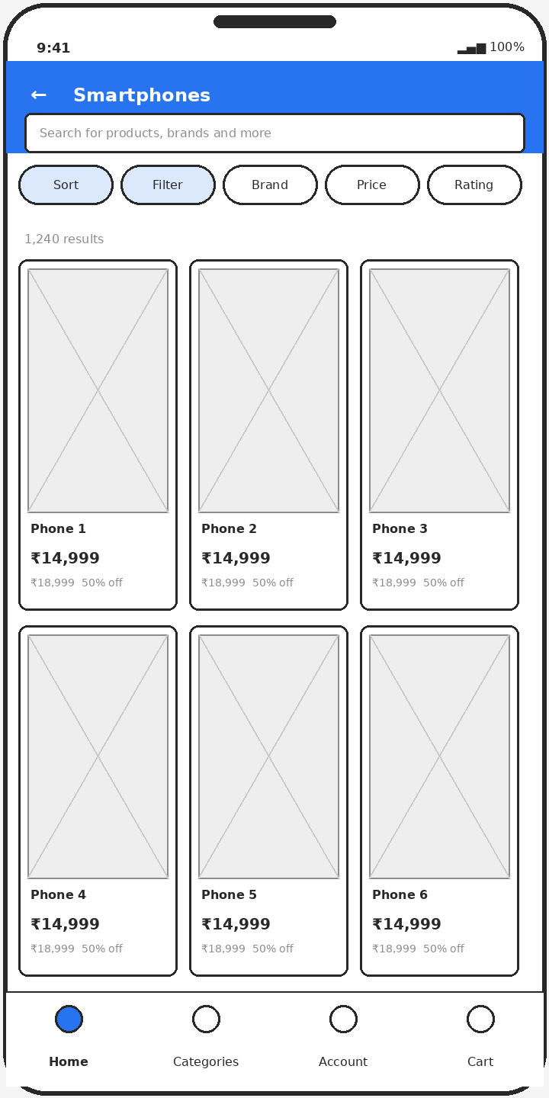  Screen 4: Search results / listing  - Sort, Filter, Brand, Price and Rating chips  - Two- or three-column product grid  - Price, strike-through price and discount on every card | 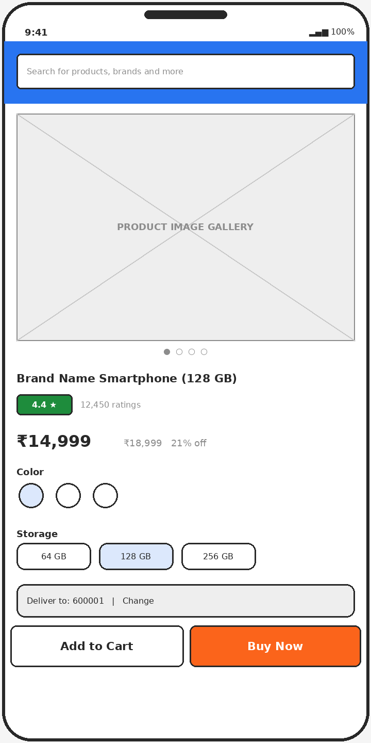  Screen 5: Product detail  - Image gallery, title, rating and price  - Colour and storage variant selectors  - Delivery pincode check  - Sticky Add to Cart and Buy Now buttons | 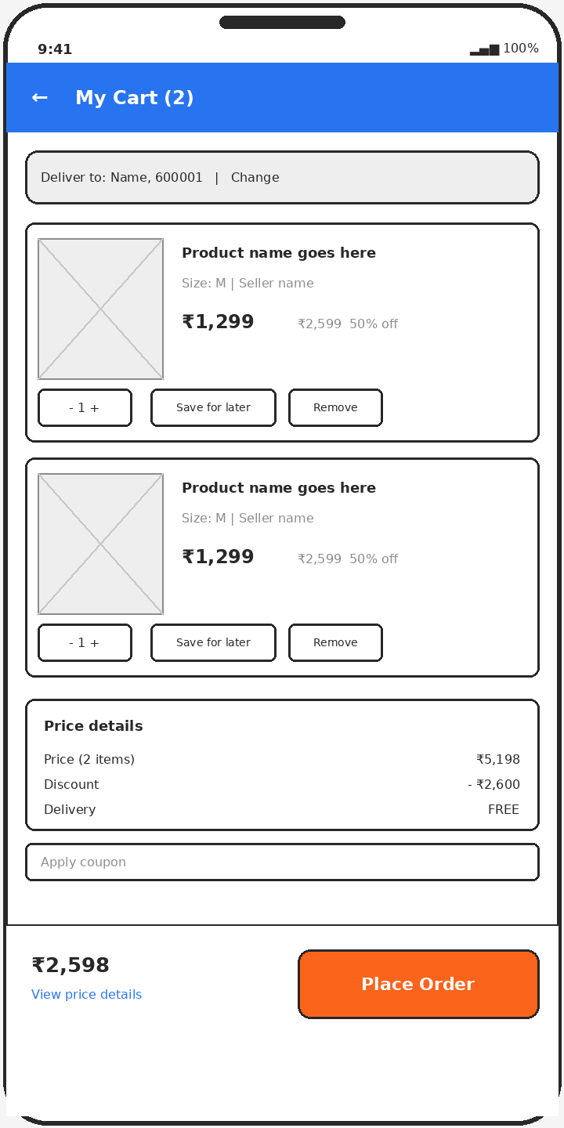  Screen 6: Cart  - Delivery address strip  - Item cards with quantity, save for later, remove  - Price details and coupon field  - Sticky total with Place Order

7. Checkout & confirmation
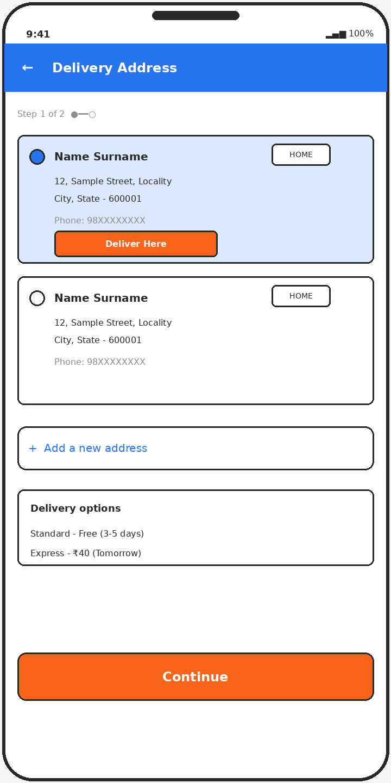  Screen 7: Delivery address  - Saved addresses with selectable radio  - Deliver Here action and Add new address  - Standard and express delivery options | 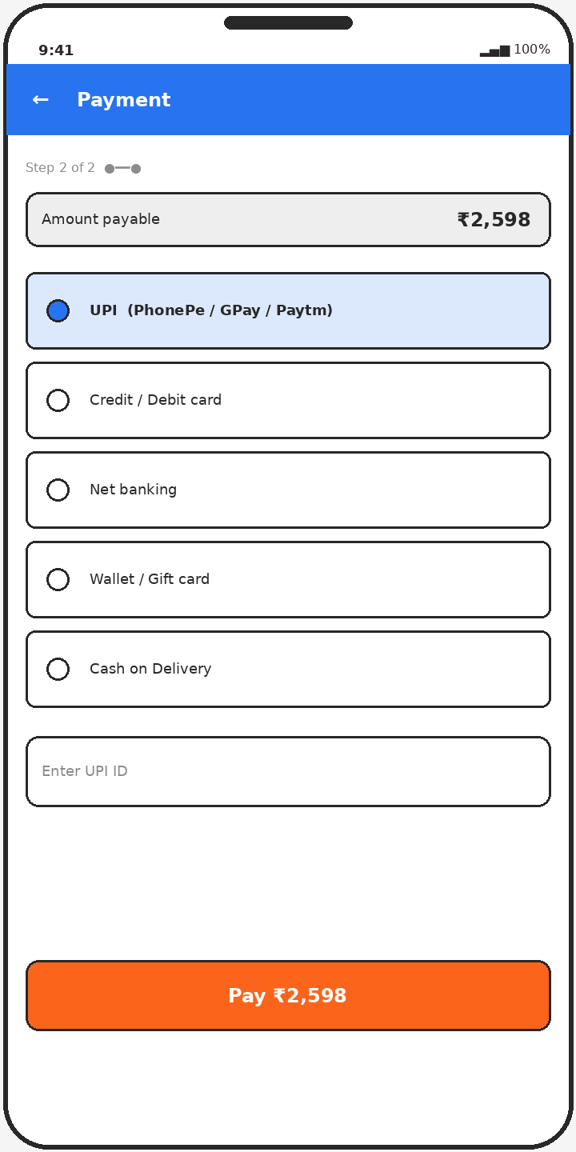  Screen 8: Payment  - Amount payable summary  - UPI, card, net banking, wallet and Cash on Delivery  - Pay button shows final amount | 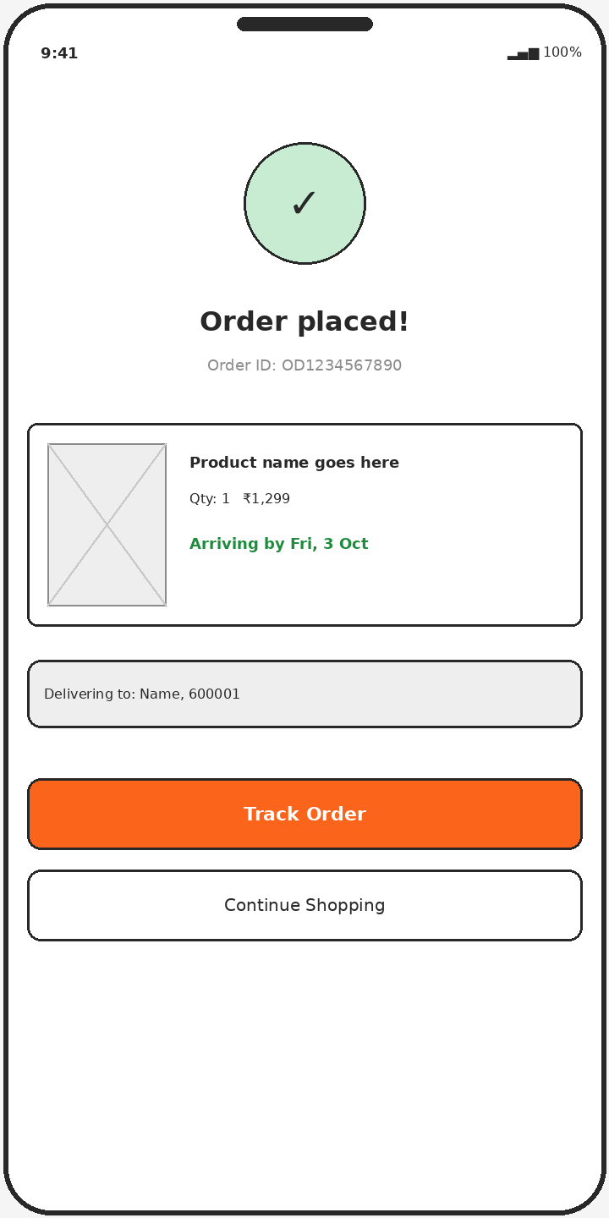  Screen 9: Order confirmation  - Success state with order ID  - Product summary and delivery date  - Track Order and Continue Shopping actions

8. Orders & account
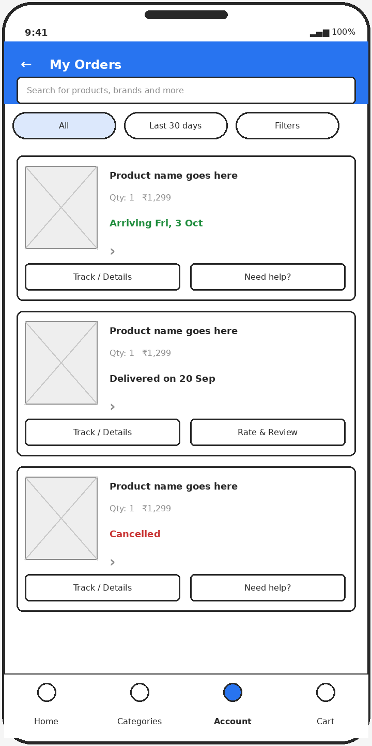  Screen 10: My Orders  - Filter chips for time range and status  - Order cards with status colour and delivery date  - Track, rate and review, or get help per order | 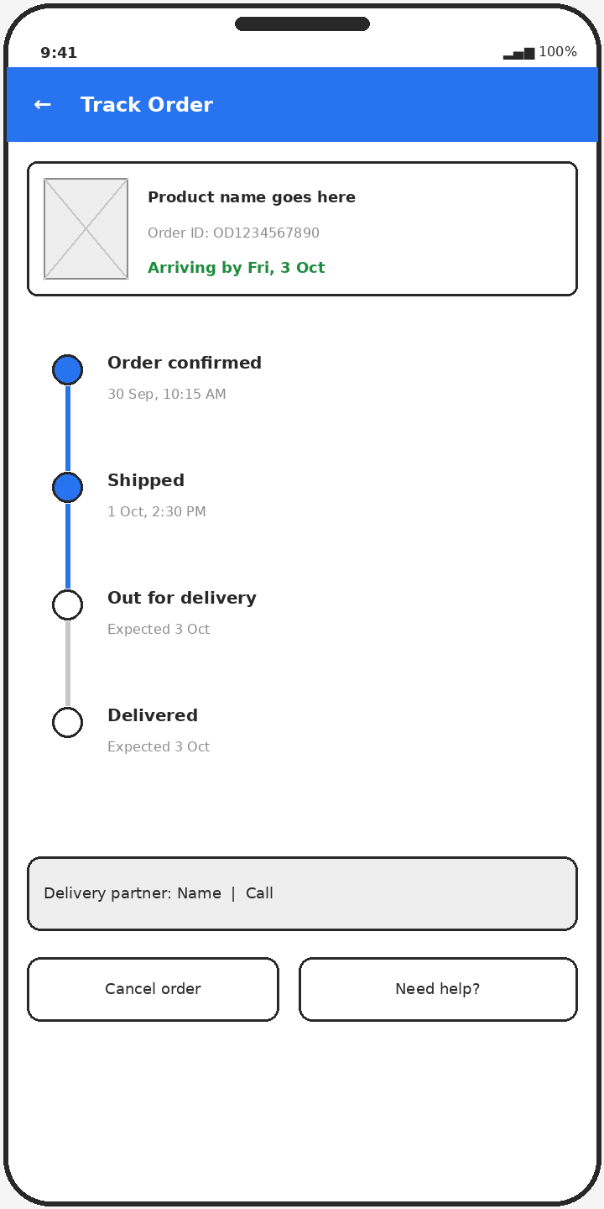  Screen 11: Order tracking  - Order summary strip  - Vertical status timeline: confirmed, shipped, out for delivery, delivered  - Delivery partner contact, cancel and help | 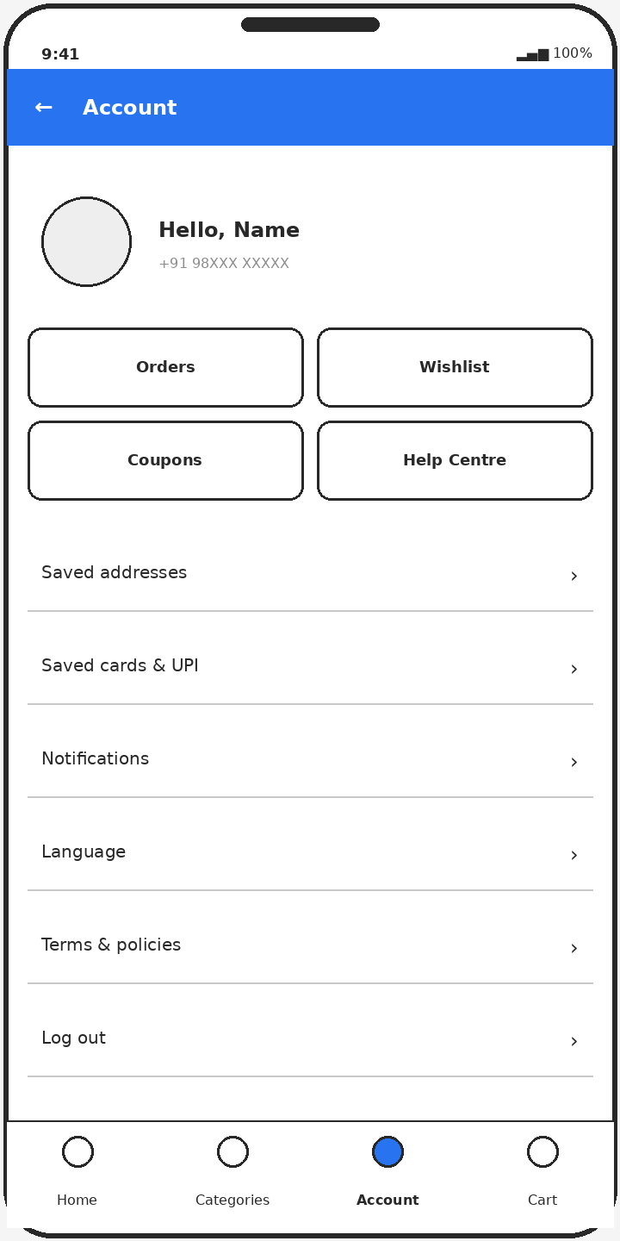  Screen 12: Account  - Greeting and phone number  - Shortcuts: Orders, Wishlist, Coupons, Help Centre  - Saved addresses, payment methods, notifications, language  - Log out

9. Navigation map & next steps

Navigation structure
- Bottom tabs: Home, Categories, Account, Cart.
- Purchase path: Home or Categories, Results, Product, Cart, Address, Payment, Confirmation (screens 2 to 9).
- Account opens My Orders, order tracking, saved addresses and settings.

Suggested next steps
- Add edge states: out of stock, payment failure, empty cart, no network, returns and refunds.
- Design wishlist, product reviews, seller pages and return flows.
- Move to mid-fidelity with real typography, colour tokens and an icon set.
- Test the purchase path (screens 4 to 9) with a clickable prototype.

