Digital Marketing Cat – II
NAME-HARIRAMAKRISHNAN S
ROLLNO-1833018
Aim:
To post the engagement activity on the posts made including likes, shares, comments, retweets, etc. Report the analytics for all the social media and pages and do the summary in a dashboard like format for each of the posts.
Elaborate if someone have reached out to you regarding your posts for a sales enquiry or just for random asks.
Explore any of the two digital marketing tools online which you have not explored so far. Analyse the product features, price and compare it with tools that you have used for similar usage.

Explanation:
For our business, we are handling the social media accounts in Twitter, Youtube.
Links:
Youtube: https://www.youtube.com/channel/UCr6QMxWnP9Is5qCfKSL0pYw
Twitter:https://twitter.com/HARIRAM45009030/status/1321794616861945858?s=20
https://twitter.com/HARIRAM45009030/status/1321776797986422786?s=20
https://twitter.com/HARIRAM45009030/status/1321722108825645057?s=20

Summary:
we see that the first post has more likes and more comments which means that this has made a quite good impression around our consumers. So, it’s better to encourage those kind of posts in the feed.
The first post in the Twitter was the Logo of Embellish yourself. The interactivity is high in this post which means that we are reaching out well with the people with the logo. So, it’s better to have logo wherever we could and this helps in gaining trust also.
We can see that there are 7 tweets(replies)
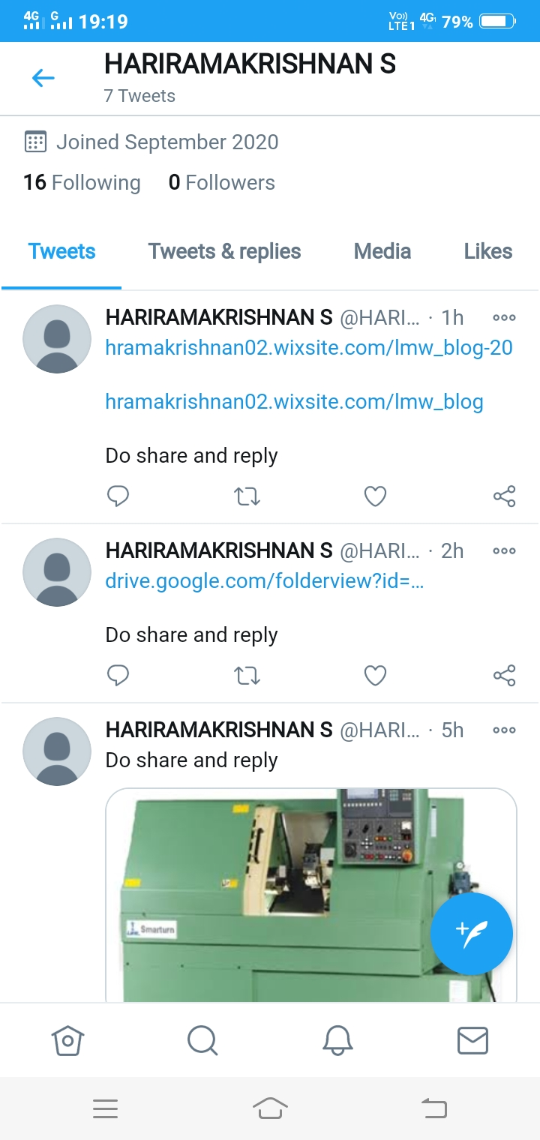
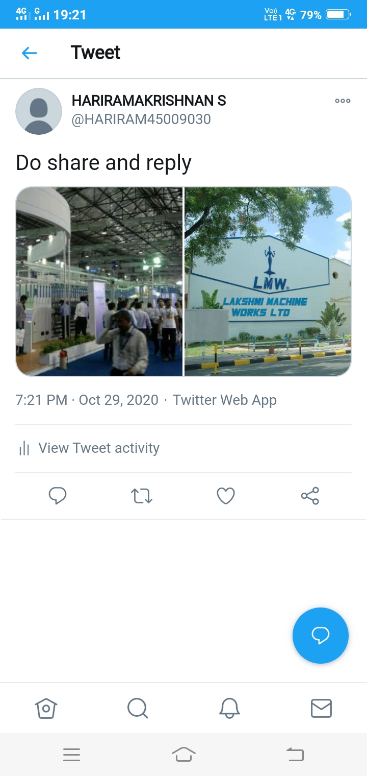

This picture is to show that we have posted 12 posts I the Twitter feed.
Post-12
Thus, it conveys that the account has been reaching out quite well for a startup business and the content is making people to show some attention. Hence, we have to concentrate more on maintaining the followers because the value has fallen a little. If it’s an increment then it’s a great result but as it has fallen we have to find some alternatives to make an increase in it.

Report generated from Wix.com for our website:
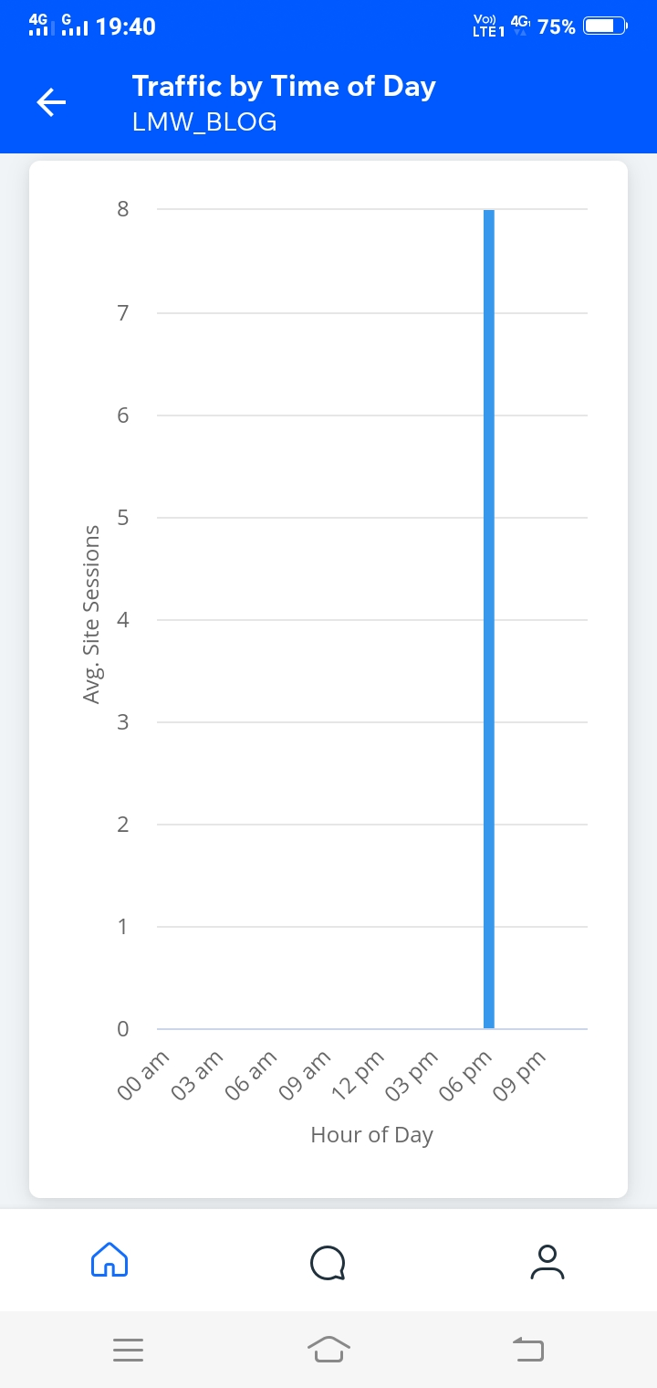
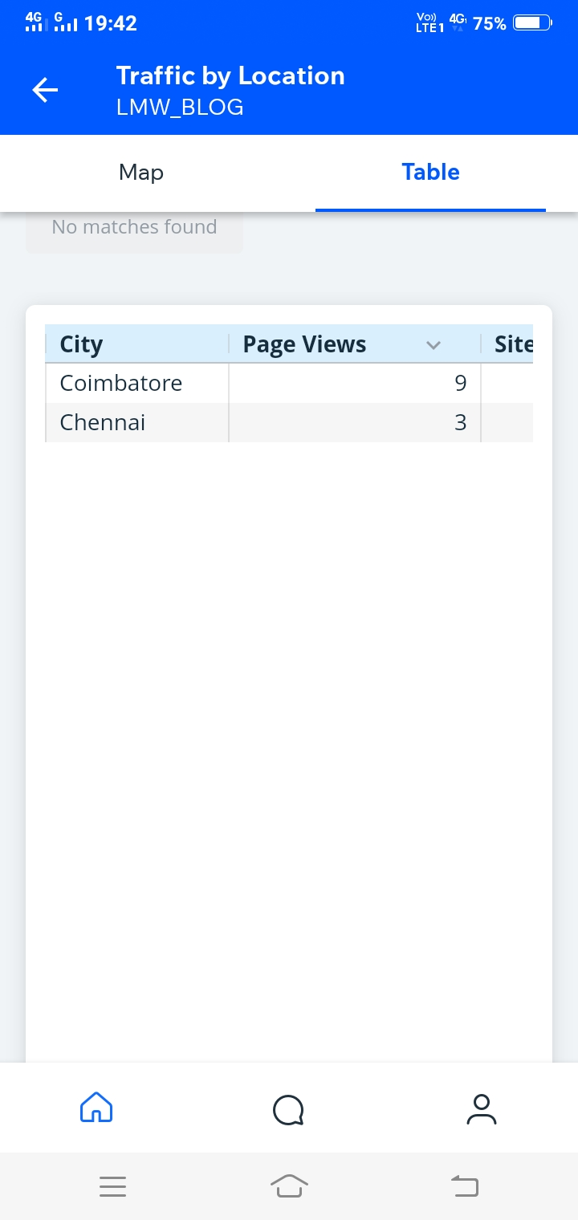

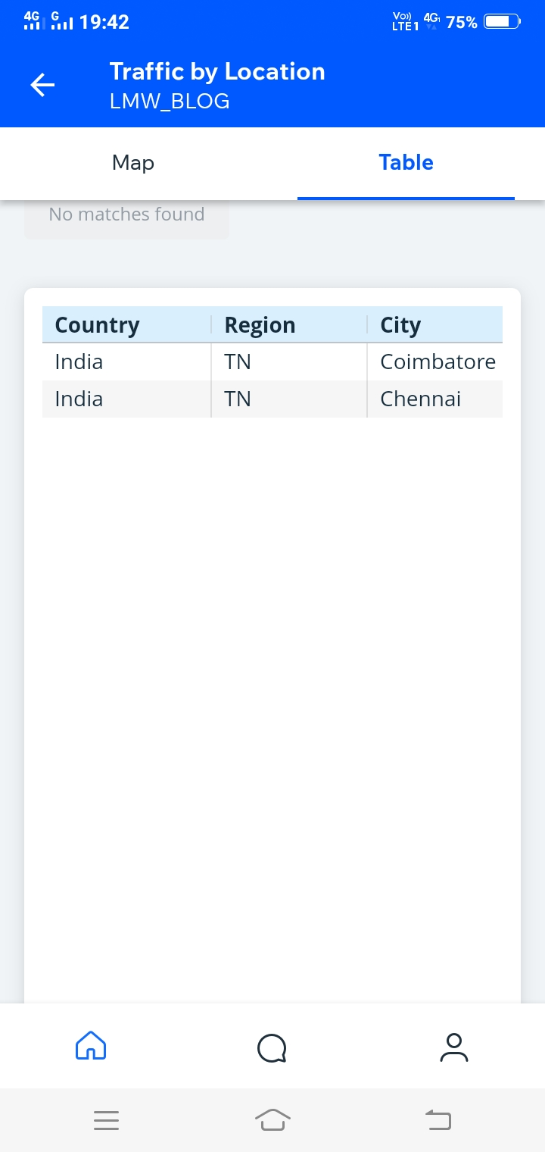
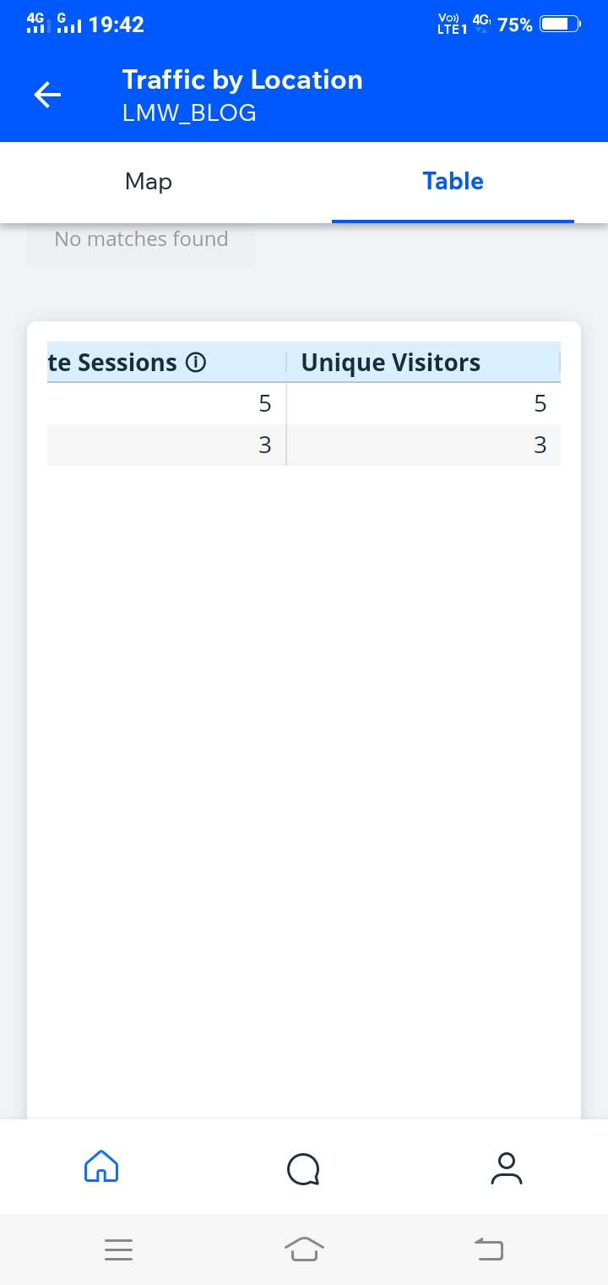
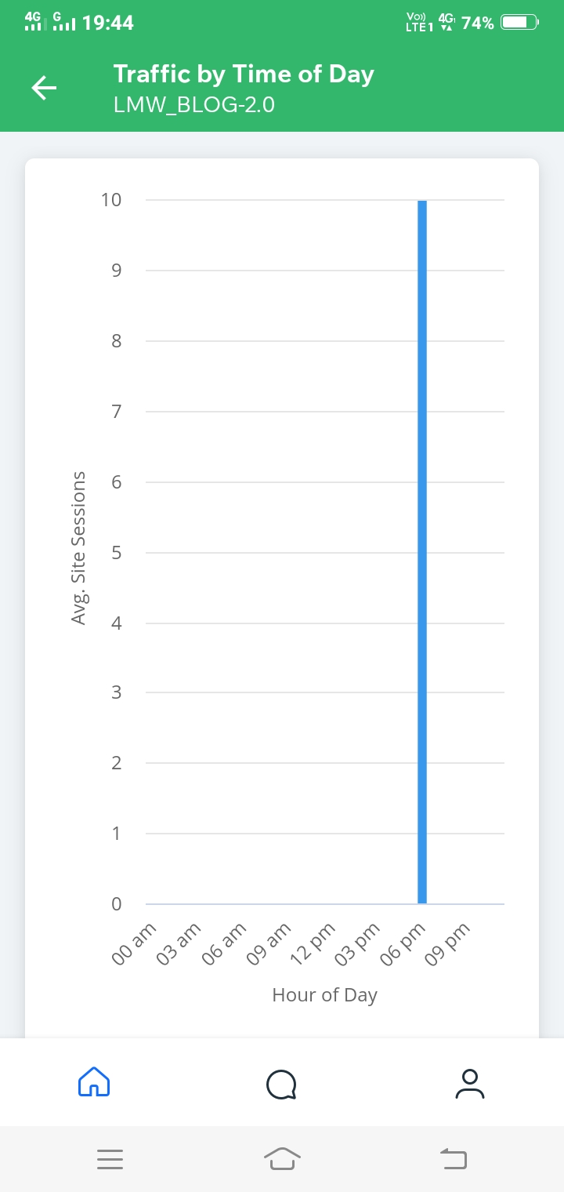
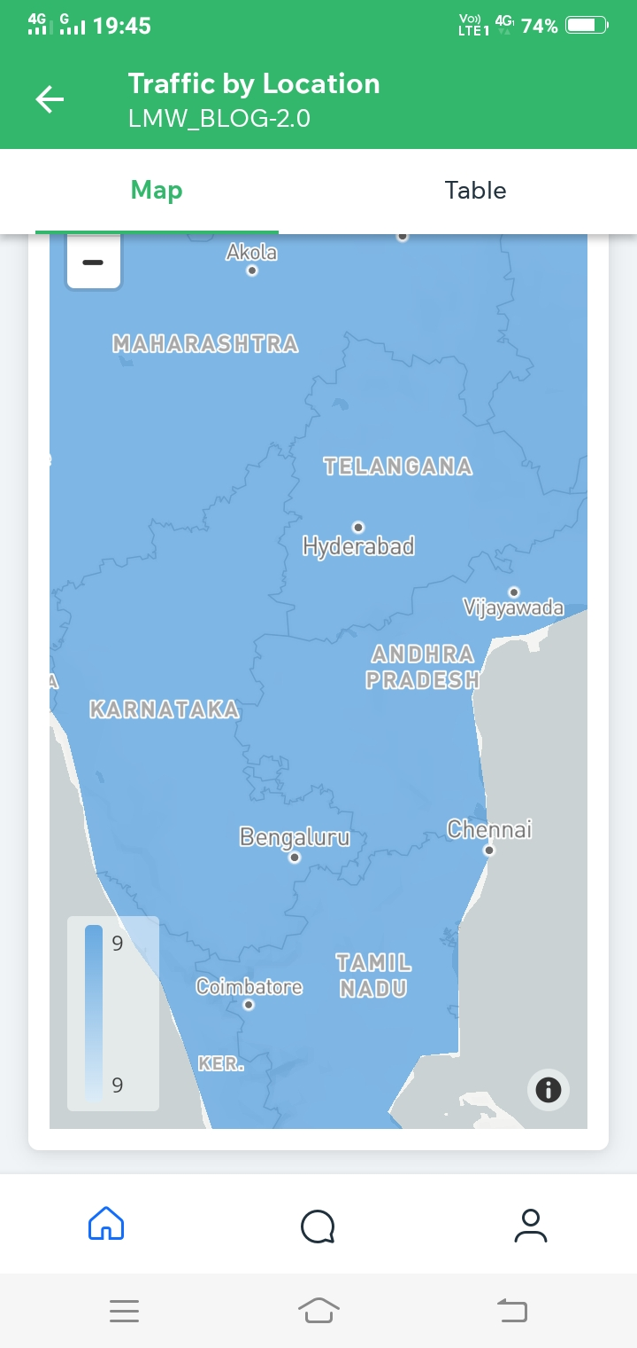
From the stats,
We can see that the home page has high views and since we kept posting frequently, there were many visitors in that particular week (7th Sep 2020 - 13th Sep 2020). Home page is the page which has more views.
To elaborate and explain how we reacted to the comments.
Explanation:

Once, when we posted our logo in the social media. The first thing consumers asked about are the offers.
When we came to know about it. We asked our customer to kindly wait until tomorrow for fabulous orders and discounts as that was the very first day of the business.
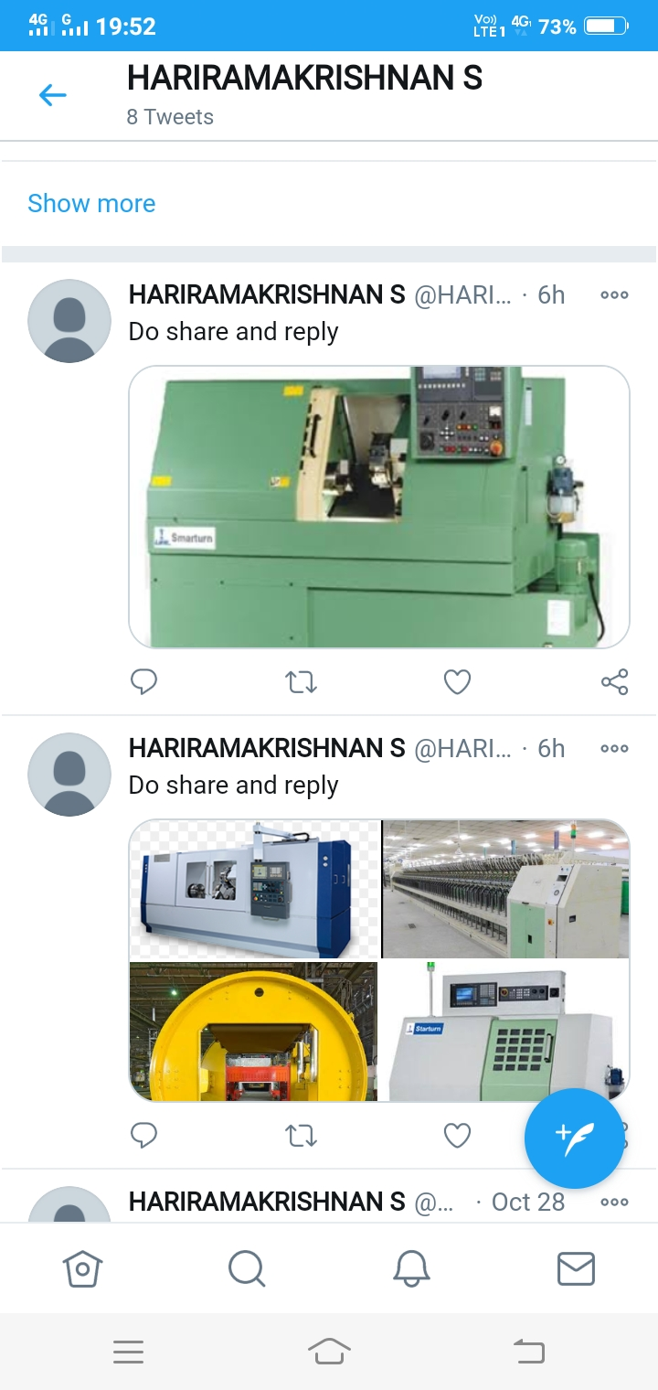
12-posts

Links of Twitter
https://twitter.com/HARIRAM45009030/status/1321811821200732161?s=20
https://twitter.com/HARIRAM45009030/status/1321794616861945858?s=20
https://twitter.com/HARIRAM45009030/status/1321776797986422786?s=20
https://twitter.com/HARIRAM45009030/status/1321722108825645057?s=20
https://twitter.com/HARIRAM45009030/status/1321721930198601730?s=20
Links of YouTube
https://youtu.be/UUrrxob0PoU
https://youtu.be/ROOXGz63ezM
https://youtu.be/_2V7WOWcfQw
https://youtu.be/qxXMlnEZyTY
https://youtu.be/w3r30KZBWNU

There are 13 subscribers in my you tube channel
And views are
Video-1: 30 views
Video-2: 25 views
Video-3: 22 views
Video-4: 18 views
Video-5: 15 views
Comments-
1.Nice da
2.Sprb...👌🏻
3.Spr da.. 🔥🔥
Wix.com Links:
https://hramakrishnan02.wixsite.com/lmw_blog
https://hramakrishnan02.wixsite.com/lmw_blog-20
Blog replies:

