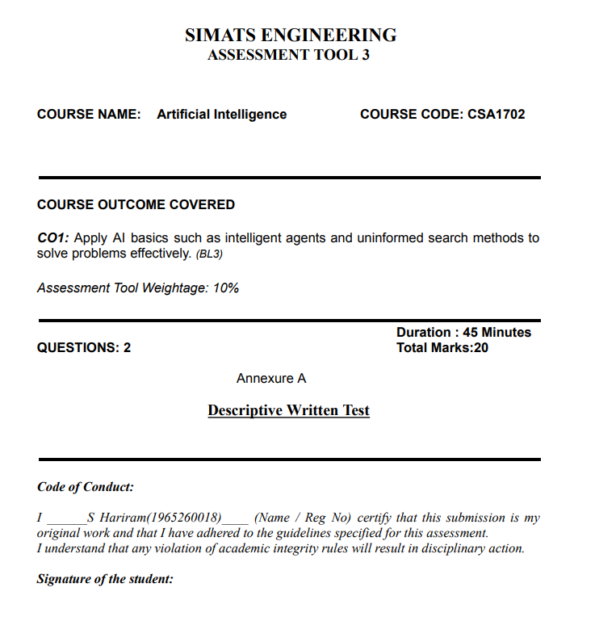
Question 1: Smart Home Automation System and Intelligent Agent Architectures

1. Analysis of Intelligent Agent Architectures in a Smart Home

a) Simple Reflex Agent
A Simple Reflex Agent makes decisions based only on the current percepts using predefined condition-action rules. It does not consider past experiences or maintain an internal state.
Function in a Smart Home:
- If motion is detected, turn on the lights.
- If the temperature exceeds 26°C, turn on the AC.
- If the door is forced open, trigger the alarm.
Limitations:
- Cannot remember previous states or learn user habits.
- Lights may turn off when a person remains still for a long time.
- Cannot make decisions based on time-of-day context.

b) Model-Based Reflex Agent
A Model-Based Reflex Agent maintains an internal state of the environment to remember previous conditions and estimate aspects that cannot be directly observed.
Function in a Smart Home:
- Stores room occupancy, the last motion detection time, and the current season.
- Keeps lights on for 15 minutes after the last detected movement.
- Checks whether windows are open before activating the AC.
Limitations:
- Mainly depends on predefined rules.
- Cannot effectively evaluate complex future goals or balance multiple objectives.

c) Goal-Based Agent
A Goal-Based Agent selects actions by considering whether they help achieve specific goals. It uses the internal state of the environment to plan a sequence of actions.
Function in a Smart Home:
- Maintains the room temperature at 22°C before the occupant arrives.
- Ensures all entry points are secured after 11:00 PM.
- Pre-cools the house before the occupant arrives to improve comfort.
Limitations:
- Focuses on achieving goals rather than measuring the quality of the outcome.
- Cannot easily balance conflicting objectives, such as comfort and electricity cost, without additional evaluation mechanisms.

d) Utility-Based Agent
A Utility-Based Agent evaluates possible actions using a utility function that assigns a numerical value to each outcome. It selects actions that maximize overall utility while considering different objectives.
Function in a Smart Home:
A utility function can be represented as:
U = w₁ × Comfort + w₂ × Energy Savings + w₃ × Security
Here, w₁, w₂, and w₃ represent the importance assigned to comfort, energy savings, and security.
- Adjusts AC settings to maintain comfort while reducing electricity costs.
- Controls lighting intensity according to ambient brightness.
- Balances energy efficiency, comfort, and security.
Advantages:
- Handles trade-offs between multiple objectives.
- Supports decisions under changing environmental conditions.
- Provides more flexible and efficient automation.
Limitations:
- Requires a carefully designed utility function.
- Can involve greater computational and modeling complexity.

2. Comparative Architectural Matrix
Agent Type | Key Mechanism | Smart Home Application | Primary Limitation
Simple Reflex | Condition-action rules | Motion-based lighting and emergency alarms | No memory or learning
Model-Based Reflex | Internal state tracking | Occupancy tracking and window-HVAC coordination | Limited planning and optimization
Goal-Based | Planning toward target states | Scheduled cooling and nighttime security | Does not directly measure outcome quality
Utility-Based | Utility function and trade-off evaluation | Energy-efficient climate control and adaptive lighting | Higher computational complexity

3. Justification of the Most Effective Approach: Hybrid Learning Utility-Based Agent
A single agent architecture may not adequately satisfy all smart home requirements, including comfort, energy efficiency, security, and adaptation to user behavior. Therefore, a Hybrid Learning Utility-Based Agent is the most effective approach.
It combines the strengths of different agent architectures through the following layers:
1. Reflex Layer for Critical Security
This layer responds immediately to critical events such as smoke detection, gas leaks, or unauthorized entry. It triggers alarms and other predefined safety actions without waiting for complex decision-making.
2. Model-Based Layer for State Estimation
This layer maintains information about room occupancy, previous sensor readings, temperature changes, and sunlight variations. It helps the system make decisions even when sensor information is temporarily unavailable.
3. Utility-Based Decision Engine
This engine balances comfort, energy consumption, and security. It adjusts lighting intensity and thermostat settings to maximize overall utility instead of relying only on ON/OFF actions.
4. Integrated Learning Element
The learning element uses user feedback and historical behavior to improve automation. For example, it can learn typical waking times, preferred room temperatures, and lighting schedules. Reinforcement learning or preference modeling can help update decisions over time.

Conclusion
The Hybrid Learning Utility-Based Agent is the most suitable architecture for a smart home automation system because it combines immediate safety responses, internal state tracking, goal-oriented planning, utility optimization, and continuous learning. This approach provides a balance between user comfort, energy efficiency, security, and adaptability.

Question 2: Unknown Maze Navigation, Uninformed Search, and Agent Design

1. Application of Uninformed Search Strategies (UCS vs. IDS)

a) Uniform Cost Search (UCS)
Uniform Cost Search expands the node with the lowest accumulated path cost, denoted by g(n)g(n). It uses a priority queue to select the least-cost path.
Application in an Unknown Maze:
- The robot uses sensors to identify nearby walls, corridors, and possible movements.
- It builds an internal graph of the maze as new locations are discovered.
- Movement costs are assigned according to the environment, such as a normal floor move = 1, a rough surface move = 3, and a turning maneuver = 1.5.
- The robot explores paths in increasing order of accumulated cost.
Advantages:
- Finds the minimum-cost path when movement costs are positive and the relevant graph has been explored sufficiently.
- Handles non-uniform movement costs.
- Helps reduce energy consumption and physical wear.
Limitations:
- Requires considerable memory to store explored nodes and paths.
- May expand many nodes before reaching the exit.
- In an unknown physical maze, it must be combined with online exploration to discover the environment.

b) Iterative Deepening Search (IDS)
Iterative Deepening Search combines the completeness of Breadth-First Search with the low memory requirements of Depth-First Search. It repeatedly performs depth-limited searches, increasing the depth limit from 0 to 1, 2, and so on.
Application in an Unknown Maze:
- The robot explores paths within the current depth limit.
- If the exit is not found, it increases the limit and searches again.
- The process continues until the exit is found.
Advantages:
- Requires less memory than UCS.
- Finds the shallowest solution when the branching factor is finite.
- Is optimal when all actions have equal costs.
Limitations:
- Repeats the exploration of previously visited nodes.
- Physical robots may need to retrace paths when performing repeated searches.
- Does not guarantee the minimum-cost path when movement costs differ.

2. Comparative Complexity Analysis
Feature | Uniform Cost Search (UCS) | Iterative Deepening Search (IDS)
Time Complexity | O(b1+C∗/ε)O(b^{1+C^*/\varepsilon}) | O(bd)O(b^d)
Space Complexity | O(b1+C∗/ε)O(b^{1+C^*/\varepsilon}) | O(bd)O(bd)
Completeness | Yes, if step costs are at least ε>0\varepsilon>0 | Yes, for a finite branching factor
Optimality | Yes, for positive movement costs | Yes, if all step costs are equal
Memory Usage | High | Low
Main Advantage | Finds the least-cost path | Memory efficient
Main Limitation | Stores many explored nodes | Repeats exploration
Suitability | Best for varying movement costs | Suitable for equal-cost paths and memory-limited searches
Where:
- bb = branching factor, or the number of possible successors per node.
- C∗C^* = cost of the optimal solution.
- ε\varepsilon = minimum positive step cost.
- dd = depth of the shallowest solution.

3. Relationship to Intelligent Agent Types and Decision-Making

a) Simple Reflex Agent
A Simple Reflex Agent reacts only to its current percepts using predefined rules.
Example: The robot follows the left-hand rule, keeping its left side against a wall.
Limitation: It may repeatedly follow the same route or fail to find the exit in mazes containing loops or disconnected wall structures.

b) Model-Based Agent
A Model-Based Agent maintains an internal representation of the environment, including visited cells, walls, corridors, and dead ends.
Example: The robot records explored locations in an occupancy grid and avoids repeatedly visiting known dead ends.
Advantage: It supports effective navigation in partially observable environments.

c) Goal-Based Agent
A Goal-Based Agent selects actions that help achieve a specific goal, such as reaching the exit.
Example: The robot identifies the exit as its target and uses a search algorithm to determine a route through discovered corridors.
Advantage: It supports systematic planning toward the destination.

d) Utility-Based Agent
A Utility-Based Agent evaluates possible routes according to factors such as distance, battery consumption, time, and physical risk.
Example: The robot chooses a slightly longer route over a damaged floor if it reduces energy consumption or the risk of getting stuck.
Advantage: It balances competing objectives and selects a route with a better overall outcome.

4. Recommended Combination and Justification
Recommended Strategy: Model-Based, Goal-Directed Online Search Agent Using Incremental Uniform Cost Search
This approach is suitable for an unknown maze because the robot must discover the environment while moving toward the exit.

Justification
1. Supports Online Exploration
The robot cannot construct a complete map before moving. It uses sensors to detect nearby obstacles and corridors, updates its internal map, and explores newly discovered paths.
2. Reduces Repeated Physical Exploration
IDS repeatedly searches from the starting point at increasing depth limits. For a physical robot, repeated traversal can consume additional time and battery power. A model-based agent can record explored paths and reduce unnecessary revisits.
3. Manages Memory Effectively
Although UCS may require considerable memory in the worst case, a practical robot can store a topological graph or occupancy grid for a bounded maze using onboard memory.
4. Handles Non-Uniform Movement Costs
Different surfaces and turns may have different costs. UCS considers these costs and can identify the minimum-cost route, whereas IDS generally minimizes the number of steps rather than total movement cost.
5. Supports Goal-Oriented Decisions
The goal-based component directs the robot toward the exit, while the model-based component maintains the map and the UCS component prioritizes lower-cost routes.

Conclusion
A Model-Based, Goal-Directed Online Search Agent using Incremental Uniform Cost Search is the most appropriate choice for an unknown maze with non-uniform movement costs. It combines environmental awareness, systematic exploration, goal-oriented planning, and cost-optimal path selection. IDS is preferable when memory is severely limited and all movements have equal costs.

