VulnForge Background Section (Draft)
Prepared as a report-ready background / research context chapter section with figures, diagrams and Harvard-style references.

2 Background
Cybersecurity education has moved steadily towards practical, scenario-based learning because many important skills are procedural rather than purely declarative. Students do not only need to recognise terms such as SQL injection, privilege escalation or access control; they need to practise reconnaissance, hypothesis testing, exploitation and verification in environments that behave plausibly under attack. NIST describes cyber ranges as interactive, simulated platforms that replicate networks, systems, tools and applications, and highlights their value for performance-based learning, teamwork, real-time feedback and experimentation (NIST, 2023). In parallel, Capture the Flag (CTF) exercises have become a widely used educational format, with prior work arguing that they complement traditional teaching and cover knowledge and skills that map well to formal cybersecurity curricula (Švábenský et al., 2021). Within this wider context, VulnForge addresses a specific research problem: whether generative AI can be used to create and manage personalised vulnerable training environments that remain educationally useful, operationally safe and practically deployable.

2.1 Cyber ranges, CTFs and the educational case for hands-on practice
The broader literature makes clear that hands-on platforms are not a novelty in cybersecurity education; they are now a core expectation. The Cyber Range: A Guide defines cyber ranges as a safe and legal way to acquire practical cyber skills, while also stressing that technical infrastructure alone is not enough: realism, accessibility, scalability and alignment with learning outcomes all matter (NIST, 2023). Katsantonis et al. (2023) similarly argue that cyber ranges have become important learning and training tools, but note that their design is often hindered by a lack of shared standards and methodologies. Their framework is especially relevant here because it treats orchestration, scenario design, participant profiles, feedback and lifecycle management as part of the same educational system rather than separate implementation details (Katsantonis et al., 2023).
This matters for the present project because VulnForge is not just attempting to generate vulnerable code snippets. The repository shows that the intended system problem is broader: an LLM produces structured vulnerability specifications, an orchestration layer deploys isolated challenge environments, the learner accesses them remotely, and a tutor provides contextual hints without disclosing the answer. In other words, the background problem is closer to cyber-range construction than to standalone code generation. Lazarov et al. (2025) reinforce this point by describing cyber ranges as controlled environments for deploying virtual machines and networks, and by showing that interactivity and gamification can improve engagement and the development of practical skills. The educational requirement, therefore, is not only to create exploitable targets, but to create exploitable targets inside a system that supports learning rather than merely hosting flaws.
CTF-style practice is particularly relevant because it provides a manageable pedagogical unit: a bounded task with a clear objective, observable progress and an explicit proof of successful exploitation. Švábenský et al. (2021) describe CTFs as a popular form of modern hands-on cybersecurity education and argue that they complement conventional teaching. For a project such as VulnForge, the appeal of this model is clear. Flags provide a convenient assessment artefact, challenge categories can be mapped to distinct vulnerability classes, and success can be operationalised without needing a full classroom cyber range with many simultaneous roles. However, traditional CTF content is often pre-authored, which raises questions about replayability, variety and personalisation once learners have exhausted a fixed content library.

2.2 Existing platforms and the specific gap this project targets
A defensible background section needs to show that VulnForge is not solving a problem nobody else has noticed. Existing platforms already demonstrate the value of hands-on cyber training. Hack The Box Academy presents cybersecurity learning as a highly interactive process with target hosts, checkpoint exercises and skills assessments that allow learners to reproduce techniques rather than merely read about them (Hack The Box Academy, n.d.). picoCTF describes picoGym as a non-competitive practice space where learners can solve challenges and build cybersecurity skills in a safe environment (picoCTF, n.d.). TryHackMe similarly offers structured rooms, modules and learning paths, and now provides organisation-facing tooling that can automatically map an uploaded curriculum or framework into a draft learning path built from existing platform content (TryHackMe Help Center, n.d.).
These platforms are important comparators because they show that three parts of the problem are already well understood. First, there is clear demand for accessible, hands-on security practice. Second, curated challenge libraries and guided pathways are a mature design pattern. Third, AI-assisted guidance is beginning to appear in mainstream platforms. Hack The Box, for example, publicly describes an AI assistant that can recommend practice scenarios, summarise write-ups and help produce training plans (Hack The Box, 2024). That means it would be inaccurate to claim that current platforms are entirely static or that personalised support does not exist.
Platform | Publicly described model | Why it matters here
Hack The Box Academy / AI assistant | Interactive modules with target hosts, checkpoint exercises and skills assessments, plus an AI assistant that recommends scenarios, summaries and training plans (Hack The Box Academy, n.d.; Hack The Box, 2024). | Shows that hands-on learning and AI-supported navigation already exist; VulnForge therefore needs a narrower claim focused on generation and lifecycle.
picoCTF / picoGym | A safe, non-competitive practice environment built around released and fresh challenges that lets learners practise at their own pace (picoCTF, n.d.). | Demonstrates the strength of approachable CTF-style practice, but remains primarily a curated challenge space.
TryHackMe | Rooms, modules and learning paths, with tooling that can automatically generate a draft learning path from an uploaded curriculum by mapping to existing content (TryHackMe Help Center, n.d.). | Shows that personalisation can operate at the level of sequencing existing material without necessarily generating a new vulnerable host per learner.
VulnForge (project niche) | On-demand generation of a new challenge instance, tied to controlled deployment, contextual tutoring and automatic retirement. | The research focus is the integration of generation, orchestration, tutoring and containment in a single pipeline.
Table 1. Comparison point for the existing-systems discussion.
Source note: author’s synthesis from official platform descriptions.
The gap targeted by VulnForge is therefore narrower and more specific than a simple “existing systems are static” claim. Public descriptions of major platforms still centre on pre-authored modules, rooms, labs or challenge repositories, even when discovery or navigation is AI-assisted (Hack The Box Academy, n.d.; Hack The Box, 2024; picoCTF, n.d.; TryHackMe Help Center, n.d.). By contrast, the core workflow in VulnForge is the generation of new challenge instances on demand, tied to a per-user deployment lifecycle and accompanied by a tutor that is aware of the active challenge context. The contribution is not that it invents hands-on labs, hints or scaffolding from scratch; rather, it investigates whether these elements can be combined into a single pipeline that produces disposable, individualised challenge environments instead of routing learners through a fixed library of authored content. This is a more defensible and precise problem statement, and it better reflects the current state of the field.
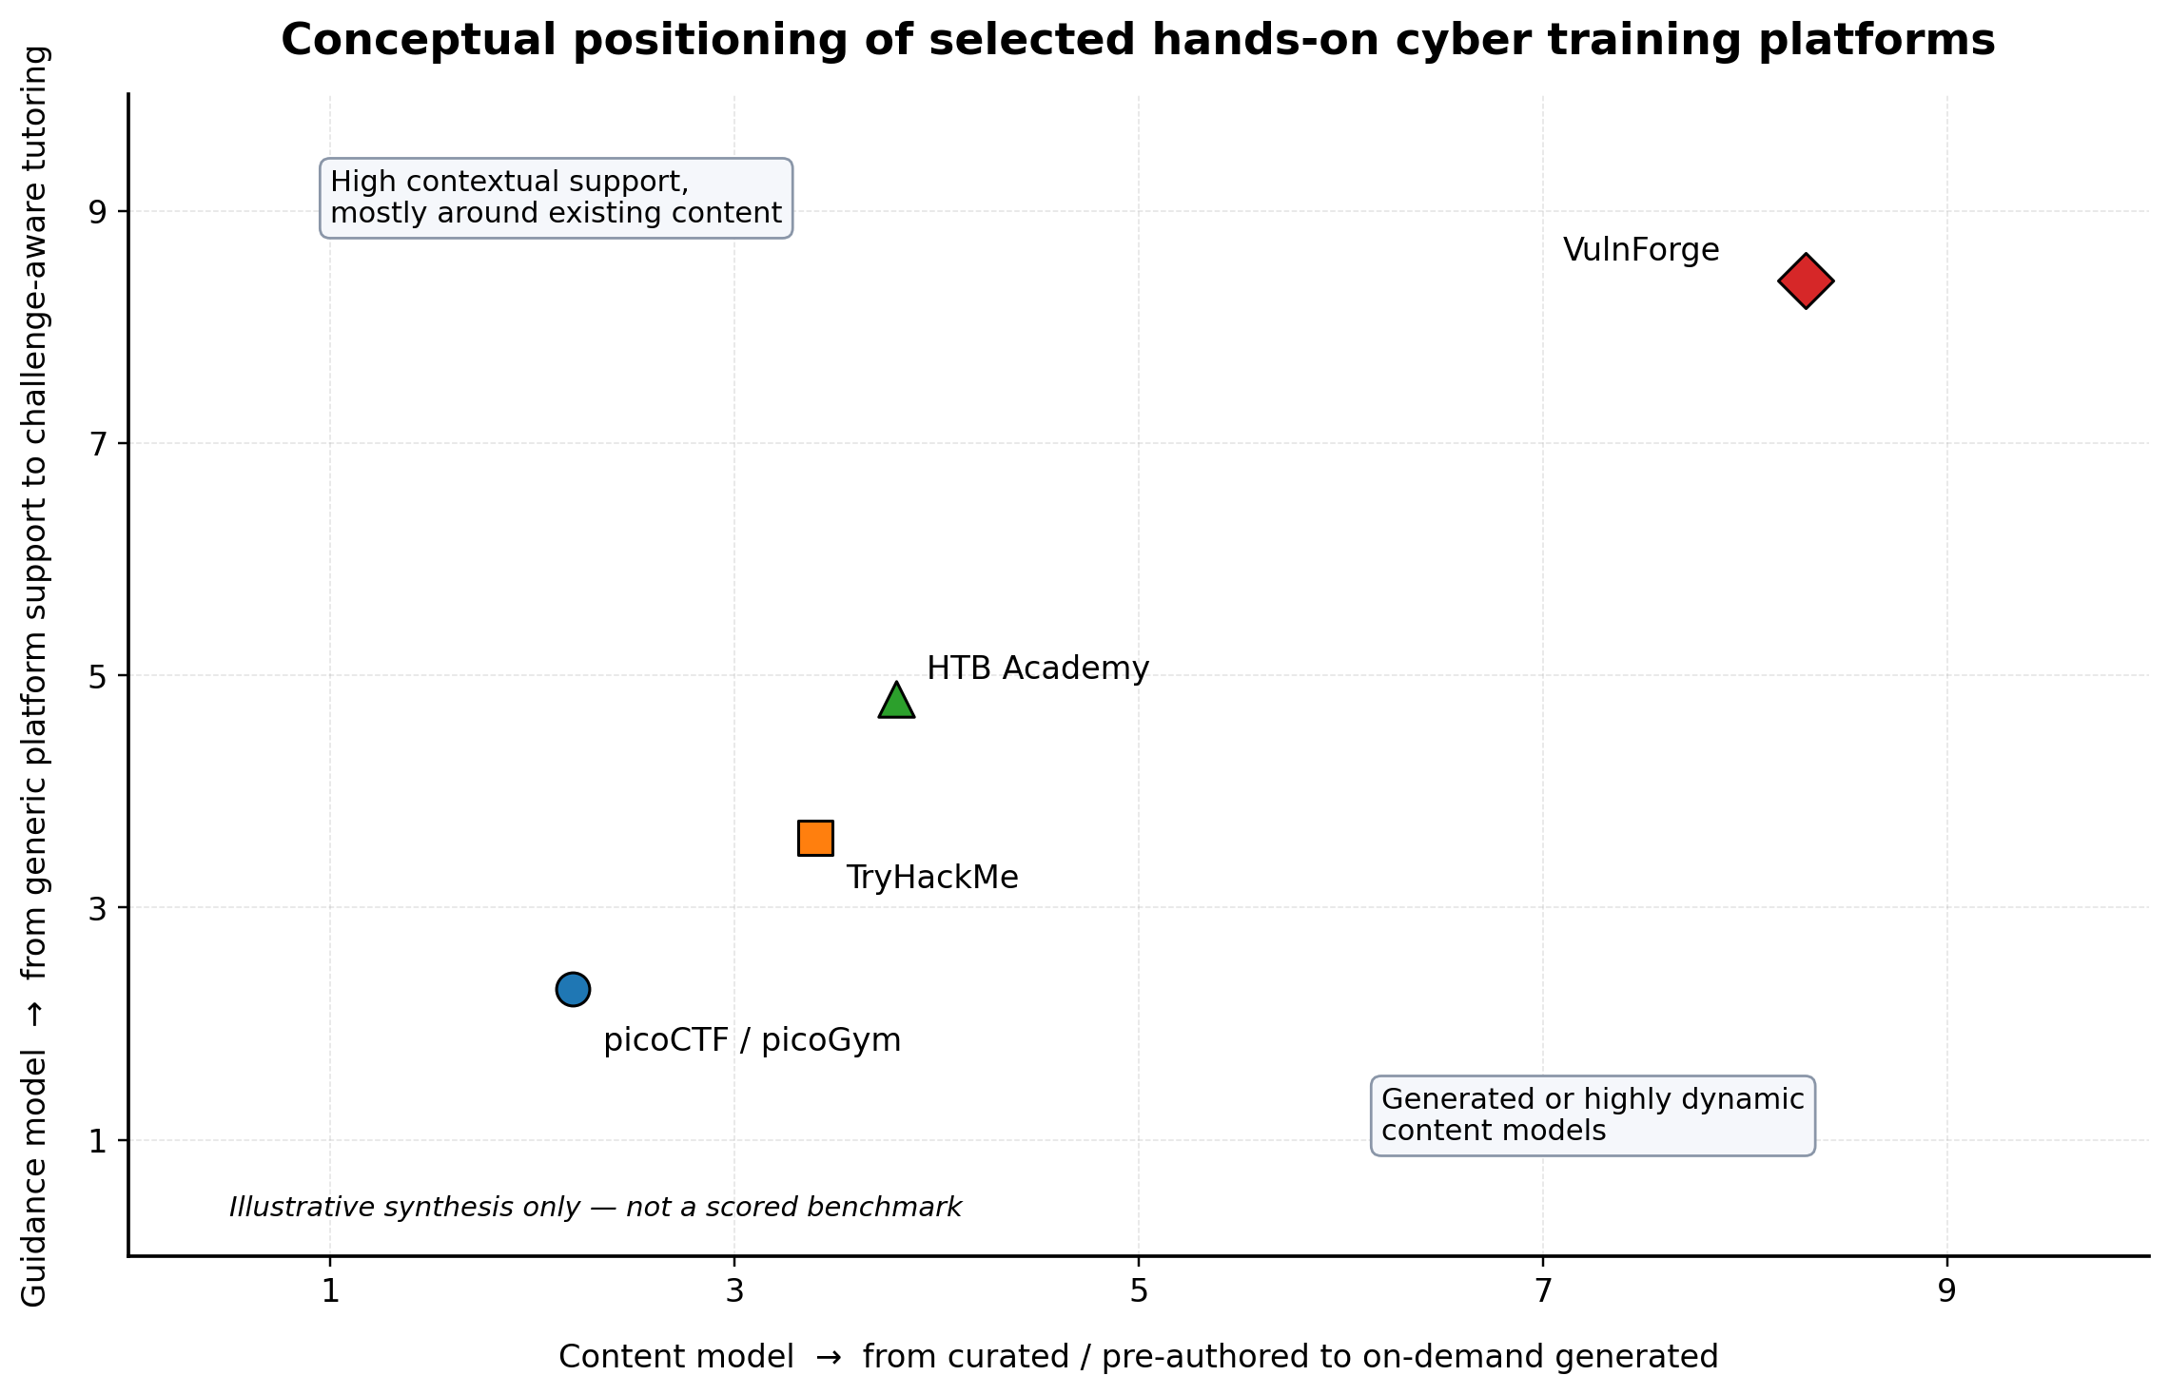
Figure 1. Conceptual positioning of selected hands-on cyber training platforms against VulnForge’s intended research niche.
Source: author’s synthesis of Hack The Box Academy (n.d.), Hack The Box (2024), picoCTF (n.d.) and TryHackMe Help Center (n.d.).

2.3 Why generative AI is attractive here, and why it is also risky
Generative AI provides an obvious possible answer to the replayability problem because it can synthesise new text, code, configuration and narrative framing on demand. The education literature already shows why this is attractive. García-Méndez, de Arriba-Pérez and Somoza-López (2025) review the use of large language models as virtual tutors and report that tutoring and automatic question generation are among their most common educational roles. In cybersecurity specifically, Mukherjee, Le and Chow (2025) argue that generative AI creates significant opportunities for higher cybersecurity education through intelligent tutoring, while also pointing to challenges around privacy, security and trustworthy integration. Taken together, these findings make an LLM-based tutor a plausible component of a cybersecurity learning platform, especially when learners become stuck and need graduated hints rather than a full worked solution.
The same properties that make LLMs attractive, however, also make them hazardous. VulnForge intentionally asks a model to produce insecure artefacts, but it must do so within a very narrow envelope: the vulnerability must be intentional, categorisable, exploitable by a learner, deployable inside the chosen environment, and isolated from the host platform. This is a much harder requirement than simply “produce vulnerable code”. Research on AI-assisted secure coding shows why uncritical trust is inappropriate. Belozerov, Barclay and Sami (2026) found that LLM-generated code in real developer interactions can contain confirmed vulnerabilities, and they caution that models may confidently provide incorrect information. Their study also shows that modern models can help detect and repair vulnerabilities when explicitly asked, but only partially and not reliably enough to remove the need for human review and static checking (Belozerov et al., 2026). For this project, the implication is inverted but important: an LLM cannot be treated as a self-certifying generator. Structured schemas, prompt constraints, post-generation validation and deployment guardrails are not optional extras; they are part of the research problem itself.
This point also reshapes the notion of “quality” in the project. In a normal software project, correctness means removing vulnerabilities. In VulnForge, quality means making the system vulnerable in the intended way without making the platform unsafe in unintended ways. A good output is not any insecure application, but a bounded and pedagogically coherent challenge instance. The repository reflects this distinction through design decisions such as server-side flag generation, tutor leak guards, challenge-aware prompts, non-root learner accounts and time-limited container cleanup. These are not merely implementation details to be described later; they arise directly from the background literature on trustworthy tutoring, controlled training environments and the need for defensible containment.

2.4 Stakeholders and non-computing context
The main stakeholder is the learner, who needs a platform that is technically realistic enough to support meaningful practice but not so operationally complex that setup becomes the main task. From a learner perspective, low-friction access, clear challenge goals, hints that preserve agency, and repeatable opportunities for practice are more important than architectural novelty. The educational literature supports this emphasis on interactivity and feedback, while existing platforms show that convenience and structure are critical to sustained use (NIST, 2023; Lazarov et al., 2025; Hack The Box Academy, n.d.).
A second stakeholder group is instructors, supervisors or curriculum designers. For them, the value of an AI-generated platform is not simply novelty but coverage, replayability and the possibility of aligning challenge categories to learning outcomes. NIST’s cyber-range guidance explicitly highlights curriculum and learning outcomes as a key design consideration, and Katsantonis et al. (2023) similarly treat assessment, participant profiling and feedback as first-class design concerns. For this stakeholder, a generated system is only useful if it can still be constrained into known categories, defended as pedagogically relevant, and evaluated systematically.
A third stakeholder is the platform operator, which in this case includes the project itself as a managed university system. This introduces non-computing concerns around ethics, safety, availability and resource use. Intentionally vulnerable machines should not remain online indefinitely, should not expose the underlying host, and should not allow one learner’s session to compromise another’s. The repository indicates that these concerns have already shaped the technical direction: the current design uses isolated challenge instances, one-active-challenge constraints, explicit expiry times, a Proxmox-side TTL reaper and a non-root student account. These choices reflect stakeholder needs that are operational and ethical as much as they are technical.

2.5 Constraints on the approach and the relevance of the chosen technical stack
The background literature helps explain why the chosen infrastructure is plausible. NIST’s container security guidance describes application containers as portable, reusable and automatable, while also noting the need to address isolation and security concerns explicitly (Souppaya, Morello and Scarfone, 2017). This matches the project requirement for disposable, reproducible training environments. Proxmox’s documentation describes Linux containers as a lightweight alternative to full virtual machines and notes that unprivileged containers map root inside the container to an unprivileged user outside it, which reduces the impact of many container-level failures (Proxmox VE, n.d.). In the context of intentionally vulnerable training labs, this is a sensible compromise between realism, cost and containment.
The cyber-range literature also makes orchestration central rather than incidental. NIST states that the orchestration layer is what ties infrastructure, isolation and target systems together, and Katsantonis et al. (2023) similarly emphasise lifecycle and scenario management. That matters because VulnForge’s repo shows a generated-challenge workflow built around structured output, automated provisioning and controlled teardown. The project therefore inherits a cyber-range problem: not just “can a model invent a flaw?” but “can an orchestration pipeline turn model output into a bounded, usable training environment?”
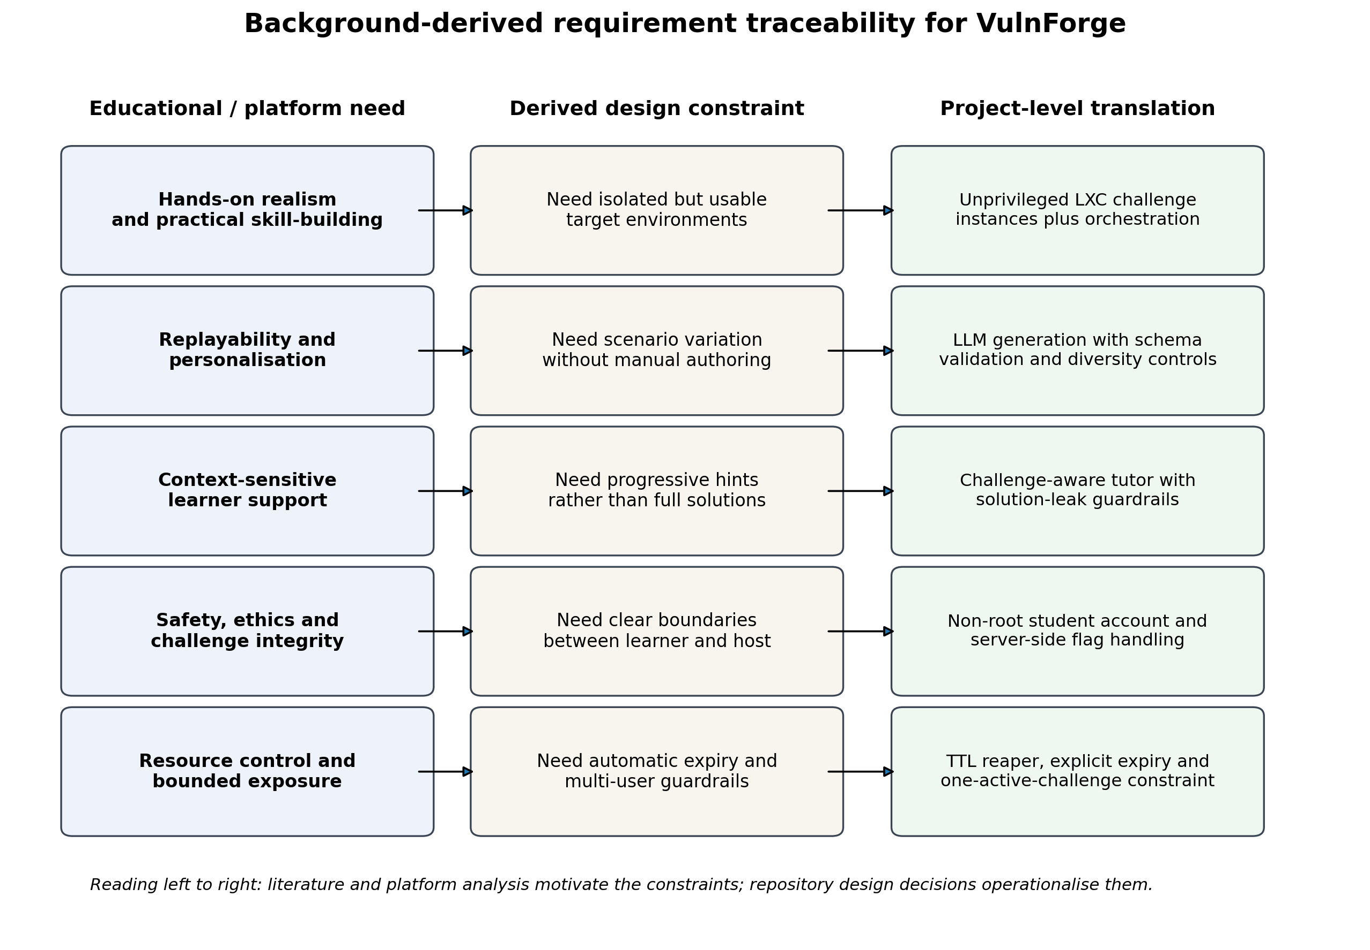
Figure 2. Background-derived requirement traceability from educational need to project-level design implication.
Source: author, synthesising literature and repository design notes.
Remote access is another background-driven constraint. Learners need access that is simple enough for practical use but controlled enough to limit unnecessary exposure. Tailscale documents subnet routers as gateways that extend access to devices or services that cannot run the client directly while preserving access-control policies (Tailscale, 2026). For a student-facing training platform, this fits the need to expose isolated challenge subnets without publishing every container as a directly reachable internet host. Combined with non-root SSH access and server-side flag handling, it supports a model in which the learner can interact with the target meaningfully while the platform still enforces basic integrity boundaries.
Finally, the current repository reveals an additional constraint that is easy to overlook in abstract discussions of AI-generated labs: diversity is itself a systems problem. The project documentation shows that repeated prompts tended to collapse towards the same canonical scenarios until explicit variation mechanisms, history-aware exclusions and creativity directives were introduced. This is significant background context because it shows that replayability cannot simply be assumed from the presence of an LLM. One of the practical research questions is therefore whether controlled generation can produce enough pedagogically meaningful variation to justify the added complexity over a curated challenge set.

2.6 Research problem and research questions
The background discussion above suggests that the real problem is not whether cybersecurity labs or AI tutors are possible in isolation; both already exist in different forms. The problem is whether they can be combined into a coherent, safe and educationally useful system that generates individual vulnerable environments on demand, exposes them through controlled infrastructure, supports the learner with contextual guidance, and then reliably retires the environment afterwards. Put differently, VulnForge investigates whether generative AI can move from being an accessory around cyber training content to becoming part of the content production and delivery pipeline itself.
This leads to the following research questions:
1. To what extent can a constrained large language model pipeline generate vulnerability specifications that are both deployable and sufficiently diverse to support repeatable cybersecurity training within defined challenge categories?
2. How can generated challenge instances be deployed and exposed through isolated, short-lived infrastructure without undermining host safety, challenge integrity or resource control?
3. Can a challenge-aware AI tutor provide progressive, context-sensitive support that helps learners progress while avoiding direct disclosure of flags or complete exploit paths?
4. Relative to a purely curated challenge library, does an on-demand generated approach offer a meaningful improvement in replayability and personalisation for this project’s selected vulnerability categories?

References
Belozerov, V., Barclay, P.J. and Sami, A. (2026) 'Secure coding with AI – from detection to repair', Empirical Software Engineering, 31, article 93. Available at: https://link.springer.com/article/10.1007/s10664-026-10812-8 (Accessed: 20 April 2026).
García-Méndez, S., de Arriba-Pérez, F. and Somoza-López, M.C. (2025) 'A Review on the Use of Large Language Models as Virtual Tutors', Science & Education, 34, pp. 877–892. Available at: https://link.springer.com/article/10.1007/s11191-024-00530-2 (Accessed: 20 April 2026).
Hack The Box (2024) 'Build threat-aligned learning plans in minutes with HTB’s AI assistant'. Available at: https://www.hackthebox.com/blog/ai-assistant (Accessed: 20 April 2026).
Hack The Box Academy (n.d.) 'Frequently Asked Questions'. Available at: https://academy.hackthebox.com/faq (Accessed: 20 April 2026).
Katsantonis, M.N., Manikas, A., Mavridis, I. and Gritzalis, D. et al. (2023) 'Cyber range design framework for cyber security education and training', International Journal of Information Security, 22, pp. 1005–1027. Available at: https://link.springer.com/article/10.1007/s10207-023-00680-4 (Accessed: 20 April 2026).
Lazarov, W., Schafeitel-Tähtinen, T., Squillace, J., Martinasek, Z., Coufalikova, A., Helenius, M., Gallus, P. and Fujdiak, R. et al. (2025) 'Lessons Learned from Using Cyber Range to Teach Cybersecurity at Different Levels of Education', Technology, Knowledge and Learning. Available at: https://link.springer.com/article/10.1007/s10758-025-09840-y (Accessed: 20 April 2026).
Mukherjee, M., Le, J. and Chow, Y.-W. (2025) 'Generative AI-Enhanced Intelligent Tutoring System for Graduate Cybersecurity Programs', Future Internet, 17(4), 154. Available at: https://www.mdpi.com/1999-5903/17/4/154 (Accessed: 20 April 2026).
National Institute of Standards and Technology (NIST) (2023) The Cyber Range: A Guide: Guidance Document for the Use Cases, Features, and Types of Cyber Ranges in Cybersecurity Education, Certification, and Training. Available at: https://www.nist.gov/system/files/documents/2023/09/29/The%20Cyber%20Range_A%20Guide.pdf (Accessed: 20 April 2026).
picoCTF (n.d.) 'picoCTF is for everyone'. Available at: https://picoctf.org/ (Accessed: 20 April 2026).
Proxmox VE (n.d.) 'Linux Container'. Available at: https://pve.proxmox.com/wiki/Linux_Container (Accessed: 20 April 2026).
Souppaya, M., Morello, J. and Scarfone, K. (2017) Application Container Security Guide. NIST SP 800-190. Available at: https://doi.org/10.6028/NIST.SP.800-190 (Accessed: 20 April 2026).
Švábenský, V., Čeleda, P., Vykopal, J. and Brišáková, S. (2021) 'Cybersecurity knowledge and skills taught in capture the flag challenges', Computers & Security, 102, 102154. Available at: https://doi.org/10.1016/j.cose.2020.102154 (Accessed: 20 April 2026).
Tailscale (2026) 'Subnet routers'. Available at: https://tailscale.com/docs/features/subnet-routers (Accessed: 20 April 2026).
TryHackMe Help Center (n.d.) 'Automated Curriculum to Learning Path Generator'. Available at: https://help.tryhackme.com/en/articles/13925628-automated-curriculum-to-learning-path-generator (Accessed: 20 April 2026).

