### 

### 

JoeyCo On-Boarding GUIDE

**Document Revision**

1.0

June 23, 2021

Contents

 1

Introduction 4

OnBoarding Portal: 4

1. Login 4

2. Dashboard: 4

2.1 5

3. Roles: 6

3.1 Roles list: 6

3.1.1 Set Privilege’s 7

3.1.2 See Role details 7

3.1.3 Edit Role detail’s 8

3.2 Add Role: 8

4. Sub Admin 9

4.1 Sub admin list: 9

4.1.1 See details 10

4.1.2 Edit Sub admin details 11

4.1.3 Delete Sub admin 11

4.1.4 Sub admin active / Inactive 12

4.2 Add Sub admin: 12

5. Zones 13

5.1 Zones list: 13

6. Preferred Work Time 14

6.1 Work Time list: 14

6.2 Work Time create: 15

7. Preferred Work Type 16

7.1 Work Type list: 16

7.2 Work Type create: 17

8. Joey Document Verification 18

8.1 Joey Document Verification list: 18

9.Training Videos and Documents 20

9.1 Training videos and document list: 20

9.2 Training video and document create: 21

10.Categories Order 22

10.1 Order Categories list: 22

10.2 Order Categories create: 23

11.Quizes Management 24

11.1 Quiz Management list: 24

11.2 Quiz create: 25

12.Joey Checklist 27

12.1 Joey checklist list: 28

12.2 Add Joey Checklist: 29

13.Documents 29

13.1 Document list: 30

14.Faqs 31

13.1 Faqs list: 31

14. Push Notification 33

15. Change password 33

16 . Logout 33

**Joeyco On-Boarding Portal**

# Introduction

This document provides the details for Joeyco QA team members including the details of the project onboarding module details and documentation as well.

# OnBoarding Portal:

Onboarding portal provides the facility to monitor the and variety functionality like creation of Sub-admins, Roles ,Permissions etc.

# 1. Login

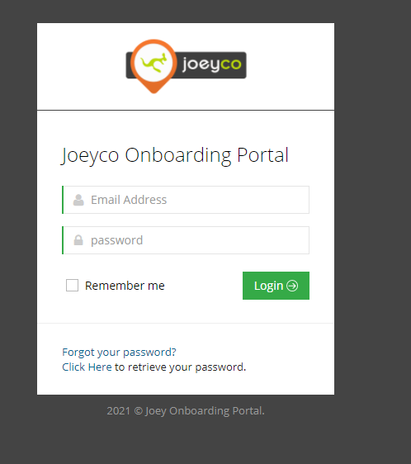

* Enter the URL of the onboarding web and press enter the login screen should look like this from where user can be able to login with their unique credentials.

# 2. Dashboard:

The dashboard screen should contain dashboard detail options like role, sub-admins, zones, work-time, work-types etc.

This menu contains 19 options:

1. Role
2. Sub-admins
3. Zones
4. Preferred Work time
5. Preferred Work type
6. Joey Documents Verification
7. Training Videos and Documents
8. Quizzes Management
9. Order Categories
10. Joey Checklist
11. Documents
12. Faqs
13. Push Notification
14. Change Password
15. Logout

## 2.1

By default, Admin is redirected to here after logged in. On this page, Admin is shown cards shown total sub-admins count,Job type count, order categories count ,zones count,work time count,work type count,training videos count and the count of the quizes plus admin can also be redirected to respective pages by clicking on it.

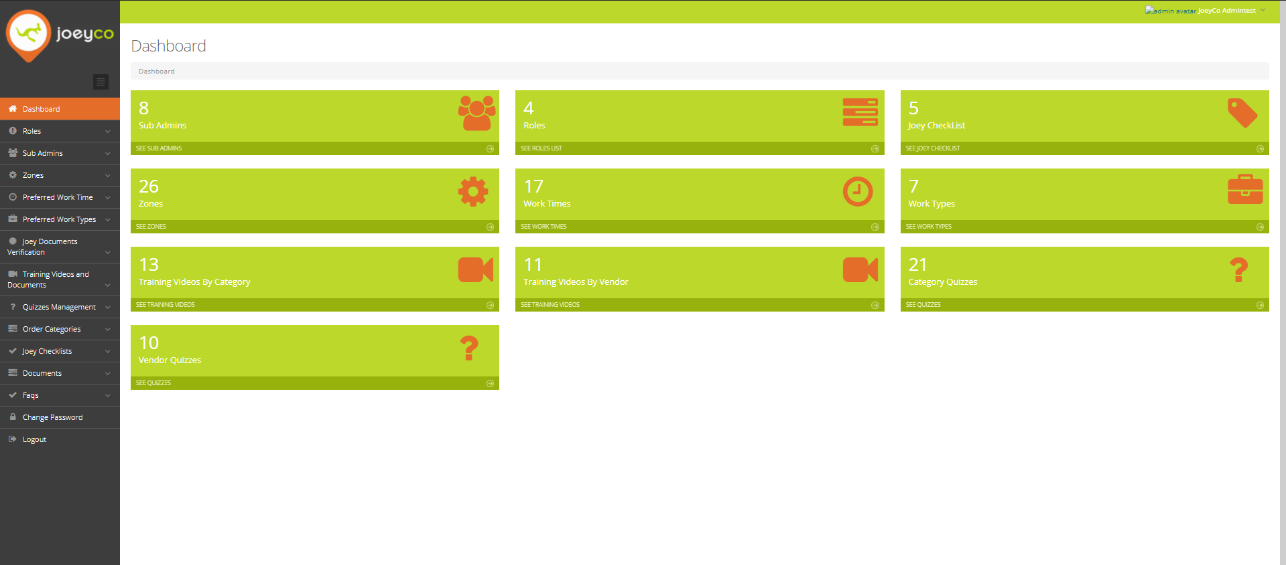

# 3. Roles:

In this tab user is shown with two options.

1. Roles list

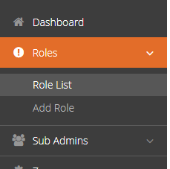

1. Add role

## 3.1 Roles list:

By Clicking on this tab admin is redirected to view all the list from where he can furthermore have three options

* + 1. Update privilege’s
    2. See role detail’s
    3. Edit role

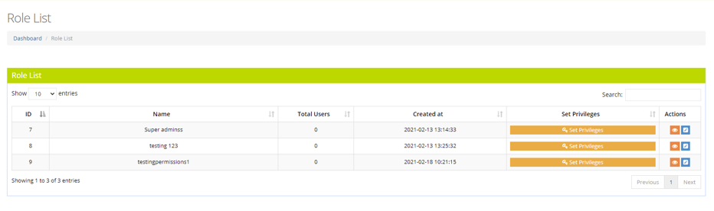

### 3.1.1 Set Privilege’s

By Clicking on this ,Admin is redirected to view all the privileges which can be assigned to the particular role and after selection admin just need to press update option for storing options, because on this selection the sub-admin will be decided which permissions are allotted to him or her by admin other-wise he will be restricted to access Url’s directly.

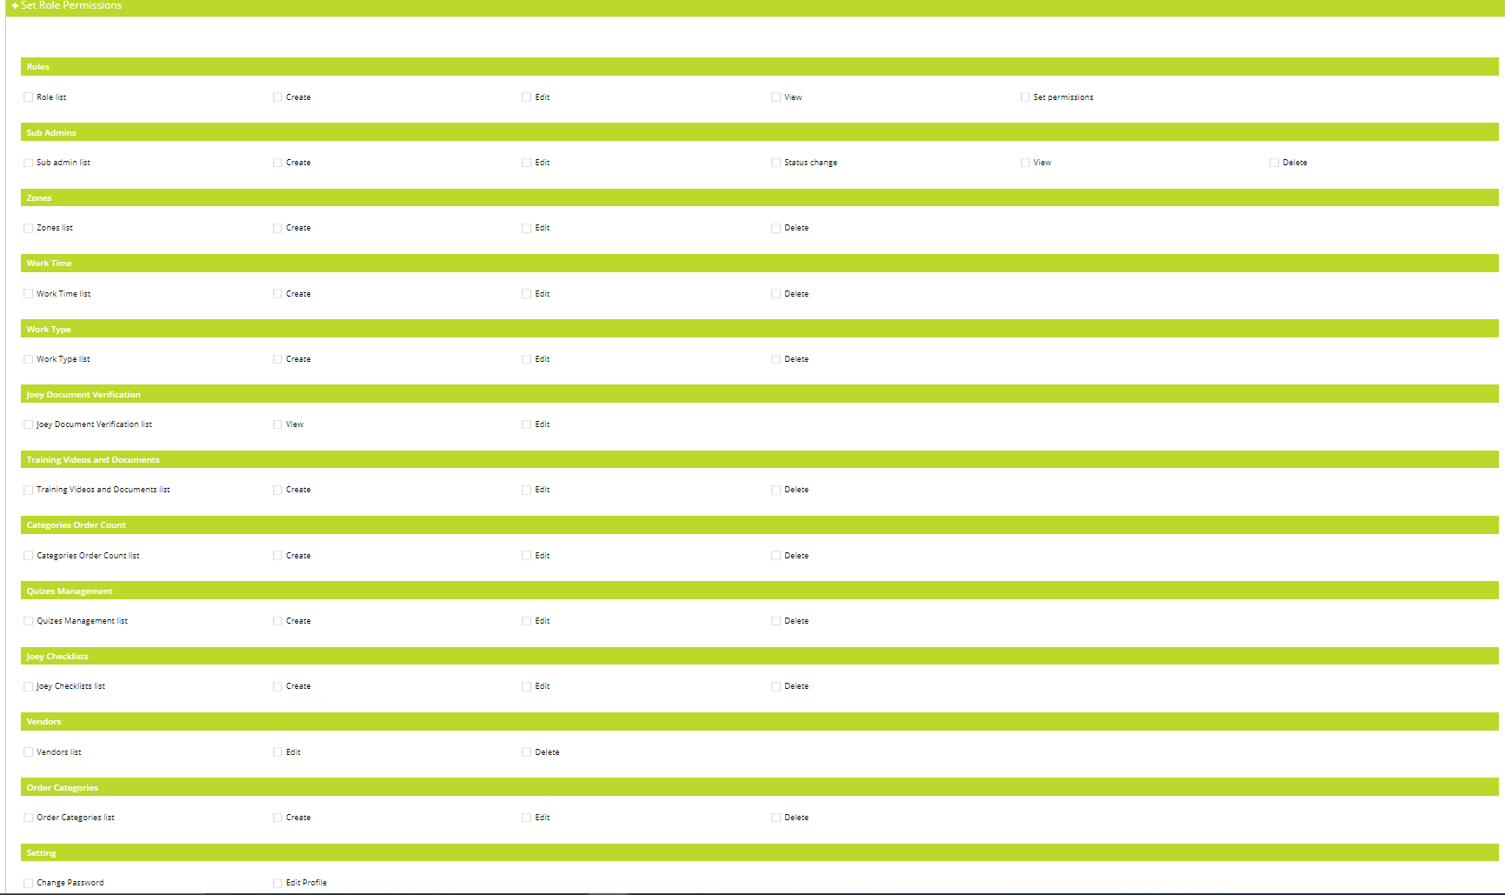

### 3.1.2 See Role details

By Clicking on this, Admin is redirected to view all the details of the specific role.

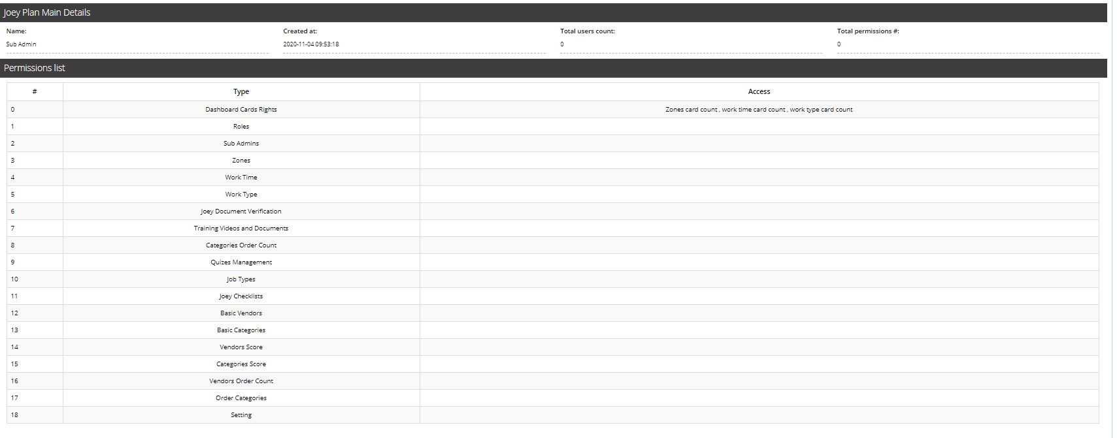

### 3.1.3 Edit Role detail’s

On this page, Admin can edit details of the role after editing the user can save them

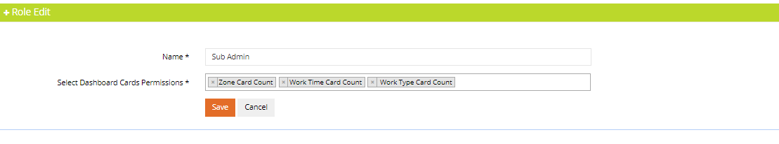

## 3.2 Add Role:

This page is creating new role with new privilege’s and new permissions

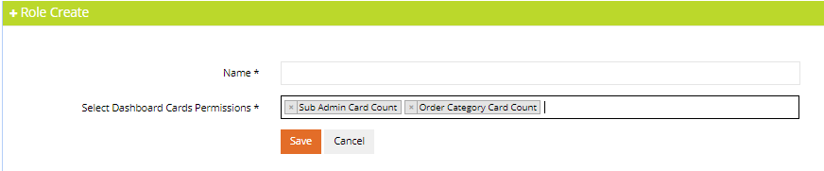

# 4. Sub Admin

In this tab admin is listed with two options.

1. Sub admin list
2. Add sub admin

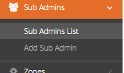

## 4.1 Sub admin list:

By Clicking on this tab admin is redirected to view all the sub admin list from where he can further more have three options

4.1.1 Sub admin details

4.1.2 Sub admin edit

4.1.3 Sub admin delete

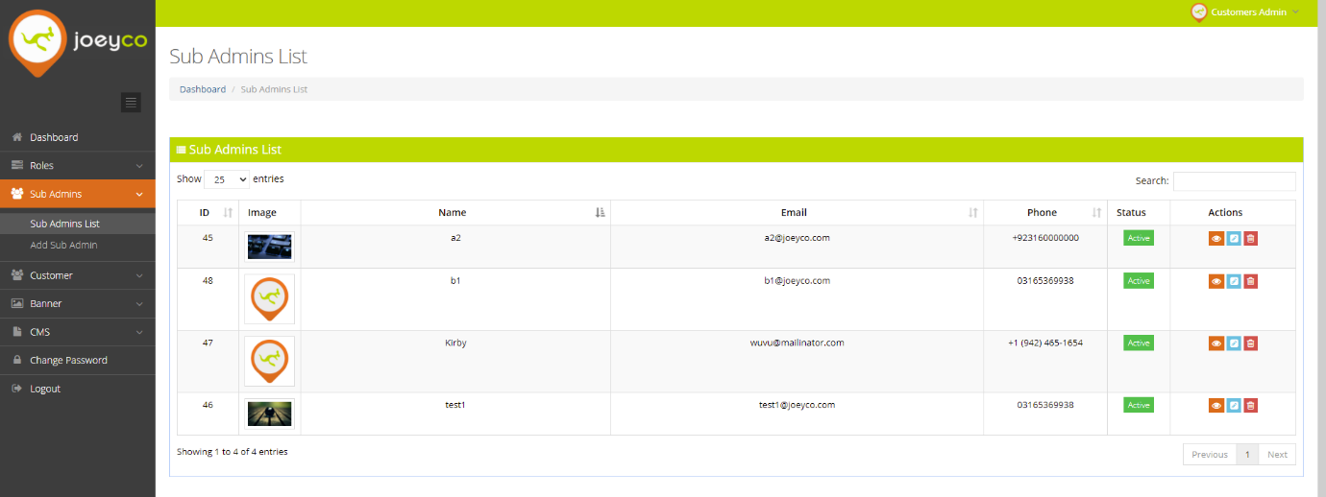4.1.4 Sub admin active/inactive

### 4.1.1 See details

By Clicking on this, Admin is redirected to view all the details of the specific sub admin.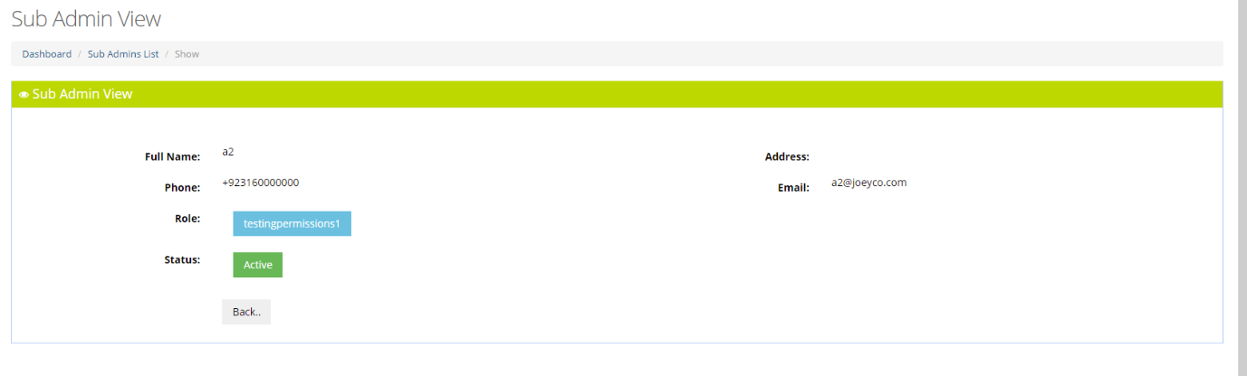

### 4.1.2 Edit Sub admin details

By Clicking on this, Admin is redirected to edit the details of the specific sub admin and later save them.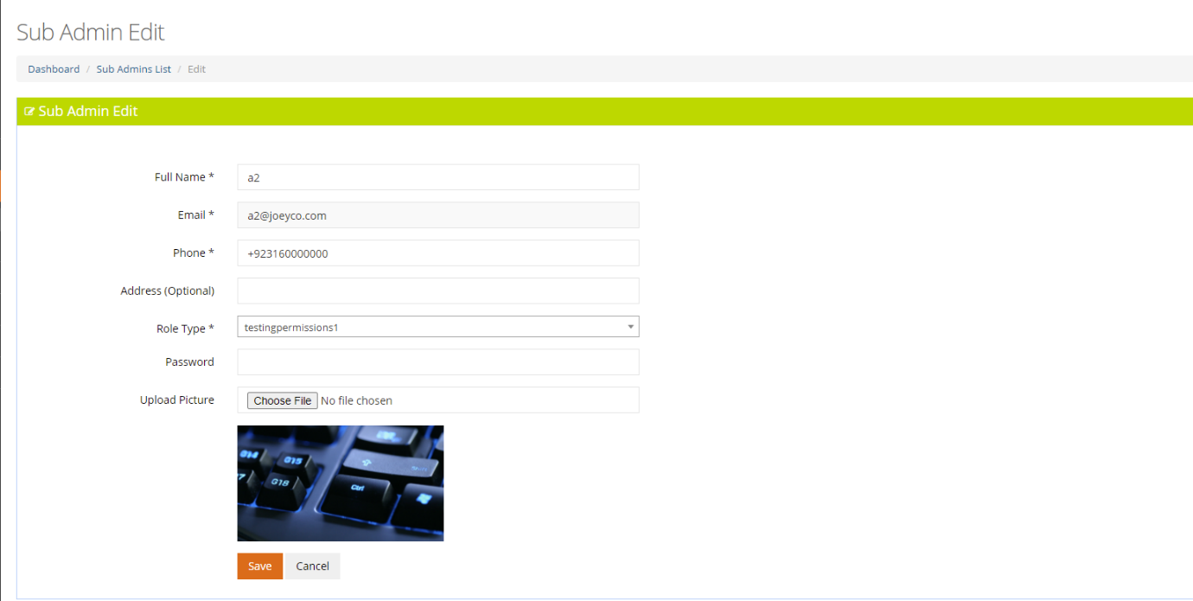

### 4.1.3 Delete Sub admin

This is the option by which the sub admin can be deleted and all there is a pop-up message for the confirmation of the deletion of the sub admin

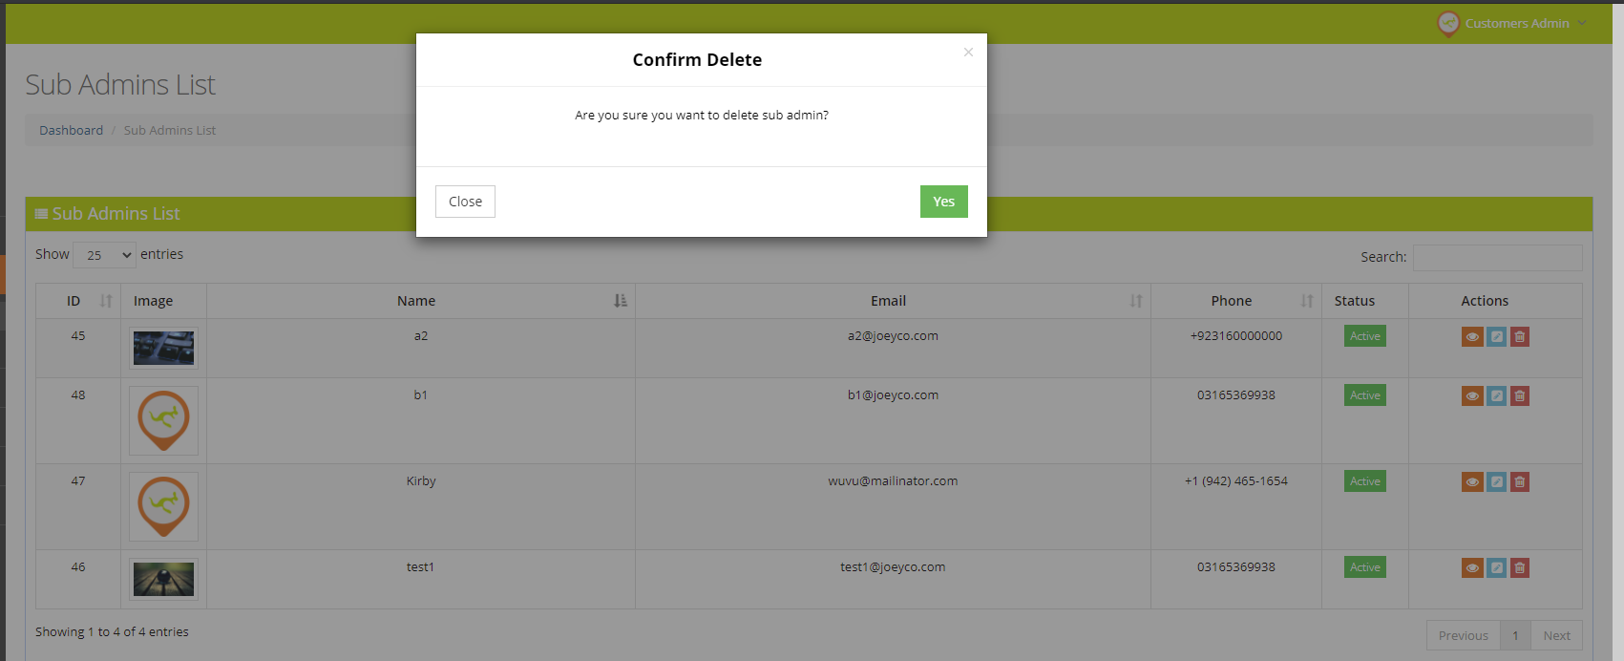

### 4.1.4 Sub admin active / Inactive

Sub admin can be made and Inactive by just clicking the active button and confirming the confirmation

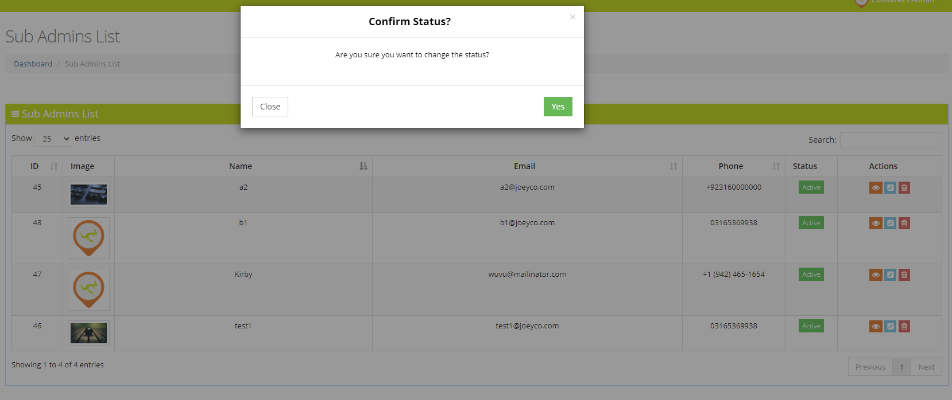

## 4.2 Add Sub admin:

This page is creating new sub admin.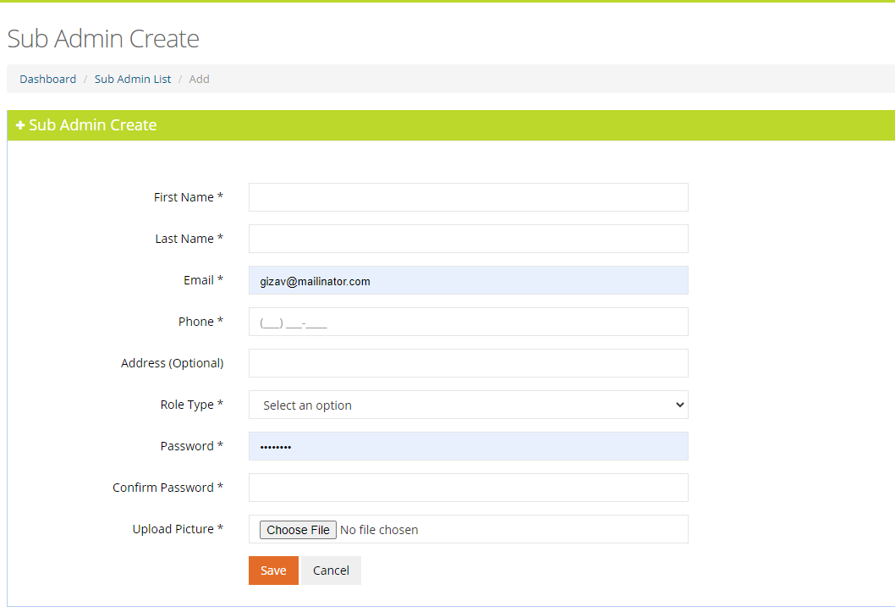

# 5. Zones

In this tab admin is listed with two options.

1. Zones list

## 5.1 Zones list:

By Clicking on this tab admin is redirected to view all the zone’s list

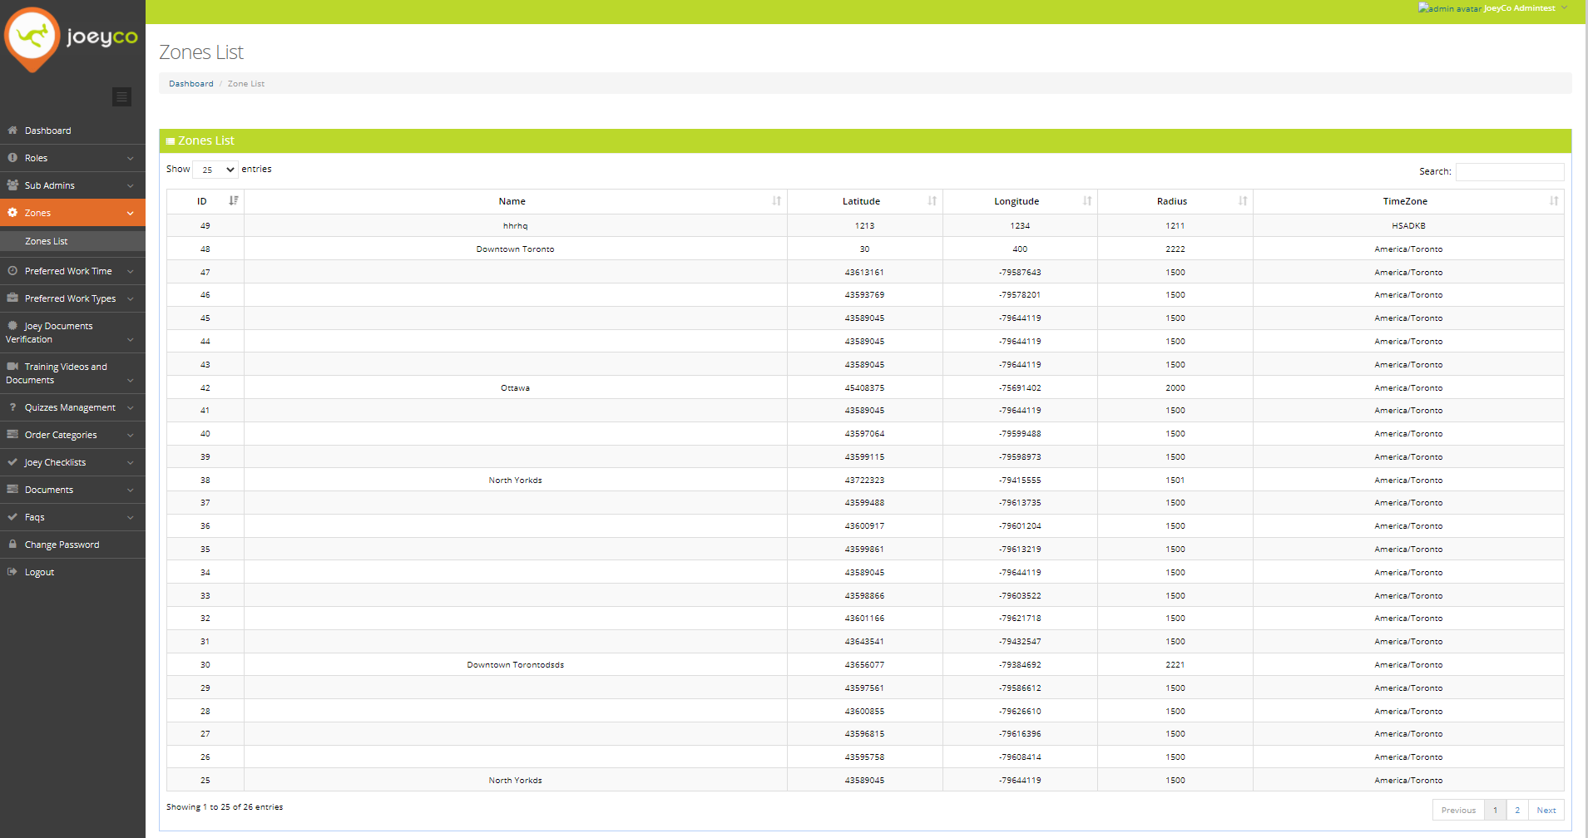

# 6. Preferred Work Time

In this tab admin is listed with two options.

1. Work time List
2. Add Work time

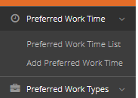

## 6.1 Work Time list:

By Clicking on this tab admin is redirected to view all the Work list from where he can further more have options of edition and deletion

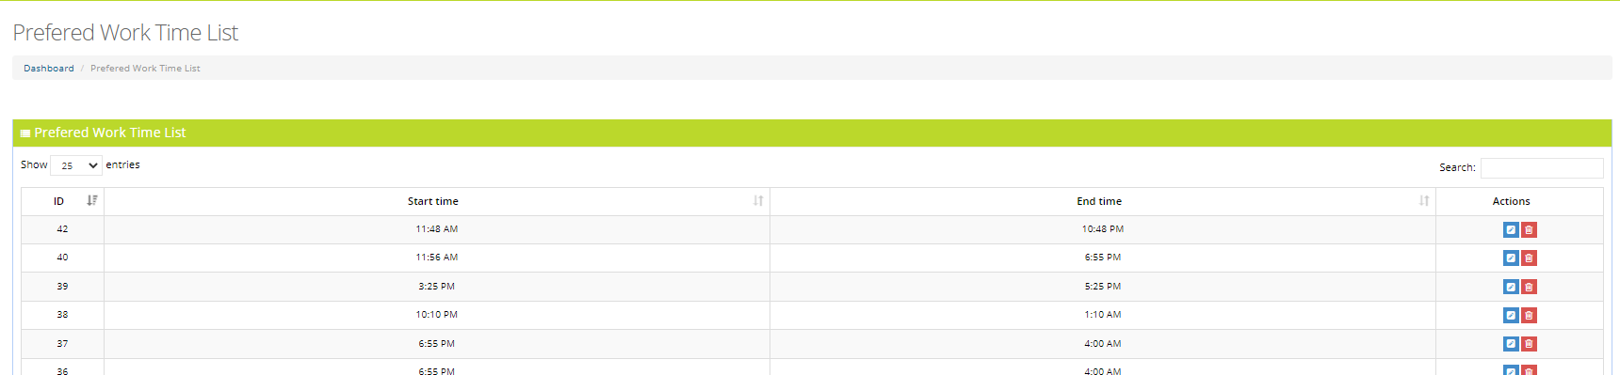

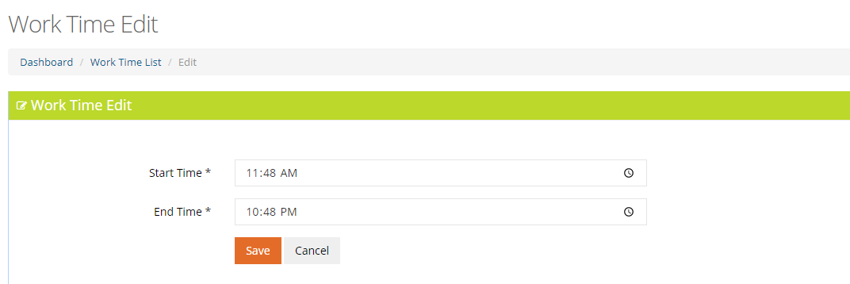

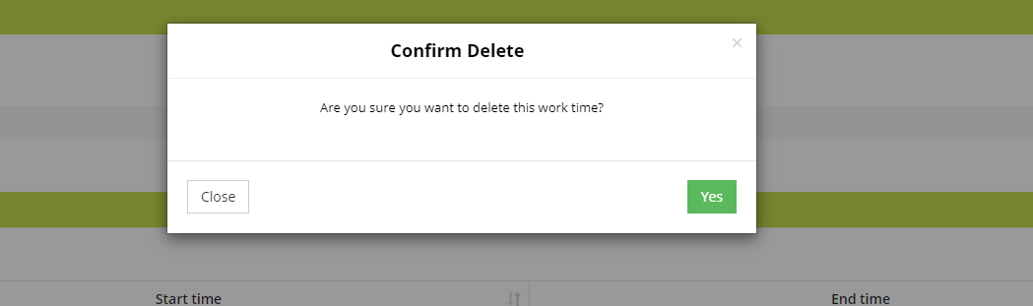

## 6.2 Work Time create:

This page is for creating new work time

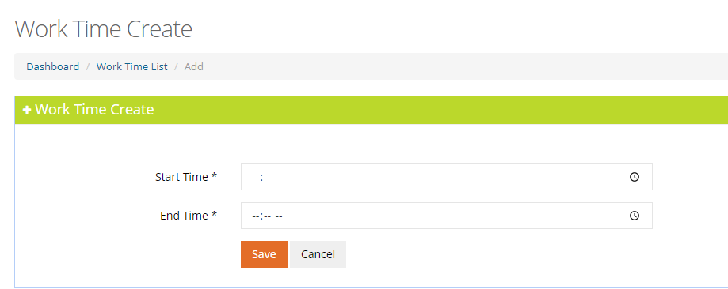

# 7. Preferred Work Type

In this tab admin is listed with two options.

1. Work type List
2. Add Work type

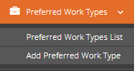

## 7.1 Work Type list:

By Clicking on this tab admin is redirected to view all the Work type list from where he can further more have options of edition and deletion

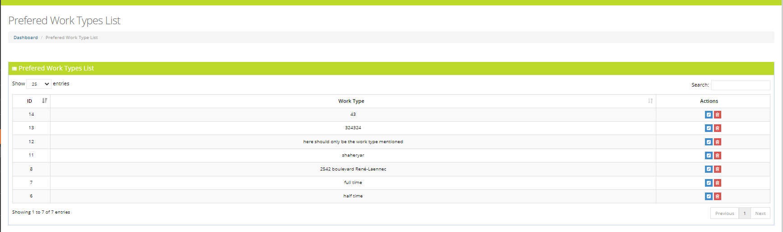

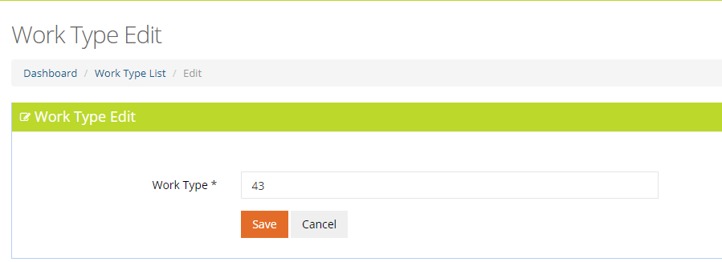

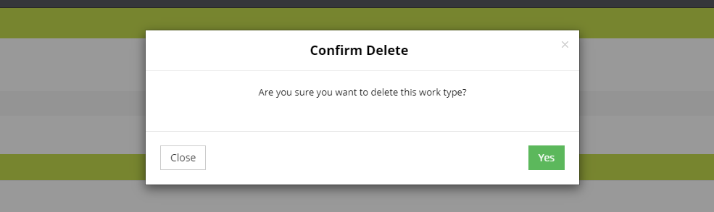

## 7.2 Work Type create:

This page is for creating new work type

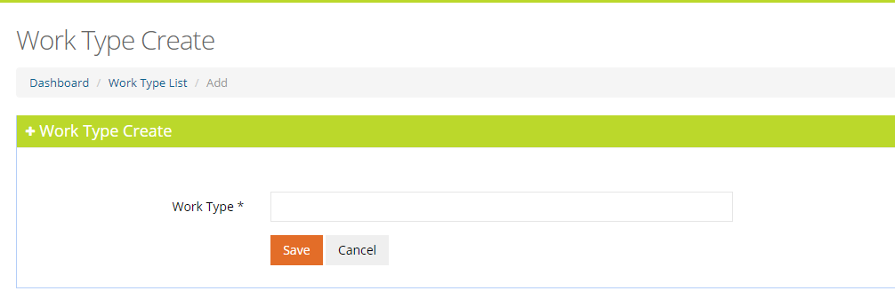

# 8. Joey Document Verification

In this tab admin is listed with one options.

1. Joey Document Verification List

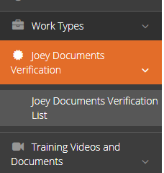

## 8.1 Joey Document Verification list:

By Clicking on this tab admin is redirected to view all the Joey document verification list from where he can also filter the result by selecting the type given in the drop down, further more have options of viewing details and edit.

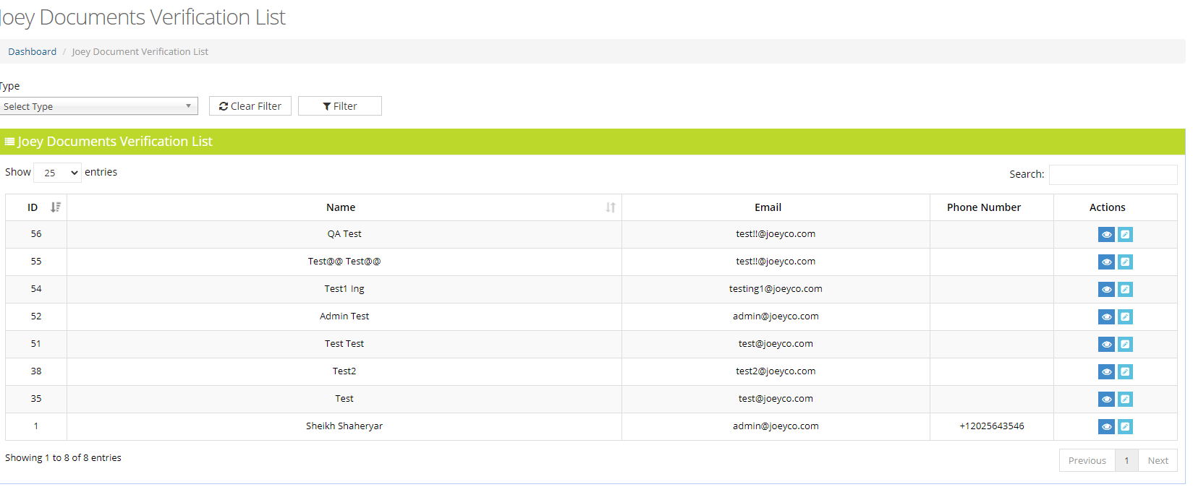

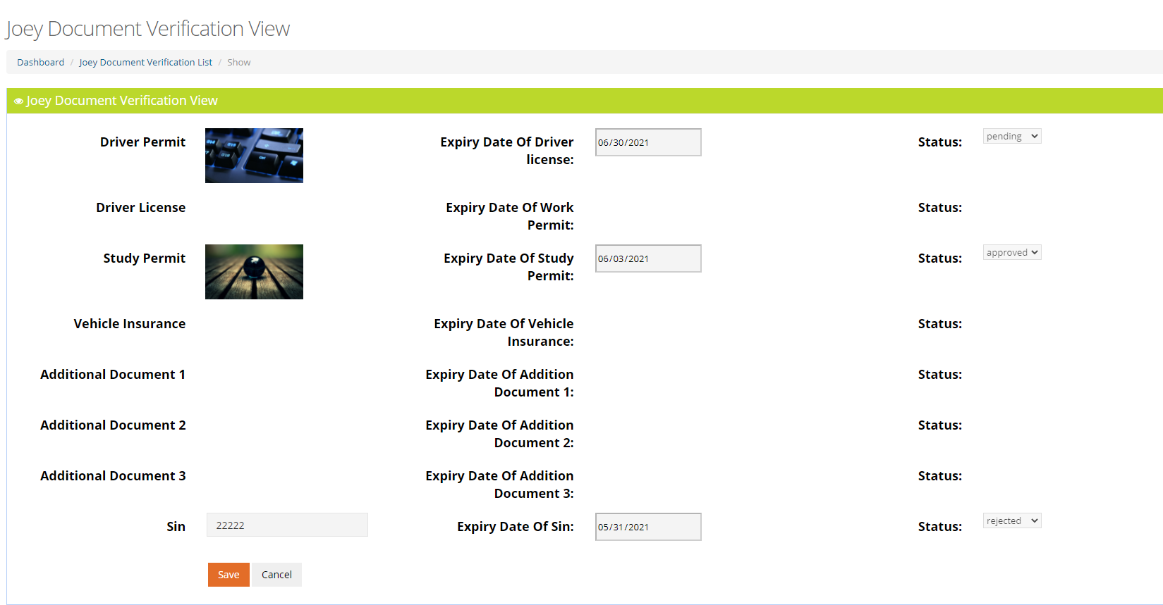

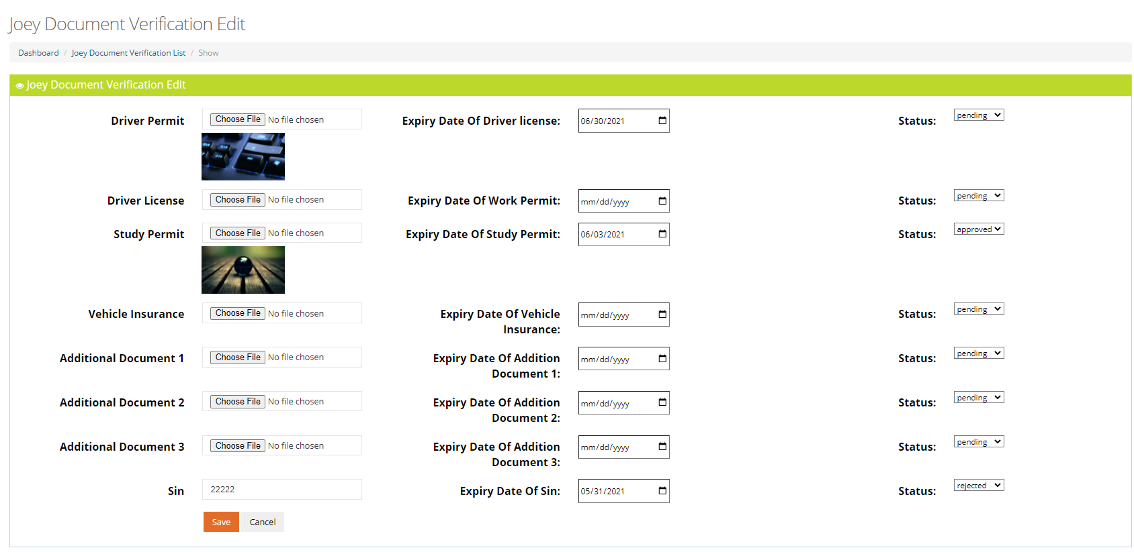

# 9.Training Videos and Documents

In this tab admin is listed with two options.

1. Training videos and document List
2. Add Training videos and document

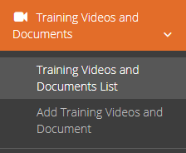

## 9.1 Training videos and document list:

By Clicking on this tab admin is redirected to view all the training videos and document list from where he can further more have options of preview and deletion

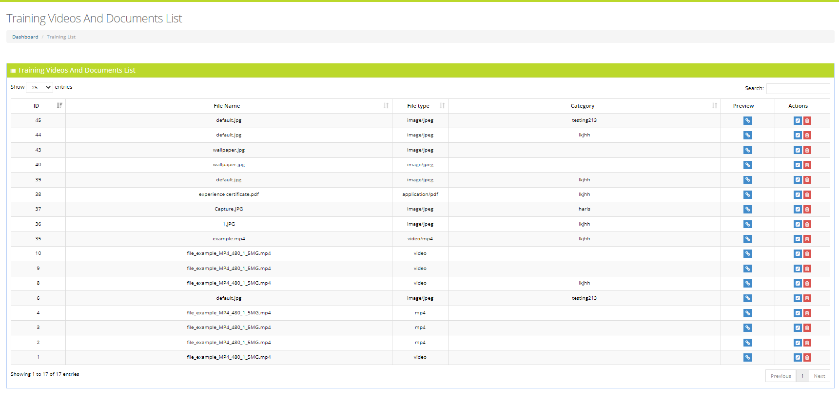

## 9.2 Training video and document create:

This page is for creating new training video and document

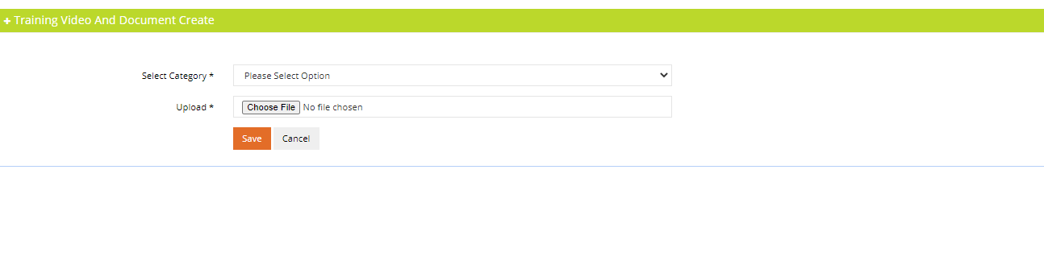

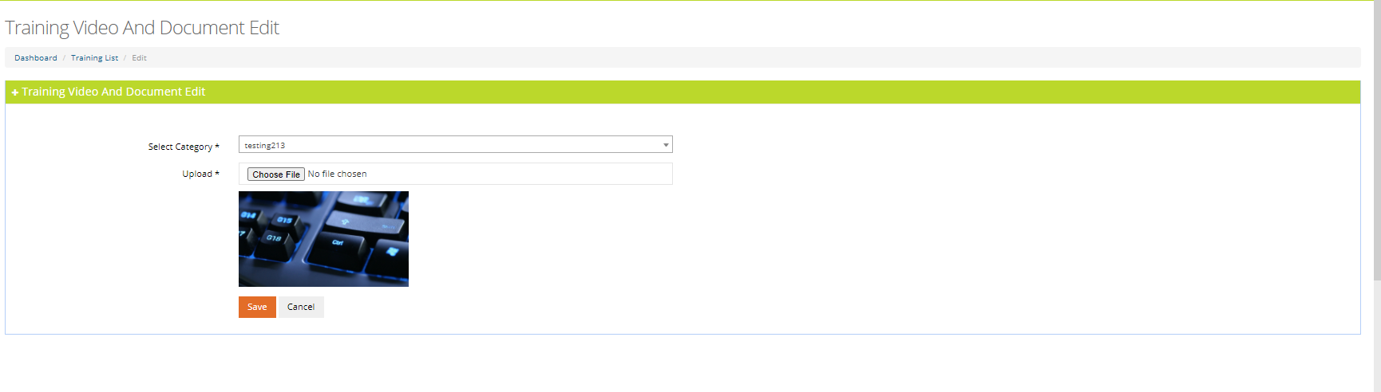

# 10.Categories Order

In this tab admin is listed with two options.

1. Categories order List
2. Add Categories order

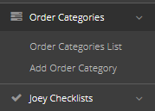

## 10.1 Order Categories list:

By Clicking on this tab admin is redirected to view all the Categories Order Count list from where he can further more have options of edition and deletion

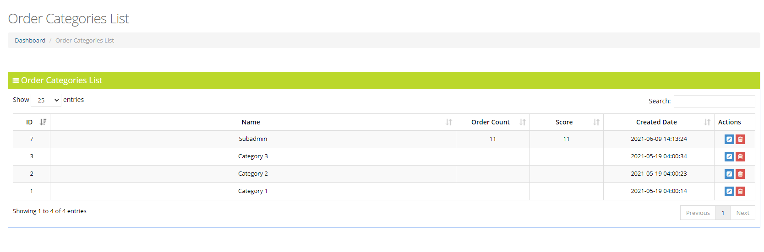

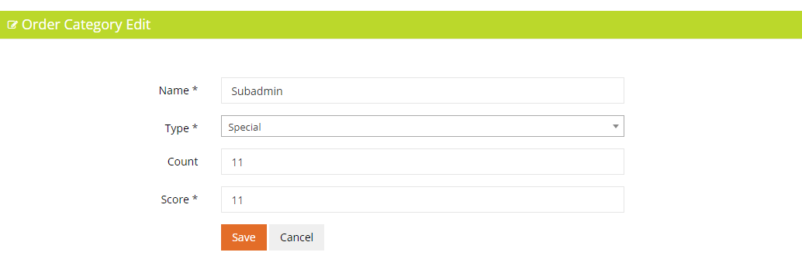

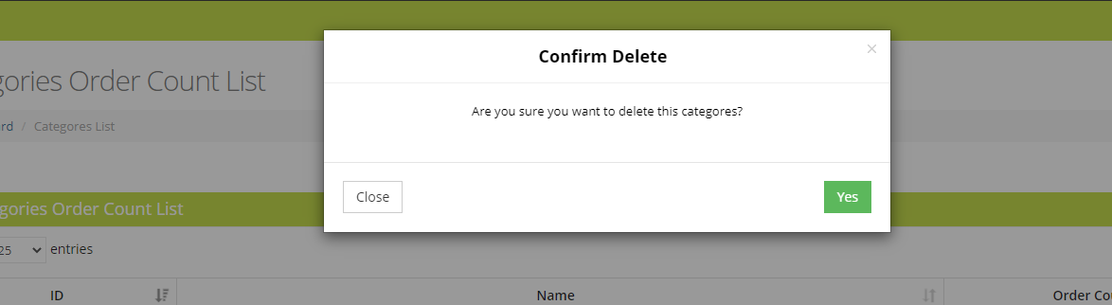

## 10.2 Order Categories create:

This page is for creating new categories order count

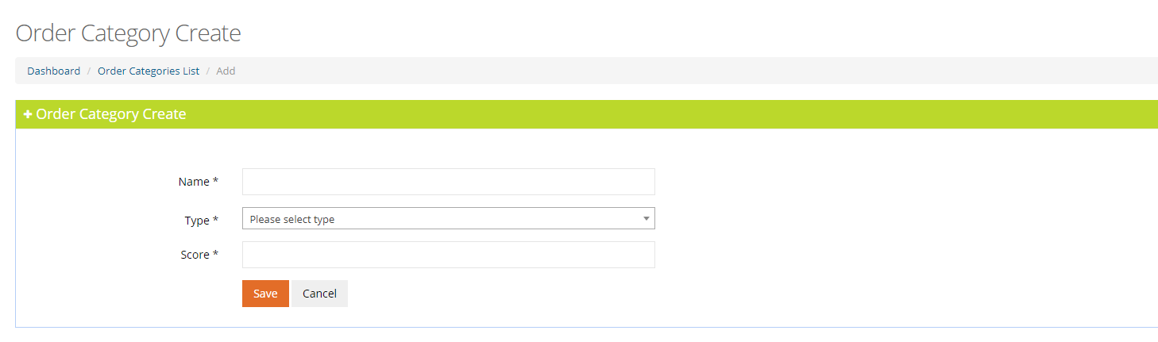

# 11.Quizes Management

In this tab admin is listed with two options.

1. Quiz Management List
2. Add Quiz

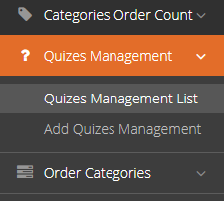

## 11.1 Quiz Management list:

By Clicking on this tab admin is redirected to view all the Quiz management list from where he can further more have optio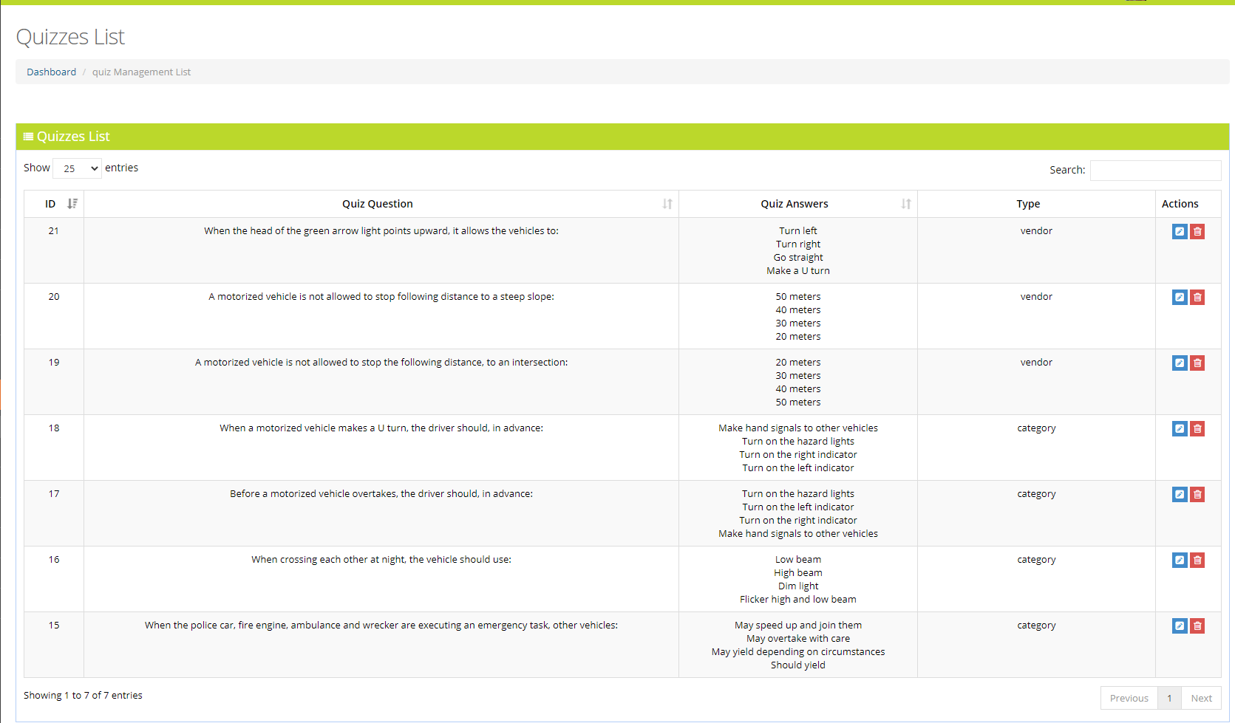ns of edition and deletion

## 11.2 Quiz create:

This page is for creating new quiz

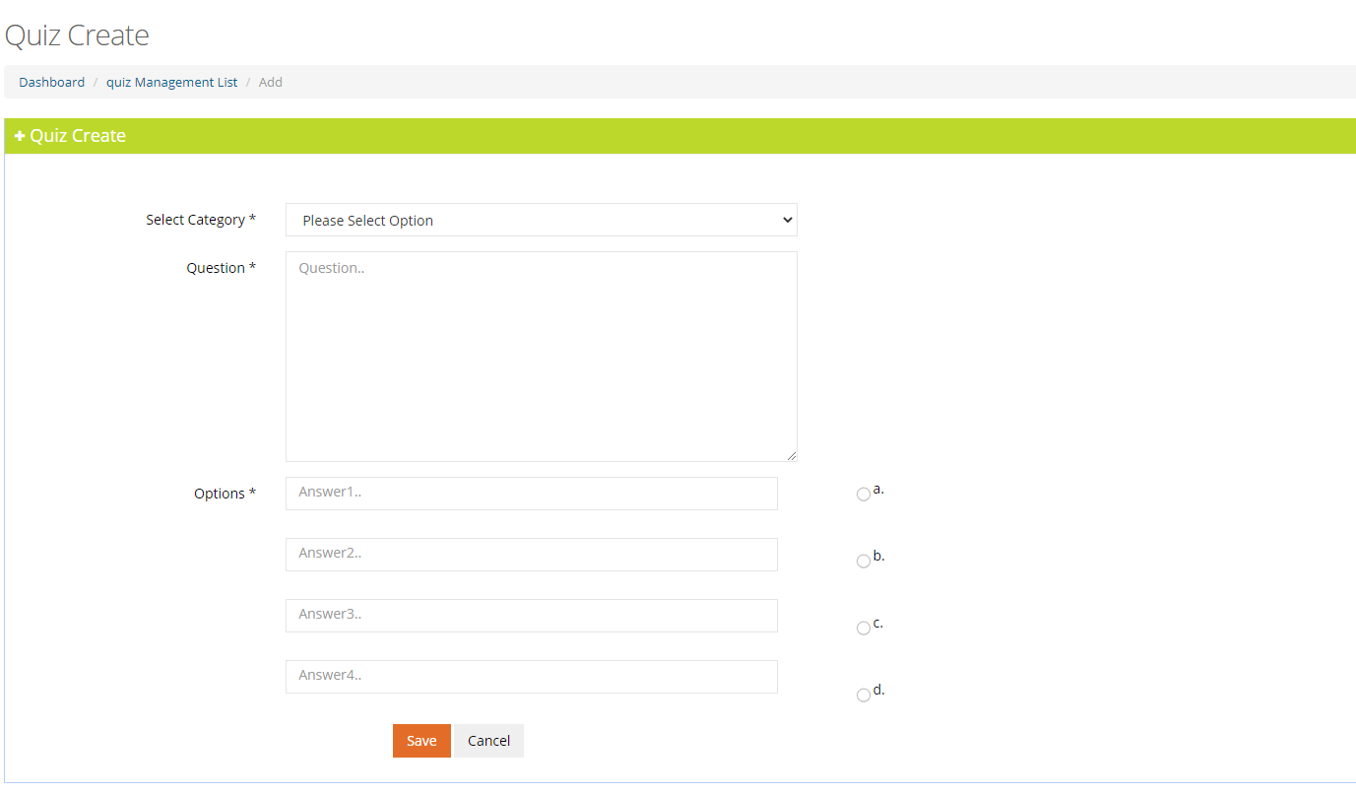

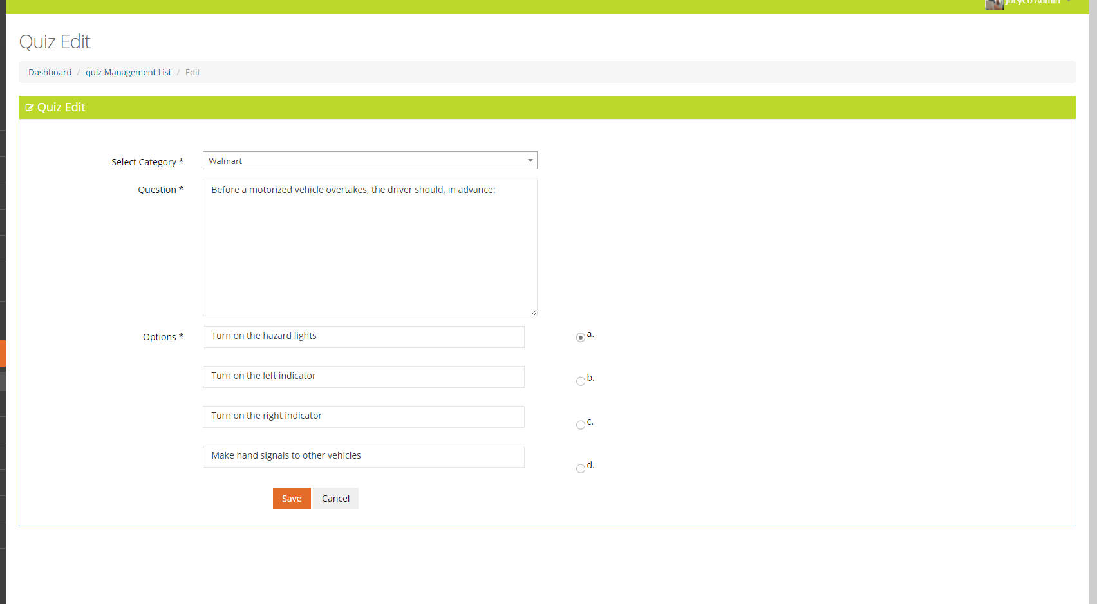

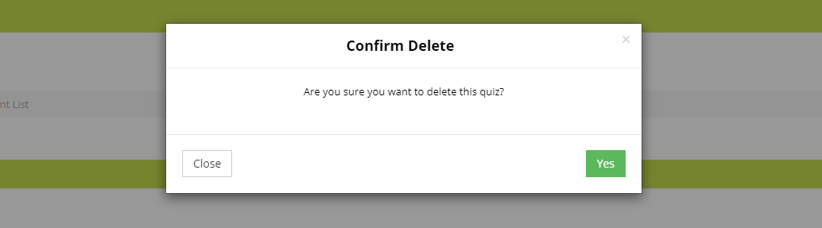

# 12.Joey Checklist

In this tab admin is listed with two options.

1. Joey Checklist List
2. Add Joey Checklist

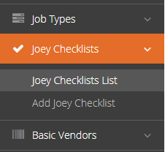

## 12.1 Joey checklist list:

By Clicking on this tab admin is redirected to view all the joey checklist list from where he can further more have options of edition and deletion

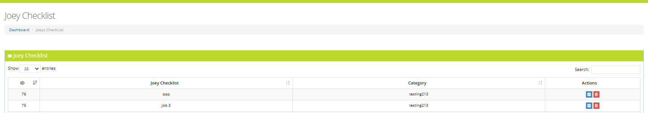

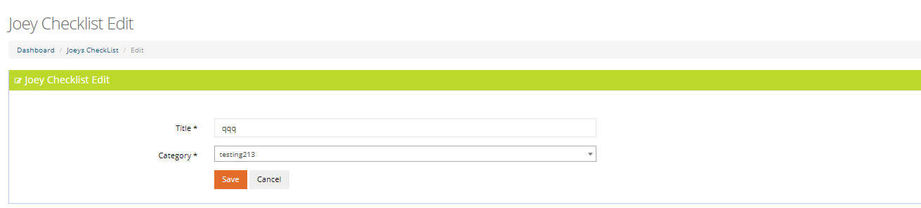

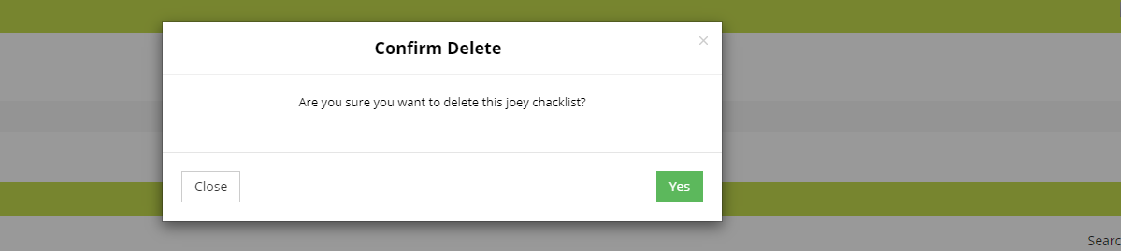

## 12.2 Add Joey Checklist:

This page is for adding new joey checklist

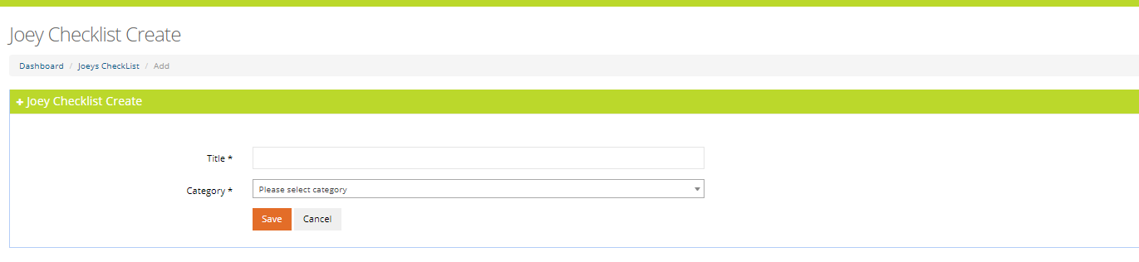

# 13.Documents

In this tab admin is listed with two options.

1. Document List

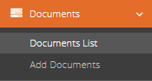

## 13.1 Document list:

By Clicking on this tab admin is redirected to view all the Documents list from where he can also analyze statistics of document type ,Is compulsory, expiry date and is document uploaded or not ,and further more have options of edition and deletion

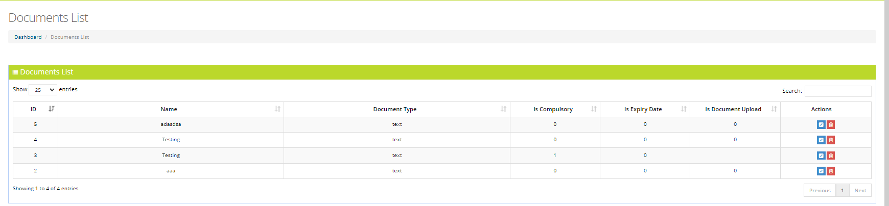

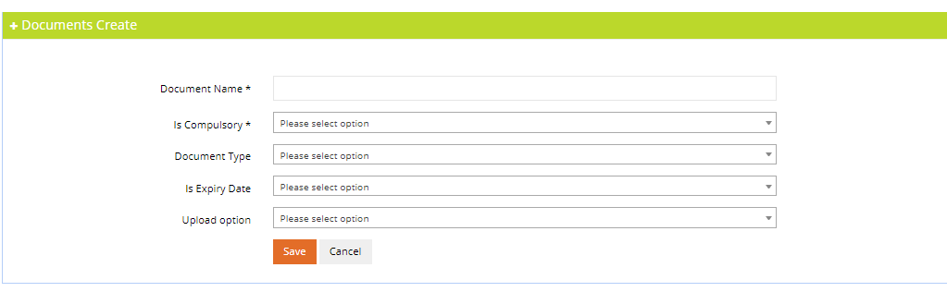

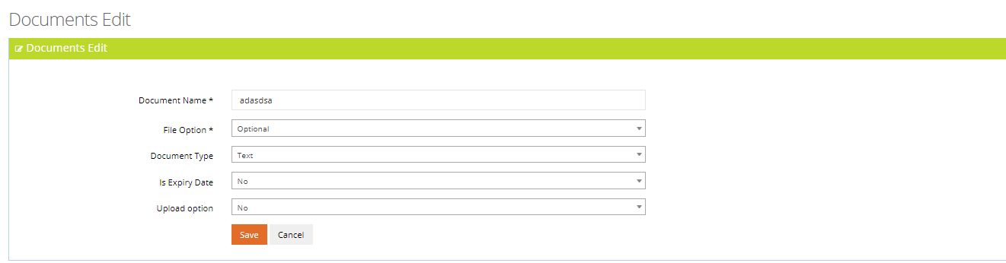

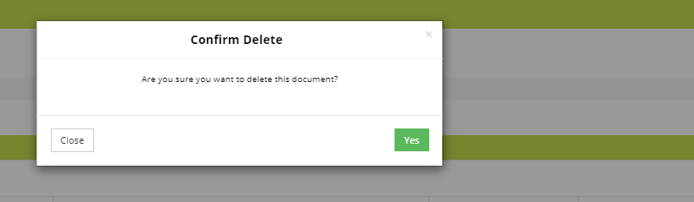

# 14.Faqs

In this tab admin have listed options.

1. Faqs List

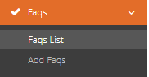

## 13.1 Faqs list:

By Clicking on this tab admin is redirected to view all the Faqs list and further more have options of edition and deletion

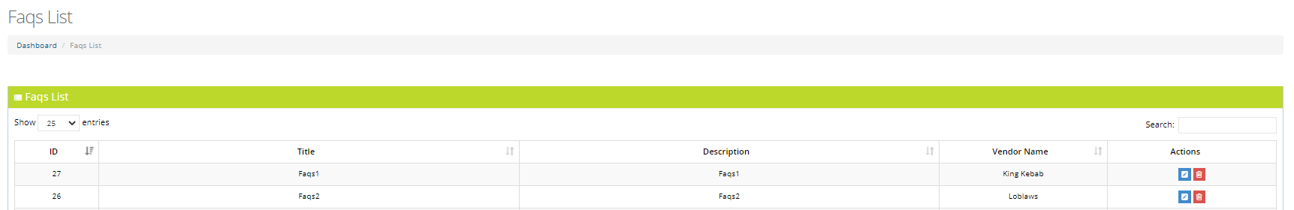

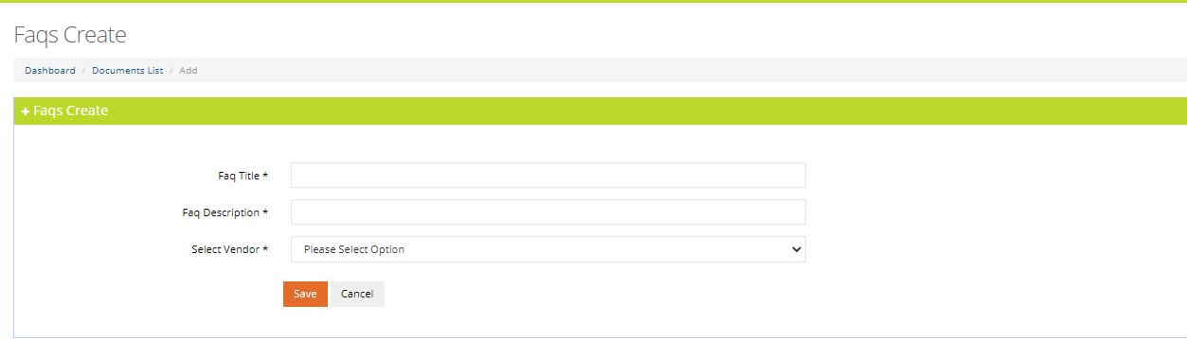

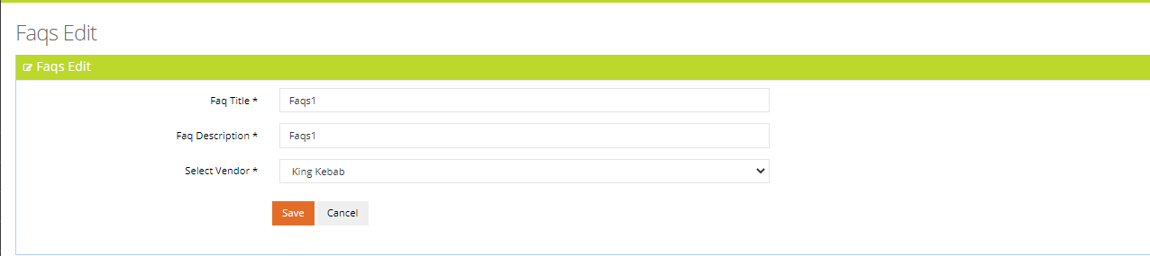

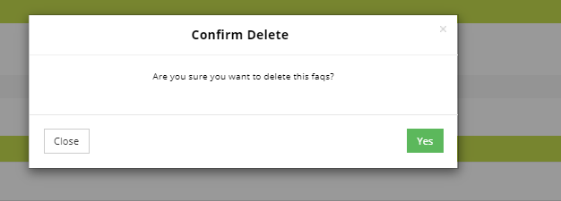

# 14. Push Notification

On clicking the this button, admin is able to send notification

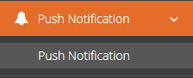

# 

# 15. Change password

On clicking the this button, admin is able to change password.

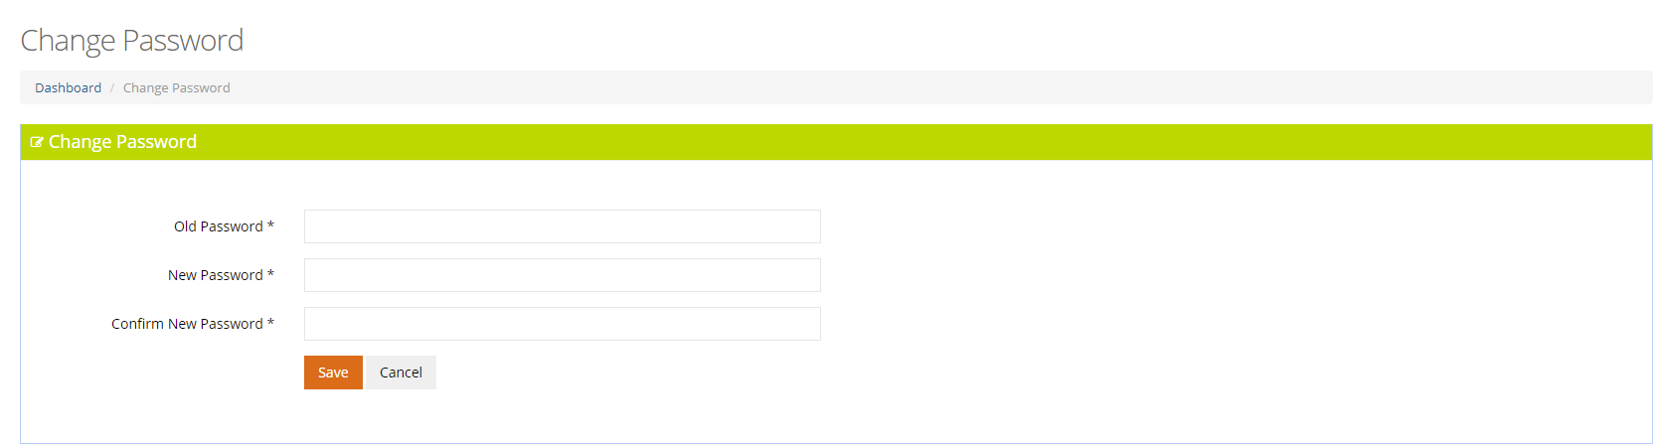

# 16 . Logout

On clicking the logout button, joey should be logout and redirect to the login page.