IMX519 MIPI CSI Camera Setup (Jetson Orin Nano)
This document provides instructions to install and configure the ArduCAM IMX519 MIPI CSI Camera on the NVIDIA Jetson Orin Nano.

1. Download the Camera Driver
Visit the official ArduCAM GitHub releases page:
ArduCAM MIPI Camera Releases
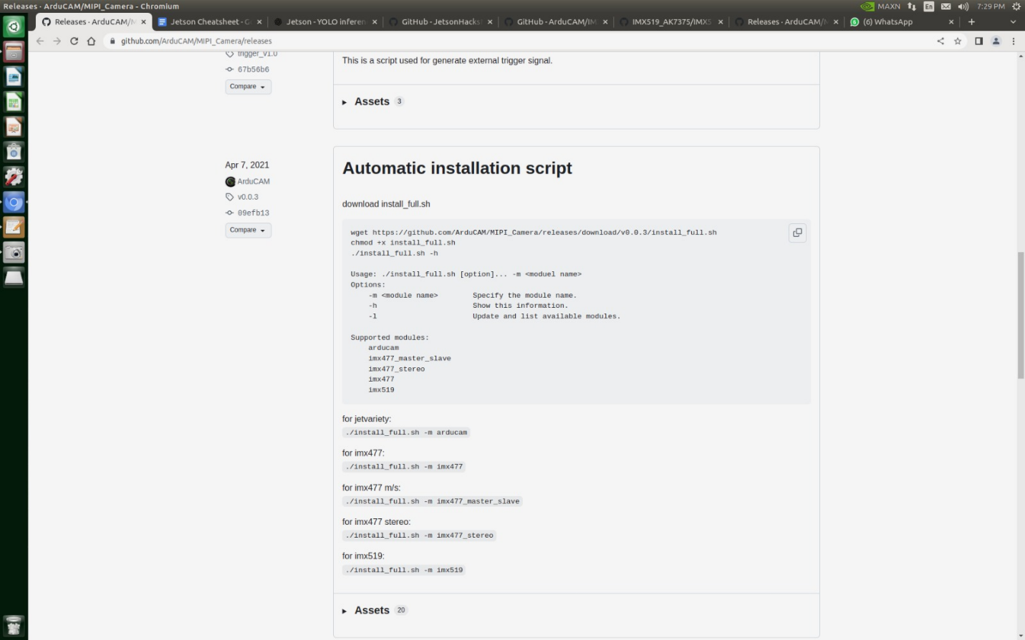
Alternatively, download the release via wget:
wget https://github.com/ArduCAM/MIPI_Camera/releases/download/v0.0.3/install_full.sh

2. Make Installer Executable
chmod +x install_full.sh

3. Install Camera Driver for IMX519
Run the installer script with the -m flag to specify the camera module:
./install_full.sh -m imx519
Follow the on-screen instructions to complete the installation.

4. Verification (Optional)
After installation, verify the camera is detected:
v4l2-ctl --list-devices
You should see imx519 listed as a connected MIPI CSI camera.

End of Document

