LAB TASKS

# **Q.1:** To check the effect of arithmetic instructions on the flags of the CPU

TITLE lab3

include irvine32.inc

.data

var1 SBYTE 7fh

var2 SBYTE -128

var3 SBYTE -1

.code

main proc

Mov al, var1

add al, 1 ; al = 80, SF = 1, CF = 0, OF = 1

call dumpregs

Mov bh, 255

add bh, 1 ; bh = 0, ZF = 1, CF = 1, OF = 0

call dumpregs

Mov ah, var2

dec ah ; ah = 7F, ZF = 0, CF = 1, OF = 1

call dumpregs

Mov al, 1

Sub al, 2 ; al = FF, SF = 1, CF = 1, OF = 0

call dumpregs

Mov ax, +7fffh

Add ax, 2 ; ax = 8001, SF = 1, CF = 0, OF = 1

call dumpregs

Mov al, 5

neg al ; al = FB, SF = 1, CF = 1, OF = 0

call dumpregs

Mov al, var3

add al, 1 ; ZF = 1, SF = 0, CF = 1, OF = 0

call dumpregs

Mov ax, -128

sub ax, 1 ; ax = FF7F, SF = 1, CF = 0, OF = 0

call dumpregs

exit

main endp

end main

## Output:

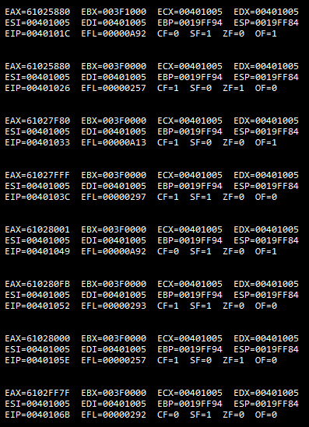

# **Q.2:** Assembly program inputs an arrayA of byte sized 5 elements. Reverses the elements of the array i-e take the mirror image of array and store the sorted elements in another arrayB.

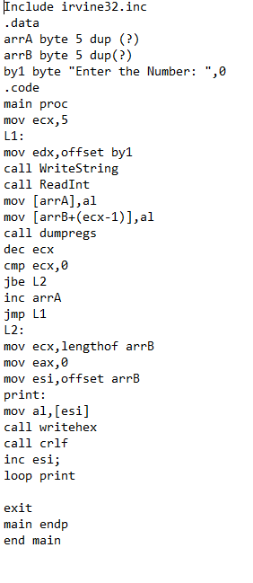

## Output:

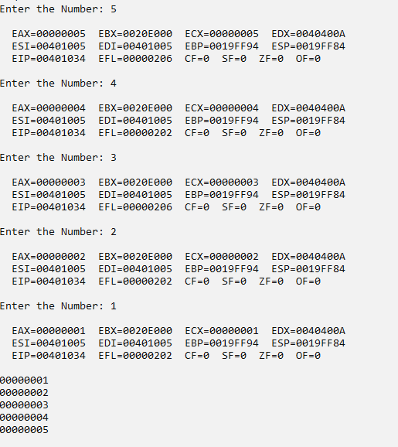

# **Q.3:** Assembly language program uses the XCHG statement no more than 3 times, reorder the values in four 8-bit registers from the order A,B,C,D to B,C,D,A.

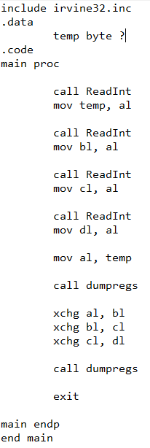

## Output:

