LAB TASK 8, 9

# Microcontroller Implementation for Digital Input and Digital Output

# INTRODUCTION:

The Purpose of this Lab was to Program the microcontroller AT89c52 to turn ON/OFF an LED on the Trainer, based on whether a switch is ON or OFF, and patch the circuit on breadboard and test it.

# Task 1:

ORG 0H ; Starting address of the ROM

setb p1.2

clr p1.1

START: ; Start Label

HERE:

JNB P1.2, HERE ; If the Switch is off then wait here

cpl p1.1

HERE2:

JB P1.2, HERE2

cpl p1.1

SJMP start

END ; End of Program

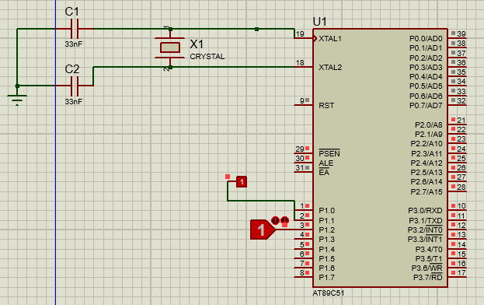

# Task 2:

ORG 0H ; Starting address of the ROM

mov p1, #00H

START: ; Start Label

HERE:

JNB P2.1, HERE ; If the Switch is off then wait here

cpl p1.0

cpl p1.1

cpl p1.2

cpl p1.3

cpl p1.4

cpl p1.5

cpl p1.6

cpl p1.7

HERE2:

JB P2.1, HERE2

SJMP start

END ; End of Program

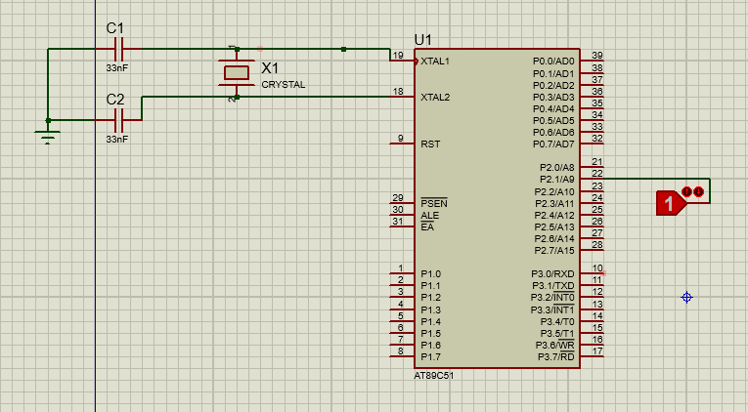

# CONCLUSION:

In this Lab we Programed the microcontroller AT89c52 to turn ON/OFF an LED (connected to Pin P1.1) on the Trainer, based on whether a switch (connected to Pin P1.2) is ON or OFF, and patched the circuit on breadboard and test it.

Snap of Task 2:

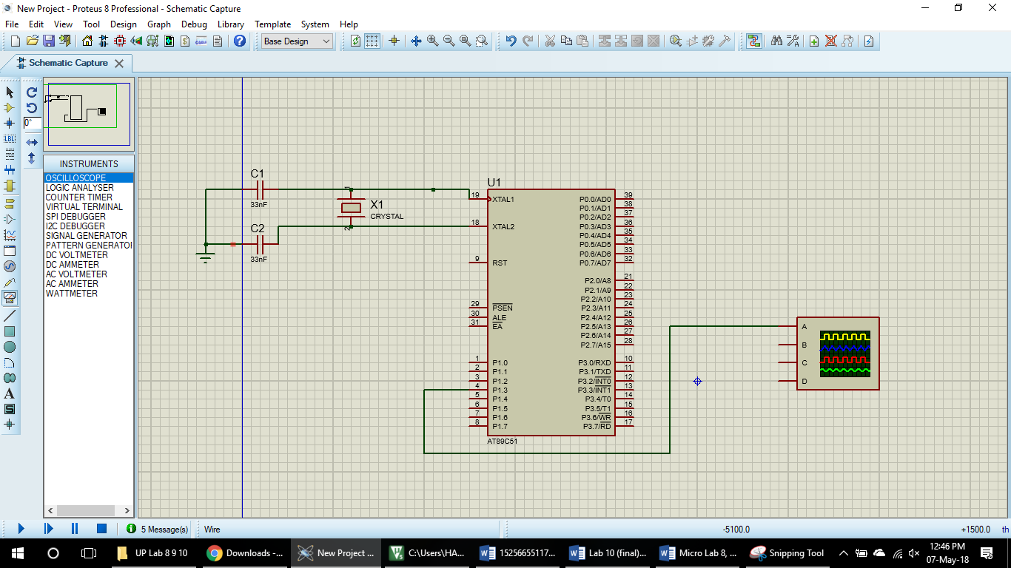

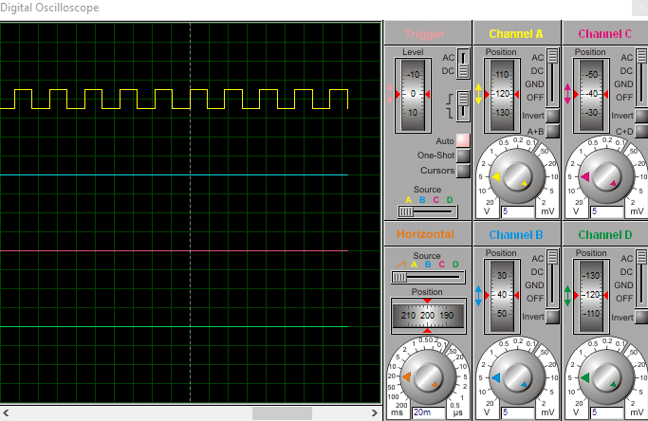

Snap of Task 3

