LAB TASK 7

# Linearity in Simulink MATLAB

## 7.3 Sample Function:

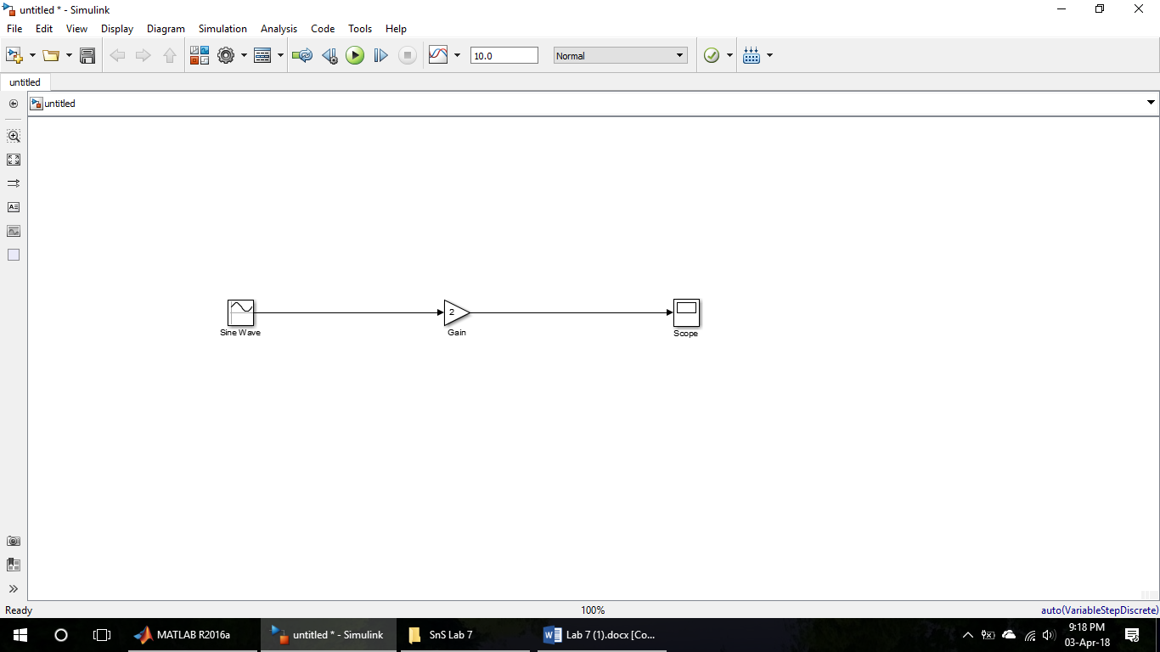

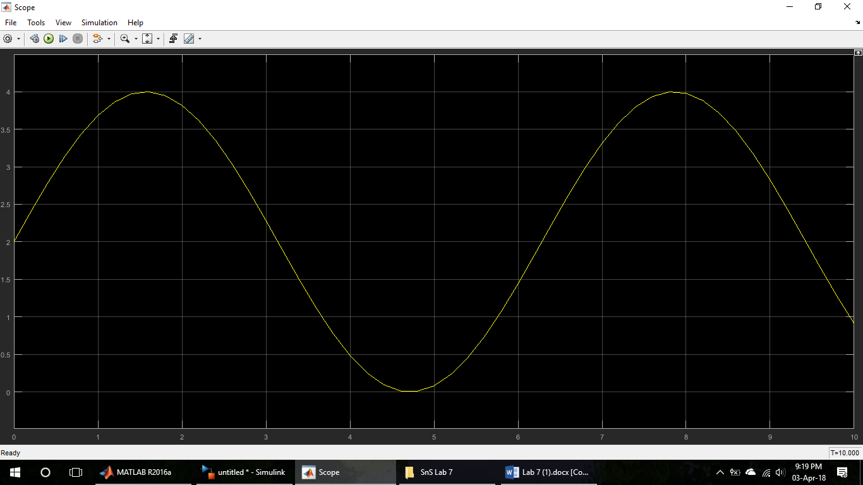

7.4 Testing Linearity:

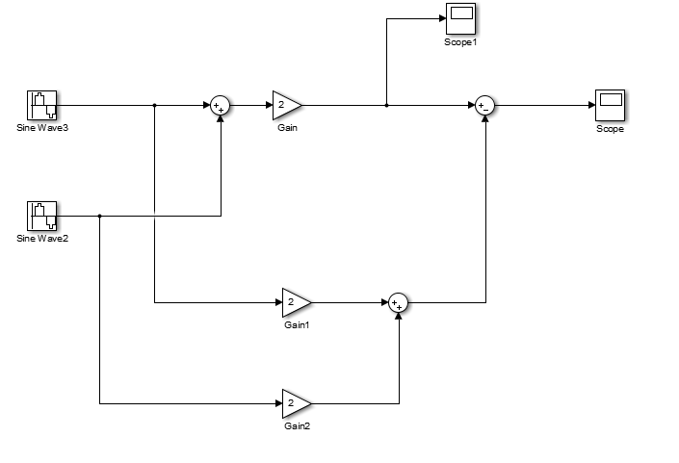

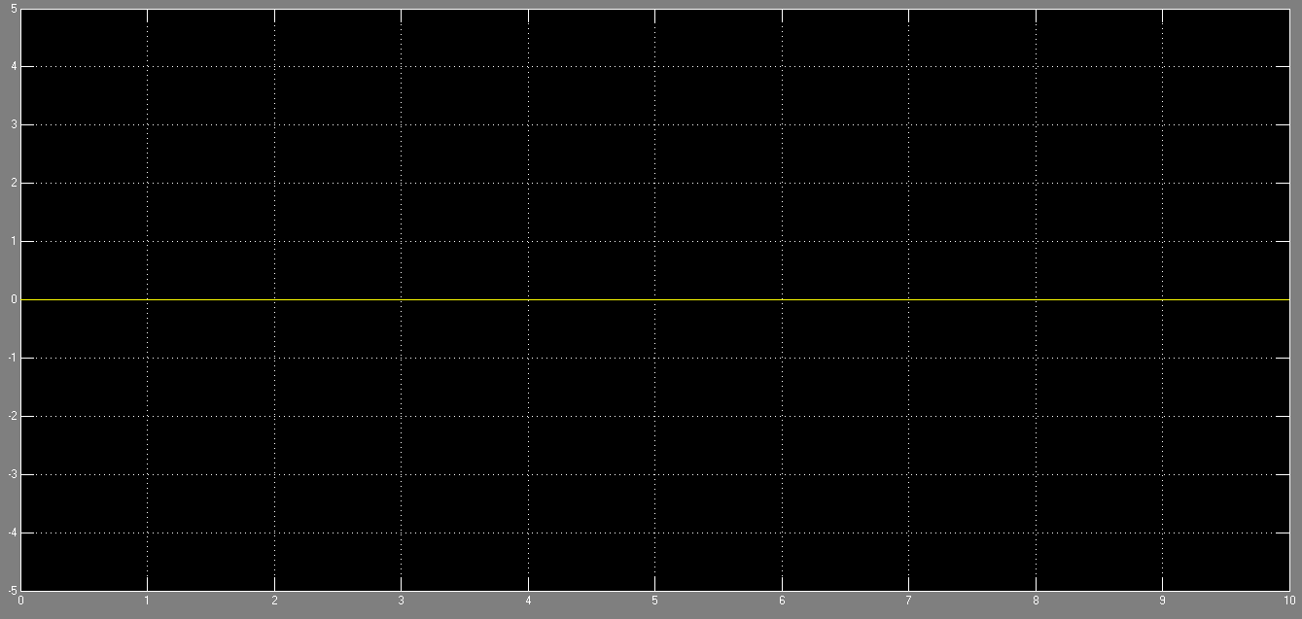

## Exercise:

1. Use Simulink to design a non-linear system, and show that the system is non-linear by showing that the principle of superposition does not hold:

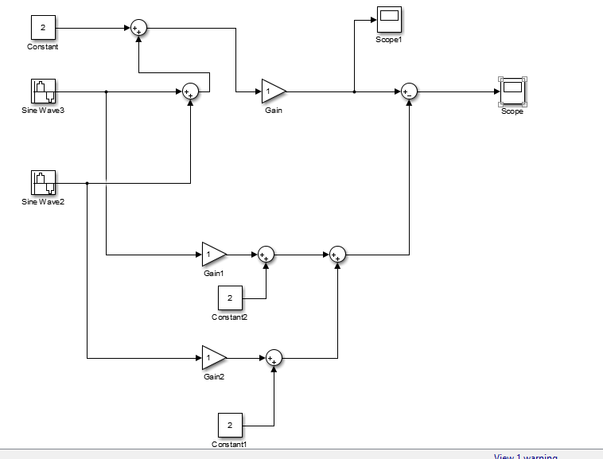

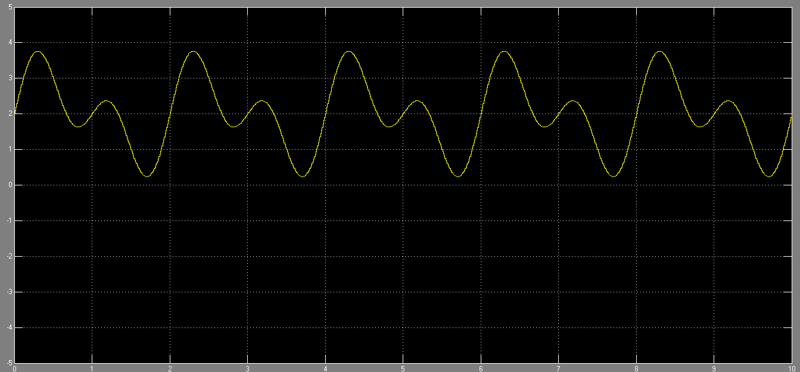

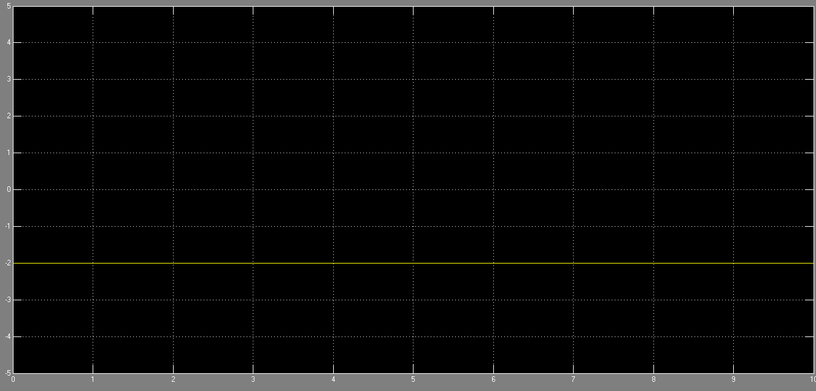

1. Use the symbolic toolbox to show that the squaring operation is not linear. That is, use the symbolic toolbox to show that

(x + y)2 != x2 + y2

