LAB TASK 8

# Pre Lab Task 1

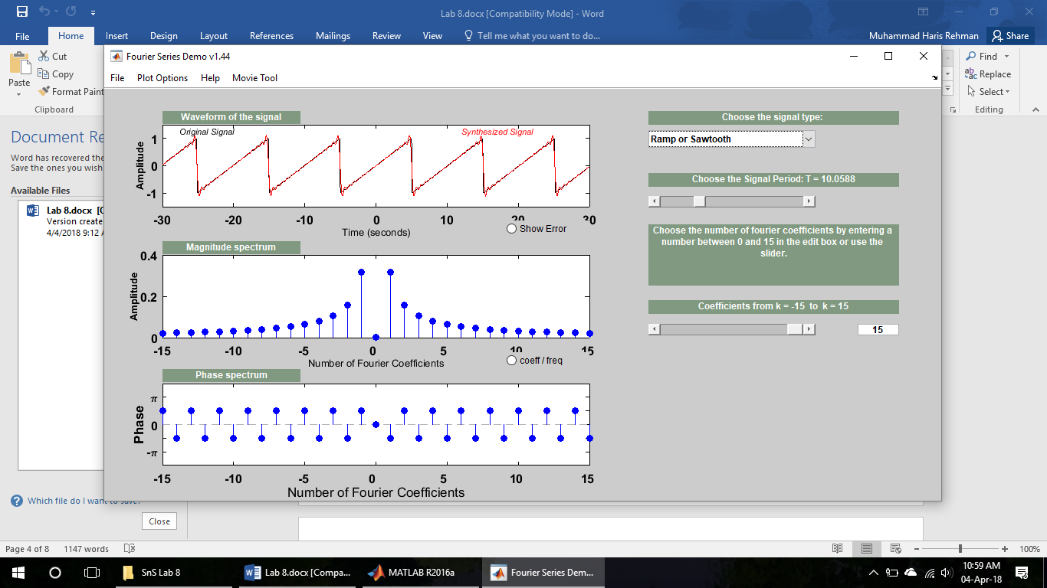

# Pre Lab Task 2

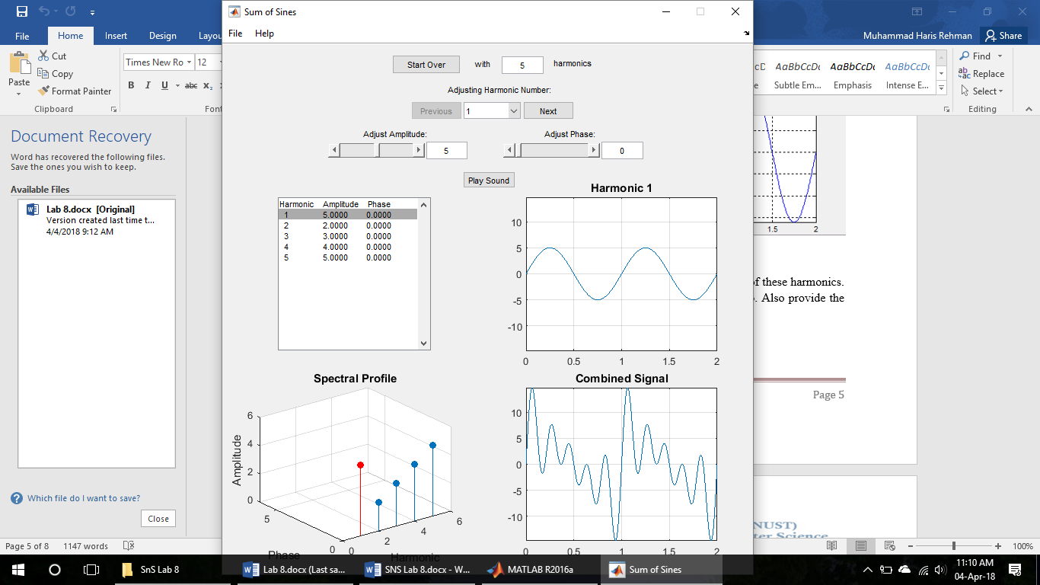

# Lab Task 1: CTFS

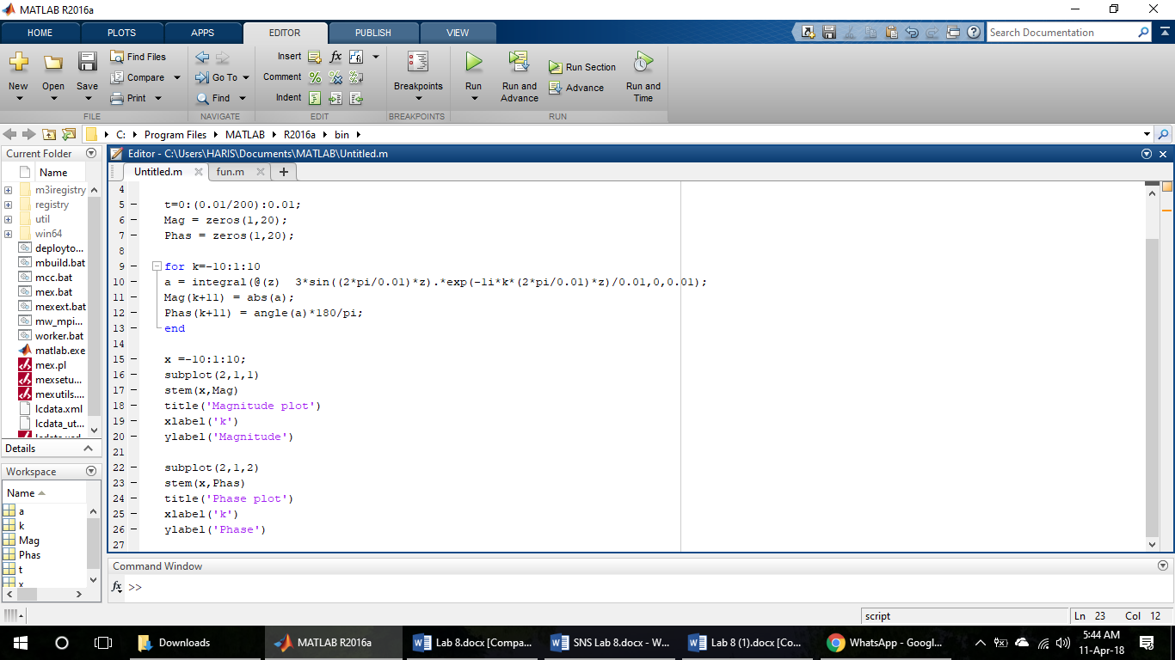

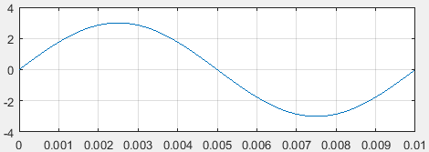

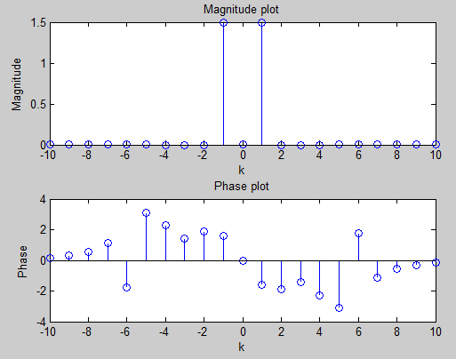

* Here, w = 2*pi/T, where T = 0.01s.
* First plot is the signal, second is the amplitude graph and the last one is the phase graph.
* For the 0 amplitude, the phase angle can be vary.

# Fourier Series of Continues Time Rectangular Wave:

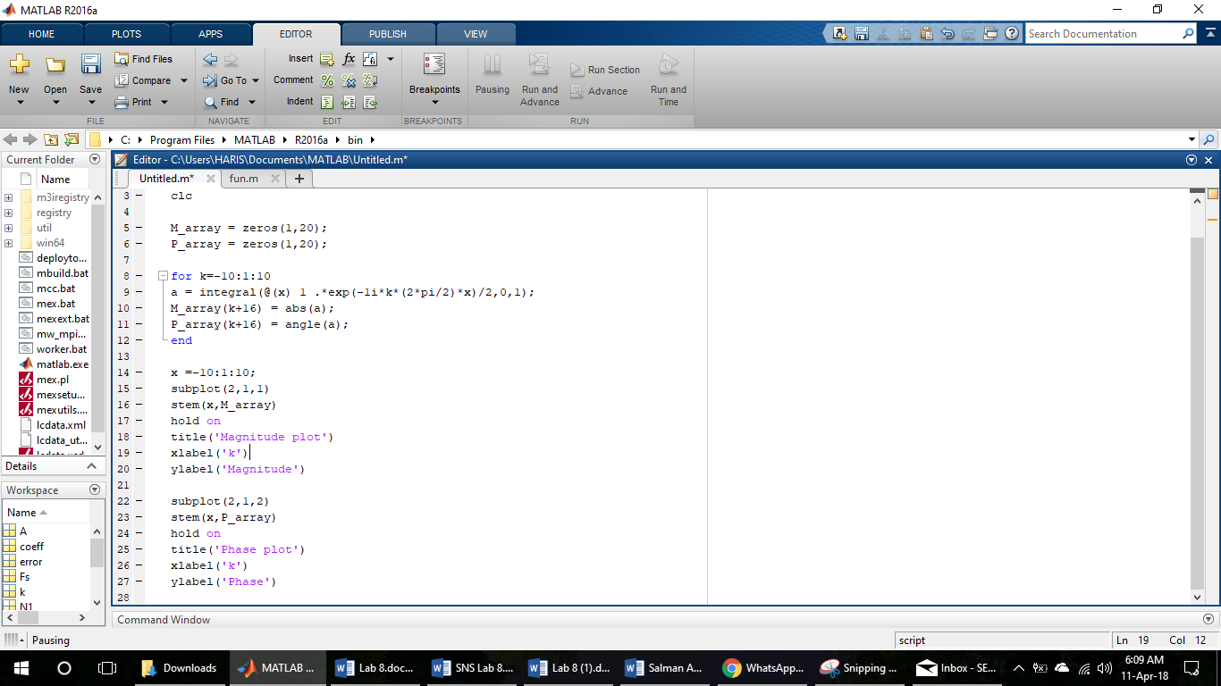

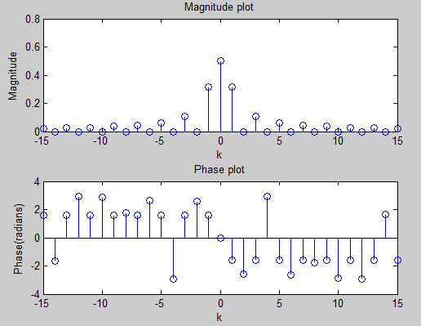

# Recovering From the Fourier Series:

## Sinusoidal:

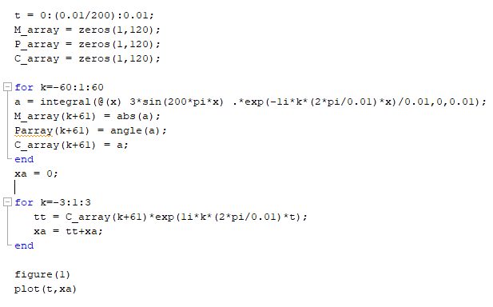

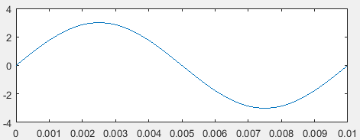

## Square:

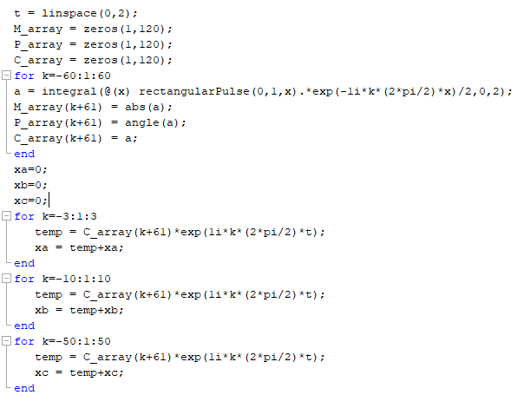

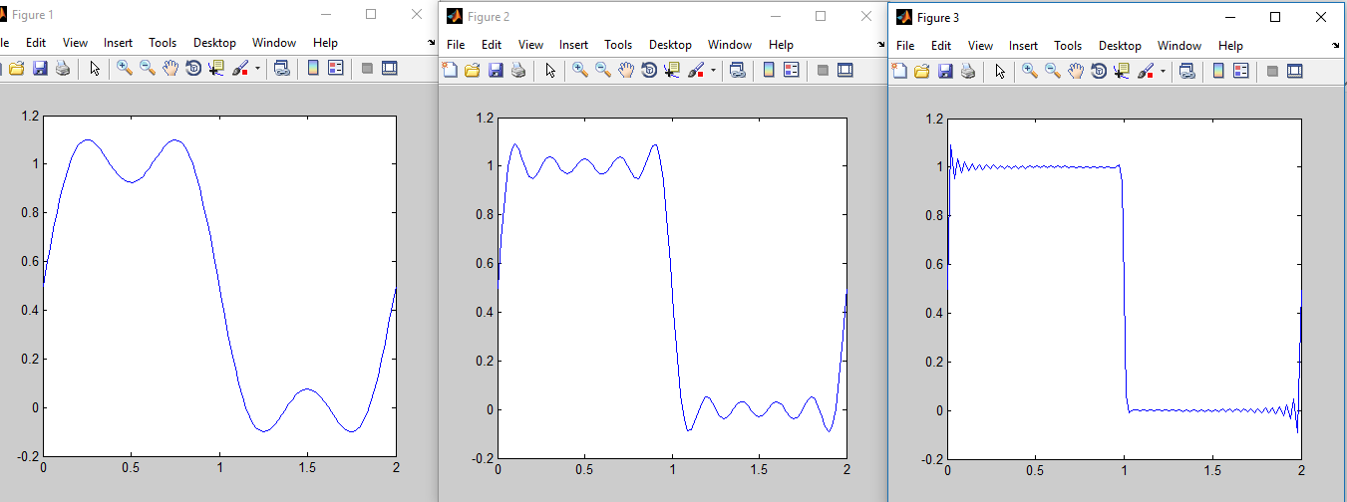

# Matlab Routines to Calculate Fourier Series:

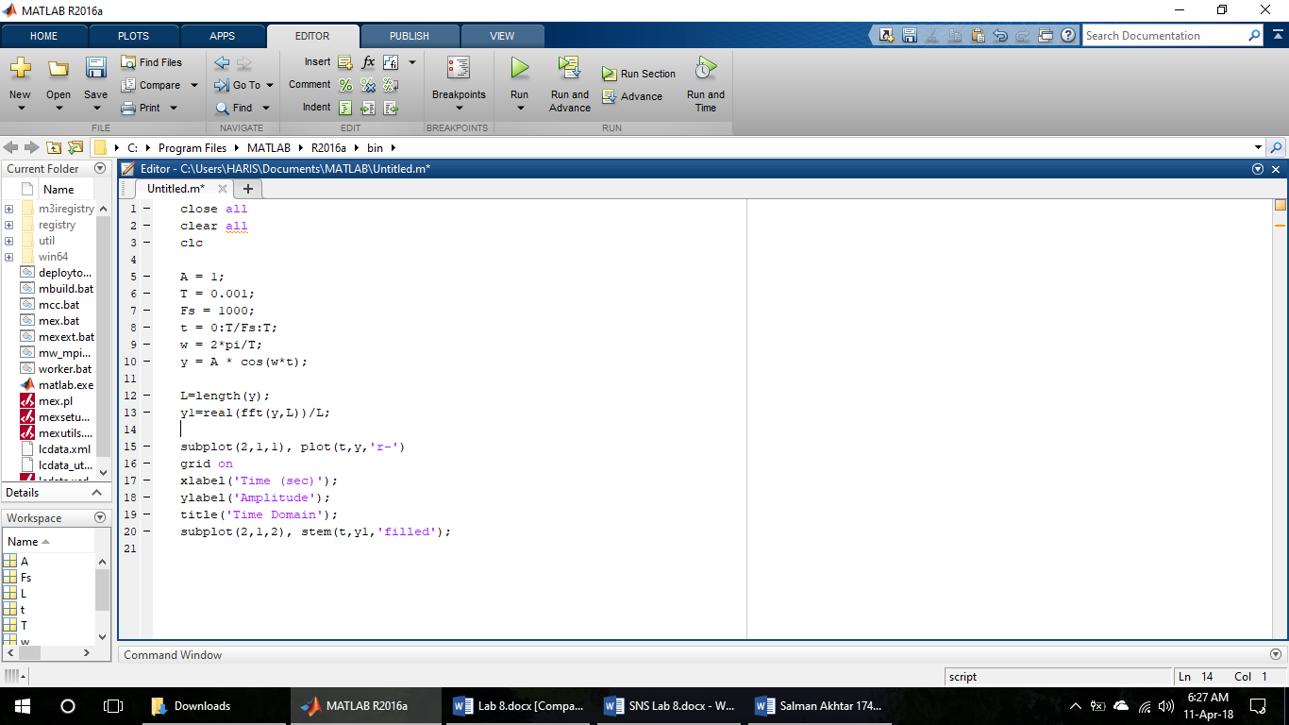

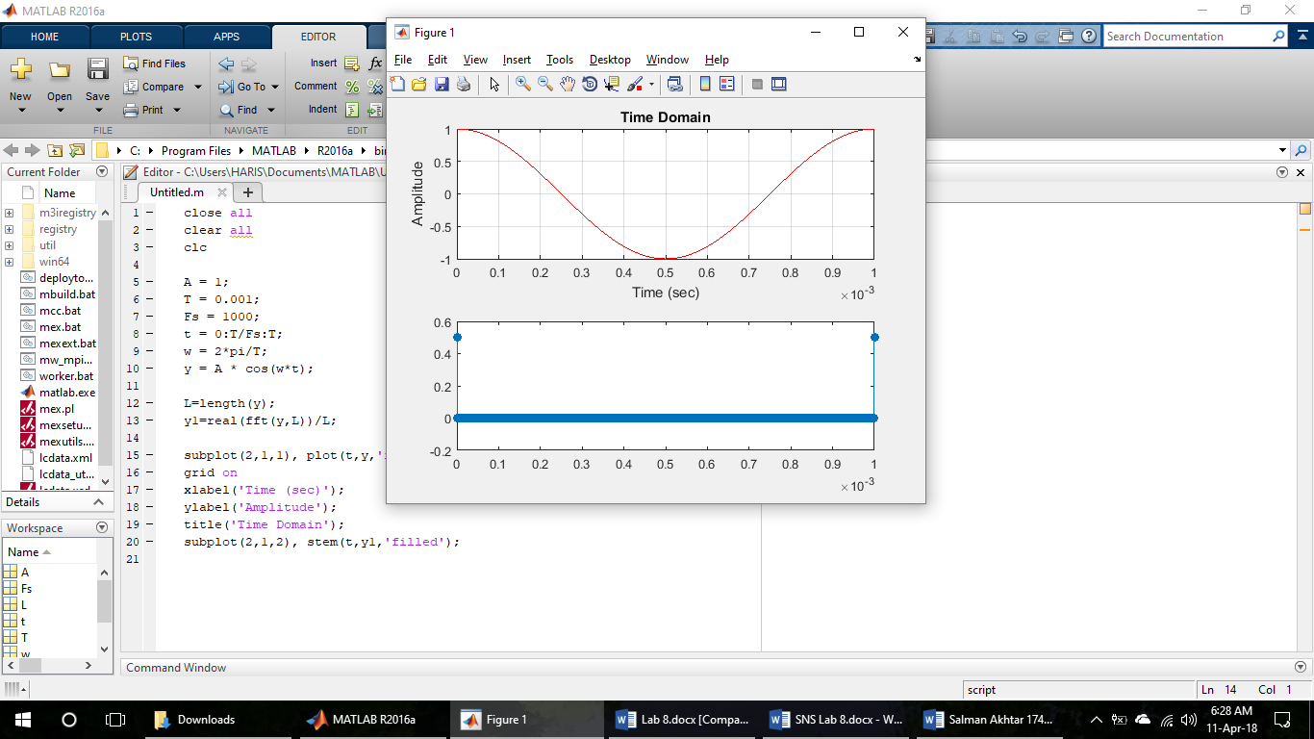

# Conclusion:

In this Lab we learnt, how to express function in time domain in the frequency domain using Matlab as a tool. And we also learnt, how to recover the signal from the Fourier series (frequency) domain to the time domain. In the last section of this lab, we learnt to use the matlab routines for the continues time Fourier series and discrete time Fourier series.