LAB TASK 9: DTFS

# Pre-Lab:

For a DT signal $x[n]$ with fundamental period $N$, the DTFS synthesis and analysis equations are given by (1) and (2), respectively.

$x\left[n\right]= \sum_{k=<N>}{a_{k}e^{jk\left(\frac{2π}{N}\right)n}}$ (1)

$a_{k}=\frac{1}{N}\sum_{n=<N>}{x[n]e^{-jk\left(\frac{2π}{N}\right)n}}$ (2)

Remember that $x\left[n\right]$ has period $N$*,* so that the summation in (2)can be replaced with a sum over any $N$ consecutive values of $n$*.* Similarly, $a_{k}$ is periodic in $k$ with period $N$ so that the summation in $(3)$ can be replaced with a sum over any $N$ consecutive values of $k$.

# Fourier Series:

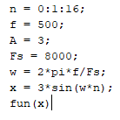 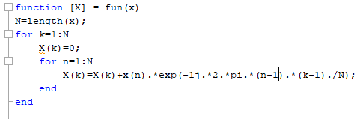

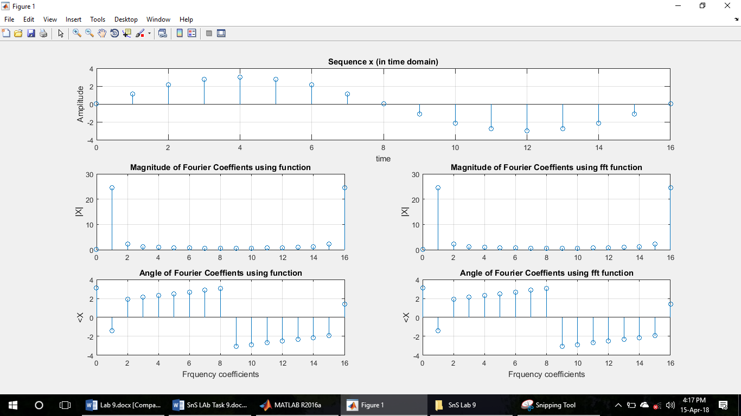

## Fourier Series of Discrete Time Square Wave:

When the Square wave is applied to the function, then the output is as follows;

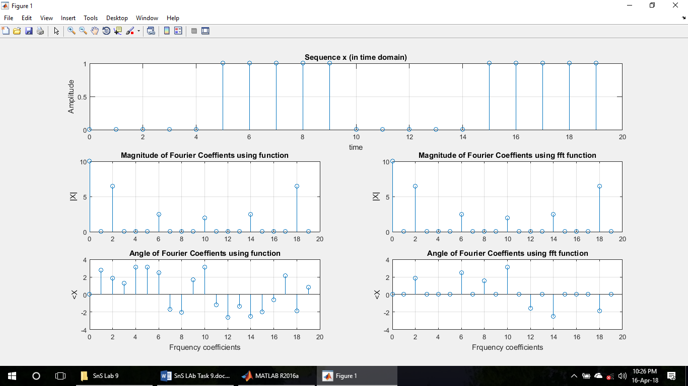

# Inverse Fourier Series:

## Inverse Fourier series Function:

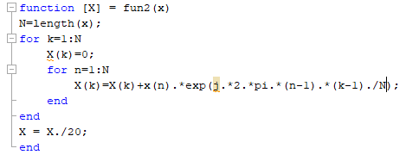

## Inverse Fourier series of Discrete time sinusoidal Wave:

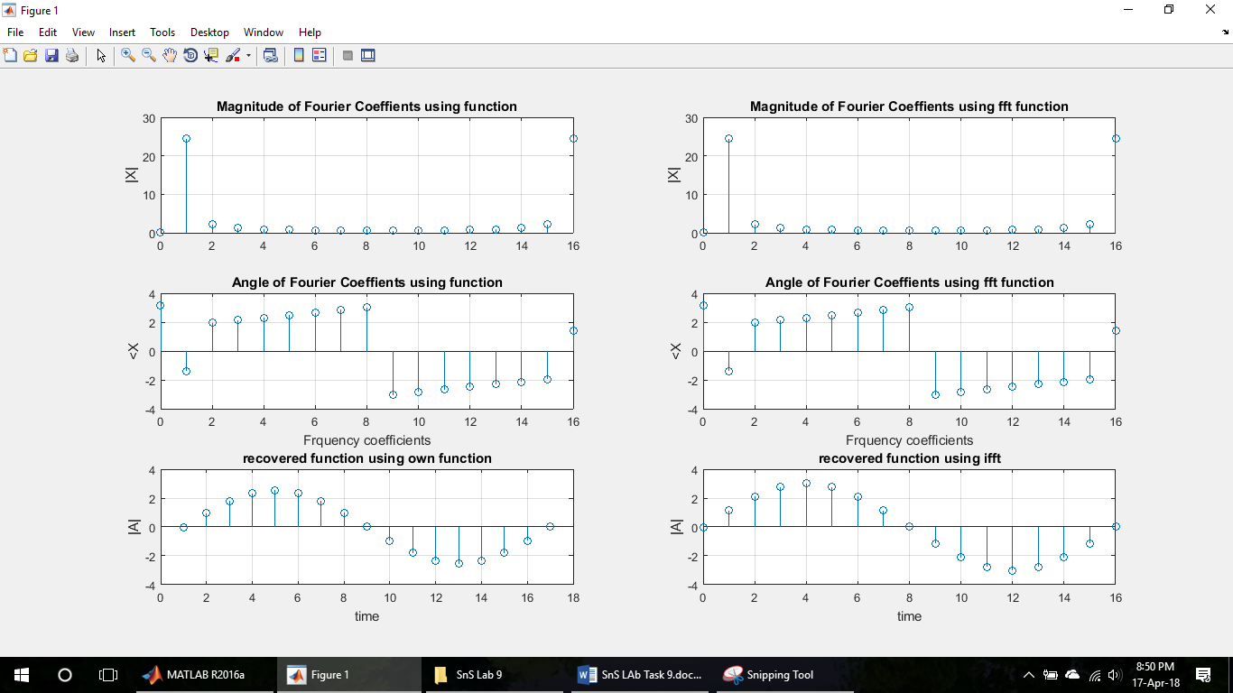

## Inverse Fourier series of Discrete time Square Wave:

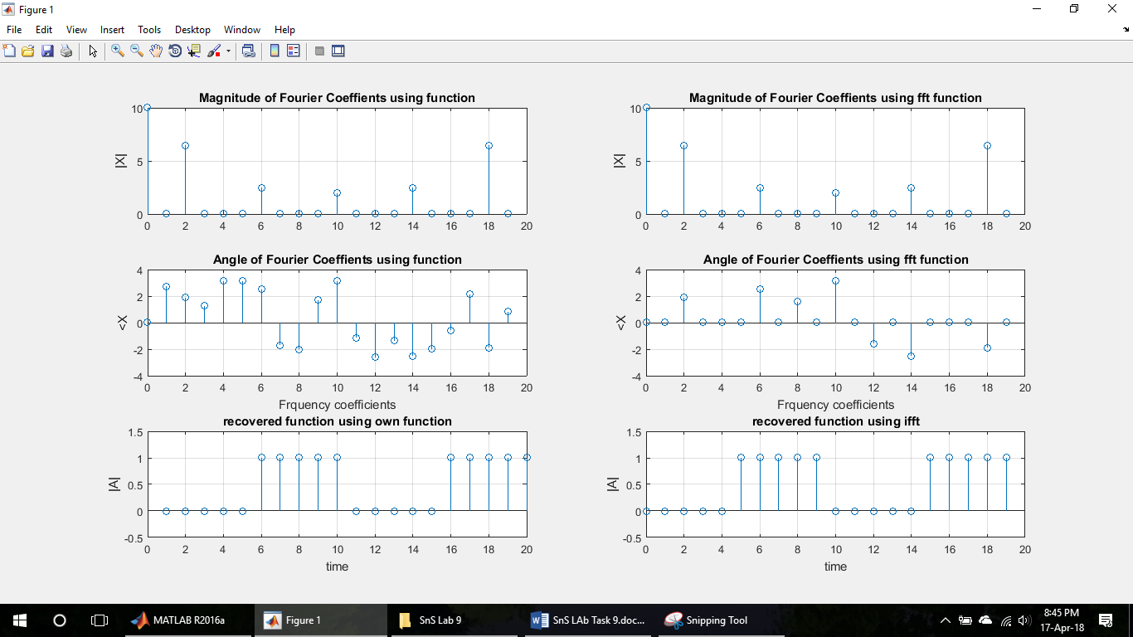

# Conclusion:

In this lab, I learnt about the discrete time Fourier series and discrete time inverse Fourier series MATLAB built in functions (i.e. fft, ifft). I also constructed our own functions in MATLAB for Fourier series and inverse Fourier series. Using the aforementioned functions, I found out the Fourier series coefficients, plotted them, and then using them, I reconstructed the original signal. This task was done on the two signals (i.e. discrete time sinusoidal signal, discrete time square wave signal).