LAB TASK 10:

# INTRODUCTION:

**Amplitude Modulation (AM)** is one of the methods of long distance radio transmission. Although this is not frequently used now a days due to certain disadvantages but it is still an excellent example for us understand the concepts. In this lab we will try to take peak into this fabulous system and perhaps try to understand its working by using the fundamental concepts we have covered in class.

# LAB TASKS:

1. Generate a signal defined by the following equation,

$$y(t)=\cos\left(2πt\right)+0.5\cos\left(4πt\right)+0.5cos⁡(8πt)$$

% SIGNAL

t = 1:1:200000;

X(t) = zeros;

f = [1 0.5 0 0.5 0 0 0 0 0 0];

fs = 100000;

for h = 1:1:200000

x = 0;

for i = 1:length(f)

x = x + f(i)*cos(2*pi*i*(h-1)/fs);

end

X(h) = x;

end

subplot(211), plot(t, X), grid

subplot(212), stem(1:10, f), grid

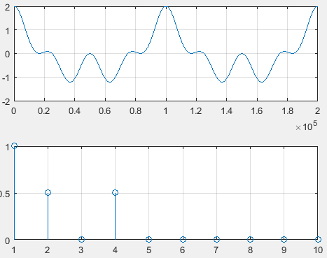

In the above task, the sampling frequency is 10^5. For each time calculation, the time is divided by sampling frequency to get the required Results.

1. Generate a cosine of 1000Hz and call it your carrier signal. Plot and analyze both the time domain and the frequency domain plots.

% Carrier Wave

t = 1:1:200000;

C(t) = zeros;

f = [zeros(1, 999), 1];

fs = 100000;

for h = 1:1:200000

c = 0;

for i = 1:length(f)

c = c + f(i)*cos(2*pi*i*(h-1)/fs);

end

C(h) = c;

end

subplot(211), plot(t, C), grid

subplot(212), stem(1:1000, f), grid

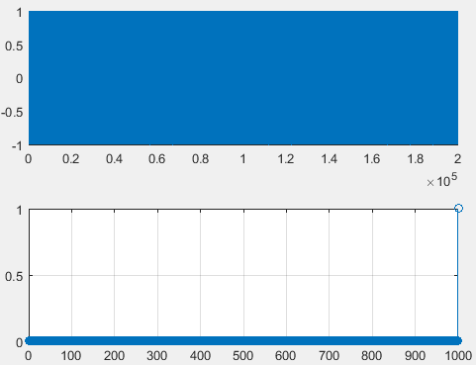

In this Part, the carrier wave has been generated. But its frequency is too high that it almost fills the space of graph. In this task, the sampling frequency is same 10^5. For each time calculation, the time is divided by sampling frequency to get the required Results.

1. Generation of Amplitude Modulated Signal

% AM

T = C.*X;

subplot(211), plot(t, T), grid

subplot(212), stem(1:200000, abs(fft(T))), grid

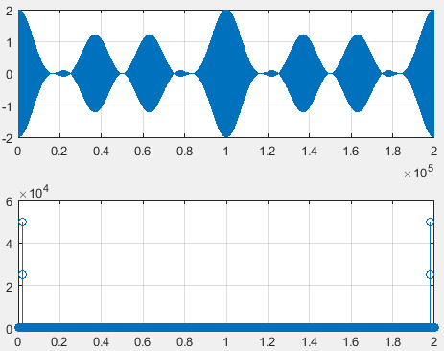

In this task, the sampling frequency is same 10^5. For each time calculation, the time is divided by sampling frequency to get the required Results. Moreover the frequency plot is also to be divided by sampling frequency.

1. Regeneration of signal from Amplitude Modulated Signal.

new = T./carier; % new is the recovered signal

length(abs(fft(new)));

subplot(211), plot(t, new), grid

subplot(212), stem(1:200001, abs(fft(new))/10.^5), grid

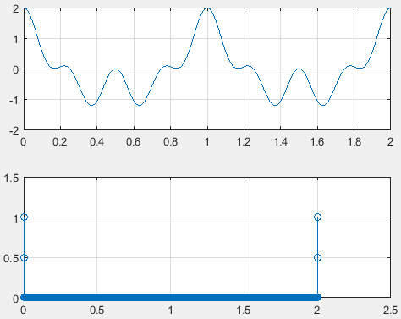

# CONCLUSION:

**Amplitude Modulation (AM)** is one of the methods of long distance radio transmission. Although this is not frequently used now a days due to certain disadvantages but it is still an excellent example for us understand the concepts. In this lab we tried to take peak into this fabulous system and perhaps tried to understand its working by using the fundamental concepts we had covered in the class.