LAB TASK 11

# DISCRETE TIME FOURIER TRANSFORM

# TASK 1:

## Code:

Fs = 20000;

t = 0:1/Fs:1;

f = 1./t;

f1 = 400;

f2 = 800;

x = sin(2*pi*f1*t) + sin(2*pi*f2*t);

l = length(x);

NFFT = 2^nextpow2(l);

y = fft(x, NFFT)/l;

fr = Fs/2*linspace(0, 1, NFFT/2+1);

k = fftshift(y);

subplot(311), plot(t, x), grid

subplot(312), plot(fr, 2*abs(y(1: NFFT/2+1))), grid

subplot(313), plot(fr.*pi/180, 2*abs(y(1: NFFT/2+1))), grid

## Output:

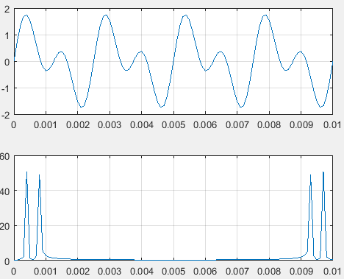

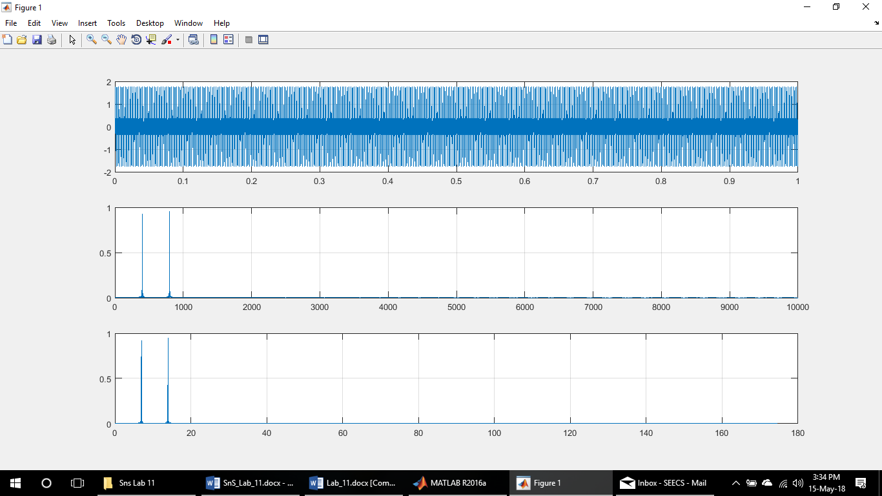

# TASK 2:

## Code:

clear all

close all

clc

alpha = 2;

Fs = 1000;

t = 0:1/Fs:2;

x = exp(-alpha*t);

subplot(511), plot(t, x), grid

l = length(x);

NFFT = 2^nextpow2(l);

y = fft(x, NFFT)/l;

fr = Fs/2*linspace(0, 1, NFFT/2+1);

k = fftshift(y);

subplot(512), plot(fr, fftshift(2*abs(y(1: NFFT/2+1)))), grid

subplot(513), plot(fr, fftshift(2*angle(y(1: NFFT/2+1)))), grid

subplot(514), plot(fr.*pi/180, fftshift(2*abs(y(1: NFFT/2+1)))), grid

subplot(515), plot(fr.*pi/180, fftshift(2*angle(y(1: NFFT/2+1)))), grid

## Output:

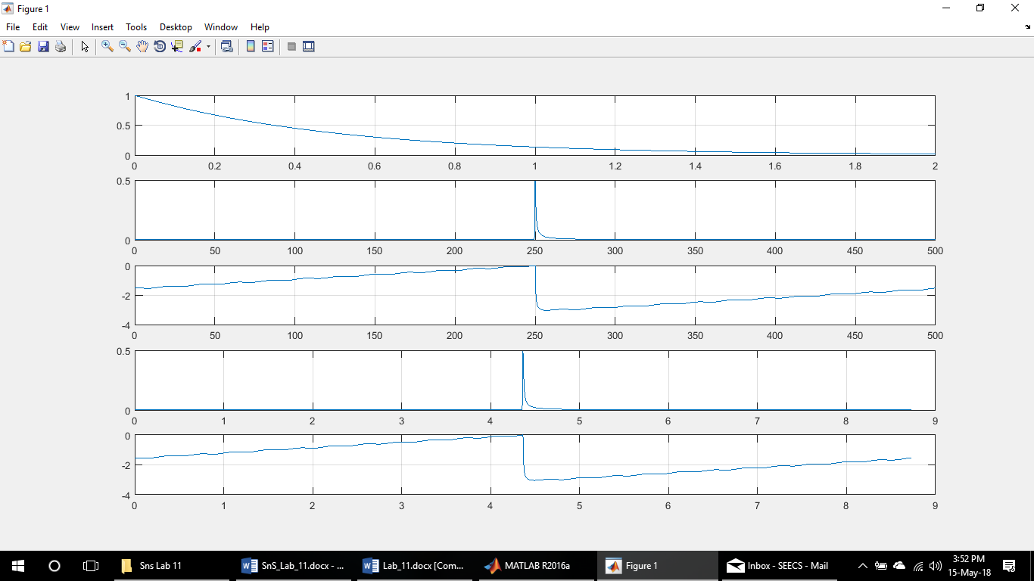

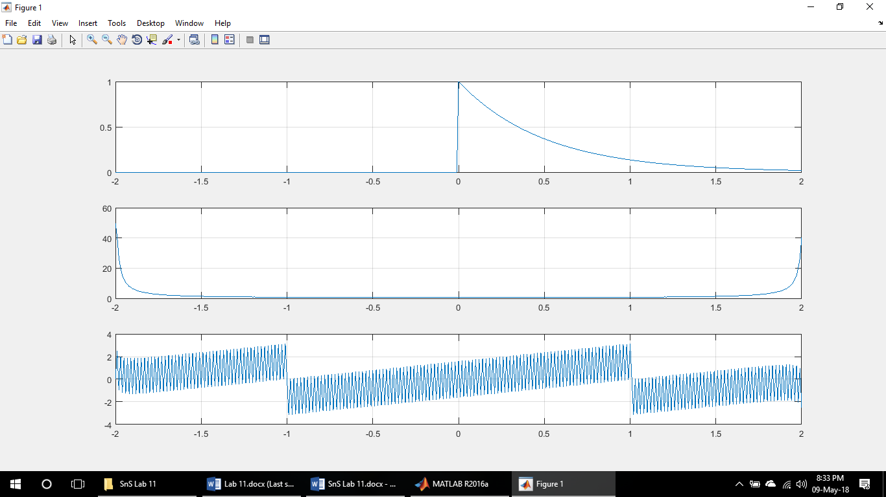

* In this plot, First one is the time domain signal, second and third ones are the frequency domain plots of magnitude and angle respectively.

# TASK 3:

## Code:

alpha = -2;

Fs = 100/20;

t = 0:1/Fs:20;

x1 = exp(alpha*t);

subplot(5, 2, 1), plot(t, x1), grid

title('x1[n]');

x2 = sin(t);

subplot(5, 2, 2), plot(t, x2), grid

title('x2[n]');

C = conv(x1, x2);

subplot(5, 2, 3), plot(1:length(C), C), grid

title('y[n] = x1[n] convolved with x2[n]');

%----------------------------------------------

y1 = fft(x1);

subplot(5, 2, 5), stem(0:length(y1)-1, abs(y1)), grid

title('|x1(e^jw)| = abs(fft(x1))');

subplot(5, 2, 7), stem(0:length(y1)-1, angle(y1)), grid

title('<x1(e^jw) = angle(fft(x1))');

y2 = fft(x2);

subplot(5, 2, 6), stem(0:length(y1)-1, abs(y2)), grid

title('|x2(e^jw)| = abs(fft(x2))');

subplot(5, 2, 8), stem(0:length(y1)-1, angle(y2)), grid

title('<x2(e^jw) = abs(fft(x2))');

New = y1.*y2;

rev = ifft(New);

subplot(5, 2, 9), plot(0:length(y1)-1, rev), grid

title('y[n] = ifft(x1(e^jw).x2(e^jw))');

## Output:

* Time Domain signals and their convolved signal.

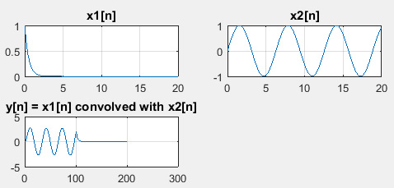

* Frequency domain signals with their magnitude and phase plots.

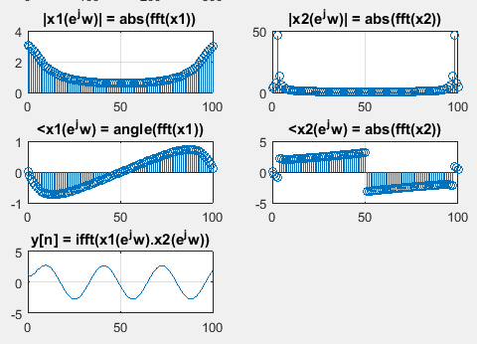

* Frequency domain signals are Multiplied and converted into time domain using ifft.

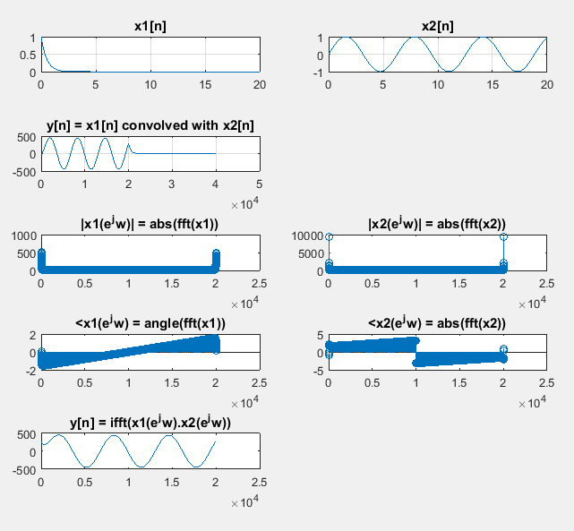

* Hence Proved that convolution in time domain is Multiplication in Frequency domain

# CONCLUSION:

In this Lab we learnt about the basic concepts of Fourier transform. Moreover, we learnt how to use the fft and fftshift commands in the matlab. We also learnt about the properties of the Fourier transform. One of those properties (i.e. convolution in time domain is Multiplication in Frequency domain) was implemented in the Task No. 3 of this Lab.