LAB TASK 12

# SAMPLING AND RECONSTRUCTION

# PRE-LAB TASKS

## (a, b, c):

GUI is as Follows;

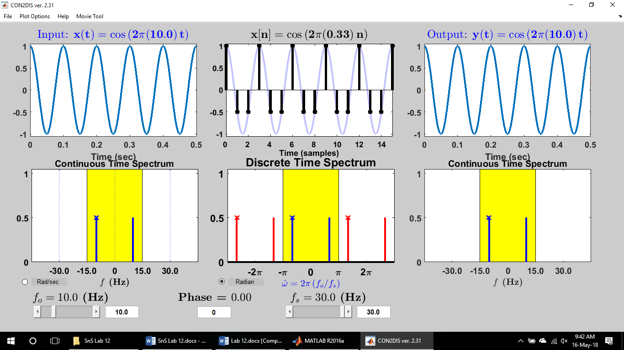

* Sampling Frequency cannot be exceeded from 30Hz.

## (d):

$w=\frac{2πf}{fs}=2π(0.333)$

$y\left(t\right)=\cos\left(2π\frac{wfs}{2π}t\right)=\cos\left(2π(10)t\right)$

## (e):

The minimum sampling frequency in this case will be 20Hz i.e. 10*2Hz. If the sampling frequency is more than this, signal can be reconstructed. Otherwise, aliasing will occur as shown in the next part.

## (f):

Snapshot of aliasing is as follows:

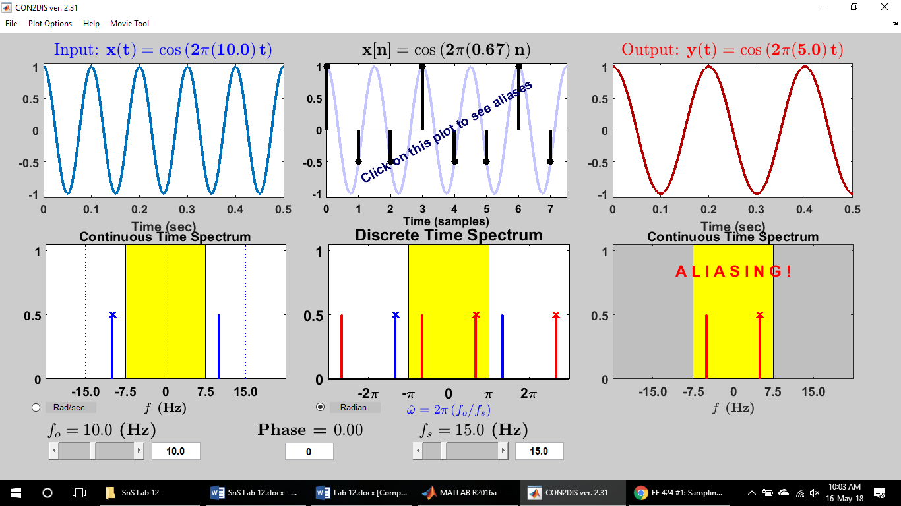

# LAB TASKS

# **Task 1:**

close all

clear all

clc

f=1;

Fs=100;

Ts=1/Fs;

t = 0:Ts:4;

x=cos(2*pi*f*t);

length(x)

plot(t, x)

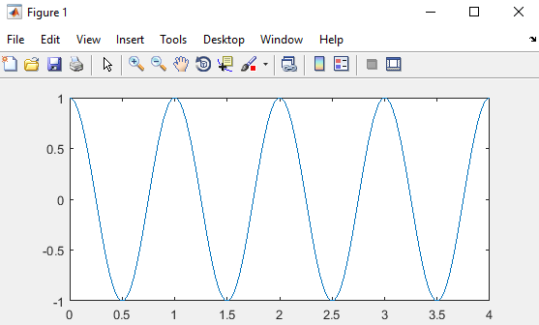

# **Task 2:**

sf = 4;

f=1;

Fs=100;

Ts=1/Fs;

t = 0:Ts:4;

SampSig = zeros(1,length(t));

x=cos(2*pi*f*t);

SampSig(1) = x(1);

for i = 1:length(t)-1

if (rem(i, Fs/sf) == 0) %4 samples per time period

SampSig(i) = x(i);

end

end

plot(t, x), hold on

stem(t, SampSig)

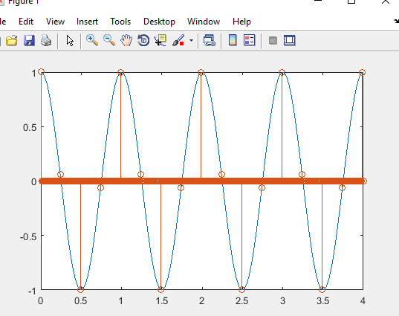

# **Task 3:**

sf = 4;

f=1;

Fs=100;

Ts=1/Fs;

t = -2:Ts:2;

SampSig = zeros(1,length(t));

x=cos(2*pi*f*t);

SampSig(1) = x(1);

for i = 1:length(t)-1

if (rem(i, Fs/sf) == 0) %4 samples per time period

SampSig(i) = x(i);

end

end

%plot(t, x), hold on

%stem(t, SampSig)

inc = 0;

for t=-2:Ts:2

inc=inc+1;

z(inc)=4*sinc(4*t);% In matlab this means sinc(4*pi*t)

end

plot((z))

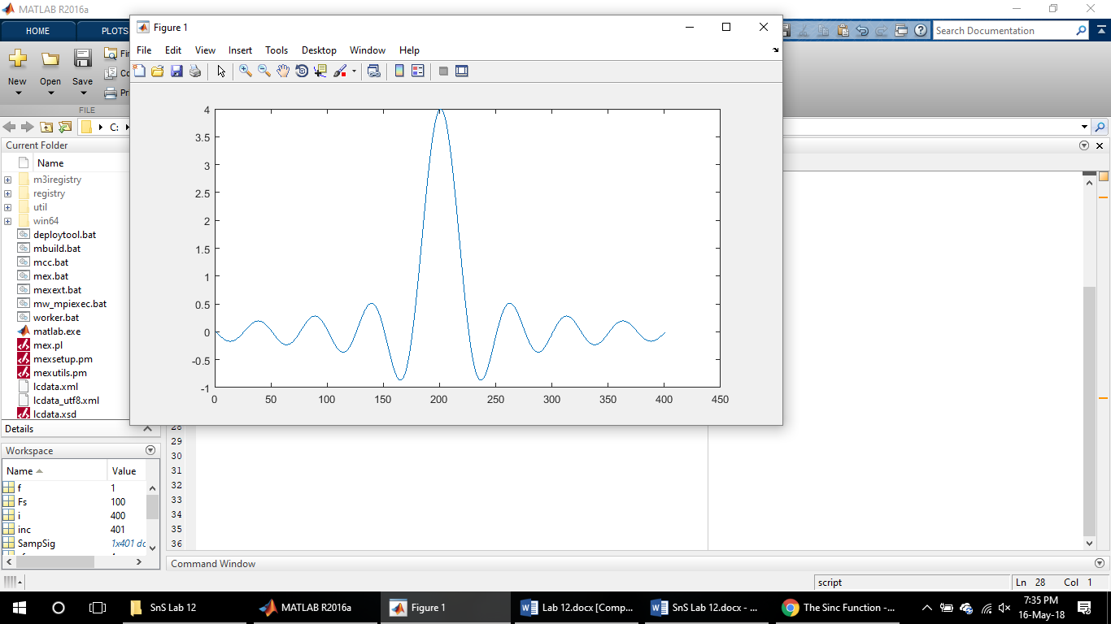

# **Task 4:**

sf = 4;

f=1;

Fs=100;

Ts=1/Fs;

t = -2:Ts:2;

SampSig = zeros(1,length(t));

x=cos(2*pi*f*t);

SampSig(1) = x(1);

for i = 1:length(t)-1

if (rem(i, Fs/sf) == 0) %4 samples per time period

SampSig(i) = x(i);

end

end

%plot(t, x), hold on

%stem(t, SampSig)

inc = 0;

for t=-2:Ts:2

inc=inc+1;

z(inc)=4*sinc(4*t);% In matlab this means sinc(4*pi*t)

end

rec = conv(z, SampSig);

plot(-4:Ts:4, rec)

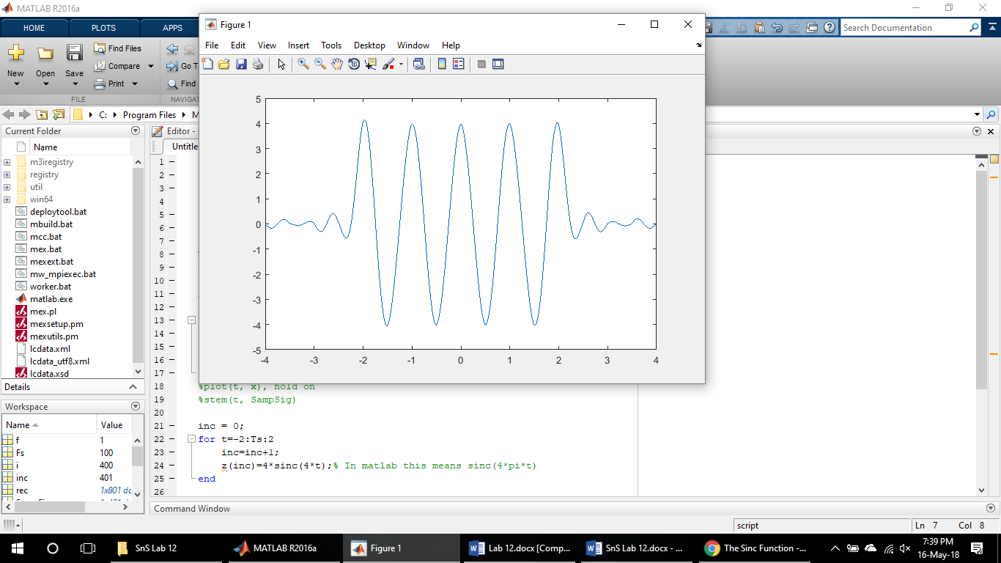

# **Task 5:**

sf = 4; % samples per period

f=1;

Fs=100;

Ts=1/Fs;

t = -2:Ts:2;

SampSig = zeros(1,length(t));

x=cos(2*pi*f*t);

SampSig(1) = x(1);

for i = 1:length(t)-1

if (rem(i, Fs/sf) == 0) %4 samples per time period

SampSig(i) = x(i);

end

end

subplot(311), plot(t, x), hold on

stem(t, SampSig)

title('signals and its samples');

inc = 0;

for j=-2:Ts:2

inc=inc+1;

z(inc)=4*sinc(4*j);% In matlab this means sinc(4*pi*t)

end

subplot(312), plot(t, z)

title('impulse response');

rec = conv(z, SampSig);

subplot(313), plot(-4:Ts:4, rec)

title('recovered signal from samples');

## 1 sample per period:

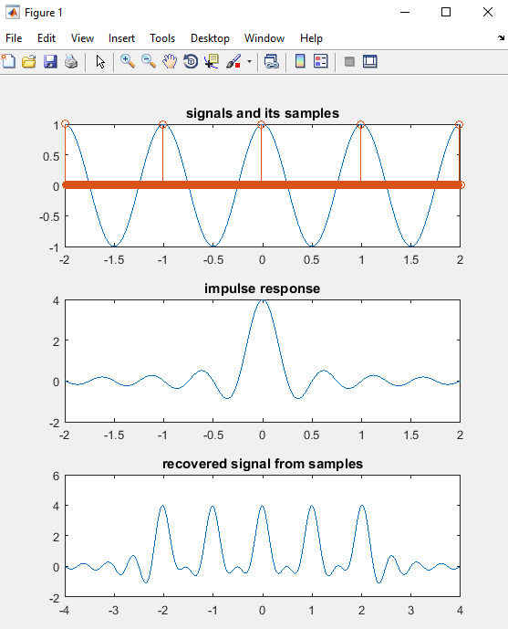

## 8 samples per period: (c) 16 samples per period:

## 

# CONCLUSION:

The steps in the first four tasks were followed in the task 5, with a slight change in code (i.e. change in samples per period). For the more number of samples per period, the signal can be reconstructed. But if the samples per period are less than 2, the signal cannot be reconstructed because of aliasing phenomena.