# INTRODUCTION

Manipulating sinusoidal functions using complex exponentials turns trigonometric problems into simple arithmetic and algebra. In this lab, we first review the complex exponential signal and the phasor addition property needed for adding cosine waves. Then we will use MATLAB to make plots of phasor diagrams that show the vector addition needed when adding sinusoids.

# PRE-LAB TASKS

## Complex Numbers in Matlab:

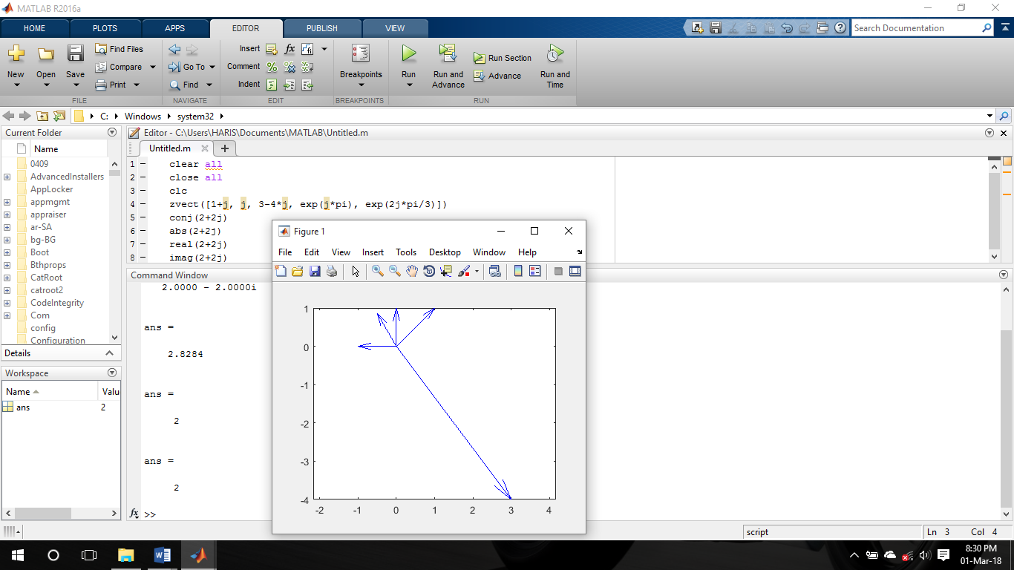

## Sinusoids Addition using Complex Exponentials:

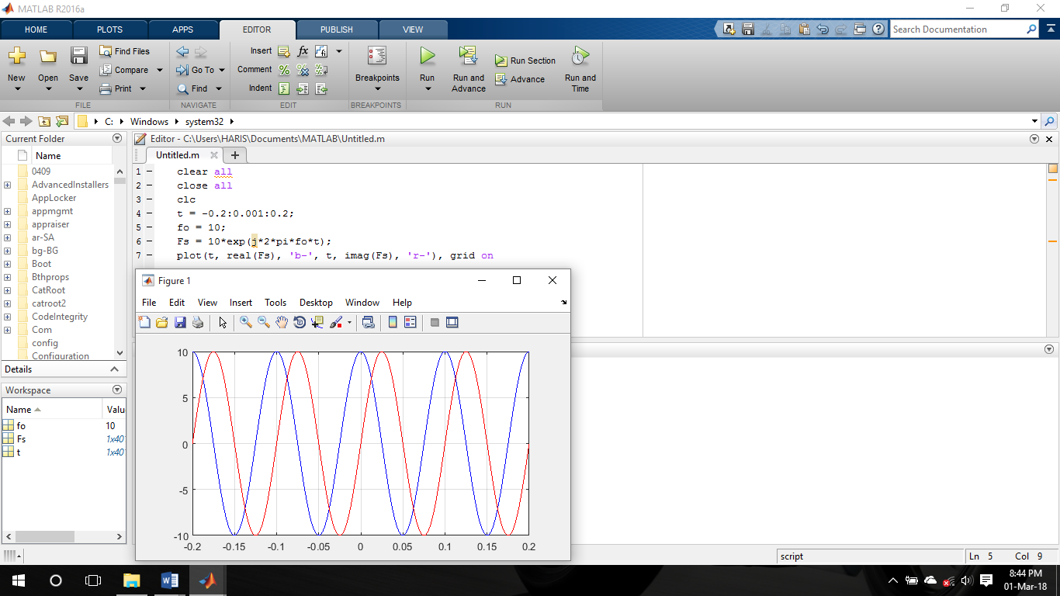

## Complex Numbers:

(a)

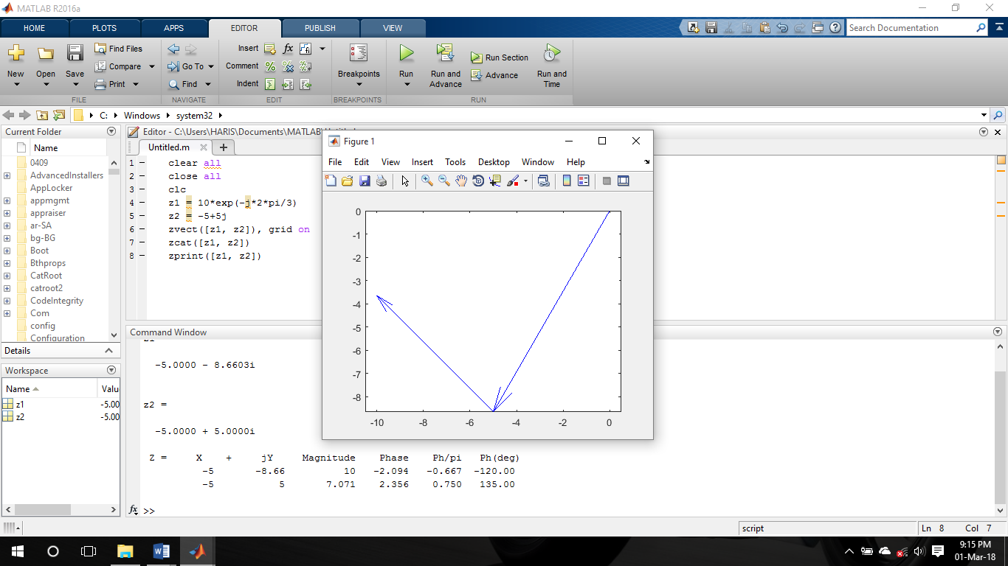

(b)

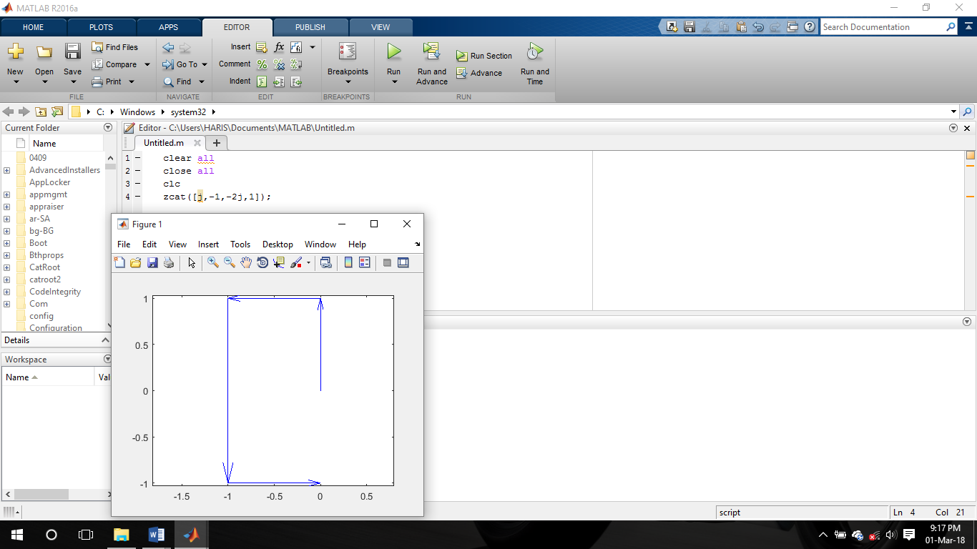

(c)

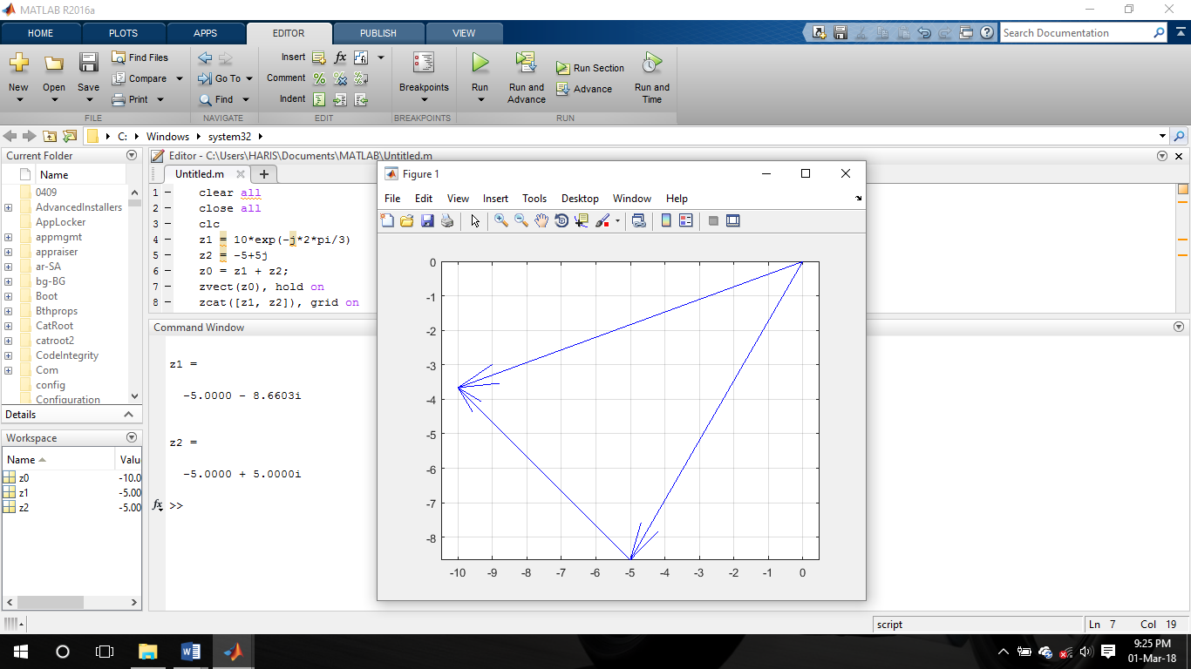

(d)

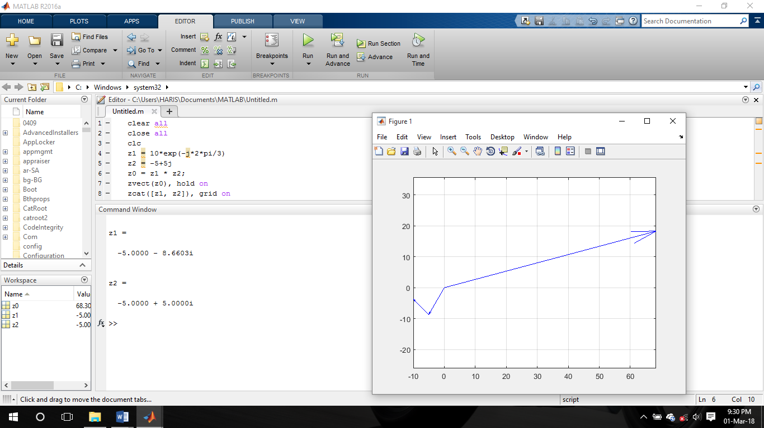

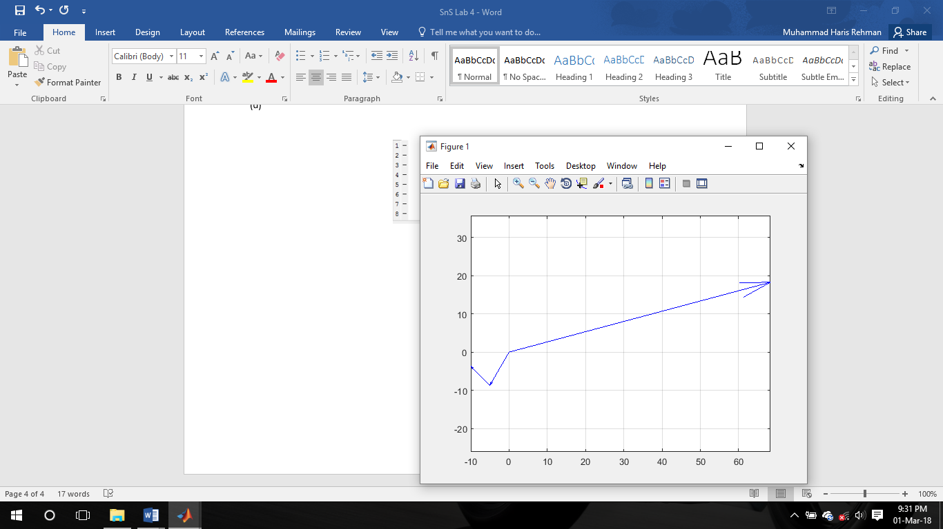

(e)

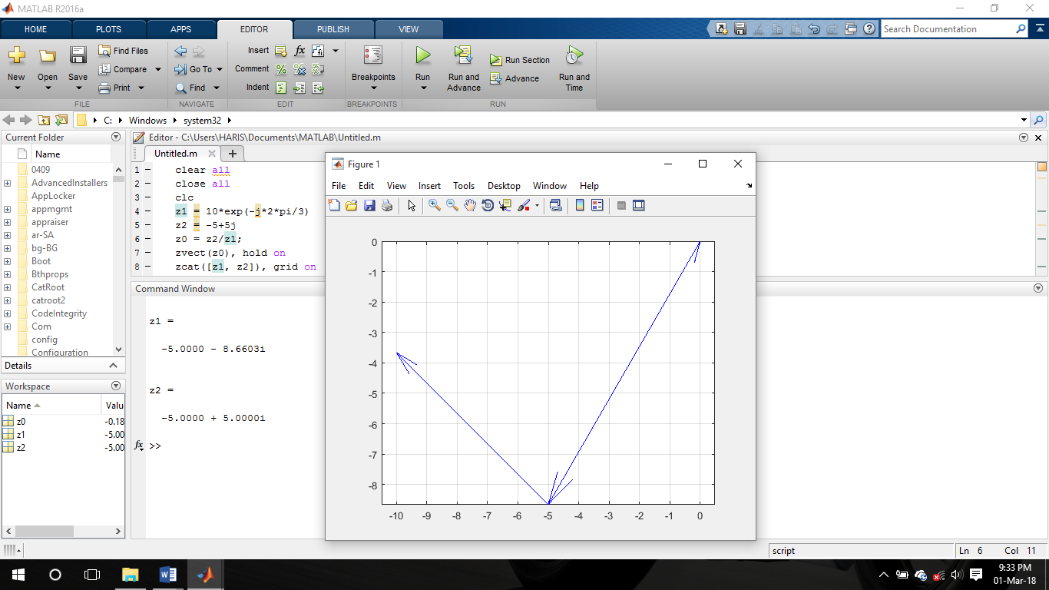

(f)

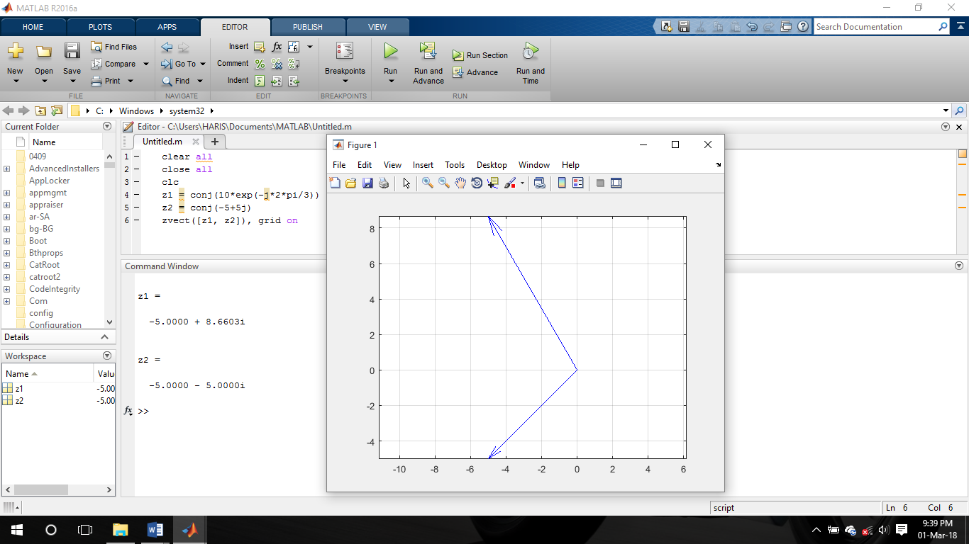

(g)

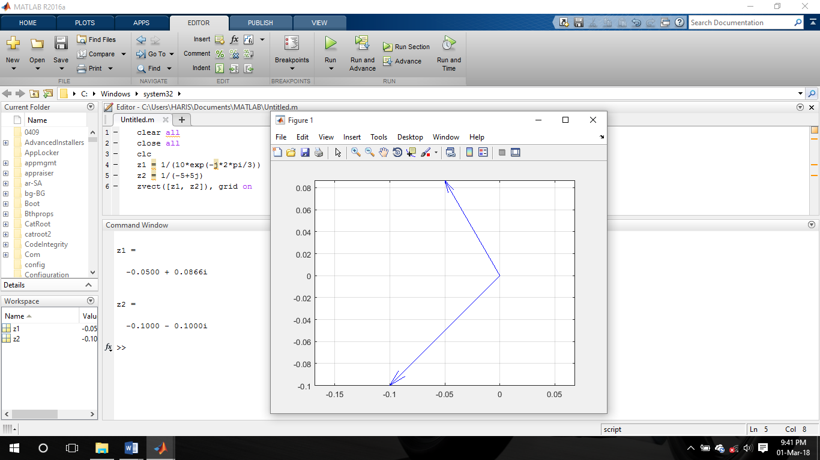

## Vectorization:

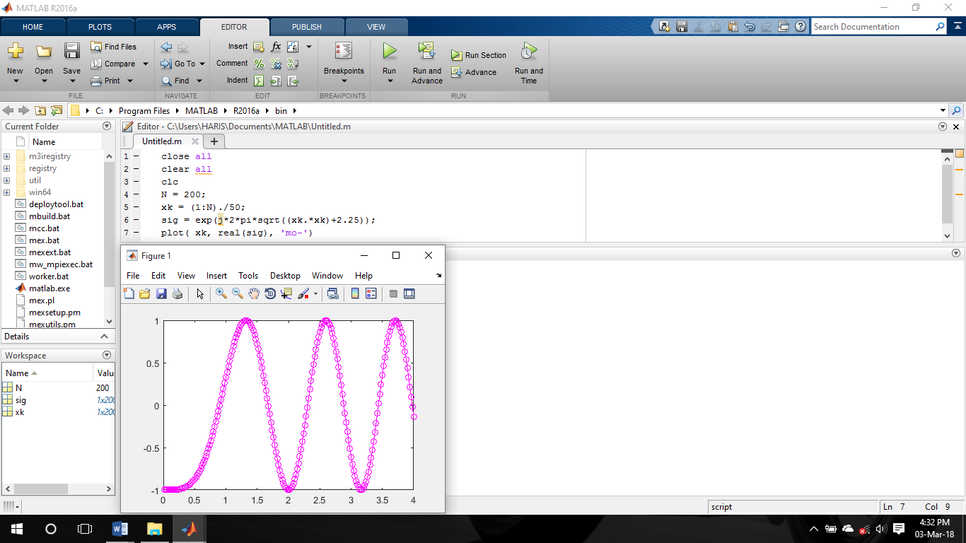

## Functions:

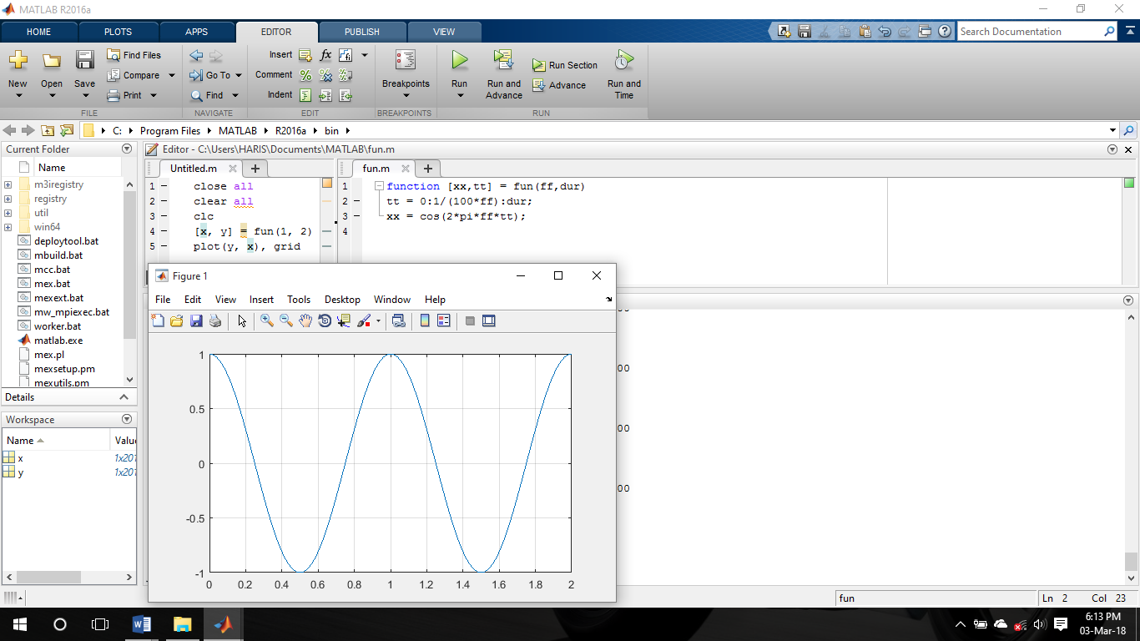

# LAB TASKS

## M-File to Generate a Sinusoid:

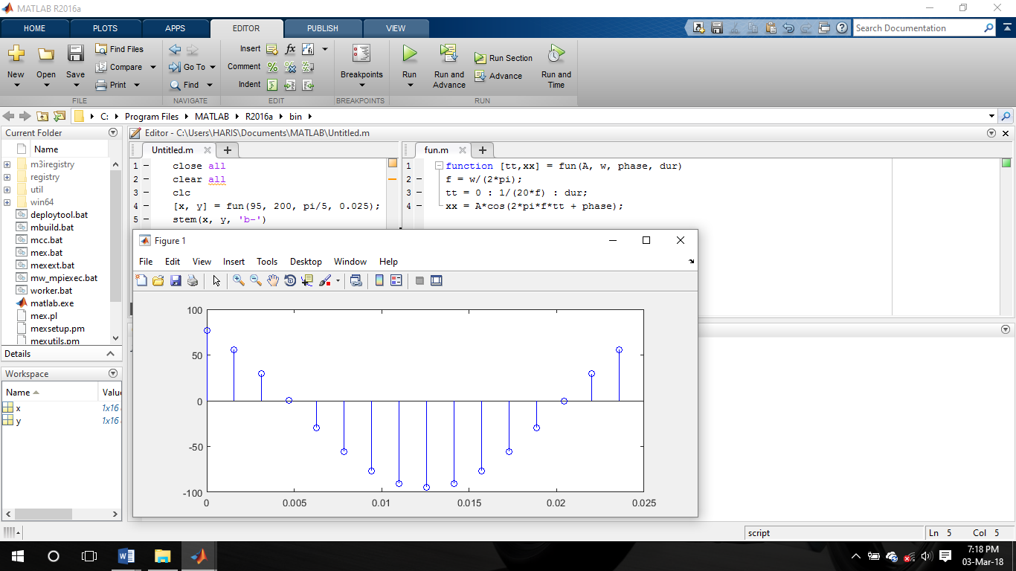

* I have divided the signal time period from 20 to get the sampling time period i.e. 20 samples per time period.

## Default inputs:

You can make the last input argument(s) take on default values if you use the nargin operator in MATLAB. For example, tstart can be made optional by including the following line of code:

*if nargin<5, tstart=0, end %--default value is zero*

## Testing

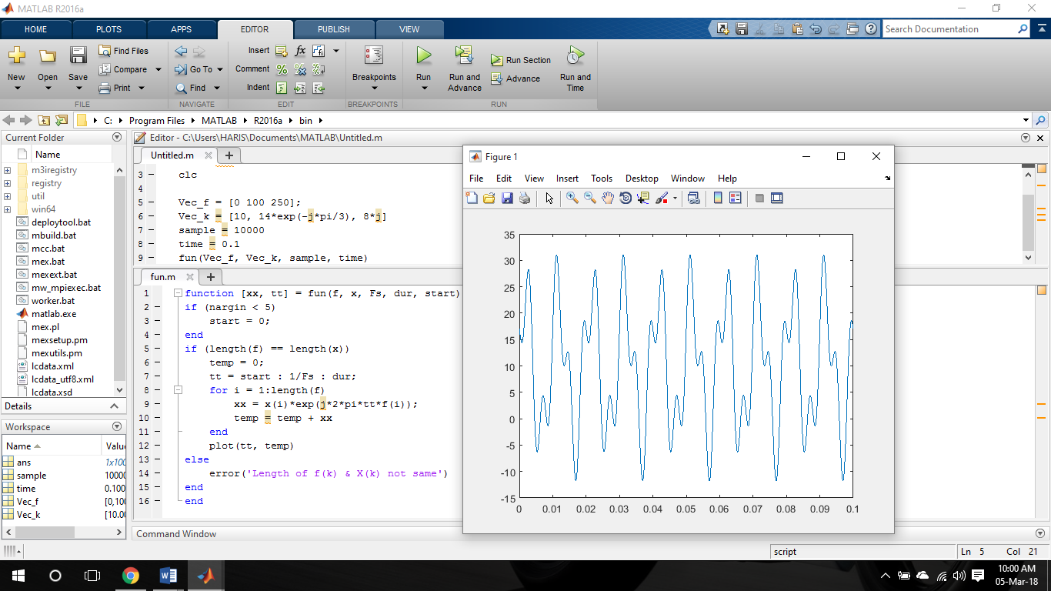

## Representation of Sinusoids with Complex Exponentials:

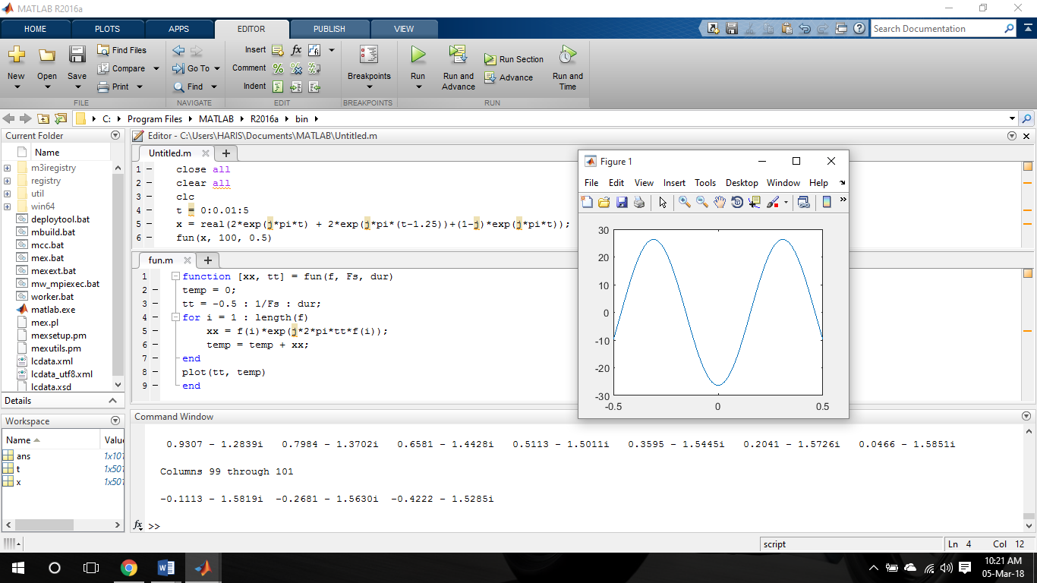

# CONCLUSION

We manipulated the sinusoidal functions using complex exponentials and turned the trigonometric problems into simple arithmetic and algebra. In this lab, we first reviewed the complex exponential signal and the phasor addition property needed for adding cosine waves. Then we used MATLAB to make plots of phasor diagrams that showed the vector addition needed when adding the sinusoids.