LAB TASKS

# Task 1:

(A)

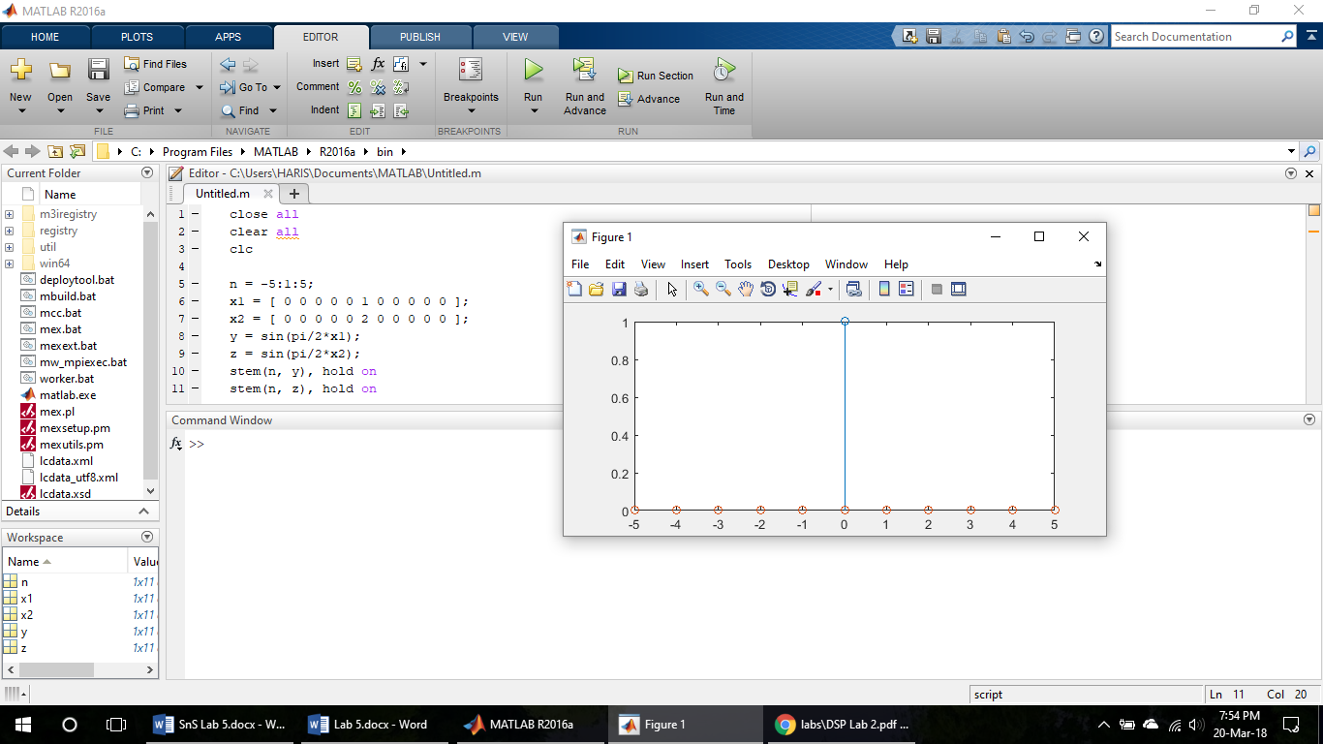



For the figure given above, it is clear that for the given system to be linear, the amplitude of the function “Z” must be double than the input if the input magnitude is doubled.

(B)

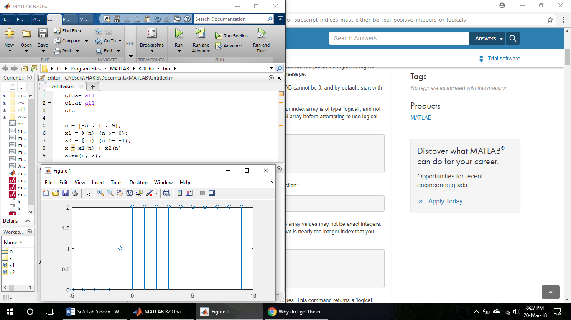

From the above experiment, it is clear that the output values are depending on the future values of the input. Hence, the function is non causal.

(C)

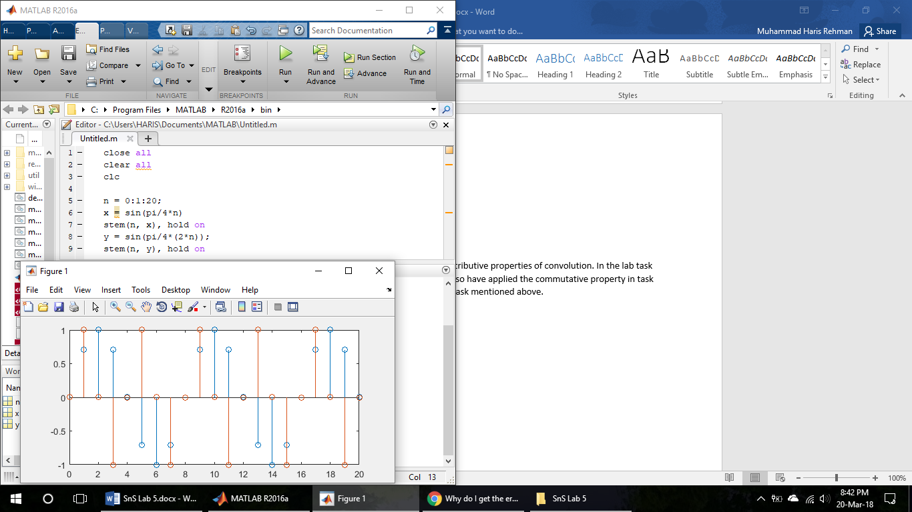

I have used the signal x(n) = sin (n). This is the signal which is plotted above for x(n) and for x(2n). and after plotting and looking at the plotted graph, it can be said that the system is time variant.

# Pre-Labs:

The pre labs involve the commutative and distributive properties of convolution. In the lab task 2(D), the commutative property has been verified. I also have applied the commutative property in task 2(D). so, my pre-labs have been covered in the same task mentioned above.

# Task 2:

(D)

Commutative Property:

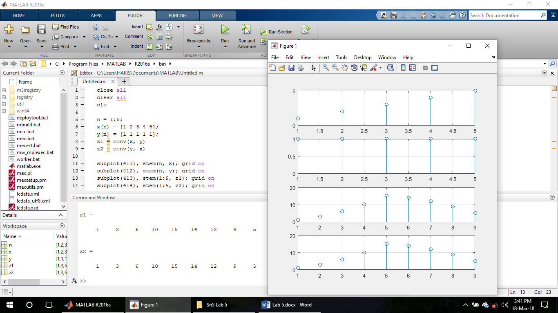



Distributive Property:

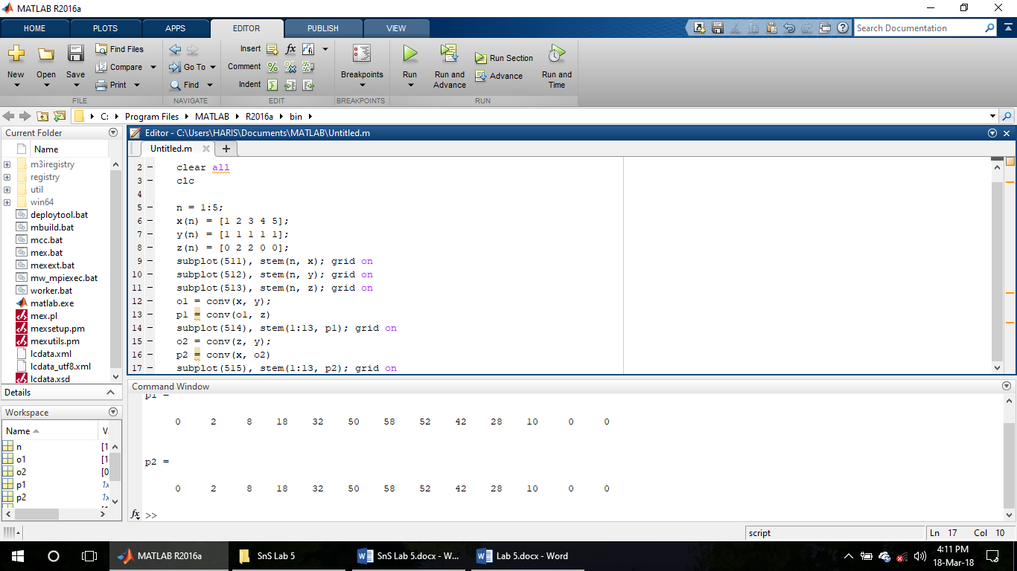

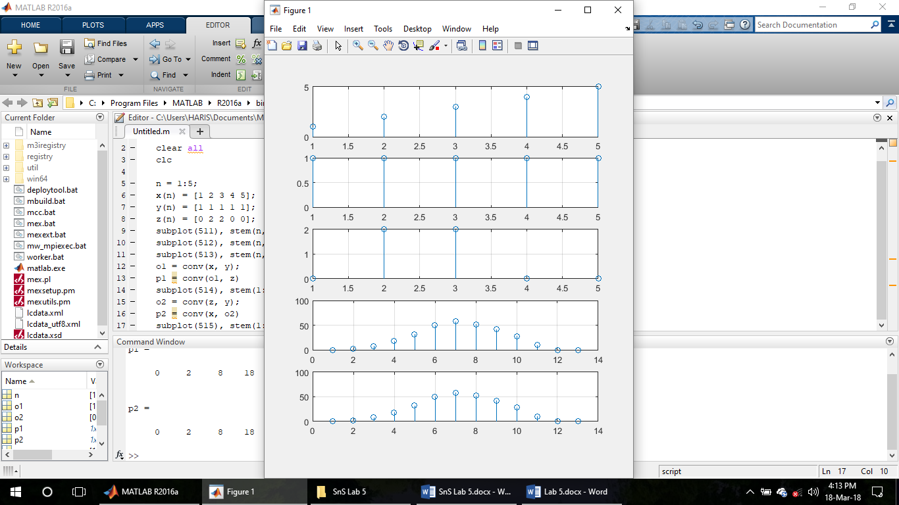

(E)

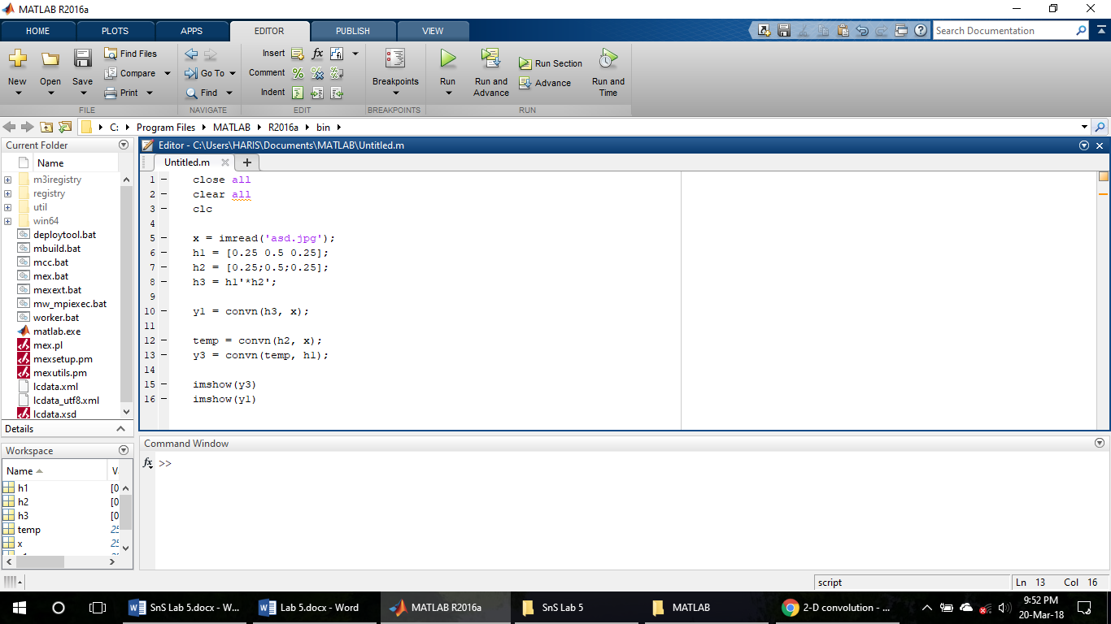

The image was convolved with the signal h3 first, and then, image was convolved with h2 first and then convolved with h1. In both of these cases, the output image is same. The image was so vague that the snap of that, if placed in the lab report will not have any benefit. But the convolved image was same in both cases.

# CONCLUSION:

In this lab we learnt about the convolution of two or more signals. Convolution is the process by which the output of a linear time invariant system can be determined to a specific input signal. Moreover, we verified the properties of the convolution using MATLAB. Systems can be classified into different categories based upon certain properties. Generally, it is easier to identify a case or input for which a particular property does not hold.