LAB TASK 6

# Convolution GUI:

## Discrete time convolution:

(a, b, c)

x[n] = 2 {u[n] - u[n - 12]} h[n]= cos (0.2*pi*n * w[n]) w[n]= u[n]-u[n-11]

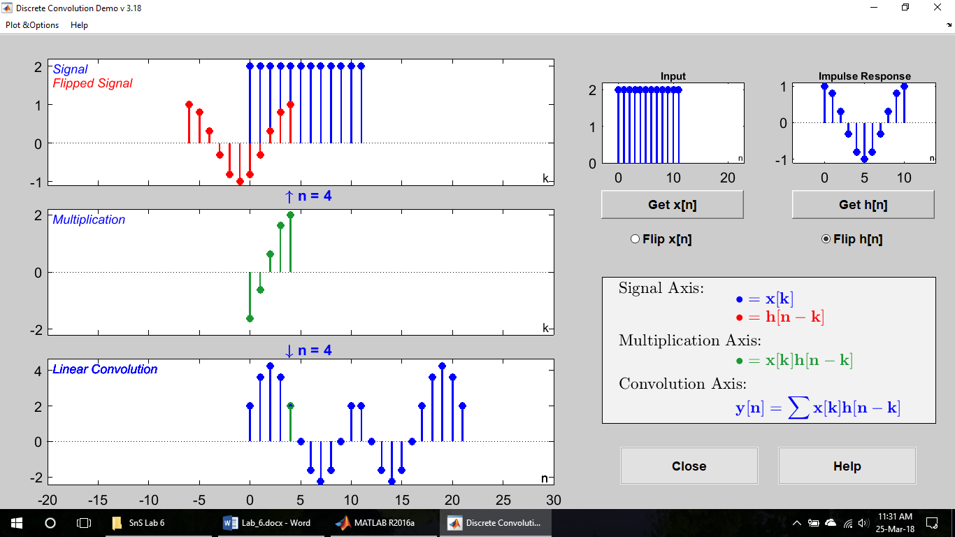

(d)

x[n] = 2 {u[n] - u[n - 12]} h[n] = 0.1{u[n] - u[n - 10]}

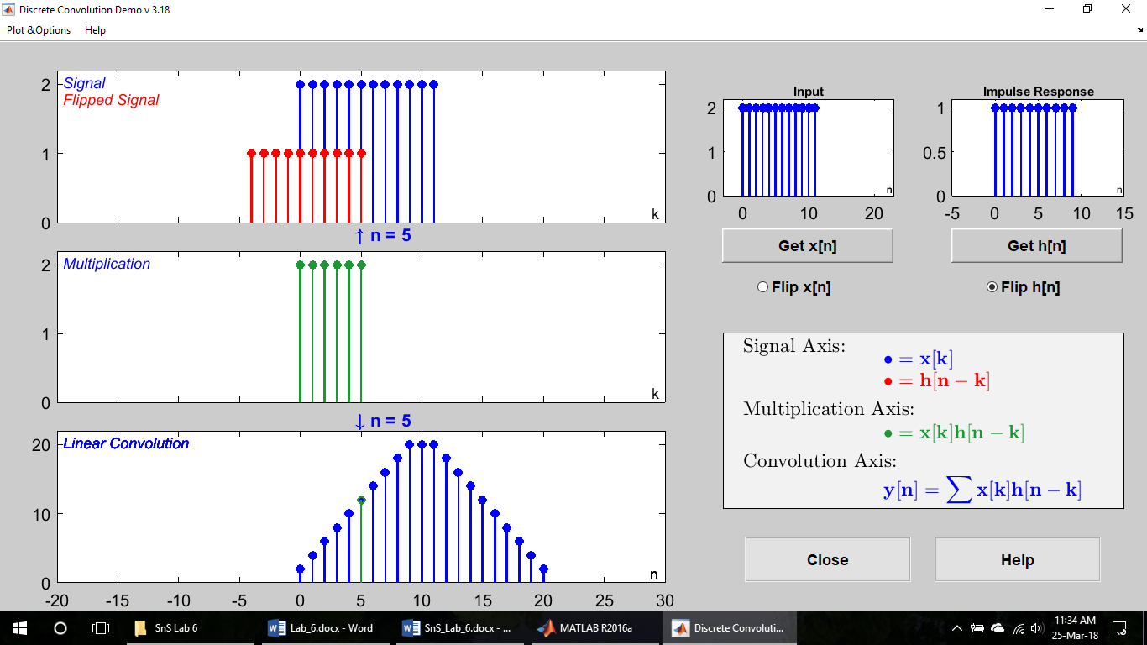

(e)

x[n] = 2 {u[n] - u[n - 12]} h[n] = delta[n - 3]

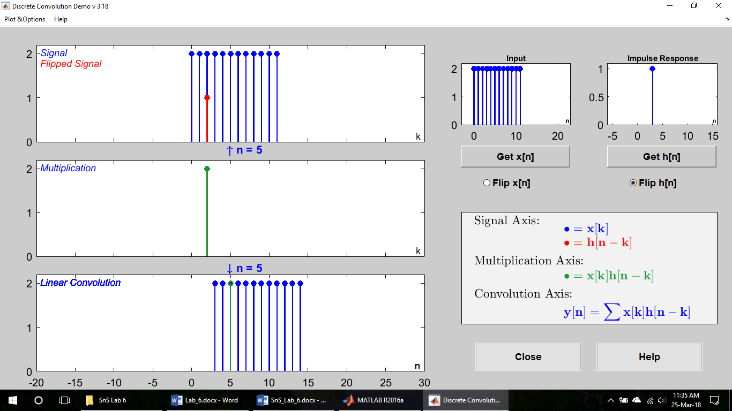

## Continues time convolution:

(a, b, c)

x(t) = u(t+1) - u(t - 3). h(t)=e-0.5t^2 [u(t-5)- u(t-5)]

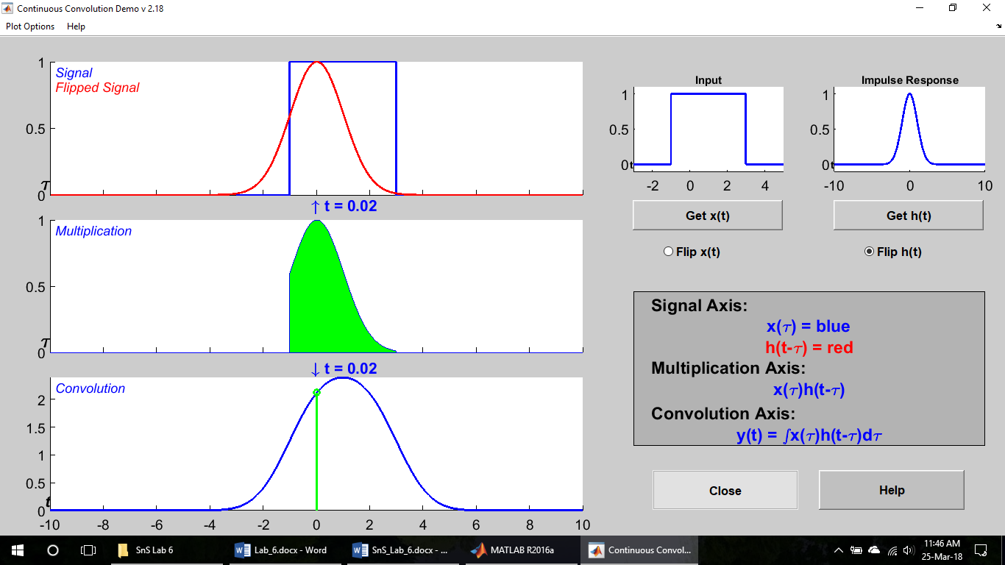

(d)

x(t) = u(t+1) - u(t - 3). h(t) = 0.25{u(t) u(t- 4)}

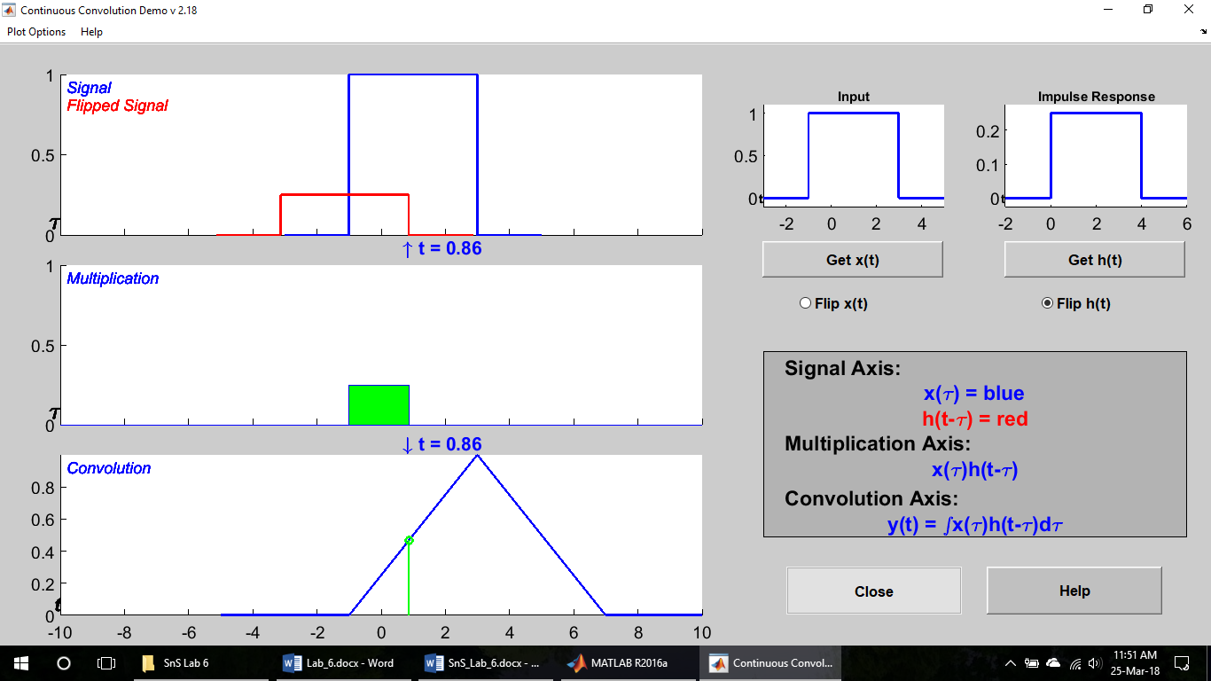

(e)

x(t) = u(t+1) - u(t - 3). h(t) = delta(t - 3)

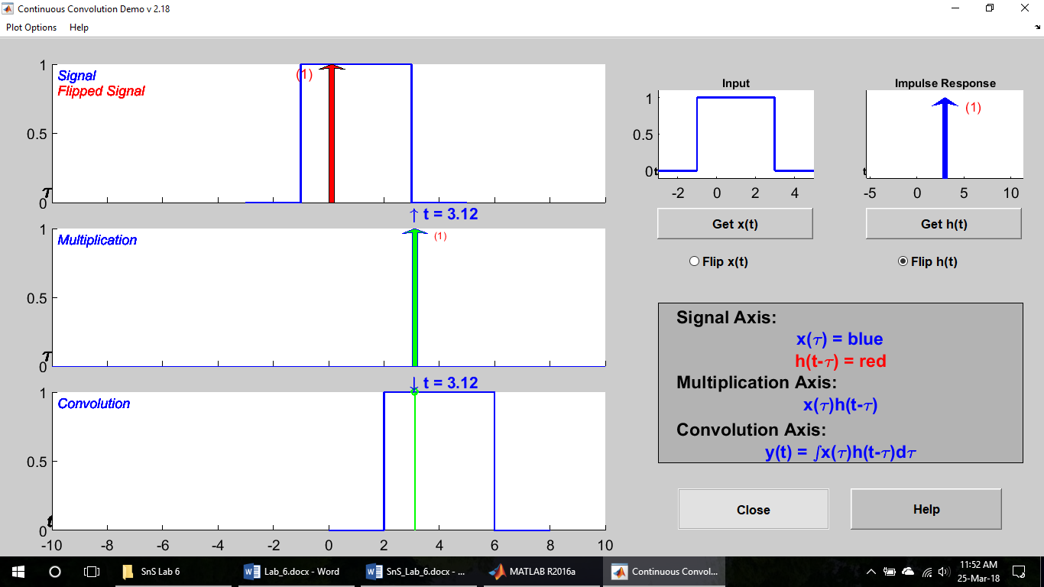

# Introduction to Systems:

## Pre lab:

1. x[n]= {1 2 1 2} h[n]= {0 1 2 3 4 1 1}

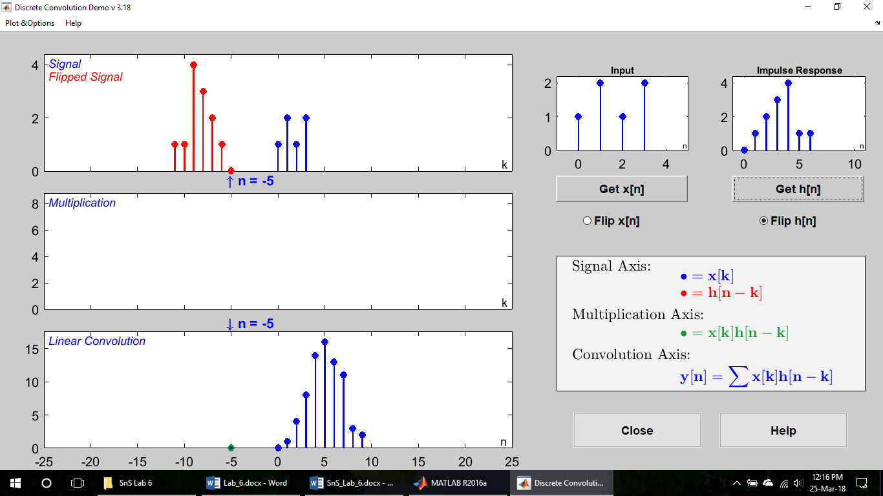

1. x[n]= {1 2 1 2} h[n]= {0 1 2 3 4 1 1}
2. x[n]= {-1 0 1} h[n]= {1 2 1}

It is the limitation of the software that the convolution cannot be performed in the user defined input using dconvdemo.

## Convolution of sequences:

(a, b, c)

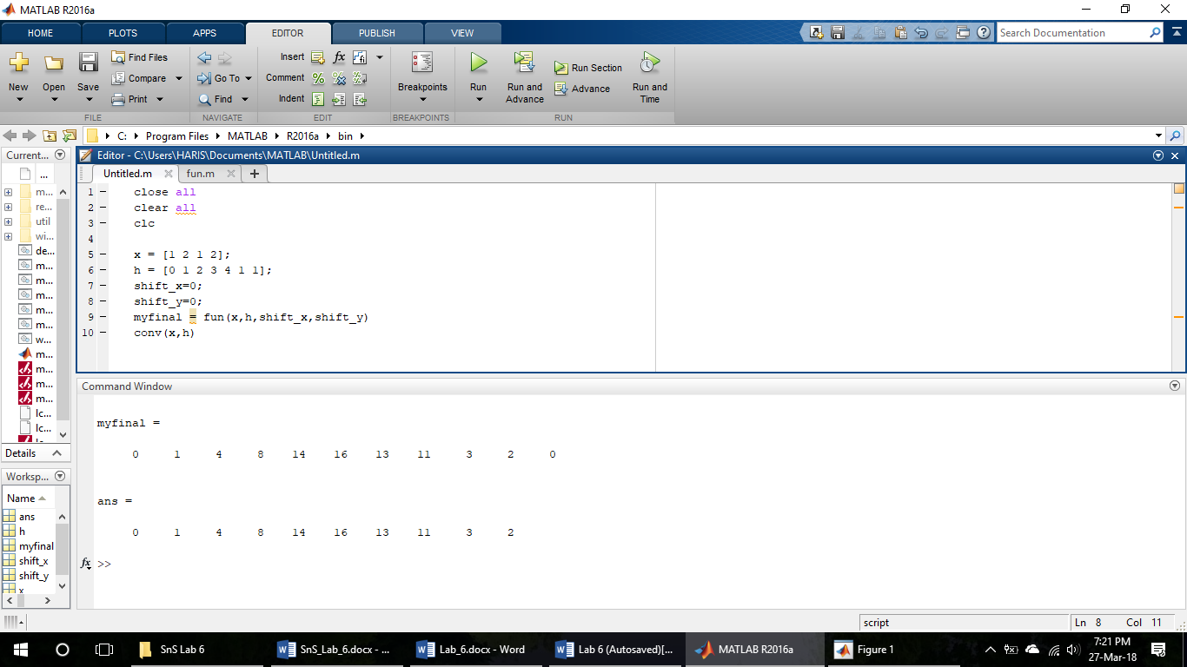



function final = fun(in,hh,sx,sy)

y = zeros(1,(length(hh)+length(in)));

temp = zeros(1,length(in));

final = y;

for i=1:length(hh)

for j=1:length(in)

temp(j)=hh(i)*in(j);

end

if i>1

l = zeros(1,(length(y)-i+1-length(temp)));

f = [zeros(1,i-1) temp l];

final = final + f;

else

final = [temp zeros(1,(length(y)-length(temp)))];

end

end

if(sx<=sy)

d=sx:0;

q=length(d);

n = sx:(length(final)-q);

stem(n, final)

else

d=sy:0;

q=length(d);

n = sy:(length(final)-q);

stem(n, final)

end

end

(d)

