**Department of Electrical Engineering**

|  |  |
| --- | --- |
| **Faculty Member: Mr. Kalimullah** | **Dated: 7th, February, 2018** |
|  |  |
| **Course/Section: BEE8** | **Semester: Spring 2019** |
|  |  |

**EE-330 Digital Signal Processing**

**Lab2: Complex Exponentials and Sinusoids**

|  |  |  |  |  |  |  |
| --- | --- | --- | --- | --- | --- | --- |
|  |  | **PLO4** | | **PLO5** | **PLO8** | **PLO9** |
| **Name** | **Reg. No** | **Viva / Quiz / Lab Performance** | **Analysis of data in Lab Report** | **Modern Tool Usage** | **Ethics and Safety** | **Individual and Team Work** |
|  |  | **5 Marks** | **5 Marks** | **5 Marks** | **5 Marks** | **5 Marks** |
| **Muhammad Haris Rehman** | **182797** |  |  |  |  |  |
| **Muhammad Hasnain Afridi** | **192414** |  |  |  |  |  |
| **Muhammad Anus Siddiqui** | **174308** |  |  |  |  |  |
|  |  |  |  |  |  |  |

**Lab2: Complex Exponentials and Sinusoids**

**Objectives**

The goal of this Part is to gain familiarity with complex numbers and their use in representing sinusoidal signals such as $x\left(t\right)=Acos\left(ωt+∅\right)$ as complex exponentials $z\left(t\right)=Ae^{jθ}e^{jωt}$. The key is to use the appropriate complex amplitude together with the real part operator as follows:

$$x\left(t\right)=Acos\left(ωt+∅\right)=Real\{Ae^{jθ}e^{jωt}\}$$

* How to work with Complex NumbersinMATLAB
* Familiarization with Matalb Function and commands for Complex Exponentials
* Sinusoid Addition Using Complex Exponentials
* Spectrogram of sinusoid

**Lab Instructions**

* The students should perform and demonstrate each lab task separately for step-wise evaluation (please ensure that course instructor/lab engineer has signed each step after ascertaining its functional verification)
* Each group shall submit one lab report on LMS within 6 days after lab is conducted. Lab report submitted via email will not be graded.

. Students are however encouraged to practice on their own in spare time for enhancing their

**Lab Report Instructions**

All questions should be answered precisely to get maximum credit. Lab report must ensure following items:

* Lab objectives
* MATLAB codes
* Results (graphs/tables) duly commented and discussed
* Conclusion

**Introduction to Complex Exponentials**

## Introduction

Manipulating sinusoidal functions using complex exponentials turns trigonometric problems into simple arithmetic and algebra. In this lab, we first review the complex exponential signal and the phasor addition property needed for adding cosine waves. Then we will use MATLAB to make plots of phasor diagrams that show the vector addition needed when adding sinusoids.

### Complex Numbers in MATLAB

Here are some of MATLAB’s built-in complex number operators:

*conj*  Complex conjugate

*abs*  Magnitude

*angle* Angle (or phase) in radians

*real* Real part

*imag* Imaginary part

*i,j* pre-defined as $\sqrt{-1}$

x = 3 + 4i , i suffix defines imaginary constant (same for j suffix)

exp(j*theta) Function for the complex exponential $e^{jθ}$

Each of these functions takes a vector (or matrix) as its input argument and operates on each element of the vector. Notice that the function names mag() and phase() do not exist in MATLAB.

### Sinusoid Addition Using Complex Exponentials

Recall that sinusoids may be expressed as the real part of a complex exponential:

$x\left(t\right)=Acos\left(2πf_{o}t+∅\right)=Real\{Ae^{jθ}e^{2jπf_{0}t}\}$ (1)

The *Phasor Addition Rule* shows how to add several sinusoids:

$x\left(t\right)=\sum_{k=1}^{N}{A_{k}cos\left(2πf_{o}t+∅\right)}$ (2)

assuming that each sinusoid in the sum has the *same* frequency, *f0*. This sum is difficult to simplify using trigonometric identities, but it reduces to an algebraic sum of complex numbers when solved using complex exponentials. If we represent each sinusoid with its *complex amplitude*

$X_{k}=A_{k}e^{j∅_{k}}$*(3)*

Then the complex amplitude of the sum is

$X_{s}={\sum_{k=1}^{N}{X_{k=}}A}_{s}e^{j∅_{s}}$ (4)

Based on this complex number manipulation, the *Phasor Addition Rule* implies that the amplitude and phase of x(t) in equation (2) are As and *ɸ*s, so

$x\left(t\right)=A_{s}cos\left(2πf_{o}t+∅_{s}\right)$ (5)

We see that the sum signal x(t) in (2) and (5) is a single sinusoid that still has the same frequency, *f0*, and it is periodic with period *T0* = 1/*f0*.

### Harmonic Sinusoids

There is an important extension where x(t) is the sum of N cosine waves whose frequencies (fk) are *different.* If we concentrate on the case where the fk are all multiples of one basic frequency *f0*.

fk = k f0 (HARMONIC FREQUENCIES),

Then the sum of N cosine waves given by (2) becomes:

$x_{h}\left(t\right)=A_{k}cos\left(2πf_{o}t+∅_{k}\right)=Real\{\sum_{k=1}^{N}{X_{k}}e^{j2πkf_{0}t}\}$ (6)

This particular signal *xh*(t) has the property that it is also periodic with period T0 = 1/f0, because each of the cosines in the sum repeats with period T0. The frequency f0 is called the *fundamental frequency*, and T0 is called the *fundamental period*.

### Sinusoid in Matlab

Following is matlab function create sinusoid if frequency ff and duration dur.

*The corrected function should look something like:*

*function [xx,tt] = goodcos(ff,dur)*

*tt = 0:1/(100*ff):dur; %-- gives 100 samples per period*

*xx = cos(2*pi*ff*tt);*

Notice the word “function” in the first line. Also, “freeq” has not been defined before being used. Finally, the function has “xx” as an output and hence “xx” should appear in the left-hand side of at least one assignment line within the function body. The function name is *not* used to hold values produced in the function.

## Lab Tasks

### Complex Exponentials

In the Previous lab, you learned how to write M-files. In this section, you will write two functions that can generate sinusoids or sums of sinusoids.

### Lab Task 1:

#### M-file to generate a Sinusoid

Write a function that will generate a single sinusoid, $x\left(t\right)=Acos\left(ωt+∅\right)$ by using four input arguments: amplitude (A), frequency (ω), phase (*ɸ*) and duration (dur). The function should return two outputs: the values of the sinusoidal signal (x) and corresponding times (t) at which the sinusoid values are known. Make sure that the function generates 20 values of the sinusoid per period. Call this function one_cos(). *Hint: use* goodcos() *from par (a) as a starting point.* Demonstrate that your one_cos() function works by plotting the output for the following parameters: A = 95, ω = 200 rad/sec, *ɸ* = π/5 radians, and dur=0.025 seconds. Be prepared to explain to the lab instructor features on the plot that indicates how the plot has the correct period and phase. What is the expected period in millisecond?

**Code:**

function [xx,tt] = goodcos(amp,freq,ph,dur)

ff=freq/(2*pi);

tt=0:1/(20*ff):dur;

xx=amp*cos(freq*tt+ph);

plot(tt,xx)

xlabel('Time(s)');

title('sinusoid plot');

ylabel('Amplitude');

end

**output:**

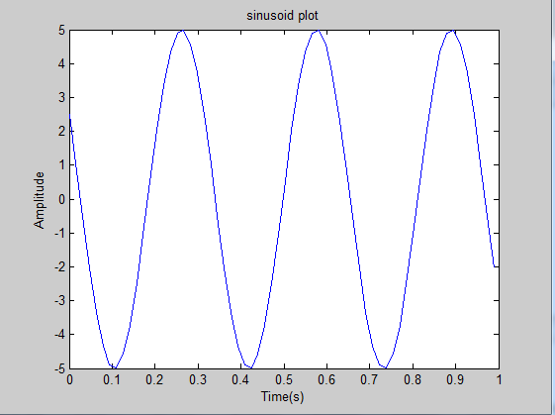

#### Sinusoidal Synthesis with an M-file: Different Frequencies

Since we will generate many functions that are a “sum of sinusoids,” it will be convenient to have a function for this operation. To be general, we will allow the frequency of each component (fk) to be different. The following expressions are equivalent if we define the complex amplitudes $X_{k}=A_{k}e^{j∅_{k}}$

$x\left(t\right)=Real\{\sum_{k=1}^{N}{X_{k}}e^{j2πf_{k}t}\}$ (7)

.

$x\left(t\right)=\sum_{k=1}^{N}{A_{k}cos\left(2πf_{k}t+∅_{k}\right)}$ (8)

ff=w/(2*pi);

phi=pi/5;

dur=0.025;

t=0:1/(20*ff):0.025;

x1 = 1*cos(2*pi*.73*t+pi/3);

x2 = 1*cos(2*pi*1.33*t-pi/4);

x3 = 1*cos(2*pi*1.93*t+pi/5);

x4 = 1*cos(2*pi*2.93*t-pi/6);

x = x1 + x2 + x3 + x4;

figure(2)

subplot(5,1,1)

h = plot(t,x1); box off; grid off

xlabel('Time(s)');

ylabel('Amplitude');

subplot(5,1,2)

h = plot(t,x2); box off; grid off

xlabel('Time(s)');

ylabel('Amplitude');

subplot(5,1,3)

h = plot(t,x3); box off; grid off

xlabel('Time(s)');

ylabel('Amplitude');

subplot(5,1,4)

h = plot(t,x4); box off; grid off

xlabel('Time(s)');

ylabel('Amplitude');

subplot(5,1,5)

h = plot(t,x); box off; grid off

xlabel('Time(s)');

ylabel('Amplitude');

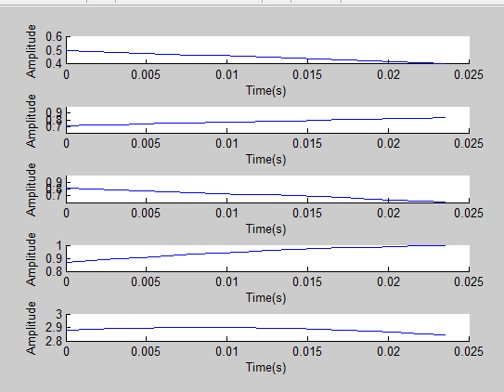

### Lab task 2:

#### Write the Function M-file

Write an M-file called syn sin.m that will synthesize a waveform in the form of (7).Although for loops are rather inefficient in MATLAB but youmust write the function with one loop in this lab. The first few statements of the M-file are the comment lines—they should look like:

*function [xx,tt] = syn_sin(fk, Xk, fs, dur, tstart)*

*%SYN_SIN Function to synthesize a sum of cosine waves*

*% usage:*

*% [xx,tt] = syn_sin(fk, Xk, fs, dur, tstart)*

*% fk = vector of frequencies*

*% (these could be negative or positive)*

*% Xk = vector of complex amplitudes: Amp*eˆ(j*phase)*

*% fs = the number of samples per second for the time axis*

*% dur = total time duration of the signal*

*% tstart = starting time (default is zero, if you make this input optional)*

*% xx = vector of sinusoidal values*

*% tt = vector of times, for the time axis*

*% Note: fk and Xk must be the same length.*

*% Xk(1) corresponds to frequency fk(1),*

*% Xk(2) corresponds to frequency fk(2), etc.*

The MATLAB syntax length(fk) returns the number of elements in the vector fk, so we do not need a separate input argument for the number of frequencies. On the other hand, the programmer (that’s you) should provide error checking to make sure that the lengths of fk and Xk are the same. See help error. Finally, notice that the input fs define the number of samples per second for the cosine generation; in other words, we are no longer constrained to using 20 samples per period. *Include a copy of the* MATLAB *code with your lab report.*

**Code:**

function [xx,tt] = good_fun(fk, Xk, fs, dur, tstart) %generalized function for adding different frequency sinusoids

xx=0; %initializing it to zero

tt=tstart:1/fs:dur;

if length(fk) == length(Xk) % checking if length of arrays are equal

for ii=1:length(fk)

xx=xx+Xk(ii)*(exp(2i*pi*fk(ii)*tt)); %adding all components of different frequencies

end

xx=real(xx); %real part of complex result

plot(tt,xx)

xlabel('time')

ylabel('magnitude')

else

disp('LENGTH OF ARRAYS DOES NOT MATCH')

end

**output:**

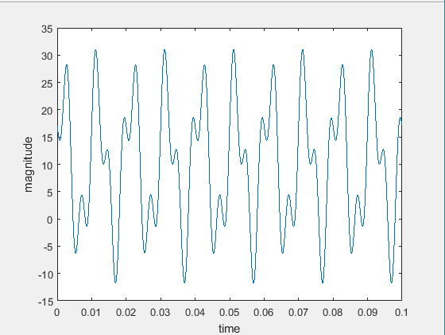

#### Testing

In order to use this M-file to synthesize harmonic waveforms, you must choose the entries in the frequency vector tobbe integer multiples of some desired fundamental frequency. Try the following test and plot the result.

*[xx0,tt0] = syn_sin([0,100,250],[10,14*exp(-j*pi/3),8*j],10000,0.1,0);*

*%-Period =* ?

Measure the period of xx0 by hand. Then compare the period of xx0 to the periods of the three sinusoids that make up xx0?

### Lab Task 3:

#### Representation of Sinusoids with Complex Exponentials

1. Generate the signal and make a plot versus t. Use the syn_sin function and take a range for t that will cover three periods starting at t = −0.5 secs. *Include the* MATLAB *code with your report.*

function [xx,tt] = syn_sin(fk, Xk, fs, dur, tstart) %generalized function for adding different frequency sinusoids

xx=0; %initializing it to zero

tt=tstart:1/fs:dur*3;

if length(fk) == length(Xk) % checking if length of arrays are equal

for ii=1:length(fk)

xx=xx+Xk(ii)*(exp(2i*pi*fk(ii)*tt)); %adding all components of different frequencies

end

xx=real(xx); %real part of complex result

plot(tt,xx)

xlabel('time')

ylabel('magnitude')

else

disp('LENGTH OF ARRAYS DOES NOT MATCH')

end

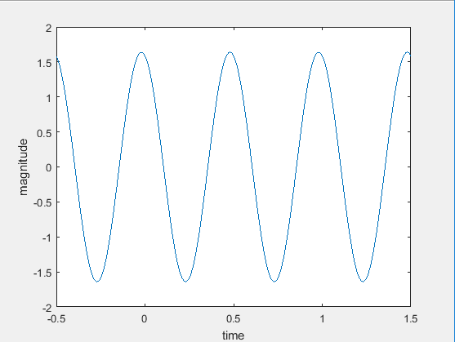

1. From the plot of x(t) versus t, measure the frequency, phase and amplitude of the sinusoidal signal by hand. Show annotations on the plots to indicate how these measurements were made and what the values are.

**Ans**: plot is shown above with amplitude 1.5 and maximum frequency 2hz .

### Lab task 4:

1. Create three sinusoids of 2 second and concatenate them after concatenation plot spectrogram of concatenated signal and explain the result

Fs = 44100;

t = 0:1/Fs:1;

f1 = 500;

f2 = 1000;

f3 = 2000;

x1 = sin(2*pi*f1*t);

x2 = sin(2*pi*f2*t);

x3 = sin(2*pi*f3*t);

x = [x1, x2, x3];

sound(x, Fs)

spectrogram(x, 512, 5, 512, Fs, 'yaxis')

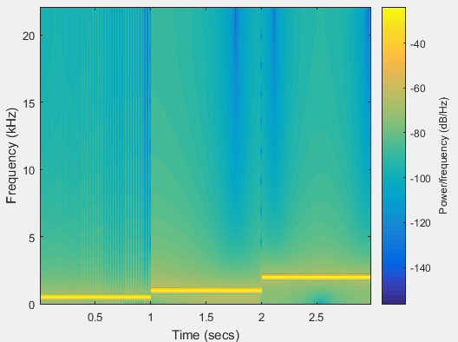

1. Explain the effect of window size on time and frequency resolution and also explain what is advantage of spectrogram over Fourier transform

**Ans:** The Fourier transform gives the frequency domain visualization of the signal. But on the other hand, the spectrogram shows the time domain as well as the frequency domain visualization of the signal. The x axis contain time and y axis contain frequency. Its resolution depends upon the second third and fourth argument of the spectrogram command in matlab.