# Assignment # 1

**Name:** M Haris Shakeel **REG:** L1F22BSCS0434

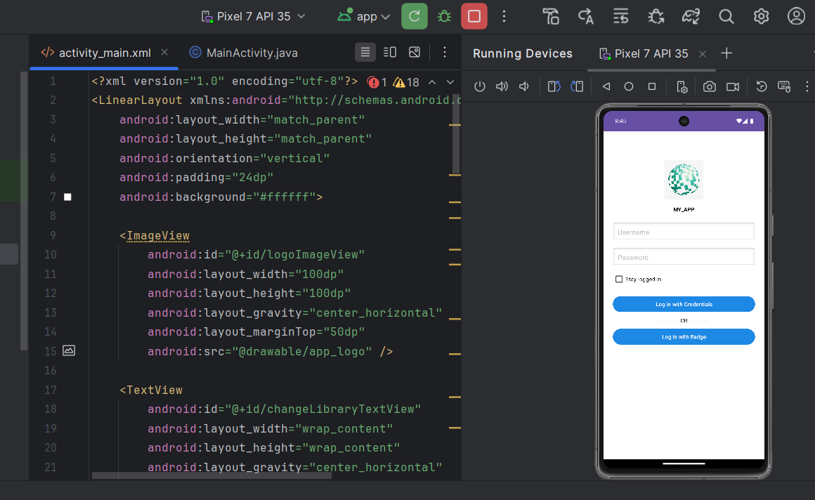

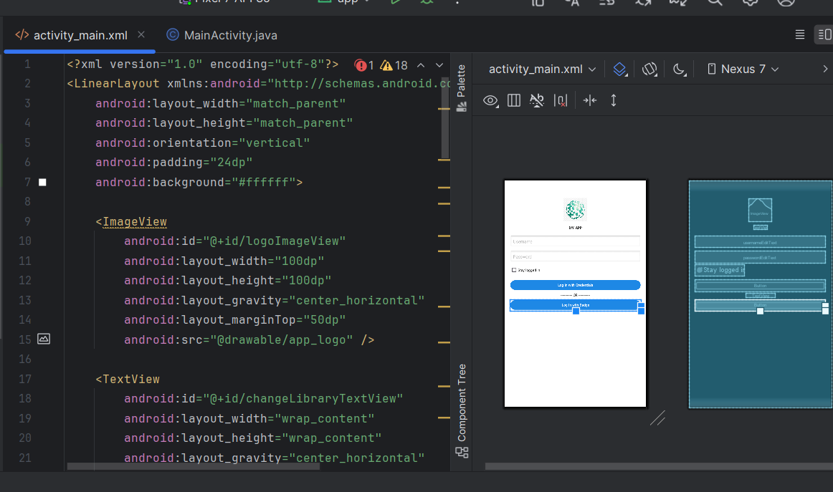

GitHub link (Zip File with name Temp): <https://github.com/Haris-Shakeel/mobile_application_development>

XML Code:

<?xml version="1.0" encoding="utf-8"?>  
<LinearLayout xmlns:android="http://schemas.android.com/apk/res/android"  
 android:layout_width="match_parent"  
 android:layout_height="match_parent"  
 android:orientation="vertical"  
 android:padding="24dp"  
 android:background="#ffffff">  
  
 <ImageView  
 android:id="@+id/logoImageView"  
 android:layout_width="100dp"  
 android:layout_height="100dp"  
 android:layout_gravity="center_horizontal"  
 android:layout_marginTop="50dp"  
 android:src="@drawable/app_logo" />  
  
 <TextView  
 android:id="@+id/changeLibraryTextView"  
 android:layout_width="wrap_content"  
 android:layout_height="wrap_content"  
 android:layout_gravity="center_horizontal"  
 android:text="MY_APP"  
 android:textColor="#000000"  
 android:textStyle="bold"  
 android:layout_marginTop="16dp"  
 android:clickable="true"  
 android:focusable="true"/>  
  
 <EditText  
 android:id="@+id/usernameEditText"  
 android:layout_width="match_parent"  
 android:layout_height="wrap_content"  
 android:hint="Username"  
 android:layout_marginTop="24dp"  
 android:background="@android:drawable/edit_text"  
 android:padding="12dp"  
 android:inputType="text"  
 android:textColor="#000000"  
 android:textColorHint="#BDBDBD"/>  
  
 <EditText  
 android:id="@+id/passwordEditText"  
 android:layout_width="match_parent"  
 android:layout_height="wrap_content"  
 android:hint="Password"  
 android:layout_marginTop="16dp"  
 android:background="@android:drawable/edit_text"  
 android:padding="12dp"  
 android:inputType="textPassword"  
 android:textColor="#000000"  
 android:textColorHint="#BDBDBD"/>  
  
  
 <CheckBox  
 android:id="@+id/stayLoggedInCheckBox"  
 android:layout_width="208dp"  
 android:layout_height="wrap_content"  
 android:layout_marginTop="8dp"  
 android:text="Stay logged in"  
 android:textColor="#000000" />  
  
  
 <Button  
 android:id="@+id/loginWithCredentialsButton"  
 android:layout_width="match_parent"  
 android:layout_height="wrap_content"  
 android:layout_marginTop="16dp"  
 android:text="Log in with Credentials"  
 android:backgroundTint="#1E88E5"  
 android:textColor="#FFFFFF"/>  
  
 <!-- OR Divider -->  
 <TextView  
 android:id="@+id/orTextView"  
 android:layout_width="wrap_content"  
 android:layout_height="wrap_content"  
 android:layout_gravity="center_horizontal"  
 android:layout_marginTop="8dp"  
 android:text="------------- OR -------------"  
 android:textColor="#000000"/>  
  
 <Button  
 android:id="@+id/loginWithBadgeButton"  
 android:layout_width="match_parent"  
 android:layout_height="wrap_content"  
 android:layout_marginTop="8dp"  
 android:text="Log in with Badge"  
 android:backgroundTint="#1E88E5"  
 android:textColor="#FFFFFF"  
 android:drawableStart="@drawable/images"  
 android:drawablePadding="10dp"/>  
  
</LinearLayout>