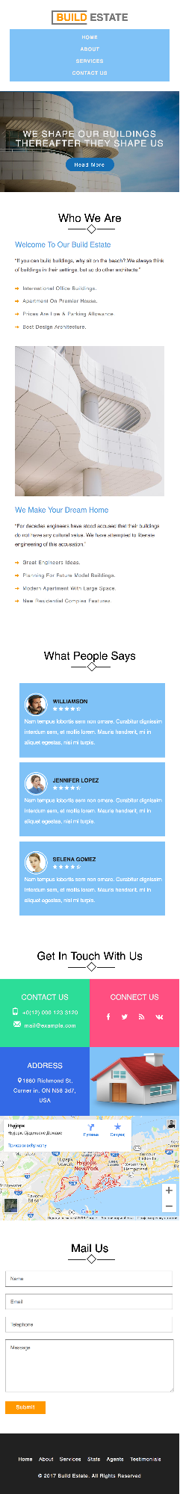

BUILD ESTATE

HOME

ABOUT

SERVICES

CONTACT US

WE SHAPE OUR BUILDINGS THEREAFTER THEY SHAPE US

Read More

Who We Are

Welcome To Our Build Estate

"If you can build buildings, why sit on the beach?,We always think of buildings in their settings, but so do other architects.”

→ International Office Buildings.

→ Apartment On Premier House.

→ Prices Are Low & Parking Allowance.

→ Best Design Architecture.

We Make Your Dream Home

"For decades engineers have stood accused that their buildings do not have any cultural value. We have attempted to liberate engineering of this accusation.”

→ Great Engineers Ideas.

Planning For Future Model Buildings.

→ Modern Apartment With Large Space.

→ New Residential Complex Features.

What People Says

**WILLIAMSON**

Nam tempus lobortis sem non ornare. Curabitur dignissim

interdum sem, et mollis lorem. Mauris hendrerit, mi in

aliquet egestas, nisi mi turpis.

JENNIFER LOPEZ

Nam tempus lobortis sem non ornare. Curabitur dignissim interdum sem, et mollis lorem. Mauris hendrerit, mi in aliquet egestas, nisi mi turpis.

**SELENA GOMEZ**

Nam tempus lobortis sem non ornare. Curabitur dignissim

interdum sem, et mollis lorem. Mauris hendrerit, mi in

aliquet egestas, nisi mi turpis.

Get In Touch With Us

CONNECT US

CONTACT US +0(12) 000 123 3120

f

w

W mail@example.com

ADDRESS

0 1680 Richmond St, Corner in, ON N58 307,

USA

Њујорк Њујорк, Сједињене Државе

Путања

Сачувај

Npnkaxu Beħy many

Morristown

Koma Comm 495

25A MEHXETHOD 280 MANHATTAN 295

-Хиксвил Hyapk

Hicksville

КВИНС Newark nyopRQUEENS XemnCTEA New York

Hempstead

*- Бе*

Bay

E 2785

278

Bridgewater

*24*

2

287

Едисон Edison

36

Google

95

nogayn ca mane ©2018 Google School Kopywherba Mpyjabu rpewky Ha mann

Mail Us

Name

Email

Telephone

Message

Submit

**Home About Services Stats**

**Agents**

**Testimonials**

© 2017 Build Estate. All Rights Reserved